**RAJSHAHI UNIVERSITY OF ENGINEERING AND TECHNOLOGY**

|  |  |
| --- | --- |
| RUET 09 | |
| Course No: EEE 2252  Lab report: 01  Name of the Experiment: Observation of different types of machines along with their specifications in electrical machine laboratory.  Date of Experiment: 30.10.2018  Date of Submission: 08.12.2018 | |
| Submitted to:  Md. Tarek Hossein  Lecturer  Department of Computer Science and Engineering  Rajshahi University of Engineering and Technology | **Submitted by:**  Riyad Morshed Shoeb  Roll No: 1603013  Section: A  Department of Computer Science and Engineering  Rajshahi University of Engineering and Technology |

**DC Motor**

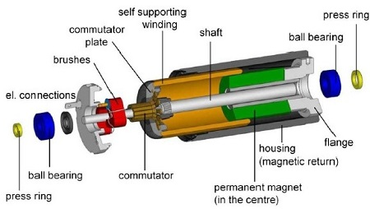

Fig: Parts of a DC Motor

**DC Generator**

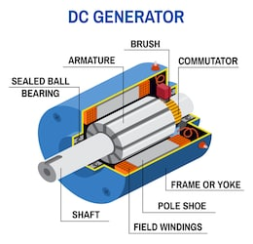

Fig: Cross section of a DC Generator

**Induction Motor**

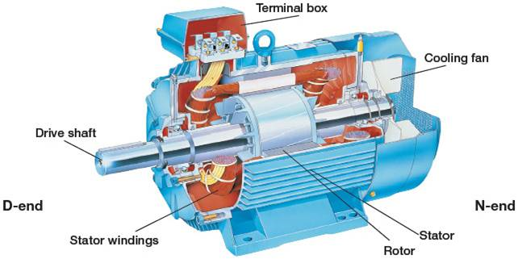

Fig: Cross section of an Induction Motor

**Induction Generator**

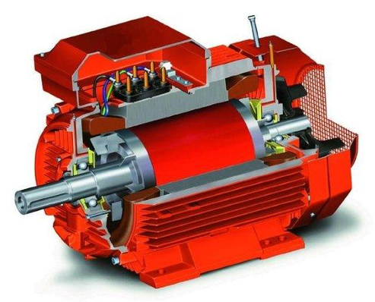

Fig: Cross section of an Induction Generator

**Synchronous Motor**

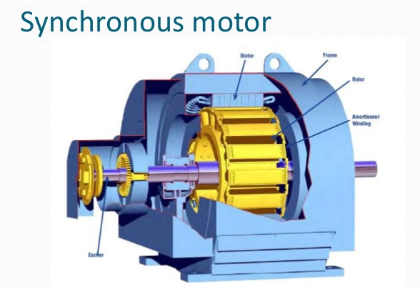

Fig: Cross section of a Synchronous Motor

**Synchronous Generator**

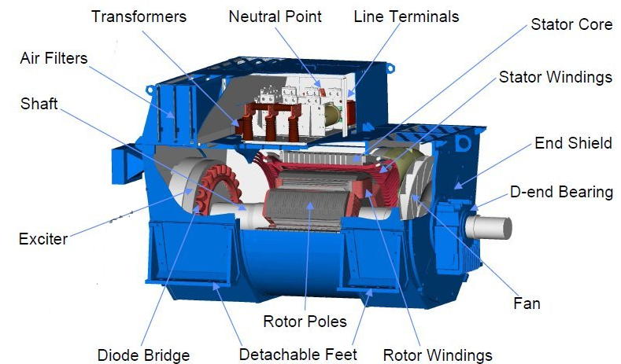

Fig: Cross section of a Synchronous Generator