Task Report:

1. Task Description:

The task was to create a Django app that allows users to sign up by providing details like name, email, and password. The user data is stored in the database and is also appended to a **.csv** file upon every form submission.

2. Screenshot of Output:

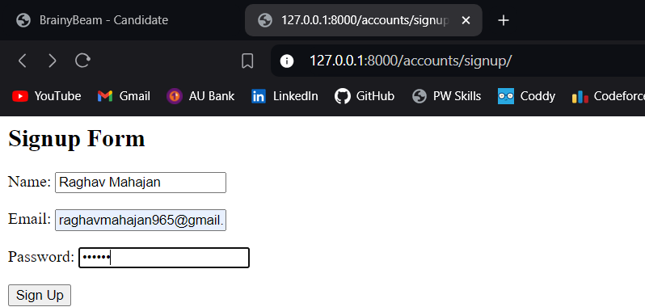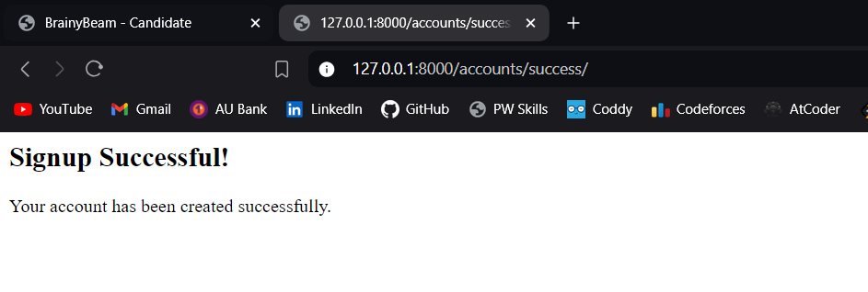

3. Widget/Algorithm Used:

- Widget: A Django **ModelForm** widget was used to render the signup form and automatically handle form validation.

- Algorithm:

- Upon form submission, the data is validated and saved to the database using Django's ORM.

- The user data is then written to a **.csv** file in append mode. This ensures that each submission appends a new row to the CSV, containing the user's name and email.