**Task-02:**

**1. Task Description:**

The task is to write a Python program that identifies and extracts words from a given string that contain exactly two occurrences of the letter 'a'. For this, a regular expression (regex) is used to scan through the input string and return all words that fit the required condition.

The input string used for this task is:

"Layla is a good data scientist"

The desired output will be a list of words that contain exactly two 'a's.

**2. Screenshot of Output:**

Here is the code execution output:

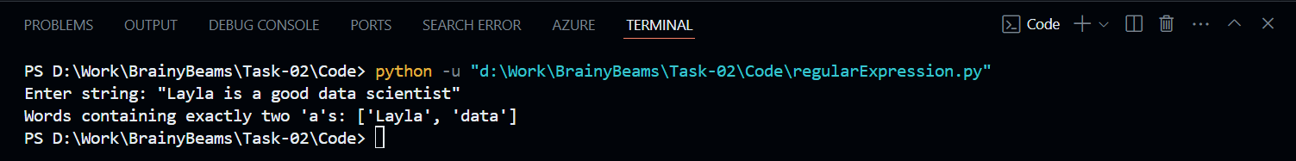

**3. Widget/Algorithm Used in the Task:**

The task uses **Regular Expressions (Regex)** in Python. Regex is a powerful tool for pattern matching and text manipulation. The specific pattern used in this task matches words that have exactly two 'a's by following these steps:

- **\b**: Specifies a word boundary to ensure the regex matches full words.

- **\w\***: Matches zero or more word characters (any combination of letters, numbers, or underscores).

- **a**: Matches the letter **a** specifically.

- This combination is repeated twice in the pattern to find words that contain exactly two '**a**'s.

- **re.findall()**: This function scans the input string and returns all occurrences that match the regex pattern.