**Student Have To Prepare Report In Format**

1. Add Task Description
2. Attach Screenshot Of Output.
3. Describe Widget/Algorithm Used In Task
4. Add Report In Your Task Zip File

**Sample Example :**

1. **Task Description**

Create Signup Page Using Widgets like EditText, AutoCompleteTextview, Radio Button, Checkbox, Spinner, Button and also use Validation. After Validating Redirect on Next Screen and Display Data Which Filled in Signup Screen

1. **Task Output Screenshot**

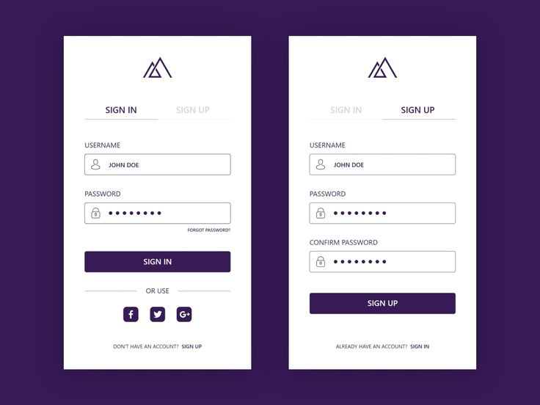

1. **Widget/Algorithm Used In Task**

* EditText Widget Used For Input Field Of UserName,Password Etc…
* Button Widget Used For Signin And Signup.
* TextView Used For Display Static Content To Uses.
* ImageView Widget Used For Display Company/Profile Logo.