Acknowledgement

We would like to take this opportunity to express our heartfelt gratitude to every individual and institution that has played a pivotal role in the successful completion of our project, Book Recommendation System. This achievement would not have been possible without the unwavering support, encouragement, and contributions of many who have guided us throughout this journey. The collective efforts and support we received helped us transform our ideas into a well-structured and functional project. This experience has been both academically enriching and personally rewarding.
First and foremost, we are profoundly thankful to our esteemed project guide, Dr. Maitri Jhaveri, whose continuous guidance, mentorship, and encouragement have been the cornerstone of our progress. From the initial stages of conceptualizing the idea to the final implementation of the system, Dr. Jhaveri has been a constant source of inspiration. Her deep knowledge, technical expertise, and critical insights not only helped us navigate challenges but also enhanced our problem-solving abilities. Her patient reviews of our work, valuable suggestions, and persistent motivation ensured that we stayed focused, improved consistently, and maintained a high standard throughout the project lifecycle. We are truly fortunate to have had the opportunity to work under her mentorship.
We would like to express our sincere gratitude to Dr. Jyoti Pareek for her guidance and academic supervision during the course of this project. Her general suggestions and observations helped us stay aligned with the academic objectives and requirements of the work. We also appreciate her encouragement and support, which contributed to a structured and disciplined approach throughout the project development. Her emphasis on clarity, consistency, and academic rigor helped us refine our work and maintain quality standards.
We also extend our gratitude to Dr. Hiren Joshi, Head of the Department of Computer Science, Gujarat University, for providing a conducive academic environment and the necessary institutional support to carry out this project. His leadership and vision have fostered a culture of learning, innovation, and practical exposure within the department. The availability of resources and encouragement for project-based learning greatly facilitated our work. We are thankful for the opportunities provided to apply theoretical knowledge to real-world problem-solving.
We sincerely thank Dr. Vaidehi Vaghela for her valuable guidance and feedback, which helped improve the documentation and overall structure of the project. We also express our gratitude to Jay Patel Sir for his technical guidance, support, and motivation, which greatly strengthened the system design and enhanced our confidence and skills.
We are thankful to all the faculty members and departmental staff for ensuring the availability of essential facilities and providing administrative support, which played an important role in the smooth and timely completion of our project. We also extend our heartfelt thanks to our friends and family members for their constant encouragement, patience, and moral support throughout this journey. Their belief in us kept us motivated and focused during challenging times, and we are deeply grateful to everyone who contributed, directly or indirectly, to the successful completion of this project.

Table of Contents

- Project Profile
- About the Project
- Requirement Engineering
  - System Overview
  - Requirement Analysis and Feasibility Study
- System Design
  - Design(Diagrams)
  - Database Design
  - Data Dictionary
  - Forms Design
  - Reports Design
  - System Security
- Implementation
- System Testing
- Sample Code
- Future Enhancements
- Bibliography

Project Profile
Project Title: Book Recommendation System
Aim:
The aim of this project is to design and develop a Book Recommendation System that provides personalized book suggestions based on users’ interests, preferences, and interactions. The system supports three user roles namely Author, Reader, and Administrator to ensure effective content management, user engagement, and platform administration. It utilizes recommendation techniques to enhance book discovery and improve the overall reading experience. The project also aims to create a scalable and user friendly platform that can be enhanced with advanced features in the future.
Software Used:
- Flask (Backend)
- MySQL (Database)
- HTML/CSS (Frontend)
- JavaScript (Client-side scripting)
Hardware Used:
- Intel Core i5 or higher processor
- 8GB RAM (minimum)
- 500GB Hard Disk

Team Size: 3
Team Members/Developed By:
- Mahale Ruchita
- Makwana Keyuri
- Patel Netra
Minimum Deployment Environment:
Hardware:
- A computer with at least an Intel Core i3 processor
- 4GB RAM (minimum)
- 250GB Hard Disk
Software:
- Operating System: Windows 10/11 or Linux
- Web Server: Flask (Python-based web framework)
- IDE: VS Code any preferred editor
- Browser: Latest version of Chrome, Firefox, or Ed

About The Project

The Book Recommendation System is a Flask-based web application designed to assist users in discovering books that closely align with their individual reading interests and preferences. The system intelligently analyzes various forms of user data, including reading history, ratings, reviews, and overall interaction behavior, to generate accurate and personalized book recommendations. By leveraging both content-based and collaborative filtering techniques, the system ensures that users receive suggestions that are relevant, diverse, and tailored to their tastes.
The platform supports three major user roles: Author, Reader, and Administrator, each with clearly defined responsibilities. Authors are provided with a secure interface to register on the platform and efficiently manage complete book information, such as titles, genres, descriptions, and other metadata. Readers can browse and search books using multiple criteria, rate and review books they have read, and organize selected books into personal bookshelves for easy access and future reference. Administrators play a critical role in maintaining the integrity of the system by approving author registrations, managing users and book data, and monitoring platform activities to ensure smooth operation.
In addition, the application integrates a robust database system to securely store user profiles, book details, ratings, reviews, and bookshelf data. The system also includes basic data visualization features that help analyze recommendation performance, track user activity trends, and identify popular books. These insights enable continuous improvement of the recommendation engine and overall system performance. Through its user-friendly design and intelligent recommendation capabilities, the Book Recommendation System enhances the book discovery experience and provides a scalable foundation for future enhancements.
Features:
General Features
- Role-based authentication and authorization
- Secure login and access control
- Personalized book recommendation engine
- Search and filter books by genre, author, and keywords
- Continuous learning from user behavior and feedback

Author Features
- Secure author registration and authentication
- Add, update, and delete book information
- Manage complete book details such as title, genre, description, and author profile
- Track approval status after administrator verification
Reader Features
- User registration and profile management
- Browse and search books using multiple criteria
- Receive personalized recommendations using content-based and collaborative filtering
- Rate and review books
- Full CRUD operations on personal bookshelves
Admin Features
- Approve or reject author registration requests
- Monitor and manage users, books, and reviews
- Remove inappropriate or invalid content
- View analytics such as popular books and user activity trends

Components of the System :
- Frontend Component
  - User interface for Admin, Author, and Reader
  - Developed using HTML, CSS, and JavaScript
- Backend Component
  - Implemented using Flask
  - Handles business logic, authentication, and access control
- Recommendation Engine
  - Uses content-based and collaborative filtering
  - Generates personalized book recommendations
- Database Component
  - Uses MySQL
  - Stores users, books, ratings, reviews, and bookshelf data
- Analytics & Visualization Module
  - Displays user activity and popular books
  - Helps monitor system performance

Users of the System :
1. Author
Authors are responsible for contributing book content to the platform. They can register securely, manage their book information, and monitor approval status after admin verification.
2. Reader
Readers are end users who browse and search for books, receive personalized recommendations, rate and review books, and manage their own bookshelves.
3. Administrator
Administrators have complete control over the system. They approve author registrations, manage users and book data, and monitor analytics related to user activity and popular books.

Requirement Engineering

System Overview:
The Book Recommendation System is a Flask-based web application designed to provide intelligent and personalized book suggestions to users by analyzing their preferences, behavior, and interaction patterns. The system uses a modular and scalable architecture that separates the frontend, backend, recommendation engine, and database components, ensuring maintainability and future extensibility. Flask serves as the core backend framework, handling request processing, business logic, user authentication, and communication between different system modules.
At the heart of the system lies the recommendation engine, which employs two primary techniques: content-based filtering and collaborative filtering. Content-based filtering recommends books by comparing book attributes such as genre, author, keywords, and descriptions with a user’s past reading history and preferences. This approach ensures that users receive recommendations closely aligned with their individual interests. Collaborative filtering, on the other hand, analyzes patterns across multiple users by identifying similarities in ratings and behavior, enabling the system to suggest books that users with similar tastes have enjoyed. By combining these two techniques, the system produces more accurate, diverse, and relevant recommendations.
The system securely stores all critical data, including user profiles, book metadata, ratings, reviews, and bookshelf information, in a relational database. This persistent data storage enables efficient retrieval, analysis, and management of information. User interactions such as searches, ratings, and reviews are continuously recorded and analyzed, allowing the recommendation engine to adapt and improve over time. This continuous learning process helps refine recommendation accuracy and enhances overall user satisfaction.
To support decision-making and system monitoring, the application includes basic visualization and analytics features. These visualizations display important metrics such as user activity trends, popular books, and overall recommendation performance. Administrators can use these insights to monitor platform usage, evaluate system effectiveness, and identify areas for improvement. Overall, the system provides a robust, user-friendly, and intelligent platform that enhances book discovery, encourages user engagement, and offers a strong foundation for future enhancements such as advanced analytics, scalability improvements, and integration with additional data sources.

Requirement Analysis and Feasibility Study:
Requirements:
- User roles: Admin, Author, and Reader
- Secure login and authentication for Admin, Author, and Reader
- Role-based access control for system operations
- Book data entry and management by Authors
- Book browsing, searching, rating, and reviewing by Readers
- Personalized book recommendation using content-based and collaborative filtering
- Personal bookshelf management with full CRUD operations
- Admin approval for Author registration
- Monitoring and management of users, books, and reviews by Admin
- Analytics and basic visualization of user activity and popular books
- User-friendly and easy-to-navigate interface
Feasibility:
Technical Feasibility
The proposed system is technically feasible as it is developed using well-established technologies such as Flask, MySQL, and standard web technologies. Content-based and collaborative filtering algorithms can be efficiently implemented using Python libraries. The required hardware and software resources are readily available and easy to maintain.
Economic Feasibility
The system is cost-effective as it uses open-source tools and frameworks, minimizing development and deployment costs. No expensive proprietary software or hardware is required, making it suitable for academic and small-scale commercial use.

Operational Feasibility
The system is user-friendly and supports intuitive interfaces for all user roles. Minimal training is required for authors, readers, and administrators. The system’s automation of recommendations and administrative tasks improves operational efficiency.
Proposed System:
a. Objectives:
- To develop a web-based Book Recommendation System using Flask
- To provide personalized book recommendations based on user preferences and behavior
- To enable Authors to register and manage book information efficiently
- To allow Readers to browse, rate, review, and manage personal bookshelves
- To ensure administrative control for approving Authors and monitoring system activities
- To enhance book discovery through continuous learning from user interaction data
b. Hardware and Software Platforms:
1. Minimum Hardware Requirements:
- Processor: Intel i3 or higher
- RAM: 4 GB (8 GB recommended)
- Storage: 100 GB or more
2. Software Requirements:
- Operating System: Windows 10 / 11 or Linux
- Backend Framework: Flask (Python)
- Database: MySQL
- Frontend Technologies: HTML, CSS, JavaScript
- Development Tools: VS Code / PyCharm
- Web Browser: Google Chrome, Firefox, or Edge

System Design
- Design(Diagrams)
  - Module Hierarchy
  - Use Case Diagram
  - Activity diagram
- Database Design
- Data Dictionary
- Forms Design
- Reports Design
- System Security

Module Hierarchy

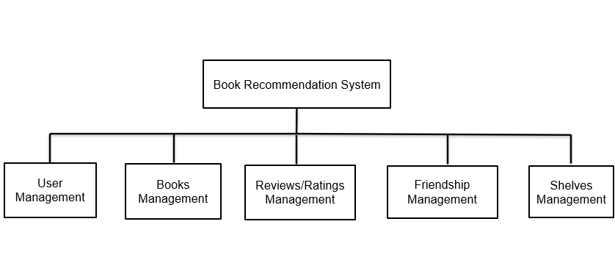

Use Case Diagram

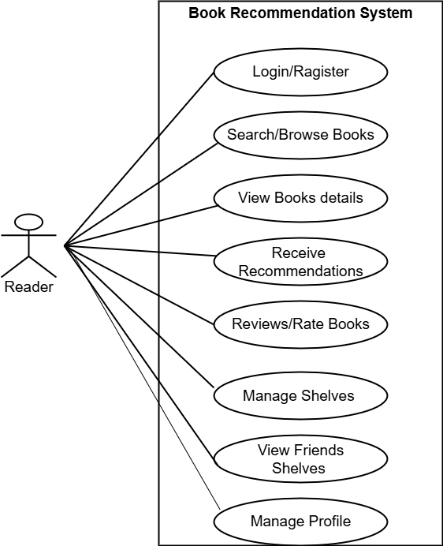
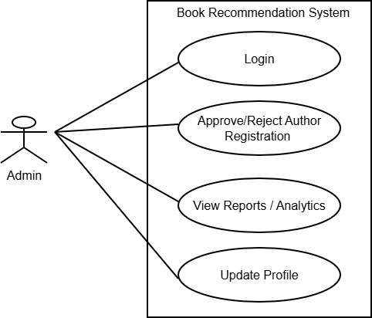

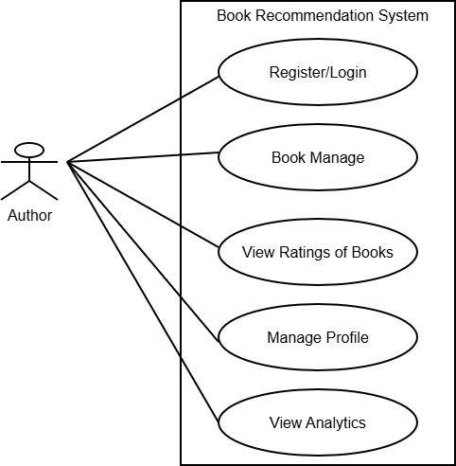

Activity Diagram
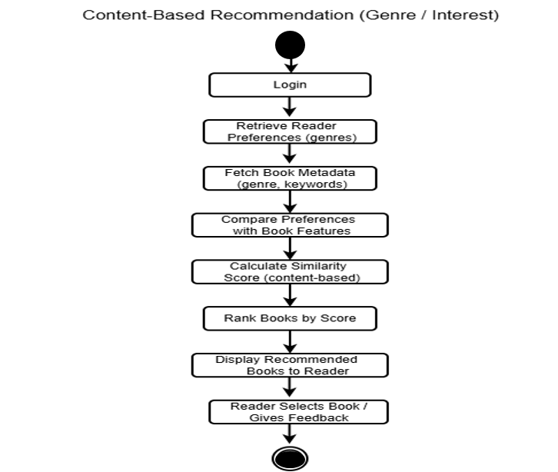

Data Dictionary
Authors Table
Column Name | Data Type | Size/Limit | Constraints | Description
author_id | INT | 11 | NOT NULL | Unique identifier for each author (primary key should be applied).
name | VARCHAR | 255 | NOT NULL | Full name of the author.
biography | TEXT | N/A | NULL allowed (default) | Detailed biography or background information about the author.
date_of_birth | DATE | N/A | NULL allowed (default) | Birth date of the author.
date_of_death | DATE | N/A | NULL allowed (default) | Date of death, if applicable.

Books Table
Column Name | Data Type | Size/Limit | Constraints | Description
book_id | INT | 11 | NOT NULL | Unique identifier for each book (should be primary key).
title | VARCHAR | 255 | NOT NULL | Title of the book.
author_id | INT | 11 | NULL allowed (default) | References the author of the book; foreign key to authors.author_id.
series_id | INT | 11 | NULL allowed (default) | References a series the book belongs to, if applicable.
published_year | INT | 11 | NULL allowed (default) | Year the book was published.
language | ENUM | Fixed set | NOT NULL, allowed: ('English','Hindi','Gujarati','Marathi') | Language in which the book is written.
description | TEXT | N/A | NULL allowed (default) | Summary or details about the book.
cover_image_url | VARCHAR | 255 | NULL allowed (default) | URL link to the book’s cover image.
isbn | VARCHAR | 20 | NULL allowed (default) | International Standard Book Number (unique identifier for books).

Book_Genres Table
Column Name | Data Type | Size/Limit | Constraints | Description
book_id | INT | 11 | NOT NULL | References the book; links to books.book_id.
genre_id | INT | 11 | NOT NULL | References the genre; links to genres.genre_id.

Follows Table
Column Name | Data Type | Size/Limit | Constraints | Description
follow_id | INT | 11 | NOT NULL | Unique identifier for each follow action (should be primary key).
follower_id | INT | 11 | NOT NULL | User who is following another user; references users.user_id.
following_id | INT | 11 | NOT NULL | User being followed; references users.user_id.
created_at | TIMESTAMP | N/A | NOT NULL, default: CURRENT_TIMESTAMP | Date and time when the follow was created.

friend_requests Table
Column Name | Data Type | Size/Limit | Constraints | Description
request_id | INT | 11 | NOT NULL | Unique identifier for each friend request (should be primary key).
requester_id | INT | 11 | NOT NULL | User who sends the friend request; references users.user_id.
requestee_id | INT | 11 | NOT NULL | User who receives the friend request; references users.user_id.
status | ENUM | Fixed set | Default 'pending' | Current state of the request: 'pending', 'accepted', or 'rejected'.
requested_at | TIMESTAMP | N/A | NOT NULL, default: CURRENT_TIMESTAMP | Date and time when the request was initiated.
responded_at | TIMESTAMP | N/A | NULL allowed (default) | Date and time when the request was responded to (accepted/rejected).

genres Table
Column Name | Data Type | Size/Limit | Constraints | Description
genre_id | INT | 11 | NOT NULL | Unique identifier for each genre (should be primary key).
genre_name | VARCHAR | 100 | NOT NULL | Name of the genre (e.g., Fiction, Mystery, Romance).

reviews Table

Column Name | Data Type | Size/Limit | Constraints | Description
review_id | INT | 11 | NOT NULL | Unique identifier for each review (should be primary key).
user_id | INT | 11 | NULL allowed (default) | User who wrote the review; references users.user_id.
book_id | INT | 11 | NULL allowed (default) | Book being reviewed; references books.book_id.
ratings | INT | 1 | NOT NULL | Rating given to the book (expected range 1–5).
review_text | TEXT | N/A | NULL allowed (default) | Written review or feedback about the book.
review_date | TIMESTAMP | N/A | NOT NULL, default: CURRENT_TIMESTAMP | Date and time when the review was submitted.

series Table
Column Name | Data Type | Size/Limit | Constraints | Description
series_id | INT | 11 | NOT NULL | Unique identifier for each book series (should be primary key).
name | VARCHAR | 255 | NOT NULL | Name/title of the series.
description | TEXT | N/A | NULL allowed | Additional details or summary about the series.

shelves Table
Column Name | Data Type | Size/Limit | Constraints | Description
shelf_id | INT | 11 | NOT NULL | Unique identifier for each shelf (should be primary key).
user_id | INT | 11 | NULL allowed (default) | User who owns the shelf; references users.user_id.
name | VARCHAR | 100 | NOT NULL | Name of the shelf (e.g., Read, Currently Reading, Favorites).
is_default | TINYINT | 1 | Default 0 | Indicates if shelf is system-default (1 = yes, 0 = user-created).
created_at | TIMESTAMP | N/A | NOT NULL, default: CURRENT_TIMESTAMP | Date and time the shelf was created.

users Table
Column Name | Data Type | Size/Limit | Constraints | Description
user_id | INT | 11 | NOT NULL | Unique identifier for each user (should be primary key).
username | VARCHAR | 100 | NOT NULL | Unique username chosen by the user (should be unique).
first_name | VARCHAR | 100 | NOT NULL | User’s first name.
last_name | VARCHAR | 100 | NOT NULL | User’s last name.
email | VARCHAR | 255 | NOT NULL | User’s email address (should be unique).
password_hash | VARCHAR | 255 | NOT NULL | Encrypted password stored securely (hashed).
join_date | TIMESTAMP | N/A | NOT NULL, default: CURRENT_TIMESTAMP | Date and time when the user registered.
bio | TEXT | N/A | NULL allowed | Short biography or personal intro.
about_me | TEXT | N/A | NULL allowed | Detailed personal description by the user.
profile_image_url | VARCHAR | 255 | NULL allowed | URL link to user's profile image.
role | ENUM | Fixed set | NOT NULL, default: 'Reader' | Defines user type: 'Admin', 'Reader', or 'Author'.

user_genres Table
Column Name | Data Type | Size/Limit | Constraints | Description
id | INT | 11 | NOT NULL | Unique identifier for each record (should be primary key).
user_id | INT | 11 | NOT NULL | References the user; links to users.user_id.
genre_id | INT | 11 | NOT NULL | References the genre; links to genres.genre_id.

user_search_history Table
Column Name | Data Type | Size/Limit | Constraints | Description
history_id | INT | 11 | NOT NULL | Unique identifier for each search entry (should be primary key).
user_id | INT | 11 | NULL allowed (default) | User who performed the search; references users.user_id.
search_query | VARCHAR | 255 | NULL allowed (default) | The search term or keyword entered by the user.
search_date | TIMESTAMP | N/A | NOT NULL, default: CURRENT_TIMESTAMP | Date and time when the search was performed.

user_shelf_books Table
Column Name | Data Type | Size/Limit | Constraints | Description
shelf_id | INT | 11 | NOT NULL | References the shelf; linked to shelves.shelf_id.
book_id | INT | 11 | NOT NULL | References the book added to the shelf; linked to books.book_id.
added_date | TIMESTAMP | N/A | NOT NULL, default: CURRENT_TIMESTAMP | Date and time when the book was added to the shelf.

System Testing

Test Case | Description | Expected Result | Status
1 | User Registration | New users (Reader/Author) should be able to register with valid details | Pass
2 | User Login | Registered users can log in using valid credentials | Pass
3 | Role-Based Access | Users can access features according to their roles (Admin, Author, Reader) | Pass
4 | Author Registration Approval | Admin can approve or reject author registration requests | Pass
5 | Add Book Details | Approved authors can add new book information | Pass
6 | Update Book Details | Authors can update or delete their book details | Pass
7 | Browse and Search Books | Readers can browse and search books by genre, author, and keywords | Pass
8 | Book Recommendation | Readers receive personalized recommendations based on preferences | Pass
9 | Rate and Review Books | Readers can rate and review selected books | Pass
10 | Bookshelf Management | Readers can add, update, and remove books from their bookshelf | Pass
11 | View Analytics | Admin can view user activity and popular book statistics | Pass
12 | User Profile Update | Users can update their profile details | Pass

Future Enhancements

1. Advanced Recommendation Engine
- a. Hybrid Recommendation System
- Mix content-based, collaborative, and friend-based suggestions
- Weighted scoring enhances recommendation accuracy
- b. Deep Learning Models
- Use NCF/BERT for better user–book similarity
- Embeddings help understand book meaning and user patterns
2. Enhanced User Interaction
- a. Personalized Dashboards
- Show favourite genres, reading stats, and patterns
- Provide real-time updates like recently viewed/suggested books
- b. Smart Search
- Offer auto-suggest, spell correction, and advanced filters
- Add voice search for quicker discovery
3. Book Shelf & Library Enhancements
- a. Smart Book Shelves
- Auto-organize shelves based on habits and interests
- Support custom shelf creation and management
- b. Reading Progress Tracker
- Track reading percentage or page progress
- Display reading history through simple charts/timeline

Bibliography

Flask Documentation
• Guidance and references from Flask’s official documentation were used for developing the backend of the Book Recommendation System, including routing, authentication, and server-side logic.
MySQL Database Documentation
• References from MySQL’s official documentation were used for designing, creating, and managing relational databases to store users, books, ratings, reviews, and bookshelf data.
Recommender Systems Reference Books
• Recommender Systems Handbook by Ricci, Rokach, and Shapira, and Recommender Systems: The Textbook by Charu C. Aggarwal were referred to understand content-based filtering, collaborative filtering, and recommendation algorithms.
Goodreads – Book Recommendation Platform
• Goodreads was studied as a real-world reference system during the survey phase to understand user ratings, reviews, personalized recommendations, and book discovery workflows.
Python Documentation
• Python’s official documentation was used to understand programming concepts, libraries, and implementation techniques required for recommendation logic and data processing.
Pandas Documentation
• Pandas documentation was used for data preprocessing, analysis of user behavior, and handling book metadata efficiently.
Stack Overflow
• Stack Overflow developer community was used for troubleshooting errors, understanding best practices, and resolving issues related to Python, Flask, database integration, and frontend development.

