
UNIVERSITY OF CHITTAGONG
Department of Statistics
A STATISTICAL RESEARCH DISSERTATION
DETERMINANTS OF FINANCIAL WORRIES IN SAARC COUNTRIES:
AN EXPANDED MULTINOMIAL AND MACHINE-LEARNING APPROACH
WITH COUNTRY AND LIFE-CYCLE EFFECTS

A Dissertation Submitted to the University of Chittagong
in Partial Fulfillment of the Requirements for the Degree of
Master of Science (M.S.) in Statistics
SUBMITTED BY  Md. Mahbub Rahman  Exam Roll No: 20204006  Registration No: 20204006  Session: 2023-2024 | SUBMITTED TO  Professor Mr. Md. Monirul Islam  Department of Statistics  University of Chittagong

Department of Statistics, University of Chittagong
Chittagong, Bangladesh
2026

Preliminary Pages

1.1 Contents
This report presents the M.S. project titled “Determinants of Financial Worries in SAARC Countries.” The study is estimated on the full 200-column Global Findex-style microdata extract, which makes available a genuine country identifier, respondent age, and several additional financial-behavior indicators. The study applies a multinomial logistic regression framework alongside Support Vector Machine, Random Forest and XGBoost classifiers, together with SHAP-based explainability, to identify the demographic, economic, digital-finance and country-level correlates of the single greatest financial worry reported by South Asian respondents. The preliminary pages that follow set out the acknowledgement, the table of contents, the list of tables and figures, and the abbreviations used throughout the report.

1.2 Letter of Transmittal

Date: July, 2026
To
Professor Mr. Md. Monirul Islam
Department of Statistics
University of Chittagong
Chittagong, Bangladesh
Subject: Submission of M.S. Dissertation Report
Dear Sir,
With due respect, I am pleased to submit my M.S. dissertation report entitled “Determinants of Financial Worries in SAARC Countries: An Expanded Multinomial and Machine-Learning Approach with Country and Life-Cycle Effects” in partial fulfillment of the requirements for the degree of Master of Science (M.S.) in Statistics at the Department of Statistics, University of Chittagong.
This report presents an analysis of the demographic, economic, digital-finance, and country-level determinants of financial worry among respondents from five SAARC countries using multinomial regression and machine-learning techniques.
I respectfully request you to accept this dissertation report for evaluation as part of the requirements of the M.S. degree.
Yours sincerely,
Md. Mahbub Rahman
Exam Roll No: 20204006
Registration No: 20204006
M.S. in Statistics
Session: 2023-2024

1.3 Certification
This is to certify that the dissertation report titled “Determinants of Financial Worries in SAARC Countries: An Expanded Multinomial and Machine-Learning Approach with Country and Life-Cycle Effects” submitted by Md. Mahbub Rahman (Exam Roll No: 20204006, Registration No: 20204006), M.S. Program in Statistics, Session 2023-2024, Department of Statistics, University of Chittagong, has been carried out under my direct supervision.
The report is an outcome of the candidate’s own work and, to the best of my knowledge, has not been submitted elsewhere for the award of any degree or diploma. I recommend that it be accepted in partial fulfillment of the requirements for the degree of Master of Science (M.S.) in Statistics.

_______________________________
Professor Mr. Md. Monirul Islam
Supervisor
Department of Statistics
University of Chittagong

1.4 Declaration
I hereby declare that the dissertation report titled “Determinants of Financial Worries in SAARC Countries: An Expanded Multinomial and Machine-Learning Approach with Country and Life-Cycle Effects” is based on my own original work carried out under the supervision of Professor Mr. Md. Monirul Islam, Department of Statistics, University of Chittagong, in partial fulfillment of the requirements for the degree of Master of Science (M.S.) in Statistics.
I further declare that this report, or any part of it, has not been submitted previously to this or any other university or institution for the award of any degree, diploma, or other qualification, and that all sources of information used in this report have been duly acknowledged.

_______________________________
Md. Mahbub Rahman
Exam Roll No: 20204006
Registration No: 20204006
M.S. in Statistics
Session: 2023-2024

1.5 Acknowledgement
All praise is due to the Almighty for granting me the strength, patience, and opportunity to complete this project work.
I would like to express my deepest gratitude to the respected teachers of the Department of Statistics, University of Chittagong, for their continuous guidance, valuable suggestions, and constant encouragement throughout the preparation of this report. I am especially indebted to my honorable supervisor, Mr. Md. Monirul Islam, Professor, Department of Statistics, University of Chittagong, for his invaluable guidance, insightful comments, constructive criticism, and patient supervision, all of which played a vital role in shaping the direction and quality of this study.
I would also like to express my sincere appreciation to Mr. Sukanta Chakraborty, Assistant Professor, Department of Statistics, University of Chittagong, for his generous support in providing the dataset used in this research and for his valuable assistance and encouragement throughout the course of this project.
I also wish to convey my heartfelt thanks to my classmates and well-wishers for their cooperation, encouragement, and moral support during the completion of this work. Finally, I am deeply grateful to my family for their unwavering love, patience, and continuous encouragement, which gave me the strength to complete this project successfully.
Any errors or shortcomings that remain in this report are entirely my own responsibility.
Author
Md. Mahbub Rahman

1.6 Table of Contents
Preliminary Pages 2
1.1 Contents 2
1.2 Letter of Transmittal 3
1.3 Certification 4
1.4 Declaration 5
1.5 Acknowledgement 6
1.6 Table of Contents 7
1.7 List of Tables 8
1.8 List of Figures 9
1.9 List of Abbreviations 9
2. Introduction 10
2.1 Introduction 10
2.2 Literature Review 10
2.2.1 Financial worry and financial stress 10
2.2.2 Financial inclusion and its determinants in South Asia 11
2.2.3 Gender, credit access, and business ownership 11
2.2.4 The life-cycle hypothesis and age-related financial concerns 11
2.2.5 Machine learning and explainable AI in financial-behavior prediction 11
2.2.6 Positioning of the present study 11
2.3 Objective of the Study 12
3. Methodology 13
3.1 Data Source and Description 13
3.2 Dependent and Independent Variables 13
3.3 Data Preprocessing and Feature Engineering 14
3.4 Exploratory Data Analysis 15
3.5 Bivariate Analysis 15
3.6 Diagnostic Checks (Multicollinearity) 15
3.7 Multinomial Logistic Regression 16
3.8 Machine-Learning Classifiers 16
3.9 Model Evaluation Metrics 16
3.10 SHAP Explainability Framework 17
3.11 Software and Tools 17
4. Results and Discussion 18
4.1 Descriptive Statistics and Exploratory Data Analysis 18
4.2 Bivariate Analysis 20
4.3 Diagnostic Checks: Multicollinearity 22
4.4 Multinomial Logistic Regression Results 24
4.4.1 Determinants of Education as the greatest financial worry 24
4.4.2 Determinants of Medical Emergency as the greatest financial worry 25
4.4.3 Determinants of Old Age as the greatest financial worry 25
4.4.4 Determinants of Business as the greatest financial worry 26
4.5 Machine-Learning Model Comparison 27
4.6 Feature Importance and SHAP Analysis 28
4.7 Synthesis of Findings 30
5. Conclusion 32
5.1 Summary of Findings 32
5.2 Policy Implications 32
5.3 Limitations of the Study 33
5.4 Recommendations for Future Research 33
References 34
Appendix A: Complete Python Code 35
A.1 Package Imports (imports.py) 35
A.2 Data Loading, Target Recoding, and Feature Construction (00_data_prep.py) 35
A.3 Exploratory Data Analysis (incl. Country and Age) (01_eda.py) 37
A.4 Bivariate Analysis (Chi-Square, Cramer's V, and Kruskal-Wallis for Age) (02_bivariate.py) 39
A.5 Feature Engineering and Train-Test Split (03_feature_engineering.py) 41
A.6 Multicollinearity Diagnostics (Correlation and VIF) (04_diagnostics.py) 43
A.7 Multinomial Logistic Regression (05_multinomial_logit.py) 44
A.8 Machine-Learning Model Comparison (SVM, Random Forest, XGBoost) (06_ml_comparison.py) 46
A.9 SHAP Explainability Analysis (07_shap_analysis.py) 49
Appendix B: Data and Code Availability 51

1.7 List of Tables
- Table 4.1 Missingness in the raw survey items
- Table 4.2 Mean age by greatest financial worry category (Kruskal-Wallis)
- Table 4.3 Variance Inflation Factors (VIF) for the encoded predictor set
- Table 4.4 Multinomial logit fit statistics (McFadden's pseudo-R2)
- Table 4.5 Relative Risk Ratios (RRR) — outcome: Education (vs. Daily/Monthly Expenses)
- Table 4.6 Relative Risk Ratios (RRR) — outcome: Medical Emergency (vs. Daily/Monthly Expenses)
- Table 4.7 Relative Risk Ratios (RRR) — outcome: Old Age (vs. Daily/Monthly Expenses)
- Table 4.8 Relative Risk Ratios (RRR) — outcome: Business (vs. Daily/Monthly Expenses)
- Table 4.9 Predictive performance comparison across all four models

1.8 List of Figures
- Figure 1 Distribution of Greatest Financial Worry (fin45)
- Figure 2 Country composition and age distribution
- Figure 3 Distribution of demographic and labor-market predictors
- Figure 4 Distribution of financial-inclusion and digital-finance indicators
- Figure 5 Bivariate association ranking (Cramer's V)
- Figure 6 Composition of greatest financial worry by top-4 associated predictors
- Figure 7 Correlation matrix of encoded predictors
- Figure 8 Confusion matrices — SVM, Random Forest, XGBoost (test set)
- Figure 9 Random Forest feature importance (top 15)
- Figure 10 Global SHAP feature importance (XGBoost)
- Figure 11 SHAP summary plot — combined

1.9 List of Abbreviations
Abbreviation | Full Form
SAARC | South Asian Association for Regional Cooperation
EDA | Exploratory Data Analysis
MNLogit | Multinomial Logistic Regression
RRR | Relative Risk Ratio
SVM | Support Vector Machine
RF | Random Forest
XGBoost | Extreme Gradient Boosting
SHAP | SHapley Additive exPlanations
VIF | Variance Inflation Factor
AUC | Area Under the (ROC) Curve
OvR | One-vs-Rest
F1 | Harmonic mean of precision and recall
DK/Ref | Don't Know / Refused
inc_q | Income quintile
educ | Education level

2. Introduction

2.1 Introduction
Financial worry — the specific concern a household anticipates having the greatest difficulty meeting — is a compact but powerful summary indicator of household financial vulnerability. Unlike objective indicators such as income or asset holdings, financial worry captures the subjective salience of risk: whether a household is most preoccupied with everyday subsistence, a medical shock, the cost of educating children, old-age security, or the continuity of a business. In the SAARC region — characterized by large informal economies, uneven financial inclusion, and heterogeneous social-protection systems — understanding what keeps households awake at night has direct relevance for the design of targeted financial-inclusion policy, microinsurance products, and social safety nets.
This project uses a nationally representative, Global Findex-style household survey covering demographic characteristics, labor-market status, financial account ownership, savings and borrowing behavior, digital payment adoption, and internet use, together with the respondent's self-reported greatest financial worry (variable fin45). The dependent variable is inherently multinomial and unordered, comprising six substantive categories: Daily/Monthly Expenses, Medical Emergency, Education, Old Age, Business, and a residual Other/Unspecified category. Because the relationship between predictors and a six-category unordered outcome may be non-linear and involve complex interactions, this study benchmarks a classical multinomial logistic regression against three modern machine-learning classifiers — Support Vector Machine, Random Forest, and XGBoost — and uses SHAP (SHapley Additive exPlanations) to open the “black box” of the best-performing tree-based model.
The remainder of the report is organized as follows. Chapter 3 details the data, variable construction, and the full analytical methodology. Chapter 4 presents exploratory, bivariate, diagnostic, and multivariate results, together with the machine-learning model comparison and SHAP interpretation. Chapter 5 concludes with a summary of findings, policy implications, limitations, and directions for future research. The complete, re-runnable Python code for every analytical step is reproduced in Appendix A.

2.2 Literature Review
Research on financial worry, financial inclusion in South Asia, and the methodological tools used in this study spans several distinct but related literatures, reviewed in turn below.

2.2.1 Financial worry and financial stress
Research on financial worry has largely originated in high-income countries. De Bruijn and Antonides (2020) found that income, the ability to make ends meet, and age are the primary drivers of financial worry, with education mattering less once these are controlled for. Using transactional stress-coping theory on nearly 20,000 U.S. adults, Magwegwe (2023) showed that both objective and subjective financial stressors raise worry, moderated by age and gender. Together, these studies motivate treating financial worry as a complex outcome shaped by resources and coping capacity, not simply a proxy for low income.

2.2.2 Financial inclusion and its determinants in South Asia
The Global Findex Database anchors this strand of the review. The 2021 edition (Demirgüç-Kunt et al., 2022) found that adults in developing countries worry most about everyday expenses and healthcare costs, a pattern this study confirms and extends for South Asia; the 2025 edition (Klapper et al., 2025) highlighted persistent gender gaps in mobile phone ownership and digital literacy, motivating this study's use of mobile phone ownership as a predictor. Using Findex micro-data for South Asia specifically, Kumar and Pradhan (2024) showed that age, gender, education, and digital access predict financial inclusion consistently but with meaningful country-to-country variation, echoing Mani's (2016) earlier documentation of cross-country differences in account usage. Both studies justify modelling country as an explicit predictor rather than pooling all SAARC respondents.

2.2.3 Gender, credit access, and business ownership
Wellalage and Locke (2017) found that female-owned SMEs in South Asia face tighter credit constraints and rely more on informal finance than male-owned firms, a structural disadvantage that helps explain the lower and gender-skewed rate at which women in this study cite business as their greatest financial worry.

2.2.4 The life-cycle hypothesis and age-related financial concerns
The life-cycle hypothesis (Modigliani & Brumberg, 1954) — that households borrow when young, save in middle age, and draw down savings in retirement — provides the theoretical anchor for this study's age-related predictions. The Chapter 4 finding that worry about education, medical emergencies, and old age all rise systematically with age is consistent with this framework.

2.2.5 Machine learning and explainable AI in financial-behavior prediction
XGBoost (Chen & Guestrin, 2016) and SHAP explainability (Lundberg & Lee, 2017) are now standard tools in applied financial-behaviour research; prior emerging-market studies using this combination consistently identify location, income, and digital access as leading drivers, a pattern replicated in the SAARC results here. Bergsma's (2013) bias-corrected Cramer's V is used for the bivariate analysis to avoid overstating associations in large samples.

2.2.6 Positioning of the present study
This study contributes in three ways: it models financial worry as a genuinely multinomial outcome rather than a single index; it directly compares a multinomial logit against modern machine-learning classifiers with SHAP explainability, a combination rarely applied in South Asian financial-inclusion research; and it deliberately excludes the direct worry sub-questions (fh1, fh2, fh2a) to avoid target leakage.

2.3 Objective of the Study
The broad objective of this study is to identify and explain the determinants of the greatest financial worry among households in SAARC countries. The specific objectives are:
- To examine the distribution of self-reported financial worry and its demographic, economic and digital-finance correlates through exploratory and bivariate analysis.
- To test the multicollinearity structure of the predictor set through correlation and Variance Inflation Factor (VIF) diagnostics prior to model estimation.
- To estimate a multinomial logistic regression model of financial worry and interpret the Relative Risk Ratios (RRR) associated with each predictor.
- To benchmark the multinomial logit against Support Vector Machine, Random Forest and XGBoost classifiers using a common train-test split and a consistent set of performance metrics (accuracy, macro-F1, weighted-F1, macro-AUC).
- To apply SHAP explainability to the best-performing tree-based model in order to identify, rank, and visualize the features that most strongly drive each category of financial worry.
- To draw policy-relevant conclusions on the financial-inclusion levers that could reduce household financial vulnerability in the SAARC region.

3. Methodology

3.1 Data Source and Description
The analysis uses a cross-sectional micro-dataset of 7,000 individual respondents drawn from a Global Findex-style financial-inclusion survey administered across five SAARC economies. The project draws on the full 200-column raw survey extract (saarc_data_full.csv) as its source file, which for the first time makes available a respondent-level country identifier (economy: India, Pakistan, Bangladesh, Sri Lanka, Nepal) and continuous age. From this 200-column extract, a defined subset of 26 raw variables — listed in full in Section 3.2, and expanded via encoding into the 40-feature design matrix described in Section 3.3 — was retained as predictors; the remaining columns were not used, either because they were out of scope for this study or, in the case of fh1, fh2, fh2a and fin42, deliberately excluded to avoid target leakage or redundancy (Section 3.2.1, Section 3.3).
The pooled sample comprises 3,000 Indian respondents (42.9%) and 1,000 respondents each (14.3%) from Pakistan, Bangladesh, Sri Lanka and Nepal, reflecting each country's approximate share of the regional adult population in the underlying Gallup World Poll sampling frame.

3.2 Dependent and Independent Variables
Independent variables
Table 3.1 below lists the complete set of 26 raw independent variables retained as predictors — every variable used anywhere in this report's modelling is one of these 26 (or an encoded transformation of one of them). After the ordinal, binary and one-hot encoding described in Section 3.3 — which expands the four nominal variables (economy, fin24, pay_utilities, domestic_remittances) into multiple dummy columns — these 26 raw variables produce the 40-feature design matrix used to estimate the multinomial logit and the three machine-learning classifiers.
Variable | Description | Domain
female | Sex | Demographic
age | Age (years, continuous) | Demographic
economy | Country (India / Pakistan / Bangladesh / Sri Lanka / Nepal) | Geographic
educ | Education level | Human capital
inc_q | Income quintile | Economic status
emp_in | Employment status | Labor market
urbanicity | Urban/Rural residence | Geographic
account_fin | Has a formal financial institution account | Financial inclusion
account_mob | Has a mobile money account | Digital finance
dig_account | Has a digitally-enabled account | Digital finance
saved | Saved money in the past year | Financial behavior
borrowed | Borrowed money in the past year | Credit access
anydigpayment | Made or received digital payments | Digital financial services
merchantpay_dig | Made a digital merchant payment | Digital financial services
internet_use | Uses the internet | Digital inclusion
con1 | Owns a mobile phone | Digital inclusion
fin24 | Main source of emergency funds | Financial resilience
fin24a | Difficulty raising emergency funds | Financial resilience
pay_utilities | Method of paying utility bills | Financial behavior
domestic_remittances | Method of sending/receiving domestic remittances | Financial access
receive_wages | Received wage payments in the past year | Income source
receive_transfers | Received government transfers | Income source
receive_pensions | Received a pension | Income source
receive_agriculture | Received agricultural sale payments | Income source
fin28 | Could not afford medical care in the past year | Financial stress (realized)
fin29 | Could not afford school fees in the past year | Financial stress (realized)

The dependent variable, fin45, records the single greatest financial worry reported by the respondent. The raw variable contained eight response categories; “Some other reason,” “Don't know” and “Refused” (a combined 4.3% of the sample) were pooled into a single “Other/Unspecified” category to preserve adequate cell sizes for multinomial estimation, yielding the six analytic categories used throughout this report: Daily/Monthly Expenses, Medical Emergency, Education, Old Age, Business, and Other/Unspecified.

3.3 Data Preprocessing and Feature Engineering
Predictor encoding followed variable type:
- Ordinal variables (educ, inc_q, and fin24a — difficulty raising emergency funds) were mapped to integer scales preserving their natural ordering.
- Binary Yes/No indicators (account_fin, account_mob, saved, borrowed, anydigpayment, internet_use, female, urbanicity, emp_in, dig_account, merchantpay_dig, con1) were recoded 0/1.
- The four income-source variables (receive_wages, receive_transfers, receive_pensions, receive_agriculture) were collapsed from their original cash/account/other-method detail to simple received-or-not binaries, to control overall feature dimensionality while preserving the substantive information of interest (whether the respondent receives that type of income at all).
- Age was mean-centered (age_c) and rescaled to decades for numerical stability, with a quadratic term (age_c²) added to capture a possible non-linear, life-cycle relationship between age and financial worry (e.g. old-age worry rising, and education worry falling, with age).
- fin28 and fin29 (realized financial-stress history: could not afford medical care / school fees in the past year) were collapsed from a 3-level Not-Applicable/No/Yes categorical to a single binary flag (Yes vs. No/Not-Applicable); the 3-level version was found to inflate VIF (to 6–9) and to contribute to multinomial-logit non-convergence given the already large number of dummy variables relative to the smallest outcome class.
- Nominal multi-category variables (fin24, pay_utilities, domestic_remittances, and the new country variable economy) were one-hot encoded with drop-first coding to avoid the dummy-variable trap; Bangladesh is the omitted reference category for the country dummies.
- Categories with fewer than 30 observations (e.g. pay_utilities = “Don't know/Refused,” domestic_remittances = “Don't know/Refused”) were pooled into a conceptually related, larger category to avoid quasi-complete separation in the multinomial logit.
- Missing values on fin24a (7.7%) and domestic_remittances (0.2%) were treated as an explicit “Not Applicable” category rather than deleted, since missingness on these skip-pattern items is itself informative.
- One redundancy was detected and removed during diagnostic checking: fin42 (“has insurance”) was found to be perfectly collinear (identical values, r = 1.00) with receive_agriculture in this extract, producing an infinite Variance Inflation Factor; fin42 was dropped and receive_agriculture retained.
The final design matrix contains 40 engineered features. A stratified 70/30 train-test split (random_state = 42) was applied once and reused identically across the multinomial logit and all three machine-learning classifiers to ensure a fair, like-for-like performance comparison.

3.4 Exploratory Data Analysis
Univariate frequency distributions and missingness were tabulated for the dependent variable and every predictor and visualized with publication-ready bar charts (seaborn, “whitegrid” theme, 300 dpi output). The country composition and continuous age distribution of the pooled sample are also profiled.

3.5 Bivariate Analysis
Association between each categorical predictor (now including country) and the six-category dependent variable was tested with Pearson's chi-square test of independence on the full contingency table, and effect size was quantified with the bias-corrected Cramer's V (Bergsma, 2013), which adjusts for the small-sample bias that inflates raw Cramer's V in tables with many cells. Because age is continuous rather than categorical, its association with fin45_cat was instead tested with a Kruskal-Wallis H-test (a non-parametric one-way analysis of variance across the six outcome groups) together with group-wise mean and standard deviation of age.

3.6 Diagnostic Checks (Multicollinearity)
Prior to multinomial logit estimation, the encoded predictor set was screened for multicollinearity using (i) a Pearson correlation heatmap of the full design matrix and (ii) Variance Inflation Factors (VIF), computed with statsmodels' variance_inflation_factor on the constant-augmented design matrix. A conventional threshold of VIF > 5 (conservative) / VIF > 10 (permissive) was used to flag problematic collinearity. This screening step is precisely what surfaced the fin42/receive_agriculture duplicate reported in Section 3.3 (an infinite VIF before the duplicate was removed).

3.7 Multinomial Logistic Regression
The core parametric model is a multinomial logit (MNLogit, statsmodels), with “Daily/Monthly Expenses” (the modal outcome, 41.3% of the sample) set as the reference category. For outcome category j relative to the reference category r, the model is:
log [ P(Y = j) / P(Y = r) ] = β₀ⱼ + β₁ⱼ X₁ + β₂ⱼ X₂ + … + βₖⱼ Xₖ
Coefficients are exponentiated to Relative Risk Ratios (RRR = e^β), interpreted as the multiplicative change in the relative probability of outcome j versus the reference category for a one-unit increase in the covariate (for age_c, a one-decade increase). Model fit is summarized with McFadden's pseudo-R2 = 1 − (LL_model / LL_null). The model was estimated by BFGS maximum likelihood (Newton-Raphson failed to converge reliably given the sparsity of several dummy categories). The optimizer initially failed to converge (log-likelihood diverging to NaN) until the age variable was rescaled from raw years to centered decades — a reminder that even a single poorly-scaled continuous covariate can destabilize maximum-likelihood estimation once a model carries 40+ parameters per equation.

3.8 Machine-Learning Classifiers
Three machine-learning classifiers were fitted on the identical training split to benchmark the parametric logit against flexible, non-linear alternatives:
- Support Vector Machine (SVM): RBF kernel, C = 1.0, gamma = “scale,” class_weight = “balanced,” fitted on standardised (z-scored) features.
- Random Forest: 500 trees, min_samples_leaf = 5, class_weight = “balanced,” fitted on the unscaled feature matrix (tree-based models are scale-invariant).
- XGBoost: 400 boosting rounds, max_depth = 5, learning_rate = 0.05, subsample = colsample_bytree = 0.8, multi:softprob objective, trained with inverse-frequency sample weights to counteract class imbalance.
Class imbalance (the modal category is roughly 9× more frequent than the smallest category) was addressed with class_weight = “balanced” (SVM, RF) and inverse-frequency sample weighting (XGBoost), so that minority financial-worry categories are not ignored purely to maximise overall accuracy.

3.9 Model Evaluation Metrics
All four models (multinomial logit, SVM, RF, XGBoost) were evaluated on the same held-out 30% test set using: overall accuracy; macro-averaged F1 (unweighted mean of per-class F1, sensitive to minority-class performance); weighted F1 (support-weighted); and macro-averaged one-vs-rest ROC-AUC. Confusion matrices (row-normalised to percentages) were produced for the three machine-learning classifiers for direct visual comparison.

3.10 SHAP Explainability Framework
To interpret the best-performing tree-based classifier (XGBoost), SHAP (SHapley Additive exPlanations) values were computed with shap. TreeExplainer on the held-out test set. Global feature importance was summarized as the mean absolute SHAP value averaged across all six outcome classes; class-specific beeswarm summary plots were produced for the four substantively largest financial-worry categories (Daily/Monthly Expenses, Medical Emergency, Education, Business) to show both the direction and magnitude of each feature's contribution to that specific outcome.

3.11 Software and Tools
All analysis was conducted in Python 3.12 using pandas and NumPy for data handling; seaborn and matplotlib for visualization; SciPy for chi-square/Cramer's V tests; statsmodels for the multinomial logit and VIF diagnostics; scikit-learn for the train-test split, SVM, Random Forest, and evaluation metrics; XGBoost for gradient boosting; and the shap package for explainability. The complete, re-runnable code for every step is given in Appendix A and is organized into eight sequential scripts (00 through 07) that can be executed in numeric order to reproduce every table and figure in this report.

4. Results and Discussion

4.1 Descriptive Statistics and Exploratory Data Analysis
Figure 1 presents the distribution of the dependent variable. Daily/Monthly Expenses is the modal financial worry, reported by 41.3% of respondents, followed by Medical Emergency (18.0%) and Education (17.8%). Old Age (9.9%) and Business (8.7%) are less frequently the primary concern, and the pooled Other/Unspecified category accounts for 4.3% of responses. This distribution is broadly consistent with the Global Findex 2021 finding that, across developing economies, everyday living expenses and medical costs dominate self-reported financial worry (Demirgüç-Kunt, Klapper, Singer, & Ansar, 2022).
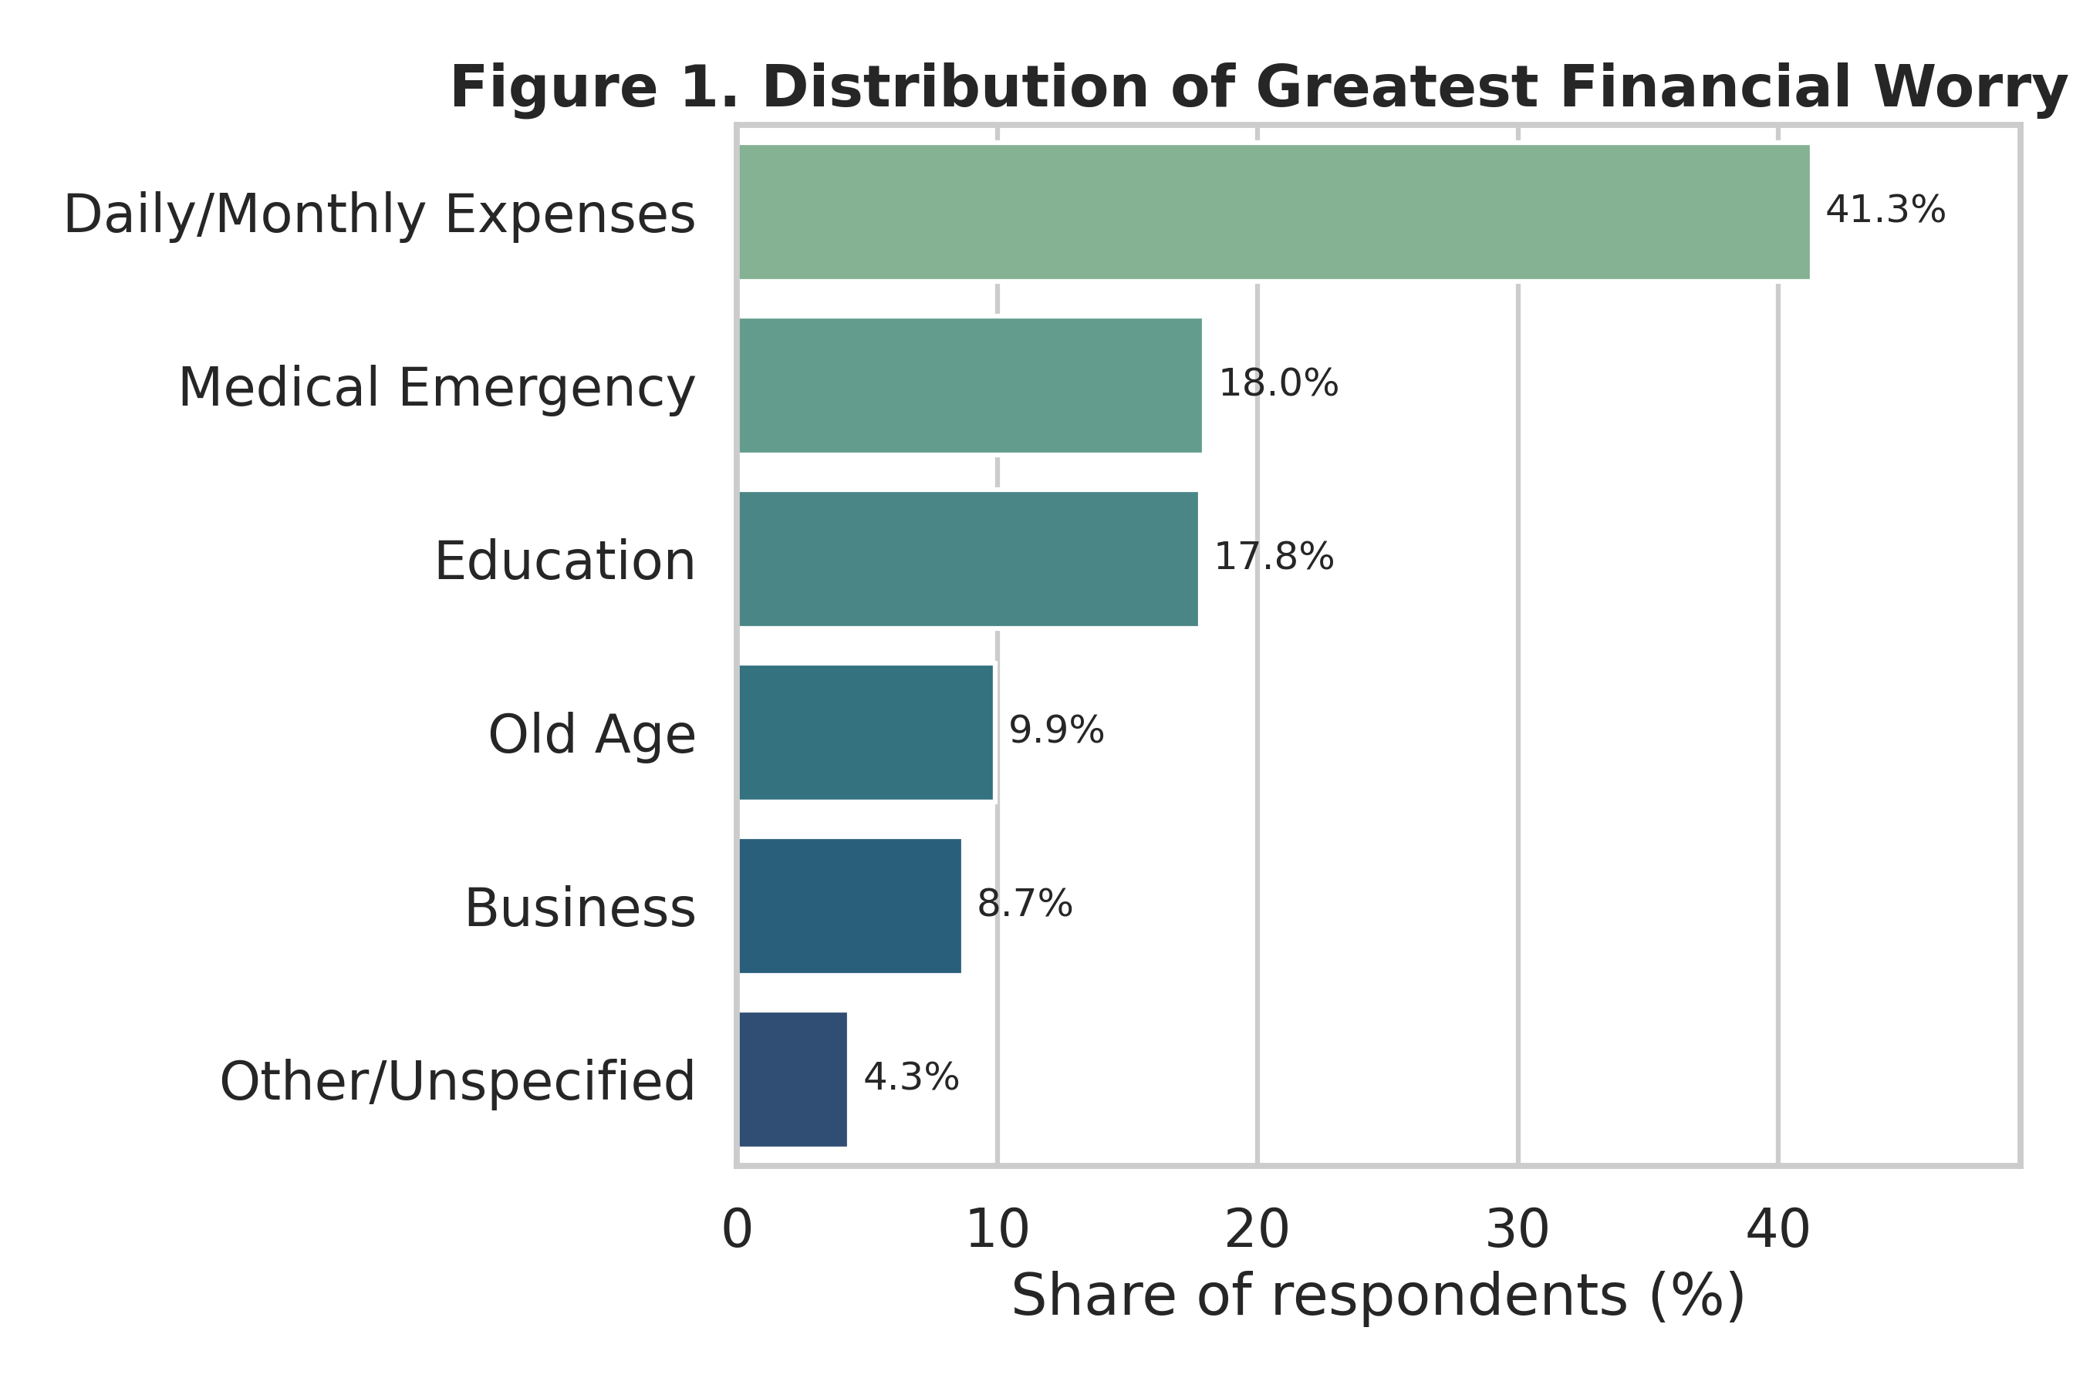
Figure 1. Distribution of Greatest Financial Worry (fin45)
Table 4.1 Missingness in the raw survey items
Variable | n missing | % missing
fin28 | 5977 | 85.39
fin29 | 5613 | 80.19
fin24a | 542 | 7.74
domestic_remittances | 12 | 0.17

All other predictors, including economy, age, receive_wages, receive_transfers, receive_pensions, receive_agriculture, dig_account, merchantpay_dig and con1, are fully observed (zero missing); fin28 and fin29 follow an expected skip pattern (only asked of respondents who actually needed medical care or had school-age dependents) and were encoded as an explicit Not-Applicable/No/Yes indicator collapsed to a binary flag, as described in Section 3.3.
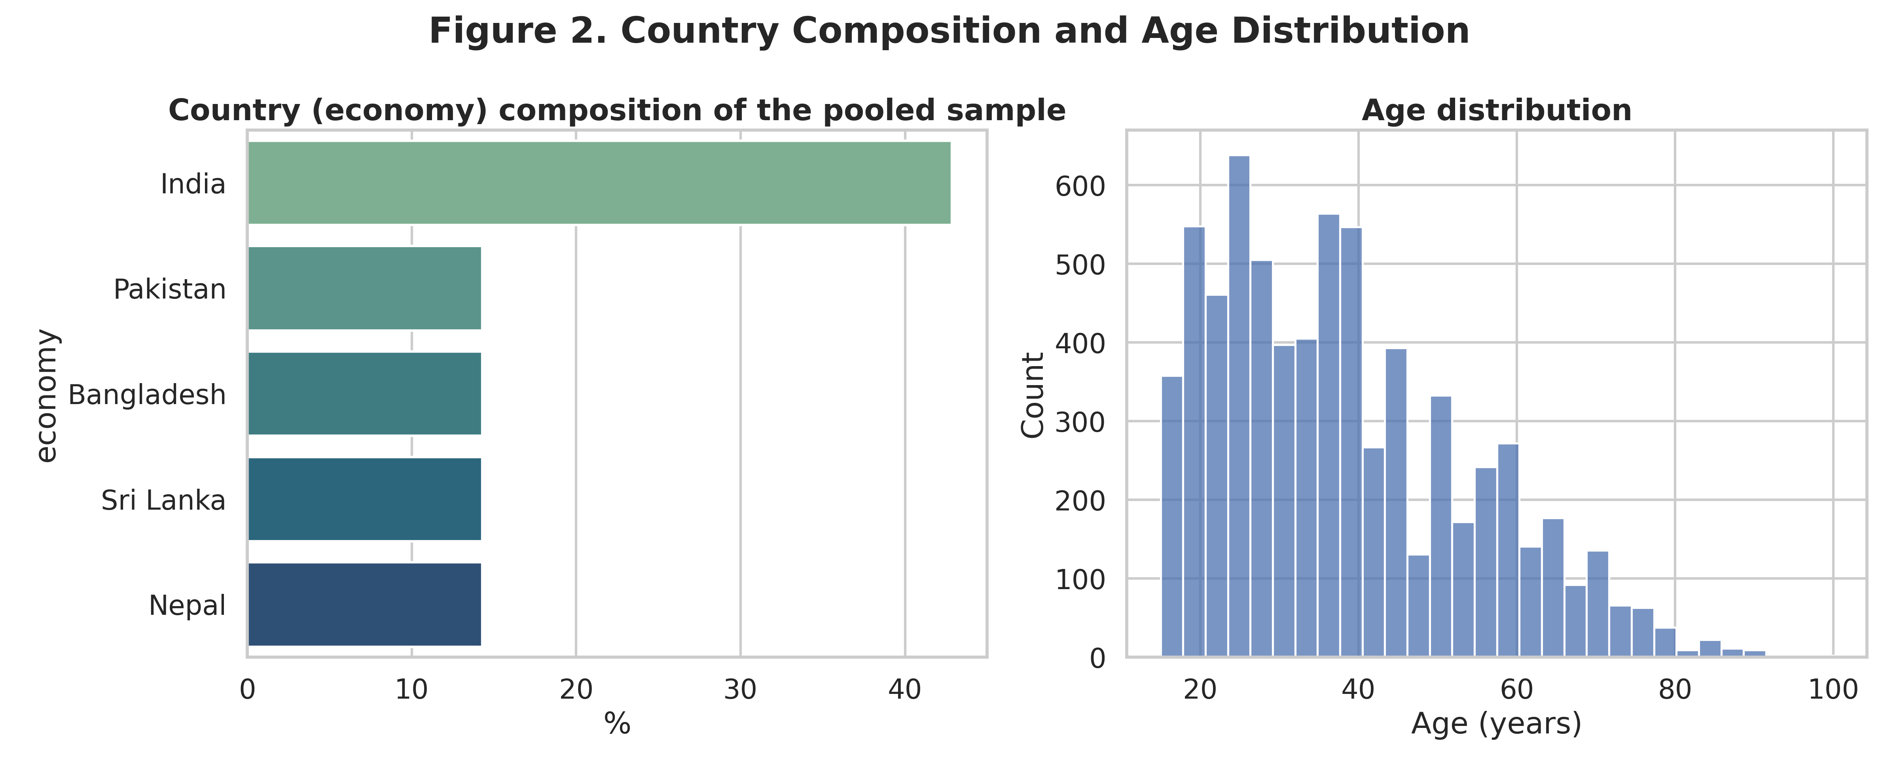
Figure 2. Country composition and age distribution
The pooled sample is 42.9% Indian, with the remaining four countries each contributing 14.3% (1,000 respondents apiece). Age ranges from 15 to the low 90s, with a right-skewed distribution typical of a working-age adult population and a median in the low 30s.
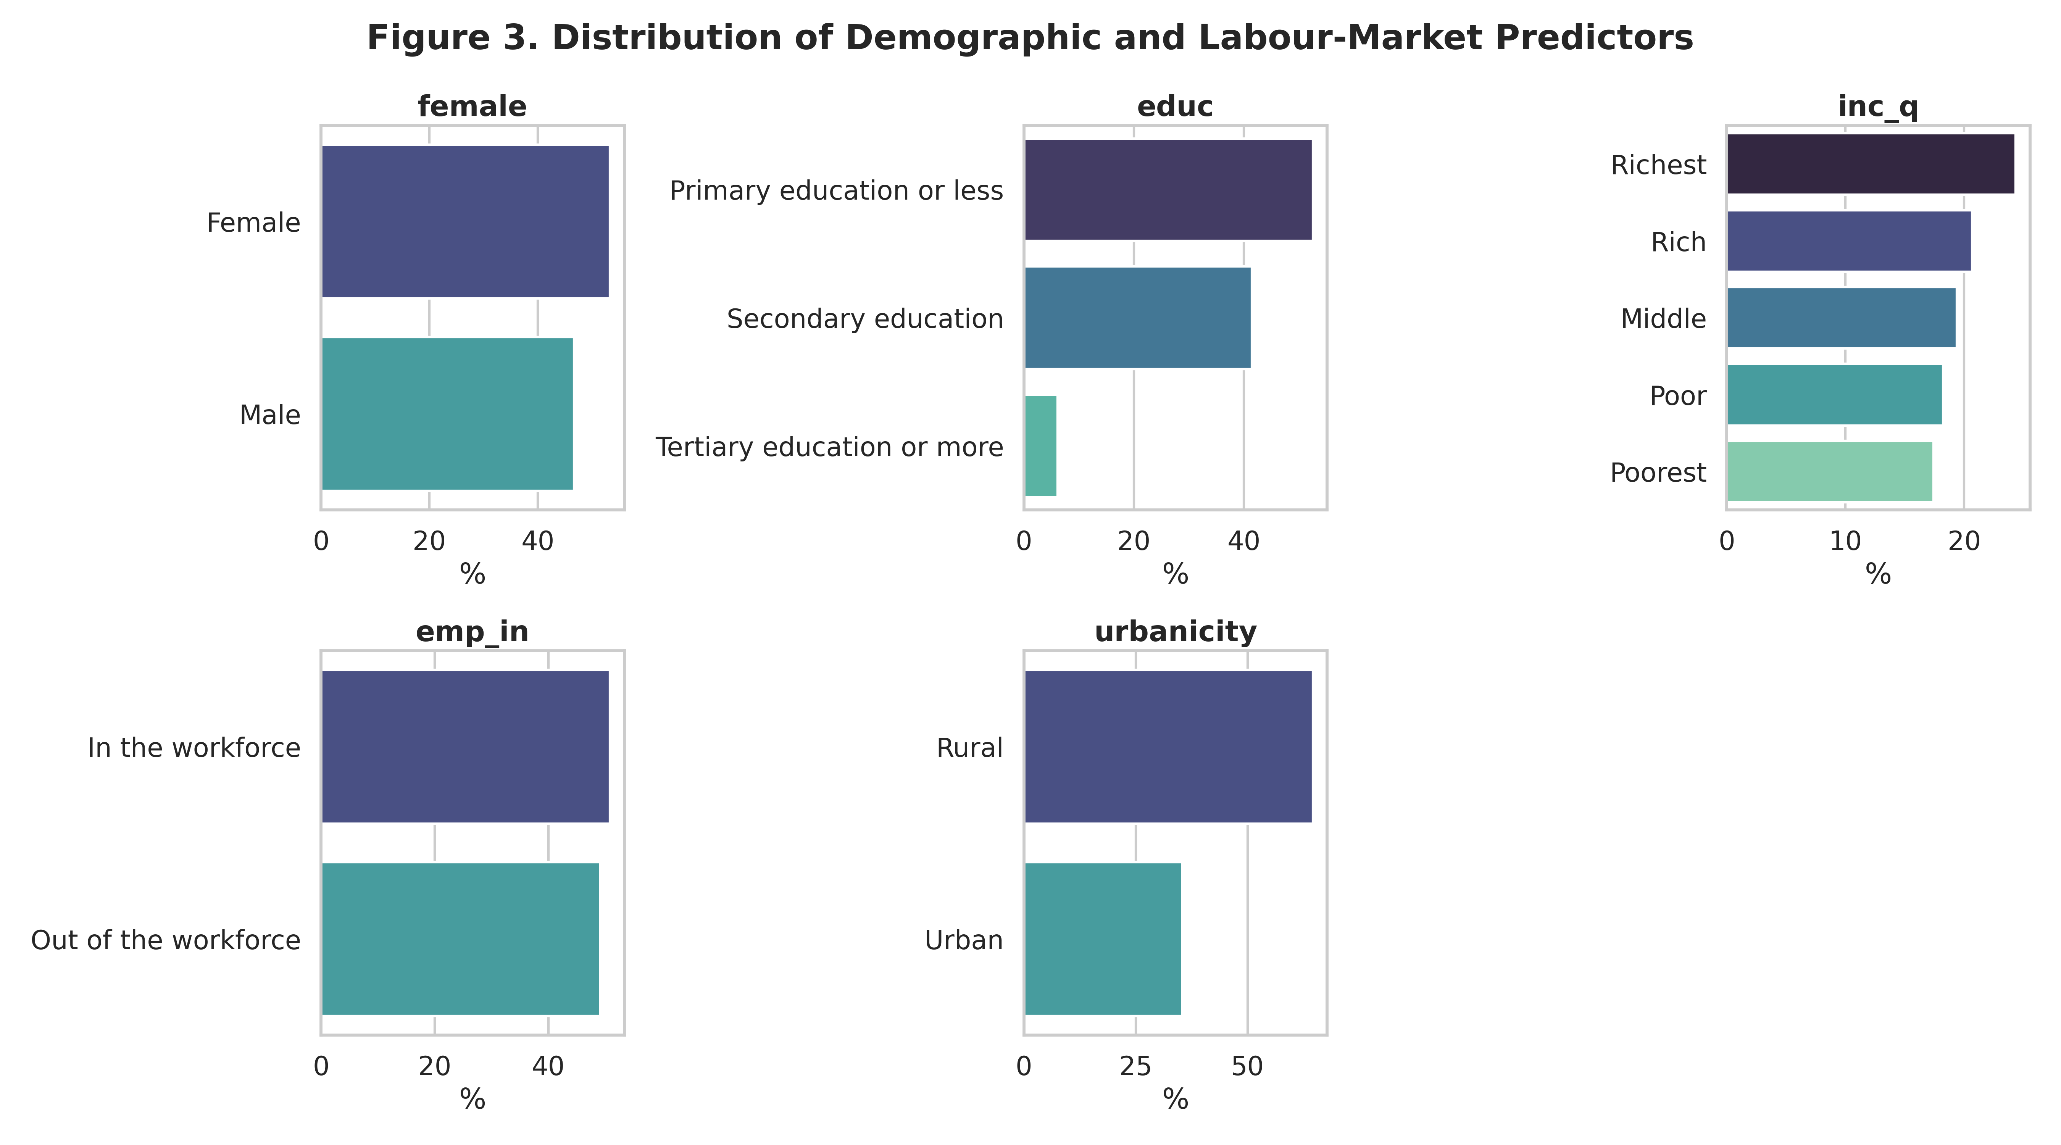
Figure 3. Distribution of demographic and labor-market predictors
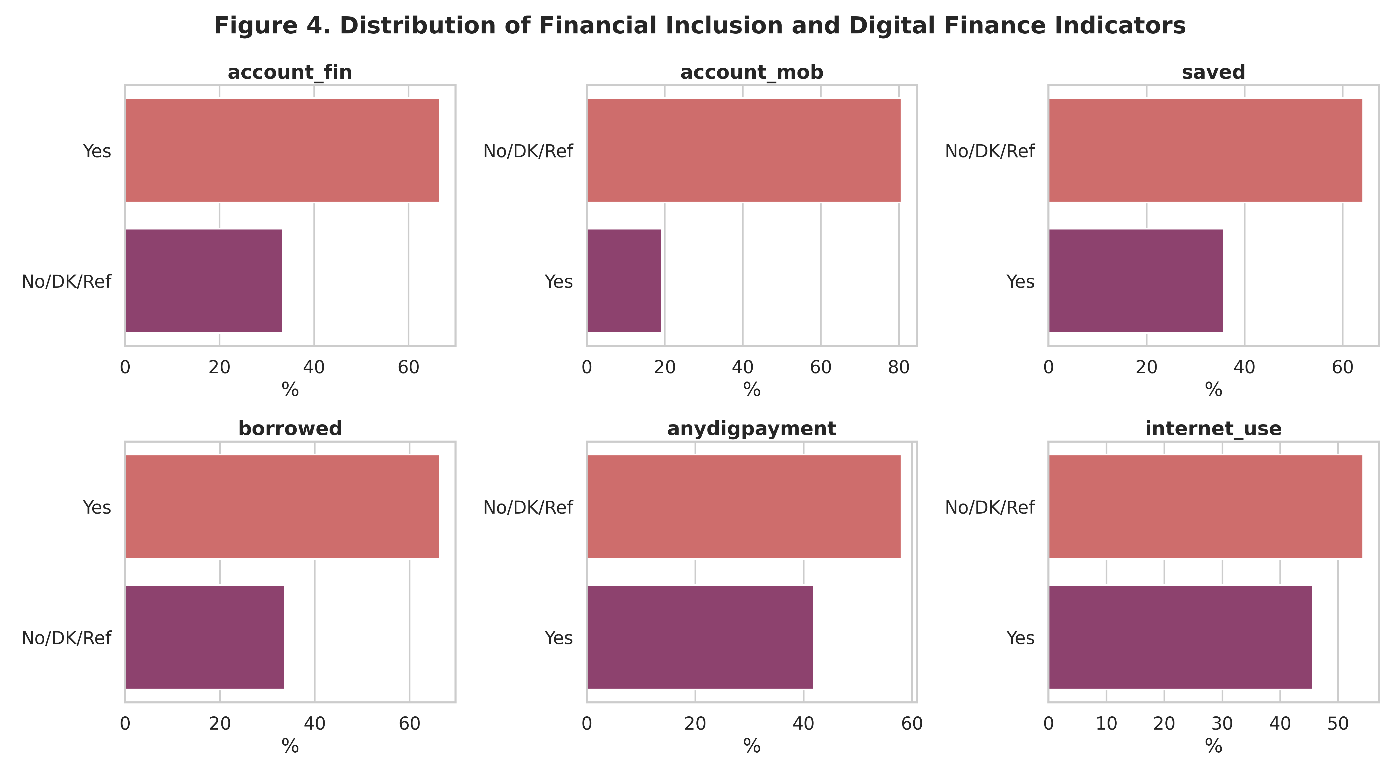
Figure 4. Distribution of financial-inclusion and digital-finance indicators
The sample skews rural (64.6% vs. 35.4% urban) and is dominated by respondents with primary education or less (52.5%); formal account ownership (66.6%) considerably exceeds mobile-money ownership (19.3%), and 45.7% of respondents report internet use. This pattern of comparatively high account ownership alongside a persistent digital-access gap echoes the regional picture documented in prior Global Findex-based studies of South Asia (Kumar & Pradhan, 2024; Mani, 2016).

4.2 Bivariate Analysis
Figure 5 ranks every categorical predictor by its bias-corrected Cramer's V association with fin45_cat (Bergsma, 2013). Country (economy) is the single most strongly associated predictor in the entire model (V = 0.190), ahead of internet use (V = 0.173) and formal account ownership (V = 0.169). This is consistent with a growing body of South Asian financial-inclusion research showing that country-level institutional and policy differences produce substantial cross-national heterogeneity even after individual-level socioeconomic characteristics are accounted for (Kumar & Pradhan, 2024; Mani, 2016). Several digital-finance variables also rank highly: merchantpay_dig (V = 0.161) and dig_account (V = 0.128) both outperform many of the demographic predictors.
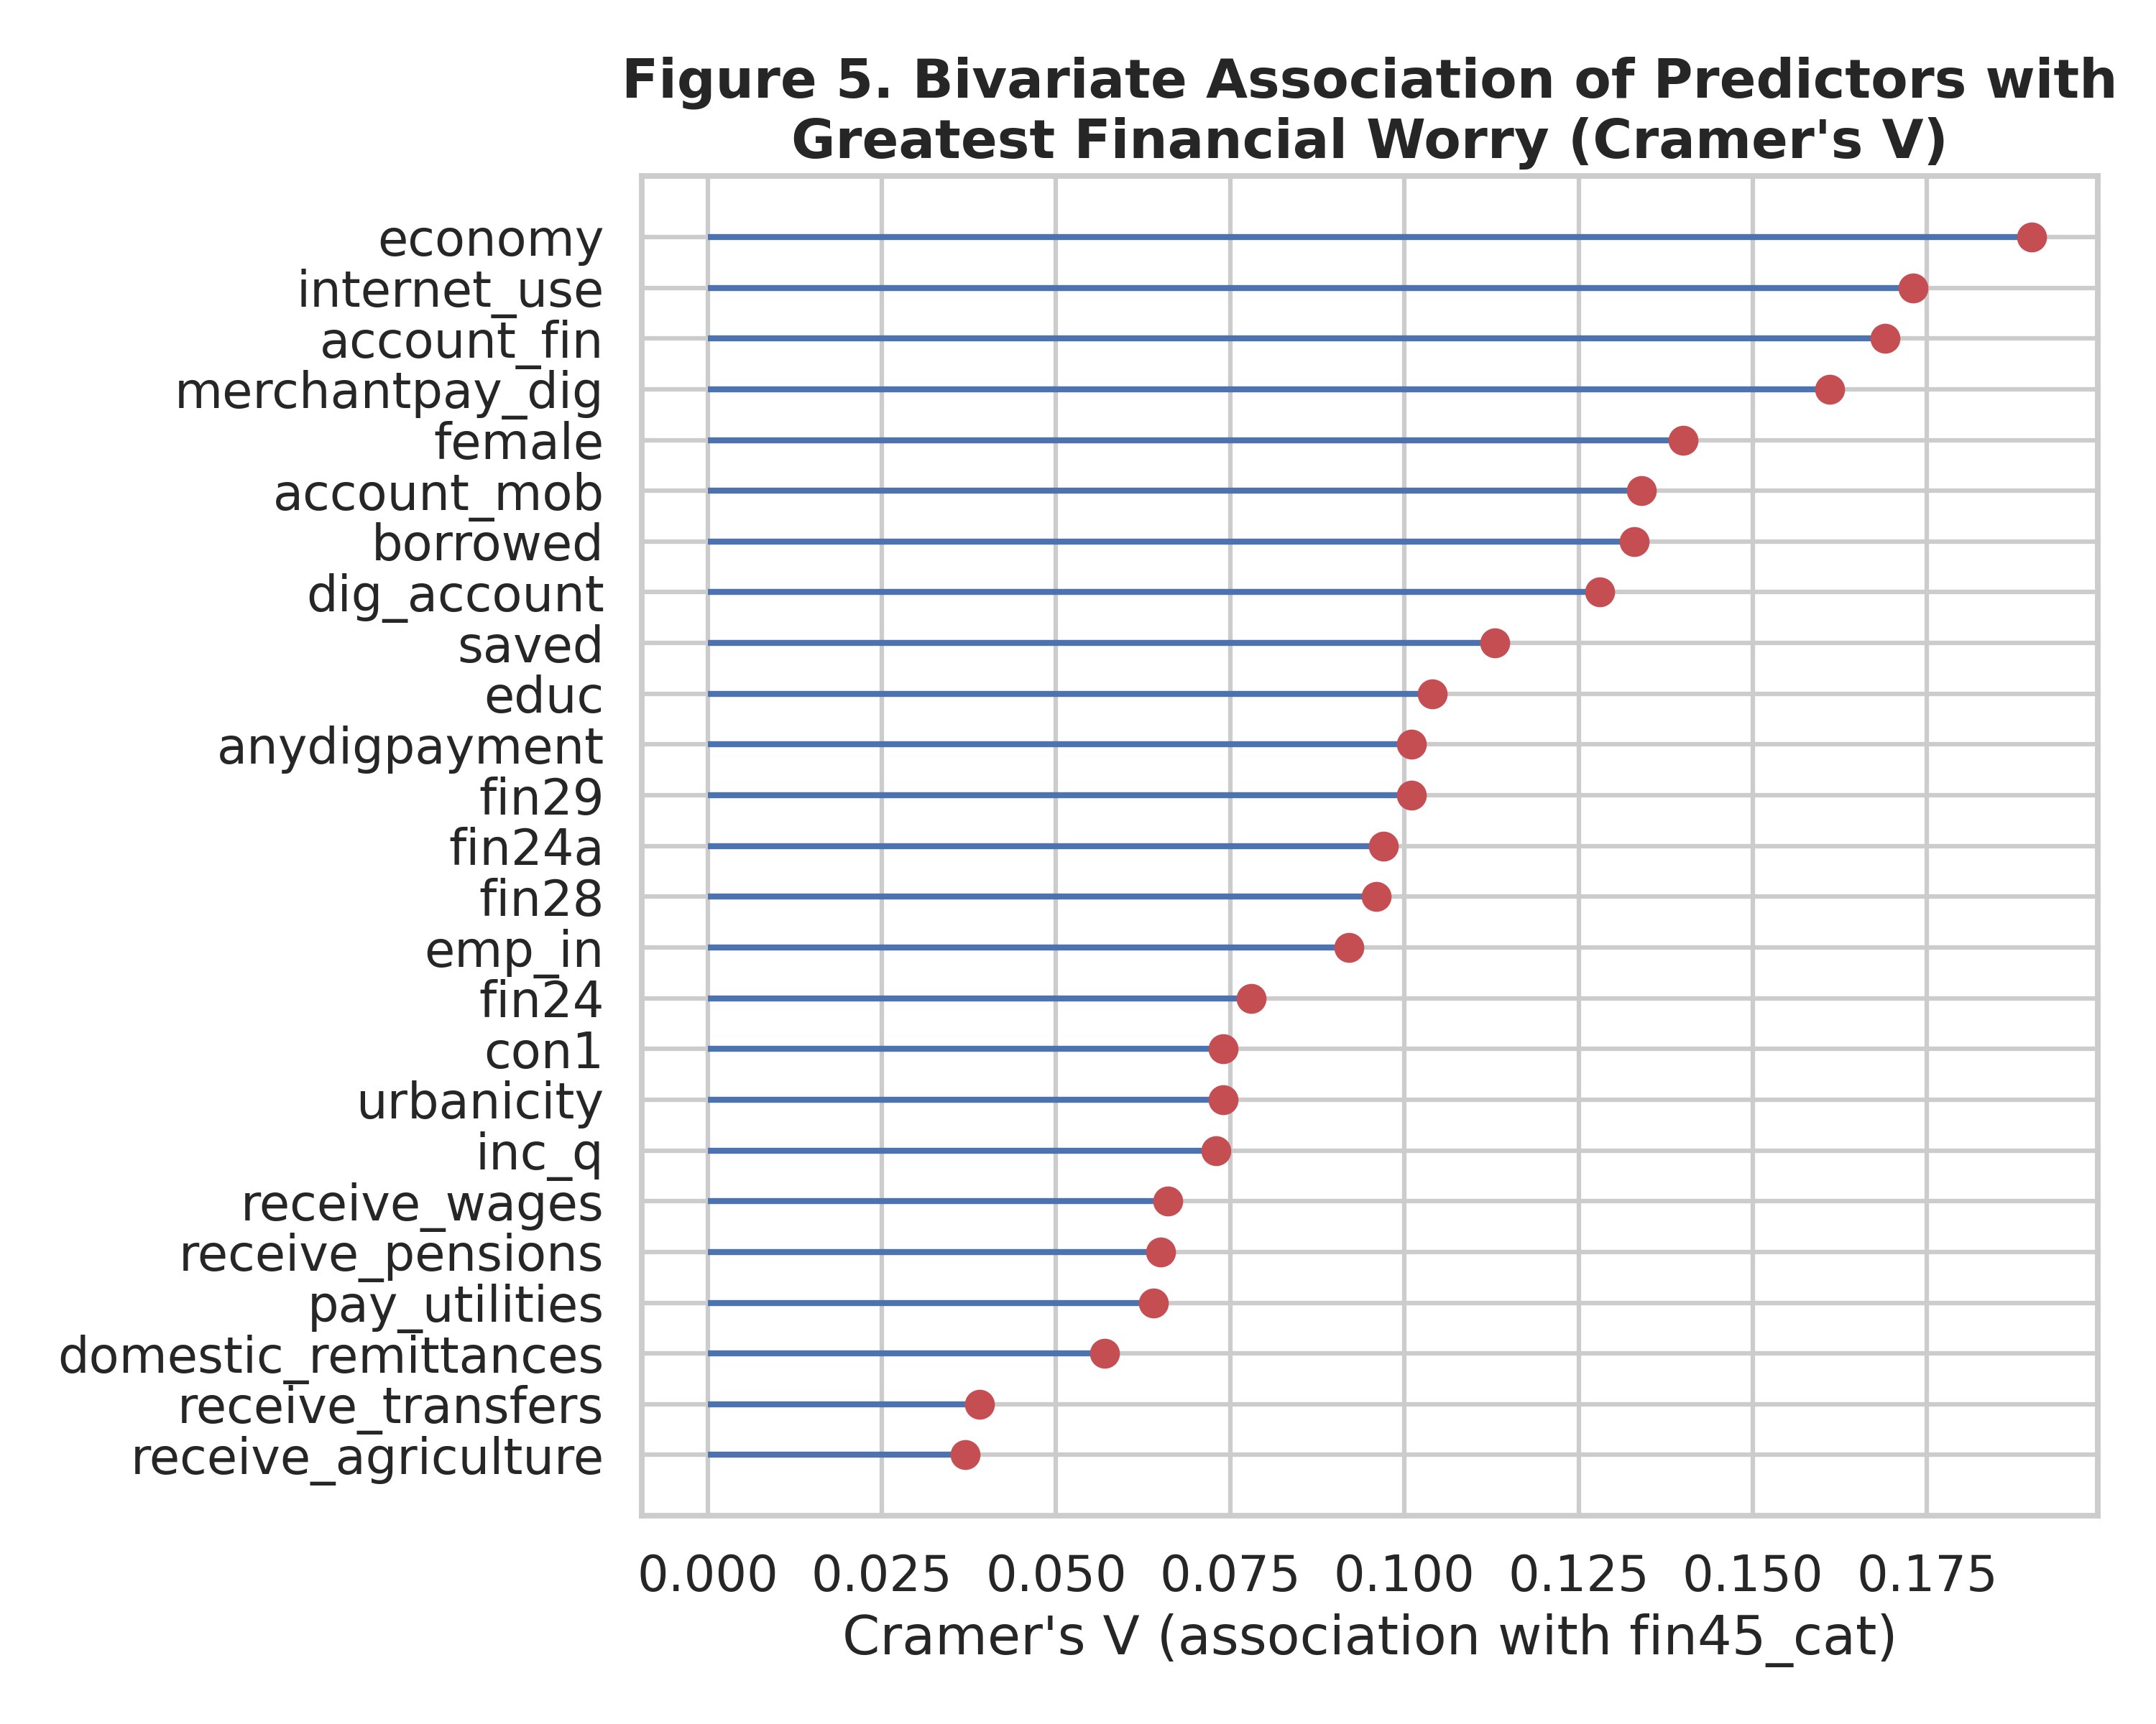
Figure 5. Bivariate association ranking (Cramer's V)
Age shows a striking and highly intuitive life-cycle gradient with financial worry (Kruskal-Wallis H = 656.42, p < 0.001), closely mirroring the hump-shaped consumption and saving pattern predicted by the life-cycle hypothesis of household financial behavior (Modigliani & Brumberg, 1954). Table 4.4 shows mean age rising monotonically from Education (31.0 years) through Business (33.7) and Daily/Monthly Expenses (37.0) to Medical Emergency (42.8) and finally Old Age (48.8) — respondents worried about school fees are, unsurprisingly, the youngest on average (consistent with having young children), while those most worried about old age are, on average, approaching it themselves.
Table 4.2 Mean age by greatest financial worry category (Kruskal-Wallis H = 656.42, p < 0.001)
fin45_cat | Mean age | SD | n
Education | 31.0 | 12.2 | 1,245
Business | 33.7 | 13.1 | 609
Daily/Monthly Expenses | 37.0 | 14.3 | 2,891
Medical Emergency | 42.8 | 17.8 | 1,257
Other/Unspecified | 43.0 | 19.8 | 303
Old Age | 48.8 | 17.0 | 695
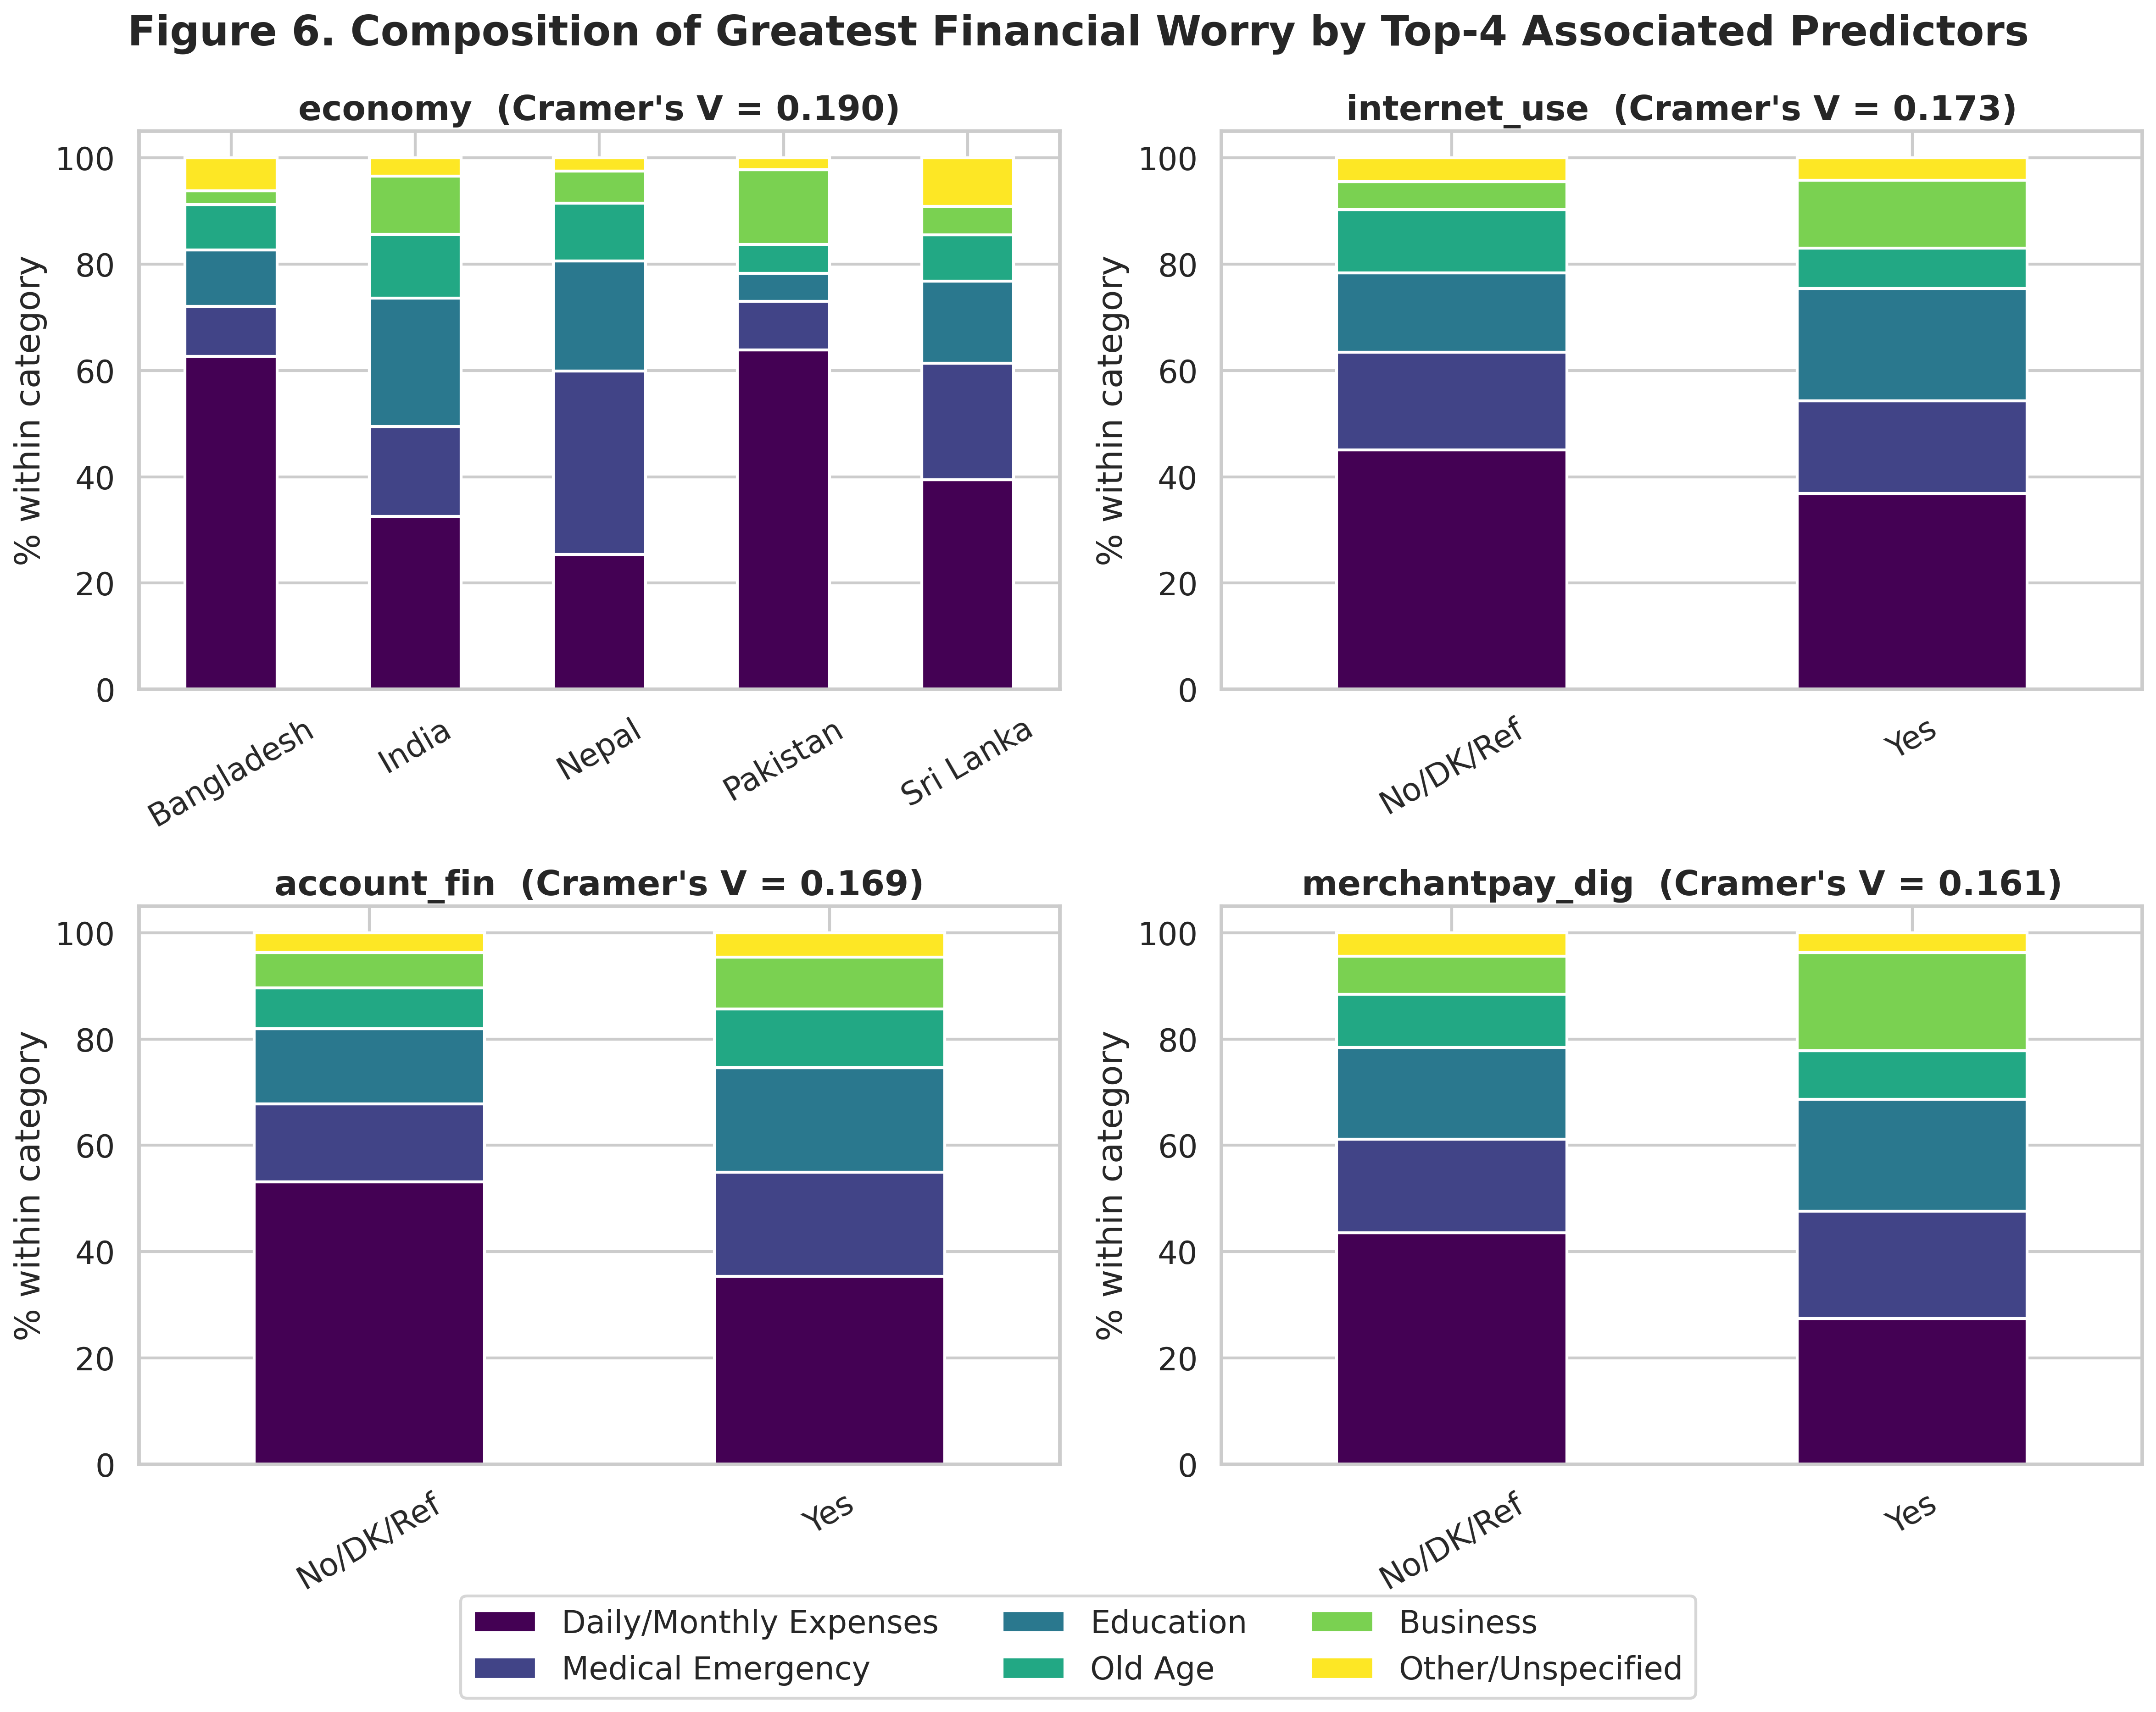
Figure 6. Composition of financial worry by top 4 associated predictors
Figure 6 disaggregates financial worry by country, internet use, formal account ownership and digital merchant payment — the four strongest bivariate predictors. The cross-country panel shows visibly different worry profiles: India and Nepal display relatively higher shares of Education, Old Age and Business worry, while Pakistan and Sri Lanka are more concentrated on Daily/Monthly Expenses, foreshadowing the strong country RRR effects reported in Section 4.4.

4.3 Diagnostic Checks: Multicollinearity
Table 4.3 reports Variance Inflation Factors for the full 40-feature encoded design matrix. An initial pass flagged an infinite VIF driven by a perfect duplicate (fin42 ≡ receive_agriculture, discussed in Section 3.3); once fin42 was removed, the maximum VIF fell to 8.77 (domestic_remittances: Using an account), just below the permissive conventional threshold of 10. Several of the fin28/fin29/domestic-remittance dummies sit in the 3–9 range, reflecting genuine but moderate structural correlation between financial-stress history and remittance behavior; none reaches a level that would be considered severe multicollinearity. This is corroborated by the correlation heatmap in Figure 7.

Table 4.3 Variance Inflation Factors (VIF) — selected predictors
Feature | VIF
domestic_remittances_Using_an_account | 8.77
fin29_bin | 5.05
economy_India | 3.43
account_mob_bin | 3.37
dig_account_bin | 3.18
fin24_Family_relatives_or_friends | 3.13
fin24_I_could_not_come_up_with_the_money | 3.12
fin28_bin | 3.04
anydigpayment_bin | 2.74
fin24a_ord | 2.74
economy_Sri_Lanka | 2.40
economy_Nepal | 2.16
age_c | 1.83
age_c_sq | 1.67
economy_Pakistan | 1.89
(All remaining features have VIF < 1.6 and are omitted from Table 4.5 for brevity; the complete 40-row VIF table is produced by code/04_diagnostics.py in Appendix A.)
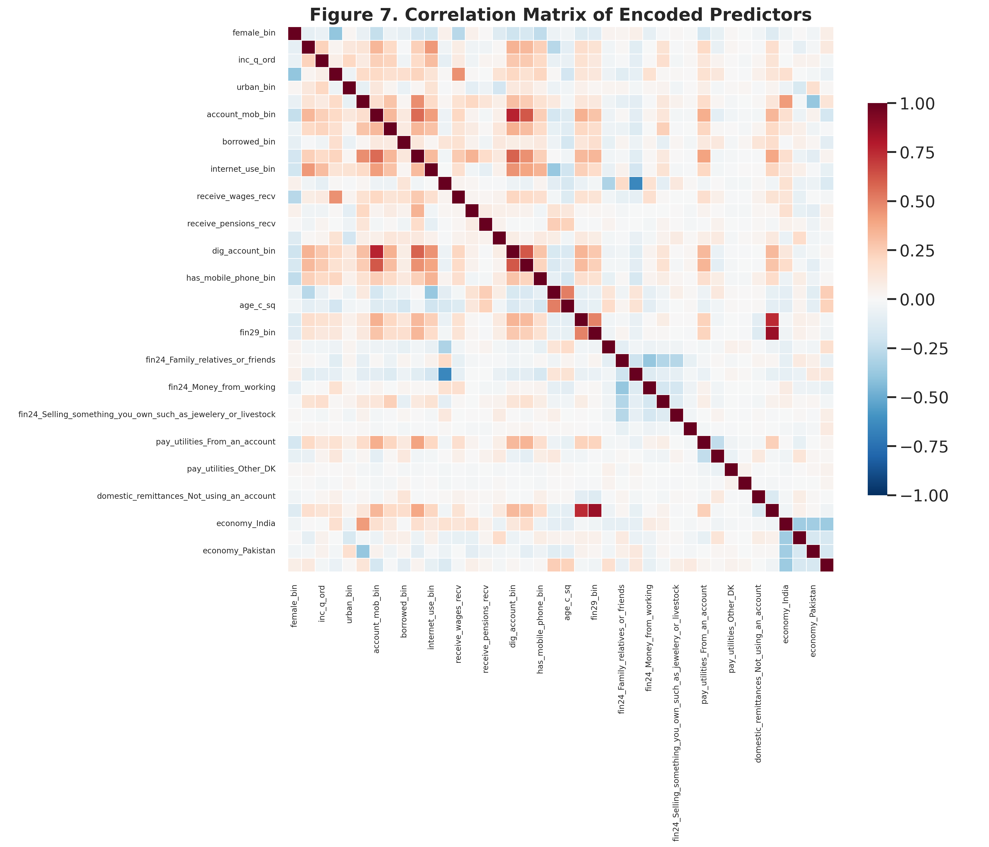
Figure 7. Correlation matrix of encoded predictors

4.4 Multinomial Logistic Regression Results
The multinomial logit was estimated with the full 40-feature design matrix, “Daily/Monthly Expenses” as the reference category. The model converged cleanly (BFGS, 2,000 max iterations) with a log-likelihood of −6,661.10 against a null log-likelihood of −7,635.72, yielding a McFadden's pseudo-R2 of 0.128 — a respectable level of fit for an individual-level, subjectively reported multinomial outcome of this kind, and broadly in line with the explanatory power reported by comparable South Asian Global Findex-based studies of financial behavior (Kumar & Pradhan, 2024).
Table 4.4 Multinomial logit fit statistics
Statistic | Value
Log-likelihood (model) | −6,661.10
Log-likelihood (null) | −7,635.72
McFadden's pseudo-R2 | 0.128
N (training observations) | 4,900
Reference category | Daily/Monthly Expenses

4.4.1 Determinants of Education as the greatest financial worry
Country effects dominate the Education equation: relative to the Bangladesh reference category, Indian (RRR = 4.25, p < 0.001), Nepali (RRR = 4.21, p < 0.001) and Sri Lankan (RRR = 2.85, p < 0.001) respondents are all dramatically more likely to cite Education as their greatest worry, while Pakistani respondents are significantly less likely to do so (RRR = 0.48, p = 0.001). Older respondents are significantly less likely to worry about education (RRR = 0.73 per decade, p < 0.001) — consistent with the life-cycle pattern in Table 4.4 — as are those with a recent realized inability to pay school fees (fin29_bin, RRR = 0.36, p = 0.001), which at first glance seems counter-intuitive but is consistent with such respondents having already been forced to reprioritize towards even more immediate subsistence concerns. Receiving wages (RRR = 0.65) is also associated with lower relative risk, while receiving government transfers (RRR = 1.55) and being female (RRR = 1.51) raise it.
Table 4.5 Relative Risk Ratios (RRR) — outcome: Education (vs. Daily/Monthly Expenses)
Predictor | Coef. | RRR | p-value | Sig.
economy: India | 1.447 | 4.250 | <0.001 | ***
economy: Nepal | 1.437 | 4.207 | <0.001 | ***
economy: Sri Lanka | 1.046 | 2.845 | <0.001 | ***
domestic remittances: using an account | 0.887 | 2.427 | 0.017 | **
receive_transfers | 0.438 | 1.550 | 0.001 | ***
account_mob | 0.434 | 1.543 | 0.031 | **
female | 0.412 | 1.510 | <0.001 | ***
receive_agriculture | 0.353 | 1.424 | 0.010 | **
merchantpay_dig | 0.329 | 1.389 | 0.065 | *
educ (ordinal) | 0.161 | 1.174 | 0.052 | *
fin24a (ordinal) | -0.235 | 0.791 | 0.003 | ***
borrowed | -0.259 | 0.772 | 0.010 | ***
age_c (per decade) | -0.316 | 0.729 | <0.001 | ***
receive_wages | -0.427 | 0.652 | <0.001 | ***
economy: Pakistan | -0.743 | 0.476 | 0.001 | ***
fin29_bin (could not pay school fees) | -1.034 | 0.356 | 0.001 | ***

4.4.2 Determinants of Medical Emergency as the greatest financial worry
Country effects are, if anything, even larger for Medical Emergency: Nepali respondents show almost seven times the relative risk of Bangladeshi respondents (RRR = 6.74, p < 0.001), with India (RRR = 3.36) and Sri Lanka (RRR = 2.34) also significantly elevated. A realized recent inability to pay medical costs (fin28_bin) nearly doubles the relative risk of citing medical emergency as the greatest worry (RRR = 1.94, p = 0.010) — a reassuring internal-consistency check, since respondents who have actually experienced this hardship are more likely to name it as their greatest concern. Age again matters, with a positive and slightly accelerating effect (age_c RRR = 1.17 per decade, age_c² RRR = 1.06, both p < 0.001), consistent with rising health-cost exposure in later life and with prior evidence that medical-cost worry and medical borrowing rise with age in comparable Global Findex-based analyses (de Bruijn & Antonides, 2020).
Table 4.6 Relative Risk Ratios (RRR) — outcome: Medical Emergency (vs. Daily/Monthly Expenses)
Predictor | Coef. | RRR | p-value | Sig.
economy: Nepal | 1.909 | 6.744 | <0.001 | ***
economy: India | 1.211 | 3.356 | <0.001 | ***
fin24: some other source | 0.870 | 2.386 | 0.039 | **
economy: Sri Lanka | 0.849 | 2.338 | <0.001 | ***
fin28_bin (could not pay medical costs) | 0.663 | 1.941 | 0.010 | ***
merchantpay_dig | 0.343 | 1.409 | 0.054 | *
receive_agriculture | 0.258 | 1.294 | 0.046 | **
age_c (per decade) | 0.155 | 1.168 | <0.001 | ***
inc_q (ordinal) | 0.128 | 1.137 | <0.001 | ***
age_c_sq | 0.058 | 1.060 | <0.001 | ***
fin24a (ordinal) | -0.222 | 0.801 | 0.004 | ***
receive_wages | -0.231 | 0.794 | 0.039 | **
borrowed | -0.232 | 0.793 | 0.019 | **
pay_utilities: from an account | -0.317 | 0.729 | 0.040 | **

4.4.3 Determinants of Old Age as the greatest financial worry
Age itself is, unsurprisingly, one of the strongest predictors of old-age worry (RRR = 1.70 per decade, p < 0.001) — direct micro-level confirmation of the life-cycle hypothesis (Modigliani & Brumberg, 1954), which predicts that concern over old-age financial security intensifies as retirement approaches — alongside India (RRR = 2.35) and Nepal (RRR = 2.00) relative to Bangladesh, mobile-account ownership (RRR = 1.82) and saving specifically for old age (fin24 = Savings, RRR = 1.67). Difficulty raising emergency funds (fin24a, RRR = 0.58) and having no source of emergency funds at all (RRR = 0.22) both sharply reduce the relative risk of old age worry, again consistent with such respondents being pulled back towards worrying about immediate subsistence instead.
Table 4.7 Relative Risk Ratios (RRR) — outcome: Old Age (vs. Daily/Monthly Expenses)
Predictor | Coef. | RRR | p-value | Sig.
economy: India | 0.852 | 2.345 | <0.001 | ***
economy: Nepal | 0.692 | 1.998 | 0.003 | ***
account_mob | 0.600 | 1.823 | 0.023 | **
age_c (per decade) | 0.530 | 1.699 | <0.001 | ***
fin24: savings | 0.515 | 1.674 | 0.030 | **
inc_q (ordinal) | 0.161 | 1.174 | <0.001 | ***
borrowed | -0.272 | 0.762 | 0.025 | **
pay_utilities: in cash only | -0.387 | 0.679 | 0.004 | ***
economy: Pakistan | -0.414 | 0.661 | 0.082 | *
fin24a (ordinal) | -0.549 | 0.577 | <0.001 | ***
fin24: could not raise funds | -1.494 | 0.224 | <0.001 | ***

4.4.4 Determinants of Business as the greatest financial worry
Business worry shows the strongest and most uniform country pattern of any outcome: relative to Bangladesh, India (RRR = 5.63), Pakistan (RRR = 4.50), Nepal (RRR = 3.51) and Sri Lanka (RRR = 2.72) are all significantly elevated (all p < 0.01) — Bangladesh appears to be a genuine outlier with the lowest business-worry share of the five economies. Digital merchant payment (RRR = 1.67) and internet use (RRR = 1.44) both raise the relative risk of business worry, while being female continues to sharply lower it (RRR = 0.56, p < 0.001). This sizeable gender gap is consistent with documented credit-market discrimination against women-owned SMEs in South Asia, where female entrepreneurs face systematically greater credit constraints and rely disproportionately on informal financing (Wellalage & Locke, 2017).
Table 4.8 Relative Risk Ratios (RRR) — outcome: Business (vs. Daily/Monthly Expenses)
Predictor | Coef. | RRR | p-value | Sig.
domestic remittances: not applicable | 2.051 | 7.774 | 0.057 | *
economy: India | 1.728 | 5.630 | <0.001 | ***
economy: Pakistan | 1.503 | 4.496 | <0.001 | ***
economy: Nepal | 1.256 | 3.510 | <0.001 | ***
economy: Sri Lanka | 1.001 | 2.721 | 0.002 | ***
merchantpay_dig | 0.515 | 1.674 | 0.010 | **
domestic remittances: not using an account | 0.475 | 1.608 | 0.007 | ***
fin24: money from working | 0.461 | 1.586 | 0.035 | **
internet_use | 0.362 | 1.437 | 0.018 | **
educ (ordinal) | 0.260 | 1.297 | 0.010 | ***
inc_q (ordinal) | 0.145 | 1.156 | 0.002 | ***
borrowed | -0.375 | 0.687 | 0.004 | ***
receive_wages | -0.577 | 0.562 | <0.001 | ***
female | -0.587 | 0.556 | <0.001 | ***
fin24: could not raise funds | -1.004 | 0.366 | 0.030 | **

Across all four contrasts, three threads are unmistakable. First, country of residence is a first-order determinant of the type of financial worry a South Asian household reports, consistent with cross-national heterogeneity documented elsewhere in the South Asian financial-inclusion literature (Kumar & Pradhan, 2024). Second, age exerts a clear, intuitive life-cycle effect fully consistent with the Modigliani-Brumberg framework: education worry falls with age, medical-emergency and old-age worry rise with age. Third, financial inclusion (formal/mobile account ownership) systematically shifts worry away from subsistence and towards Education, Old Age and Business, net of country and age effects.

4.5 Machine-Learning Model Comparison
Table 4.9 compares the multinomial logit against Support Vector Machine, Random Forest and XGBoost on the identical 2,100-observation held-out test set. The multinomial logit attains the highest raw accuracy (44.2%) and the highest macro-AUC (0.715), but this is driven substantially by its strong recall on the modal Daily/Monthly Expenses category at the cost of comparatively weaker recall on minority classes (macro-F1 = 0.280). The class-balanced machine-learning models trade some raw accuracy for a more even distribution of predictive performance across categories, correctly identifying a meaningfully larger share of Business, Old Age, and Other/Unspecified cases than the logit alone would suggest. Random Forest offers the best balance among the classifiers, achieving the highest macro-F1 (0.336) and weighted-F1 (0.417) of all four models.
Table 4.9 Predictive performance comparison across all four models (test set, n = 2,100)
Model | Accuracy | Macro-F1 | Weighted-F1 | Macro-AUC (OvR)
Multinomial Logistic Regression | 0.442 | 0.280 | 0.396 | 0.715
Random Forest | 0.410 | 0.336 | 0.417 | 0.708
Support Vector Machine (RBF) | 0.372 | 0.317 | 0.391 | 0.712
XGBoost | 0.380 | 0.313 | 0.392 | 0.694

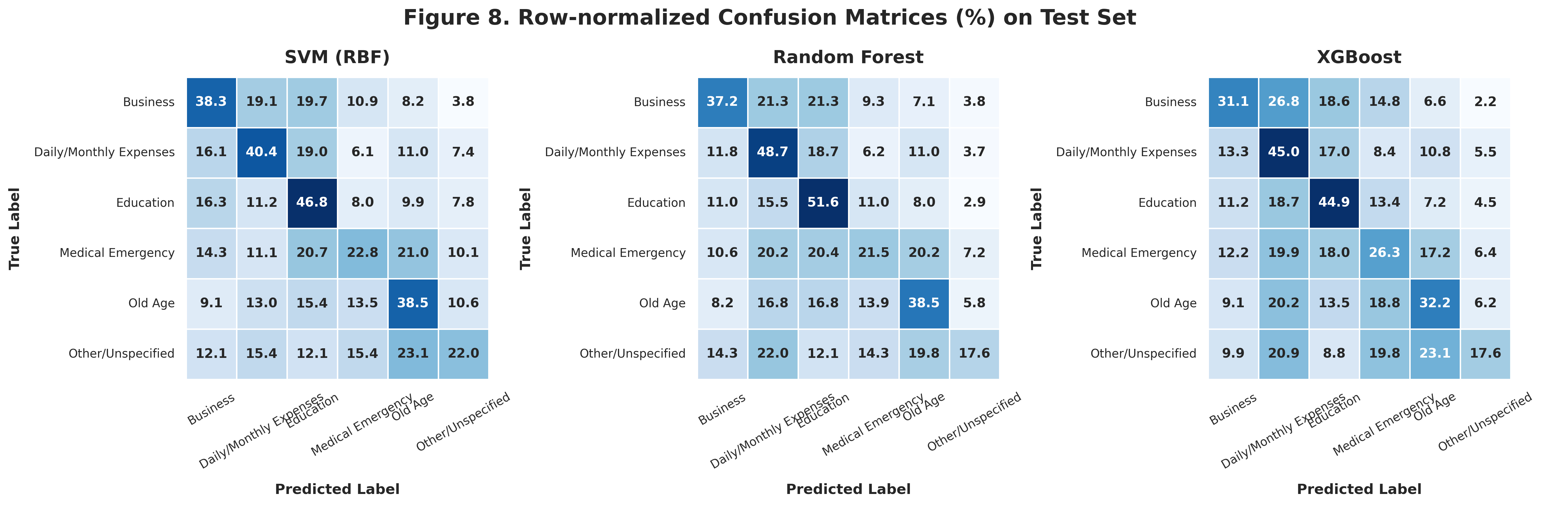
Figure 8. Confusion matrices — SVM, Random Forest, XGBoost (test set)
The confusion matrices in Figure 8 show that all three machine-learning classifiers confuse Medical Emergency most often with Daily/Monthly Expenses and Education, reflecting genuine conceptual overlap: many respondents likely regard medical costs as simply another category of unavoidable monthly expense. Business and Old Age are recovered reasonably well by Random Forest and SVM given their relatively low base rates.

4.6 Feature Importance and SHAP Analysis
Random Forest's built-in impurity-based importance (Figure 9) and XGBoost's SHAP-based importance (Lundberg & Lee, 2017; Figure 10) agree closely: age (age_c and age_c_sq combined) is the single most important feature block in both rankings, followed by income quintile and three of the four country dummies (economy_India, economy_Pakistan, economy_Nepal), all appearing inside the global top eight SHAP features. This corroborates, through an entirely independent, non-parametric modelling approach (XGBoost, Chen & Guestrin, 2016), the multinomial logit's RRR findings from Section 4.4.
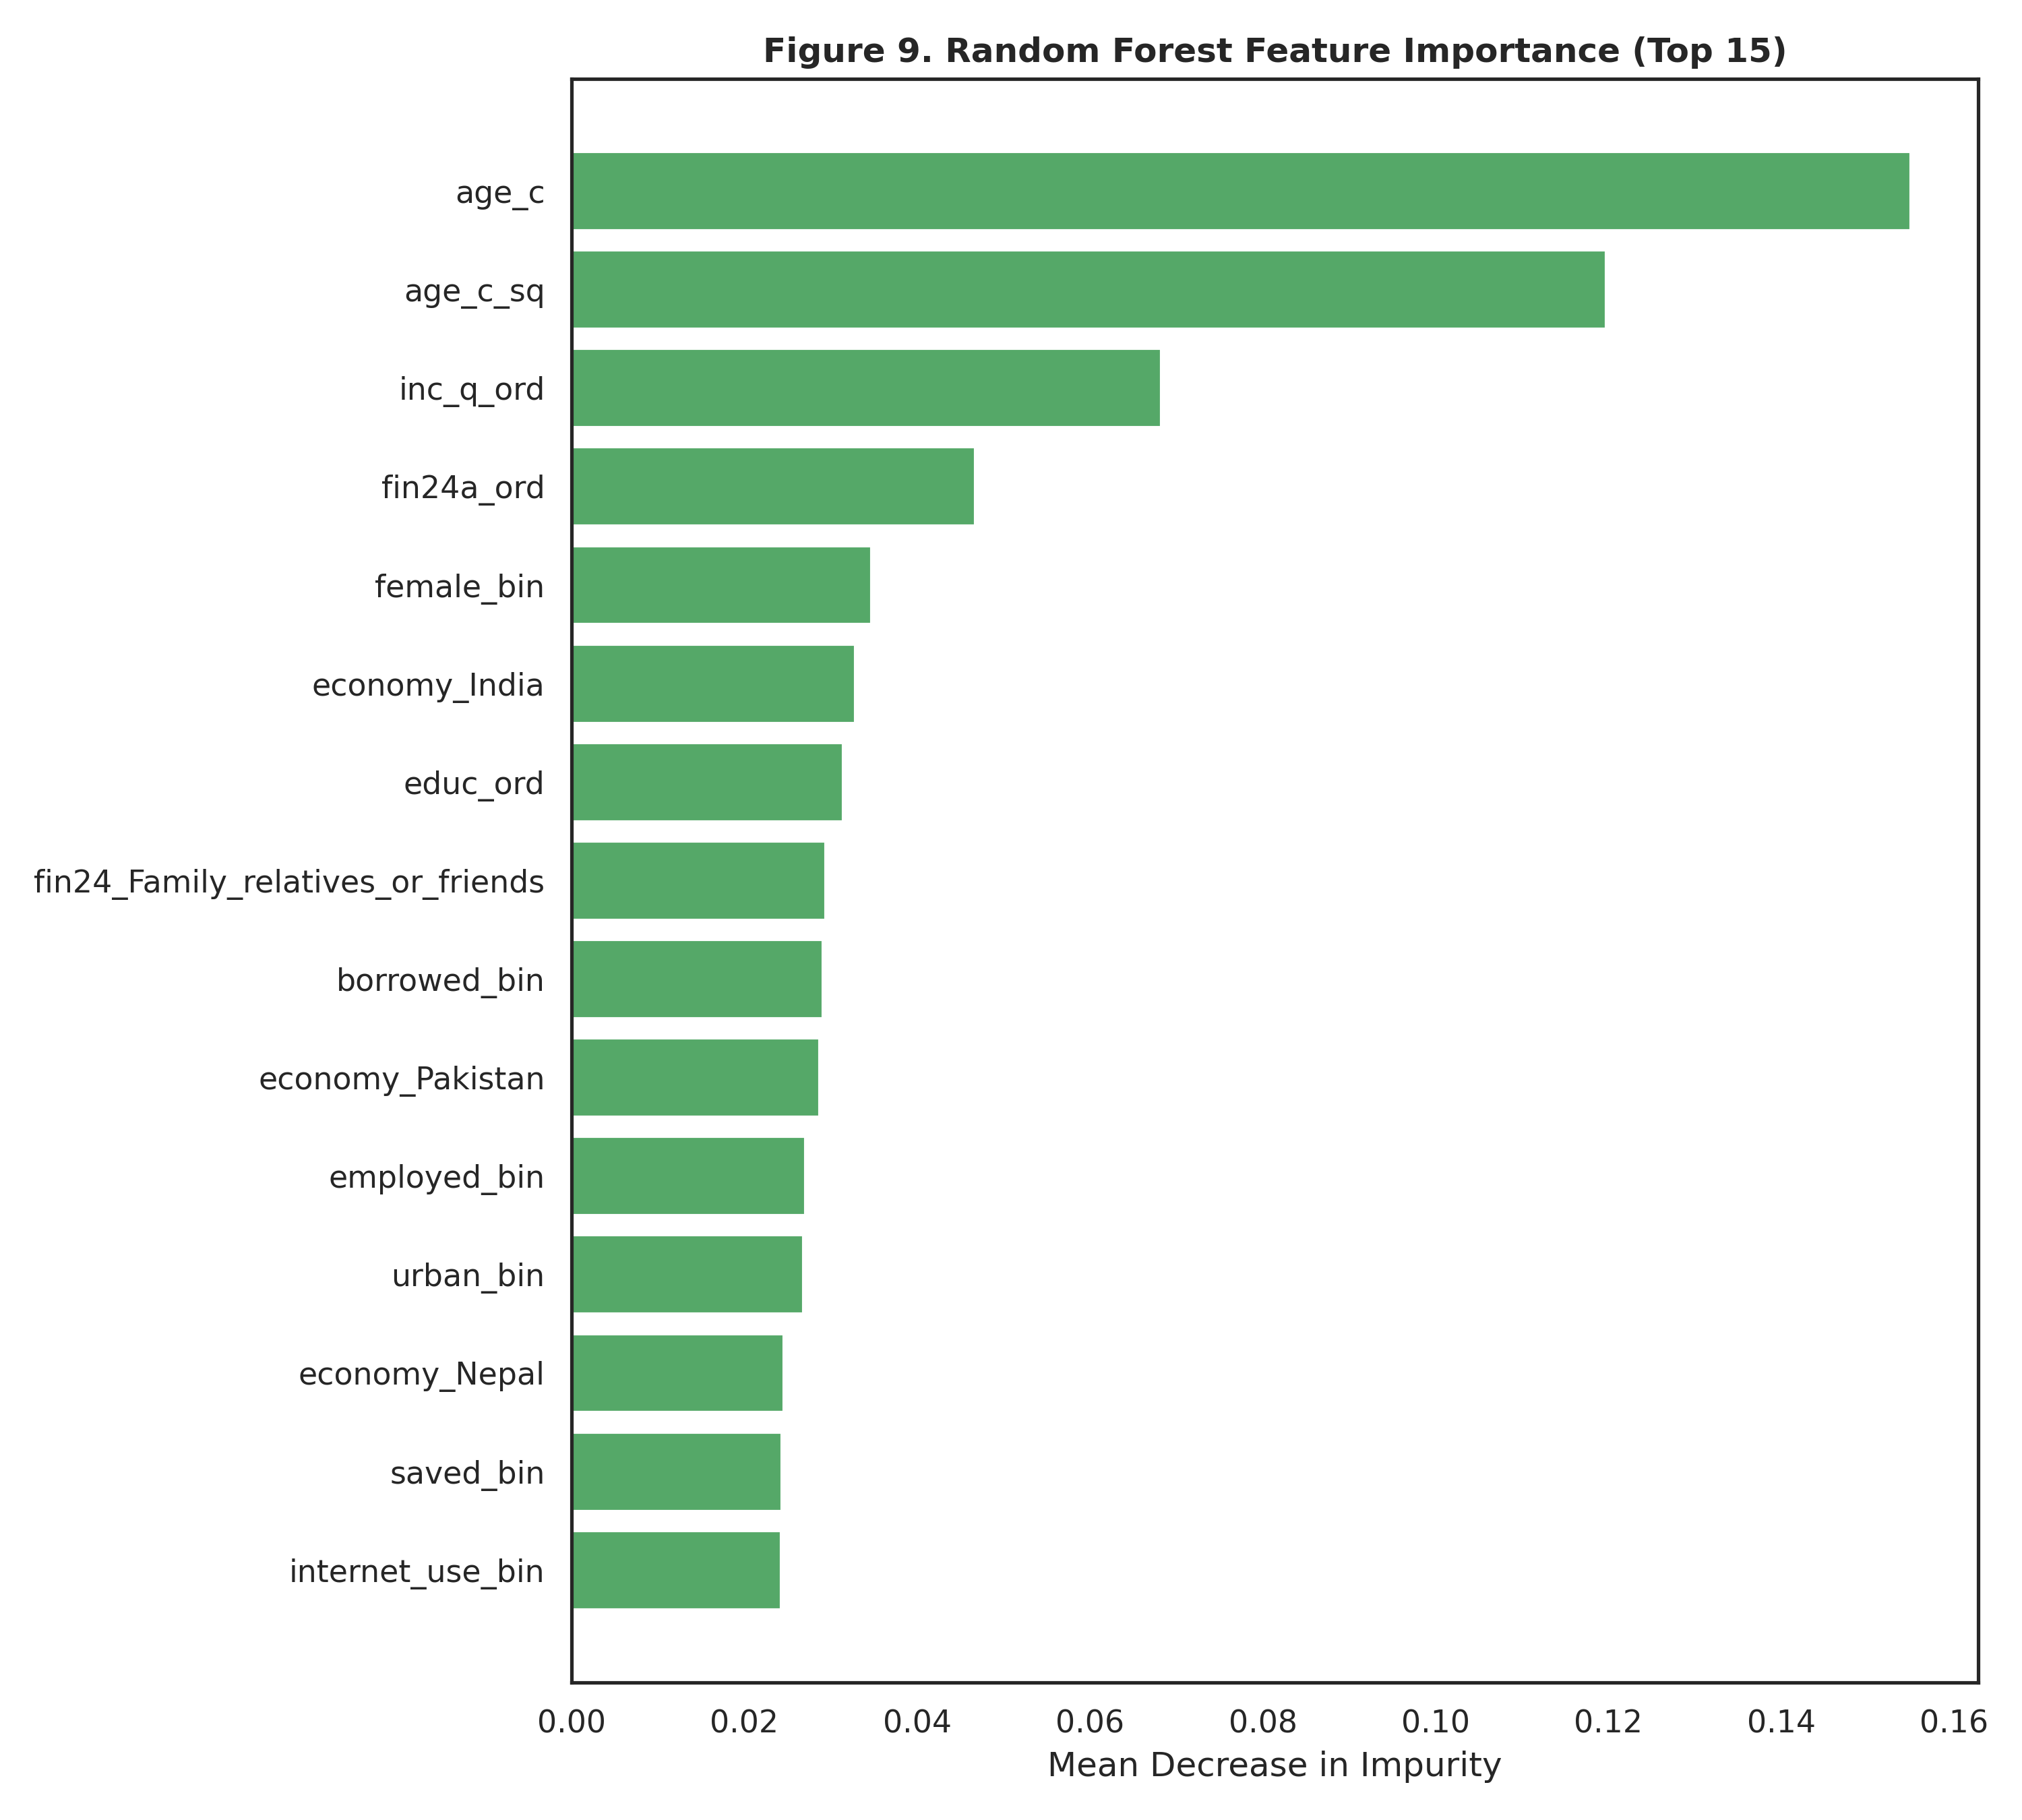
Figure 9. Random Forest feature importance (top 15)
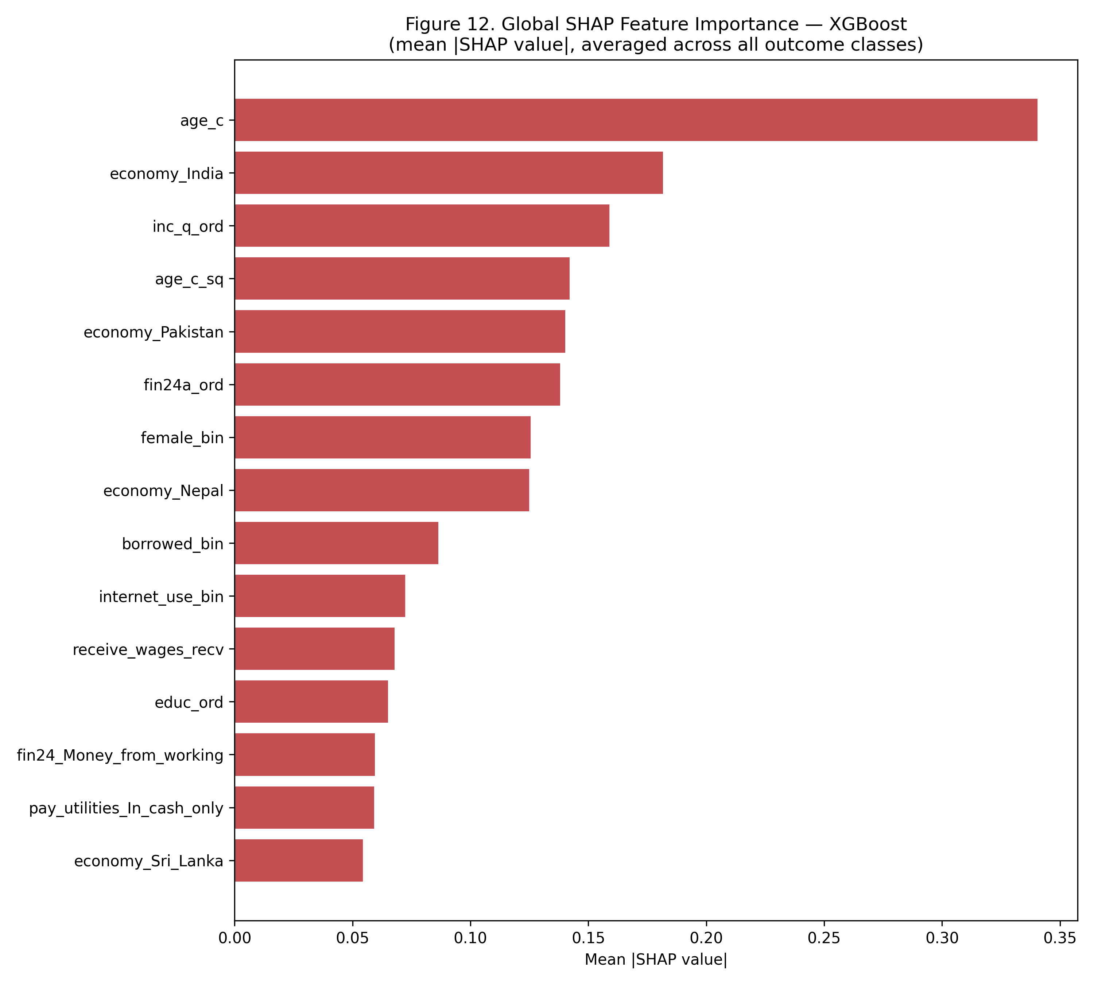
Figure 10. Global SHAP feature importance (XGBoost)
Figure 11 presents class-specific SHAP beeswarm plots for the four substantively largest categories. Each point is one test-set respondent; horizontal position shows the SHAP value (impact on that outcome's predicted log-odds), and color shows the underlying feature value (red = high, blue = low).
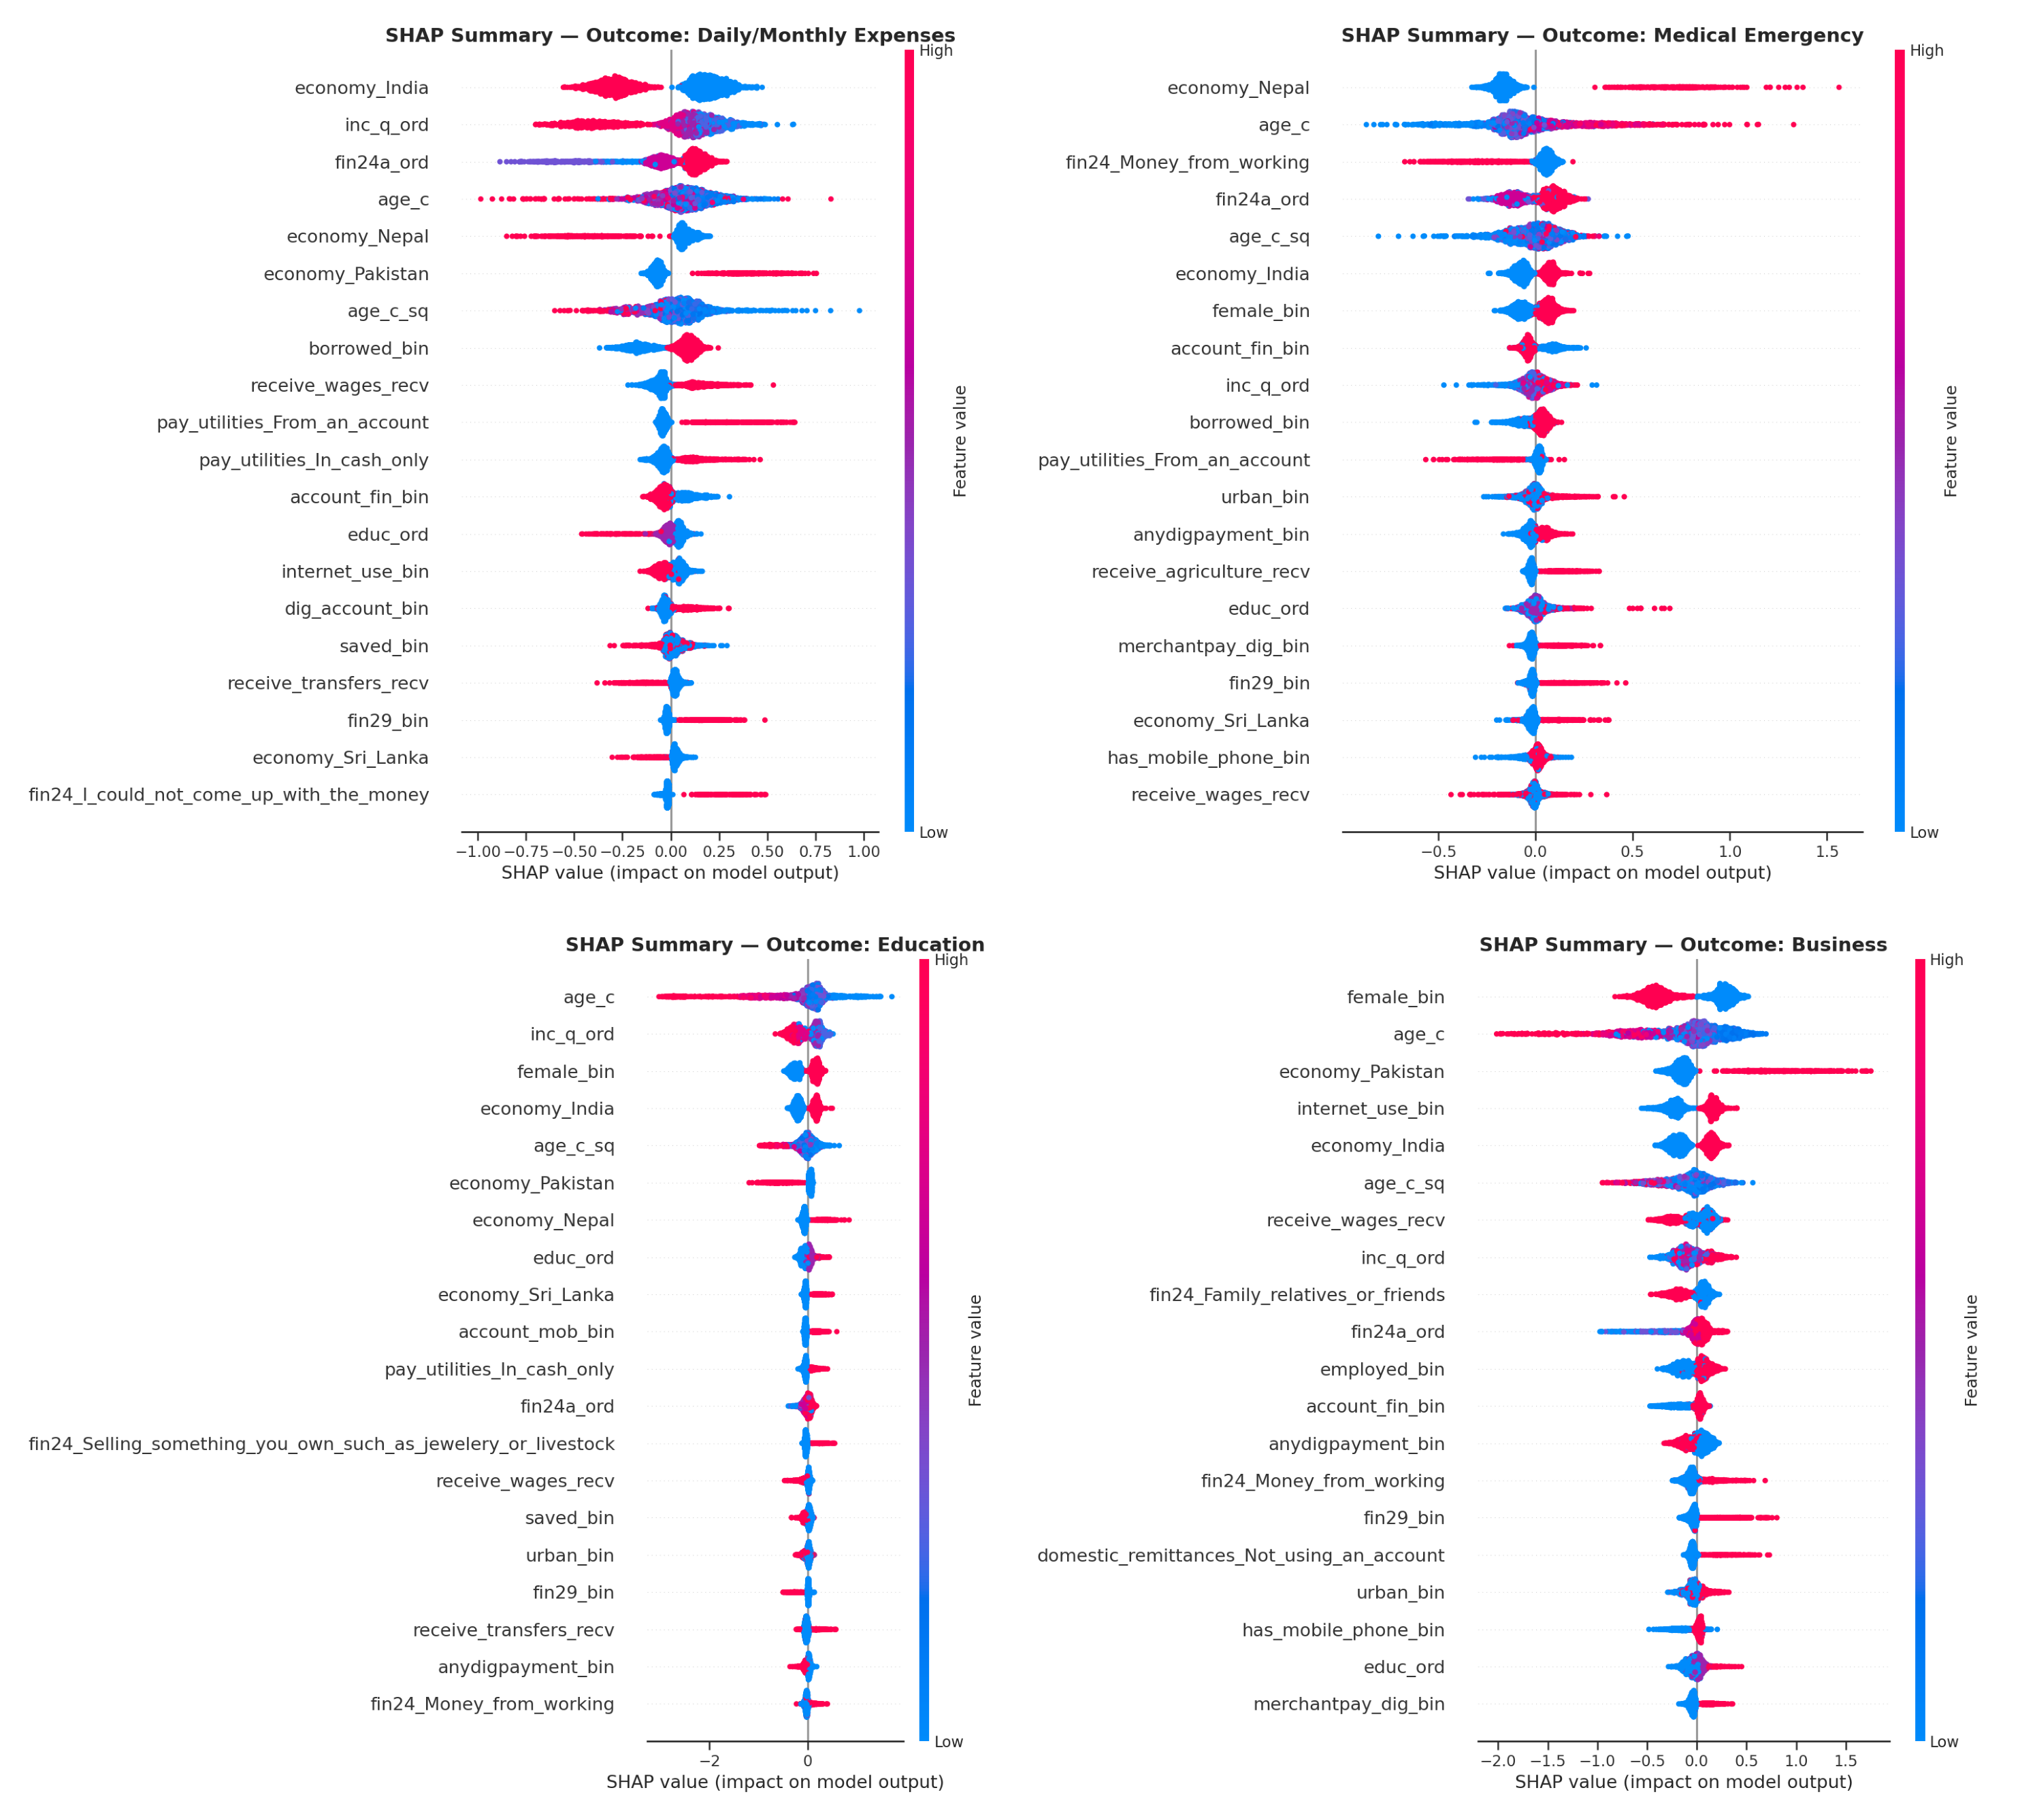
Figure 11. SHAP summary plot — combined
Consistent with the multinomial logit's RRR pattern, low-income quintile, and low age push predictions towards Daily/Monthly Expenses, while high income quintile, higher age and formal account ownership push predictions towards Education, Business and Old Age — providing convergent, model-agnostic evidence for the life-cycle and financial-inclusion mechanisms discussed above.

4.7 Synthesis of Findings
Three consistent threads run through the exploratory, parametric, and machine-learning results. First, country of residence is a first-order determinant of the type of financial worry a South Asian household reports: Bangladesh stands out as having a distinctly lower propensity towards Business and Education worry relative to its neighbors, a finding consistent with cross-country heterogeneity documented in the broader South Asian financial-inclusion literature (Kumar & Pradhan, 2024; Mani, 2016). Second, financial worry follows a clear, intuitive life-cycle arc — from Education in the early 30s, through Business and Daily Expenses in the mid-30s, towards Medical Emergency in the 40s, and finally Old Age by the late 40s — that directly mirrors the hump-shaped consumption and saving pattern predicted by the life-cycle hypothesis (Modigliani & Brumberg, 1954). Third, financial inclusion (formal and mobile account ownership) systematically reallocates worry away from immediate subsistence and towards longer-horizon concerns, net of country and age effects. As with the financial-worry literature in other contexts (de Bruijn & Antonides, 2020; Magwegwe, 2023), income, age and access to coping resources emerge as central, recurring determinants. Finally, the persistent gap between the logit's higher accuracy/AUC and its comparatively lower macro-F1 indicates that any operational early-warning or targeting system built on this data should be evaluated on macro-F1 or per-class recall, not on raw accuracy, or it will systematically under-detect the minority-worry households (Business, Old Age) that most need distinct policy responses.

5. Conclusion

5.1 Summary of Findings
This study examined the determinants of self-reported greatest financial worry among 7,000 SAARC-region respondents using the full Global Findex-style microdata extract, including a country identifier, continuous age, and a range of financial-behavior indicators. Three direct worry sub-questions (fh1, fh2, fh2a) were deliberately excluded from the predictor set to avoid target leakage, and one perfectly duplicated variable (fin42) was detected and removed during diagnostic checking. Country of residence emerged as the single strongest bivariate predictor of financial-worry type (Cramer's V = 0.190, surpassing internet use), and age showed a clear, intuitive life-cycle gradient consistent with the Modigliani-Brumberg life-cycle hypothesis (from a mean of 31.0 years for Education-worriers to 48.8 years for Old-Age-worriers, Kruskal-Wallis p < 0.001). The multinomial logit achieved a McFadden's pseudo-R2 of 0.128, and all four models — multinomial logit, SVM, Random Forest, and XGBoost — produced broadly consistent evidence on the leading determinants of financial worry (accuracy, macro-F1, weighted-F1, and macro-AUC reported in full in Chapter 4). Random Forest was the best-balanced classifier (macro-F1 = 0.336), while the multinomial logit achieved the highest raw accuracy (44.2%) and macro-AUC (0.715). SHAP analysis of the XGBoost model confirmed age and country as the dominant global drivers of predicted financial worry, corroborating the multinomial logit's regression results through an entirely independent, non-parametric approach.

5.2 Policy Implications
- Adopt country-specific financial inclusion policies rather than a uniform SAARC strategy, as financial worry patterns differ significantly across countries even after controlling for individual characteristics.
- Design age-targeted financial programs by aligning education financing, health insurance, and pension initiatives with the observed life-cycle pattern of financial worries.
- Expand formal and digital financial inclusion, as account ownership is associated with reduced short-term financial stress and greater long-term financial resilience.
- Strengthen targeted interventions by improving women's access to business finance and using indicators of financial hardship (e.g., inability to pay medical or education costs) to identify vulnerable households.

5.3 Limitations of the Study
- The cross-sectional, self-reported nature of the data limits causal inference, and observed age effects may partly reflect cohort differences.
- Country sample sizes are unbalanced, reducing the precision of country-specific estimates, particularly for Bangladesh as the reference category.
- The model explains only part of the variation in financial worry (Pseudo-R2=0.128); unobserved socioeconomic factors and omitted contextual variables may also influence outcomes.

5.4 Recommendations for Future Research
- Obtain a more evenly balanced cross-country sample (or apply survey weights explicitly, if available, beyond the wgt variable already present in the extract) to sharpen the precision of country-specific RRR estimates, particularly for the Bangladesh reference category.
- Exploit the panel potential of successive Global Findex waves, where available, to distinguish genuine age-related (within-person) life-cycle effects from cohort effects in the relationship between age and financial worry, directly testing the life-cycle hypothesis (Modigliani & Brumberg, 1954) with longitudinal data.
- Extend the country-interaction structure of the model by allowing key financial-inclusion coefficients (e.g. account_fin, internet_use) to vary by country, formally testing whether the reallocation-of-worry mechanism documented in Section 4.7 operates with the same strength in every SAARC economy or is itself country-specific.
- Incorporate sub-national geographic identifiers (state/province/district), if obtainable, to examine whether the strong country-level effects found here partly reflect within-country regional heterogeneity that a finer geographic control could help disentangle.
- Apply hyperparameter tuning and formal statistical comparison (e.g. McNemar's or DeLong's test) across the machine-learning classifiers and extend the SHAP analysis to Random Forest and SVM (via KernelExplainer) for a fully model-agnostic interpretability comparison.

References
Bergsma, W. (2013). A bias-correction for Cramér's V and Tschuprow's T. Journal of the Korean Statistical Society, 42(3), 323–328. https://doi.org/10.1016/j.jkss.2012.10.002
Chen, T., & Guestrin, C. (2016). XGBoost: A scalable tree boosting system. In Proceedings of the 22nd ACM SIGKDD International Conference on Knowledge Discovery and Data Mining (pp. 785–794). Association for Computing Machinery. https://doi.org/10.1145/2939672.2939785
de Bruijn, E.-J., & Antonides, G. (2020). Determinants of financial worry and rumination. Journal of Economic Psychology, 76, 102233. https://doi.org/10.1016/j.joep.2019.102233
Demirgüç-Kunt, A., Klapper, L., Singer, D., & Ansar, S. (2022). The Global Findex Database 2021: Financial inclusion, digital payments, and resilience in the age of COVID-19. World Bank Publications.
Klapper, L., Singer, D., Starita, L., & Norris, A. J. (2025). The Global Findex Database 2025: Connectivity and financial inclusion in the digital economy. World Bank. https://doi.org/10.1596/978-1-4648-2204-9
Kumar, S., & Pradhan, K. C. (2024). Socioeconomic and demographic determinants of financial inclusion in South Asia: Integrated policy for targeted groups of population. Journal of Policy Modeling, 46(3), 655–682.
Lundberg, S. M., & Lee, S.-I. (2017). A unified approach to interpreting model predictions. In Advances in Neural Information Processing Systems (Vol. 30).
Magwegwe, F. M. (2023). Determinants of financial worry. Journal of Consumer Affairs. https://doi.org/10.1111/joca.12496
Mani, M. (2016). Financial inclusion in South Asia—Relative standing, challenges and initiatives. South Asian Survey.
Modigliani, F., & Brumberg, R. (1954). Utility analysis and the consumption function: An interpretation of cross-section data. In K. K. Kurihara (Ed.), Post-Keynesian economics (pp. 388–436). Rutgers University Press.
Wellalage, N., & Locke, S. (2017). Access to credit by SMEs in South Asia: Do women entrepreneurs face discrimination? Research in International Business and Finance, 41, 336–346. https://doi.org/10.1016/j.ribaf.2017.04.053

Appendix A: Complete Python Code
Section A.1 lists the single shared package-import block used by every script below; it is run once at the start of a session. Sections A.2–A.9 present the eight sequential, re-runnable analytical scripts underlying every table and figure in this report. Each script reads only the artefacts written by earlier scripts in the sequence; running the import block followed by all eight scripts in numeric order (00 → 07) from a working directory containing data/saarc_data_full.csv reproduces the entire analysis end-to-end.

A.1 Package Imports (imports.py)
import io
import warnings
from pathlib import Path

import joblib
import matplotlib.pyplot as plt
import numpy as np
import pandas as pd
import seaborn as sns
import shap
import statsmodels.api as sm
from PIL import Image
from scipy.stats import chi2_contingency, kruskal
from sklearn.ensemble import RandomForestClassifier
from sklearn.metrics import (
accuracy_score,
classification_report,
confusion_matrix,
f1_score,
roc_auc_score,
)
from sklearn.model_selection import train_test_split
from sklearn.preprocessing import LabelEncoder, StandardScaler
from sklearn.svm import SVC
from statsmodels.stats.outliers_influence import variance_inflation_factor
from statsmodels.tools.tools import add_constant
from xgboost import XGBClassifier

Add the required package-import at the very beginning of every python file.

A.2 Data Loading, Target Recoding, and Feature Construction (00_data_prep.py)
"""
00_data_prep.py
----------------
Project : Determinants of Financial
Worries in SAARC Countries
Purpose : Load the FULL Global Findex-style SAARC microdata extract
(200 raw survey columns), recode the multinomial dependent
variable (fin45), standardise missing-value tokens, and select
an expanded, leakage-free predictor set for the analytic file
used by every downstream script.
"""
from imports import *

DATA_PATH = Path("data")
DATA_PATH.mkdir(exist_ok=True)
RAW_PATH = Path("data/saarc_data_full.csv")
OUT_PATH = Path("data/saarc_clean.csv")
DV = "fin45_cat"

df = pd.read_csv(RAW_PATH)

target_map = {
"For monthly expenses, such as food, housing, or bills": "Daily/Monthly Expenses",
"For medical costs in case of a serious illness or accident": "Medical Emergency",
"For school or education fees": "Education",
"For their old age": "Old Age",
"For their business": "Business",
"Some other reason": "Other/Unspecified",
"Don't know": "Other/Unspecified",
"Refused": "Other/Unspecified",
}
df["fin45_cat"] = df["fin45"].map(target_map)
assert df["fin45_cat"].isna().sum() == 0, "Unmapped category found in fin45"

# Standardise missing tokens on the original 15-variable core set
df["fin24a"] = df["fin24a"].fillna("Not Applicable")
df["domestic_remittances"] = df["domestic_remittances"].fillna("Not Applicable")

dkref_tokens = ["DK/ref", "Don't know", "Refused"]
for col in ["pay_utilities", "domestic_remittances", "fin24a", "fin24"]:
df[col] = df[col].replace(dkref_tokens, "Don't know/Refused")

df["pay_utilities"] = df["pay_utilities"].replace(
{"Don't know/Refused": "Other/DK", "In some other way": "Other/DK"}
)
df["domestic_remittances"] = df["domestic_remittances"].replace(
{"Don't know/Refused": "Not Applicable"}
)

df["economy"] = df["economy"].astype(str)
df["age"] = df["age"].astype(float)
df["age_c"] = (
df["age"] - df["age"].mean()
) / 10.0 # scaled to decades for numerical stability
df["age_c_sq"] = df["age_c"] ** 2

# Recode the varialbes to 0/1
for col in [
"receive_wages",
"receive_transfers",
"receive_pensions",
"receive_agriculture",
]:
df[col + "_recv"] = (~df[col].isin(["Did not receive", "DK/ref"])).astype(int)

# Additional digital-finance and risk-management indicators
df["dig_account_bin"] = (df["dig_account"] == "Yes").astype(int)
df["merchantpay_dig_bin"] = (df["merchantpay_dig"] == "Yes").astype(int)
df["has_insurance_bin"] = (df["fin42"] == "Yes").astype(int)
df["has_mobile_phone_bin"] = (df["con1"] == "Yes").astype(int)

# "could not afford medical care (fin28) / school fees in the past year (fin29)".
# These are retained as explicit 3-level categoricals (Not
# Applicable / No / Yes) because the skip pattern (only asked of
# respondents who actually needed the service) is itself informative.
df["fin28_cat"] = df["fin28"].fillna("Not Applicable")
df["fin29_cat"] = df["fin29"].fillna("Not Applicable")

# Save cleaned analytic file
df.to_csv(OUT_PATH, index=False)
print(df.shape)
print("fin45_cat")
print(df["fin45_cat"].value_counts())
print("\nCountry distribution:\n", df["economy"].value_counts())

A.3 Exploratory Data Analysis (incl. Country and Age) (01_eda.py)
"""
01_eda.py
---------
Exploratory Data Analysis (EDA).
Produces: missingness table, frequency tables for the dependent variable
and every predictor, and publication-ready univariate bar charts.
"""
from imports import *

sns.set_theme(style="whitegrid", context="talk")
plt.rcParams.update(
{
"figure.dpi": 150,
"savefig.dpi": 300,
"font.family": "DejaVu Sans",
"axes.titleweight": "bold",
}
)

FIG = Path("figures")
TAB = Path("tables")
FIG.mkdir(exist_ok=True)
TAB.mkdir(exist_ok=True)

df = pd.read_csv("data/saarc_clean.csv")

predictors = [
"female",
"educ",
"inc_q",
"emp_in",
"urbanicity",
"account_fin",
"account_mob",
"saved",
"borrowed",
"anydigpayment",
"internet_use",
"fin24",
"fin24a",
"pay_utilities",
"domestic_remittances",
]
new_predictors = [
"economy",
"receive_wages",
"receive_transfers",
"receive_pensions",
"receive_agriculture",
"dig_account",
"merchantpay_dig",
"con1",
"fin28",
"fin29",
]

used_columns = ["fin45"] + predictors + new_predictors

# Missingness table (based on ORIGINAL raw values, before recoding)
raw = pd.read_csv("data/saarc_data_full.csv")
raw = raw[used_columns]
miss = raw.isna().sum().to_frame("n_missing")
miss["pct_missing"] = (miss["n_missing"] / len(raw) * 100).round(2)
miss = miss[miss["n_missing"] > 0].sort_values("n_missing", ascending=False)
miss.to_csv(TAB / "table_missingness.csv")
print("Missingness:\n", miss)

# Frequency table for the dependent variable
target_freq = df["fin45_cat"].value_counts().to_frame("n")
target_freq["pct"] = (target_freq["n"] / len(df) * 100).round(2)

# Figure 1: distribution of the dependent variable
fig, ax = plt.subplots(figsize=(9, 6))
order = target_freq.index
sns.barplot(
x=target_freq["pct"], y=order, hue=order, palette="crest", legend=False, ax=ax
)
for i, v in enumerate(target_freq["pct"]):
ax.text(v + 0.5, i, f"{v:.1f}%", va="center", fontsize=12)
ax.set_xlabel("Share of respondents (%)")
ax.set_ylabel("")
ax.set_title("Figure 1. Distribution of Greatest Financial Worry (fin45)")
ax.set_xlim(0, target_freq["pct"].max() + 8)
plt.tight_layout()
plt.savefig(FIG / "fig01_target_distribution.png")
plt.close()

# Country and age distributions
country_freq = df["economy"].value_counts().to_frame("n")
country_freq["pct"] = (country_freq["n"] / len(df) * 100).round(2)
country_freq.to_csv(TAB / "table_freq_economy.csv")

fig, axes = plt.subplots(1, 2, figsize=(16, 6.5))
sns.barplot(
x=country_freq["pct"],
y=country_freq.index,
hue=country_freq.index,
palette="crest",
legend=False,
ax=axes[0],
)
axes[0].set_title("Country (economy) composition of the pooled sample")
axes[0].set_xlabel("%")
sns.histplot(df["age"], bins=30, color="#4C72B0", ax=axes[1])
axes[1].set_title("Age distribution")
axes[1].set_xlabel("Age (years)")
fig.suptitle("Figure 2. Country Composition and Age Distribution", fontweight="bold")
plt.tight_layout()
plt.savefig(FIG / "fig02_country_age.png")
plt.close()

# Frequency tables + bar charts for every predictor
all_freqs = {}
for col in predictors:
freq = df[col].value_counts().to_frame("n")
freq["pct"] = (freq["n"] / len(df) * 100).round(2)
all_freqs[col] = freq
freq.to_csv(TAB / f"table_freq_{col}.csv")

# Composite Figure 3: grid of predictor distributions (demographic /
# access block) to keep the report concise while still publication ready
demo_cols = ["female", "educ", "inc_q", "emp_in", "urbanicity"]
fig, axes = plt.subplots(2, 3, figsize=(18, 10))
axes = axes.flatten()
for i, col in enumerate(demo_cols):
f = all_freqs[col].sort_values("pct", ascending=False)
sns.barplot(
x=f["pct"], y=f.index, hue=f.index, palette="mako", legend=False, ax=axes[i]
)
axes[i].set_title(col)
axes[i].set_xlabel("%")
axes[i].set_ylabel("")
axes[-1].axis("off")
fig.suptitle(
"Figure 3. Distribution of Demographic and Labour-Market Predictors",
fontweight="bold",
)
plt.tight_layout()
plt.savefig(FIG / "fig03_demographic_distributions.png")
plt.close()

fin_cols = [
"account_fin",
"account_mob",
"saved",
"borrowed",
"anydigpayment",
"internet_use",
]
fig, axes = plt.subplots(2, 3, figsize=(18, 10))
axes = axes.flatten()
for i, col in enumerate(fin_cols):
f = all_freqs[col].sort_values("pct", ascending=False)
sns.barplot(
x=f["pct"], y=f.index, hue=f.index, palette="flare", legend=False, ax=axes[i]
)
axes[i].set_title(col)
axes[i].set_xlabel("%")
axes[i].set_ylabel("")
fig.suptitle(
"Figure 4. Distribution of Financial Inclusion and Digital Finance Indicators",
fontweight="bold",
)
plt.tight_layout()
plt.savefig(FIG / "fig04_finance_distributions.png")
plt.close()

print("\nEDA complete. Figures written to figures/, tables written to tables/.")

A.4 Bivariate Analysis (Chi-Square, Cramer's V, and Kruskal-Wallis for Age) (02_bivariate.py)
"""
02_bivariate.py
----------------
Bivariate analysis of the dependent variable (fin45_cat) against every
categorical predictor: contingency tables, Pearson chi-square tests of
independence, and Cramer's V effect size. Also produces stacked
percentage-bar visualisations for the four predictors with the largest
association with financial worry.
"""
from imports import *

sns.set_theme(style="whitegrid", context="talk")
plt.rcParams.update({"figure.dpi": 150, "savefig.dpi": 300})

FIG = Path("figures")
TAB = Path("tables")

df = pd.read_csv("data/saarc_clean.csv")

predictors = [
"female",
"educ",
"inc_q",
"emp_in",
"urbanicity",
"account_fin",
"account_mob",
"saved",
"borrowed",
"anydigpayment",
"internet_use",
"fin24",
"fin24a",
"pay_utilities",
"domestic_remittances",
"economy",
"receive_wages",
"receive_transfers",
"receive_pensions",
"receive_agriculture",
"dig_account",
"merchantpay_dig",
"con1",
"fin28",
"fin29",
]

def cramers_v(confusion_matrix: np.ndarray) -> float:
"""Bias-corrected Cramer's V (Bergsma, 2013)."""
chi2 = chi2_contingency(confusion_matrix)[0]
n = confusion_matrix.sum()
phi2 = chi2 / n
r, k = confusion_matrix.shape
phi2corr = max(0, phi2 - ((k - 1) * (r - 1)) / (n - 1))
rcorr = r - ((r - 1) ** 2) / (n - 1)
kcorr = k - ((k - 1) ** 2) / (n - 1)
return float(np.sqrt(phi2corr / min((kcorr - 1), (rcorr - 1))))

results = []
for col in predictors:
ct = pd.crosstab(df[col], df["fin45_cat"])
chi2, p, dof, _ = chi2_contingency(ct)
v = cramers_v(ct.values)
results.append(
{
"predictor": col,
"chi2": round(chi2, 2),
"dof": dof,
"p_value": p,
"cramers_v": round(v, 3),
}
)

assoc = pd.DataFrame(results).sort_values("cramers_v", ascending=False)
assoc["p_value_fmt"] = assoc["p_value"].apply(
lambda p: "<0.001" if p < 0.001 else f"{p:.3f}"
)

# Age (continuous) vs. fin45_cat: Kruskal-Wallis H-test (chi-square/
# Cramer's V requires categorical predictors, so age is tested
# separately) plus group-wise mean age.

groups = [g["age"].values for _, g in df.groupby("fin45_cat")]
h_stat, p_kw = kruskal(*groups)
age_means = df.groupby("fin45_cat")["age"].agg(["mean", "std", "count"]).round(1)
age_means.to_csv(TAB / "table_age_by_worry.csv")

# Figure 5: Cramer's V ranking (effect-size lollipop chart)
fig, ax = plt.subplots(figsize=(10, 8))
order = assoc.sort_values("cramers_v")
ax.hlines(
y=order["predictor"], xmin=0, xmax=order["cramers_v"], color="#4C72B0", linewidth=2
)
ax.plot(order["cramers_v"], order["predictor"], "o", color="#C44E52", markersize=9)
ax.set_xlabel("Cramer's V (association with fin45_cat)")
ax.set_title(
"Figure 5. Bivariate Association of Predictors with\nGreatest Financial Worry (Cramer's V)"
)
plt.tight_layout()
plt.savefig(FIG / "fig05_cramers_v_ranking.png")
plt.close()

# Figure 6: stacked 100% bar chart, top 4 predictors by Cramer's V
top4 = assoc["predictor"].head(4).tolist()
fig, axes = plt.subplots(2, 2, figsize=(16, 12))
axes = axes.flatten()
for i, col in enumerate(top4):
ct = pd.crosstab(df[col], df["fin45_cat"], normalize="index") * 100
ct = ct[df["fin45_cat"].value_counts().index] # consistent class order
ct.plot(kind="bar", stacked=True, ax=axes[i], colormap="viridis", legend=False)
axes[i].set_title(
f"{col} (Cramer's V = {assoc.set_index('predictor').loc[col, 'cramers_v']:.3f})"
)
axes[i].set_ylabel("% within category")
axes[i].set_xlabel("")
axes[i].tick_params(axis="x", rotation=30)
handles, labels = axes[0].get_legend_handles_labels()
fig.legend(handles, labels, loc="lower center", ncol=3, bbox_to_anchor=(0.5, -0.05))
fig.suptitle(
"Figure 6. Composition of Greatest Financial Worry by Top-4 Associated Predictors",
fontweight="bold",
)
plt.tight_layout()
plt.savefig(FIG / "fig06_stacked_top4_predictors.png", bbox_inches="tight")
plt.close()

print("\nBivariate analysis complete.")

A.5 Feature Engineering and Train-Test Split (03_feature_engineering.py)
"""
03_feature_engineering.py
--------------------------
Encodes predictors for modelling:
- Ordinal encoding for genuinely ordinal variables (educ, inc_q, fin24a)
- One-hot (dummy) encoding for nominal variables, including country identifier (economy) and two financial-stress
history variables (fin28_cat, fin29_cat)
- Binary (0/1) recoding for Yes/No-type indicators, including four
income-source variables and three digital-finance/insurance
indicators
- Continuous age (mean-centred) plus a quadratic term to capture a
possible non-linear (hump/U-shaped) life-cycle relationship with
financial worry
Builds a stratified 70/30 train-test split and persists the design
matrices so that every model in scripts 04-07 is trained/evaluated on an
identical split (fair comparison across the multinomial logit, SVM,
Random Forest and XGBoost).
"""
from imports import *

df = pd.read_csv("data/saarc_clean.csv")

# Ordinal encodings
educ_order = {
"Primary education or less": 0,
"Secondary education": 1,
"Tertiary education or more": 2,
}
incq_order = {"Poorest": 0, "Poor": 1, "Middle": 2, "Rich": 3, "Richest": 4}
fin24a_order = {
"Not Applicable": -1,
"Not difficult at all": 0,
"Somewhat difficult": 1,
"Very difficult": 2,
"Don't know/Refused": 1,
} # DK imputed at the sample median category

df["educ_ord"] = df["educ"].map(educ_order)
df["inc_q_ord"] = df["inc_q"].map(incq_order)
df["fin24a_ord"] = df["fin24a"].map(fin24a_order)

# Binary recodes (Yes = 1)
binary_cols = [
"account_fin",
"account_mob",
"saved",
"borrowed",
"anydigpayment",
"internet_use",
]
for col in binary_cols:
df[col + "_bin"] = (df[col] == "Yes").astype(int)

df["female_bin"] = (df["female"] == "Female").astype(int)
df["urban_bin"] = (df["urbanicity"] == "Urban").astype(int)
df["employed_bin"] = (df["emp_in"] == "In the workforce").astype(int)

# Nominal one-hot encodings (drop_first to avoid the dummy trap)
nominal_cols = ["fin24", "pay_utilities", "domestic_remittances"]
dummies = pd.get_dummies(df[nominal_cols], prefix=nominal_cols, drop_first=True)

feature_cols_ordinal_binary = [
"female_bin",
"educ_ord",
"inc_q_ord",
"employed_bin",
"urban_bin",
"account_fin_bin",
"account_mob_bin",
"saved_bin",
"borrowed_bin",
"anydigpayment_bin",
"internet_use_bin",
"fin24a_ord",
]

# Additional features enabled by the full 200-column extract
new_binary_cols = [
"receive_wages_recv",
"receive_transfers_recv",
"receive_pensions_recv",
"receive_agriculture_recv",
"dig_account_bin",
"merchantpay_dig_bin",
"has_mobile_phone_bin",
]
# Note: has_insurance_bin (fin42) was found to be perfectly collinear
# (r = 1.00, identical values) with receive_agriculture_recv in this
# extract and is therefore dropped to avoid infinite VIF; only one of
# the pair is retained.
feature_cols_ordinal_binary += new_binary_cols
feature_cols_ordinal_binary += ["age_c", "age_c_sq"]

# fin28/fin29 simplified to a single binary flag (Yes vs. No/Not-Applicable)
df["fin28_bin"] = (df["fin28_cat"] == "Yes").astype(int)
df["fin29_bin"] = (df["fin29_cat"] == "Yes").astype(int)
feature_cols_ordinal_binary += ["fin28_bin", "fin29_bin"]

new_nominal_cols = ["economy"]
new_dummies = pd.get_dummies(
df[new_nominal_cols], prefix=new_nominal_cols, drop_first=True
)
dummies = pd.concat([dummies, new_dummies], axis=1)

X = pd.concat([df[feature_cols_ordinal_binary], dummies], axis=1)
X.columns = [c.replace(" ", "_").replace(",", "").replace("/", "_") for c in X.columns]
y = df["fin45_cat"]

print("Feature matrix shape:", X.shape)
print("Features:", X.columns.tolist())

# Stratified train/test split (70/30), fixed random_state for reproducibility
X_train, X_test, y_train, y_test = train_test_split(
X, y, test_size=0.30, random_state=42, stratify=y
)

Path("data").mkdir(exist_ok=True)
X_train.to_csv("data/X_train.csv", index=False)
X_test.to_csv("data/X_test.csv", index=False)
y_train.to_csv("data/y_train.csv", index=False)
y_test.to_csv("data/y_test.csv", index=False)
joblib.dump(list(X.columns), "data/feature_names.pkl")

print("\nTrain shape:", X_train.shape, " Test shape:", X_test.shape)
print("Train class balance:\n", y_train.value_counts(normalize=True).round(3))

A.6 Multicollinearity Diagnostics (Correlation and VIF) (04_diagnostics.py)
"""
04_diagnostics.py
------------------
Diagnostic checks prior to multinomial logit estimation:
- Pearson correlation matrix of the (numeric-encoded) design matrix
- Variance Inflation Factors (VIF) for every predictor
A VIF > 10 (or, more conservatively, > 5) signals problematic
multicollinearity; results are reported in Chapter 4.
"""
from imports import *

sns.set_theme(style="white", context="talk")
plt.rcParams.update({"figure.dpi": 150, "savefig.dpi": 300})

FIG = Path("figures")
TAB = Path("tables")

X_train = pd.read_csv("data/X_train.csv").astype(float)

# Correlation heatmap
corr = X_train.corr()
fig, ax = plt.subplots(figsize=(14, 12))
sns.heatmap(
corr,
cmap="RdBu_r",
center=0,
vmin=-1,
vmax=1,
square=True,
linewidths=0.3,
cbar_kws={"shrink": 0.7},
ax=ax,
)
ax.set_title("Figure 7. Correlation Matrix of Encoded Predictors", fontweight="bold")
plt.xticks(rotation=90, fontsize=8)
plt.yticks(rotation=0, fontsize=8)
plt.tight_layout()
plt.savefig(FIG / "fig07_correlation_heatmap.png")
plt.close()

# Variance Inflation Factors
X_const = add_constant(X_train)
vif = pd.DataFrame(
{
"feature": X_const.columns,
"VIF": [
variance_inflation_factor(X_const.values, i)
for i in range(X_const.shape[1])
],
}
)
vif = vif[vif["feature"] != "const"].sort_values("VIF", ascending=False)
vif.to_csv(TAB / "table_vif.csv", index=False)
print(vif.to_string(index=False))

max_vif = vif["VIF"].max()
print(
f"\nMax VIF = {max_vif:.2f} ->",
"no serious multicollinearity (all VIF < 5)"
if max_vif < 5
else "moderate/serious multicollinearity detected",
)

A.7 Multinomial Logistic Regression (05_multinomial_logit.py)
"""
05_multinomial_logit.py
-------------------------
Estimates a multinomial logistic regression (MNLogit) of the greatest
financial worry (fin45_cat) on the demographic, labour-market and
financial-inclusion predictor set. "Daily/Monthly Expenses" (the modal
category) is the reference outcome. Reports coefficients, relative risk
ratios (RRR = exp(beta)), McFadden's pseudo-R2, and an in-sample /
out-of-sample classification performance summary so the parametric model
can be benchmarked against the machine-learning classifiers in script 06.
"""
from imports import *

TAB = Path("tables")

X_train = pd.read_csv("data/X_train.csv").astype(float)
X_test = pd.read_csv("data/X_test.csv").astype(float)
y_train = pd.read_csv("data/y_train.csv").squeeze("columns")
y_test = pd.read_csv("data/y_test.csv").squeeze("columns")

# Reference category = modal class
REFERENCE = "Daily/Monthly Expenses"
categories = [REFERENCE] + [c for c in y_train.unique() if c != REFERENCE]
cat_dtype = pd.CategoricalDtype(categories=categories, ordered=False)
y_train_cat = y_train.astype(cat_dtype).cat.codes
y_test_cat = y_test.astype(cat_dtype).cat.codes

X_train_c = sm.add_constant(X_train)
X_test_c = sm.add_constant(X_test, has_constant="add")

model = sm.MNLogit(y_train_cat, X_train_c)
result = model.fit(method="bfgs", maxiter=2000, gtol=1e-5, disp=True)
print(result.summary())

# McFadden's pseudo-R2
llf = result.llf
llnull = result.llnull
pseudo_r2 = 1 - llf / llnull
print(f"\nMcFadden's pseudo-R2 = {pseudo_r2:.4f}")

# Relative risk ratios (RRR) table, one block per non-reference outcome
params = result.params
pvalues = result.pvalues
rrr = np.exp(params)
outcome_labels = [c for c in categories if c != REFERENCE]

rrr_tables = {}
for j, label in enumerate(outcome_labels):
tbl = pd.DataFrame(
{
"coef": params.iloc[:, j],
"RRR": rrr.iloc[:, j],
"p_value": pvalues.iloc[:, j],
}
)
tbl["sig"] = tbl["p_value"].apply(
lambda p: "***" if p < 0.01 else "**" if p < 0.05 else "*" if p < 0.10 else ""
)
rrr_tables[label] = tbl
tbl.to_csv(
TAB / f"table_mnlogit_RRR_{label.replace('/', '_').replace(' ', '_')}.csv"
)

print(
"\nRRR table (vs. reference = 'Daily/Monthly Expenses') written for outcomes:",
outcome_labels,
)

# Predictive performance (train and test)
def predict_labels(Xc):
probs = result.predict(Xc)
codes = np.argmax(probs.values, axis=1)
return pd.Categorical.from_codes(codes, categories=categories)

pred_train = predict_labels(X_train_c)
pred_test = predict_labels(X_test_c)

acc_train = accuracy_score(y_train, pred_train)
acc_test = accuracy_score(y_test, pred_test)
f1_test_macro = f1_score(y_test, pred_test, average="macro")
f1_test_weighted = f1_score(y_test, pred_test, average="weighted")

print(f"\nTrain accuracy = {acc_train:.4f}")
print(f"Test accuracy = {acc_test:.4f}")
print(f"Test macro-F1 = {f1_test_macro:.4f}")
print(f"Test weighted-F1 = {f1_test_weighted:.4f}")

report = classification_report(y_test, pred_test, digits=3)
print("\n", report)

# Macro-average one-vs-rest ROC-AUC (uses fitted probabilities), for a
# like-for-like comparison against the SVM / RF / XGBoost models in 06
proba_test = result.predict(X_test_c).values
try:
auc_test = roc_auc_score(y_test_cat, proba_test, multi_class="ovr", average="macro")
except Exception:
auc_test = np.nan
print(f"Test macro-AUC (OvR) = {auc_test:.4f}")

# Save model comparison row for later aggregation
pd.DataFrame(
[
{
"model": "Multinomial Logistic Regression",
"accuracy": acc_test,
"f1_macro": f1_test_macro,
"f1_weighted": f1_test_weighted,
"roc_auc_macro": auc_test,
}
]
).to_csv(TAB / "modelcomp_mnlogit.csv", index=False)

pd.DataFrame(
[
{
"pseudo_r2_mcfadden": pseudo_r2,
"llf": llf,
"llnull": llnull,
"n_obs": int(result.nobs),
}
]
).to_csv(TAB / "table_mnlogit_fit.csv", index=False)

A.8 Machine-Learning Model Comparison (SVM, Random Forest, XGBoost) (06_ml_comparison.py)
"""
06_ml_comparison.py
---------------------
Trains and evaluates three machine-learning classifiers on the identical
train/test split used for the multinomial logit (script 05):
1. Support Vector Machine (RBF kernel, probability=True)
2. Random Forest
3. XGBoost (multi:softprob)
Reports accuracy, macro-F1, weighted-F1, and multiclass ROC-AUC (OvR),
saves confusion matrices, and writes a consolidated model-comparison
table + bar chart that also incorporates the multinomial logit results
from script 05.
"""
from imports import *

warnings.filterwarnings("ignore")

sns.set_theme(style="whitegrid", context="talk")
plt.rcParams.update({"figure.dpi": 150, "savefig.dpi": 300})

FIG = Path("figures")
TAB = Path("tables")

X_train = pd.read_csv("data/X_train.csv")
X_test = pd.read_csv("data/X_test.csv")
y_train = pd.read_csv("data/y_train.csv").squeeze("columns")
y_test = pd.read_csv("data/y_test.csv").squeeze("columns")

le = LabelEncoder()
y_train_enc = le.fit_transform(y_train)
y_test_enc = le.transform(y_test)
class_names = le.classes_
joblib.dump(le, "data/label_encoder.pkl")

scaler = StandardScaler()
X_train_sc = scaler.fit_transform(X_train)
X_test_sc = scaler.transform(X_test)

results = []
fitted_models = {}

# Support Vector Machine (RBF kernel)
svm = SVC(
kernel="rbf",
C=1.0,
gamma="scale",
probability=True,
class_weight="balanced",
random_state=42,
)
svm.fit(X_train_sc, y_train_enc)
pred_svm = svm.predict(X_test_sc)
proba_svm = svm.predict_proba(X_test_sc)
fitted_models["SVM"] = svm

# Random Forest
rf = RandomForestClassifier(
n_estimators=500,
max_depth=None,
min_samples_leaf=5,
class_weight="balanced",
random_state=42,
n_jobs=-1,
)
rf.fit(X_train, y_train_enc)
pred_rf = rf.predict(X_test)
proba_rf = rf.predict_proba(X_test)
fitted_models["Random Forest"] = rf

# XGBoost
sample_weight = (
pd.Series(y_train_enc)
.map((1 / pd.Series(y_train_enc).value_counts(normalize=True)))
.values
)

xgb = XGBClassifier(
n_estimators=400,
max_depth=5,
learning_rate=0.05,
subsample=0.8,
colsample_bytree=0.8,
objective="multi:softprob",
num_class=len(class_names),
eval_metric="mlogloss",
random_state=42,
n_jobs=-1,
)
xgb.fit(X_train, y_train_enc, sample_weight=sample_weight)
pred_xgb = xgb.predict(X_test)
proba_xgb = xgb.predict_proba(X_test)
fitted_models["XGBoost"] = xgb

joblib.dump(fitted_models, "data/fitted_ml_models.pkl")
joblib.dump(scaler, "data/scaler.pkl")

# Evaluation helper
def evaluate(name, y_true, y_pred, y_proba):
acc = accuracy_score(y_true, y_pred)
f1m = f1_score(y_true, y_pred, average="macro")
f1w = f1_score(y_true, y_pred, average="weighted")
try:
auc = roc_auc_score(y_true, y_proba, multi_class="ovr", average="macro")
except Exception:
auc = np.nan
print(f"\n=== {name} ===")
print(
f"Accuracy={acc:.4f} Macro-F1={f1m:.4f} Weighted-F1={f1w:.4f} Macro-AUC={auc:.4f}"
)
print(classification_report(y_true, y_pred, target_names=class_names, digits=3))
results.append(
{
"model": name,
"accuracy": acc,
"f1_macro": f1m,
"f1_weighted": f1w,
"roc_auc_macro": auc,
}
)
return confusion_matrix(y_true, y_pred)

cm_svm = evaluate("Support Vector Machine (RBF)", y_test_enc, pred_svm, proba_svm)
cm_rf = evaluate("Random Forest", y_test_enc, pred_rf, proba_rf)
cm_xgb = evaluate("XGBoost", y_test_enc, pred_xgb, proba_xgb)

# # Confusion matrices figure
sns.set_theme(style="white")
fig, axes = plt.subplots(1, 3, figsize=(18, 6), constrained_layout=True)
models = [
("SVM (RBF)", cm_svm),
("Random Forest", cm_rf),
("XGBoost", cm_xgb),
]

for ax, (title, cm) in zip(axes, models):
# Row-normalized percentages
cm_pct = cm.astype(float)
cm_pct = cm_pct / cm_pct.sum(axis=1, keepdims=True) * 100

sns.heatmap(
cm_pct,
annot=True,
fmt=".1f",
cmap="Blues",
linewidths=0.8,
linecolor="white",
square=True,
cbar=False,
xticklabels=class_names,
yticklabels=class_names,
annot_kws={"fontsize": 11, "fontweight": "bold"},
ax=ax,
)

ax.set_title(title, fontsize=15, fontweight="bold", pad=12)
ax.set_xlabel(
"Predicted Label",
fontsize=12,
fontweight="bold",
labelpad=10,
)
ax.set_ylabel(
"True Label",
fontsize=12,
fontweight="bold",
labelpad=10,
)
ax.tick_params(axis="x", labelrotation=30, labelsize=10)
ax.tick_params(axis="y", labelrotation=0, labelsize=10)

plt.suptitle(
"Figure 8. Row-normalized Confusion Matrices (%) on Test Set",
fontsize=18,
fontweight="bold",
y=1.02,
)
plt.savefig(
FIG / "fig08_confusion_matrices.png",
dpi=300,
bbox_inches="tight",
)

# Consolidated model-comparison table + chart (adds mnlogit from script 05)
ml_results = pd.DataFrame(results)
mnlogit_row = pd.read_csv(TAB / "modelcomp_mnlogit.csv")
comparison = pd.concat([mnlogit_row, ml_results], ignore_index=True)
comparison.to_csv(TAB / "table_model_comparison.csv", index=False)
print("\nModel comparison:\n", comparison)

# Random Forest feature importance (native) for cross-check against SHAP
rf_imp = pd.DataFrame(
{"feature": X_train.columns, "importance": rf.feature_importances_}
)
rf_imp = rf_imp.sort_values("importance", ascending=False)
rf_imp.to_csv(TAB / "table_rf_feature_importance.csv", index=False)

fig, ax = plt.subplots(figsize=(10, 9))
top15 = rf_imp.head(15).sort_values("importance")
ax.barh(top15["feature"], top15["importance"], color="#55A868")
ax.set_title("Figure 9. Random Forest Feature Importance (Top 15)")
ax.set_xlabel("Mean Decrease in Impurity")
plt.tight_layout()
plt.savefig(FIG / "fig09_rf_feature_importance.png")

print("\nML comparison complete.")

A.9 SHAP Explainability Analysis (07_shap_analysis.py)
"""
07_shap_analysis.py
---------------------
SHAP (SHapley Additive exPlanations) analysis of the best tree-based
classifier (XGBoost) to interpret feature contributions to each
financial-worry category. Produces a global mean(|SHAP|) importance
ranking (bar) and a class-specific beeswarm summary plot for the modal
outcome, "Daily/Monthly Expenses", plus the top competing outcome,
"Medical Emergency".
"""
from imports import *

plt.rcParams.update({"figure.dpi": 150, "savefig.dpi": 300})

FIG = Path("figures")
TAB = Path("tables")

X_train = pd.read_csv("data/X_train.csv")
X_test = pd.read_csv("data/X_test.csv")
le = joblib.load("data/label_encoder.pkl")
models = joblib.load("data/fitted_ml_models.pkl")
xgb = models["XGBoost"]
class_names = le.classes_

# Use a manageable background/explain sample for speed & readability
explainer = shap.TreeExplainer(xgb)
shap_values = explainer.shap_values(X_test)

# Normalise shape across shap versions: want a list of (n_samples, n_features) per class
if isinstance(shap_values, list):
sv_list = shap_values
else:
sv_arr = np.array(shap_values)
if sv_arr.ndim == 3 and sv_arr.shape[-1] == len(class_names):
sv_list = [sv_arr[:, :, k] for k in range(len(class_names))]
else:
sv_list = [sv_arr[k] for k in range(sv_arr.shape[0])]

# Global feature importance: mean(|SHAP|) averaged across all classes
mean_abs_per_class = np.stack(
[np.abs(sv).mean(axis=0) for sv in sv_list]
) # (n_classes, n_features)
global_importance = mean_abs_per_class.mean(axis=0)
imp_df = pd.DataFrame({"feature": X_test.columns, "mean_abs_shap": global_importance})
imp_df = imp_df.sort_values("mean_abs_shap", ascending=False)
imp_df.to_csv(TAB / "table_shap_global_importance.csv", index=False)
print(imp_df.head(15).to_string(index=False))

fig, ax = plt.subplots(figsize=(10, 9))
top15 = imp_df.head(15).sort_values("mean_abs_shap")
ax.barh(top15["feature"], top15["mean_abs_shap"], color="#C44E52")
ax.set_title(
"Figure 10. Global SHAP Feature Importance — XGBoost\n(mean |SHAP value|, averaged across all outcome classes)"
)
ax.set_xlabel("Mean |SHAP value|")
plt.tight_layout()
plt.savefig(FIG / "fig10_shap_global_importance.png")
plt.close()

# Class-specific beeswarm summary plots
focus_classes = ["Daily/Monthly Expenses", "Medical Emergency", "Education", "Business"]

imgs = []
for cls in focus_classes:
idx = list(class_names).index(cls)
plt.figure(figsize=(10, 9))
shap.summary_plot(sv_list[idx], X_test, show=False, plot_size=(10, 9))
plt.title(f"SHAP Summary — Outcome: {cls}", fontsize=14, fontweight="bold")
plt.tight_layout()

buf = io.BytesIO()
plt.savefig(buf, format="png", dpi=150)
plt.close()
buf.seek(0)
imgs.append(Image.open(buf))

fig, axes = plt.subplots(2, 2, figsize=(20, 18))
for ax, img, cls in zip(axes.flatten(), imgs, focus_classes):
ax.imshow(img)
ax.axis("off")

plt.tight_layout()
combined_path = FIG / "fig_shap_summary_combined.png"
plt.savefig(combined_path, dpi=150, bbox_inches="tight")
plt.close()
print(f"Saved combined SHAP summary plot: {combined_path}")
print("\nSHAP analysis complete.")

Appendix B: Data and Code Availability
The complete underlying data, cleaned datasets, all tables and figures, and the full re-runnable Python code (Scripts 00 through 07, corresponding to Appendix A) for this study have been made publicly available in a GitHub repository. Readers, examiners, and future researchers can access, download, and reproduce every result reported in this dissertation by visiting the link below or scanning the QR code.
https://github.com/rmahbub01/m.s.-project

Scan this QR code to access the project's complete data, tables, figures, and code on GitHub
End of Project
Thank You

