1a) Since we are going to work with the data, it is important to make sure that:
I) all features and the outcome are centered around the same point. That is why we make all averages 0
II) sum of squares of all elements of a feature need to be 1 (or a uniform value), so that they can be compared.

1b)
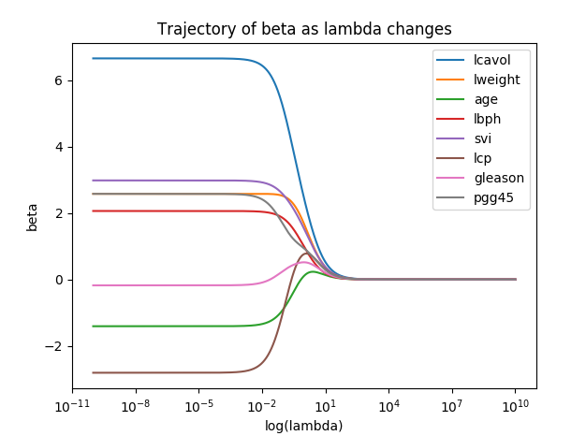
1c)
lambda = 0.1 is the best value. This lambda is where the regression coefficients of all features start to converge.
