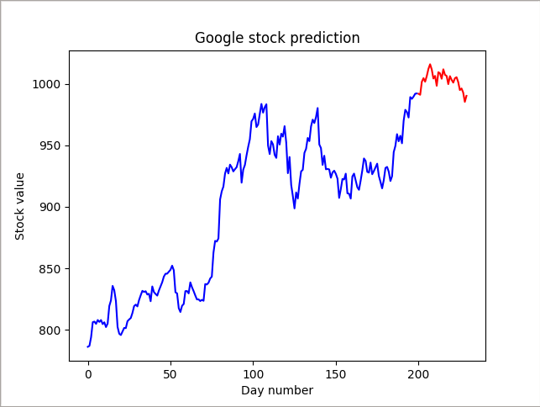

This is the Google stock prediction. The blue is what was already given. The red shows the stock values I predicted.

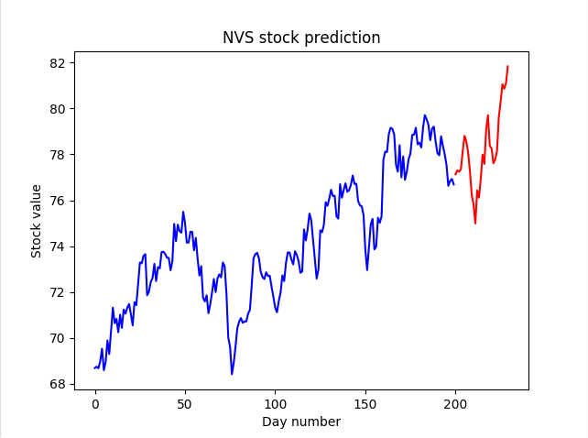
This is the NVS stock prediction. The blue is what was already given. The red shows the stock values I predicted.

