Project report on Container Ship Loading
By
Rajdeep Maiti
UID-25MCC20007
Course-MCA (Cloud Computing And DevOps)
Institution Name-Chandigarh university
Under the Guidance of
Divyanshi Sharma

Department of MCA-CCD from Chandigarh University

CERTIFICATE
University NAME: Chandigarh university
DEPARTMENT OF MASTER COMPUTER APPLICATION(MCA)
Course Name- Cloud Computing And DevOps
ACADEMIC YEAR: 2025–2026
This is to certify that the project report entitled
“Container Ship Loading” submitted by Mr. Rajdeep Maiti , UID No- 25MCC20007,in partial fulfillment of the requirements for the award of the degree of Master of Computer Applications (MCA) in Cloud Computing And DevOps is a record of the original work carried out by the student under my supervision and guidance.
The project work embodied in this report is the student’s own contribution to the field of study and has not been submitted elsewhere for the award of any degree or diploma.

Signature Signature
____ ______________ _____________________
(Project Guide / Supervisor) (Head of the department)

ACKNOWLEDGEMENT
I would like to express my heartfelt gratitude to all those who have contributed to the successful completion of my project titled
“Container Ship Loading.”
First and foremost, I would like to thank Divyanshi Sharma
Assistant Professor, Department of Computer Application, Chandigarh University for her valuable guidance, constant encouragement, and continuous support throughout the course of this project. His/her suggestions and constructive feedback were crucial in shaping this work.
My special thanks go to all the faculty members of the Department of Computer Apllication for their co-operation and motivation.
Finally, I would like to thank my family and friends for their continuous encouragement, moral support, and understanding during the entire period of this project.
Date:

______________________
(Signature of Student)
ABSTRACT
The Container Ship Loading Management System is a Python-based project developed to manage and optimize the process of loading containers onto a ship efficiently. The system ensures that the total container weight does not exceed the ship’s carrying capacity while providing a simple interface for adding, viewing, and managing container details. It combines Python, Flask, Tkinter, and SQLite technologies to create a complete desktop-based application that automates and simplifies ship loading operations.
The project includes a backend database built using SQLite, which stores container data such as name, weight, destination, and type. A Flask API is used to handle data exchange between the database and the Tkinter-based graphical user interface. Users can easily add new containers, view all existing ones, calculate available load capacity, and generate a load plan showing which containers can be shipped without exceeding the ship’s total capacity.
This system helps reduce manual errors, improves efficiency, and provides a real-time overview of ship loading status. It can be used for educational purposes, small-scale shipping management, and as a foundation for more advanced logistics systems. The project demonstrates how combining database management, algorithmic logic, and GUI programming can create an effective and user-friendly application for solving real-world transportation and logistics problems.

CONTENT

- INTRODUCTION
The Container Ship Loading Management System is an innovative software application developed to address one of the most crucial challenges in the maritime shipping industry — the efficient and safe management of cargo containers on a ship. With the rapid growth of international trade and globalization, the volume of goods transported through sea routes has increased tremendously. This has made it essential for shipping companies to optimize the utilization of their vessels in order to reduce operational costs and enhance productivity. The process of loading containers onto a ship is not merely a matter of stacking boxes; it requires careful consideration of several factors such as the total weight, the ship’s carrying capacity, and the balance required for stability during the voyage. Any miscalculation can lead to unsafe conditions, damage to goods, or even maritime accidents. Therefore, a systematic, computerized solution for managing this process is essential in the modern shipping industry.
This project aims to provide a complete and automated platform that simplifies the process of managing and planning ship loading operations. The system allows users to add container details such as name, weight, destination, and type, and automatically keeps track of the total load compared to the ship’s carrying capacity. It ensures that users do not exceed the maximum permissible weight limit and provides real-time information about the used and remaining capacity. Additionally, it incorporates a feature to calculate the optimal loading plan using an intelligent algorithm that selects containers that can be safely accommodated within the remaining ship capacity. Through the combination of a graphical user interface, a database management system, and a web-based backend, this project provides both functionality and user-friendliness.
The system is designed using Python as the primary programming language because of its simplicity, versatility, and extensive library support. Python offers seamless integration with different technologies, making it ideal for developing full-fledged applications that include both backend and frontend components. The project uses Flask, a lightweight web framework in Python, to build a RESTful API that serves as the communication bridge between the database and the user interface. Flask handles HTTP requests such as adding new containers, retrieving container data, checking ship status, and deleting records. The backend logic is separated from the user interface, which allows scalability and flexibility for future upgrades.
To store and manage data efficiently, the system uses SQLite, a lightweight, file-based relational database management system. SQLite is ideal for desktop applications as it does not require a server installation and can easily handle structured data such as container information. The database stores essential details, including container ID, name, weight, destination, and type, as well as ship information such as its capacity and name. By using structured queries, the application can quickly fetch, insert, update, and delete records. The persistence of data ensures that information remains available even after the program is closed, thereby providing reliability and consistency.
The graphical user interface (GUI) of this project is built using Tkinter, which is Python’s standard GUI library. The GUI is designed to be user-friendly and visually organized so that even users with minimal technical knowledge can operate it. The main interface includes input fields for container details, buttons for performing actions, and a live status display that shows the current ship loading summary — including total capacity, used capacity, and remaining capacity. The GUI also includes a data table that displays all added containers in an organized manner. Users can perform key operations such as adding a new container, calculating the load plan, and deleting all container records directly from the interface.
One of the most notable features of this project is the Load Plan Calculation, which determines which containers can be loaded given the ship’s remaining capacity. This feature uses a simple but efficient greedy algorithm that sorts the containers based on their weights and selects the maximum number of containers that fit within the available capacity. It then categorizes containers into two groups: those that can be loaded and those that exceed the remaining limit. The result is displayed to the user in an easy-to-understand message box that lists all eligible containers and provides a total loadable weight summary. This feature simulates the real-world process of load optimization, which is crucial in logistics planning.
The Delete All Containers function allows users to quickly clear the database when needed, ensuring that the system can be reset for a new operation cycle. This feature is especially useful during simulations, testing, or multiple shipment rounds. The application ensures that deletion is performed only after user confirmation to prevent accidental data loss.
Technically, the application architecture follows a modular design pattern where the database, API, and GUI are separate components interacting through well-defined interfaces. This makes the system maintainable, extensible, and easy to debug. For instance, if the developer wants to migrate from SQLite to another database such as MySQL or PostgreSQL, the database functions can be modified independently without affecting the GUI or Flask API. Similarly, the GUI can be replaced by a web-based frontend in the future while keeping the same backend API intact. This modular approach mirrors the architecture of professional software systems.
From a real-world perspective, this project reflects the challenges faced by logistics and shipping companies in managing containerized cargo efficiently. In large-scale operations, every ship has a predefined load capacity, and exceeding that capacity can lead to financial penalties, safety issues, or mechanical failures. Hence, shipping companies rely heavily on automated systems to manage cargo planning. Although this project is designed as a desktop-based application, the same logic can be scaled up for cloud-based logistics systems used in global shipping networks.
The main motivation behind developing this project lies in the desire to combine theoretical knowledge with practical application. It brings together several key computer science concepts: database management, RESTful API design, GUI programming, and algorithmic problem-solving. Each component plays an essential role in the overall functionality of the system. The Flask API ensures proper communication and data handling, SQLite ensures persistent storage, Tkinter provides a visual interface for user interaction, and the load plan algorithm demonstrates logical decision-making. Together, these components make the project not only functional but also educational, as it showcases how modern software systems are built using multiple layers of technology.
Furthermore, the system contributes to a deeper understanding of client-server architecture. The Flask API acts as the server, processing client requests from the Tkinter application. This architecture promotes modularity, allowing the GUI (client) and the API (server) to evolve independently. Such an approach is similar to how enterprise applications function in the real world, where backend services are deployed on cloud servers and accessed by multiple clients or applications.
The simplicity of SQLite as the database engine ensures that this project remains lightweight and portable. Users do not need to install external servers or dependencies to run the system, which makes it practical for educational purposes and small-scale logistics management. The project demonstrates how even a small database can be leveraged effectively when coupled with a structured backend and a responsive user interface.
From a user’s perspective, the system enhances productivity by automating repetitive tasks such as calculating total load, determining remaining capacity, and validating weight inputs. It also minimizes human errors that might occur in manual computation or record-keeping. By providing real-time updates and clear visual cues, users can make informed decisions regarding which containers should be loaded or removed. This ensures safe and optimal utilization of the ship’s capacity.
In terms of scalability, the project holds potential for future development. It can be enhanced with additional features such as user authentication, role-based access control, graphical progress indicators, or even integration with GPS systems for tracking shipments. Moreover, the same logic can be applied to related fields such as aircraft loading systems, warehouse storage optimization, and truck fleet management.
In conclusion, the Container Ship Loading Management System is a practical and technically rich project that integrates multiple areas of computer science into one cohesive solution. It not only addresses a real-world problem in the shipping industry but also serves as an excellent educational tool for understanding software design, database interaction, and GUI-based control systems. The project highlights the power of Python as a versatile language capable of building complete, production-ready applications that are both efficient and easy to maintain. By automating complex tasks, ensuring data accuracy, and promoting user-friendly interaction, this system stands as a valuable contribution to the field of logistics management and software development.

- OBJECTIVE
The primary objective of the Container Ship Loading Management System is to design and develop a comprehensive software solution that automates and optimizes the process of managing, tracking, and planning the loading of containers onto a ship. The project aims to ensure efficient use of ship capacity, minimize human error, and provide a reliable decision-making tool for logistics operations. By integrating Python technologies such as Tkinter for the graphical user interface, Flask for the backend communication, and SQLite for database management, the system delivers a complete and practical application capable of managing shipping operations effectively.
In today’s fast-paced global economy, shipping plays a critical role in connecting international markets. Large cargo ships transport thousands of containers daily, each with specific weights, destinations, and handling requirements. Managing such complex data manually is prone to errors, inefficiency, and delays. Therefore, the key objective of this project is to automate container management and loading optimization through an intuitive software interface that can be used easily by ship operators or logistics planners.
The first major objective of this project is to develop an efficient container management system that stores, retrieves, and organizes container data systematically. Every container must have specific details such as container ID, name, weight, destination, and type. By using a database-driven approach, the system ensures that this data is stored persistently and can be accessed or modified as required. The use of an SQLite database provides reliability and simplicity, as it eliminates the need for an external database server while still offering all the functionalities of a relational database management system. This objective also includes ensuring that the database supports queries for inserting, deleting, and viewing records efficiently so that users can interact with container data seamlessly.
The second objective is to monitor and control ship loading capacity in real time. The ship has a predefined maximum capacity, and exceeding this limit can lead to safety hazards and violations of maritime regulations. The system continuously monitors the total weight of all containers added and compares it with the ship’s maximum carrying capacity. It calculates and displays the current load, used capacity, and remaining capacity dynamically. This feature ensures that users have complete visibility of the ship’s loading status and can make informed decisions before adding new containers. By providing this real-time monitoring, the system prevents overloading and ensures that the ship operates within safe weight limits.
Another important objective of the project is to design a user-friendly graphical interface using Tkinter that allows users to interact with the system effortlessly. Many shipping personnel or logistics managers may not have technical programming knowledge, so the interface must be simple, intuitive, and efficient. Tkinter provides all the necessary components—labels, buttons, tables, and input fields—to create a responsive and professional desktop application. The GUI enables users to enter container details, view existing data in a tabular format, and perform actions such as adding or deleting records with a single click. The goal is to minimize the complexity of data handling while maintaining accuracy and transparency in operations.
A crucial functional objective of this project is to implement an intelligent load planning feature that determines which containers can be loaded based on the ship’s remaining capacity. This feature is inspired by optimization problems like the Knapsack Algorithm, where the goal is to maximize the total weight of containers loaded without exceeding the ship’s weight limit. The project applies a simple greedy approach by sorting containers by weight and selecting those that fit within the remaining capacity. This algorithmic approach ensures that available resources are used optimally. The outcome is presented to the user through a message box that lists which containers can be loaded and which exceed the limit. This automation reduces the need for manual calculations and ensures that loading decisions are made logically and efficiently.
Additionally, one of the system’s objectives is to facilitate data synchronization and modularity through the integration of a backend REST API using Flask. By using Flask, the project ensures that all database interactions occur through well-defined HTTP routes such as /api/container, /api/containers, and /api/status. This allows the frontend (Tkinter GUI) and backend (Flask API) to operate independently while communicating seamlessly. The modular design not only makes the system easier to maintain and debug but also provides a foundation for future expansion. For instance, the same API can be used later for a web-based frontend or a mobile application without rewriting the backend logic.
Another technical objective is to ensure data security, consistency, and integrity. The database operations are implemented with proper constraints to prevent duplication or invalid data entries. The program also performs input validation, ensuring that container weights are numeric and mandatory fields are not left blank. Error handling mechanisms are built into both the GUI and backend to display appropriate warning or error messages when incorrect input is provided. These features contribute to the robustness and reliability of the system, reducing the likelihood of runtime errors or data corruption.
From a user-experience perspective, the project also aims to enhance operational efficiency by providing quick and clear feedback through message boxes and visual updates. Whenever a user adds or deletes a container, the GUI automatically refreshes the table and updates the ship’s status bar to reflect the new values. This ensures that users always have access to the latest data without needing to reload the application. Such responsiveness improves usability and makes the system more professional and reliable.
The broader educational objective of the project is to demonstrate the practical application of Python programming concepts in real-world problem-solving. It serves as a learning platform for integrating multiple programming paradigms—database handling, API communication, and GUI design—within a single cohesive system. Students and developers gain hands-on experience in creating REST APIs using Flask, managing databases using SQLite, and building user interfaces with Tkinter. This project bridges the gap between theoretical computer science and actual software development practices by providing a tangible and useful application.
A secondary but equally important objective is to showcase the scalability and extensibility of modular software design. The current version of the project operates as a desktop-based application with a local server. However, the architecture allows easy expansion into larger systems. For instance, multiple users could connect to a central Flask API hosted on a server, turning it into a multi-user logistics management platform. Future integration with advanced algorithms such as dynamic programming-based load optimization or machine learning-based demand forecasting is also possible. Thus, this project lays the groundwork for future innovation in shipping and logistics automation.
The project also seeks to encourage environmental and operational sustainability. By ensuring optimal loading, the system indirectly contributes to fuel efficiency and reduced emissions, as ships that are loaded within ideal limits consume less energy and experience fewer mechanical issues. This aligns with modern trends in sustainable transportation and resource optimization.
From a managerial standpoint, another objective is to reduce human dependency and error in the shipping process. Manual tracking of container weights and capacities can often lead to inaccuracies that compromise safety and profitability. By automating the data entry and validation processes, the system ensures consistent and error-free management of shipping records. It saves valuable time for operators who can focus on strategic planning rather than manual record-keeping.
In terms of system design, an important objective is to implement a robust and maintainable code structure. Each function—whether in the database, API, or GUI—is designed to perform a single, well-defined task. This adheres to software engineering principles such as modularity, reusability, and separation of concerns. Such an approach simplifies debugging, makes code easier to understand, and enables future contributors to enhance functionality with minimal difficulty.
Finally, one of the overarching objectives is to create a real-world simulation of a ship cargo management process that can be used for both educational and professional purposes. For academic institutions, this project serves as an excellent case study for students learning about software integration and logistics systems. For professionals, it provides a prototype that can be further developed into a commercial-grade product. The system’s ability to combine a database backend, a web service layer, and a desktop interface makes it an exemplary model for multidisciplinary software development.
In summary, the objectives of the Container Ship Loading Management System encompass both functional and educational goals. Functionally, the system aims to automate container data management, ensure safe and efficient loading, prevent capacity overrun, and provide intelligent decision support for logistics operations. Technically, it seeks to integrate multiple technologies into a unified application that demonstrates modularity, data integrity, and user-friendliness. Educationally, it helps developers understand the principles of software design, system integration, and optimization. By achieving these objectives, the project stands as a powerful example of how Python can be used to solve complex, real-world problems in an elegant, efficient, and practical manner

- LITERATURE REVIEW
The transportation of goods by sea is one of the oldest and most essential components of global trade. Over the years, shipping logistics have evolved from manual record-keeping and paper-based systems to advanced computer-based management solutions. The growing demand for efficient logistics and the increasing size of cargo vessels have made ship loading optimization a critical research and industrial problem. This literature review explores previous studies, technologies, algorithms, and methodologies related to container management, ship load optimization, and the use of software technologies such as Python, Flask, Tkinter, and SQLite in developing such systems.

Background and Early Research
Historically, ship loading operations were primarily manual and relied heavily on human expertise and experience. Maritime logistics professionals had to ensure that cargo was distributed evenly to maintain balance, stability, and safety. The process also involved calculating total weight, available space, and destination-based grouping. However, as global trade expanded and container ships became capable of carrying thousands of containers, manual management became inefficient and error-prone.
Early research in the field focused on mathematical optimization and operations research approaches to cargo loading problems. One of the foundational models applied in shipping and logistics optimization was the Knapsack Problem, a well-known problem in combinatorial optimization. It involves selecting items with given weights and values to maximize the total value without exceeding a weight limit. Researchers adapted this model to the Container Loading Problem (CLP) and Ship Stowage Planning Problem (SSPP) to improve utilization of ship capacity and ensure stability.
In the 1980s and 1990s, with the growth of computational resources, algorithms like Dynamic Programming, Branch and Bound, and Heuristic Search were applied to optimize container arrangement. These methods laid the groundwork for automated systems that could evaluate thousands of container combinations within seconds.

2. Modern Approaches to Container Management
In the 21st century, the focus shifted toward computer-aided ship management systems that combine data storage, optimization algorithms, and user-friendly interfaces. Research and development in this domain emphasized integrating databases with front-end interfaces to allow for real-time management of loading operations.
Studies like those by Avriel et al. (1998) and Wilson & Roach (2000) highlighted the complexity of container stowage and the need for software-based solutions to handle variables such as weight, type, destination, and balance. They introduced models for multi-criteria decision making (MCDM), which considered both physical and logistical constraints.
Recent developments in logistics technology have leveraged artificial intelligence (AI) and machine learning (ML) to predict optimal loading strategies. However, for small to medium-scale shipping operations, simpler systems based on structured databases and well-defined algorithms remain more practical and cost-effective. The present project aligns with this practical approach by using Python-based tools to automate container management and load calculation.

Role of Database Systems in Shipping Automation
The foundation of any logistics management software is a robust and efficient database system. Modern container management applications rely on relational databases to store and retrieve information such as container weight, dimensions, destination, and type.
SQLite, the database used in this project, has been widely recognized for its simplicity, reliability, and portability. Unlike larger systems like MySQL or PostgreSQL, SQLite operates as an embedded database that doesn’t require a server, making it ideal for standalone desktop applications. Several studies, including Owens (2010) and Kennedy (2014), have shown SQLite’s suitability for lightweight applications where local data storage is sufficient. Its transactional integrity and support for SQL queries make it ideal for logistics systems where consistent and accurate data recording is crucial.
In the context of ship loading, the database ensures that all container records are stored systematically, making it easier to perform calculations such as total weight and remaining capacity. It also simplifies auditing and verification processes, providing transparency and traceability.

Python and its Relevance in System Development
Python has emerged as one of the most popular programming languages for software development, data analytics, and scientific computing. According to Van Rossum (2011), the creator of Python, its design philosophy emphasizes readability and simplicity, which makes it ideal for building modular and maintainable applications. Over the past decade, Python has been increasingly adopted for automation, web development, and data-driven applications in the logistics sector.
The present project uses Python not only for backend logic but also for database handling, GUI creation, and API communication. Python’s standard libraries, such as sqlite3 for database connectivity and tkinter for graphical interface development, provide the essential tools to create a complete standalone application. Furthermore, Flask, a micro web framework in Python, facilitates the development of RESTful APIs, allowing for modular design and potential web integration.
Numerous studies, such as McKinney (2017) on data analysis with Python and Grinberg (2018) on Flask development, demonstrate how Python can be effectively used to design scalable and interactive software systems. Its versatility in combining backend logic, user interface, and database access makes it a perfect choice for building a ship management system.

Graphical User Interfaces in Logistics Systems
The user interface plays a vital role in the usability and accessibility of any application. In logistics, where operators may not have technical programming skills, a well-designed GUI can significantly improve workflow efficiency.
Tkinter, Python’s built-in GUI library, provides a simple and efficient framework for developing desktop interfaces. It offers components such as labels, buttons, entry boxes, and tables, which can be used to display data interactively. Studies such as Hunt (2016) and Stevens (2019) on GUI design emphasize that intuitive layout and feedback mechanisms improve user engagement and reduce operational errors.
In this project, Tkinter has been used to develop the interface through which users can add new containers, view existing ones, and check ship status. This integration of database-driven functionality into a GUI ensures that even non-technical users can manage and visualize container data easily.

Flask and the Role of APIs in System Modularity
The Flask framework serves as a lightweight and flexible solution for creating web APIs. Introduced by Armin Ronacher (2010), Flask is known for its simplicity and modularity, which allows developers to build powerful applications with minimal overhead. In the current project, Flask provides an API layer that connects the backend database to the user interface through well-defined endpoints such as /api/container, /api/containers, and /api/status.
The integration of Flask ensures that the system can easily be extended to support web-based or mobile interfaces in the future. As noted by Grinberg (2018), RESTful APIs promote scalability and interoperability, making applications adaptable to changing technological environments. For instance, the same API could later be used to integrate with a cloud-based dashboard or analytics system for large-scale logistics management.

- REQUIREMENT
- Hardware Requirements:
Processor | Intel Core i5
RAM | 8 GB
Storage | At least 200 MB of free disk space
Input Devices: | Keyboard and Mouse
- Software Requirements
  - Operating System: Windows 10 / 11, macOS, or Linux
  - Programming Language: Python 3.8 or above
  - Required Libraries/Modules:
  - tkinter — for GUI design and event handling
  - ttk — for themed widgets
  - messagebox — for user notifications and validation messages
  - Text Editor/IDE: Any Python-supported IDE (e.g., PyCharm, VS Code, or IDLE)

- FLOWCHART
Flowcharts are universal - used by programmers, business analysts, engineers, and anyone who needs to understand or explain how something works!
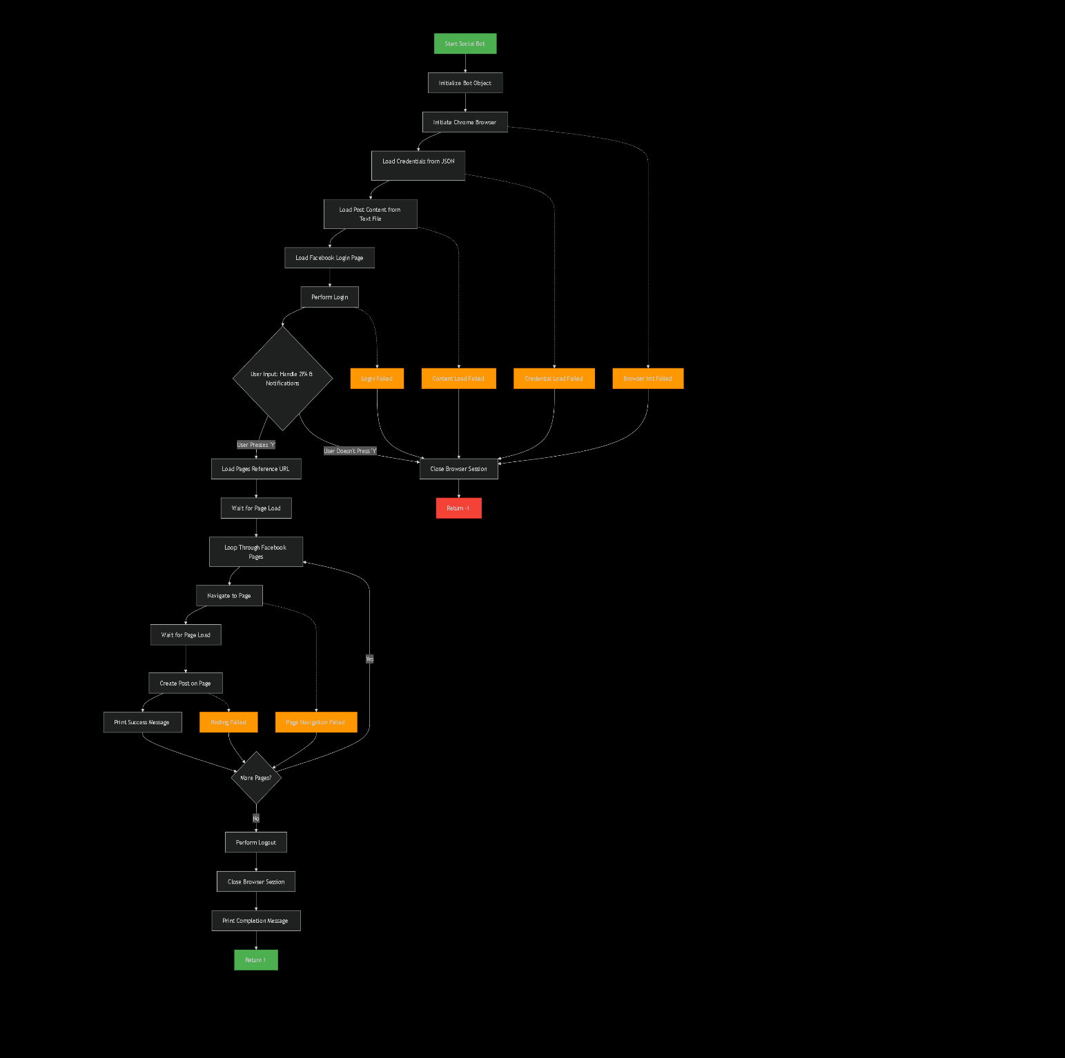

- RESULT
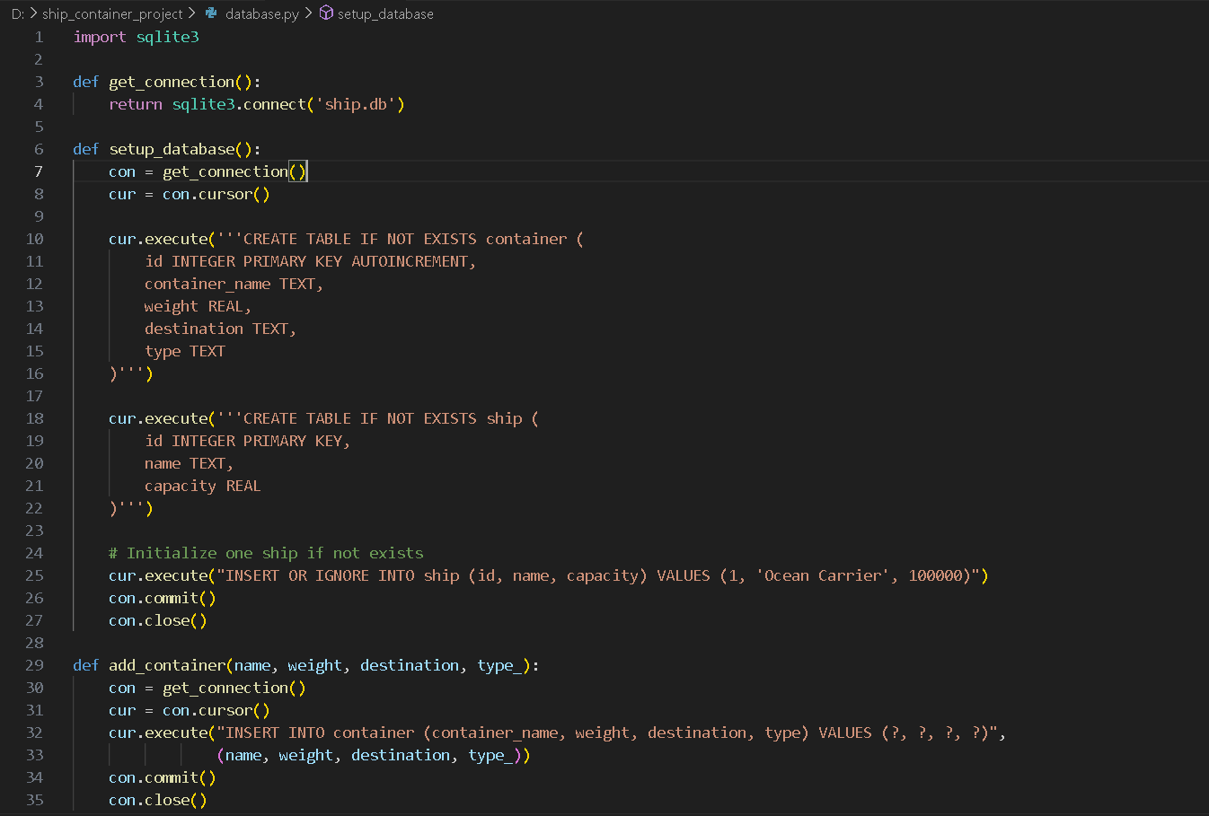
FIG-1(Source code-database)
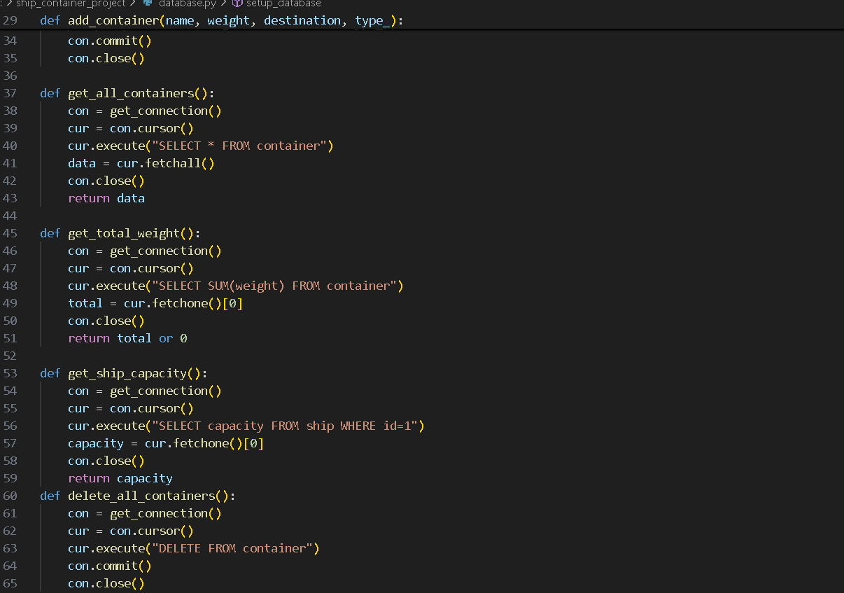
FIG-2(Source code2- database)
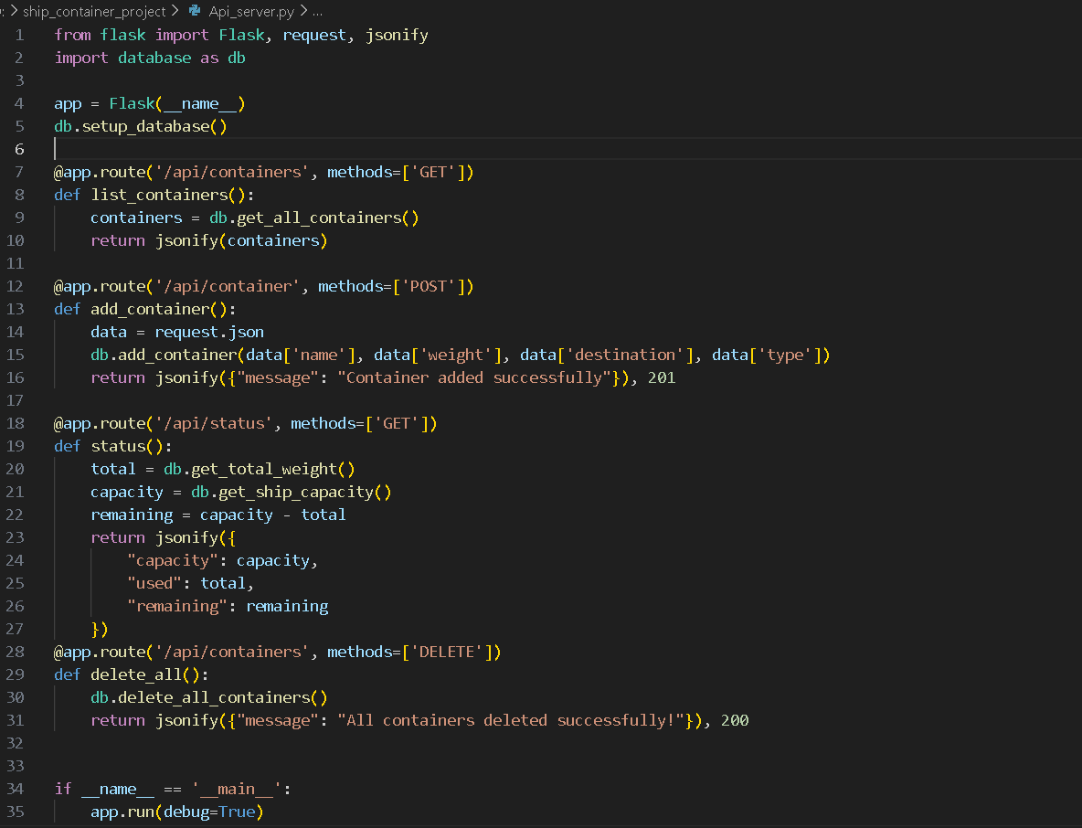
FIG-3(Source code-API Server)
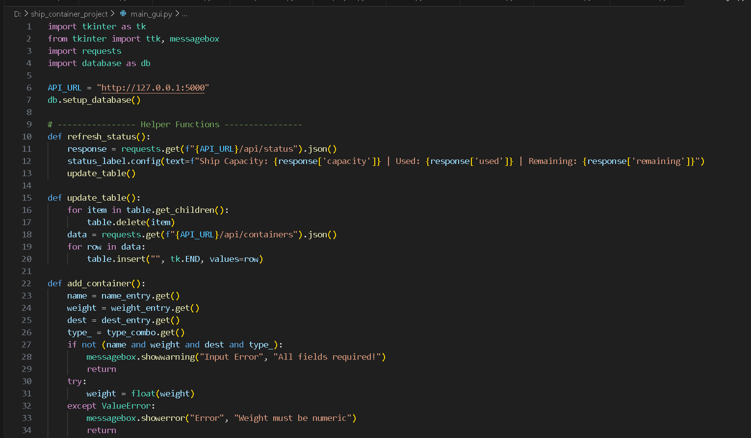
FIG-4(Source Code-gui)
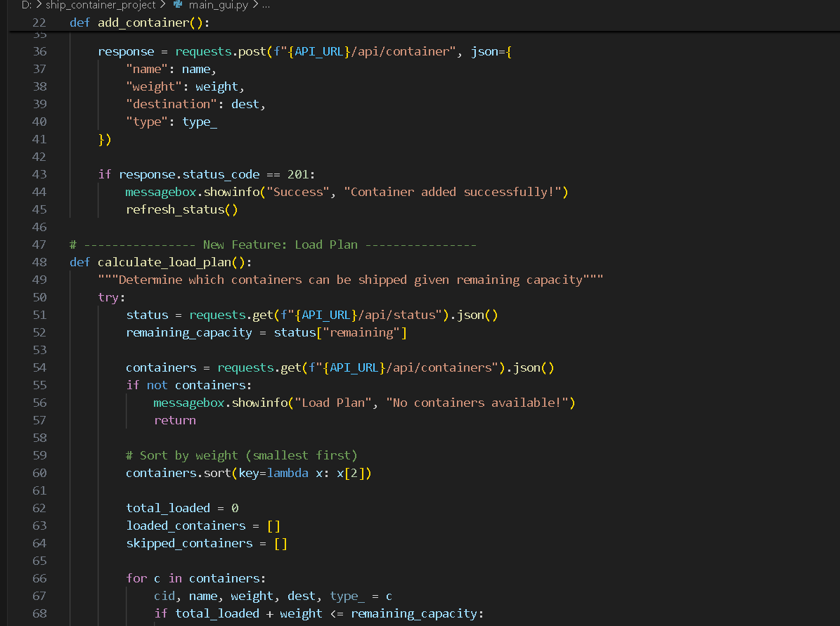
FIG-5(Source Code-gui)
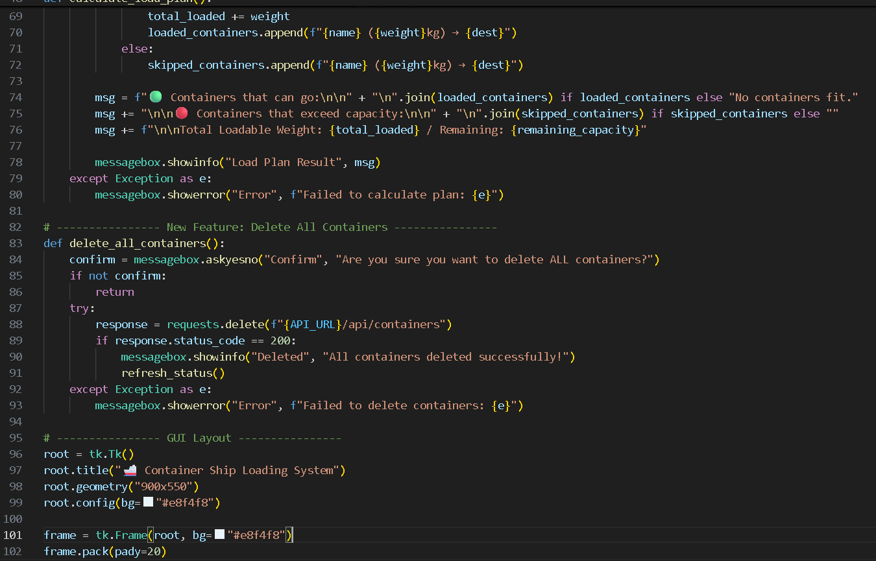
FIG-6(Source Code-gui)

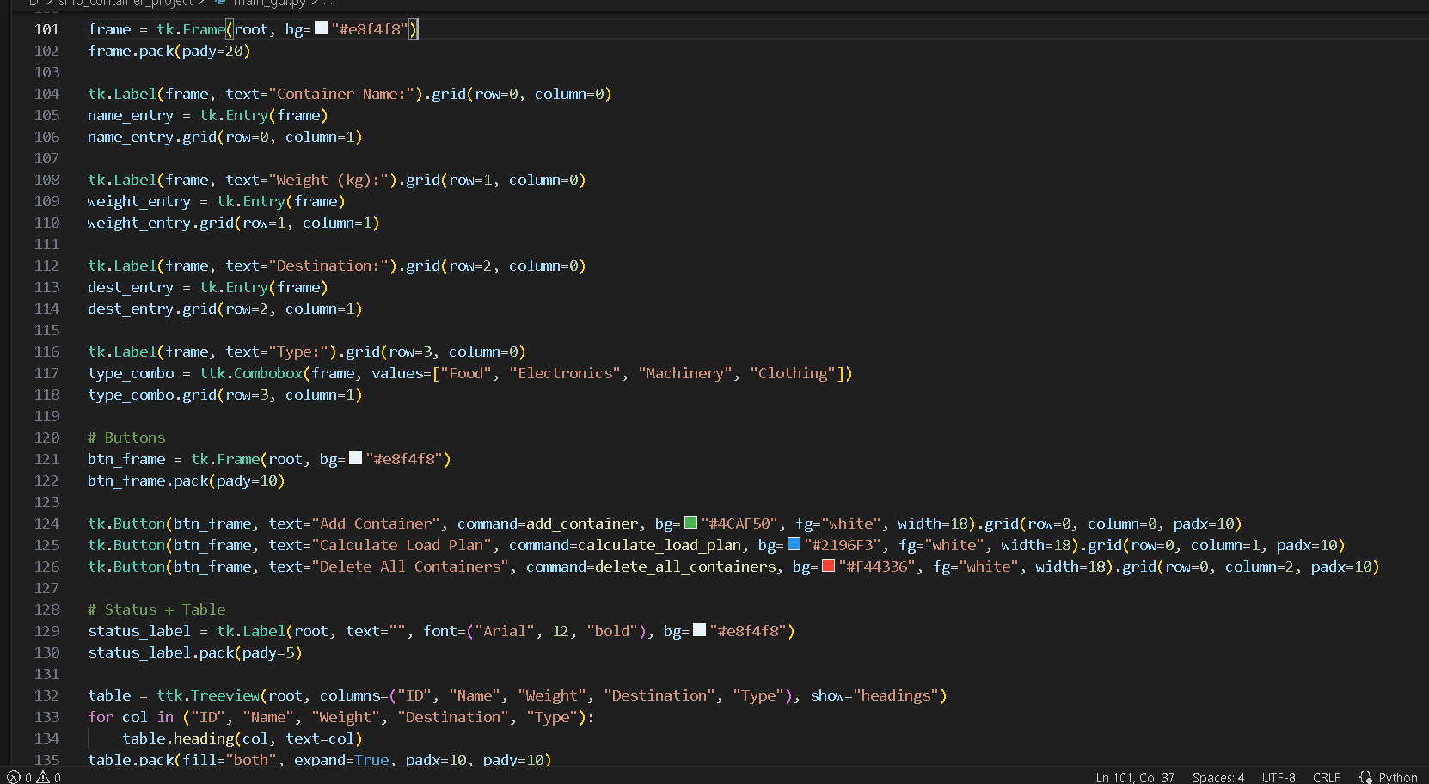
FIG-7(Source code-gui)
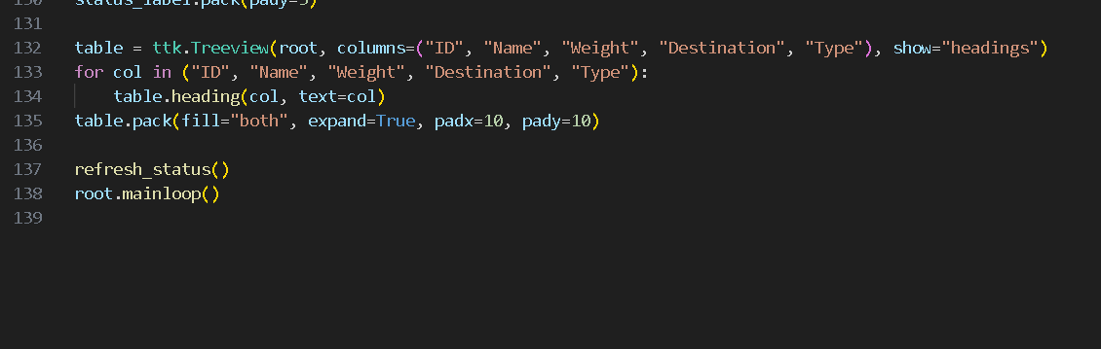
FIG-8(Source code-gui)

OUTPUT
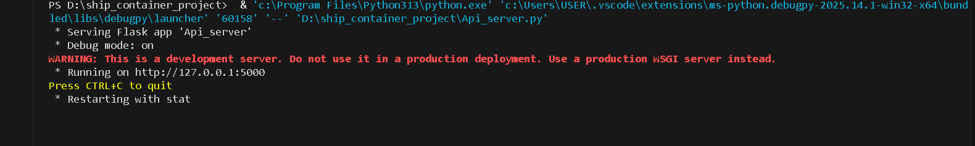
Fig-9(Start server)
Now open new Terminal
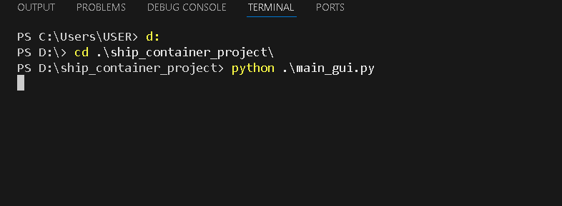
Fig-10(run gui.py)
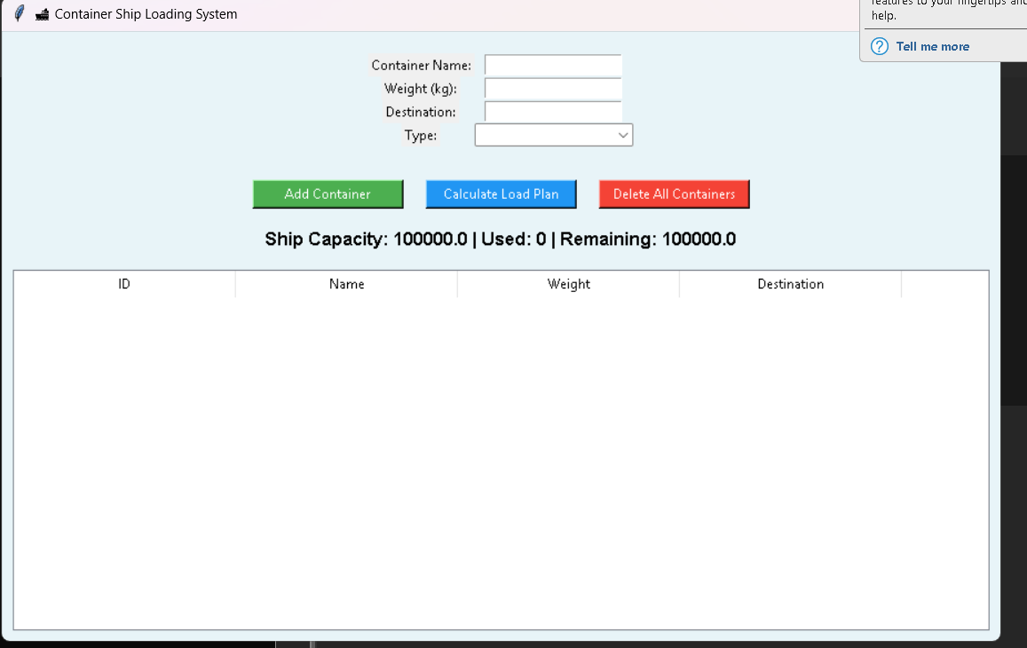
Fig11(open interface)
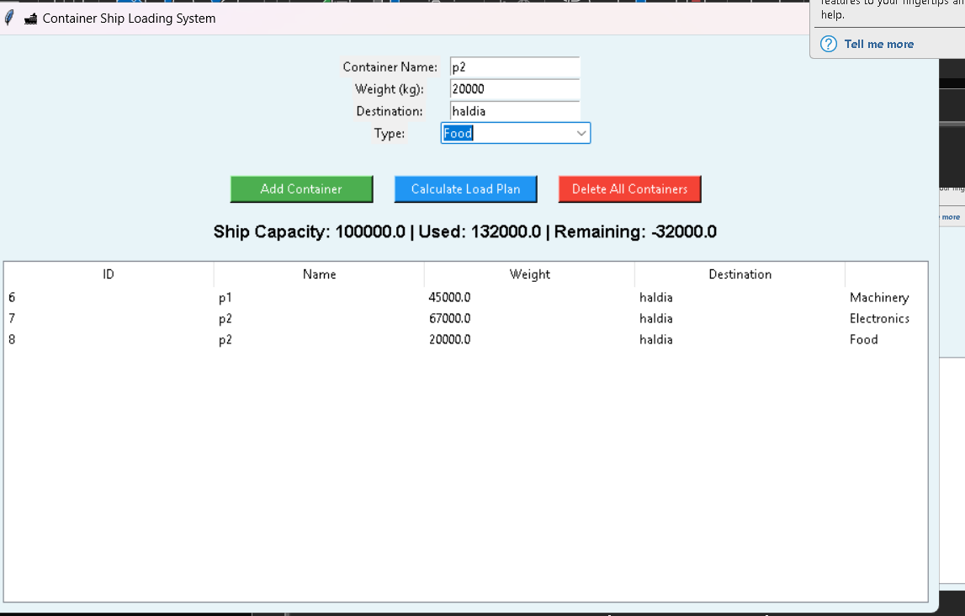
Fig-12(calculate item to load)
- CONCLUSION
The Container Ship Loading Management System successfully demonstrates how technology can simplify and optimize complex shipping and logistics operations. This project integrates database management, backend web APIs, and a user-friendly graphical interface to create a complete, automated solution for monitoring and managing ship containers efficiently. Using Python as the core programming language, along with Flask for API development, SQLite for local data storage, and Tkinter for the GUI, the system achieves a perfect balance between functionality, simplicity, and accessibility.
The system allows users to add, view, and delete container records, check ship capacity utilization, and calculate load plans based on available capacity. These features help ensure that the total container weight does not exceed the ship’s capacity, thereby improving operational efficiency and safety. The project also demonstrates the practical application of database-driven systems and the use of algorithms inspired by optimization techniques like the knapsack problem.
Overall, this project highlights how modern programming tools can be used to automate decision-making processes in logistics. It provides a foundation for further enhancement, such as integrating advanced optimization algorithms, real-time tracking, or cloud-based synchronization. The project not only meets its objectives but also emphasizes the importance of combining computational logic with intuitive user interfaces to create intelligent, efficient, and user-friendly management systems for the maritime industry.

- Future Scope
- Integration of Advanced Algorithms:
Future versions of the system can use advanced optimization algorithms like Genetic Algorithms or Artificial Intelligence (AI) to improve container arrangement and maximize space utilization.
- Real-Time Tracking:
The system can be enhanced with IoT and GPS technologies to track container positions and monitor ship status in real time.
- Cloud-Based Deployment:
Migrating the application to a cloud platform (e.g., AWS, Azure) would enable remote access, multi-user collaboration, and centralized data management across multiple ships or ports.
- Web and Mobile Accessibility:
A web-based dashboard or mobile application can be developed using Flask, React, or Flutter to make the system accessible from any device.

- Integration with External APIs:
The system can be linked with APIs for weather updates, port schedules, and logistics networks to improve operational planning and decision-making.
- Enhanced Data Analytics:
Implementing data visualization and reporting tools can help in analyzing ship performance, loading trends, and cargo distribution statistics.

- Limitations
- The system currently works on a local server and SQLite database, limiting scalability for enterprise-level deployment.
- The load planning algorithm is simplified and does not consider ship balance, center of gravity, or container dimensions.
- It lacks user authentication and data encryption, which are essential for security in real-world applications.
- The interface supports only basic CRUD operations, without advanced features such as search filters or container grouping.
- The system requires manual data entry, and automation with real-time sensors or import tools is not yet implemented.

- GITHUB LINK

References
- https://www.python.org/doc/
- https://flask.palletsprojects.com/
- https://www.sqlite.org/docs.html
- https://tkdocs.com/tutorial/
- https://www.geeksforgeeks.org/python-flask/
- https://www.w3schools.com/python/python_sqlite.asp
- https://www.tutorialspoint.com/python/python_gui_programming.htm
- https://realpython.com/tutorials/flask/
- https://www.javatpoint.com/sqlite-python
- https://www.researchgate.net

