**Angular_Session_1_Assignment_1_3**

1. Clone the project from Angular Github seed.

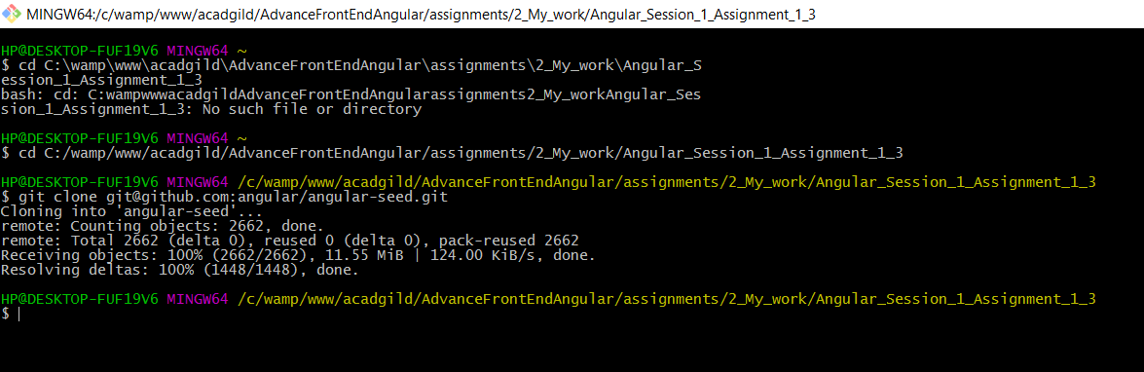

1. Install all the packages in the project.

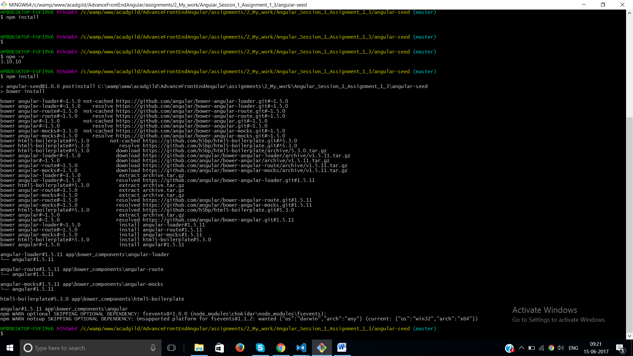

1. Start the project using npm start.

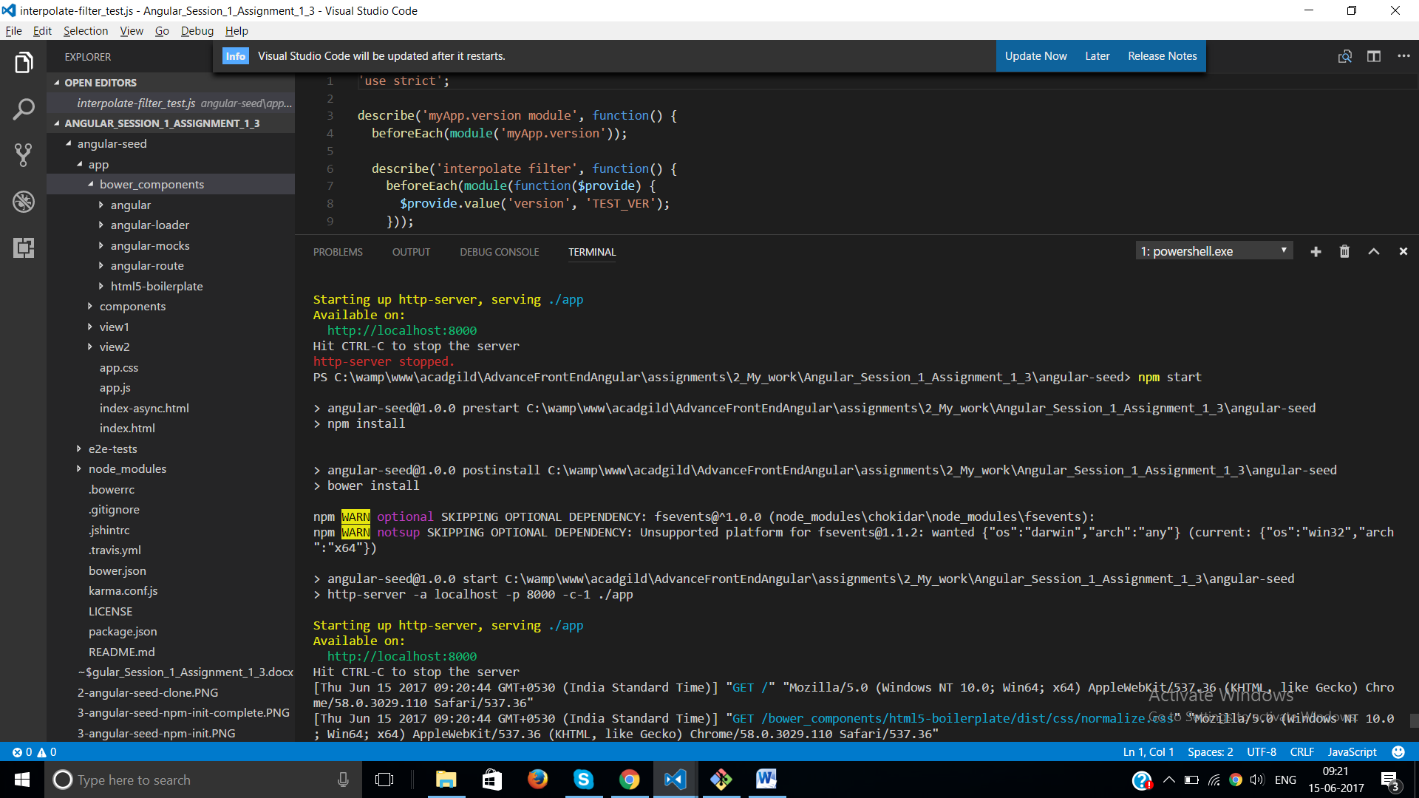

1. Out put after npm start

