**Angular_Session_1_Assignment_1_4**

1. Preparing for angular js project

* Installing packages via npm

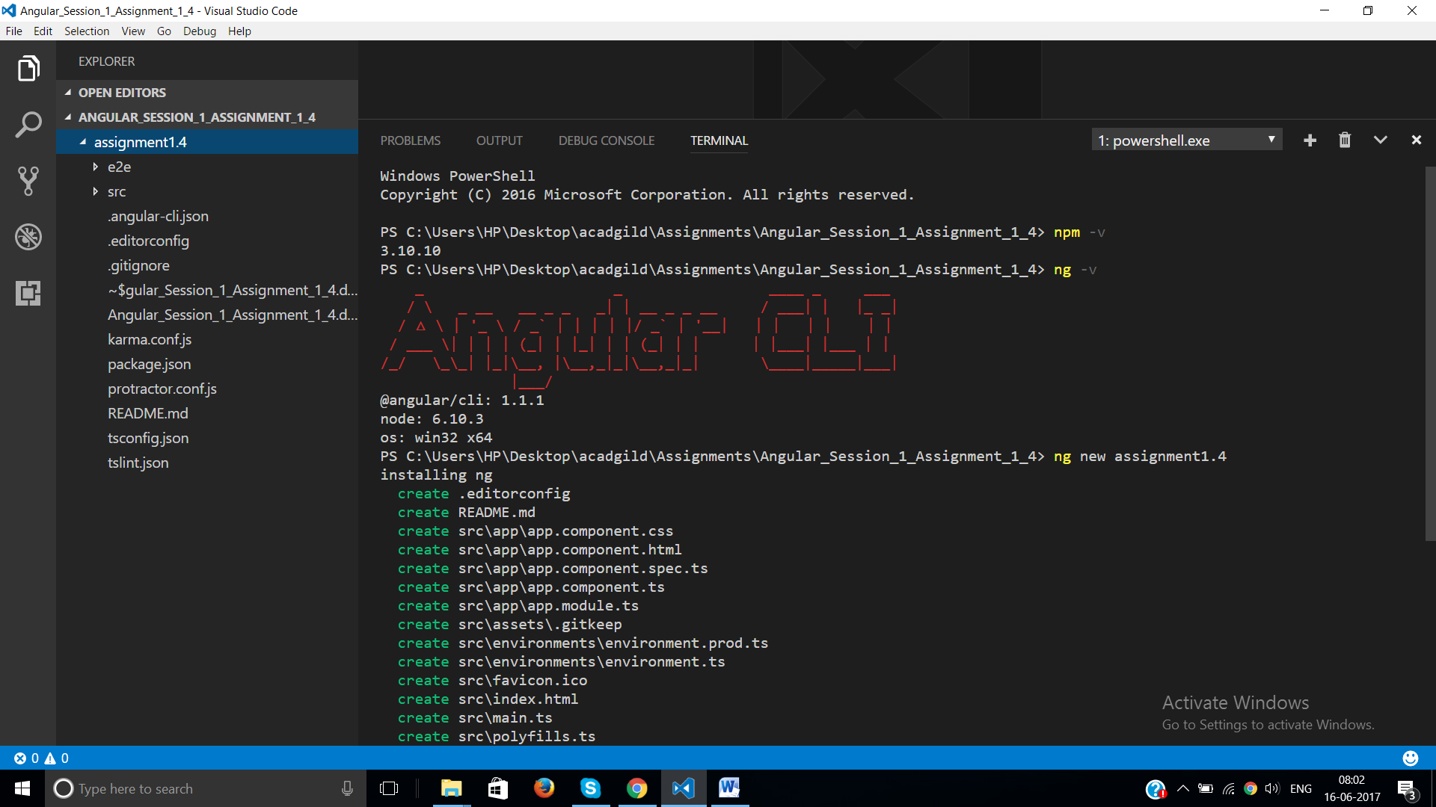

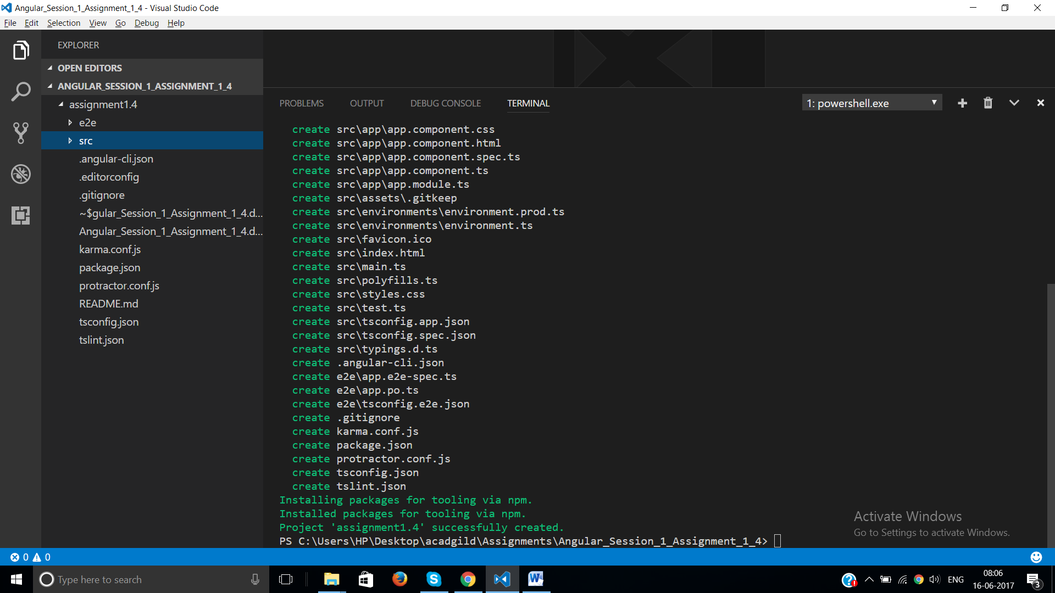

1. Installing bootstrap Module via npm

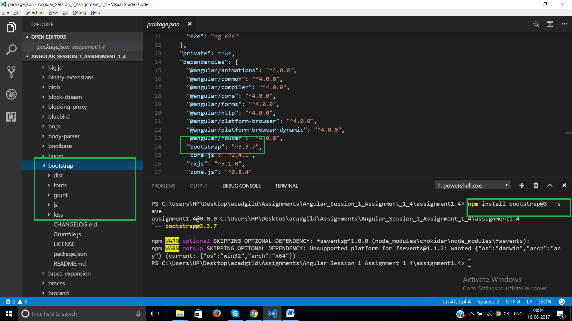

1. Including bootstrap css path in angular-cli.json

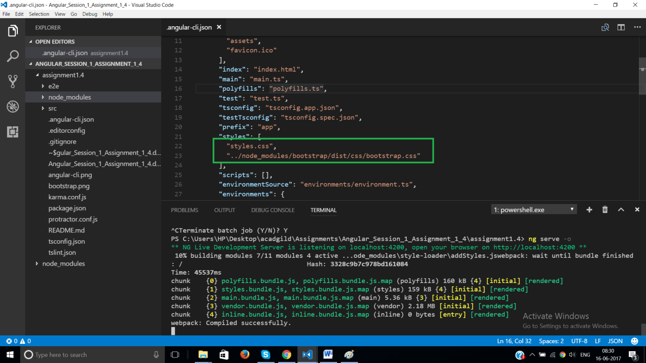

1. Adding html in index page

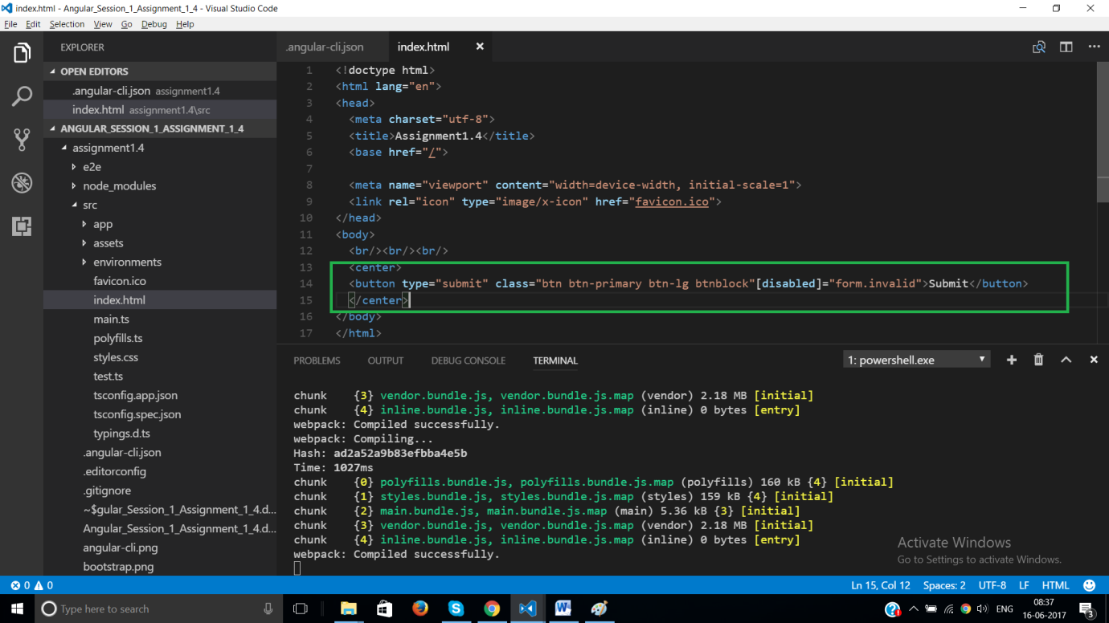

1. Output

