**FACE RECOGNITION ATTENDANCE SYSTEM**

**A Capstone Project and Research Study**

**Presented to the**

**Department of Information Technology**

**University of Science and Technology of Southern Philippines**

**Oroquieta City** **In Partial Fulfillment of the Requirements for**

**Capstone Project and Research Study leading to the Degree in**

**Bachelor of Science in Information Technology  
  
  
  
  
Angelo A. Maquiling**

**Emelyn J. Monteza**

**Kristan Torres**

**Rolan T. Manales**

**March 2025**

**APPROVAL SHEET**

**ABSTRACT**

**DEDICATION**

**ACKNOWLEDGMENT**

**TABLE OF CONTENT**

**TITLE PAGEi**

**APPROVAL SHEETii**

**ABSTRACTiii**

**DEDICATIONiv**

**ACKNOWLEDGMENTv**

**TABLE OF CONTENTSvi**

**LIST OF TABLESx**

**LIST OF FIGURESxi**

**CHAPTER 1 – INTRODUCTION……………………………………………...1**

1.1 Background of the Study1

1.2 Statement of the Problem2

1.3 Statement of the Objectives3

1.3.1 General Objectives3

1.3.2 Specific Objective3

1.4 Significance of the Study4

1.5 Scope and Limitations of the Study5

1.6 Definition of Terms6

**CHAPTER 2 – REVIEW OF RELATED LITERATURE……………………8**

2.1 Review of Literature 8

2.1.1 Review of Literature 8

2.1.2 The Role of Face Recognition in Attendance Tracking 10

2.1.3 Machine Learning for Attendance Verification 12

2.1.4 Automated Alerts for Attendance Monitoring 13

2.1.5 Attendance Tracking for Teachers 15

2.2 Review of Related Application 16

2.3 Synthesis and Gap Analysis20

**CHAPTER 3 – METHODOLOGY……………………………………………23**

3.1 Description of the Current System (Information Gathering)29

3.2 System Architecture and Development30

3.2.1 Overview of the Proposed System 30

3.2.2 System Objectives 30

3.3 System Tools and Requirements31

3.3.1 Programming Languages 31

3.3.2 Hardware Requirements 31

3.3.3 Software Requirements 32

3.3.4 System Flow/Functions 33

3.3.5 Scope and Limitations of the System 35

3.3.6 Calendar of Activities 36

3.4 Conceptual Design and Implementation 37

3.4.1 System Design 37

3.4.2 Database Design 38

3.4.3 Use Case Design 40

3.4.4 Prototype Design 41

3.4.4 Prototype Design 54

**LIST OF TABLES**

Table 1. System Feature Comparison 19

Table 2. Existing Studies 21

Table 3. Hardware Requirements31

Table 4. Software Requirements 32

Table 5. Software Requirements36

**LIST OF FIGURES**

Figure 1. NCheck Bio Attendance16

Figure 2. timeero17

Figure 3. Jibble18

Figure 4. Buddy Punch Facial Recognition18

Figure 5. SDLC Model24

Figure 6. Slovin’s Formula with the computed total respondents of USTP Teachers*.* 28

Figure 7. Admin Flowchart33

Figure 8. Teacher Flowchart34

Figure 9. System Design37

Figure 10. Entity Relationship Diagram (ERD) 38

Figure 11. Use Case Diagram.40

Figure 12. Admin Dashboard41

Figure 13. Admin Manage Teacher 42

Figure 14. Admin Manage Students 43

Figure 15. Admin Manage Subject 43

Figure 16. Admin Activity Logs 44

Figure 17. Admin Log out 45

Figure 18. Mobile app landing Page 46

Figure 19. Mobile app log in Page 46

Figure 20. Mobile app Sign up 47

Figure 21. User Dashboard 48

Figure 22. Select Attendance Type 49

Figure 23. Create Attendance 49

Figure 24. Attendance Pending 50

Figure 25. Submitted Attendance 51

Figure 26. Generate Report 52

Figure 27. Asynchronous Attendance 53

Figure 28. Personal Information54

Figure 29. Context Diagram 54

**CHAPTER I  
INTRODUCTION**

**1.1 Background of the Study**

Attendance tracking is a fundamental part of educational institutions, ensuring student engagement and teacher accountability. However, traditional methods such as manual roll calls and sign-in sheets are time-consuming, prone to errors, and inefficient. Schools struggle with proxy attendance, lost records, and delayed reporting, which hinder institutional accountability and decision-making.

To address these challenges, the FaceAttend system was conceptualized. This system is a mobile application that integrates machine learning and real-time face recognition to automate attendance tracking. Designed for USTP Oroquieta, FaceAttend eliminates manual errors and ensures real-time attendance verification using a live camera feed. Students simply scan their faces upon entering classroom, and the system instantly records their attendance, preventing fraudulent practices such as proxy sign-ins.

Similar innovations have demonstrated significant improvements in attendance accuracy and efficiency. An Android-Based Class Attendance Monitoring System Using Face Recognition Technology, which highlighted the advantages of automated attendance tracking in educational settings. Such systems

reduce administrative workload, enhance security, and provide real-time access to attendance data for school management.

Beyond automating attendance tracking, FaceAttend enhances institutional efficiency. The system generates comprehensive attendance reports, including date, time, and student participation records, which are accessible to administrators for monitoring trends and enforcing school policies.

**1.2 Statement of Problem**

Educational institutions face several challenges in managing student and teacher attendance due to the continued reliance on manual processes. These challenges include errors in recording attendance, proxy attendance, lost records, time consuming and delays in monitoring student absences. The following issues must be addressed to improve the accuracy and efficiency of attendance tracking:

* Manual attendance methods are time-consuming and often result in recording errors, causing delays in monitoring student and teacher attendance.
* The current process is vulnerable to proxy attendance and the loss of physical records, which affects the reliability and integrity of attendance data.
* Educational institutions lack an automated, centralized system that provides accurate, real-time tracking and secure storage of attendance information.

**1.3 Statement of the Objectives**

**1.3.1 General Objectives**

This research aims to develop a Face Recognition Attendance System that provides an efficient, accurate, and automated method for tracking attendance in educational institutions. The system will replace traditional manual roll calls and sign-in sheets, eliminating human errors, proxy attendance, and inefficiencies in attendance tracking.

**1.3.2 Specific Objectives**

The specific objectives aim to address key challenges in attendance management and ensure the practicality, efficiency, and reliability of the FaceAttend system. By breaking down the main goal into targeted steps, this study adopts a structured approach to automating attendance, enhancing record accuracy, and supporting effective classroom monitoring.

1. To develop an automated system that records attendance efficiently and minimizes human error and time delays.
2. To implement facial recognition technology that ensures only physically present students are marked, reducing proxy attendance and lost records.
3. To create a centralized, cloud-based platform that enables real-time tracking, secure data storage, and generation of accurate attendance reports.

**1.4 Significance of the Study**

* **For Schools and Educational Institutions:** FaceAttend will help streamline attendance management, saving time and reducing manual errors in recording student attendance.
* **For Teachers:** Teachers will benefit from automated attendance logging and easy access to detailed attendance reports, allowing them to focus more on teaching and less on administrative tasks.
* **For Students:** Students will experience a faster, more accurate attendance process and increased accountability for their class participation.
* **For Administrators:** Admins will have tools to manage students, teachers, and subjects, and monitor system activity efficiently through real-time dashboards and reports.
* **For Future Researchers:** This study can serve as a reference for developing similar attendance automation systems, encouraging improvements in school management technologies.

**1.5 Scope and Limitations of the Study**

This study focuses on creating FaceAttend, a mobile app that uses face recognition to make attendance checking easier and faster. The app helps reduce mistakes, stops proxy attendance, Lost of record and time consuming it gives real-time attendance reports. Teachers can manage class attendance, and Generate report school admins can keep track of students, teacher, and manage subject, section. FaceAttend stores all data safely in the cloud and is made especially for use at the University of Science and Technology of Southern Philippines (USTP) Oroquieta Campus for classroom attendance.

FaceAttend requires a clear camera view with good lighting and a stable internet connection to function properly. It is designed for both face-to-face and asynchronous classes but does not support remote or offline attendance. The system cannot detect fake attendance using printed photos or videos. For face-to-face classes, physical presence is required. However, for asynchronous classes, teachers can upload a screenshot showing students attending an online class (e.g., a screenshot of a video call) to check attendance. The system only records check-ins and cannot detect if a student leaves or escapes from class after being marked present. Additionally, it does not monitor student logouts after class.

* 1. **Definition of Terms**
* **Attendance Tracking –** The process of monitoring student and teacher presence in classrooms at USTP Oroquieta using a Machine Learning-based Face Recognition Attendance System, ensuring accuracy and preventing fraudulent attendance practices.
* **Camera System –** The hardware component responsible for capturing students' facial images upon entering the classroom to verify attendance.
* **Digital Attendance Records –** Securely stored attendance data that eliminates manual errors, prevents lost records, and allows real-time tracking.
* **Face Recognition Technology –** A Machine Learning-powered system that identifies and verifies students' identities through facial scanning to automate attendance marking.
* **Machine Learning (ML) –** A subset of artificial intelligence that enables the face recognition system to learn and improve from data, increasing accuracy in identifying students over time.
* **Generate Report –** The system's ability to generate accurate attendance reports that include date, time, and participation trends for school management.
* **Teacher Attendance Monitoring –** A feature that allows administrators to ensure instructors are present for their scheduled classes.
* **Web-Based Portal –** The online platform that school administrators and teachers use to access attendance reports, monitor absenteeism trends, and track teacher attendance

**CHAPTER II**

**REVIEW OF RELATED LITERATURE**

This chapter explores existing studies and literature related to automated attendance systems, particularly those using face recognition technology and machine learning. Traditional methods of attendance tracking, such as manual roll calls and sign-in sheets, are time-consuming and prone to errors, proxy attendance, and data loss. Automated systems have been introduced to enhance accuracy, security, and efficiency in monitoring student and teacher attendance.

**2.1 Review of Literatures**

* + 1. **Traditional Attendance Methods and Challenges**
    2. Traditional attendance tracking methods, such as manual roll calls and sign-in sheets, are widely used in educational institutions. However, research highlights several drawbacks of these methods, including inefficiency, inaccuracies, and susceptibility to fraudulent practices like proxy attendance. Anzar et al. (2021) emphasize that conventional attendance systems often lead to delayed reporting, data loss, and reduced classroom productivity. Similarly, Vlachopoulos and Jan (2020) found that student engagement and motivation are directly influenced by attendance

methods, with manual processes often being ineffective in fostering consistent attendance.

Hartono et al. (2024) discuss the necessity of improving attendance accuracy and efficiency, particularly in the context of the Industrial Revolution 4.0, where digital transformation is crucial. Moreover, Budiarto et al. (2024) highlight how technological advancements can significantly enhance attendance monitoring in both schools and colleges, reducing administrative burdens and improving record-keeping.

H. S. et al. (2024) examined the implementation of automated attendance systems, demonstrating their advantages in reducing human error and improving data management efficiency. Mondal and Mondal (2023) conducted a systematic review on various attendance tracking methods in medical education and found that biometric-based systems, particularly facial recognition, offer higher accuracy and reliability compared to traditional methods.

Heru et al. (2024) explored the impact of web-based e-attendance systems in vocational high schools, demonstrating a positive correlation between automated attendance tracking and student learning motivation. Tarmissi et al. (2024) reinforced the effectiveness of face recognition-based attendance systems, indicating that these solutions ensure seamless monitoring while integrating artificial intelligence (AI) for enhanced accuracy.

Alharbi and Alharbi (2024) discussed future developments in attendance tracking, emphasizing AI-driven monitoring systems and their role in enhancing real-time tracking capabilities. Additionally, Moores et al. (2020) analyzed determinants of university students' attendance, underlining how efficient attendance monitoring influences student participation and institutional policies.

**2.1.2 The Role of Face Recognition in Attendance Tracking**

Recent studies highlight the increasing adoption of face recognition technology in attendance tracking systems due to its accuracy and efficiency. Raj et al. (2024) explored the implementation of facial recognition-based student attendance systems, emphasizing their ability to reduce fraudulent sign-ins and ensure real-time authentication. Alburaiki et al. (2021) examined mobile-based attendance solutions integrating facial recognition and location detection using machine learning, which enhances security and accuracy.

Shukla et al. (2024) introduced CNN-LSTM models for automated attendance systems, demonstrating their potential in improving student identification and tracking. Ritchie et al. (2021) analyzed public attitudes toward the use of facial recognition in justice systems, raising ethical and privacy concerns that also apply to educational settings. Khan et al. (2021) reviewed machine learning applications in computer vision, emphasizing the role of AI in refining facial recognition accuracy for attendance management.

Alam (2022) discussed the integration of AI-driven tutoring robots in smart campuses, incorporating facial recognition for adaptive learning environments. Almeida et al. (2022) investigated the ethical implications of facial recognition technologies, particularly regarding surveillance and accountability, which are critical considerations in attendance tracking applications.

Pabba and Kumar (2022) developed intelligent systems for monitoring student engagement through facial expression recognition, further expanding the role of AI in automated attendance. Fauzan et al. (2024) examined the use of digital attendance in human resource management, drawing parallels between workplace monitoring and academic attendance tracking. Setta et al. (2021) explored real-time facial recognition using SURF-FAST, demonstrating advancements in high-speed and accurate face detection techniques applicable to attendance systems.

**2.1.3 Machine Learning for Attendance Verification**

Recent advancements in machine learning have significantly improved the accuracy and efficiency of attendance verification systems. Haq and Saqlain (2023) explored iris detection for attendance monitoring, demonstrating its effectiveness in educational institutions during the pandemic. Seelam et al. (2021) examined deep learning and computer vision techniques for smart attendance tracking, emphasizing real-time authentication and fraud prevention.

Razzaq et al. (2023) introduced DeepClassRooms, a deep learning-based digital twin framework for classroom attendance monitoring, which enhances accuracy through AI-powered analysis. Alburaiki et al. (2021) investigated mobile-based attendance systems utilizing facial recognition and machine learning for location verification, reinforcing the role of AI in attendance security.

Mridha and Yousef (2021) analyzed the implementation of smart attendance systems based on OpenCV and machine learning, providing insights into real-time face detection and attendance tracking efficiency. Duggal et al. (2021) proposed a gamification and machine learning-inspired approach for classroom engagement, highlighting AI-driven attendance monitoring as an engagement tool.

Trivedi et al. (2022) discussed automated attendance systems based on face recognition, demonstrating improvements in verification accuracy through deep learning techniques. Kaddoura et al. (2022) systematically reviewed machine learning models for online learning and examination systems, reinforcing AI’s role in digital attendance verification.

Trabelsi et al. (2023) developed a real-time attention monitoring system for classrooms using deep learning, enhancing student behavior recognition and attendance tracking. Shukla et al. (2024) explored CNN–LSTM-based automatic attendance systems, showcasing their efficiency in ensuring accurate real-time student verification.

**2.1.4 Automated Alerts for Attendance Monitoring**

Implementation of automated alerts in attendance monitoring systems has greatly improved real-time tracking and intervention. Ali et al. (2022) conducted a systematic review of automated attendance management systems, emphasizing their role in reducing absenteeism. Gao et al. (2021) proposed a crowdsensing-based student attendance management method, improving attendance tracking in classroom environments.

Trabelsi et al. (2023) developed a real-time attention monitoring system using deep learning, which enhances classroom behavior recognition and attendance verification. Alpasan et al. (2021) examined a web-based attendance system with SMS notifications, demonstrating its effectiveness in public high schools.

Qureshi et al. (2021) explored Internet of Things (IoT)-based attendance monitoring and alert systems, ensuring secure and smart school environments. Seelam et al. (2021) discussed deep learning and computer vision applications in smart attendance tracking, reinforcing automated alerts as a crucial feature.

Lopez and De Guzman (2024) designed a scalable RFID-based attendance recording system, enhancing real-time data collection and reporting. Kabir et al. (2021) examined fingerprint recognition-based attendance and leave management systems, improving employee and student attendance tracking.

Vishe et al. (n.d.) developed a face recognition-based student attendance system, highlighting the advantages of automated alerts in reducing absenteeism. Munthe et al. (2021) analyzed online student attendance systems using Android applications, further reinforcing the role of automation in modern attendance tracking.

**2.1.5 Attendance Tracking for Teachers**

Attendance tracking systems are not only essential for students but also play a significant role in monitoring teachers' engagement and performance. Liu and Loeb (2021) investigated the impact of teachers on student attendance, emphasizing the importance of tracking teacher presence to enhance student participation. Vyavahare et al. (2023) introduced an IoT-based biometric attendance system for smart classrooms, highlighting its efficiency in tracking both students and teachers.

Agarwal et al. (2021) proposed a deep CNN-based face recognition attendance system, improving robustness and accuracy in monitoring faculty attendance. Trabelsi et al. (2023) explored deep learning approaches for real-time attention monitoring, which can be extended to evaluating teacher engagement in classrooms.

Naen et al. (2021) developed an AI-optimized cloud-based attendance monitoring system, demonstrating its scalability for tracking both students and teachers. Qutishat et al. (2022) analyzed attendance trends in online classrooms during the COVID-19 pandemic, reinforcing the need for teacher attendance verification in remote learning environments.

Tee et al. (2022) discussed facial recognition attendance systems in emerging technologies, providing insights into their application for both students and educators. Selwyn et al. (2023) examined the implementation of classroom facial recognition systems, raising concerns about automation and privacy in tracking teacher attendance.

Trivedi et al. (2022) presented an automated attendance management system based on face recognition, improving institutional accountability for both students and faculty. Parambil et al. (2022) introduced a smart classroom framework utilizing deep learning for behavior detection, which can be used to monitor teacher engagement and effectiveness.

**2.2 Review of Related Application**

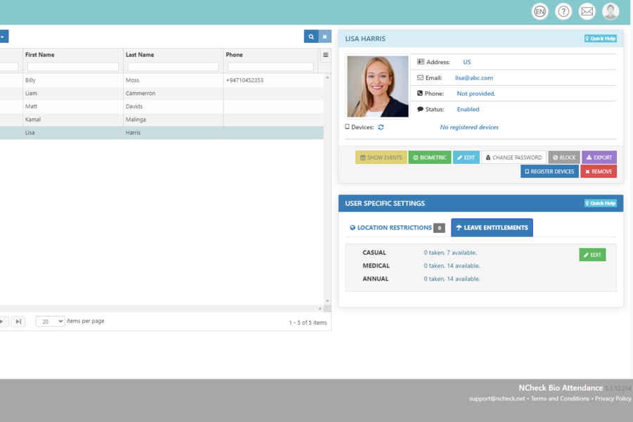This section presents applications that are similar to the proposed FaceAttend system. It highlights their key features and functionalities to better understand existing attendance solutions and to identify useful ideas that can guide and enhance the development of FaceAttend.

*Figure 1. NCheck Bio Attendance*

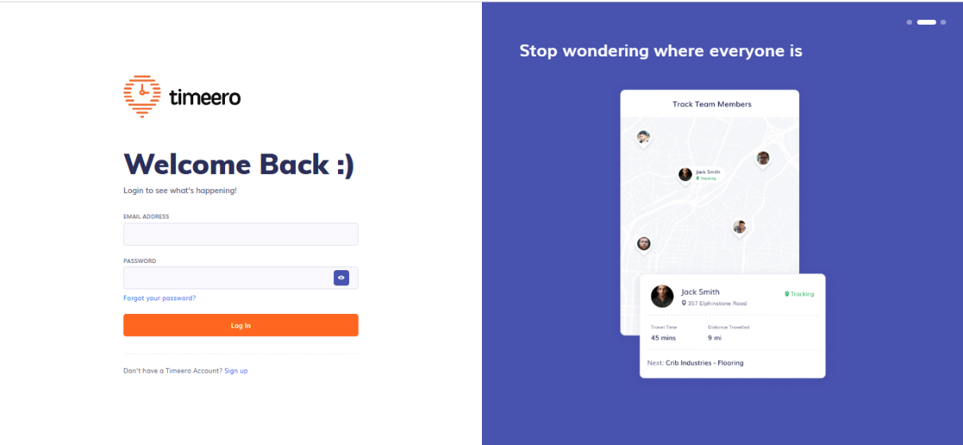Figure 1 shows the NCheck attendance system, an all-in-one solution that uses facial, fingerprint, and iris recognition for managing employee and visitor attendance. Developed by Neurotechnology, it highlights the use of multiple biometric methods to ensure accurate and secure attendance tracking.

*Figure 2. timeero*

Figure 2 shows the Timeero attendance system, an employee time and attendance management platform. It features GPS time tracking with geofencing, mileage tracking, and employee scheduling, providing location-based monitoring and efficient workforce management.

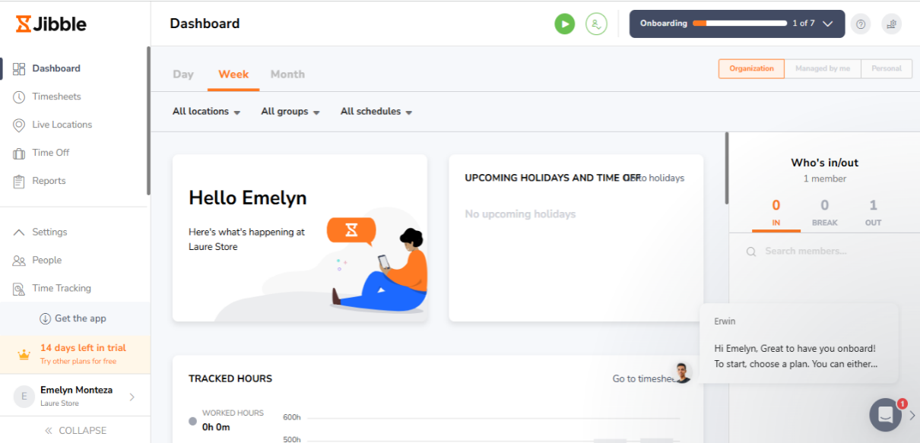*Figure 3. Jibble*

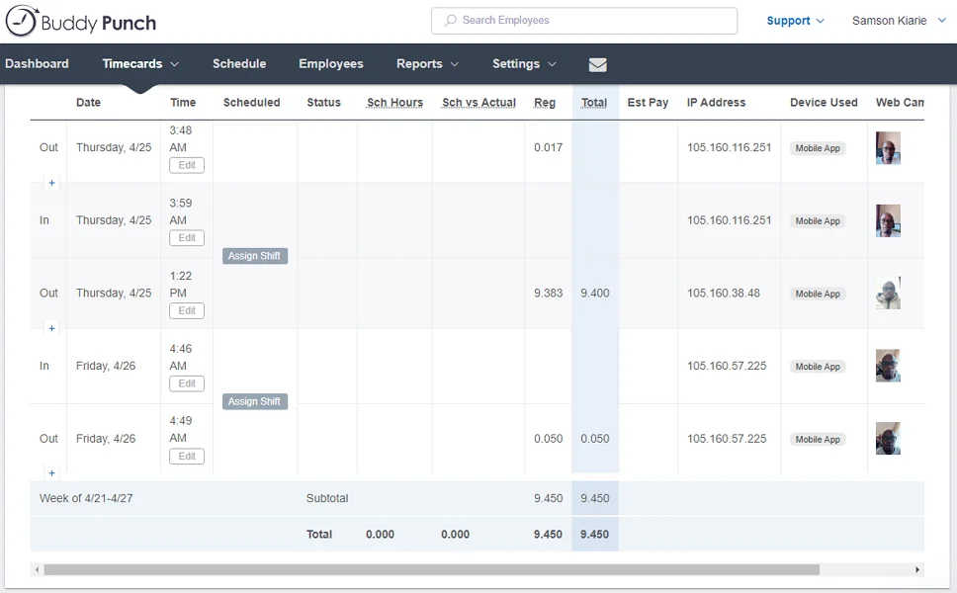Figure 3 shows the Jibble attendance system, where employees clock in by showing their face to a mobile device or shared kiosk. It offers a secure and efficient way to track attendance using facial recognition, making the process quick and user-friendly.

*Figure 4. Buddy Punch Facial Recognition*

Figure 4 shows the Buddy Punch attendance system, which integrates facial recognition with Apple’s Face ID. This feature allows employees to log in and clock in or out using their facial features, eliminating the need for usernames, passwords, or PINs for a more secure and convenient experience.

*Table 1. System Feature Comparison*

|  |  |  |  |  |  |
| --- | --- | --- | --- | --- | --- |
| **Application** | **Attendance Analystic** | **Smartphone camera Based** | **Cloud-Based Storage** | **Automated Activity Logs** | **Generate Report** |
| NCheck Bio Attendance |  |  |  |  |  |
| timeero |  |  |  |  |  |
| Jibble |  |  |  |  |  |
| Buddy Punch Facial Recognition |  |  |  |  |  |
| FaceAttend |  |  |  |  |  |

Table 1 presents a feature comparison of five attendance systems. FaceAttend supports most key features, including attendance analytics, smartphone camera use, cloud-based storage, and report generation. Compared to other systems, FaceAttend offers a more complete solution for educational attendance tracking.

**2.3 Synthesis and Gap Analysis**

The development of FaceAttend responds to long-standing issues in traditional attendance tracking, such as manual errors, time-consuming roll calls, and proxy attendance. While some schools have adopted biometric systems like fingerprint scanners, these still require physical contact and additional hardware, which can be inconvenient and costly. Other digital methods may record attendance but often lack automation, real-time tracking, or administrative management features.

FaceAttend addresses these gaps by offering a mobile-based facial recognition solution that eliminates the need for physical tools and manual recording. It provides real-time attendance login, time tracking, cloud-based data storage, and report generation all within a system tailored for educational environments. Additionally, it includes tools for administrators to manage users, subjects, and activity logs. This integration of features ensures a smoother, faster, and more accurate attendance process, bridging the gap between existing attendance methods and the growing need for smart, contactless solutions in schools.

*Table 2. Existing Studies*

|  |  |  |  |
| --- | --- | --- | --- |
| **Study** | **Methodology** | **Findings** | **Limitations** |
| Anzar et al. (2021) | Multimodal system (RIAMS) using behavioral and biometric data | Enhanced virtual attendance tracking and engagement | Limited validation beyond online education settings |
| Mondal et al. (2023) | Systematic review of classroom attendance methods | Compared manual, semi-automated, and automated approaches | No quantitative comparison of method effectiveness |
| Ritchie et al. (2021) | Cross-national public opinion survey on facial recognition in justice systems | Attitudes vary significantly by country and usage context | Privacy concerns and trust issues were significant |
| FaceAttend | FaceAttend was developed using the Agile methodology, following phases such as planning, design, development, testing, and deployment to create a mobile-based face recognition attendance system. | Combines face recognition, real-time attendance logging, and automated report generation | FaceAttend requires good lighting, a stable internet connection, and is limited to in-person use, which may affect its performance in certain classroom conditions. |

Figure 2 presents a comparison of related studies on attendance systems and facial recognition technologies. The table highlights the methodologies, key findings, and limitations of previous works by Anzar et al. (2021), Mondal et al. (2023), and Ritchie et al. (2021), alongside the current FaceAttend system. While previous studies focused on virtual attendance, method comparisons, and public opinion, FaceAttend fills existing gaps by providing a mobile-based, real-time facial recognition solution tailored for classroom use. The comparison emphasizes FaceAttend practical development process, automated features, and specific limitations related to lighting, internet dependence, and in-person application.

**Chapter III  
Methodology**

This chapter explains how we planned, developed, and tested the FaceAttend system from beginning to end. It highlights how we collected information and user requirements, designed the system’s structure, and turned those ideas into a fully working mobile application. We also discuss the development model we used, the programming language chosen, and the different stages of the system’s lifecycle. You'll also learn about our target user’s teachers and how their input helped shape the system. Overall, this chapter provides a clear walkthrough of how FaceAttend was built to address real challenges in attendance tracking.

We used a Mixed Methods approach for this study to get a well-rounded understanding of the problem and how our system, FaceAttend, could help solve it. On the qualitative side, we spoke directly with school teachers to learn about their day-to-day struggles with taking attendance and what kind of improvements they hoped for. Their input gave us a clearer picture of what the system needed to do and helped guide how we built it. On the quantitative side, we tested FaceAttend in real classroom measuring how fast and accurately it recognized faces and recorded attendance. We also collected feedback from users to see how well the system performed in practice. By combining both perspectives, we were able to design a

solution that works well technically and also meets the real needs of the people using it.

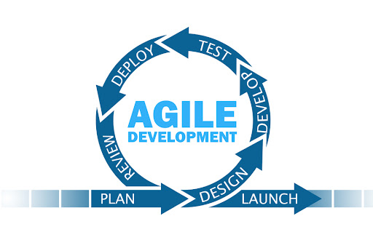For the development of our face recognition attendance system, FaceAttend, we decided to use the Agile model because it gave us the flexibility to adapt as the project evolved. Since we were working closely with teachers and client, it was important to get their feedback regularly and make adjustments along the way. Agile made this possible by breaking the development into smaller parts, or “sprints,” allowing us to build the system step by step and improve it continuously. Whenever we faced issues like how to handle attendance if the camera didn’t detect a student’s face we could quickly respond and adjust the design. This approach helped us stay focused on creating a system that was not only functional but also easy to use in real classroom settings. In the end, Agile helped us build a practical, user-centered system that responds to the real needs of schools and educators.

*Figure 5. SDLC Model*

**1.Planning**

In the planning phase, we focused on identifying what the system needed to achieve, who would use it, and what problems it was designed to solve. We defined the scope of FaceAttend as an attendance system that uses facial recognition through a camera without relying on biometric tools like fingerprints. Our main objective was to create a tool that helps teachers easily track student attendance in real time, with features for both admin and teacher users. During this stage, we also outlined the core functionalities, such as automated attendance logging, user dashboards, subject and student management, and reporting tools. We gathered initial input from potential user’s teachers to make sure we were addressing real classroom challenges. This phase helped set a clear direction for the rest of the development process.

**2.Design**

In the design phase, we focused on shaping how the system would look and function. We started by creating the system architecture, which outlined how different parts of FaceAttend like the user login, face recognition, attendance records, and admin dashboard would connect and work together. Next, we designed the database structure to store important information such as user profiles, attendance logs, subjects, and class schedules in an organized and secure way. For the UI/UX design, we used Figma to create wireframes and interactive prototypes. This helped us visualize the user experience for both teachers and admins, making sure the interface was simple, intuitive, and easy to navigate. Our goal in this phase was to design a system that wasn’t just functional, and accessible to everyone who would be using it.

**3.Develop**

FaceAttend is a mobile attendance app built with Flutter, making it easy to uses Firebase on the backend for secure login, real-time data storage, and cloud syncing. The system features face recognition using ML so students can simply scan their faces to mark attendance. If the camera doesn’t work or the face isn’t recognized, there’s also a manual check-in option. Admins can easily manage students, teachers, subjects, and sections through a dashboard. Some of the key features include real-time attendance tracking, monitoring of logins and logouts, and generating attendance reports. The development process followed a step-by-step approach starting with designing the interface, setting up login functionality, adding face recognition, building the attendance and admin tools, and then testing everything to make sure it works smoothly

**4.Testing**

The testing phase involved conducting unit testing, integration testing, and user acceptance testing to make sure the FaceAttend app functioned as intended. We carefully tested each feature like face detection, attendance recording, and data storage to ensure they worked smoothly on their own and together. We also prepared real users, such as teachers to try out the app and give feedback based on their experience. This helped us identify any issues and fine-tune the app’s performance, stability, and ease of use. The goal was to ensure FaceAttend was not only technically sound but also practical and reliable for daily classroom use.

**5.Deployment**

Once testing was completed, we deploy the FaceAttend mobile app for real classroom use. This phase involved releasing the app to its intended users teachers and students and making sure it worked smoothly during actual attendance-taking. We closely monitored how the system performed to ensure everything functioned as expected, from face recognition to recording and storing attendance data. This step was all about making the app fully operational in real use and confirming that it was ready to support day-to-day classroom activities.

**6.Review**

Looking back at the development of FaceAttend, we’re proud of how the system came together and met the goals we set from the start. It tackled real problems like manual attendance taking, proxy sign-ins, and lost records and turned them into a smooth, automated process using facial recognition. Teachers found the app easy to use for tracking attendance, managing students and subjects, and generating reports. Admins were able to monitor activity, handle user records, and keep things organized. Even during testing in actual classrooms, the app worked well and showed it could keep up with the day-to-day needs of school environments. Overall, FaceAttend became exactly what we hoped it would be a simple, smart, and reliable way to manage attendance**.**

**7.Launch**

After testing and making sure everything worked well, we finally launched FaceAttend in real classrooms. The app was easy for both teachers and students to use, and it was great to see attendance being recorded just by scanning faces. We kept an eye on the system during the first few days to make sure there were no issues, and everything ran smoothly. It felt really good to see our hard work being used and making attendance faster and easier. The launch showed us that FaceAttend was ready to help schools in a real and practical way.

**Respondents of the Study:**

****To determine the appropriate number of respondents, Slovin’s formula was applied.

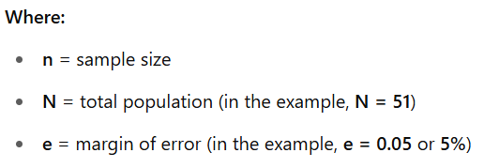

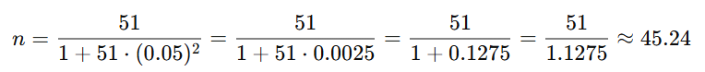

*Figure 6. Slovin’s Formula with the computed total respondents of USTP Teachers.*

This figure illustrates the use of Slovin’s Formula to determine the appropriate sample size for the study. Using a total population of 51 USTP teachers and a margin of error of 5%, the computed sample size is approximately 45.24 respondents. This calculation ensures that the survey results are statistically representative of the entire teacher population at USTP.

**3.1 Description of the Current System (Information Gathering)**

Before developing FaceAttend, we gathered information about how attendance is currently managed in many schools. We conducted interviews and informal conversations with teachers and school staff to better understand their daily process. Most schools still rely on manual attendance methods, such as calling out names or using sign-in sheets. While some schools have tried biometric systems like fingerprint scanners, these methods can be time-consuming, prone to errors, and easily disrupted if students forget or refuse to scan in. Manual methods also create problems like proxy attendance and missing records, which make it hard for administrators to monitor attendance accurately. This research helped us identify the need for a more efficient, touchless, and automated system—leading to the development of FaceAttend.

**3.2 System Architecture and Development**

**3.2.1 Overview of the Proposed System**

FaceAttend is a mobile-based attendance system that uses facial recognition to automate student check-ins and check-outs. By simply facing the camera, a student’s attendance is recorded accurately and instantly. The system supports two roles: teachers, who manage sessions and export reports, and administrators, who oversee student data, subjects, and system activity. It also includes features like a holiday calendar and reminders. FaceAttend eliminates manual errors, prevents proxy attendance, and saves time offering a fast, reliable, and touchless attendance solution.

**3.2.2 System Objectives**

The main goal of FaceAttend is to make the attendance process easier, faster, and more accurate for both teachers and students. Instead of relying on roll calls or sign-in sheets, the system uses a mobile device’s camera and facial recognition to automatically mark students as present or absent. This helps reduce mistakes, prevents proxy attendance, and saves valuable time in class. FaceAttend also gives teachers and school staff access to real-time attendance records and reports, making it easier to keep track of student participation. By automating the process and reducing the need for manual work, the system aims to create a smoother and more reliable way of handling daily attendance in schools.

**3.3 System Tools and Requirements**

**3.3.1 Programming Languages**

**Dart:** Dart was used as the main programming language for developing the FaceAttend mobile app through the Flutter framework. Since Flutter supports building apps for both Android and iOS from a single codebase, Dart made it easier and faster to develop and maintain the system. Dart also supports asynchronous programming, which helps the app handle tasks like real-time face detection and smooth camera interactions without delays. Its performance and simplicity made it a great fit for FaceAttend, allowing us to build a responsive and efficient app that offers a seamless experience for teachers and students during attendance tracking.

**3.3.2 Hardware Requirements**

*Table 3. Hardware Requirement*

|  |  |
| --- | --- |
| **Component** | **Specification** |
| Mobile Devices | Mobile Devices such as Android/iOS smartphones |
| Camera | Camera with High-resolution camera (phone/wireless camera) |

Table 3 shows the hardware requirements that the team aims to use in developing and designing the TAPATTEND mobile and web application system.

**3.3.3 Software Requirements**

*Table 4. Software Requirements*

|  |  |
| --- | --- |
| **Software/Tool** | **Purpose** |
| Flutter Dart | Front-end and User Interface |
| Firebase | Backend/database & authentication |
| TensorFlow | Train data |
| Android Studio | App testing |
| Figma | UI/UX design |
| Flutter_docx(API) | Export PDF/Word |

Table 4 shows the software requirements that the team aims to use in developing and designing the FaceAttend mobile and web application system.

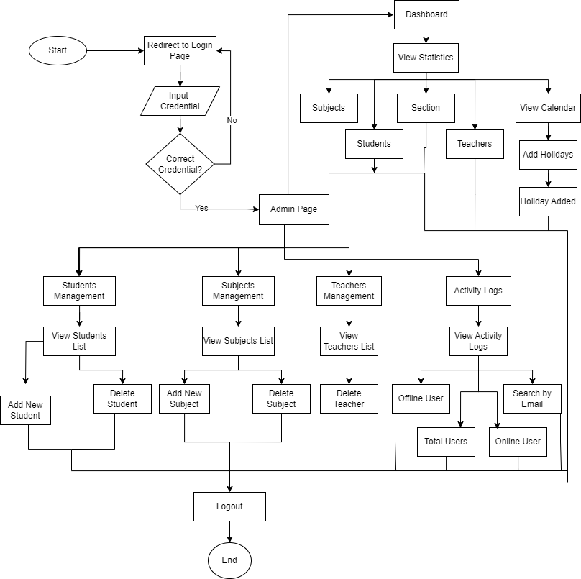**3.3.4 System Flow/Functions**

*Figure 7. Admin Flowchart*

Figure 7 shows the admin flow of the FaceAttend system. After logging in with an email and password, the admin accesses a dashboard with options to manage students, subjects, and teachers. The admin can view system statistics, add holidays, and monitor user activity through logs. Each management section allows viewing, adding, or deleting entries. The process concludes with the option to log out.

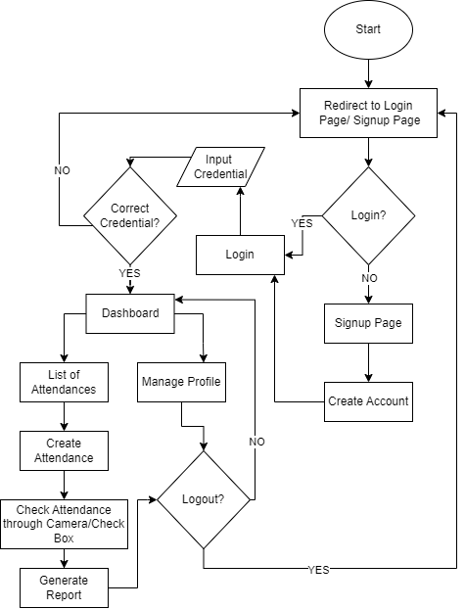

*Figure 8. Teacher Flowchart*

Figure 8 illustrates the user flow of the FaceAttend system. The process begins by redirecting the user to the login or signup page. If the user already has an account, they proceed to input their credentials. Upon successful authentication, the user is directed to the dashboard, where they can manage their profile, view attendance lists, create and check attendance, and generate reports. New users are taken to a signup page to create an account before accessing the system. The process concludes with the option to log out.

**3.3.5 Scope and Limitations of the System**

This study focuses on creating FaceAttend, a mobile app that uses face recognition to make attendance checking easier and faster. The app helps reduce mistakes, stops proxy attendance, Lost of record and time consuming it gives real-time attendance reports. Teachers can manage class attendance, and Generate report school admins can keep track of students, teacher, and manage subject, section. FaceAttend stores all data safely in the cloud and is made especially for use at the University of Science and Technology of Southern Philippines (USTP) Oroquieta Campus for classroom attendance.

FaceAttend requires a clear camera view with good lighting and a stable internet connection to function properly. It is designed for both face-to-face and asynchronous classes but does not support remote or offline attendance. The system cannot detect fake attendance using printed photos or videos. For face-to-face classes, physical presence is required. However, for asynchronous classes, teachers can upload a screenshot showing students attending an online class (e.g., a screenshot of a video call) to check attendance. The system only records check-ins and cannot detect if a student leaves or escapes from class after being marked present. Additionally, it does not monitor student logouts after class.

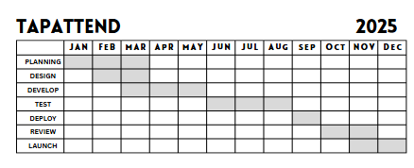**3.3.6 Calendar of Activities**

*Table 5. Software Requirements*

Table 5 presents the project timeline for the development of the FaceAttend system, outlining key phases and activities across three quarters. The timeline begins with project initiation in early February, including documentation, database setup, and wireframe design. The planning phase follows in late February, focusing on finalizing requirements and selecting machine learning tools. Data collection and preparation take place in March, involving dataset collection, labeling, and augmentation. In late March through April, the machine learning model is developed and optimized. Finally, mobile app development begins in late April and continues into May, integrating the model, implementing camera features, and developing backend systems.

**3.4 Conceptual Design and Implementation**

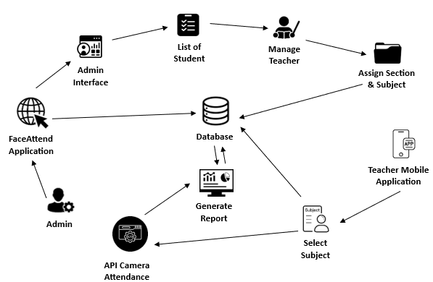**3.4.1 System Design**

*Figure 9. System Design*

Figure 9 illustrates the system design of the FaceAttend Application, a facial recognition-based attendance monitoring system. The process begins with the admin accessing the system through the admin interface, where they can manage the list of students and teacher accounts. The admin is responsible for assigning sections and subjects to each teacher. These assignments are then made available to the teachers through the Teacher Mobile Application, allowing them to select the appropriate subject for attendance tracking. The FaceAttend Application integrates with an API Camera, which captures and records student attendance using facial recognition technology. The attendance data is sent to a centralized database, which serves as the core of the system, storing and managing all information related to users, subjects, and attendance records. The database also enables the generation of attendance reports, which can be accessed by the admin for monitoring and evaluation. This system design ensures a seamless flow of information between components, improving efficiency and accuracy in attendance management.

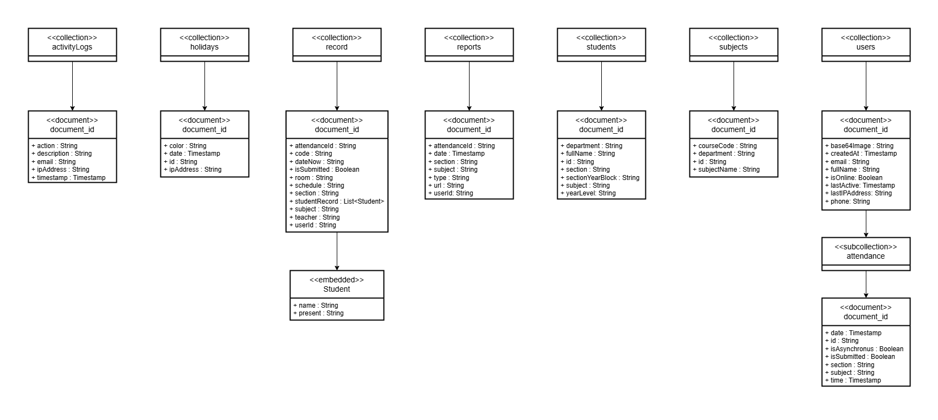**3.4.2 Database Design**

*Figure 10. ERD*

Figure 10. System Design presents the FaceAttend system's data architecture using a NoSQL database structure. The design consists of multiple collections such as users, students, subjects, reports, record, holidays, and activity Logs, each containing documents with specific attributes. The users collection holds account-related information, including full name, email, phone, and login activity, and contains a subcollection for attendance records. The students collection stores student profiles with details such as department, section, subjects, and year level. The subjects collection includes course codes and subject names. The reports and record collections manage attendance data, capturing details like attendance ID, date, section, subject, and a list of students with their attendance status. Holidays are stored in a dedicated collection with color-coded markers and dates. The activity Logs collection tracks user actions, email, IP address, and timestamps for auditing purposes. This overall structure supports the efficient, real-time operation of the FaceAttend system.

**3.4.3 Use Case Design**

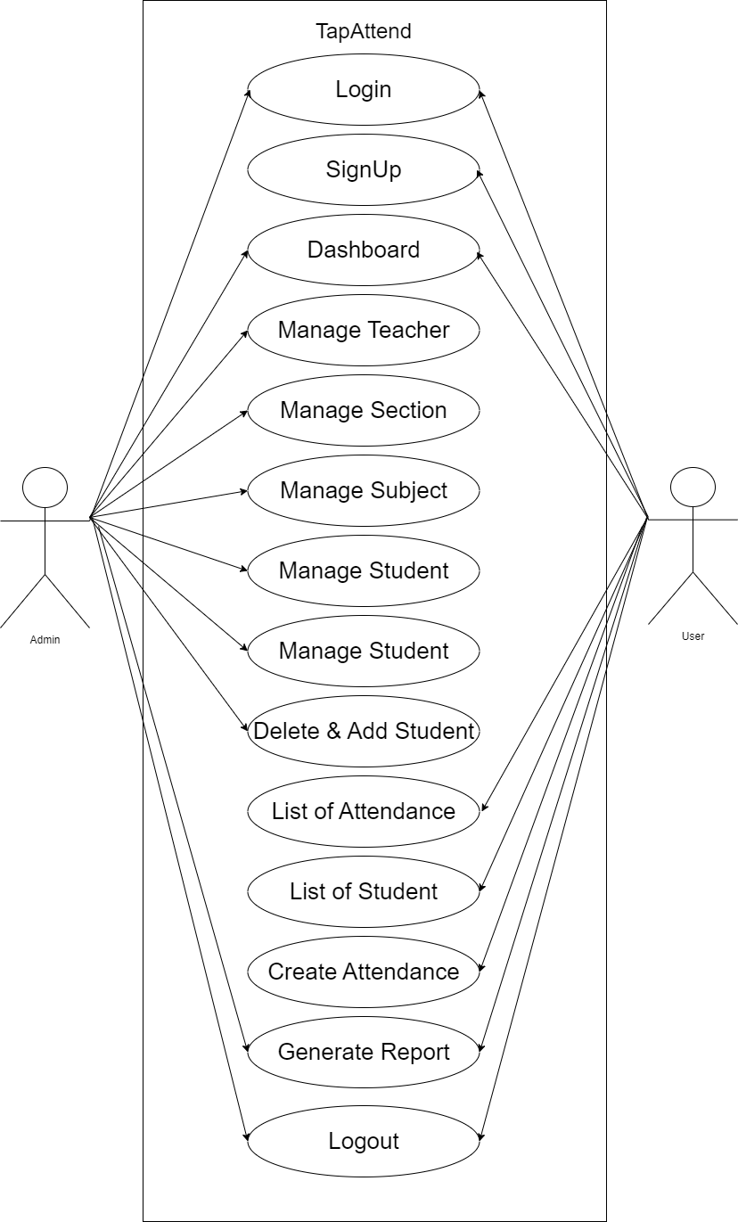

*Figure 11. Use Case Diagram.*

Figure 11 illustrates Use Case Diagram illustrates the primary interactions between the system, FaceAttend, and its two main users: the Admin and the User (Teacher). The diagram highlights various functionalities within the system. Both Admin and User can perform actions such as logging in, signing up, accessing the dashboard, viewing attendance lists, generating reports, and logging out. The admin has additional responsibilities, including managing teachers, sections, subjects, and students, as well as handling student enrollment or removal. The User, typically a teacher, can create attendance sessions and manage class records. This diagram helps visualize how each role interacts with the system to perform their tasks.

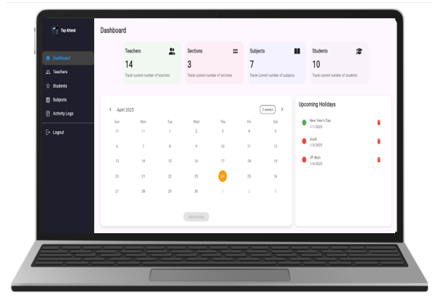**3.4.4 Prototype Design**

*Figure 12. Admin Dashboard*

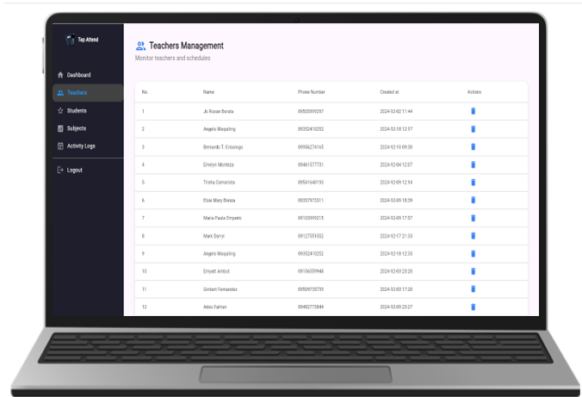This figure displays the FaceAttend Admin Dashboard, showing totals for teachers, students, sections, and subjects. It includes a calendar for holidays and quick access to manage users, subjects.

*Figure 13. Admin Manage Teacher*

This figure 13 shows the Admin Manage Teacher panel in FaceAttend. It allows the admin to view, add, or remove teacher accounts and access their information. This feature helps streamline teacher management within the system

*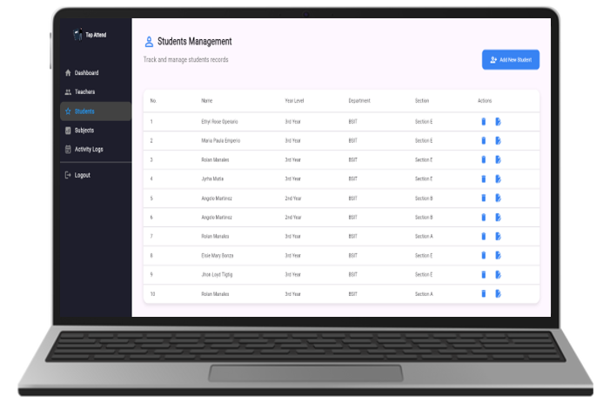Figure 14. Admin Manage Students*

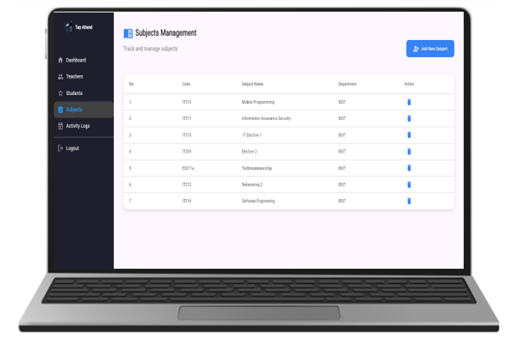This figure 14 shows the Admin Manage Students section of FaceAttend. It enables the admin to view, add, update, or remove student records. The feature helps maintain accurate and organized student information within the system*.*

*Figure 15 Admin Manage Subject*

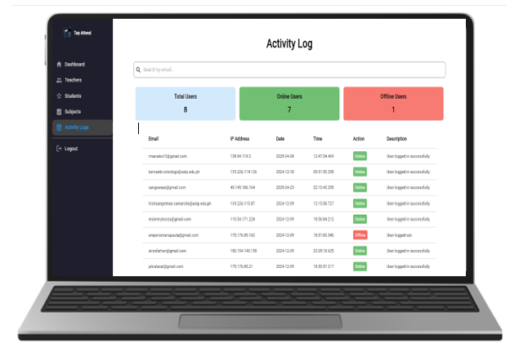This figure 15 displays the Admin Manage Subject panel in FaceAttend. It allows the admin to add, view, or delete subjects, ensuring that all subject records are up-to-date and properly assigned within the system

*Figure 16. Admin Activity Logs*

This figure shows the Admin Activity Logs section in the FaceAttend system. It allows the admin to monitor user activities, including login and logout times, online and offline statuses, and email records. This feature helps administrators track system usage and ensure accountability among users.

*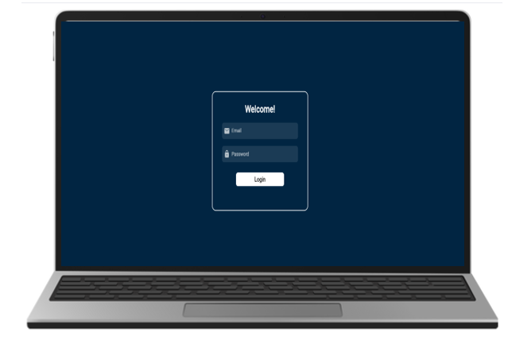Figure 17. Admin Log out*

This figure shows the Admin Log Out option in the FaceAttend system, allowing the admin to securely exit the dashboard and end their session.

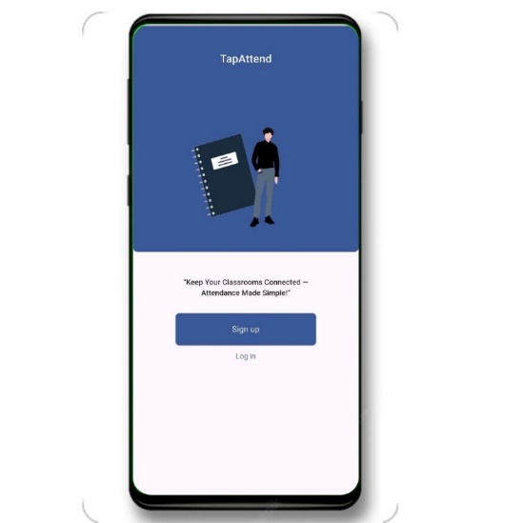

*Figure 18. Mobile app landing Page*

This figure 18 shows the landing page of the FaceAttend mobile app, where users are given two options: Sign Up to create a new account or Log In to access an existing one. This simple and user-friendly interface serves as the entry point to the system for both students and teachers.

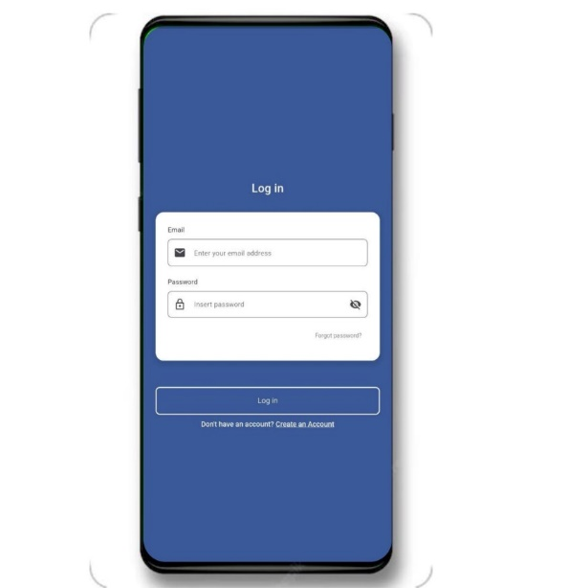

*Figure 19. Mobile app log in Page*

This figure shows the login page of the FaceAttend mobile app. Users enter their registered email and password to access their account. The page provides a clean and straightforward interface for secure and easy access to the system.

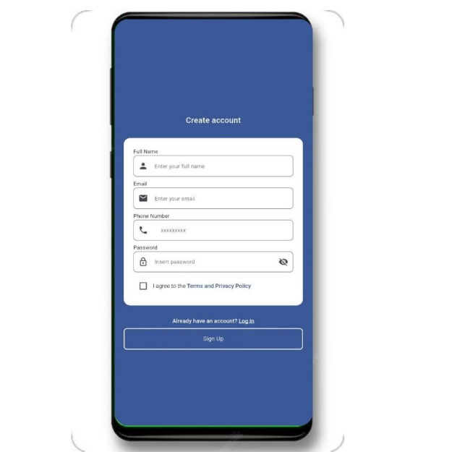

*Figure 20. Mobile app Sign up*

This figure 20 displays the sign-up page of the FaceAttend mobile app, where new users can create an account by entering required details such as name, email, and password. The page offers a simple and accessible interface to ensure a smooth registration process.

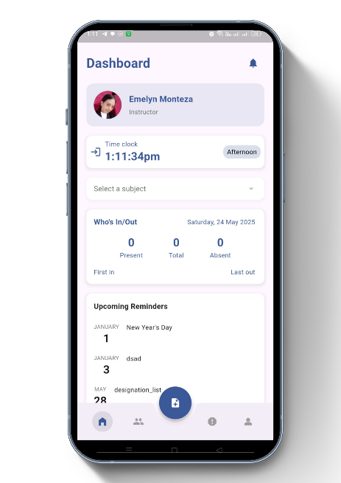

*Figure 21. User Dashboard*

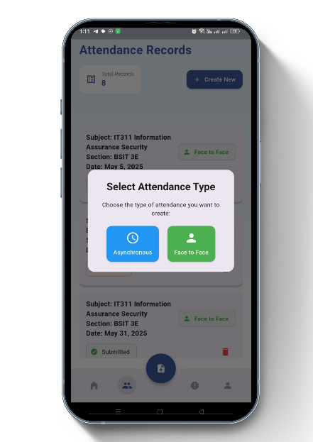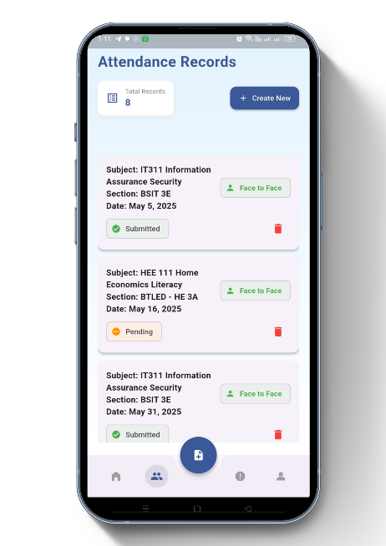This figure 21 displays the User Dashboard of the FaceAttend mobile app. It shows real-time information such as the time students check IN and OUT, their present or absent status, and any upcoming reminders. The dashboard provides teachers with a clear overview of daily attendance activities and important notifications

*Figure 22. Select Attendance Type*

Figure 22 illustrates the " *Select Attendance Type* " feature in the FaceAttend system. When a teacher clicks the "Create New Attendance" button, they must select the type of attendance based on the scheduled class Face-to-Face or Asynchronous. If Face-to-Face is selected, the system activates the camera to scan student faces for automatic attendance logging. If the teacher chooses Asynchronous, they are given the option to either upload an image as proof of student participation or manually mark students as present. This flexibility allows teachers to record attendance accurately.

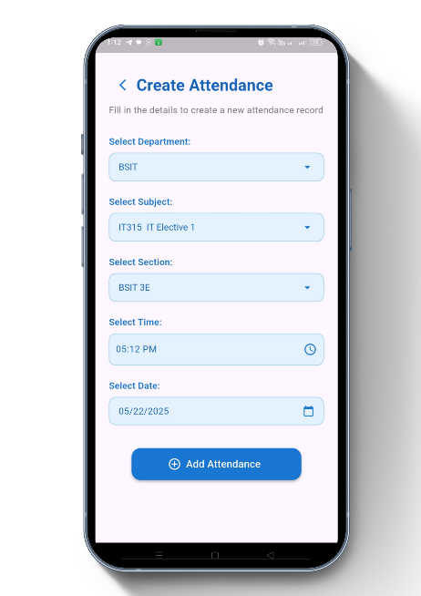

*Figure 23. Create Attendance*

Figure 23 shows the extended "Create Attendance" interface in the FaceAttend system. In this step, the teacher selects the department such as BSIT, BFPT, or BTLED followed by the specific subject, section, time, and date of the class. Once all the necessary fields are selected, the teacher clicks the "Add Attendance" button to begin recording attendance for that session. This organized setup ensures that attendance data is accurately linked to the correct course and schedule.

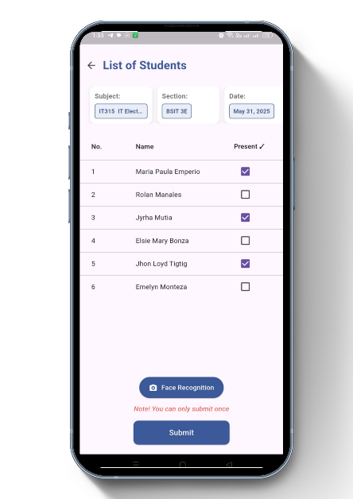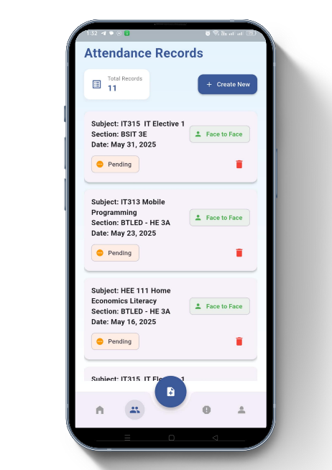

*Figure 24. Attendance Pending*

Figure 24 shows the "Attendance Pending" screen in the FaceAttend system, which appears right after creating a new attendance session. As seen in the figure, a "Pending" status is displayed when the teacher clicks on it, they are directed to a list of students for that session. The system will then begin checking attendance using facial recognition through the camera. If the camera encounters an error or fails to detect a student’s face, the teacher has the option to manually mark attendance using checkboxes. This process ensures that all students are accounted for.

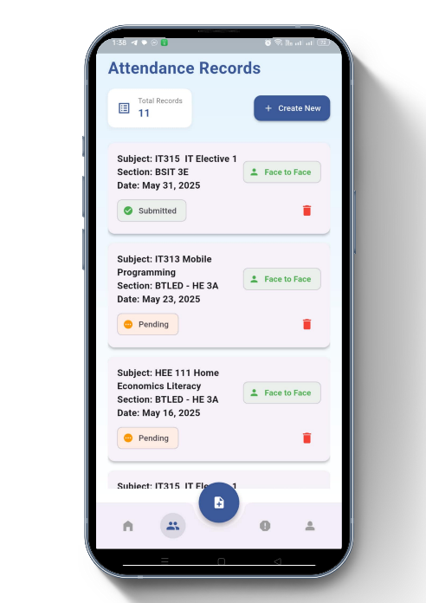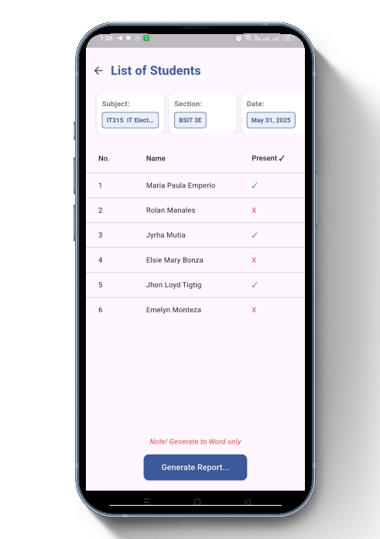

*Figure 25. Submitted Attendance*

Figure 25 displays the "Submitted Attendance" screen in the FacepAttend system. After completing the attendance checking process, the teacher returns to the attendance records and clicks on the "Submitted" status. This opens a list of students whose attendance has already been checked. In this view, the teacher can clearly see which students are marked as present or absent. After reviewing the list, the teacher can then click the button "Generate Report".

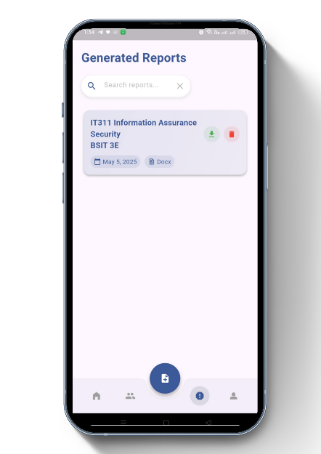

*Figure 26. Generate Report*

Figure 26 shows the "Generate Report" feature in the FaceAttend system. After completing the attendance checking process, teachers can use this function to create and download a report summarizing the attendance for the selected session. The downloaded file includes details such as student names, attendance status, date, time, and subject.

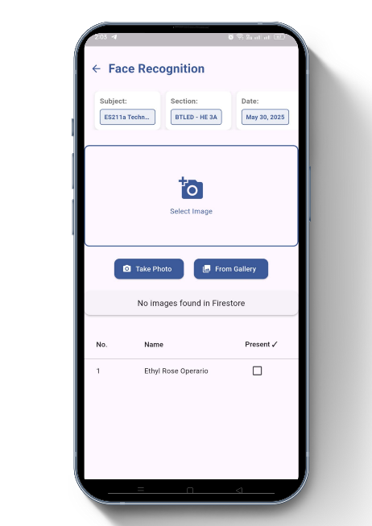

*Figure 27. Asynchronous Attendance*

Figure 27 shows the "Asynchronous Attendance" feature in the FaceAttend system. This screen appears when the teacher selects Asynchronous as the attendance type. In this mode, the teacher uploads a screenshot or image showing students attending an online class (e.g., a screenshot of a video call). Once the image is uploaded, the system can identify the students and automatically mark them as present or absent based on the image. If some students are not detected or there are errors, the teacher can manually check attendance.

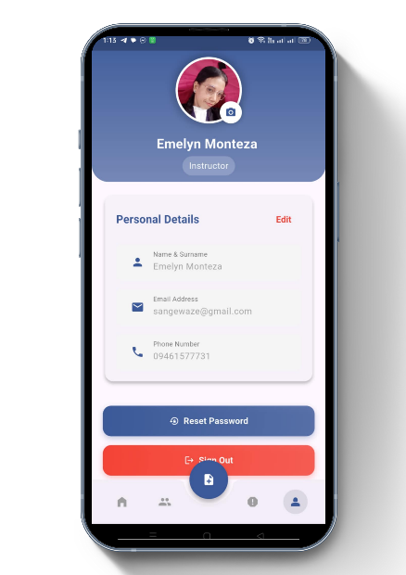

*Figure 28. Personal Information*

Figure 28 displays the "Personal Information" section in the FaceAttend system. This feature allows users to view and edit their personal details such as name, email, and password. However, only teachers have the permission to update or modify this information.

***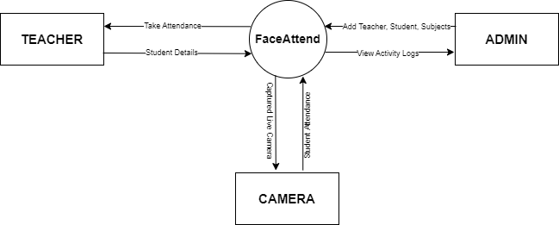*3.4.6 Context Diagram**

*Figure 29. Context Diagram*

This diagram illustrates the overall interaction between the FaceAttend system and its external entities: the Teacher, Admin, and Camera. The Teacher interacts with the system by providing student details and taking attendance. The admin is responsible for adding and managing data such as teachers, students, and subjects, and can also view system activity logs. The Camera plays a crucial role in capturing student attendance through live facial recognition. The FaceAttend system acts as the central processor that connects and processes data from all these components to facilitate automated and accurate attendance tracking.  
**Reference**Agarwal, L., Mukim, M., Sharma, H., Bhandari, A., & Mishra, A. (2021, March). Face recognition based smart and robust attendance monitoring using deep CNN. In 2021 8th International Conference on Computing for Sustainable Global Development (INDIACom) (pp. 699-704). IEEE.

Alam, A. (2022). Employing adaptive learning and intelligent tutoring robots for virtual classrooms and smart campuses: reforming education in the age of artificial intelligence. In Advanced computing and intelligent technologies: Proceedings of ICACIT 2022 (pp. 395-406). Singapore: Springer Nature Singapore.

Alburaiki, M. S. M., Johar, G. M., Helmi, R. A. A., & Alkawaz, M. H. (2021, August). Mobile based attendance system: face recognition and location detection using machine learning. In 2021 IEEE 12th Control and System Graduate Research Colloquium (ICSGRC) (pp. 177-182). IEEE.

Alburaiki, S. M., Johar, G. M., Helmi, R. A. A., & Alkawaz, M. H. (2021). Mobile-based attendance system: Face recognition and location detection using machine learning. In 2021 IEEE 12th Control and System Graduate Research Colloquium (ICSGRC) (pp. 177–182). IEEE. <https://doi.org/10.1109/ICSGRC53186.2021.9515221>

Alharbi, S., & Alharbi, O. (2024). Tomorrow’s attendance system. In C. Stephanidis, M. Antona, S. Ntoa, & G. Salvendy (Eds.), HCI International 2024 Posters. HCII 2024. Communications in Computer and Information Science (Vol. 2120). Springer, Cham. <https://doi.org/10.1007/978-3-031-62110-9_38>

Almeida, D., Shmarko, K., & Lomas, E. (2022). The ethics of facial recognition technologies, surveillance, and accountability in an age of artificial intelligence: a comparative analysis of US, EU, and UK regulatory frameworks. AI and Ethics, 2(3), 377-387.

Alpasan, B. G. B., Maligang, A. K., & Esimos, M. J. V. (2021). Public High School Web-Based Attendance Monitoring System with SMS Notification. International Journal of Social Science and Human Research, 4(12), 3941-3946.

Budiarto, M., Audiah, S., Astuti, E. D., Sanjaya, Y. P. A., & Firli, M. Z. (2024). Enhancing school and college attendance using advanced technology. In 2024 3rd International Conference on Creative Communication and Innovative Technology (ICCIT) (pp. 1–6). IEEE. <https://doi.org/10.1109/ICCIT62134.2024.10701150>

Duggal, K., Gupta, L. R., & Singh, P. (2021). Gamification and machine learning inspired approach for classroom engagement and learning. Mathematical Problems in Engineering, 2021(1), 9922775.

Fauzan, R., Harsono, K., Meisandy, R. P., Barokah, M., & Muhaimin, M. I. (2024). Optimising Human Resource Management as an Effort to Improve Employee Performance through Digital Attendance. Riwayat: Educational Journal of History and Humanities, 7(1), 16-25.

Gao, Z., Huang, Y., Zheng, L., Li, X., Lu, H., Zhang, J., ... & Fang, J. (2021). A student attendance management method based on crowdsensing in classroom environment. IEEE Access, 9, 31481-31492.

H. S., S. M., C. I., P. N., Velmurugan, K. J., & Shali, A. (2024). Automated attendance system. In 2024 International Conference on Power, Energy, Control and Transmission Systems (ICPECTS) (pp. 1–6). IEEE. <https://doi.org/10.1109/ICPECTS62210.2024.10780085>

Haq, H. B. U., & Saqlain, M. (2023). Iris detection for attendance monitoring in educational institutes amidst a pandemic: A machine learning approach. Journal of industrial intelligence, 1(3), 136-147.

Hartono, T., Henry, B. N., Nurm, S., Pasha, L., & Julianingsih, D. (2024). The importance of increasing attendance efficiency accuracy with presence system in Era Industrial Revolution 4.0. International Journal of Cyber and IT Service Management, 4(2), 133–142. <https://doi.org/10.34306/ijcitsm.v4i2.168>

Heru, M. J. A., Jatimi, A., Sulfiyan, W., Nisa'Fiddaroini, F., Munir, Z., & Dewi, N. E. C. (2024). The impact of implementing a web-based e-attendance system on enhancing student learning motivation in vocational high schools. In 2024 10th International Conference on Education and Technology (ICET) (pp. 52–58). IEEE. <https://doi.org/10.1109/ICET64717.2024.10778456>

Kabir, M. H., Roy, S., Ahmed, M. T., & Alam, M. (2021). Smart attendance and leave management system using fingerprint recognition for students and employees in academic institute. International Journal of Scientific & Technology Research, 10(6), 268-276.

Kaddoura, S., Popescu, D. E., & Hemanth, J. D. (2022). A systematic review on machine learning models for online learning and examination systems. PeerJ Computer Science, 8, e986.

Khan, A. A., Laghari, A. A., & Awan, S. A. (2021). Machine learning in computer vision: A review. EAI Endorsed Transactions on Scalable Information Systems, 8(32).

Liu, J., & Loeb, S. (2021). Engaging teachers: Measuring the impact of teachers on student attendance in secondary school. Journal of Human Resources, 56(2), 343-379.

Lopez, C. D., & De Guzman, J. A. (2024, December). Scalable RFID-Based Automated Attendance Recording and Reporting System. In TENCON 2024-2024 IEEE Region 10 Conference (TENCON) (pp. 1507-1511). IEEE.

Mondal, H., & Mondal, S. (2023). Methods of collecting and recording attendance of medical students in a classroom: A systematic review. Journal of Education and Health Promotion, 12(1), 427. <https://doi.org/10.4103/jehp.jehp_737_23>

Moores, E., Birdi, G. K., & Higson, H. E. (2020). Determinants of university students’ attendance. Educational Research, 61(4), 371–387. <https://doi.org/10.1080/00131881.2019.1660587>

Mridha, K., & Yousef, N. T. (2021, June). Study and analysis of implementing a smart attendance management system based on face recognition tecqnique using OpenCV and machine learning. In 2021 10th IEEE International Conference on Communication Systems and Network Technologies (CSNT) (pp. 654-659). IEEE.

Munthe, B., Arifin, A., Nugroho, B. S., & Fitriani, E. (2021, June). Online student attendance system using android. In Journal of Physics: Conference Series (Vol. 1933, No. 1, p. 012048). IOP Publishing.

Naen, M. F., Adnan, M. H. M., Yazi, N. A., & Nee, C. K. (2021). Development of attendance monitoring system with artificial intelligence optimization in cloud. International Journal of Artificial Intelligence, 8(2), 88-98.

Pabba, C., & Kumar, P. (2022). An intelligent system for monitoring students' engagement in large classroom teaching through facial expression recognition. Expert Systems, 39(1), e12839.

Parambil, M. M. A., Ali, L., Alnajjar, F., & Gochoo, M. (2022, February). Smart classroom: A deep learning approach towards attention assessment through class behavior detection. In 2022 Advances in Science and Engineering Technology International Conferences (ASET) (pp. 1-6). IEEE.

Qureshi, K. N., Naveed, A., Kashif, Y., & Jeon, G. (2021). Internet of Things for education: A smart and secure system for schools monitoring and alerting. Computers & Electrical Engineering, 93, 107275.

Qutishat, D., Obeidallah, R., & Qawasmeh, Y. (2022). An Overview of Attendance and Participation in Online Class During the COVID Pandemic: A Case Study. International Journal of Interactive Mobile Technologies, 16(4).

Raj, A., Srivastav, H., Shukla, S., Vipin, & Gupta, N. (2024). Facial recognition-based student attendance system. In 2024 11th International Conference on Reliability, Infocom Technologies and Optimization (Trends and Future Directions) (ICRITO) (pp. 1–5). IEEE. <https://doi.org/10.1109/ICRITO61523.2024.1052216>

Razzaq, S., Shah, B., Iqbal, F., Ilyas, M., Maqbool, F., & Rocha, A. (2023). DeepClassRooms: a deep learning based digital twin framework for on-campus class rooms. Neural Computing and Applications, 1-10.

**References**  
Anzar, S. M., Subheesh, N. P., Panthakkan, A., Malayil, S., & Ahmad, H. A. (2021). Random Interval Attendance Management System (RIAMS): A novel multimodal approach for post-COVID virtual learning. IEEE Access, 9, 91001–91016. <https://doi.org/10.1109/ACCESS.2021.3092260>

Ritchie, K. L., Cartledge, C., Growns, B., Yan, A., Wang, Y., Guo, K., et al. (2021). Public attitudes towards the use of automatic facial recognition technology in criminal justice systems around the world. PLoS ONE, 16(10), e0258241. <https://doi.org/10.1371/journal.pone.0258241>

Seelam, V., kumar Penugonda, A., Kalyan, B. P., Priya, M. B., & Prakash, M. D. (2021). Smart attendance using deep learning and computer vision. Materials Today: Proceedings, 46, 4091-4094.

Seelam, V., kumar Penugonda, A., Kalyan, B. P., Priya, M. B., & Prakash, M. D. (2021). Smart attendance using deep learning and computer vision. Materials Today: Proceedings, 46, 4091-4094.

Selwyn, N., Campbell, L., & Andrejevic, M. (2023). Autoroll: Scripting the emergence of classroom facial recognition technology. Learning, Media and Technology, 48(1), 166-179.

Setta, S., Sinha, S., Mishra, M., & Choudhury, P. (2021). Real-time facial recognition using SURF-FAST. In Data Management, Analytics and Innovation: Proceedings of ICDMAI 2021, Volume 2 (pp. 505-522). Singapore: Springer Singapore.

Shukla, A. K., Shukla, A., & Singh, R. (2024). Automatic attendance system based on CNN–LSTM and face recognition. International Journal of Information Technology, 16, 1293–1301. <https://doi.org/10.1007/s41870-023-01495-1>

Shukla, A. K., Shukla, A., & Singh, R. (2024). Automatic attendance system based on CNN–LSTM and face recognition. International Journal of Information Technology, 16(3), 1293-1301.Ali, N. S., Alhilali, A. H., Rjeib, H. D., Alsharqi, H., & Al-Sadawi, B. (2022). Automated attendance management systems: systematic literature review. International Journal of Technology Enhanced Learning, 14(1), 37-65.

Tarmissi, K., Allaaboun, H., Abouellil, O., Alharbi, S., & Soqati, M. (2024). Automated attendance taking system using face recognition. In 2024 21st Learning and Technology Conference (L&T) (pp. 19–24). IEEE. <https://doi.org/10.1109/LT60077.2024.10469452>

Tee, F. K., Loh, G. X., Sumaiya, K., Cha, Z. Y., JosephNg, P. S., Phan, K. Y., & Lim, J. T. (2022). JomFacial recognition attendance systems. In Proceedings of International Conference on Emerging Technologies and Intelligent Systems: ICETIS 2021 (Volume 1) (pp. 673-681). Springer International Publishing.

Trabelsi, Z., Alnajjar, F., Parambil, M. M. A., Gochoo, M., & Ali, L. (2023). Real-time attention monitoring system for classroom: A deep learning approach for student’s behavior recognition. Big Data and Cognitive Computing, 7(1), 48.

Trabelsi, Z., Alnajjar, F., Parambil, M. M. A., Gochoo, M., & Ali, L. (2023). Real-time attention monitoring system for classroom: A deep learning approach for student’s behavior recognition. Big Data and Cognitive Computing, 7(1), 48.

Trabelsi, Z., Alnajjar, F., Parambil, M. M. A., Gochoo, M., & Ali, L. (2023). Real-time attention monitoring system for classroom: A deep learning approach for student’s behavior recognition. Big Data and Cognitive Computing, 7(1), 48.

Trivedi, A., Tripathi, C. M., Perwej, Y., Srivastava, A. K., & Kulshrestha, N. (2022). Face recognition based automated attendance management system. Int. J. Sci. Res. Sci. Technol, 9, 261-268.

Trivedi, A., Tripathi, C. M., Perwej, Y., Srivastava, A. K., & Kulshrestha, N. (2022). Face recognition based automated attendance management system. Int. J. Sci. Res. Sci. Technol, 9, 261-268.

Vishe, A., Shirsath, A., Gujar, S., & Thakur, N. Student attendance system using face recognition. Engpaper Journal.

Vlachopoulos, P., & Jan, S. (2020). Exploring modes of lecturing as a teaching method in higher education: Student attendance, preference, and motivation. Journal of University Teaching and Learning Practice, 17(5), 1–20. <https://search.informit.org/doi/10.3316/informit.T2025012500016301122485911>

Vyavahare, G. P. V., Prakash, G. S., Subhash, M. S., Aslam, S. P., & Natha, S. V. (2023). IoT based biometric attendance system for smart classroom. International Journal, 7(8).