Universidad San Francisco de Quito
Artificial Intelligence
Name: Raymond Portilla NRC: 1651
Banner ID: 00335050 Date: 08/09/2026
LAB #01
Tests Output
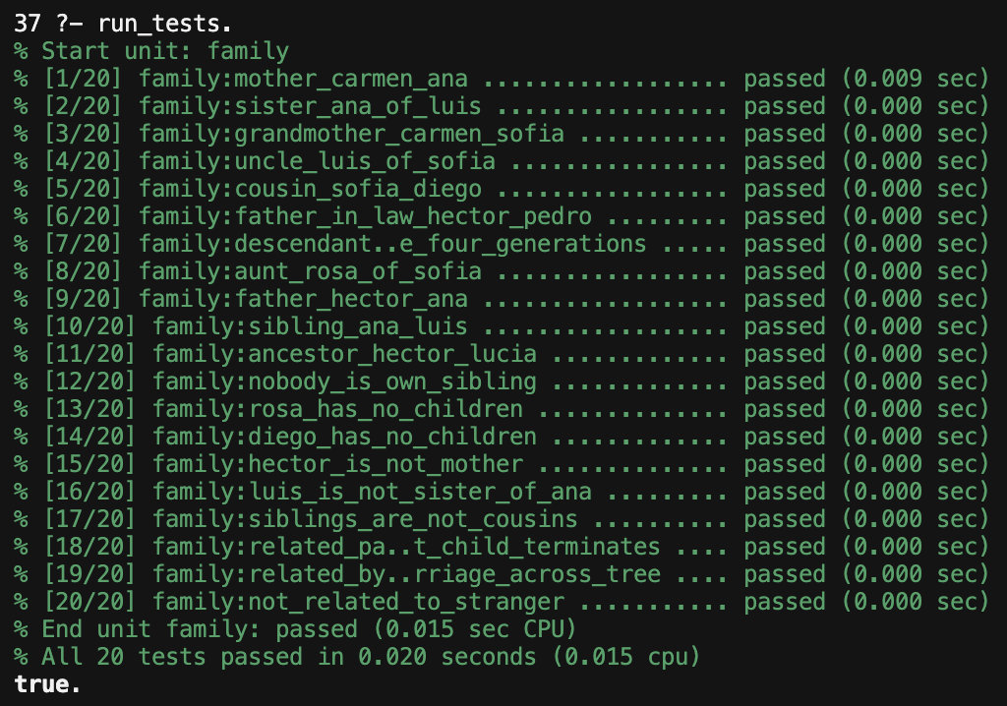
My Analysis
1) Sibling/2 needs X \= Y. Without that check, the two arguments can be the same person. For example, father(F, X) and father(F, Y) both succeed when X and Y are ana, so ana would count as her own sibling. Same for everyone else who has a father. A person always shares a parent with themselves, so the rule would keep saying yes. That is not what sibling means, and it is why sibling(X, X) has to fail. With X \= Y the two names have to be different, so ana comes out as a sibling of luis and rosa, not of ana.
2) Same answer twice. The simple sibling rule (same parent P for X and for Y) answers twice for ana and luis: once through hector and once through carmen, because every child has two parent/2 facts. If semicolon is pressed you get true, then true again, same pair. I wrote sibling with the same father and the same mother, so that pair only comes out once. sister/2 and brother/2 use sibling, so they do not repeat either. uncle/2 and aunt/2 can still look twice, because they start from parent(P, Child) and a child has two parents, but in this tree only one of those parents is a brother or sister of the uncle, so uncle(luis, sofia) is once. related/2 still repeats. related(ana, hector) comes back four times. There is more than one path (direct parent, or through carmen, and so on) and each path is another proof of the same thing. That is why some tests use once/1. cousin/2 could do this too, since it walks parent/2 on both sides, but here only one pair of parents are siblings, so cousin(sofia, diego) shows up once.
3) Closed-world assumption. I never wrote that rosa has no children, or that diego has none, or that there is no person called stranger. Prolog still treats those queries as false because the facts are not in the file and the rules cannot prove them. That is the closed-world assumption: if it is not in the knowledge base, it did not happen. Same for anyone I did not list. There are only the 16 people in male/1 and female/1. I also never wrote “hector is not a mother”, mother/2 just fails because hector is not female. The negative tests lean on this. parent(rosa, _) fails and we take that as “rosa has no kids,” even though there is no childless/1 fact. If a person was missing from the file, Prolog would not say unknown. It would just say no.
.

