Universidad San Francisco de Quito
Artificial Intelligence
Name: Raymond Portilla NRC: 1653
Banner ID: 00335050 Date: 24/08/2026
A* vs Dijkstra - Shortest Path
- Take the example in the book and compute Dijkstra's Algorithm vs A*. Which one is the best, why?
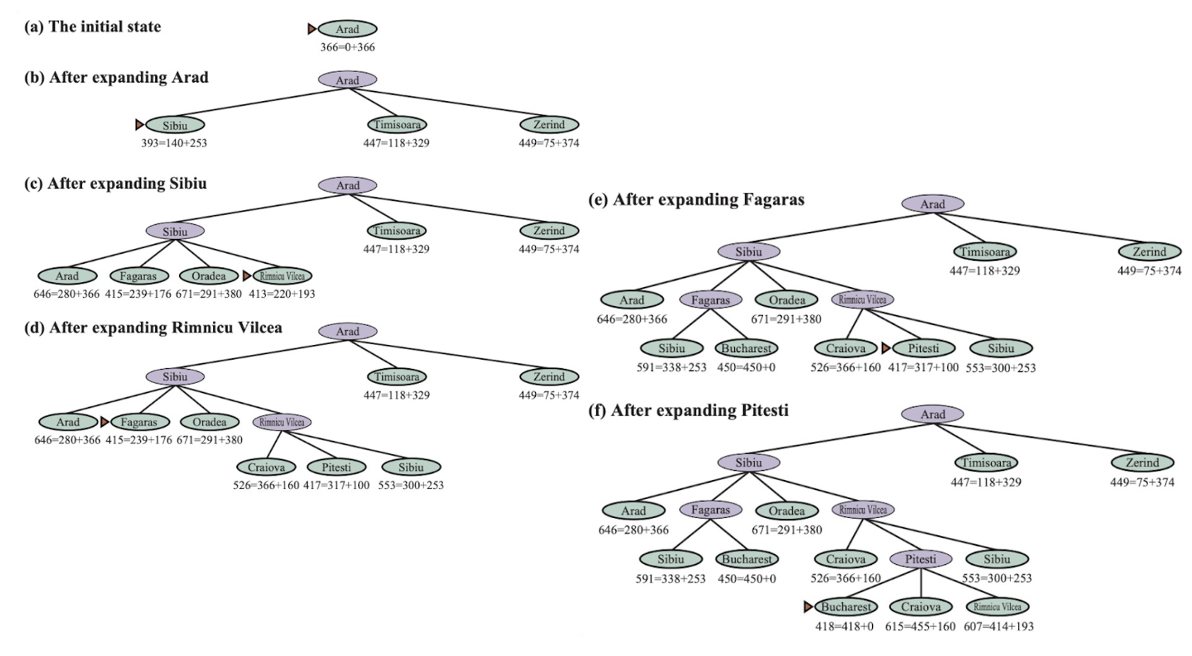
The diagram already shows A* in action. The numbers are formatted as f(n) = g(n) + h(n), where g is the real cost from Arad and h is the straight-line distance to Bucharest. Dijkstra's algorithm uses only g(n), it has no idea where Bucharest is, so it expands outward equally in every direction.
A* keeps expanding the node with the lowest f = g + h.
Arad → Sibiu (f = 393) → Fagaras (f = 415) → Rimnicu Vilcea (f = 413) → Pitesti (f = 417) → Bucharest (f = 418, g = 418)
Only 5 expansions before reaching the goal, and the path found costs 418, which is optimal.
Since Dijkstra ignores h(n) and just expands by g(n), it fans out uniformly:
Order | Node | g(n)
1 | Arad | 0
2 | Zerind | 75
3 | Timisoara | 118
4 | Sibiu | 140
5 | Oradea | 146
6 | Rimnicu Vilcea | 220
7 | Lugoj | 229
8 | Fagaras | 239
9 | Mehadia | 299
10 | Pitesti | 317
11 | Craiova | 366
12 | Dobreta | 374
13 | Bucharest | 418

Dijkstra also finds the optimal cost of 418, but only after expanding 13 nodes, including dead-end branches like Zerind, Timisoara, Lugoj, Mehadia, and Dobreta that lie nowhere near Bucharest.
A* wins here. Both algorithms are guaranteed to find the optimal-cost path (418) because in this graph the heuristic never overestimates the true cost, it's admissible. But Dijkstra pays for that guarantee by exploring blindly in every direction (toward Zerind, Timisoara, Lugoj, etc., which are geographically opposite Bucharest), while A*'s heuristic tells it "Fagaras and Pitesti are closer to the goal, focus there", pruning away irrelevant branches almost immediately.
In general, we can conclude A* dominates Dijkstra whenever we have a good admissible heuristic; it offers the same optimality guarantee with far fewer node expansions, since its search is directed rather than uniform. Dijkstra is only preferable when no useful heuristic is available, or when the application requires exhaustively exploring the state space (such as computing shortest paths to all nodes rather than to a single goal), since without any sense of direction it degrades gracefully into blind uniform-cost search.

