Romany Manriquez

March 24, 2024

Link to Github Repository

<https://github.com/rmanriquez13/csd-340.git>

Local

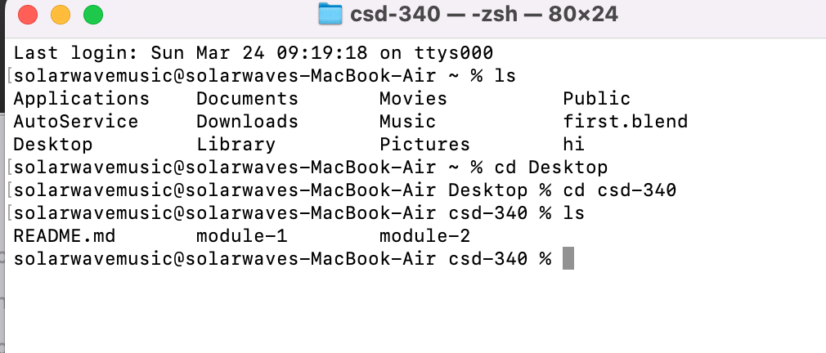

Github Screenshot

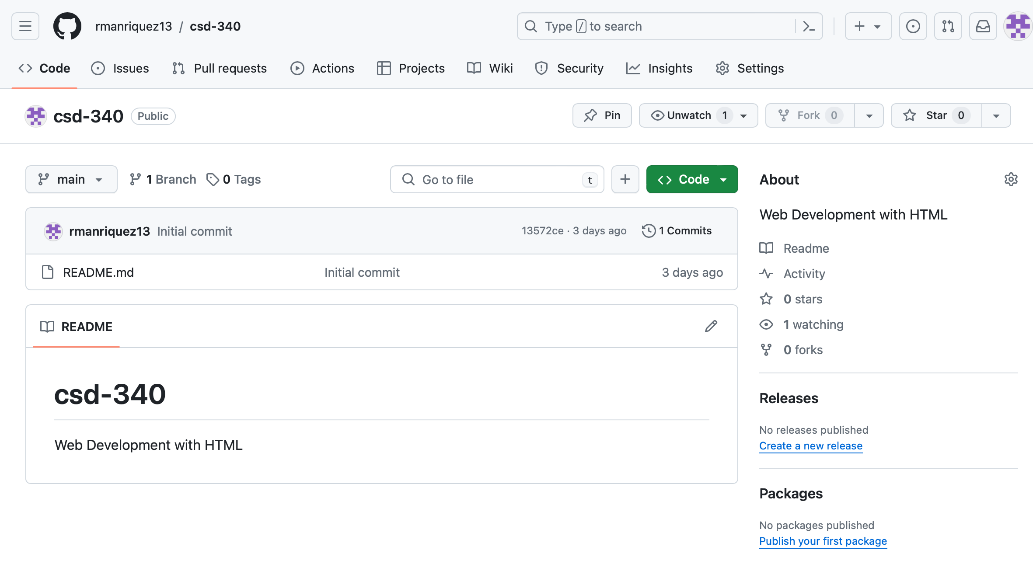

ReadME

