Romany Manriquez

Outhayvanh Somchaleun

Kristina Vasquez

Revised our distributor MySQL report to reflect the same outcome our already turned in python script shows, the total sales with a $ indicator.

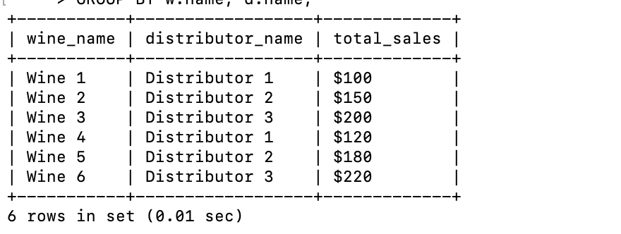

Also Revised our ERD to show the Primary key, foreign key.