Romany Manriquez

Module 5.2 MySQL Functions

Function 1 COUNT()

1. Would be used to count the number of rows that meet a condition.

2.Alias:Total_Count

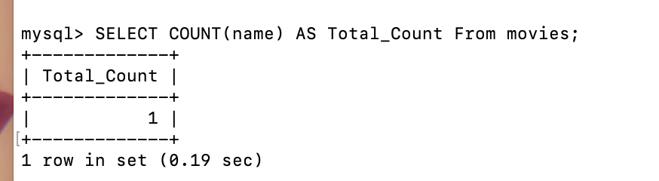

Function 2 UPPER()

1.Used when the characters in a string need to be converted to capital letters.

2.Alias: Uppercase_Name

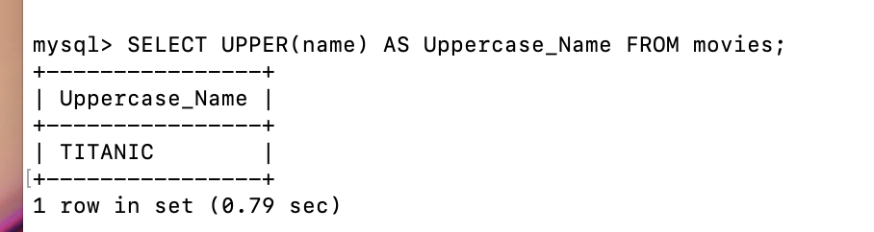

Function 3 LOWER()

1. Used when all the characters in a string need to be converted to lower-case letters.

2.Lowercase_Description

