Romany Manriquez

February 10, 2024

Assignment 6.2

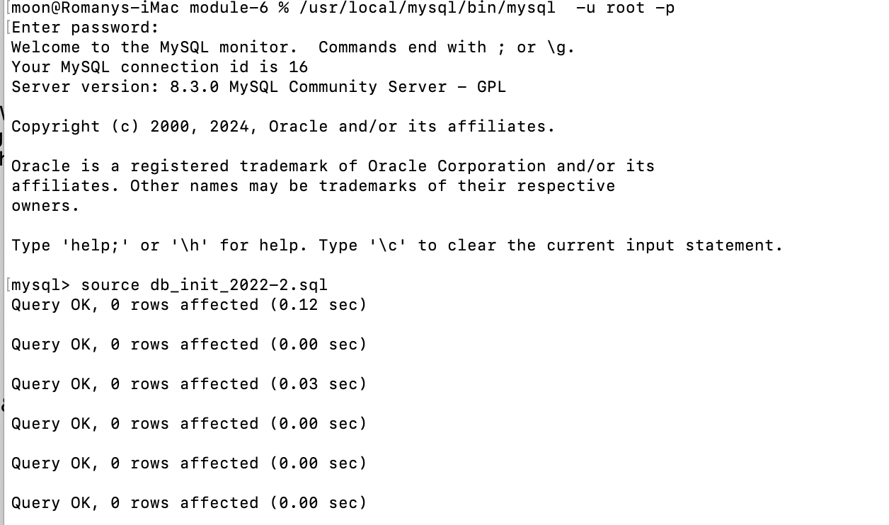

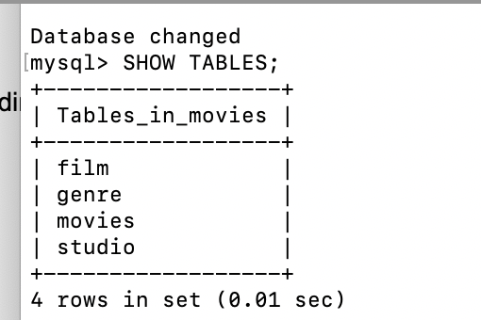

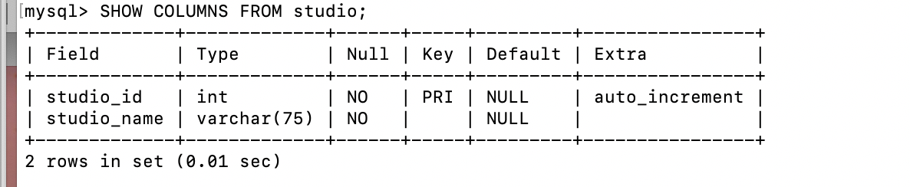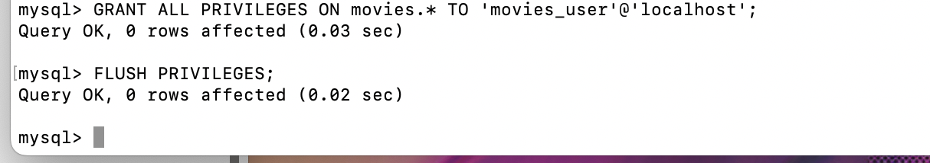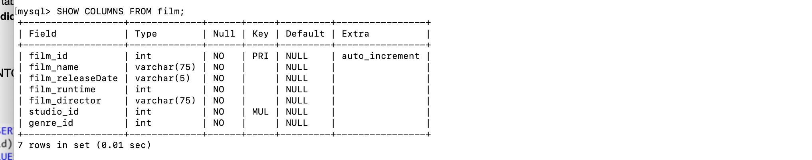

PYTHON OUTPUT

