Romany Manriquez

Module 8 Assignment

Feb 17, 2023

I got confused on this assignment, when I would run and save my python program with the updates and deletions it would alter my python outcome every time. I was uncertain if the final python program had to show the results at the very end with everything included as you showed in the images. But here are the outcomes I got.

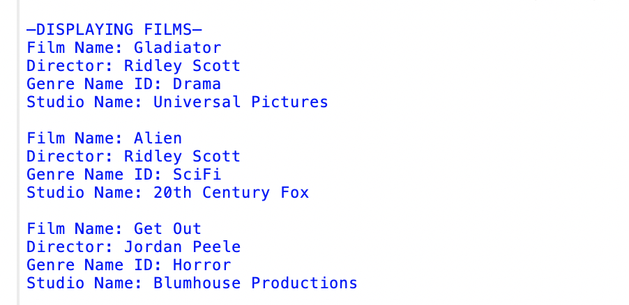

Then after executing the delete and rerunning my python program displayed this:

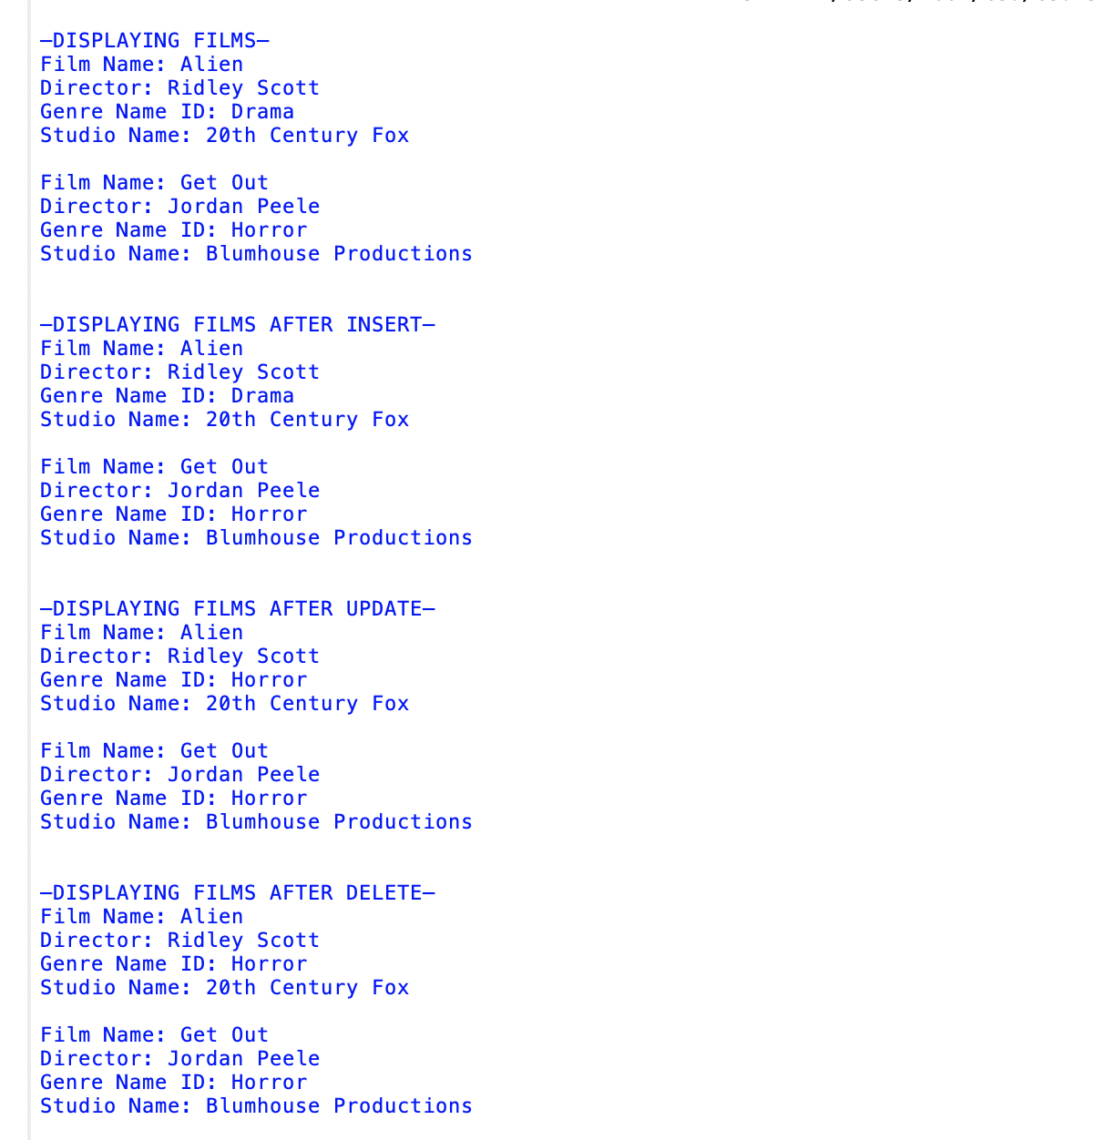

It did not display the Gladiator Film in the first –DISPLAY FILMS--

I also tried really hard to get the information I inserted for the additional film to show up but it did not.