Romany Manriquez

Outhayvanh Somchaleun

Kristina Vasquez

Case Chosen: Bacchus Winery

Stan and Davis Bacchus inherited their winery from their father, George, three years ago upon his retirement. While they both appreciate all the hard work their father put into the business, they are anxious to incorporate new business methods to help them improve their products and customer service. When they started running the winery, the owners decided to keep all existing personnel in place, hoping to effect minimum change during the turnover. Presently they employ Janet Collins, who is in charge of all finances and payroll; Roz Murphy, who heads up the marketing department, she has one assistant, Bob Ulrich, working for her; Henry Doyle, who manages the production line, as well as 20 employees; and Maria Costanza, who is in charge of distribution. Bacchus Winery grows the grapes needed to make a Merlot, a Cabernet, a Chablis, and a Chardonnay. They have been receiving their supplies; bottles and corks from one supplier, labels and boxes from another, and vats and tubing from a third supplier, each of which ships the components every month or so. Stan and Davis are responsible for keeping track of the supply inventory and would like to find a more efficient method of keeping track and ordering supplies, perhaps over the internet. Maria, who is responsible for distribution, would like their distributors to be able to order online, and to be able to track shipments. Stan and Davis know the yearly ‘snapshot’ of the business is due in a few weeks, and need the information to determine the state of the inventory, the distribution and the employees. They need information on… - Are all suppliers delivering on time? Is there a large gap between expected delivery and actual delivery? A month by month report should show problem areas. - The wine distribution, are all wines selling as they thought? Is one wine not selling? Which distributor carries which wine? - Employee time. During the last four quarters, how many hours did each employee work?

Business Rules:

* Stan and Davis Bacchus inherited the winery from their dad, George, three years ago when George retired.
* Bacchus Winery produces four types of wine: Merlot, Cabernet, Chablis, and Chardonnay, using grapes grown on-site.
* All existing personnel were kept in place during the turnover.
* Key personnel include

-Stan and Davis Bacchus (owners)

-Janet Collins (Finance and Payroll)

-Roz Murphy (Marketing)

-Bob Ulrich (Marketing Assistant)

-Henry Doyle (Production Manager)

-Maria Costanza (Distribution).

* Quarterly reports are needed to analyze supplier delivery performance, wine distribution, and employee hours worked important information.
* They are looking to incorporate new business methods to improve products and customer service.
* Supplies are sourced from different suppliers and are shipped monthly.
* Stan and Davis want to improve supply tracking and ordering, possibly using the internet.
* Maria wants distributors to be able to order online and track shipments.

Suppliers:

Each supplier is responsible for delivering specific components required for winemaking.

Such as (bottles & corks) from one supplier, (labels & boxes) from a second supplier, and (vats & tubing) from a third supplier.

Keep track of supplier details (name, contact information, pricing, etc.).

Inventory:

We need to track the stock level of materials and components required for winemaking, including grape varieties and suppliers' materials (bottles, corks, labels, etc.).

Each grape variety has its own inventory and is associated with a unique identifier, allowing for accurate tracking and management of stock levels.

Record delivery details for each component (supplier, quantity, delivery date).

Wine Production:

Grape varieties produce different types of wine (Merlot, Cabernet, Chablis, Chardonnay).

Production managers oversee the production line, scheduling production runs, allocating resources, and ensuring adherence to quality standards and production schedules.

Production records capture details of each production batch, including production dates.

Each type of wine requires specific components (grape, bottle, corks, labels).

Distribution:

Track distribution of wines to various distributors.

Distributor profiles include company information, contact details, geographic coverage, sales territories, and contractual agreements.

Each distributor may carry multiple wines.

Shipment tracking allows distributors to monitor the status of their orders in real-time, providing transparency and improving customer satisfaction.

Employees:

Record details of employees (name, role, contact information, etc.).

Timekeeping functionality captures employee work hours, including regular overtime, breaks, and absences.

ERD:

Entity-Relationship Diagram (ERD):

ERD LINK

<https://online.visual-paradigm.com/share.jsp?id=333132343532332d31>

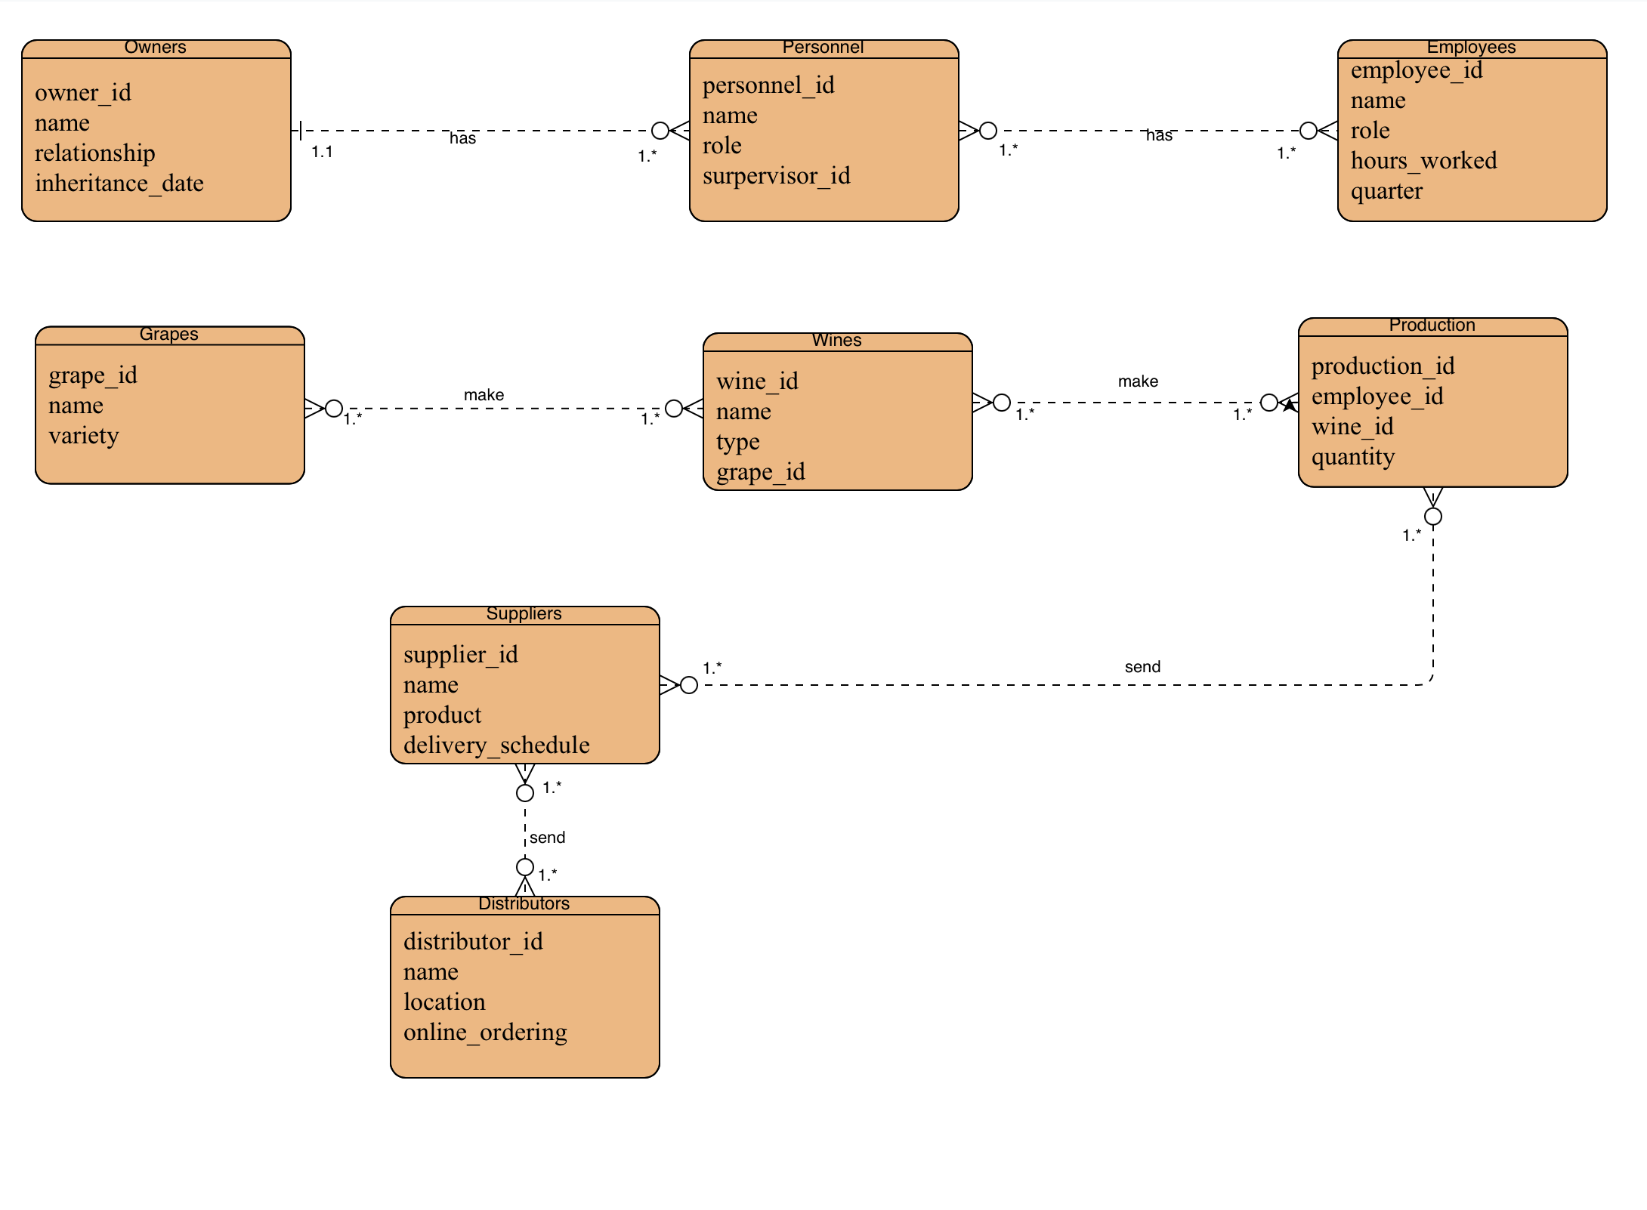

Tables going to be in ERD

|  |  |  |  |
| --- | --- | --- | --- |
| Owner | Personnel | Grapes | Suppliers |
| owner_id | personnel_id | grape_id | supplier_id |
| name | name | name | name |
| relationship | role | variety | product |
| inheritance_date | supervisor_id |  | delivery_schedule |
|  |  |  |  |

|  |  |  |  |
| --- | --- | --- | --- |
| Distributors | Wines | Employee | Production |
| distributor_id | wine_id | employee_id | production_id |
| name | name | name | employee_id |
| location | type | role | wine_id |
| online_ordering | grape_id | hours_worked | quantity |
|  |  | quarter |  |

ERD:

Entities:

* Owners
* Personnel
* Grapes
* Supplies
* Distributors
* Wines
* Employees
* Production