# The Complete Guide to UML Diagram Types with Examples

UML stands for **U**nified **M**odeling **L**anguage. It’s a rich language to model software solutions, application structures, system behavior and business processes. There are **14 UML diagram types** to help you model these behaviors.

## List of UML Diagram Types

So what are the different UML diagram types? There are two main categories; **structure diagrams** and **behavioral diagrams**.

### Structure Diagrams

Class Diagram

Component Diagram

Deployment Diagram

Object Diagram

Package Diagram

Profile Diagram

Composite Structure Diagram

### Behavioral Diagrams

Use Case Diagram

Activity Diagram

State Machine Diagram

Sequence Diagram

Communication Diagram

Interaction Overview Diagram

Timing Diagram

**[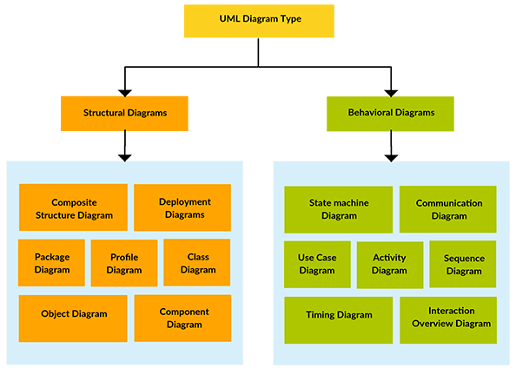](http://static3.creately.com/blog/wp-content/uploads/2012/02/UML-Diagram-types1.png)**

Figura 1- UML Diagram Types

**Structure diagrams** show the things in the modeled system. In a more technical term, they show different objects in a system. **Behavioral diagrams** show what should happen in a system. They describe how the objects interact with each other to create a functioning system.

## Class Diagram

Class diagrams are the main building block of any object oriented solution. It shows the classes in a system, attributes, and operations of each class and the relationship between each class.

In most modeling tools, a class has three parts. Name at the top, attributes in the middle and operations or methods at the bottom. In a large system with many related classes, classes are grouped together to create class diagrams. Different relationships between classes are shown by different types of arrows.

Below is an image of a class diagram. **[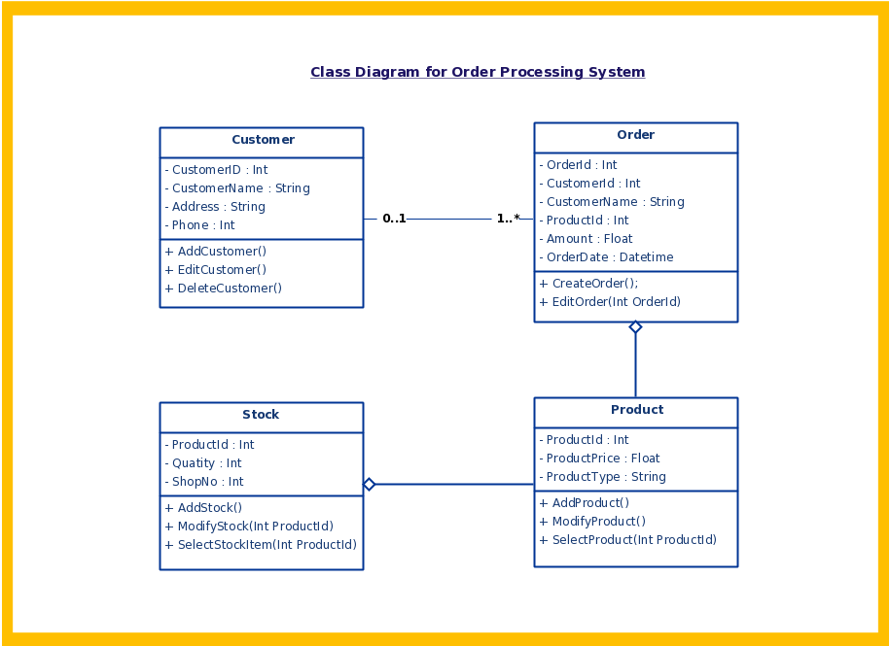](http://creately.com/diagram/example/gsxncbybu/UML+-+Order+Processing+System+Template)**

Figura 2- UML Class Diagram with Relationships

## Component Diagram

A component diagram displays the structural relationship of components of a software system. These are mostly used when working with complex systems with many components. Components communicate with each other using [**interfaces**](http://en.wikipedia.org/wiki/Interface_(object-oriented_programming)). The interfaces are linked using connectors. The image below shows a component diagram.

**[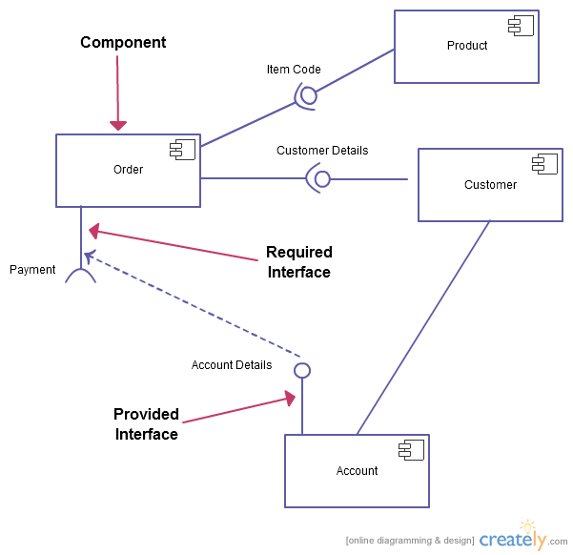](http://creately.com/diagram/example/gqz0nrua1/Component+Diagram)**

Figura 3- Simple Component Diagram with Interfaces

## Deployment Diagram

A deployment diagram shows the hardware of your system and the software in that hardware. Deployment diagrams are useful when your software solution is deployed across multiple machines with each having a unique configuration. Below is an example deployment diagram.

**[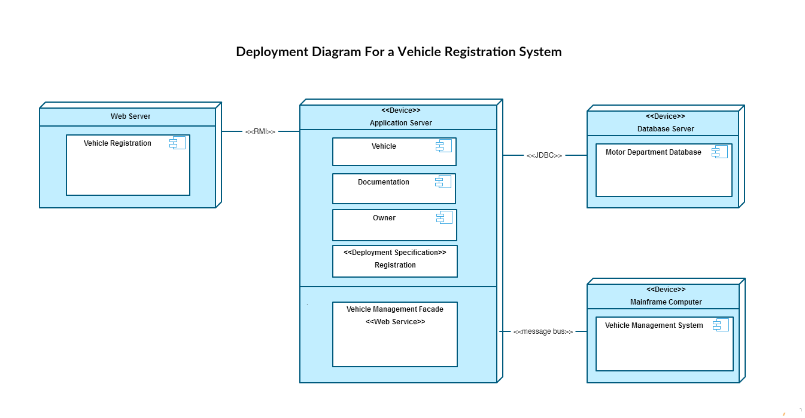](http://creately.com/diagram/example/gsx1cnemh/Deployment+Diagram+For+a+Vehicle+Registration+System)**

Figura 4- UML Deployment Diagram

## Object Diagram

Object Diagrams, sometimes referred to as Instance diagrams are very similar to class diagrams. Like class diagrams, they also show the relationship between objects but they use real world examples.

They show how a system will look like at a given time. Because there is data available in the objects, they are used to explain complex relationships between objects.

**[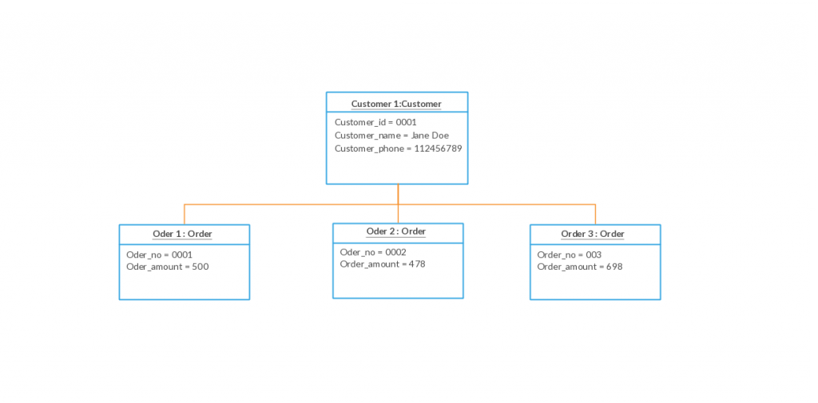](http://creately.com/diagram/example/gsxghfo2f/Object+Diagram)**

Figura 5- UML Object Diagram Example

## Package Diagram

As the name suggests, a package diagram shows the dependencies between different packages in a system.

**[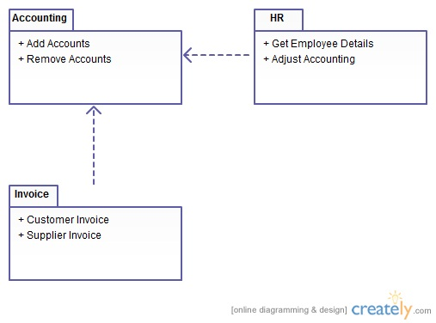](http://static3.creately.com/blog/wp-content/uploads/2012/02/Package-Diagram-UML.jpeg)**

Figura 6- Package Diagram in UML

## Profile Diagram

Profile diagram is a new diagram type introduced in UML 2. This is a diagram type that is very rarely used in any specification.

**[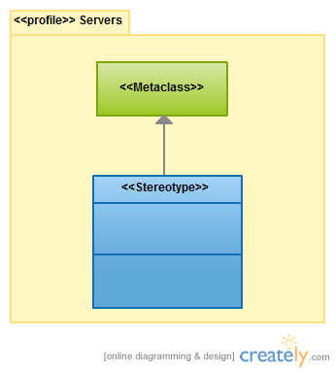](http://static1.creately.com/blog/wp-content/uploads/2012/02/profile-diagrams-UML.jpeg)**

Figura 7- Basic UML Profile Diagram structure

## Composite Structure Diagram

Composite structure diagrams are used to show the internal structure of a class.

**[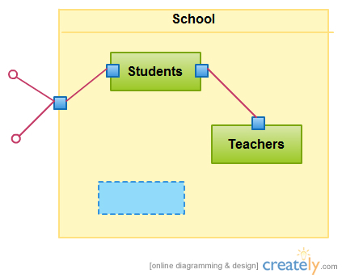](http://static1.creately.com/blog/wp-content/uploads/2012/02/composite-Strcuture-Diagram-UML1.jpeg)**

Figura 8- A simple Composite Structure Diagram

## Use Case Diagram

As the most known diagram type of the behavioral UML diagrams, Use case diagrams give a graphic overview of the actors involved in a system, different functions needed by those actors and how these different functions interact.

It’s a great starting point for any project discussion because you can easily identify the main actors involved and the main processes of the system.

**[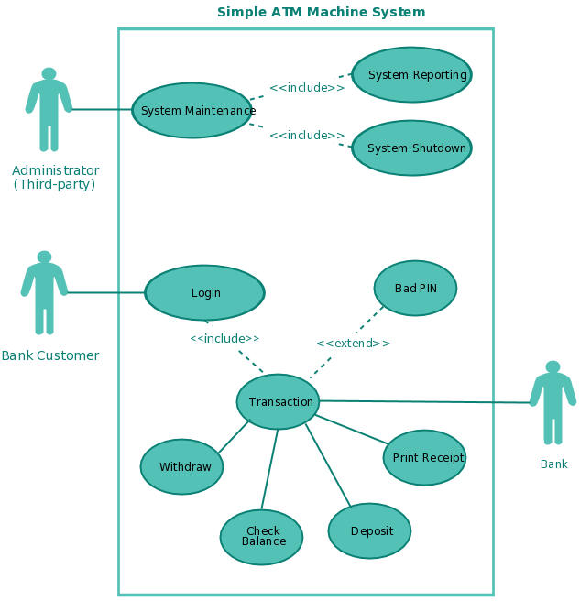](http://creately.com/diagram/example/gsxncbyb1/ATM+System+%28Use+Case%29)**

Figura 9- Use Case diagram showing Actors and main processes

## Activity Diagram

Activity diagrams represent workflows in a graphical way. They can be used to describe the business workflow or the operational workflow of any component in a system. Sometimes activity diagrams are used as an alternative to State machine diagrams.

**[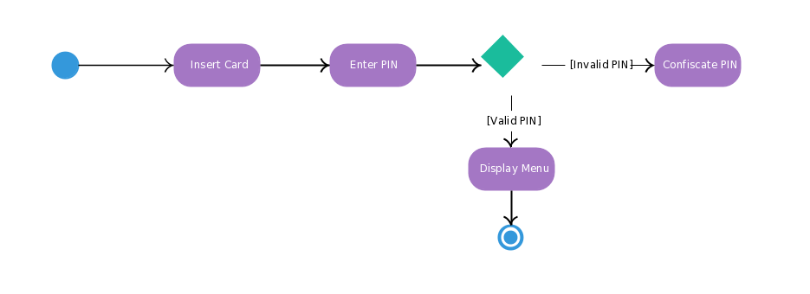](http://creately.com/diagram/example/gsxhmadt1/Activity+Diagram+Template+of+ATM)**

Figura 10- Activity Diagrams with start, end, processes and decision points

## State Machine Diagram

State machine diagrams are similar to activity diagrams, although notations and usage change a bit. They are sometimes known as state diagrams or state chart diagrams as well. These are very useful to describe the behavior of objects that act differently according to the state they are in at the moment. The State machine diagram below shows the basic states and actions.

**[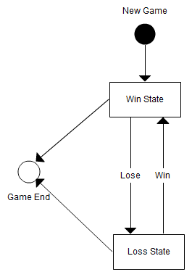](http://static3.creately.com/blog/wp-content/uploads/2012/01/State-Machine-Diagram.png)**

Figura 11- State Machine diagram in UML, sometimes referred to as State or State chart diagram

## Sequence Diagram

Sequence diagrams in UML show how objects interact with each other and the order those interactions occur. It’s important to note that they show the interactions for a particular scenario. The processes are represented vertically and interactions are shown as arrows.

**[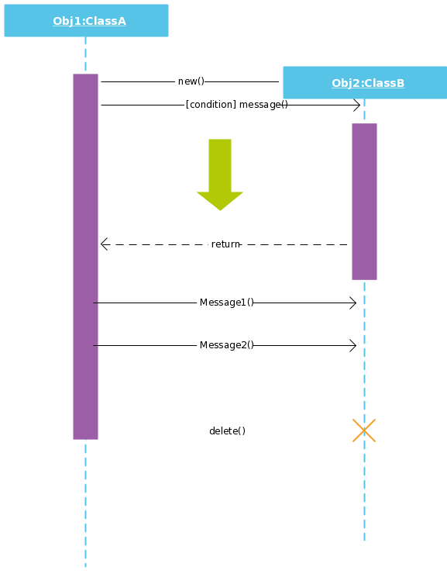](http://creately.com/diagram/example/gsx1cnemi/Sequence+diagram)**

Figura 12- Sequence Diagrams in UML shows the interaction between two processes

## Communication Diagram

In UML 1 they were called collaboration diagrams. They are similar to sequence diagrams, but the focus is on messages passed between objects. The same information can be represented using a sequence diagram and different objects.

**[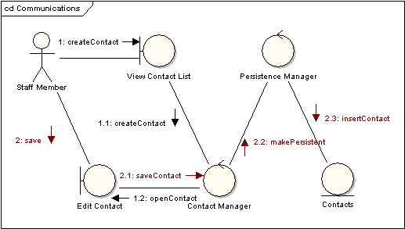](http://static2.creately.com/blog/wp-content/uploads/2012/02/Communication-Diagram-UML.gif)**

Figura 13- Communication Diagram in UML

## Interaction Overview Diagram

Interaction overview diagrams are very similar to activity diagrams. While activity diagrams show a sequence of processes, Interaction overview diagrams show a sequence of interaction diagrams.

They are a collection of interaction diagrams and the order they happen. As mentioned before, there are seven types of interaction diagrams, so any one of them can be a node in an interaction overview diagram.

**[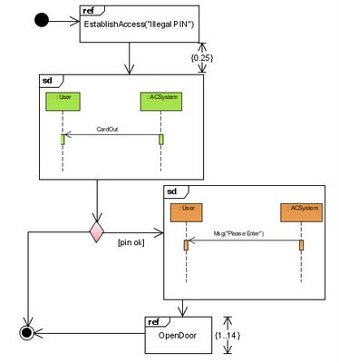](http://static2.creately.com/blog/wp-content/uploads/2012/02/Interaction-Overview-Diagram-UML.jpg)**

Figura 14- Interaction overview diagram in UML

## Timing Diagram

Timing diagrams are very similar to sequence diagrams. They represent the behavior of objects in a given time frame. If it’s only one object, the diagram is straight forward. But, if there is more than one object is involved, a Timing diagrams can be used to show interactions between objects during that time frame.

**[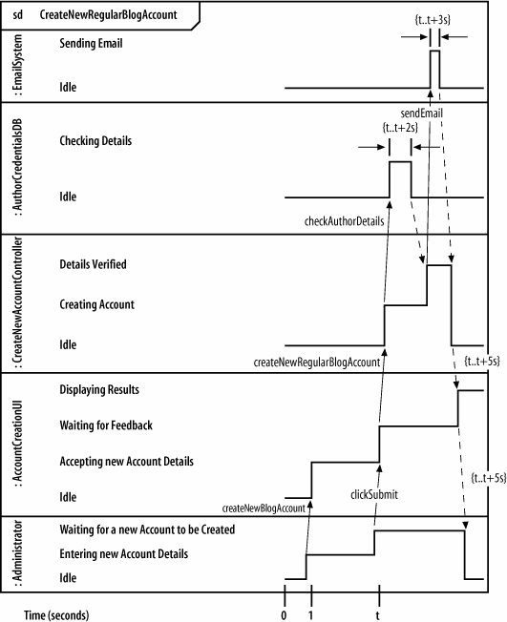](http://static2.creately.com/blog/wp-content/uploads/2012/02/timing-Diagram-UML.png)**

Figura 15- Timing Diagram in UML

Mentioned above are all the UML diagram types. UML offers many diagram types, and sometimes two diagrams can explain the same thing using different notations.