What is Github?

Github is a web-based version control repository and Internet hosting service. It offers all the distributed version control and source code management functionality of Git.

When was it created? Why? By who?

Github was launched in April 10, 2008. While Git is a command-line tool, Github provides a web-based graphical interface. The site was created to provide access control and several collaboration features. It operates as a social networking-like function with feeds, followers, wikis, and a social networking graph. Its founders are Tom Preston-Werner, Chris Wanstrath, and PJ Hyett.

Why would you use such a platform?

The main purpose functionality of Github is, “forking.” This allows users to copy a repository from one account to another. Then, you can modify a project that you don’t have write access to. You can then send a pull request to share changes with the original owner. If the owner accepts these changes, you get credit and it shows up on your profile.

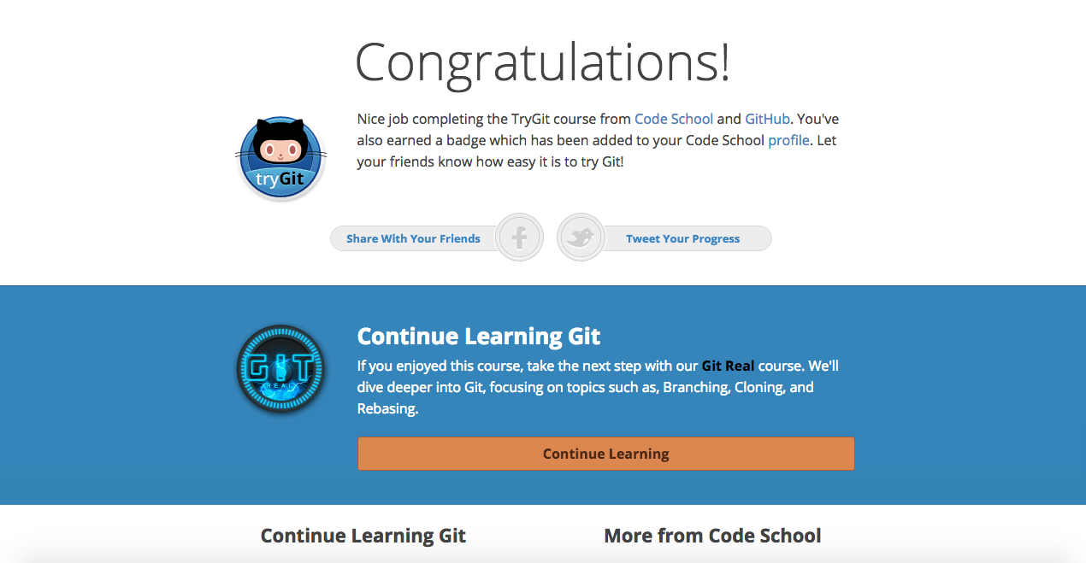

**Repository-** A repository contains all the project files and stores each file’s revision history.

**Commit-** An individual change to a file, kind of like a save to a file with a unique ID that keeps track of changes made, when they were made, and by who.

**Push-** Sending your committed changes to a remote repository, such as a repository hosted on Github.

**Branch-** A parallel version of a repository contained within the repository but does not affect the primary or master branch.

**Fork-** A personal copy of another person’s repository that lives in your account.

**Merge-** Takes the changes from one branch and applies them into another (from the same repository or fork).

**Clone-** Copy of a repository that lives on your computer instead of a website’s server somewhere.

**Pull-** Refers to when you are fetching in changes and merging them.

**Pull Request –** Proposed changes to a repository submitted by a user and accepted or rejected by collaborators.

For this assignment, I changed my working directory to the current folder that contains the MarchettiRobertGitTutorial-Oct-16-2017.docx file. I used the commands:

Git add .

Git commit –m “Add existing file”

Git push origin <https://github.com/rmarchetti92/CS3892017>

This was the strategy I utilized to create the new repository.