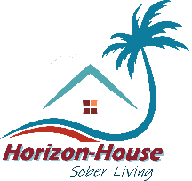
Horizon House Sober Living
28351 Horizon Road • Cathedral City, California 92234
760-766-0300 • Fax 442-212-2345
https://horizon-house.org

March 31, 2025

Re: Sonja Sadi

To whom it may concern,


I am pleased to provide this progress report for Ms.Sonja Sadi, who has been consistently engaged in the Virtual After Care Program at Horizon House Sober Living. Through her dedicated participation, she has demonstrated a commendable commitment to her recovery journey and personal growth.

Ms. Sadi attends twice-weekly group sessions via Microsoft Teams meetings as part of this program. She also submits proof of attendance at a minimum of five 12-step meetings per week and has complied fully with random UA testing requirements. I am happy to report that all tests have returned negative for illicit substances, reflecting her adherence to a substance-free lifestyle.

Her progress is evident in the remarkable changes in her attitude and outlook on life. Ms. Sadi’s enthusiasm and active involvement in her recovery not only benefit her but also serve as a source of encouragement and hope for newer members of the group. Her dedication and positive spirit are truly inspiring and make her a valuable participant in our community.
I wholeheartedly believe Ms. Sadi is an individual committed to her personal transformation and recovery.

Sincerely,
Charles Landan, RADT-II
Program Director, Horizon Recovery, LLC

HHSL/SonjaSAftercare033125

