Setup

1. Create github account
2. Download and install git bash

To get a file

1. Goto githu.com
2. Find the directory

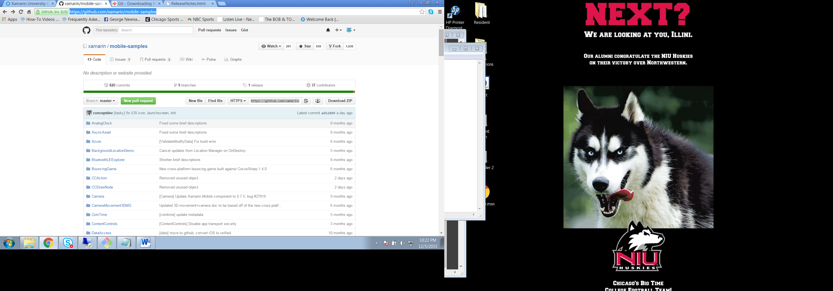

1. On the repository location will see the location by https: in above it is <https://github.com/xamarin/mobile-samples.git> please note in a sub directory will not see the https since must checkout at the top level.
2. On Mac goto the application called terminal on pc start the application git bash
3. Change directory is cd for both
4. List files is dir on pc and ls on mac
5. Go to target directory where you will want your file
6. Use clone command: git clone <https://github.com/xamarin/mobile-samples.git>
7. This will get you the files

To check for update enter command

1. From the root level of what you checked out enter command: git status

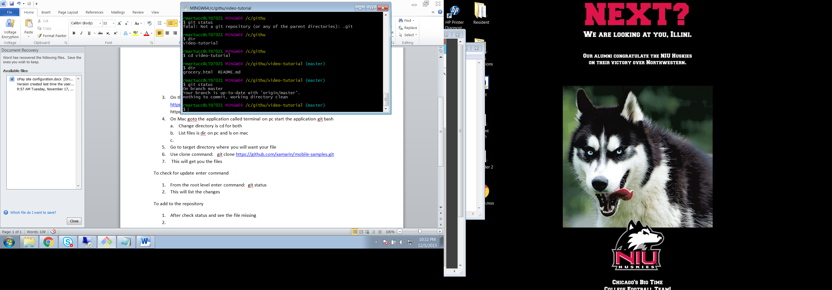

1. This will list the changes

To add to the repository

1. After check status and see the file missing
2. Type in command: git add filename.txt

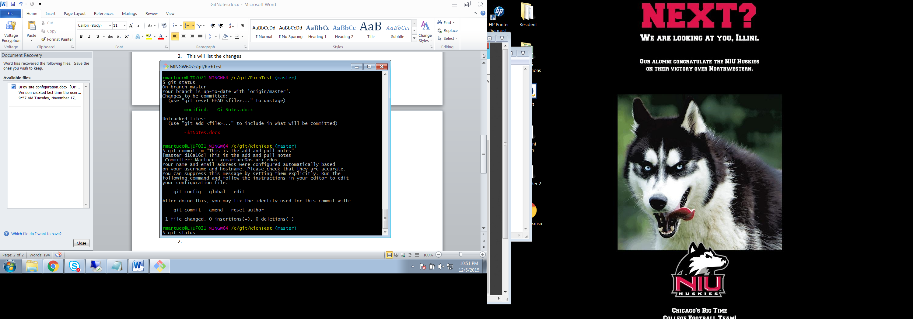

1. If multiple files can type to save the all: Git Add A
2. Commit the change: git commit – m “this is your comment file still not uploaded”
3. Git push is the last process

To get the latest change:

1. Git pull

If conflict when do git push will say don’t have local copy

1. You will then do a git pull
2. It will say what your commands are
3. Then edit the file to correct the conflict

Typing git will list all the commands