Frontend Documentation
By:
Kardinas, Al Christian
Negrido, Ross Mathew D.
Villalobos, Sean Matthew

Project:
Bacolod City Business One Stop Shop (BOSS) — Public Landing Page
Maintained by:
Management Information Technology and Computer Services Department (MITCS), Bacolod City Government
Last reviewed:
April 26, 2026

Table of Contents
Frontend Documentation i
Project Context 1
What is BOSS? 1
Project Overview 2
Tech Stack 3
Project Structure 4
Design System 5
Color Tokens 5
Section Accent Colors 5
Typography 6
Spacing & Layout 6
Elevation (Shadows) 6
Components 7
Layout Components 7
Shared Components 10
UI Primitives 12
Pages 16
Data Layer 17
Exported Constants 17
Hooks 19
Responsive Behavior 20
Technique 1 — Inline isMobile State 20
Technique 2 — clamp() for Fluid Scaling 20
Technique 3 — Injected <style> Tags with Media Queries 20
Breakpoint Summary 21
Animations & Transitions 22
Scroll-triggered Fade-In 22
Navbar Scroll Transition 22
Mobile Navigation Drawer 22
Mobile Document Modal 22
Button Hover States 22
fadeSlideIn Keyframe 22
Marquee Keyframe (Defined, Not Applied) 23
Naming Conventions 24
UI Reference 25
Navbar 25
Agency Strip 27
How It Works — New Business Permit 27
Renewal of Business Permit 29
Video Section 30
Footer 31
Known Gaps & Items for Future Development 32
Incomplete Navigation Links 32
Unused PHASES Constant 32
Placeholder Download Files 32
Footer Links Not Wired 33
CSS Color Tokens Not Consumed 33
Marquee Animation Defined but Unused 33

Project Context

What is BOSS?
The Business One Stop Shop (BOSS) is a public-facing service of the Bacolod City Government that consolidates all business permit transactions into a single point of access. Rather than visiting multiple city offices separately, business owners and applicants can go through the entire permit process—application, review, clearances, assessment, payment, and release—through one coordinated service.
BOSS is mandated under Republic Act 11032 (Ease of Doing Business and Efficient Government Service Delivery Act of 2018), which requires local government units to streamline business permit processing.
Its purpose is to:
- Introduce the BOSS service and what it offers
- Explain the step-by-step requirements and procedures for both new permit applications and renewals
- Provide downloadable reference documents
- Embed a video tutorial for using EBIS 4.0
- Direct applicants to the relevant sections of the system
This landing page is purely informational. It does not process applications, collect form data, authenticate users, or communicate with any backend service. All content is static.

Project Overview

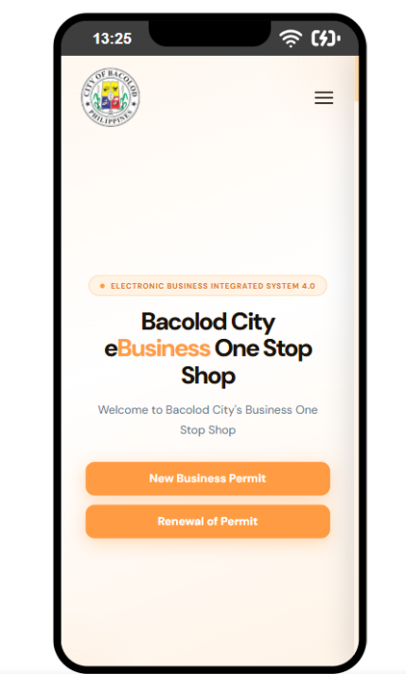
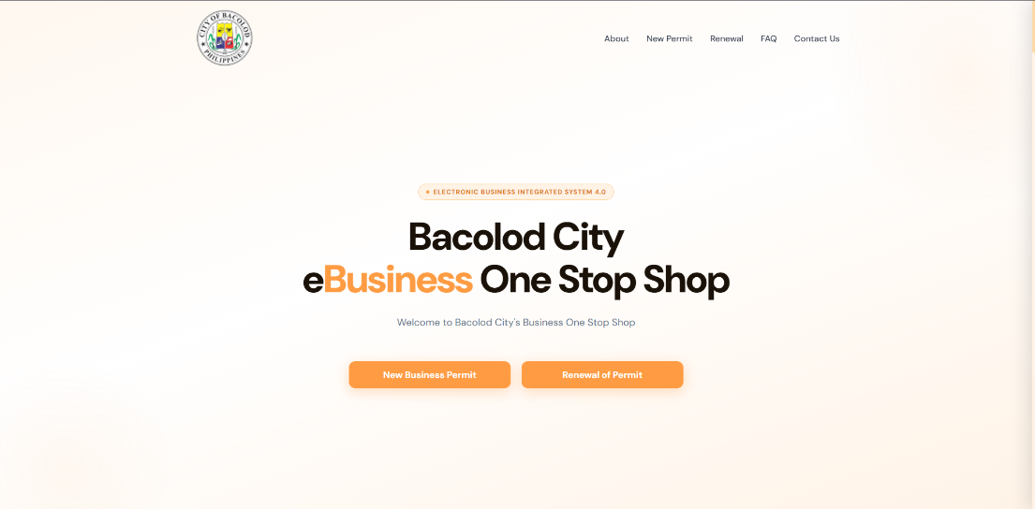

The landing page is a single-page React application composed of the following sections, rendered in order from top to bottom:
Section | Purpose
Navbar | Fixed top navigation with links to page sections
Hero | Introductory headline and call-to-action buttons
Agency Strip | Lists all participating government departments and offices
How It Works | Full requirements and procedure guide for new business permits
Renewal Section | Same structure as above, scoped to permit renewals
Video Section | Embedded YouTube tutorial for using EBIS 4.0
Footer | Site links, attribution, and legal compliance notices

For non-technical readers: Each "section" above is an independent part of the webpage. They are built and maintained separately, which makes it straightforward to update the content of one section without affecting the others.

Tech Stack
The following technologies were used to build this landing page.
Category | Technology | Notes
UI Library | React 18 | The JavaScript framework used to build the interface
Build Tool | Vite | Packages and serves the application for development and production
Language | JavaScript (JSX) | Standard JavaScript with HTML-like syntax; no TypeScript
Styling | Inline styles + CSS files | All visual styling is hand-authored; no external UI framework
Fonts | DM Sans (Google Fonts) | Loaded via App.css; fallbacks: Segoe UI, system-ui, sans-serif
Animations | CSS transitions & keyframes | No animation library; all effects are written in standard CSS
Scroll detection | Native IntersectionObserver API | Wrapped in a custom React hook (useInView)
Linting | ESLint | Code quality rules defined in eslint.config.js

For non-technical readers: This page has no external dependencies on paid services or third-party UI kits. All visual styling was written from scratch by the development team, which means the design is fully owned and controlled by MITCS.

Project Structure
The source files are organized as follows:
src/
├── assets/ Static images — logos, hero image
├── components/
│ ├── layout/ Page sections rendered directly on the page
│ │ ├── AgencyStrip.jsx
│ │ ├── Footer.jsx
│ │ ├── Hero.jsx
│ │ ├── Navbar.jsx
│ │ └── VideoSection.jsx
│ ├── shared/ Reusable components used across multiple sections
│ │ └── PermitSection.jsx
│ └── ui/ Low-level building blocks (cards, rows, document viewer)
│ └── PermitUI.jsx
├── data/
│ └── constants.js All static content — text, permit data, agency list
├── hooks/
│ └── useInView.js Scroll-detection utility
├── pages/
│ └── public/
│ └── PermitPages.jsx Connects permit data to the PermitSection component
├── App.css Global styles: fonts, resets, scrollbar, animations
├── App.jsx Root component — assembles all sections into one page
├── index.css Design tokens (color variables)
└── main.jsx Application entry point
public/
├── downloads/
│ ├── docs/ Intended for downloadable document files
│ ├── pdf/ Intended for downloadable PDF files
│ └── reference.pdf Current placeholder file used by the document viewer
├── favicon.svg
├── icons.svg
└── logo.png
For non-technical readers: The src/data/constamts.js file is where all text content lives—permit requirements, agency names, procedure steps, and officer names. Updating page content typically only requires editing this file, without touching any component code.

Design System
This section documents the visual language of the landing page—the colors, typography, spacing, and other design decisions applied consistently throughout.

Color Tokens
The canonical color values are defined in src/index.css as CSS custom properties. These serve as the single source of truth for the palette.
Token | Value | Used For
--color-primary | #ff9c43 | Brand orange — buttons, active states, highlights
--color-primary-hover | #e07620 | Darker orange on hover
--color-text-dark | #1a1208 | Primary body text (warm near-black)
--color-text-muted | #64748b | Secondary and descriptive text
--color-bg-light | #fff3e6 | Warm white background tint
--color-border-light | #ffd9a8 | Warm orange borders and dividers
--color-footer-dark | #1a0f00 | Footer background (very dark warm brown)
--color-footer-deeper | #120a00 | Reserved for deeper footer contrast layers

Note on implementation: In practice, these token values are applied as hardcoded hex strings directly in component inline styles, rather than consumed via var(--token-name). The token declarations in index.css are accurate and current, but not automatically enforced — if a color value needs to change, it must be updated both in index.css and in every component where that color appears. This is a known inconsistency and is noted as an item for future standardization in Section 13.

Section Accent Colors
The two permit sections use different accent colors to visually distinguish them. These are passed in as props when each section is configured.
Section | Accent Color | Border Color | Visual Feel
New Business Permit | #ff9c43 (orange) | #ffd9a8 | Warm, action-oriented
Renewal of Permit | #3b82f6 (blue) | #bfdbfe | Calm, administrative
Step blocks (both sections) | #3b82f6 (blue) | — | Procedural consistency

Typography
- Primary font: DM Sans — a clean, modern sans-serif suitable for both headings and body text
- Weights loaded: 300 (light), 400 (regular), 500 (medium), 600 (semibold), 700 (bold), 800 (extrabold); italic 400 also loaded
- Variable font axis: Optical size 9–40, allowing the typeface to subtly adapt its letterforms at different display sizes
- Application: Declared globally on body in App.css; also declared redundantly on the root <div> in App.jsx as an explicit fallback

Spacing & Layout
- Maximum content width: 1200px, centered via margin: 0 auto within each section
- Horizontal section padding: 2rem on desktop; 1rem–1.25rem on mobile
- Border radius scale:
  - Full-width cards and panels: 16px
  - Badges and pill labels: 999px (fully rounded)
  - Buttons: 12px
  - Document rows and step blocks: 8px–12px

Elevation (Shadows)
Shadows are applied sparingly to indicate visual depth. Values in use:
0 2px 12px rgba(0,0,0,0.05) — Base card elevation (SectionCard)
0 4px 20px rgba(0,0,0,0.06) — Video section card
0 6px 24px rgba(255,156,67,0.35) — Primary CTA buttons (warm orange glow)
0 24px 64px rgba(0,0,0,0.22) — Mobile document modal

Components

Layout Components
These components make up the visible sections of the page. They are located in src/components/layout/.

Navbar.jsx
The fixed navigation bar displayed at the top of the page at all times.
In plain terms: This is the top menu bar. It stays visible as the user scrolls and changes its appearance based on scroll position and screen size.

Behavior:
- When the page is at the top, the navbar background is fully transparent, allowing the Hero section gradient to show through.
- Once the user scrolls past 20px, the background transitions to a near-white (rgba(255,255,255,0.97)) with a subtle blur effect (backdrop-filter: blur(10px)).
- On screens 768px wide and below, the desktop navigation links are replaced by a hamburger icon. Tapping it opens a slide-in drawer from the right.
- While the drawer is open, the page behind it is locked from scrolling.
- Tapping anywhere on the backdrop overlay behind the drawer closes it.
Props: None — reads NAV_LINKS from constants.js directly.

State managed internally:
State | Type | Purpose
scrolled | boolean | Tracks whether the page has scrolled past 20px
mobileOpen | boolean | Tracks whether the mobile drawer is open

Navigation links (sourced from constants.js):
Label | Target Anchor
About | #about
New Permit | #how-it-works
Renewal | #renewal
FAQ | #faq
Contact Us | #contact-us
Future development: #faq and #contact-us are present in the navigation but have no corresponding sections on the current page. These are placeholders. See Section 13.1.

Hero.jsx
The first visible section of the page, immediately below the Navbar.
In plain terms: This is the banner area — the large headline, introductory text, and the two main buttons that direct users to the permit guide sections.

Structure:
- Background: a soft diagonal gradient from #fff8f0 → #ffffff → #fff3e6
- Two non-interactive decorative radial-gradient circles positioned top-right and bottom-left for visual warmth
- A badge label reading "Electronic Business Integrated System 4.0"
- Main headline: "Bacolod City eBusiness One Stop Shop" — the word "Business" is highlighted in brand orange (#ff9c43)
- A short welcome subtext paragraph
- Two CTA buttons: one linking to #how-it-works, one to #renewal

Responsive behavior:
- All font sizes and vertical padding use clamp() to scale smoothly across viewport widths
- Below 420px, the two CTA buttons stack vertically instead of sitting side by side

Props: None.

AgencyStrip.jsx
A dark full-width band listing all participating government departments and offices.
In plain terms: This is the strip of department names shown below the Hero. It signals to visitors which offices are involved in the BOSS process.

Structure:
- Background: #1a0f00
- Heading: "Participating Departments & Offices" in small all-caps, low-opacity white text
- Agency names sourced from the AGENCIES array in constants.js

Layout behavior:
- Desktop: Agencies displayed in a single horizontal flex row, with small orange dot separators between items
- Mobile (≤ 640px): Agencies displayed in a centered two-column CSS grid
Visual treatment:
- The first agency ("BPLO") is always rendered in primary orange (#ff9c43) as a visual anchor point
- All remaining agencies use rgba(255,255,255,0.5) (semi-transparent white)
Note: App.css defines a .marquee-track keyframe animation intended for a scrolling ticker. The current AgencyStrip uses a static layout and does not apply this class. See Section 13.6.
Props: None.

VideoSection.jsx
A centered card containing an embedded YouTube tutorial video.
In plain terms: This section shows an instructional video that walks users through the EBIS 4.0 application process.

Structure:
- Section background: #fff8f0
- A white card with a border and shadow containing the video embed
- A section label, title ("How to use eBOSS EBIS 4.0"), and description above the iframe
- A responsive 16:9 video embed using the standard CSS padding-bottom: 56.25% technique
- The card animates in via useInView when it scrolls into the viewport

Video source: The YouTube video ID is stored in YOUTUBE_VIDEO_ID in constants.js (current value: UDLKp0DqoFU). To change the embedded video, update only that constant.
Props: None.

Footer.jsx
The site footer at the bottom of the page.
In plain terms: The footer contains supporting navigation links, the MITCS attribution, and legal compliance notices. It automatically switches between a desktop and mobile layout.

Structure:
- Background: #1a0f00
- Desktop (above 768px): Brand information on the left; three link columns on the right in a flex row
- Mobile (768px and below): Brand and all columns stacked in a responsive CSS grid
Footer link columns:
Column | Links
Services | New Application, Renew Permit, Track Application, Pay Fees Online
Departments | BPLO, Bureau of Fire Protection, City Health Office, Zoning Division
Support | Help Center, Privacy Policy, Terms of Use, Contact BPLO

Bottom bar: Displays the copyright line and a compliance reference: RA 10173 (Data Privacy Act), RA 11032 (Ease of Doing Business), and JMC Standards.

Logo: Loads logo-m.png from src/assets/. Fails gracefully — if the image cannot load, the element is hidden via an onError handler.

Future development: All footer links currently point to # and do not navigate anywhere. See Section 13.4.
Props: None.

Shared Components
Located in src/components/shared/.

PermitSection.jsx
The primary content component used for both the New Permit and Renewal permit guides. A single reusable component that adapts its appearance and content based on the props passed to it.
In plain terms: This is the most substantial part of the page. It presents all the requirements, documents, and step-by-step procedures for a given permit type. When a user clicks on a requirement or a step, the right side of the screen updates to show associated downloadable documents. On mobile, the same information appears in a pop-up overlay instead.
Props:
Prop | Type | Description
id | string | The HTML anchor ID for this section (e.g. "how-it-works")
data | object | The permit data object from PERMIT_DATA in constants.js
bg | string | Background color of the section
accentColor | string | Primary highlight color for this section instance
borderColor | string | Border color for accents and dividers
siblingHref | string | Anchor link pointing to the other permit section
siblingLabel | string | Display label for the sibling section link

Desktop layout (900px and above):

A three-column CSS grid:
1. Left column — Requirements
A card (SectionCard) containing:
  - Meta badges (issuing office, classification, transaction type, who may avail)
  - "Upon Encoding" document list (DocItem components — clickable)
  - Proxy/representative instructions (amber callout box)
  - "Upon Receiving / Submission" document list
  - Submission instructions (blue callout box)
  - Where to secure documents (green callout box)
2. Center column — Procedure Flow
A card containing:
  - Numbered procedural step blocks (StepBlock components — clickable)
  - Total processing time badge at the bottom
3. Right column — Documents & Forms (sticky)
A panel that remains fixed on screen as the user scrolls through the other two columns. When the user clicks a requirement or a step, this panel updates to show the relevant downloadable files via DocumentViewer. When nothing is selected, it displays an instructional empty state.

Mobile layout (below 900px):
The layout collapses to a single column. The sticky right panel is hidden entirely. When a user taps a DocItem or StepBlock, a DocModal slides up with the document viewer content.

Mobile `DocModal` behavior:
- Appears with a scale and slide-up entrance animation
- Semi-transparent blurred backdrop behind the sheet
- Dismissed by tapping the backdrop, tapping the close button, or pressing Escape
- Page scroll is locked while the modal is open

State managed internally:
State | Type | Purpose
selectedKey | string or null | Identifies the currently selected requirement or step
isMobile | boolean | Whether the viewport is below the 900px threshold
modalOpen | boolean | Whether the mobile document modal is visible

UI Primitives
Located in src/components/ui/PermitUI.jsx.

This file contains all low-level building blocks used by PermitSection. It also defines DOC_REGISTRY, the internal lookup table that maps selected items to their downloadable document lists.
For non-technical readers: These are the small visual pieces — individual document rows, labeled badges, step cards, and the document download panel — that together compose the permit guide sections.

SectionCard
A white card with a colored left-bar header, used to group related content within the permit sections.

Props: title (string), accent (color string), children

SubHeading
A small all-caps label used as a visual divider between content groups within a card.

Props: label (string), top (top margin in px, default 0), accentColor (string)

DocItem
A single numbered document requirement row. Optionally interactive to trigger the document viewer.

Props:
Prop | Type | Description
number | number | Display number shown in the circle badge
title | string | Name of the required document
notes | string, string[], or null | Supporting notes; rendered as a list if an array
accentColor | string | Color for the badge and the selected highlight state
onClick | function or undefined | If provided, the row becomes clickable
isSelected | boolean | Applies a tinted highlight background
isMobile | boolean | Adjusts font size and padding for smaller screens

MetaBadge
A compact pill displaying a label–value pair. Used in the requirements card to surface metadata such as the issuing office, transaction classification, and who may avail.

Props: label (string), value (string), color (string)

StepBlock
A numbered procedural step displaying both the client action and the corresponding agency action. Optionally interactive to show associated documents.

Props:
Prop | Type | Description
index | number | Zero-based index; displayed as index + 1
step | object | Step data object from PERMIT_DATA.steps[]
isLast | boolean | Omits the vertical connector line after the final step
onClick | function or undefined | Makes the block interactive
isSelected | boolean | Applies a blue-tinted highlight background
isMobile | boolean | Adjusts layout density for smaller screens

Client and agency sub-sections are displayed side by side on desktop and stacked on mobile. A vertical gradient line (#3b82f620 to transparent) visually connects consecutive steps. It is hidden on the last step.

DocumentViewer
Displays the list of downloadable files associated with the currently selected requirement or step. When no item is selected, renders a placeholder with instructional text.

Props: selectedKey (string or null), label (string), accentColor (string)

Looks up content from DOC_REGISTRY using selectedKey. Each file entry contains:

Field | Type | Description
name | string | Display name of the document
tag | string | Short type label (e.g. "Required", "Checklist", "Guide", "Sample")
tagColor | string | Color for the tag badge
href | string or null | Download path; null if the file is not yet available

When href is valid, a download link (<a download>) is rendered. When null, a visually disabled button is shown instead. A note at the bottom of the viewer states that documents are for reference only.

ViewerPlaceholder
A thin wrapper that renders DocumentViewer with no selection (selectedKey={null}). Retained for backward compatibility; not actively used in the current page.

DOC_REGISTRY (internal)
A plain JavaScript object defined inside PermitUI.jsx that maps string keys to arrays of document entries. Not exported — consumed exclusively by DocumentViewer.

Current key mapping:
Key | Displayed Title
req_0 | Step 1 — Application & Encoding
req_1 | Step 2 — Submit Requirements
req_2 | Step 3 — Receive Mayor's Permit
new_step_0 | Step 1 — Application & Encoding
new_step_1 | Step 2 — Assessment & Payment
new_step_2 | Step 3 — Receive Mayor's Permit
renewal_step_0 | Step 1 — Application & Encoding (Renewal)
renewal_step_1 | Step 2 — Submit & Review (Renewal)
renewal_step_2 | Step 3 — Receive Mayor's Permit (Renewal)
Future development: All href values currently point to /downloads/reference.pdf as a temporary placeholder. Actual files must be added before the download feature is functional. See Section 13.3.

Pages
Located in src/pages/public/PermitPages.jsx.

This file exports two named components that act as thin configuration wrappers. Each calls PermitSection with a specific data set and visual theme, keeping that configuration out of App.jsx.
HowItWorks → uses PERMIT_DATA.new → orange accent (#ff9c43)
RenewalSection → uses PERMIT_DATA.renewal → blue accent (#3b82f6)
Both are imported into App.jsx and rendered in sequence.

Data Layer
Located in src/data/constants.js.

All page content is stored statically in this single file. There is no database, no CMS, and no external API — content updates are made by editing this file directly.

Exported Constants
`YOUTUBE_VIDEO_ID` — string
The YouTube video ID embedded b VideoSection. Current value: UDLKp0DqoFU. To update the embedded video, replace this value with the new video's ID (the string after ?v= in a YouTube URL).

`NAV_LINKS` — array of { label, href }
Navigation items consumed by Navbar. Each entry has a visible label and an anchor href target.

`PHASES` — array of { number, title, color, icon, desc }
Describes the four high-level phases of the BOSS process: Register & Apply, BPLO Review & Clearances, Assessment & Payment, and Receive Your Permit.
Future development: This constant is fully populated but not rendered anywhere on the page. It is intended for a visual phases component that has not yet been built. See Section 13.2.
`AGENCIES` — array of strings
The list of participating government offices displayed in AgencyStrip. To add or remove an agency, edit this array.

`PERMIT_DATA` — object with keys new and renewal
The primary content object for the permit guide sections. Each key maps to a full permit record with the following fields:
Field | Type | Description
label | string | Display title of the section
office | string | Name of the issuing office
classification | string | Transaction complexity (e.g. "Simple")
transaction | string | Transaction category (e.g. "G2B — Government to Business Entity")
whoMayAvail | string | Who is eligible to apply
totalTime | string | Total estimated processing time
encodingDocs | array | Documents required at the encoding/submission stage
proxyNote | object | Requirements for authorized representatives
receivingDocs | array | Documents required at the receiving/payment stage
whereToSecure | string | Office where documents are to be secured
steps | array | Step-by-step procedural instructions

Shape notes for developers:
encodingDocs
items follow { title, notes } where notes is one of: null, a plain string, or an array of strings (rendered as a sub-list).

receivingDocs
differs between the two permit types:
- New Permit: a flat array of plain strings
- Renewal: an array of group objects { groupLabel, items[] }, where each item is { title, notes }

steps items follow { client, agency, fees, time, responsible }. The responsible field is either a plain string or an array of strings, depending on the number of officers listed for that step.

Hooks
Located in src/hooks/useInView.js.

useInView(threshold?)
A utility hook that uses the browser's native IntersectionObserver API to detect when an element enters the visible portion of the screen.
In plain terms: This hook is what enables the "fade in as you scroll" effect. Attach it to any element, and it tells the component when that element becomes visible so an animation can be triggered.

Parameter: threshold — a number between 0 and 1 indicating how much of the element must be visible to trigger. Default: 0.15 (15%).

Returns: [ref, visible]

Return value | Description
ref | Attach to the target element via ref={ref}
visible | Boolean; becomes true once the element enters the viewport. Does not reset to false — the trigger fires once and stays.

Used in: VideoSection and PermitSection for scroll-triggered entrance animations.

Responsive Behavior
The page does not rely on a CSS framework for responsive behavior. Three techniques are used in combination.
"Responsive" means the page automatically adjusts its layout for different screen sizes — desktop monitors, tablets, and mobile phones. The following describes how that is achieved in this codebase.

Technique 1 — Inline isMobile State
PermitSection and several UI components in PermitUI.jsx listen to the browser's resize event and track whether window.innerWidth is below 900px. This boolean is passed to child components, which use it to apply different spacing, font sizes, and layout behavior.
A local useIsMobile hook (defined inside PermitUI.jsx) is used for component-level viewport checks.

Technique 2 — clamp() for Fluid Scaling
Hero.jsx and Navbar.jsx use CSS clamp(minimum, preferred, maximum) for font sizes and padding values. This causes those values to scale continuously and smoothly with viewport width, rather than snapping at a fixed breakpoint.

Technique 3 — Injected <style> Tags with Media Queries
When a component needs to show or hide an entire layout block based on screen width, a <style> tag is injected directly inside the JSX. This approach is used to toggle between "desktop" and "mobile" versions of the same content.

Components using this technique:
Component | Breakpoint | Effect
Navbar.jsx | ≤ 768px | Hides desktop nav links; shows hamburger button
AgencyStrip.jsx | ≤ 640px | Switches from horizontal flex row to two-column grid
Footer.jsx | ≤ 768px | Switches from flex row layout to stacked grid
Hero.jsx | ≤ 420px | Stacks CTA buttons vertically

Breakpoint Summary
Breakpoint | Affected Components
≤ 420px | Hero — CTA buttons stack vertically
≤ 640px | AgencyStrip — grid layout
≤ 768px | Navbar — hamburger menu; Footer — mobile grid layout
< 900px | PermitSection — single-column layout; modal replaces sticky panel

Animations & Transitions
All animations are implemented with standard CSS — no animation libraries are used.

Scroll-triggered Fade-In
Used in: VideoSection, PermitSection section headers

When an element enters the viewport (via useInView), it transitions from opacity: 0 and translateY(20px) to fully visible and in position. Duration: 0.55s ease.

Navbar Scroll Transition
When the user scrolls past 20px, the navbar background, border, and blur effect animate in over 0.3s ease.

Mobile Navigation Drawer
The right-side drawer slides in via transform: translateX() over 0.3s cubic-bezier(0.4, 0, 0.2, 1). The backdrop overlay fades in via opacity over 0.3s ease simultaneously.

Mobile Document Modal
The modal sheet enters with a combined opacity and scale + translateY transition over 0.28s ease. The backdrop transitions its background and backdrop-filter blur over 0.25s ease.

Button Hover States
Primary CTA buttons in Hero lift by translateY(-2px) and darken on hover. Navbar and footer links transition their text color. All hover transitions are 0.2s.

fadeSlideIn Keyframe
Defined in PermitUI.jsx and injected into document.head once when the module loads:
@keyframes fadeSlideIn {
from { opacity: 0; transform: translateY(8px); }
to { opacity: 1; transform: translateY(0); }
}
Applied to the DocumentViewer content panel when the selected document set changes, creating a subtle refresh effect. Duration: 0.22s ease.

Marquee Keyframe (Defined, Not Applied)
App.css defines the following animation for a potential scrolling ticker:
@keyframes marquee {
0% { transform: translateX(0); }
100% { transform: translateX(-50%); }
}
The .marquee-track class applies animation: marquee 28s linear infinite and pauses on hover. This class is not currently applied by any component. See Section 13.6.

Naming Conventions
The following conventions are applied consistently throughout the codebase.
Scope | Convention | Examples
Component files | PascalCase | Navbar.jsx, PermitSection.jsx
Utility and data files | camelCase | useInView.js, constants.js
React components | PascalCase, matching filename | export default function Navbar()
CSS class names | kebab-case, prefixed by component name | nav-desktop, footer-mobile, agency-strip-inner
Object properties in data | camelCase | encodingDocs, accentColor, totalTime
Document registry keys | snake_case with section prefix | req_0, new_step_1, renewal_step_2
HTML anchor IDs | kebab-case | #how-it-works, #contact-us

UI Reference
This section provides a visual walkthrough of the landing page as rendered in the browser. Screenshots are organized in the order the sections appear on the page, from top to bottom. Where applicable, both desktop and mobile states are shown.

All images in this section are for reference and documentation purposes only.

Navbar
The fixed navigation bar in its two visual states: transparent at the top of the page, and the frosted/filled state after scrolling.

Desktop — top of page (transparent)
Desktop — scrolled state (filled background)

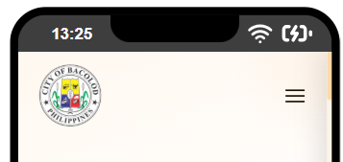
Mobile — hamburger button visible

Mobile — drawer open
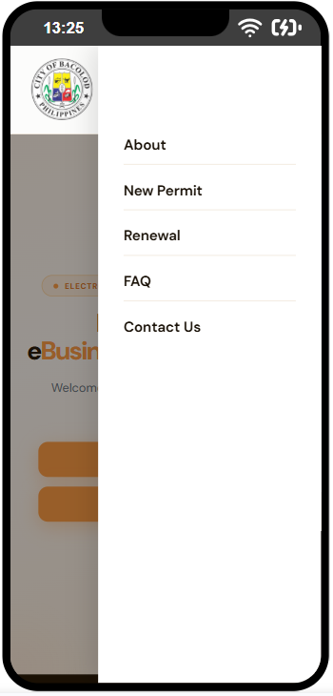

Hero Section
The introductory banner with the BOSS headline and the two primary call-to-action buttons.

Desktop
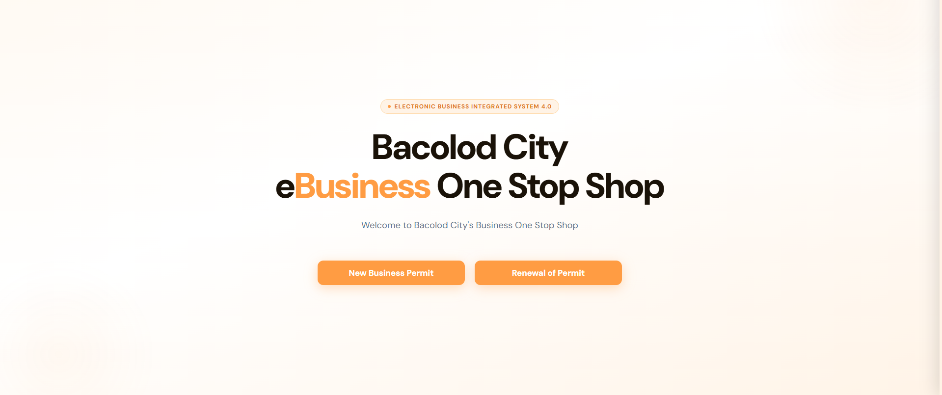

Mobile
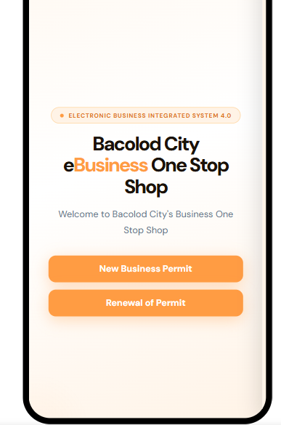

Agency Strip
The dark band listing all participating government departments and offices.

Desktop — horizontal flex row

Mobile — two-column grid
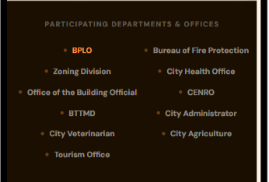

How It Works — New Business Permit
The full permit requirements and procedure guide for new business permit applications, using the orange accent theme.

Desktop — three-column layout (Requirements / Procedure / Documents)
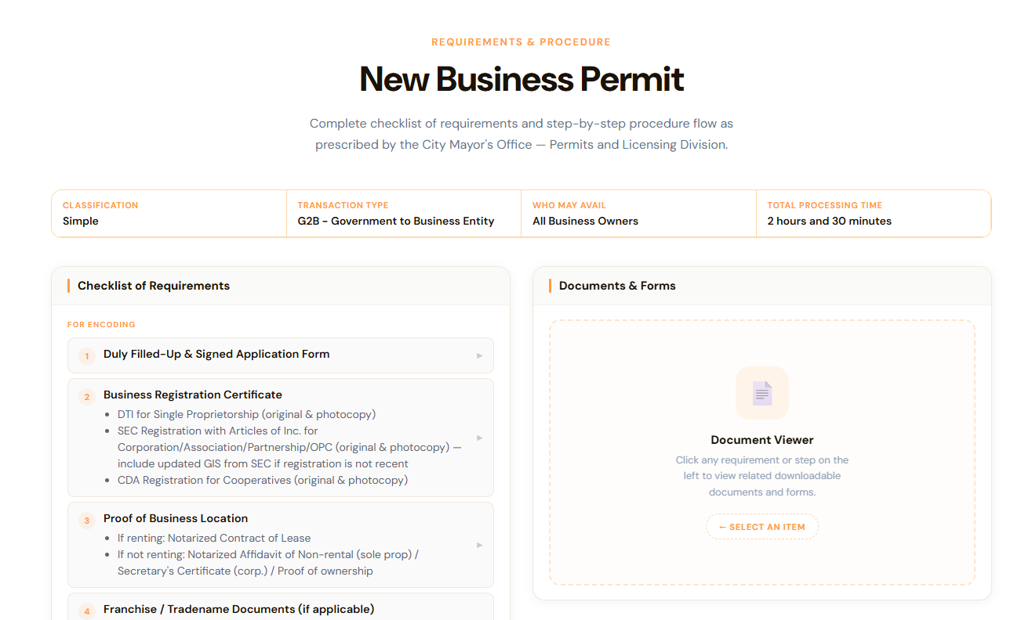

Desktop — document viewer with a requirement selected
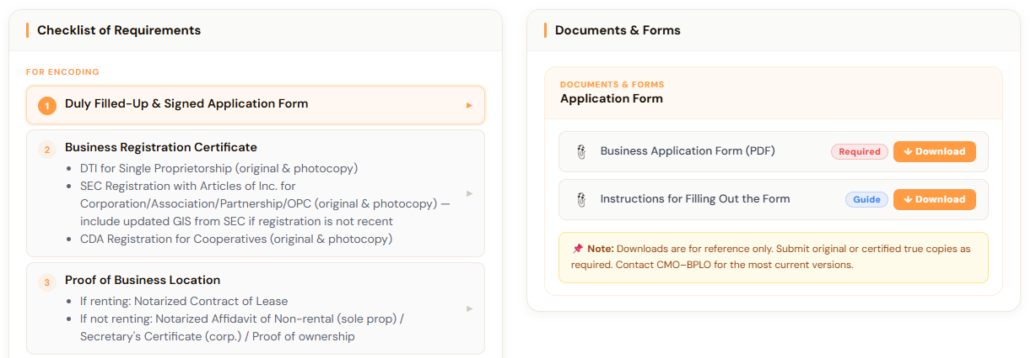
Mobile — single-column layout
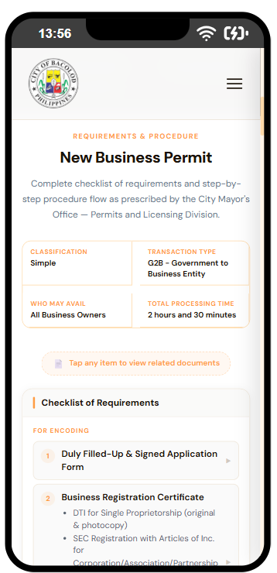

Mobile — document modal open
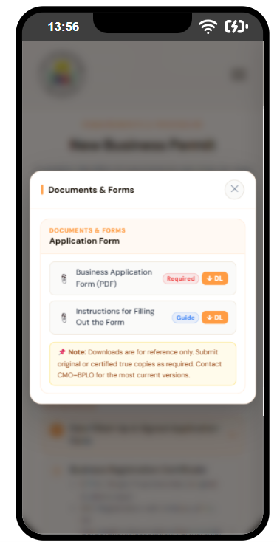

Renewal of Business Permit
The permit guide for renewal applications, using the blue accent theme. Shares the same layout structure as Section 14.4.

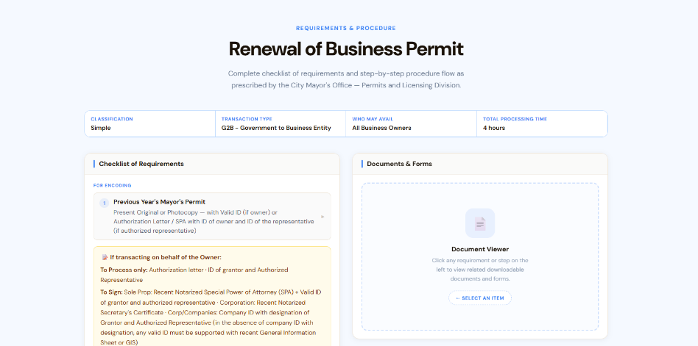
Desktop

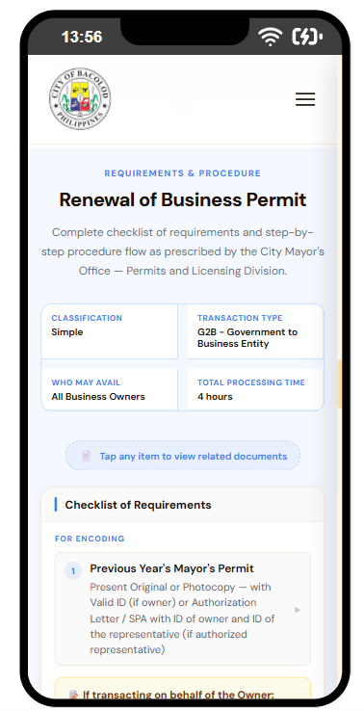
Mobile

Video Section
The embedded YouTube tutorial card with the fade-in animation fully resolved.

Desktop
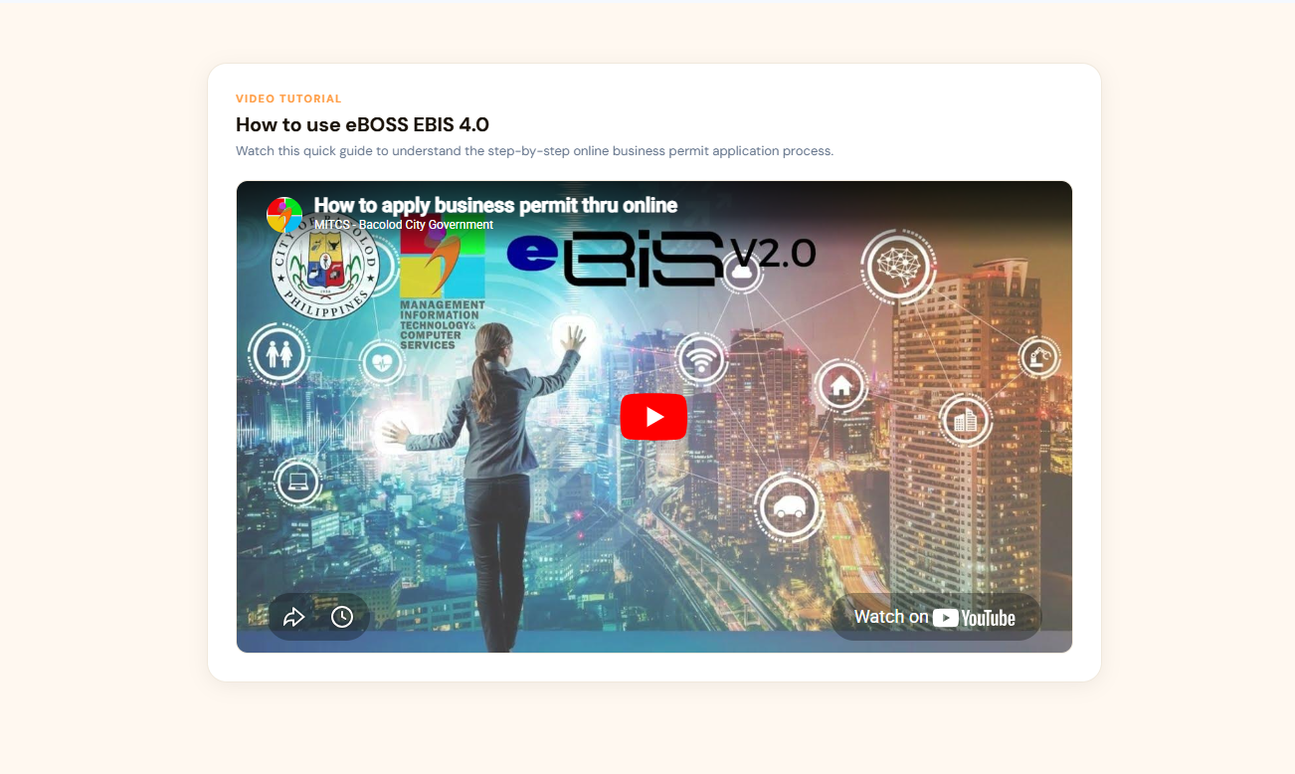

Mobile
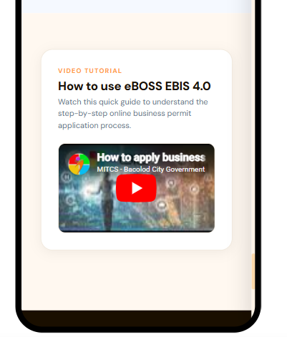

Footer
The site footer with brand attribution, navigation columns, and the compliance notice bar.

Desktop


Mobile
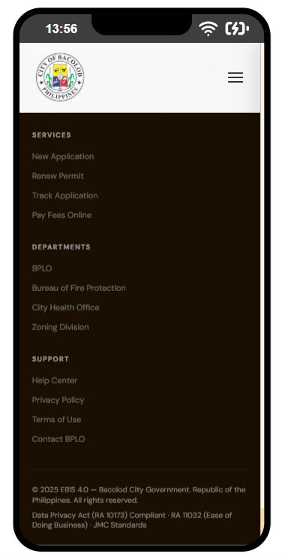

Known Gaps & Items for Future Development
The following items are present in the codebase in an incomplete or unused state. They are documented here both as an accurate record of current standing and as a reference for the next development cycle.

Incomplete Navigation Links
Location: src/data/constants.js → NAV_LINKS

Current state: The navigation includes links to #faq and #contact-us. Neither of these sections currently exists on the page. Clicking these links scrolls to nothing.

Recommended action: Build FAQ and Contact Us sections and register them in App.jsx, or remove the links from NAV_LINKS until those sections are ready for release.

Unused PHASES Constant
Location: src/data/constants.js → PHASES

Current state: A fully populated array describing the four phases of the BOSS process — including titles, descriptions, icons, and color assignments — is defined but not rendered anywhere on the page.

Recommended action: Develop a visual component (such as a phases timeline or step strip) that consumes this data and place it on the page, likely between the Hero section and the Agency Strip. The content and color values (#ff9c43, #3b82f6, #10b981, #8b5cf6) are already prepared.

Placeholder Download Files
Location: src/components/ui/PermitUI.jsx → DOC_REGISTRY; public/downloads/

Current state: All downloadable document links in DOC_REGISTRY point to /downloads/reference.pdf as a temporary stand-in. The public/downloads/docs/ and public/downloads/pdf/ directories exist but are otherwise empty.

Recommended action: Place the actual reference documents (application forms, checklists, sample permits, and similar materials) in public/downloads/, then update the href value for each entry in DOC_REGISTRY to point to the correct file. The tag and tagColor fields for each entry may also be finalized at that time.

Footer Links Not Wired
Location: src/components/layout/Footer.jsx

Current state: All links in the footer columns (Services, Departments, Support) point to # and do not navigate anywhere.

Recommended action: Assign the correct URLs or anchor targets to each footer link once the corresponding pages or sections become available.

CSS Color Tokens Not Consumed
Location: src/index.css (token declarations); all component files (usage)

Current state: Color tokens are defined as CSS custom properties in index.css but are not referenced via var()in component code. Instead, raw hex values are repeated as hardcoded strings throughout inline styles. A color change currently requires updating both index.css and every component where that color appears.

Recommended action: Refactor component inline styles to reference design tokens via var(--color-primary) etc. This is a lower-priority housekeeping item and does not affect current visual output or functionality, but would significantly reduce the effort required for future design changes.

Marquee Animation Defined but Unused
Location: src/App.css → .marquee-track, @keyframes marquee

Current state: A CSS keyframe animation for a horizontally scrolling ticker (28s linear infinite, pausing on hover) is defined and ready to use. The current AgencyStrip renders its content in a static layout and does not apply this class.

Recommended action: Apply .marquee-track to the AgencyStrip layout if a continuous scrolling effect is the intended design. If the static layout is preferred for the final release, the unused animation definition may be removed from App.css to keep the stylesheet clean.

