Matthew Ryan – Containers

**UBUNTU:**

**SOURCE(from the docker site documentation):** <https://docs.docker.com/engine/install/ubuntu/>

**First, we will set up a repo**

**Start off with a**

sudo apt-get update

**then, we must begin creating our repository.**

sudo apt-get install apt-transport-https ca-certificates curl gnupg-agent software-properties-common

**The packages will install, afterwards, enter this to add docker’s GPG key:**

curl -fsSL https://download.docker.com/linux/ubuntu/gpg | sudo apt-key add –

**when entered correctly, the terminal should output “OK”.**

**Now we will verify the key by matching the last 8 letters of it with the fingerprint.**

sudo apt-key fingerprint 0EBFCD88

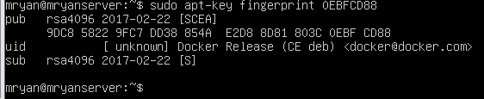

**If entered correctly, you should see this as output.**

**Now we will set up the repository.**

sudo add-apt-repository “deb [arch=amd64] <https://download.docker.com/linux/ubuntu> $(lsb_release -cs) stable”

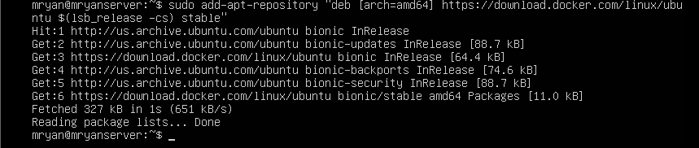

**If your terminal matches the picture above, you’re on the right track!**

**Now install the docker engine, run a**

sudo apt-get update

**Followed by,**

sudo apt-get install docker-ce docker-ce-cli containerd.io

**Now the docker engine should be installed! Try running this test script:**

sudo docker run hello-world

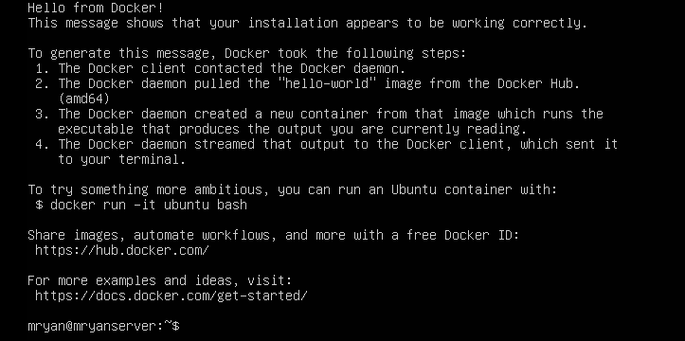**This output will let you know you did it correctly.**

**Installing Kubernetes:**

**Source:** <https://kubernetes.io/docs/tasks/tools/install-kubectl/>

**First, we’ll start off by downloading the latest version:**

curl -LO https://storage.googleapis.com/kubernetes-release/release/`curl -s https://storage.googleapis.com/kubernetes-release/release/stable.txt`/bin/linux/amd64/kubectl

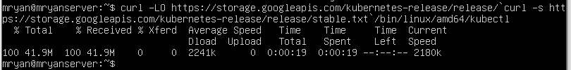

**You should see this output if you have entered it correctly.**

**Next, we will make Kubernetes executable:**

chmod +x ./kubectl

**Now, move it to your users folder so it may be ran**

sudo mv ./kubectl /usr/local/bin/kubectl

**Now, Kubernetes should be installed! You can verify this by entering**

kubectl cluster-info

**Note: A kubeconfig file is required for a cluster to be accessed by kubectl, it is created automatically when a Minikube cluster is created. The config location for kubectl is ~/.kube/config**

Minikube thoughts:

The Minikube installation was somewhat easy – I did run into some errors when I tried to start it. My terminal suggested to me that my minikube was out of date, so I followed the directions it suggested and I initiated a ‘sudo snap install’ of Minikube, this seemed to break it even further. It turns out I completely skipped installing a ‘hypervisor’, the problem seemed to be fixed after I installed VirtualBox.