Matthew Ryan

Linux Administration – Lab 1

STEP 1 – Go ahead and create a new virtual machine in VMware, and select the Ubuntu Server ISO for the installer disc image file.

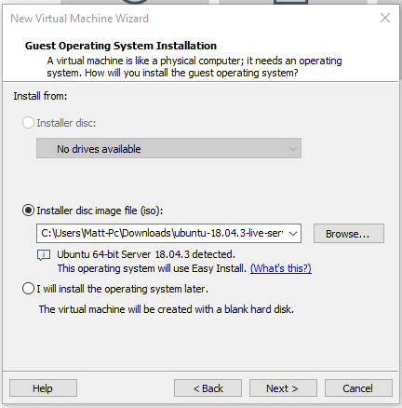

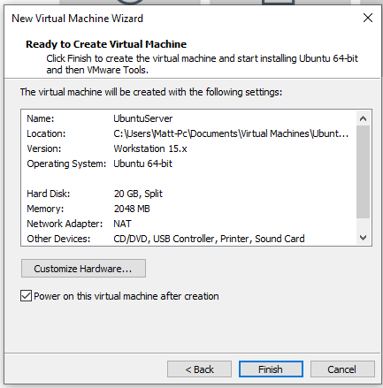

You can leave most of the Virtual Machine settings as is, go ahead and click ‘Finish’ to begin creating your virtual machine for Ubuntu Server.

STEP 2 – Once your Virtual machine starts, your screen should look something like this.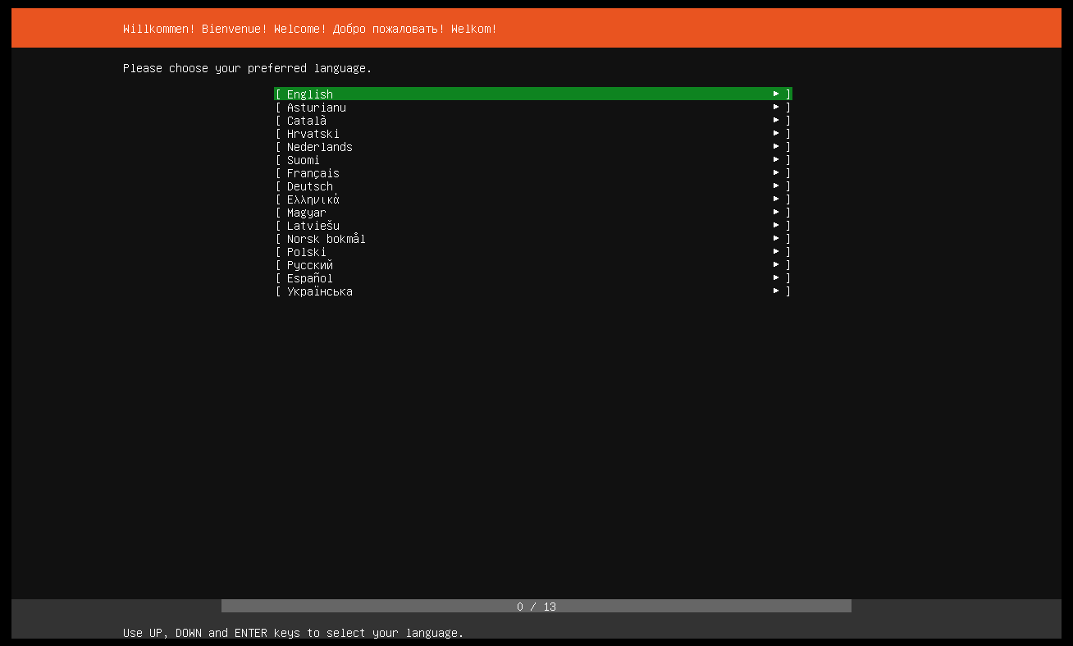

Go ahead and select any language of your choosing, using the arrow keys and enter to confirm.

STEP 3 – Create a server name, username and password.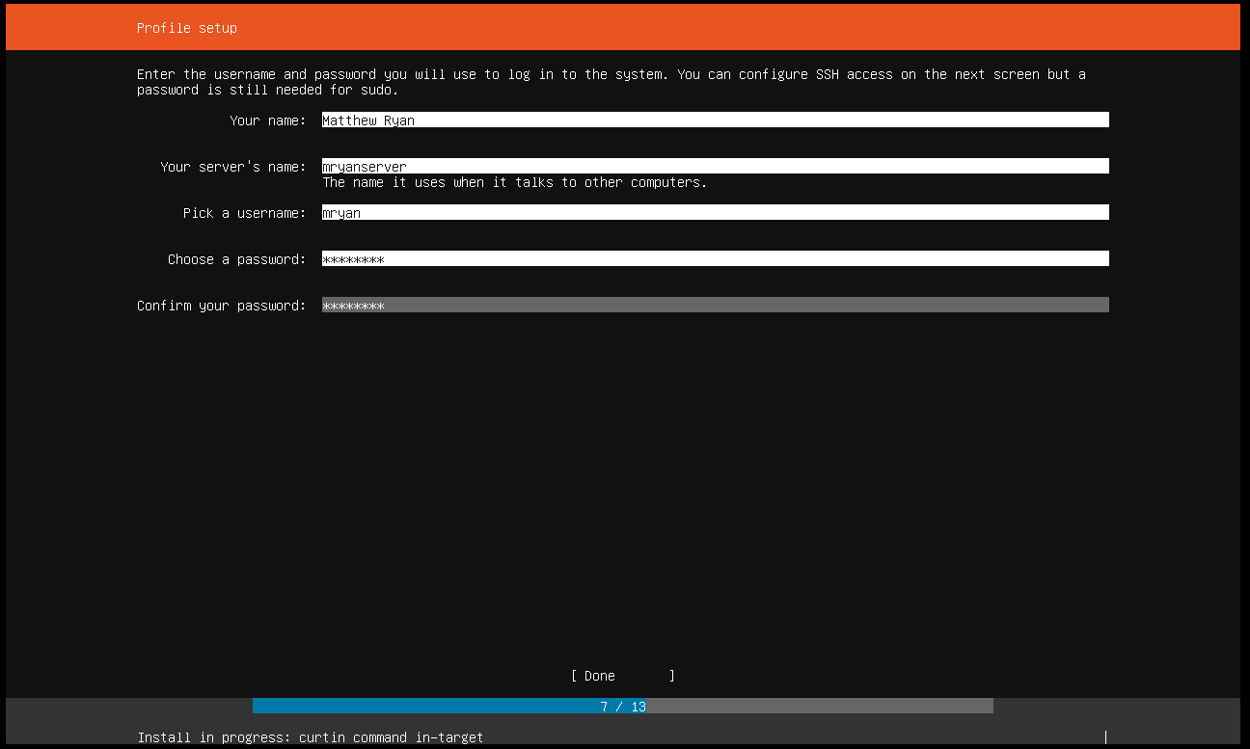

STEP 4 – When you select done, you can now wait for your server to finish installing. Select ‘Reboot’ at the bottom once the install has finished. 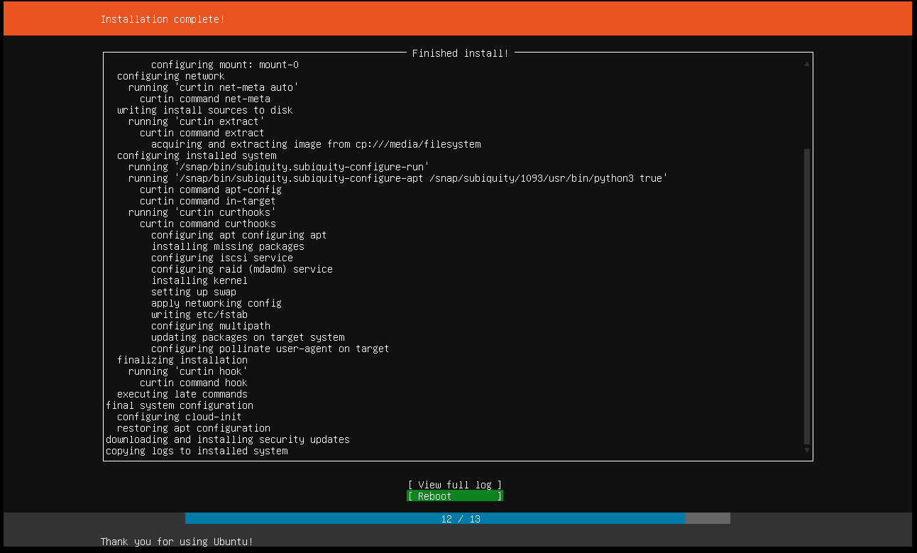

Go ahead and log into your server! You can start by running ‘sudo apt-get update’ , followed by‘sudo apt install nfs-kernel-server’ so we can begin file sharing on our network.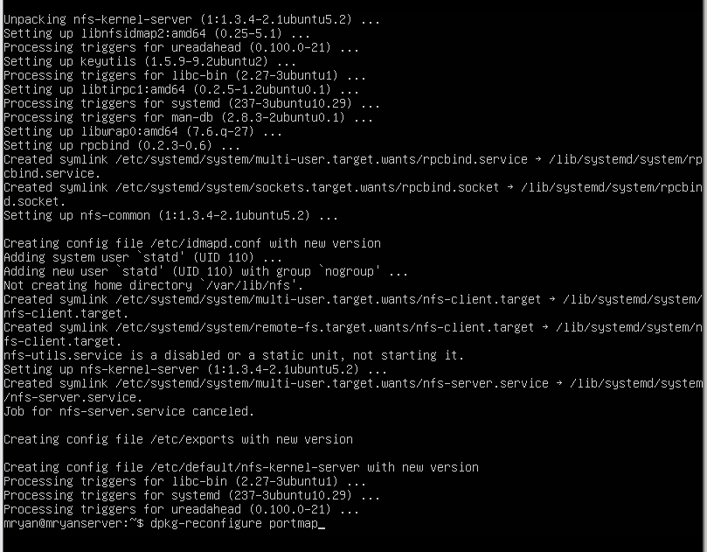

Now let’s get our Centos server up and running! If you are using CentOS 8, you need to first create a BLANK virtual machine with no operating system loaded onto it. Start your virtual machine, then change the settings to read from your CentOS 8 iso image. This is a workaround to an error we would recieve about a kickstart file.

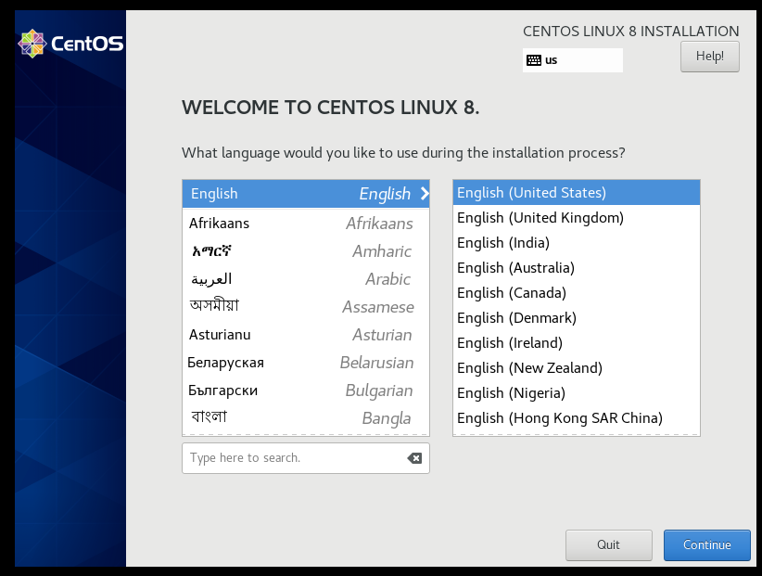

Now we should be at this screen! Go ahead and choose any language of your liking.

STEP 2 - 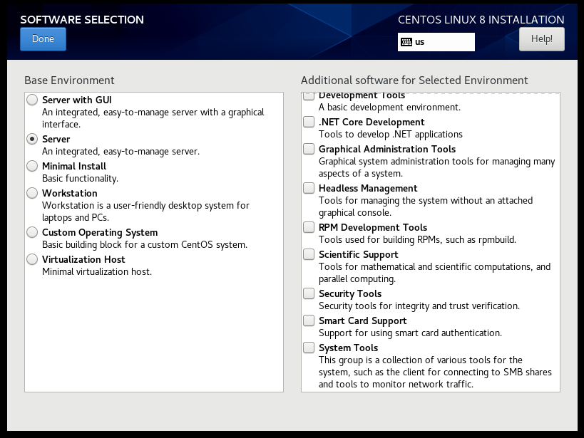

At the next menu select the ‘Software Selection’ panel using your cursor. Select the ‘Server’ option for th basic environment. Click ‘done’.

STEP 3 -

Select the ‘Installation Destination’ panel. Select the 20gb Virtual Machine memory unit. Click ‘done’.

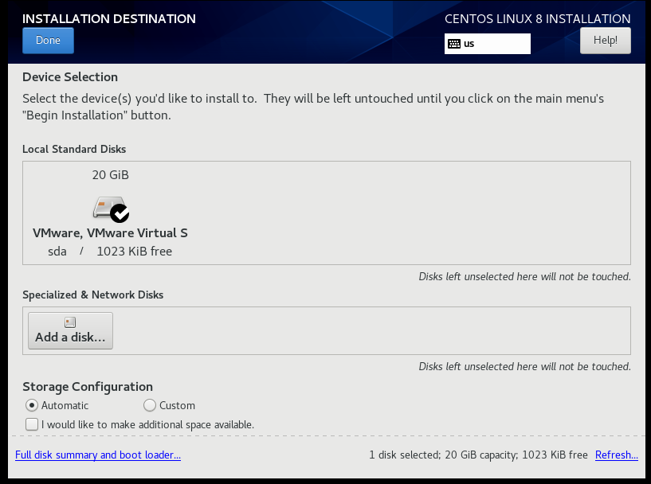

STEP 4 -

You should be able to install your server now! While this is happening, you can create your root password and user. Click ‘reboot’ once it is finished.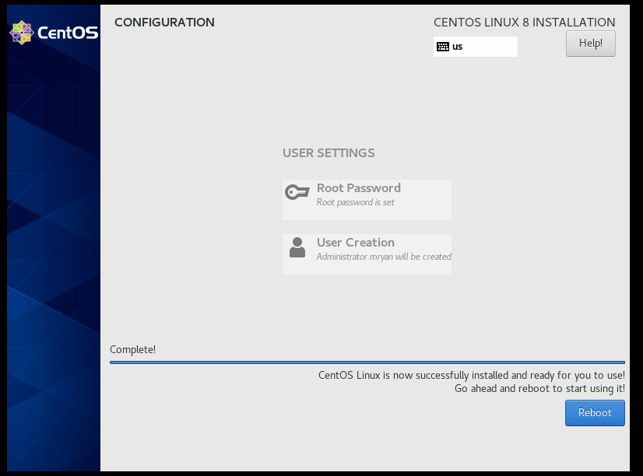

STEP 5 -

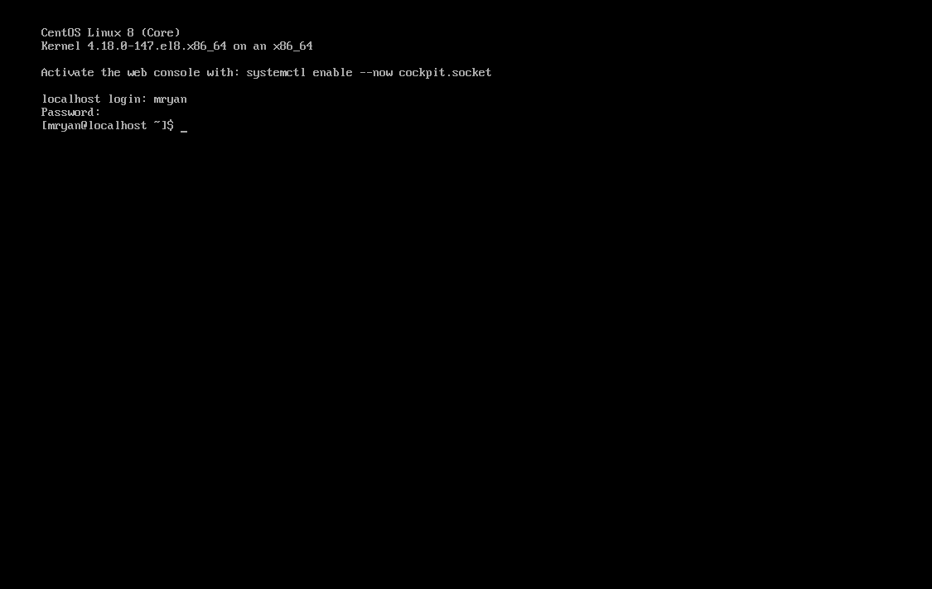

When the system reboots, you should be able to log into your new Linux server using CentOS!