**Matthew Ryan**

**Network Setup document**

UBUNTU:

Installed net-tools (sudo apt-get net-tools) : Feb 1

Network configuration file location:

/etc/netconfig

List DNS servers –

/etc/resolv.conf

SSH active on May 3,

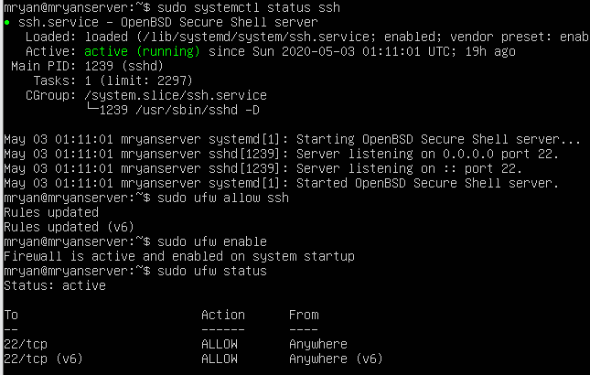

Running the script on a UBUNTU linux server:

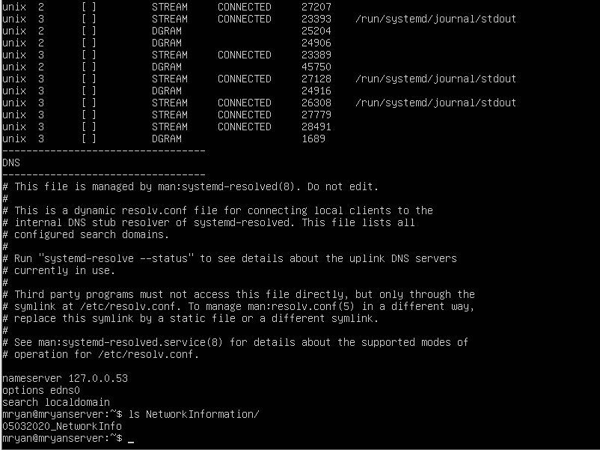

The script created a directory called “NetworkInformation” and dumped the contents of the command to a file labeled (date)_NetworkInfo. This script should be ran in the home directory.

CENTOS:

Installed net-tools, (sudo yum install net-tools): Feb 1,