GitHub Fundamentals: A Complete Instructional Guide for Students

Table of Contents
- Introduction
- Chapter 1: Introduction to Git and GitHub
- Chapter 2: Setting Up Git and GitHub
- Chapter 3: Your First GitHub Repository
- Chapter 4: The Essential Git Commands
- Chapter 5: Branching and Merging
- Chapter 6: Collaborating with Teams
- Chapter 7: Managing Issues and Projects
- Chapter 8: GitHub Best Practices
- Chapter 9: GitHub Actions & Automation
- Chapter 10: GitHub Pages and Hosting
- Chapter 11: Advanced GitHub Features
- Chapter 12: Contributing to Open Source Projects
- Chapter 13: Troubleshooting and Common Issues
- Conclusion
- Appendix: Glossary, Resources, Cheat Sheet
- Teaching Strategy

Introduction
Why Learn GitHub?
GitHub is the industry standard for hosting code, managing version control, and collaborating across teams. Students who learn GitHub gain practical skills for real-world development workflows, open-source contribution, and reproducible project management.

Chapter 1: Introduction to Git and GitHub
Git is a distributed version control system that tracks changes to files over time, allowing you to revert to earlier versions, collaborate safely, and maintain a history of work.
GitHub is a cloud-based hosting service built on top of Git. It adds collaboration features such as pull requests, issues, and web hosting.
Key terms: repository (a project storage), commit (a recorded change), branch (parallel line of development), clone (a local copy of a repo).
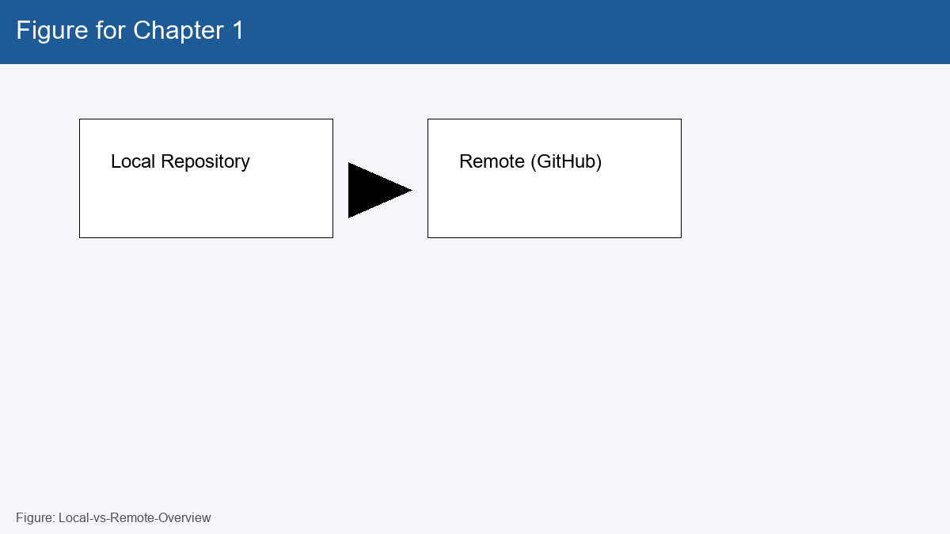
Figure 1: Local-vs-Remote-Overview

Post-Assessment Quiz
1) What is Git and why is it used?
2) How does Git differ from GitHub?
3) Define a repository in your own words.
4) What information does a commit store?
5) Explain what a branch is.
6) What does cloning a repository do?
7) Name two benefits of version control.
8) What is the purpose of a commit message?
9) How would you view the commit history of a repo?
10) Give an example scenario to create a branch.

Chapter 2: Setting Up Git and GitHub
Install Git from the official website, package manager, or use GitHub Desktop for a GUI experience.
Configure your username and email so your commits are associated with your identity: these settings appear in commit metadata and on GitHub profiles.
Set up SSH keys or use HTTPS for authentication; SSH is more convenient for frequent pushes.
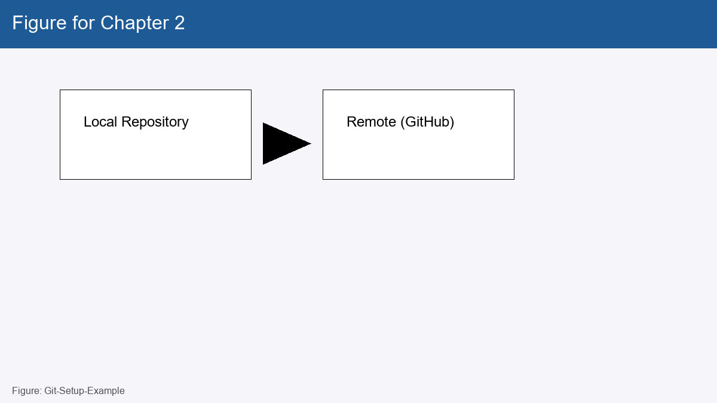
Figure 2: Git-Setup-Example

Post-Assessment Quiz
1) How do you install Git on a machine? (list common methods)
2) What commands set your Git username and email?
3) Why is configuring your email important for commits?
4) What is GitHub Desktop used for?
5) Describe one benefit of the GitHub CLI.
6) How do you connect your local Git to GitHub?
7) What are the pros/cons of SSH vs HTTPS for Git remotes?
8) How can you verify your Git installation?
9) Where are global Git configs stored?
10) How do you create a GitHub account?

Chapter 3: Your First GitHub Repository
A repository contains the project files, history, and configuration. On GitHub you can create repos from the website or import existing code.
Cloning copies a remote repository to your local machine. Initializing a repo locally creates a new Git history for your project.
Making your first commit captures the initial state of your project and starts the history.
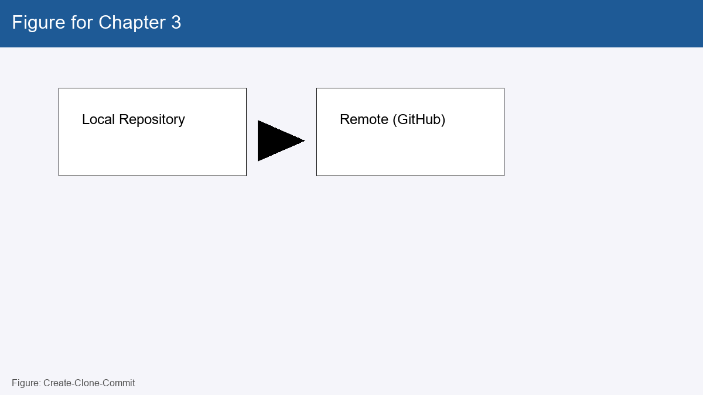
Figure 3: Create-Clone-Commit

Post-Assessment Quiz
1) Chapter 3 question 1: Explain or describe a concept from chapter 3.
2) Chapter 3 question 2: Explain or describe a concept from chapter 3.
3) Chapter 3 question 3: Explain or describe a concept from chapter 3.
4) Chapter 3 question 4: Explain or describe a concept from chapter 3.
5) Chapter 3 question 5: Explain or describe a concept from chapter 3.
6) Chapter 3 question 6: Explain or describe a concept from chapter 3.
7) Chapter 3 question 7: Explain or describe a concept from chapter 3.
8) Chapter 3 question 8: Explain or describe a concept from chapter 3.
9) Chapter 3 question 9: Explain or describe a concept from chapter 3.
10) Chapter 3 question 10: Explain or describe a concept from chapter 3.

Chapter 4: The Essential Git Commands
git init initializes a new local repository.
git add stages changes to be included in the next commit; git commit records those changes.
git status shows current state; git log lists commit history; git push uploads commits to a remote; git pull fetches and merges updates.
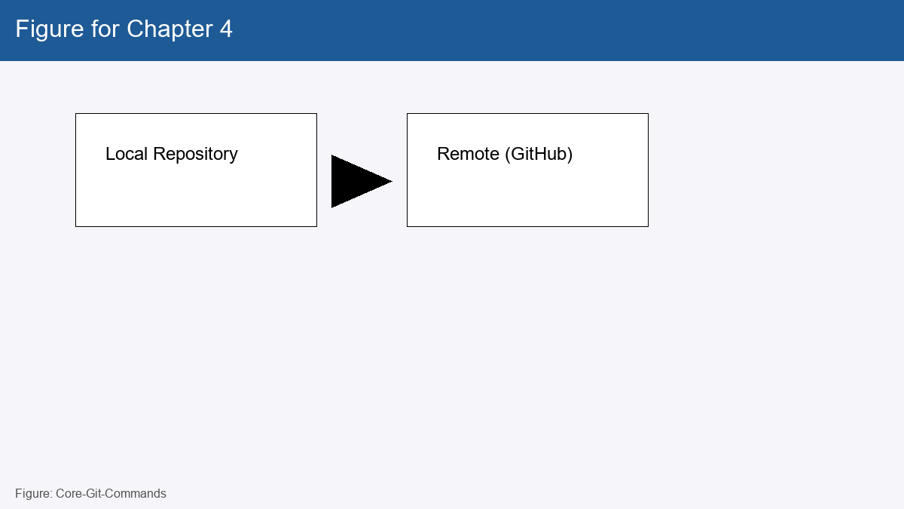
Figure 4: Core-Git-Commands

Post-Assessment Quiz
1) Chapter 4 question 1: Explain or describe a concept from chapter 4.
2) Chapter 4 question 2: Explain or describe a concept from chapter 4.
3) Chapter 4 question 3: Explain or describe a concept from chapter 4.
4) Chapter 4 question 4: Explain or describe a concept from chapter 4.
5) Chapter 4 question 5: Explain or describe a concept from chapter 4.
6) Chapter 4 question 6: Explain or describe a concept from chapter 4.
7) Chapter 4 question 7: Explain or describe a concept from chapter 4.
8) Chapter 4 question 8: Explain or describe a concept from chapter 4.
9) Chapter 4 question 9: Explain or describe a concept from chapter 4.
10) Chapter 4 question 10: Explain or describe a concept from chapter 4.

Chapter 5: Branching and Merging
Branches let you work on features independently of the main codebase. Use branches for new features, bug fixes, or experiments.
Merging integrates changes from one branch into another. Conflicts may occur when the same lines were edited; resolving them is part of collaboration.
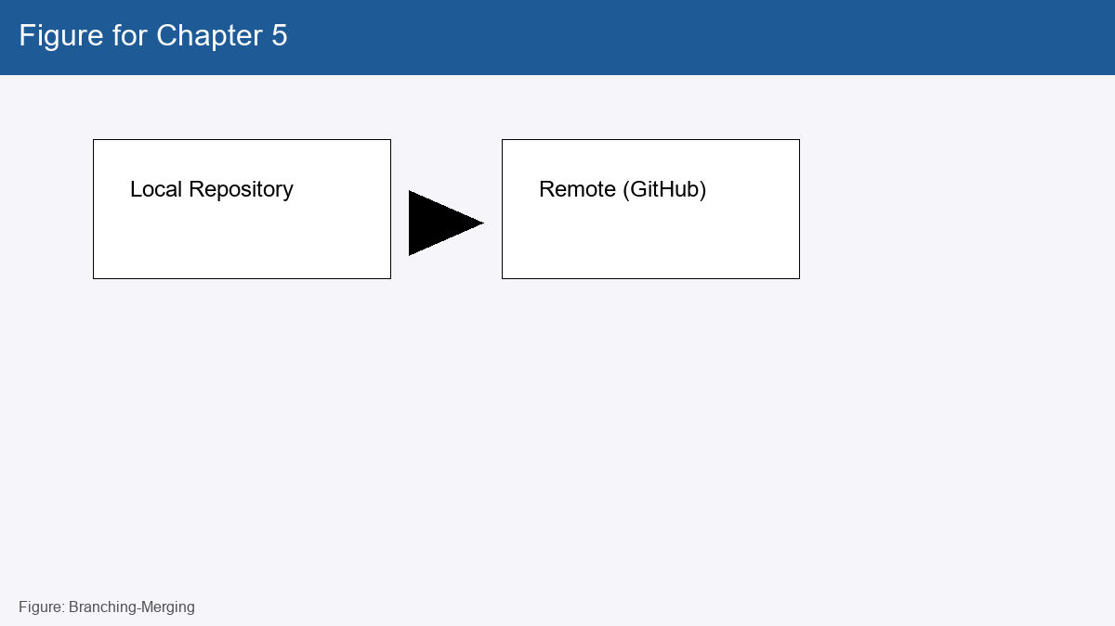
Figure 5: Branching-Merging

Post-Assessment Quiz
1) Chapter 5 question 1: Explain or describe a concept from chapter 5.
2) Chapter 5 question 2: Explain or describe a concept from chapter 5.
3) Chapter 5 question 3: Explain or describe a concept from chapter 5.
4) Chapter 5 question 4: Explain or describe a concept from chapter 5.
5) Chapter 5 question 5: Explain or describe a concept from chapter 5.
6) Chapter 5 question 6: Explain or describe a concept from chapter 5.
7) Chapter 5 question 7: Explain or describe a concept from chapter 5.
8) Chapter 5 question 8: Explain or describe a concept from chapter 5.
9) Chapter 5 question 9: Explain or describe a concept from chapter 5.
10) Chapter 5 question 10: Explain or describe a concept from chapter 5.

Chapter 6: Collaborating with Teams
GitHub provides collaboration tools: forks, pull requests, code review, protected branches, and collaborators/teams.
A typical workflow: fork (or branch) -> implement changes -> open a PR -> review -> merge when approved.
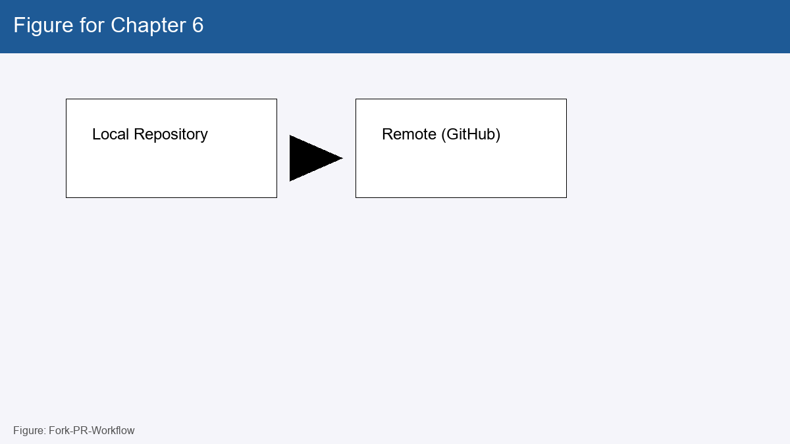
Figure 6: Fork-PR-Workflow

Post-Assessment Quiz
1) Chapter 6 question 1: Explain or describe a concept from chapter 6.
2) Chapter 6 question 2: Explain or describe a concept from chapter 6.
3) Chapter 6 question 3: Explain or describe a concept from chapter 6.
4) Chapter 6 question 4: Explain or describe a concept from chapter 6.
5) Chapter 6 question 5: Explain or describe a concept from chapter 6.
6) Chapter 6 question 6: Explain or describe a concept from chapter 6.
7) Chapter 6 question 7: Explain or describe a concept from chapter 6.
8) Chapter 6 question 8: Explain or describe a concept from chapter 6.
9) Chapter 6 question 9: Explain or describe a concept from chapter 6.
10) Chapter 6 question 10: Explain or describe a concept from chapter 6.

Chapter 7: Managing Issues and Projects
Issues track bugs, tasks, and feature requests. Labels, assignees, and milestones help triage work.
GitHub Projects (Kanban) help visualize workflow: backlog -> in progress -> done.
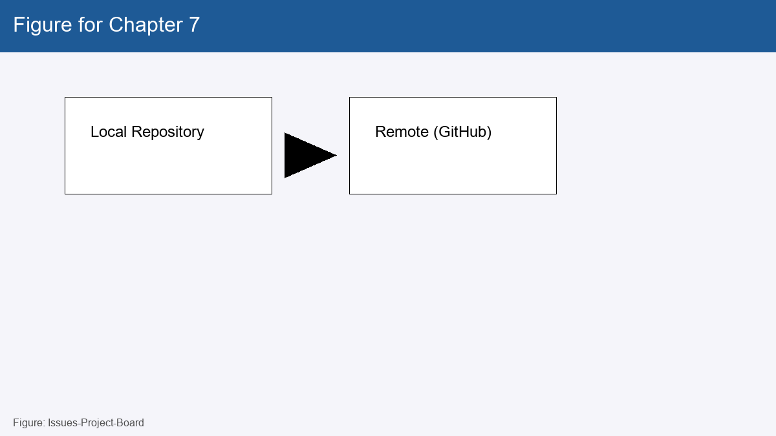
Figure 7: Issues-Project-Board

Post-Assessment Quiz
1) Chapter 7 question 1: Explain or describe a concept from chapter 7.
2) Chapter 7 question 2: Explain or describe a concept from chapter 7.
3) Chapter 7 question 3: Explain or describe a concept from chapter 7.
4) Chapter 7 question 4: Explain or describe a concept from chapter 7.
5) Chapter 7 question 5: Explain or describe a concept from chapter 7.
6) Chapter 7 question 6: Explain or describe a concept from chapter 7.
7) Chapter 7 question 7: Explain or describe a concept from chapter 7.
8) Chapter 7 question 8: Explain or describe a concept from chapter 7.
9) Chapter 7 question 9: Explain or describe a concept from chapter 7.
10) Chapter 7 question 10: Explain or describe a concept from chapter 7.

Chapter 8: GitHub Best Practices
Write clear commit messages (what and why), keep repositories modular, maintain a concise README, and use .gitignore to exclude generated files.
Use branches, descriptive PR titles, and periodic rebase or squash to keep history readable where appropriate.
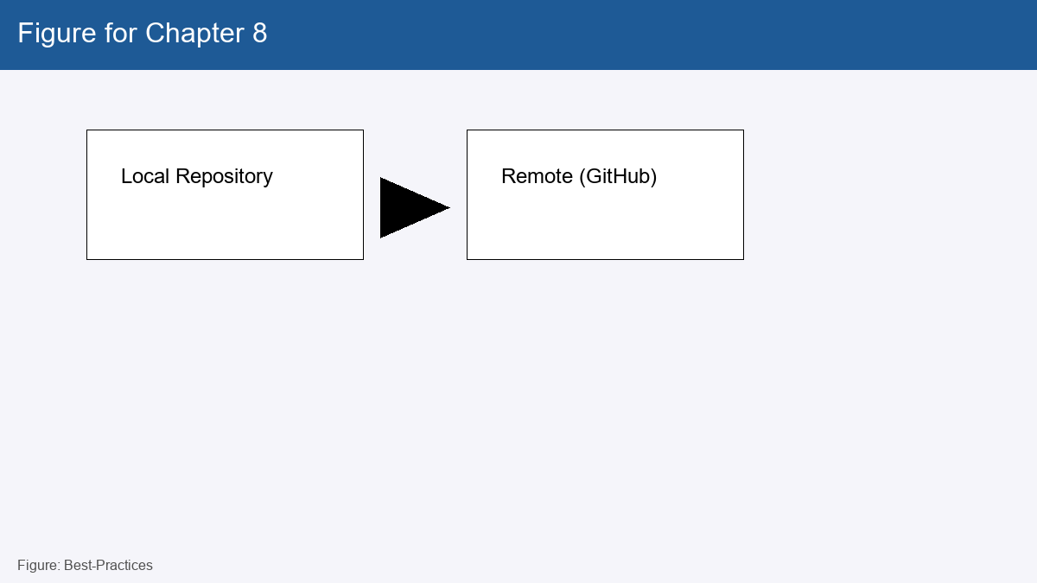
Figure 8: Best-Practices

Post-Assessment Quiz
1) Chapter 8 question 1: Explain or describe a concept from chapter 8.
2) Chapter 8 question 2: Explain or describe a concept from chapter 8.
3) Chapter 8 question 3: Explain or describe a concept from chapter 8.
4) Chapter 8 question 4: Explain or describe a concept from chapter 8.
5) Chapter 8 question 5: Explain or describe a concept from chapter 8.
6) Chapter 8 question 6: Explain or describe a concept from chapter 8.
7) Chapter 8 question 7: Explain or describe a concept from chapter 8.
8) Chapter 8 question 8: Explain or describe a concept from chapter 8.
9) Chapter 8 question 9: Explain or describe a concept from chapter 8.
10) Chapter 8 question 10: Explain or describe a concept from chapter 8.

Chapter 9: GitHub Actions & Automation
Actions automate workflows like running tests, linting, and deployment. Define workflows in YAML files under .github/workflows.
Continuous Integration (CI) runs tests automatically on push or PRs to catch regressions early.
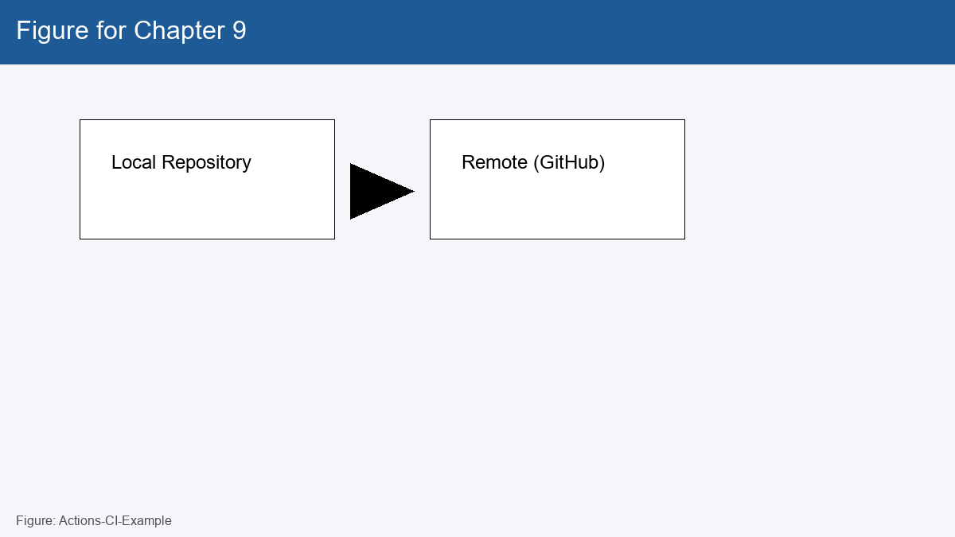
Figure 9: Actions-CI-Example

Post-Assessment Quiz
1) Chapter 9 question 1: Explain or describe a concept from chapter 9.
2) Chapter 9 question 2: Explain or describe a concept from chapter 9.
3) Chapter 9 question 3: Explain or describe a concept from chapter 9.
4) Chapter 9 question 4: Explain or describe a concept from chapter 9.
5) Chapter 9 question 5: Explain or describe a concept from chapter 9.
6) Chapter 9 question 6: Explain or describe a concept from chapter 9.
7) Chapter 9 question 7: Explain or describe a concept from chapter 9.
8) Chapter 9 question 8: Explain or describe a concept from chapter 9.
9) Chapter 9 question 9: Explain or describe a concept from chapter 9.
10) Chapter 9 question 10: Explain or describe a concept from chapter 9.

Chapter 10: GitHub Pages and Hosting
GitHub Pages hosts static websites directly from a repository. Use it for project pages, documentation, or personal sites.
Choose a publishing source (branch or /docs folder) and optionally configure a custom domain.
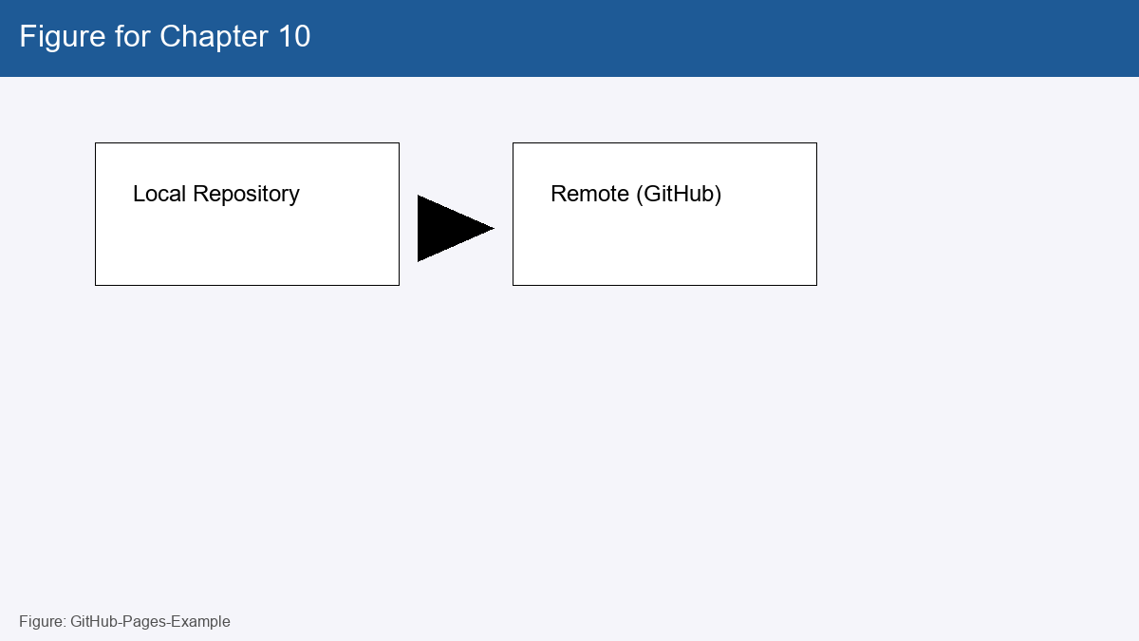
Figure 10: GitHub-Pages-Example

Post-Assessment Quiz
1) Chapter 10 question 1: Explain or describe a concept from chapter 10.
2) Chapter 10 question 2: Explain or describe a concept from chapter 10.
3) Chapter 10 question 3: Explain or describe a concept from chapter 10.
4) Chapter 10 question 4: Explain or describe a concept from chapter 10.
5) Chapter 10 question 5: Explain or describe a concept from chapter 10.
6) Chapter 10 question 6: Explain or describe a concept from chapter 10.
7) Chapter 10 question 7: Explain or describe a concept from chapter 10.
8) Chapter 10 question 8: Explain or describe a concept from chapter 10.
9) Chapter 10 question 9: Explain or describe a concept from chapter 10.
10) Chapter 10 question 10: Explain or describe a concept from chapter 10.

Chapter 11: Advanced GitHub Features
GitHub Packages lets you publish packages; Insights provides repository analytics; the GitHub API enables automation and integrations.
Explore Actions marketplace, Dependabot alerts, and security scanning for mature workflows.
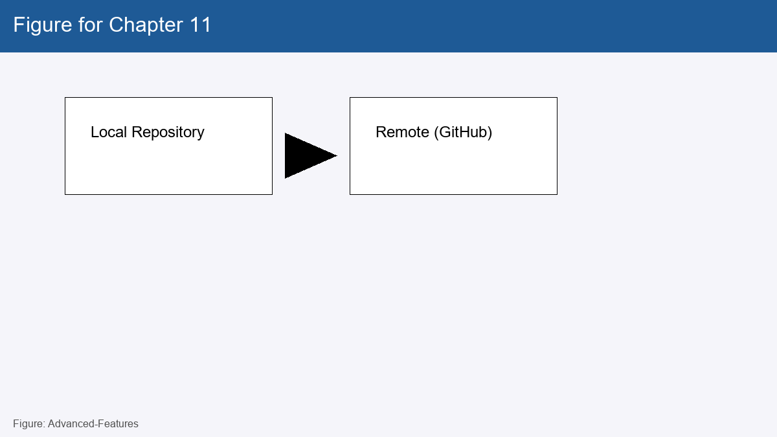
Figure 11: Advanced-Features

Post-Assessment Quiz
1) Chapter 11 question 1: Explain or describe a concept from chapter 11.
2) Chapter 11 question 2: Explain or describe a concept from chapter 11.
3) Chapter 11 question 3: Explain or describe a concept from chapter 11.
4) Chapter 11 question 4: Explain or describe a concept from chapter 11.
5) Chapter 11 question 5: Explain or describe a concept from chapter 11.
6) Chapter 11 question 6: Explain or describe a concept from chapter 11.
7) Chapter 11 question 7: Explain or describe a concept from chapter 11.
8) Chapter 11 question 8: Explain or describe a concept from chapter 11.
9) Chapter 11 question 9: Explain or describe a concept from chapter 11.
10) Chapter 11 question 10: Explain or describe a concept from chapter 11.

Chapter 12: Contributing to Open Source Projects
Find projects by interests, check contribution guidelines, and start with small issues or documentation improvements.
Respect project etiquette: read the README and CODE_OF_CONDUCT, write clear PR descriptions, and respond to review feedback.
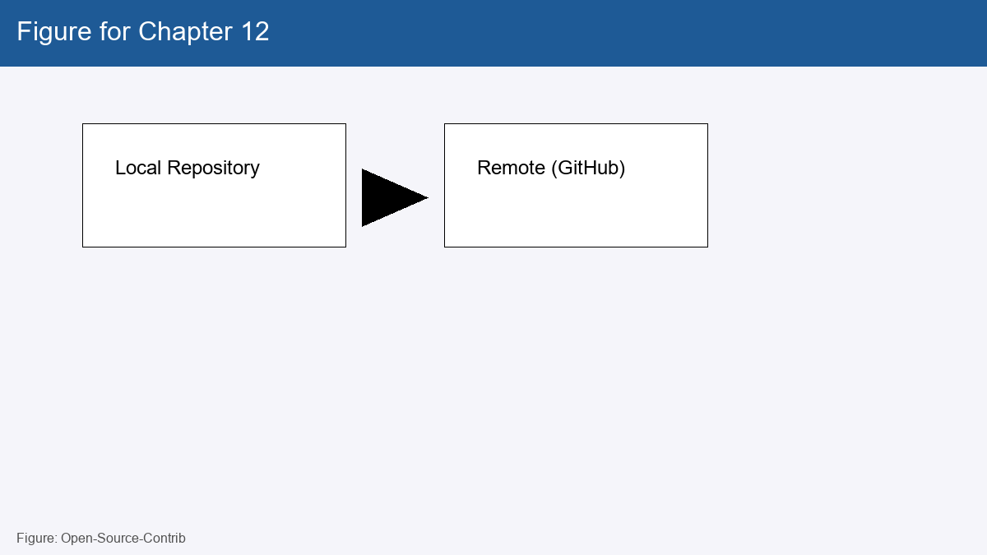
Figure 12: Open-Source-Contrib

Post-Assessment Quiz
1) Chapter 12 question 1: Explain or describe a concept from chapter 12.
2) Chapter 12 question 2: Explain or describe a concept from chapter 12.
3) Chapter 12 question 3: Explain or describe a concept from chapter 12.
4) Chapter 12 question 4: Explain or describe a concept from chapter 12.
5) Chapter 12 question 5: Explain or describe a concept from chapter 12.
6) Chapter 12 question 6: Explain or describe a concept from chapter 12.
7) Chapter 12 question 7: Explain or describe a concept from chapter 12.
8) Chapter 12 question 8: Explain or describe a concept from chapter 12.
9) Chapter 12 question 9: Explain or describe a concept from chapter 12.
10) Chapter 12 question 10: Explain or describe a concept from chapter 12.

Chapter 13: Troubleshooting and Common Issues
Common problems: merge conflicts, authentication errors, accidental commits. Use git reflog, revert, and reset carefully to recover.
When push fails, check remote URL, authentication, and if the branch is protected.
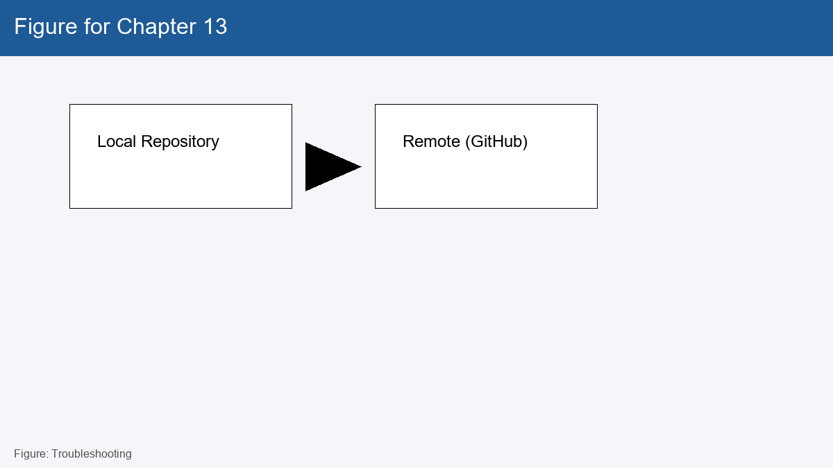
Figure 13: Troubleshooting

Post-Assessment Quiz
1) Chapter 13 question 1: Explain or describe a concept from chapter 13.
2) Chapter 13 question 2: Explain or describe a concept from chapter 13.
3) Chapter 13 question 3: Explain or describe a concept from chapter 13.
4) Chapter 13 question 4: Explain or describe a concept from chapter 13.
5) Chapter 13 question 5: Explain or describe a concept from chapter 13.
6) Chapter 13 question 6: Explain or describe a concept from chapter 13.
7) Chapter 13 question 7: Explain or describe a concept from chapter 13.
8) Chapter 13 question 8: Explain or describe a concept from chapter 13.
9) Chapter 13 question 9: Explain or describe a concept from chapter 13.
10) Chapter 13 question 10: Explain or describe a concept from chapter 13.

Appendix
Glossary of Terms
Additional Resources (Books, Websites, Tutorials)
Further Reading on GitHub Features
Cheat Sheet of Common Git Commands

Teaching Strategy
Hands-On Approach: Each chapter will come with practical exercises and a post-assessment quiz.
Project-Based Learning: Students will work on collaborative projects and apply what they've learned.
Real-Life Scenarios: Encourage students to create personal or group projects on GitHub.
Peer Review & Collaboration: Foster a collaborative environment by integrating peer reviews and GitHub PRs.

