Prototype

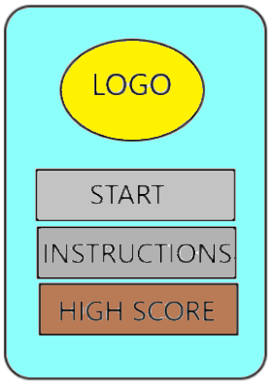

This is the main screen of the game that we are planning on creating.

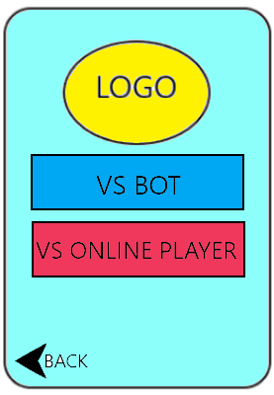



After clicking in start button this will be the next pop up screen that will appear.

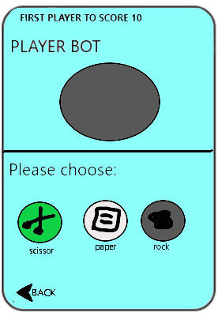

If you click on the “VS BOT” this will be the next scene on your screen, with this you have to fight against bot player that randomly pick its choice between scissors, paper, and rock.

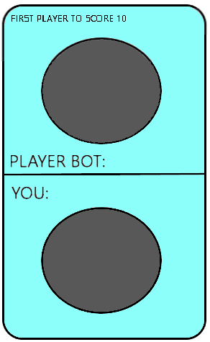

After making your choice, this screen will pop up your pick and the randomly picked but the bot and this will determine if you win the round or not.

After determining the choices this screen will tell you the score of the game for several seconds and the game still continuous.

This screen will tell you who will win the game, if you click on exit it will give you the main screen. For try again it will only repeat the game.

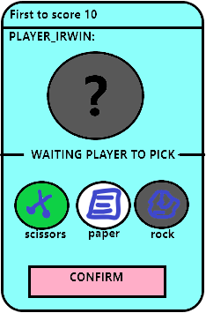.

This is the screen that will pop up if you click on the “VS ONLINE PLAYER”. You will compete with different people in the world with the use of internet connection.

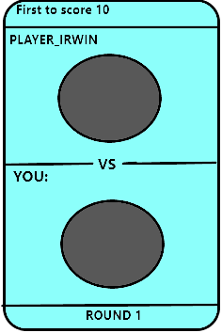

This is when you picked your choice and you are waiting for the other player to pick and as soon as both sides pick their choice it will automatically shows and with that you will determine if you won the game or not.

It will also show the match points per game and still continuous until one player reached up to 10 point and this will pop up and tells the players who won the match.

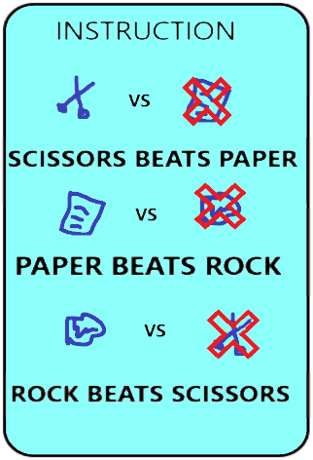

This is the next path if you click on the instruction in the main screen of the game.

This is the “HIGH SCORE” path wherein it will continuously change depending on the wins of the users of the game through online mode.