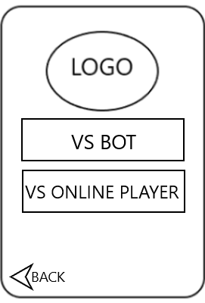Wireframe



