**Reva Baumann**

**Web 330**

**Assignment 1.5**

**22 April 2019**

Inspiration:

<http://seanhalpin.io/>

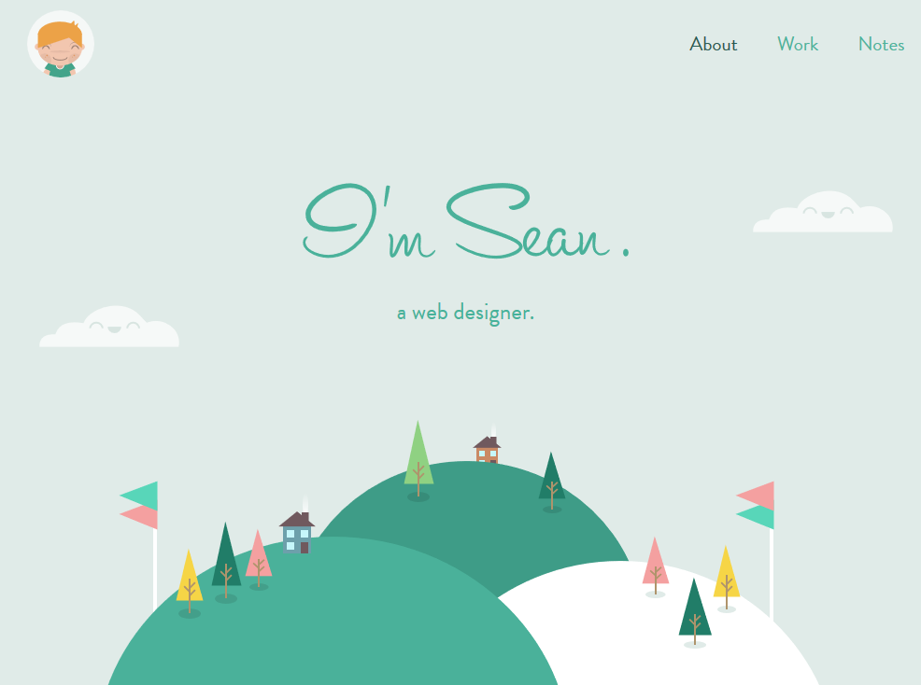

**Advantages**: Simplistic layout with minimalist graphics. Simple explanation of services offered. Website is extremely simple, it has three hyperlinks and a button to email the developer. **Disadvantages**: Website could be too simplistic, could add more information or details to make the website more dynamic. The layout is also very simple, so there’s few items to interact with. This could appeal to people that find it difficult to use the website. Overall, the style and aesthetic of the website is something that appeals to me. It’s colorful, it has a strong illustrational influence and a solid typeface. It has ease of use and a simple functionality.

**Overall Grade**: B

<http://www.rleonardi.com/>

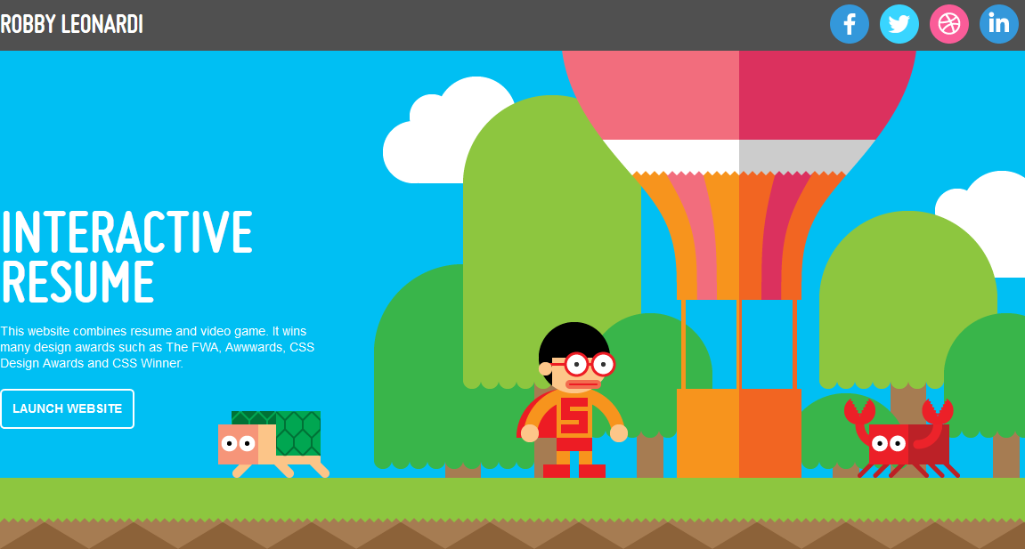

**Advantages**: This website is interactive and easily keeps clients and potential customers engaged. It’s colorful, bright and illustrative. Each button launches a different environment, like the resume, portfolio, and design portfolio. When a client clicks the Resume button, a new window opens. It’s fun and intuitive and although it’s extremely responsive, the layout is simplistic and easy to use. **Disadvantages**: Since each button launches a different area of the website, that means working with multiple dynamic systems and could mean a lot of work on the front end. However, any changes made to a single page could potentially not break the website, just the single page (assuming that each button launches an independent project, which it’s possible that it isn’t coded that way). I enjoy the style choices, it’s reminiscent of Mario and old-school video games. I like that it combines old school tech nostalgia with a modern feel. It’s has strong usability and it’s interactive, simple and engaging.

**Overall Grade:** A

<http://findmatthew.com/>

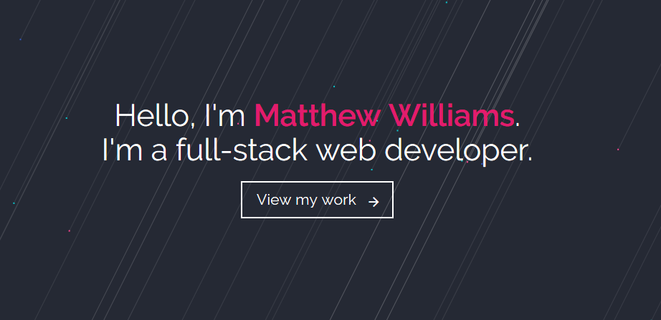

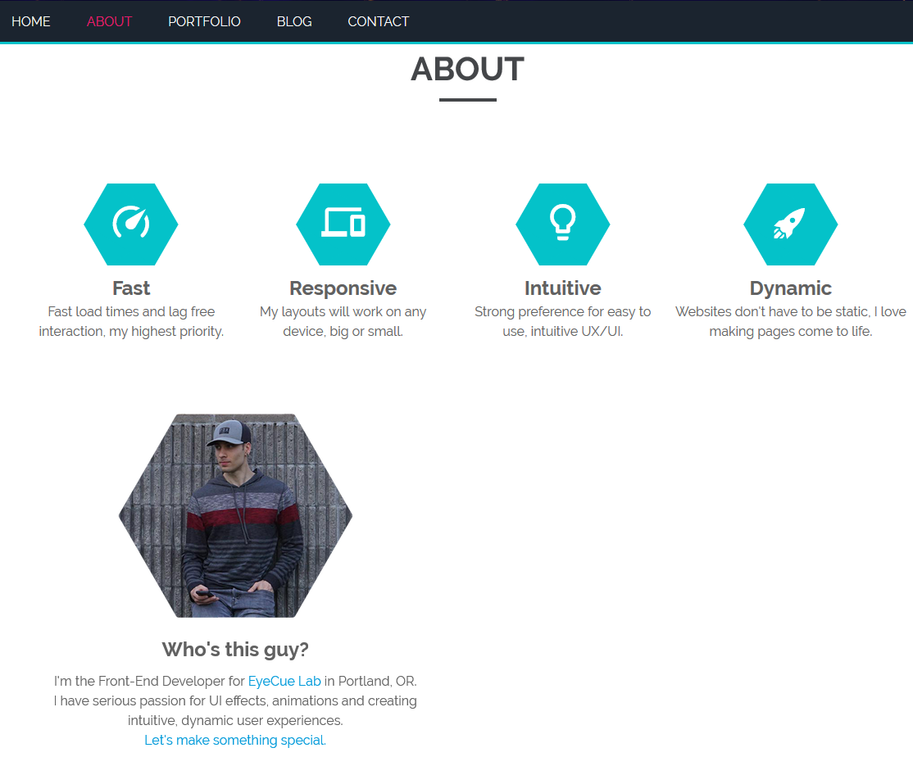

**Advantages**: Simplistic website that’s responsive and feels easy to use. It’s minimalistic and each element is responsive and simple. **Disadvantages**: Another simplistic website. It’s possible that it’s not enough to keep the customer engaged. Aesthetically, I like the style. It’s also a little flat, because it has only a few colors to focus on. I think there could be more available on this page, just by listing more services and creating more elements that a client can interact with.

**Overall Grade**: B-

https://toyfight.co/what/

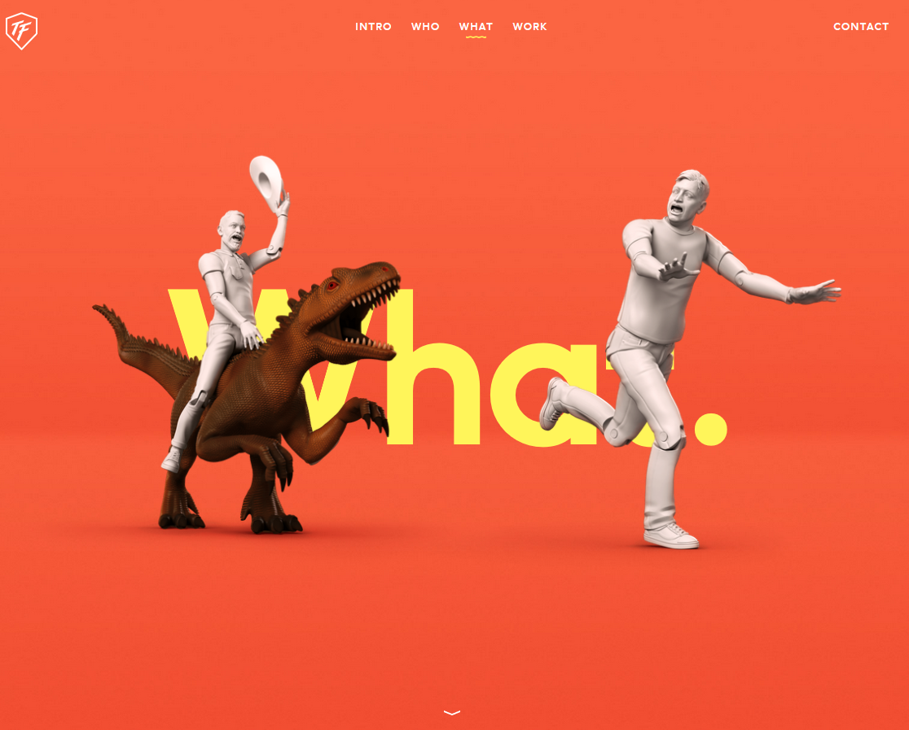

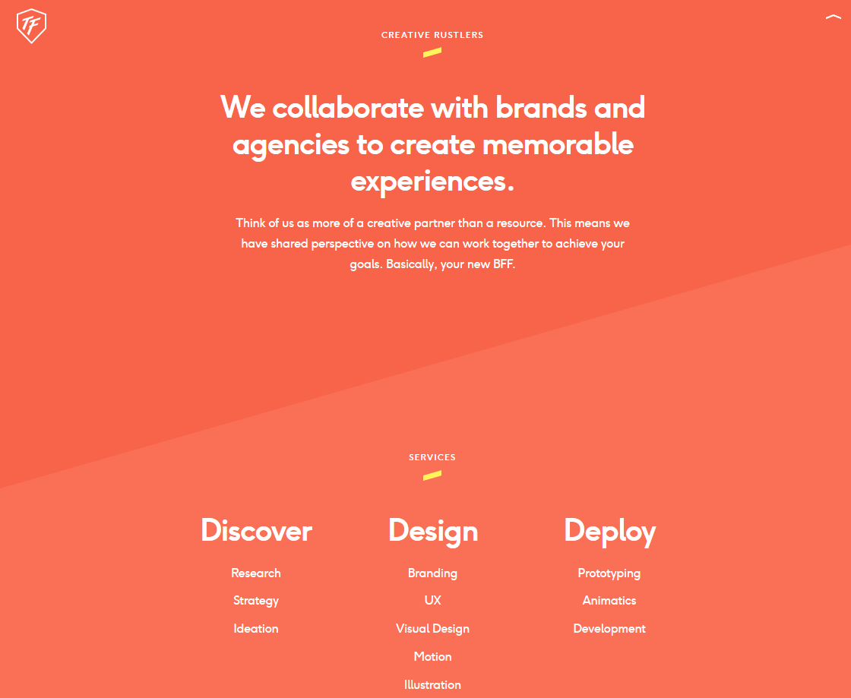

**Advantages**: This website is fun and responsive. It’s graphically minimalistic, but lists a number of their services. It’s intuitive, without being overly complicated. They list a number of their client brands and awards. **Disadvantages**: I don’t find any disadvantages on this website. It’s professional, it has some humor and it appeals to users. This website stylistically is very strong, the colors feel warm, typeface is appealing and graphics are engaging.

**Overall Grade:** A+

http://hannahpurmort.com/

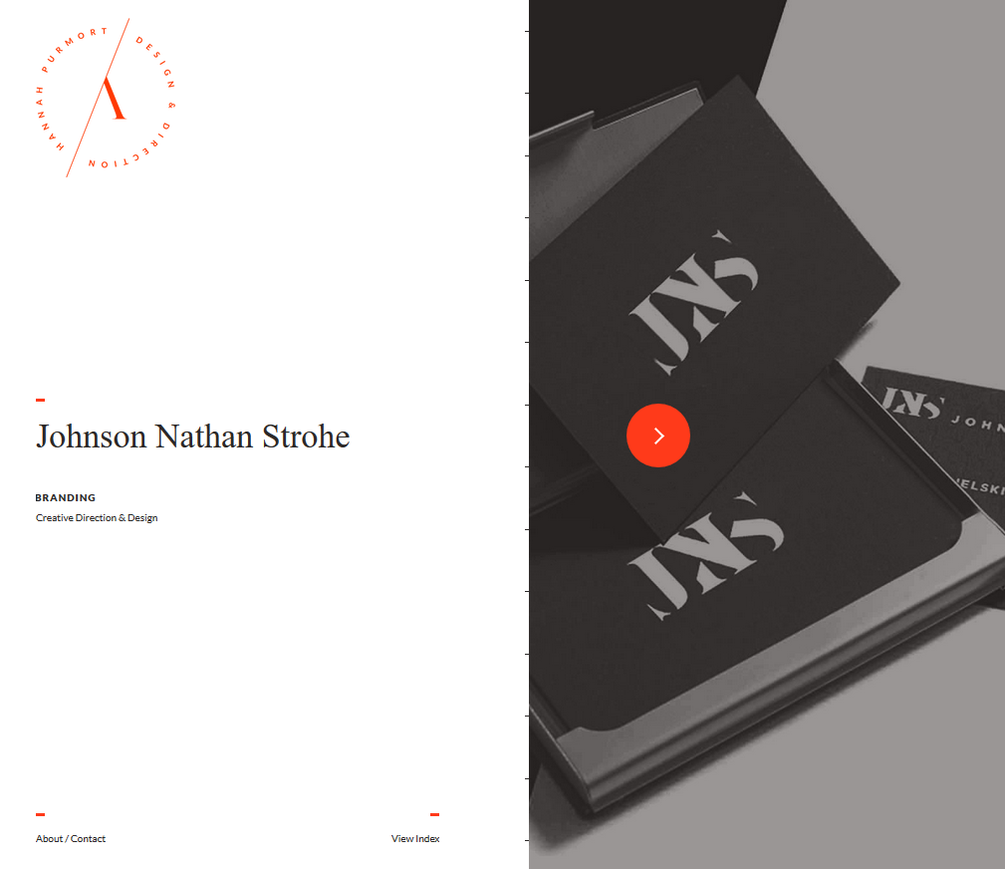

**Advantages**: This website is very minimalistic and focuses on branding capability. My largest focus on this is branding and aesthetics, which is what I enjoy about it. **Disadvantages**: It’s extremely simplistic. It doesn’t list a lot about the person creating it, services, we just know they do branding. The scope of their skill isn’t really listed. There’s no elements to really interact with, other than About/Contact or View Index. Although stylistically, it’s very strong, the website itself lacks a dynamic usability.

**Overall Grade**: C-