AUTOMATING STUDENT MANAGEMENT SYSTEM USING CHATBOT AND RPA TECHNOLOGY.

Vrushil Gajra

UG student, Department of Computer Engineering

K.J. Somaiya Institute of Engineering and Information Technology(KJSIEIT)

Sion(E), Mumbai. *University of Mumbai* [vrushil.g@somaiya.edu](mailto:vrushil.g@somaiya.edu)

Khwajaavais Lakdawala

UG student, Department of Computer Engineering

K.J. Somaiya Institute of Engineering and Information Technology(KJSIEIT)

Sion(E), Mumbai. *University of Mumbai* [khwajaavais.l@somaiya.edu](mailto:khwajaavais.l@somaiya.edu)

Rahul Bhanushali

UG student, Department of Computer Engineering

K.J. Somaiya Institute of Engineering and Information Technology(KJSIEIT)

Sion(E), Mumbai. *University of Mumbai* [rmb1@somaiya.edu](mailto:rmb1@somaiya.edu)

Dr. Sunita Patil Professor,Department of Computer Engineering

K.J. Somaiya Institute of Engineering and Information Technology(KJSIEIT)

Sion(E), Mumbai. *University of Mumbai* [spatil@somaiya.edu](mailto:spatil@somaiya.edu)

# Abstract —These Robotic Process Automation (RPA) is a technology that is being increasingly used as a tool that allows users to automate, manage, analyze and update existing databases efficiently and without any error. This paper highlights how RPA is being used to integrate repetitive tasks within an ERP system and automate many of the processes that exist when managing a Student Management System. The solution is designed in a way that allows students, Faculty and Group Admin to access records and databases from a platform free web-based solution - using both desktops and mobile phones. It allows Faculty and Admin to post Student related notifications, post and assign assignments, class schedules, examination dates, amongst many others both singularly for an individual student as well as a group of students. A ChatBot Module has also been integrated within the solution that allows users to retrieve important information using a GUI.

***Keywords—****ERP, Databases, ChatBot, GUI, RPA*

* 1. INTRODUCTION

The Student Management System is an ERP based solution that handles information related to three major stakeholders, - the Student, Faculty and the Admin. This solution has been designed into various modules and provides a plethora of information. These modules are

1. Student Profile/Faculty Profile
2. Marks Submission
3. Attendance Record
4. Record of Examination Result
5. Record of student and faculty detail
6. Time table management

While the existing system is designed to maintain all information manually through data entry into the ERP system, this solution integrates many of the manual processes. It employs a ChatBot that allows these three stakeholders a GUI based interactive mode of data retrieval method. While user access is based on the type of stakeholder, the ChatBot provides easy and secure access to ERP information. Based on Google's Dialog- Flow technology, the ChatBot has been designed to use the keywords as inputs and generate a relevant response to the input keywords. The whole process has been automated with Robotic Process Automation (RPA) technology.

A ChatBot is a software that simulates human communication via speech or text [1]. It is an Artificial Intelligence feature that can be combined through any instant message applications. Natural Language Processing (NLP) can also be embedded to enhance and improvise the ChatBot. Basically, chatbot works in two ways: machine learning and set guidelines. Inset guidelines, it`s function is limited in communication. In machine learning, it has ANN inspired by neural nodes of the human brain.

Robotic Process Automation (RPA) is a software that can be computerized to do easily as well as repetitive tasks [2]. RPA built and deploy the bot to operate the other software applications. For the education system, RPA can perform various activities like Attendance Management, Scheduling Timetable, Course Registration, etc [3]. Apart from education, it is also implemented in various industries like Insurance, Banking, Human Resource [4].

Apart from the ChatBot automation, RPA has also been extensively used to process many of the manual processes

within the ERP system. This has not only automated everyday repetitive processes with little or no human intervention, but has improved the efficiency of the Student Management System.

* 1. LITERATURE SURVEY

One of the earliest ChatBot was devised and demonstrated for conversation between the user and the machine. The chatbot is built based on the user interface, granting the user to type the query and accept the response in the text as well as speech. The college inquiry chatbot is deployed on artificial intelligence algorithms that study the user queries and sense the user`s message. With the help of artificial algorithms, the chatbot answers the query asked by the students without physically being available in the college. It uses artificial intelligence techniques such as Natural Language Processing (NLP), image and video processing and audio analysis. Porter Stemmer Algorithm and Word Order Similarity between Sentences is used for removing the suffixes from the word in English. This system helped many organizations to ensure good services and customer satisfaction with the less human intervention [5].

Another seminal Chatbot, known as UniBOT was developed for University Information System. The Chatbot provides data related to college or university and also about student activities. As a student have to visit the institute to collect various data or notices like Tuition Fees, Defaulter List, Academic schedule, etc. This practice can be tedious and time-consuming & to overcome this Chatbot is introduced. Besides the academic data, this Chatbot can also be used to provide additional information using Natural Language Processing [6].

Applying RPA in administrative processes of public administration provides the benefits of RPA and applications of RPA in different domains. This automates the functions and processes by reducing the cost through the introduction of the robotization process. The latest technologies are carried out in all the area of activity rapidly. Technologies are meant to optimize or improve the process of management and development of organizations, by bringing the new level of efficiency of quality of services. Intelligent machines and smart devices perform many tasks and operations in manufacturing. RPA is used as specialized software that simulates human interaction with the information system to carry out a business process. This paper also presents some criteria for RPA repetitive tasks, the volume of data processed & how well the operation can be algorithmized is presented. This paper also sheds light on how RPA can also be applicable in the public sector as well as in private companies [7].

In Delineated Analysis of Robotic Process Automation Tools, a detailed study of the leading RPA platforms namely, UiPath Studio, Automation Anywhere (AA) and Blue Prism (BP) is shown. When swiftness is expected in all the sectors, the speed of execution of various

processes becomes an important factor. They compared these tools considering various factors such as Front office automation, back-office automation, security, it`s code-free and user-friendly nature. This paper sheds light on the future scope as UiPath exceeds imaginable boundaries due to its adaptive algorithms [8].

RPA has also been found to be critical in automating processes within an ERP system. ERP based processes are structured by first identifying relevant business processes, aligning various activities in an order of events and aligning all processes based on definite business logic. Research showed that using RPA technology, data mining processes using BOTs can replace human processes and thereby enhance ERP processing [9].

* 1. METHODOLOGY

1. EXISTING SYSTEM

Student Information Management has been traditionally managed using ERP based database solutions. For student records to be continuously updated it requires a permanent operator to update the records either using query-based updates or through manual data entry. Often times it is susceptible and vulnerable to wrong data entry leading to further risks.

While data entry is a known risk that has the capability to be mitigated through query-based up-dating or macros, there are many other operations that are repeatable and need constant curing. It has been observed that some of the routine tasks and functions that require constant maintenance relate to the following:

* Updating student attendance on a daily basis.
* Another Faculty uploading student assignments with assignment notifications.
* Student choosing course(s) and receiving course related information.
* Students able to view important college notifications which can be personal, course related, assignment related etc.
* Authentication of student information at login to student/ faculty/ admin.
* Generation of reports.

While automation of some of these processes can be mitigated using various coding techniques, it is a cumbersome task and needs efficient database management. The integration of a ChatBot with RPA has the capability to mitigate these drawbacks. Attended BOTs allow users to communicate through the ChatBot and information relevant to the user requirement can be displayed efficiently and without errors. Many of the functions that are executed within the system can be accomplished using unattended BOTs using a defined set of business rules. RPA automates everyday processes that require human intervention.

1. PROPOSED SYSTEM

Using RPA and ChatBot, it can be demonstrated that the Student Information Management within an ERP system can be efficiently managed with no errors. It will not only automate repeatable tasks but will allow efficient management of numerous functions based on set business rules.

The workflow designed for the proposed solution uses multiple technologies that have been integrated together. While MySQL has been used as the RDBMS, the development of the solutions is divided into two significant parts:

# Development of the ChatBot

* + **DialogFlow:**

Google's DialogFlow has been used to develop a portion of the ChatBot. Based on the user query, the Intent and entities are matched together to provide a result and displayed on the ChatBot. DialogFlow sends Webhook's request to Server to query the data.

# Webhook:

Webhook works as a bridge to connect the UiPath platform and MySQL server. The response is generated by Webhook which is connected to MySQL Server. Webhook uses the Application Program Interface (API) to get the data from MySQL databases.

Figure1 and 2 show the creation of Intents in DialogFlow [10] for keywords matching. Intents are created for every action that the user performs.

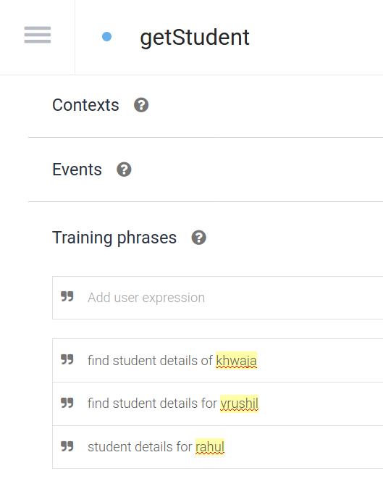

**Figure 1: Dialog-Flow and Webhook Interface for Get-Student Intents.**

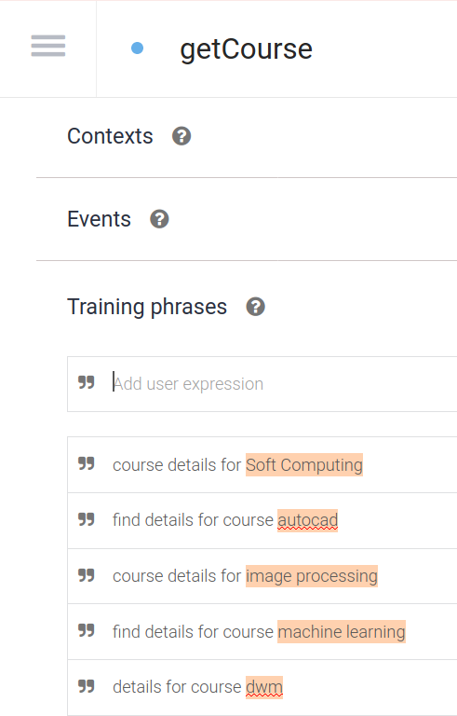

**Figure 2: DialogFlow and Webhook Interface for Get-Course Intents.**

Figure3 shows the Restful API to integrate MySQL with NodeJS server. Data in the API is in the JSON format as Webhook integrated with Dialog-flow takes data in JSON format only. The API is hosted on Heroku [11].

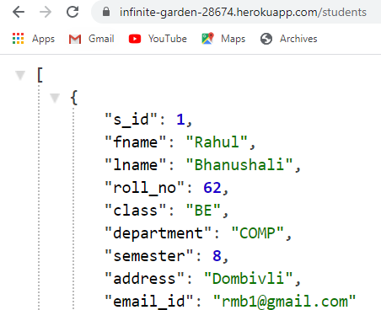

**Figure 3: Restful API**

Figure4 shows the User Interface created for the user to access the ERP system using the ChatBot. Here the user is querying for reading operation from the MySQL database.

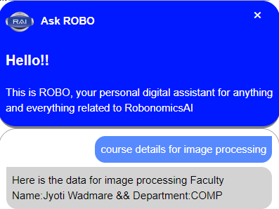

**Figure 5: Chatbot Integration for fetching course details.**

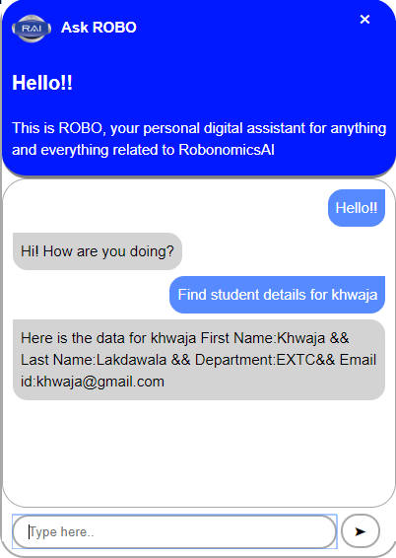

**Figure 4: Chatbot Integration fetching student data.**

# Development of the Automated Process Flow

The development of the automated process flow was designed using RPA’s UiPath that was integrated with the ChatBot and MySQL database. It was observed that many of the business rule workflows were repeatable and prone to errors. A study of the workflows identified three major stakeholders – the student, faculty and the admin. While the student-based workflows were mainly related to course selection, assignment notifications, assignment uploading, etc., the faculty-based workflows were mainly related to uploading of assignments, maintaining attendance record, sharing important student related notifications etc. The admin tasks were mainly related to maintenance of student and faculty information, student fees monitoring, other important notifications.

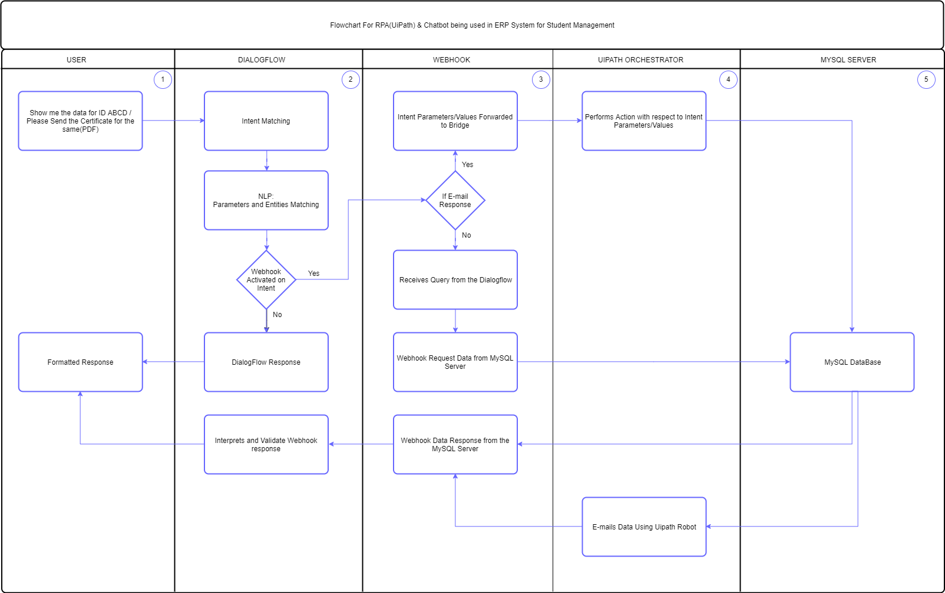

**Figure 6: Automated Workflow.**

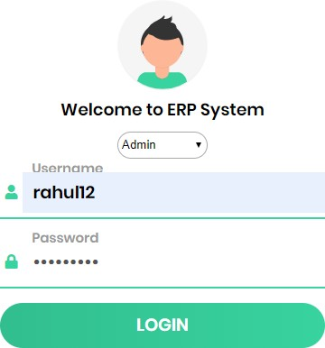Figure7 shows the Login Module to the Student Management System. The admin, faculty and the students are the users of the system. User will login via the credentials & will be redirected to their respective webpages.

**Figure 7: Login Module.**

Figure8 shows the Assignment Module of the Student Management System. Here the faculty can upload the assignments/ notes. Students will get these assignments and notes via Email. UiPath Email Automation Tool [12] is used for this process.

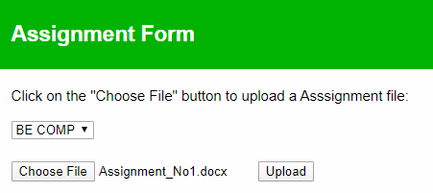

**Figure8: Assignment Module.**

* 1. TECHNOLOGY

1. NEED OF ROBOTIC PROCESS AUTOMATION IN DIGITAL WORLD

In the digital world, every enterprise not only looks to cut costs but also to automate the entire business process. RPA is a technology that not-only automates the processes but also provides the business swiftness. A time-consuming and labor-intensive task like invoice processing, processing HR information, price comparison, extracting information from different formats can be executed efficiently through RPA [13].

1. PROS & CONS OF ROBOTIC PROCESS

AUTOMATION

The significant benefits of RPA when robotizing ERP System is its high-quality results, faster return on investment, reduce man-force, saving in time, simplifying and automating tedious business tasks or processes reduced business cost [14].

Even though the bot can perform the various repetitive and tedious process, it does not have the ability for decision-making. It is inadequate to handle human intervention.

1. COMMERCIAL ENTERPRISE OF ROBOTIC PROCESS AUTOMATION

Robotic Process Automation (RPA) and Chatbot Technology can be implemented to be deployed in various industrial and institutional sectors. Retail & consumer goods industry, Education Industry, Manufacturing Industry, Airline Industry are the industries in which Chatbots can be implemented efficiently and effectively [15]. Finance, Government agencies, Manufacturing, Human Resource, Education are some of the places where automation can be implemented [16]. The education sector is one of the sectors where both Chatbot and RPA can be implemented simultaneously.

* 1. RESULTS

The significant advantage of the Automated Student Management System is that the institute is able to keep a track of data related to users. This comprises data such as student personal details, submission of assignments by students, attendance list, notices, etc. Faculty can completely track student performance and can communicate with the student in-person. Users can have complete access to the system but with certain limits. With this system, human interventions can be minimized [17].

* 1. CONCLUSION

This is a demonstrative usage of RPA and ChatBot integration that has been successfully implemented. These technologies have been integrated together within a website thus providing a user-friendly interface, efficient ERP and a Chatbot integration. Similar integration is possible to be implemented in more and more businesses and offices. It will not only help to increase the firm's functionality by providing data in a more efficient way, but it can also help in maintaining control over data, monitoring data and its performance, and prior intimation about events and holidays via notification. RPA can be further integrated with artificial intelligence (AI) and machine learning (ML) that will be able to handle a high volume of data, repetitive tasks that are previously performed by humans.

* 1. FUTURE SCOPE

Currently, the system is able to perform CRUD-Create, Read, Update and Delete Operations. But in near future system will be able to function in all kinds of SQL Operations in database related systems. Additional tools can be added to this solution where it would be possible to integrate more functionalities within a student information management system. Tools can be developed for maintaining control and monitor institute data, provide information related to institute events, and other critical information that would enable all stakeholders to be informed of institute works.

While an attempt has been made using RPA as the backend technology, there are few areas that exist that requires further research especially related to the integration of unstructured data and providing necessary research ideas in designing the Chatbots. An example is the integration and analysis of high

volumes of data that uses RPA technology with AL and ML technologies. This involves efficient queries, calculations, and maintenance of records and transactions.

REFERENCES

1. <https://www.investopedia.com/terms/c/chatbot.asp>
2. <https://www.investopedia.com/terms/r/robotic-process-automation-rpa.asp>
3. <https://automationedge.com/rpa-for-education-industry/>
4. <https://disruptionhub.com/robotic-process-automation/>
5. Bala, K., Mukesh Kumar, Sayali Hulawale, and Sahil Pandita. "Chat-bot for college management system using ai." International Research Journal of Engineering and Technology 4, no. 11 (2017).
6. Patel, Neelkumar P., Devangi R. Parikh, Darshan A. Patel, and Ronak R. Patel. "AI and Web-Based Human-Like Interactive University Chatbot (UNIBOT)." In 2019 3rd International conference on Electronics, Communication and Aerospace Technology (ICECA), pp. 148-150. IEEE, 2019.
7. Uskenbayeva, Raissa, Zhyldyz Kalpeyeva, Ryskhan Satybaldiyeva, Aiman Moldagulova, and Aizhan Kassymova. "Applying of RPA in Administrative Processes of Public Administration." In 2019 IEEE 21st Conference on Business Informatics (CBI), vol. 2, pp. 9-12. IEEE, 2019.
8. Issac, Ruchi, Riya Muni, and Kenali Desai. "Delineated analysis of robotic process automation tools." In 2018 Second International Conference on Advances in Electronics, Computers and Communications (ICAECC), pp. 1-5. IEEE, 2018.
9. Fettke, Peter & Loos, Peter. (2018). “Structuring Information Systems in the Era of Robotic Process Automation” In ResearchGate, 10.1314 0/RG.2.2. 18811.36648.
10. <https://dialogflow.com/>
11. <https://www.heroku.com/>
12. <https://platform.uipath.com/>
13. <https://automationedge.com/10-best-use-cases-to-automate-using-rpa-in-2019/>
14. <https://probotiqsolutions.com/2019/02/22696/>
15. <https://botcore.ai/blog/top-chatbot-use-cases-in-different-industries/>
16. <https://www.nintex.com/blog/rpa-benefits/>
17. <https://fedena.com/blog/2018/02/student-management-system.html>