Membership fee

A plugin for the free online membership management software Admidio

Documentation

August 2026

Rainer M. Binder

Prolog

In the fall of 2010, I was asked by my then 1st chairman whether I would like to take on the post of secretary in the local sports club. I agreed after a moment's thought. The activity included, among other things, the administration of members and the calculation of membership fees.
A membership management program was in place, but despite having worked in IT for 30 years, I couldn't get by with this program. Various functions could only be accessed using special, undocumented key combinations.
So I went looking for another program and found it at Admidio. In 2011 the membership fee plugin was already available in version 1.0.1. With the consent of the author Gerald Lutter, I took it over from him and have continuously developed it since then.
In 2012 the plugin was completely revised and provided with an accordion menu. In 2013 came the next major leap in version and membership fee was expanded to include SEPA functionalities. Up to this point, there were still very few SEPA-enabled programs. Free ones were almost impossible to find.
Membership fee is different than other programs. This is mainly due to the fact that the plugin uses the role structure specified by Admidio to calculate the contributions (a contribution and a contribution period can be assigned to a role in Admidio. The plugin evaluates this information). Membership fee was designed from the ground up, no other program served as a model.
Version history
52 updates have been released since 2011, the current version is 6.0.3. A change history can be found on admidio.org.
Demo version
A demo version of Membership Fee is available on my website admidiopluginsdemo.rmb.de.
Source code
The source code is available on GitHub (https://github.com/rmbinder/Mitgliedsbeitrag).
Content
Function 5
Installation 6
Upload the files 6
The installation routine 6
The menu item 9
The first basic settings 10
Contribution settings 10
Account details 10
Mandate management 10
View definitions 10
Testing the basic functions 11
The views 11
Contribution calculation 13
Update 13
The menu structure 14
Fees menu 14
Mandate management menu 14
Export menu 14
Options menu 15
Preferences menu 16
Age-based roles 17
Basics 17
Usage 17
Remapping of age-based roles 18
Reference time/month offset 18
Family roles 19
Basics 19
Usage 19
Payer 20
Multiplier roles 20
Fixed Contribution Roles 21
Basics 21
Usage 21
Individual contributions 22
Basics 22
Usage 22
Basic amount 22
Consumption amount 23
Contribution calculation 24
Contribution and contribution period 24
Prorated contribution calculation 24
Prorated contribution calculation of family roles 25
Recalculation 25
Individual contributions 26
Contribution payments 26
Payment reminder 27
Membership fee analysis 29
Contribution history 29
Export 30
SEPA 30
Due date 30
XML file 32
Control file 32
Pre-notification 33
Invoice 35
The Export button 35
The E-mail button 35
Mandate management 37
Create mandate references 37
Edit mandate 38
Options 39
Generate membership number(s). 39
Update family roles 40
Copy 41
Tests 42
Age-bases roles 42
Role membership (age-based roles) 42
Role membership (mandatory) 42
Role membership (exclusion) 42
Family roles 42
Account details 42
Mandate management 42
IBAN test 42
BIC test 43
Overview of roles 44
Plugin information 44
Preferences 45
Contribution settings 45
Age-based roles 45
Family roles 46
Multiplier roles 46
Advanced role editing 46
Apointment selection 47
Individual contributions 47
Account details 48
Mandate management 50
The prefix 50
The zeros 50
The sequential number 50
View definitions 51
Export 51
Email notifications 52
Tests 52
Enable tests 52
Role membership (age-based roles) 53
Role membership (mandatory) and Role membership (exclusion) 53
Family roles 54
Access permission for preferences 56
Delete Amounts 56
Uninstall 57
Saving the configuration 58
Information on contribution calculation on the overview page 59
Procedure for a contribution calculation 60
Rough process 60
Schedule 60
Admission of the new member 60
Generate membership number 60
Create mandate reference 60
Enter mandate date 60
Perform remapping 61
Contribution calculation 61
Due Date 61
XML file 61
Pre-notification 61
Distribution of the XML file 61
Completion of a contribution calculation 61

Membership fee

Function

The membership fee plugin is used to calculate membership fees and export them either as a SEPA XML file or in the form of a list (XLSX, CSV). Since membership fee does not offer a way to send a SEPA XML file directly to a bank, an external home banking application (e.g. Jameica/Hibiscus) must be used for this. If the bank allows it, it may even be possible to submit the SEPA XML file using a USB stick.
The contribution calculation and the export are two processes that run independently of one another.
- First, contributions are calculated based on role memberships and stored in a member's profile data (The required additional profile fields were created during the installation routine). After the data has been saved, this process is complete. The values for contribution, contribution period or sequence type can be changed later in a member's profile at any time.

- For the export, all members are run through in a loop and it is checked whether there is data from membership fees (such as contribution or contribution period) in the profile fields. If yes, they will be read. No further calculation is carried out. After the data has been imported, it can be exported as a SEPA XML file or in the form of a list (Excel, CSV).

Since the contributions are determined based on role memberships, various role types have been defined for this purpose. These will be referred to as contribution roles in the following.

- Age-based roles
  - Contribution calculation depending on the age of a member

- Family roles
  - Contribution calculation for families or groups where one member is the contributor
  - as a special form of family roles, there are multiplier roles in which the contribution value of the role is not added, but serves as a multiplier

- Fixed Contribution roles
  - Calculation of contributions for divisions, honorary members, young people, etc.

In addition to these contribution roles, there are also individual contributions that can be used to calculate individual contributions such as electricity or water consumption.

Notice

References in this description to certain menu items of the plugin are shown as follows:

→ <Tab> - <menu item> - <possible single point>

(e.g. → Preferences – Contribution settings - Separator)

Installation

Upload the files

In the first step, the program files must be uploaded to the server in a subdirectory of adm_plugins. The name of the directory can be chosen arbitrarily. However, it is recommended to use the name "membership_fee".

There are two options here:

1st possibility:

- Unzip the file "mitgliedsbeitrag_x.y.z.zip". A directory with the name "MembershipFee" is created with program files contained in it.
- In the Admidio directory adm_plugins create a new folder called "MembershipFee".
- Copy all files and folders from the local subscriptions folder to the subscriptions folder on the server.

2nd possibility:

Many file managers offer the option of uploading and unpacking ZIP files in one step.
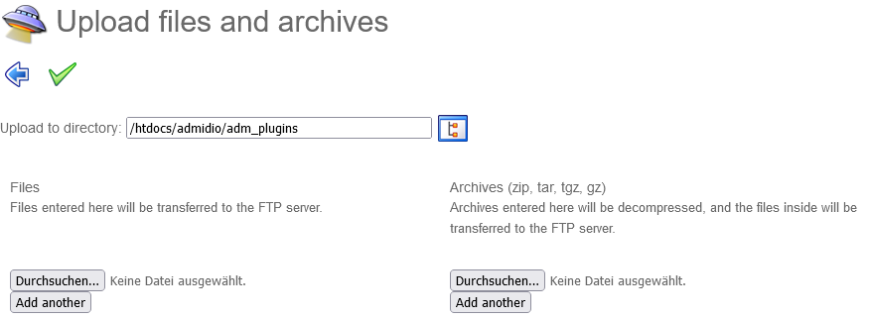
If this option is available, the "mitgliedsbeitrag_x.y.z.zip" file only needs to be uploaded to the adm_plugins directory and unzipped. The sub folder "MembershipFee" is created automatically.

After the program files have been uploaded, the plugin's installation routine must be called up. To do this, log in to Admidio, enter a contribution and a contribution period for an existing role, and run the following PHP file in your browser:

<your-admidio-page>/adm_plugins/MembershipFee/system/install.php

The installation routine

Running install.php initiates an installation process that creates all necessary profile fields and categories. From plugin version 6.0.0 onwards, this installation process runs in the background. Minor user input is required.

Additionally, each time the plugin starts, it checks whether the values ​​of "version" and "stand" in the version.php file match the values ​​stored in the database and whether all profile fields are still present.

If there are any differences, a detailed installation process will be initiated. and further checks are carried out. Existing configuration data can be reinitialized and overwritten with changed data.

This installation process consists of two passes:

First pass: Creation of missing profile fields and categories

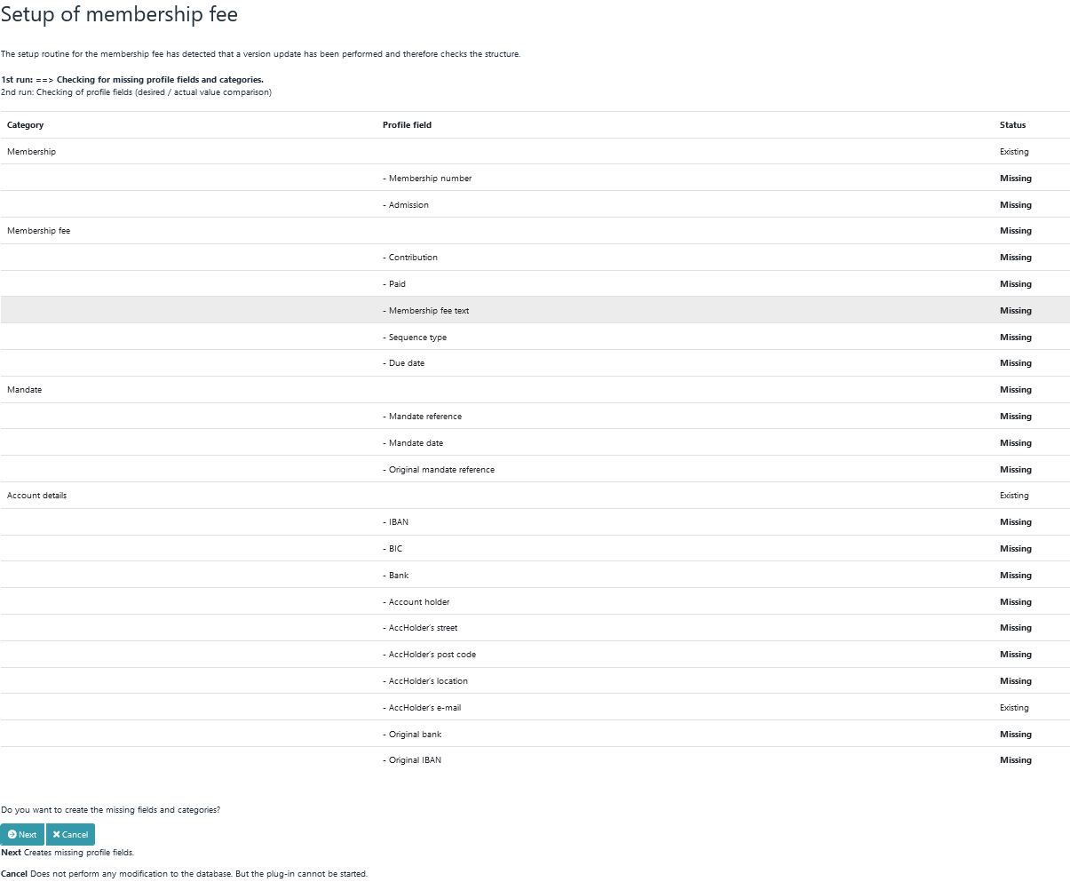

In the first pass of the installation routine, the database is checked for missing profile fields and categories. If profile fields or categories are missing, they can be created using the "Next" button.

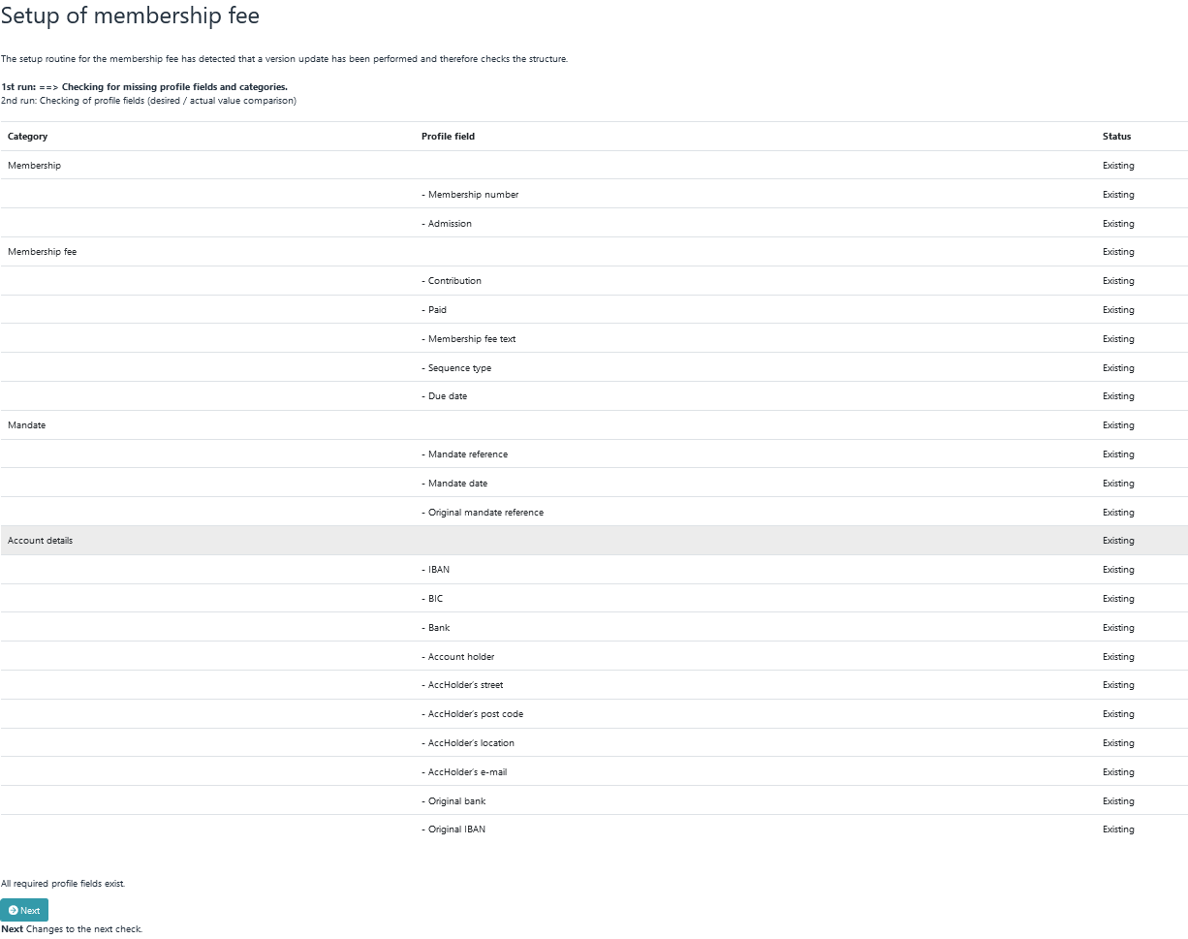

You can only switch to the second round if all the necessary profile fields are available.

Second pass: target/actual comparison

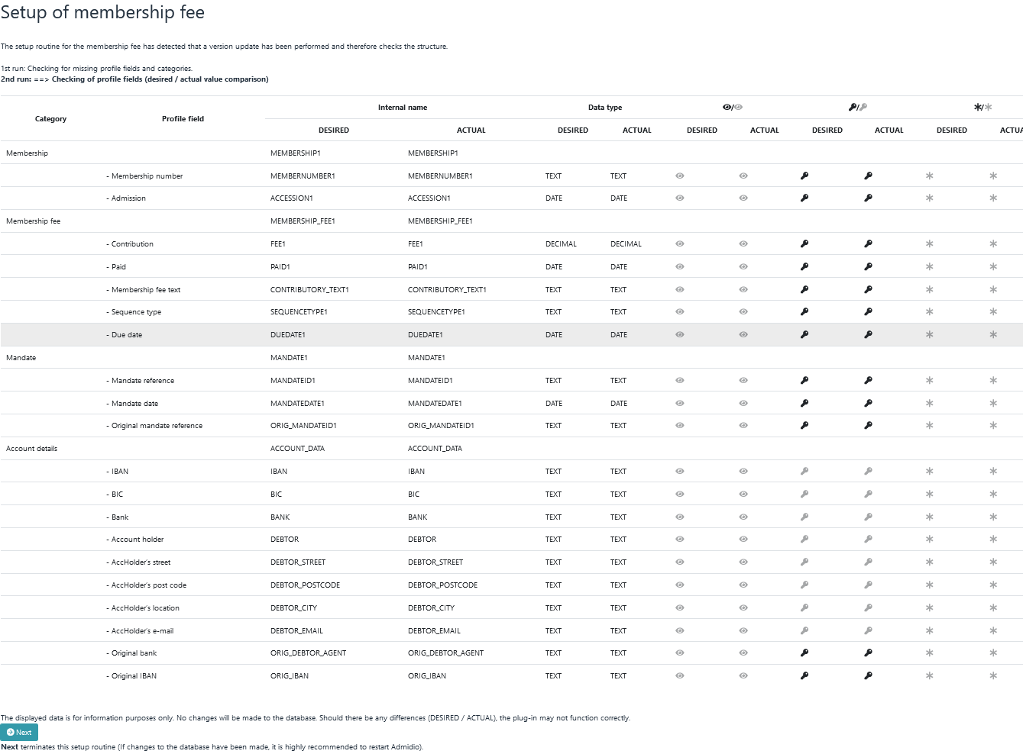

The second pass of the installation routine is only a target/actual comparison to show how necessary categories and profile fields should be defined. Differences are highlighted in bold.

For example, it's possible that a profile field called "Membership number" already exists, but it's not the correct data type. Necessary changes are not carried out by the installation routine.

The menu item

The installation routine creates:
1. an additional menu item (starting with membership version 5.3.1) to launch the plugin
2. a role (hereinafter referred to as the access role) for accessing the plugin

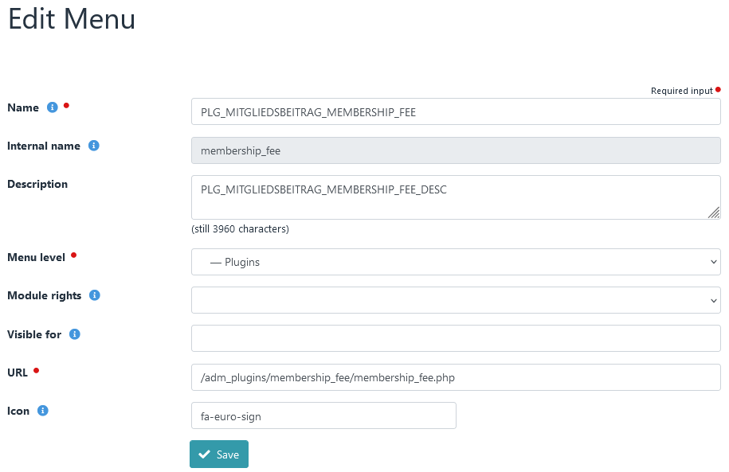

For your information:
In Admidio, the Menu module allows you to restrict the visibility of a menu item using the "Visible for" setting. However, this permission does not affect access to the underlying page.
The access role created by the installation routine is listed under "Visible for" in the menu item. The current user is already a member of this role. Additional users can be added to the role.
Based on this access role, the plugin creates access permissions only for members of this role. Afterward, it is no longer possible for non-members of this role to directly access a program via the browser's address bar, such as .../adm_plugins/MembershipFee/system/payments.php.
The name of the menu item and the access role must not be changed, as they will only be removed unchanged during uninstallation.

The first basic settings

After successful installation, important basic settings must be made. To do this, call up the Preferences menu of the plugin.

Contribution settings

The first settings, such as the proportional calculation of contributions, are to be made under → Preferences - Contribution settings. All individual points are provided with a short help text.

Account details

The account details of the association must be entered under → Preferences - Account details.

Mandate management

Under → Preferences - Mandate management it is important to make the right selection under Data field for sequence number. The data field selected here determines an important segment of the mandate reference. Once a decision has been made, it should not be changed.

View definitions

In → Preferences – View definitions, a content field must be specified for each column (no field may be empty)

Background

In some cases, IDs from profile fields cannot be read out correctly during the installation process. This can be recognized by the fact that the content field for some columns is empty. In this case, click the "Save" button once in the view definitions module.

Testing the basic functions

After installation, the basic functions should be tested.

The views

Membership fee offers views in several modules in which data is only displayed if certain requirements are met.

These modules are:
- Contribution payments
- Invoice
- Due date
- Advance information

Data is only displayed in the Contribution payments and Edit invoice data modules if the profile field Fee is NOT EMPTY.

To test this, we call up a member's profile and enter the number 99 under Fee.

Notice

The number 99 is now displayed for the total in the overview.

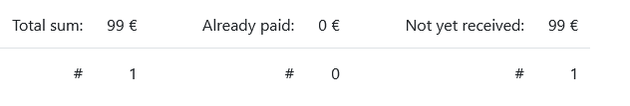

If we now call up the Contribution payments module (→ Fees - Contribution payments - Edit contribution payments) or the Invoice module (→ Export - Invoice - Edit invoice data), this one member (for whom the €99 was entered) is displayed.

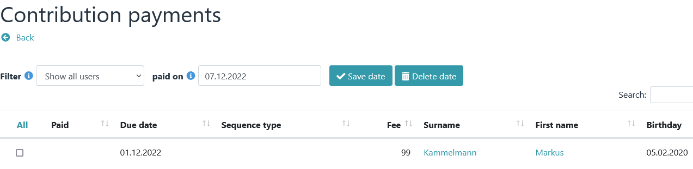

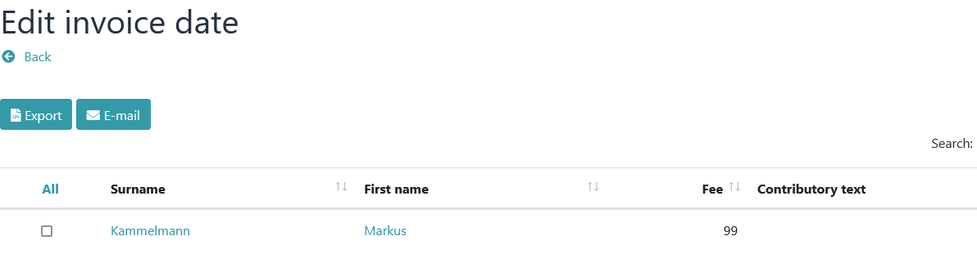

The Due date module requires the following as minimum requirements for an ad:
- Fee
- Mandate reference
- Mandate date
- IBAN
- and: the Paid date must be empty

In the next step, we therefore open the profile of the member (where the €99 was entered) and enter values under Mandate reference, Mandate date and IBAN.

Then we open the Due date module (→ Export - SEPA - Due date). Since all requirements are met, the member concerned should also be displayed here.

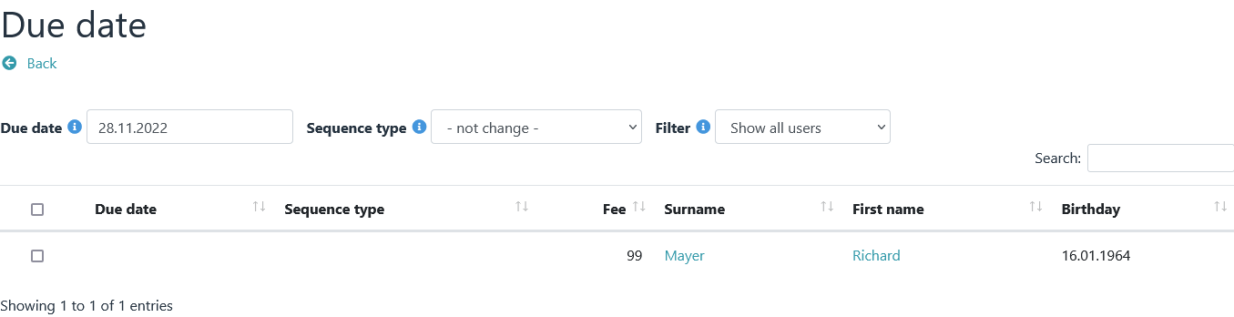

Now click the check box in the first column. The current date is entered in the Due date column.

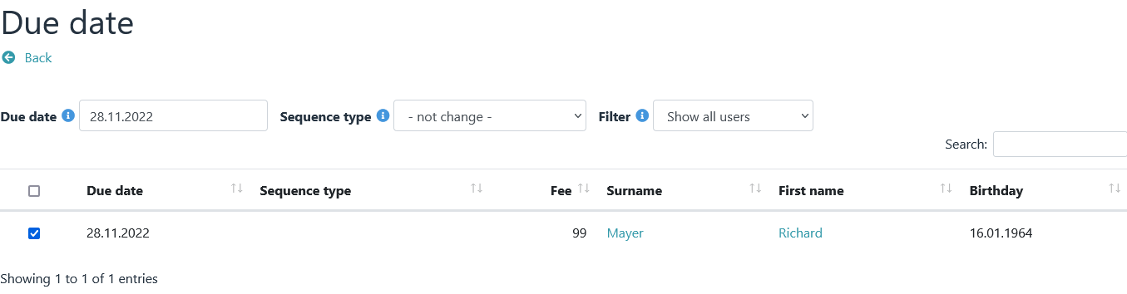
We go back one step using the Back button.

A new line with checkboxes should now appear under → Export – SEPA – Due date/Sequence type.

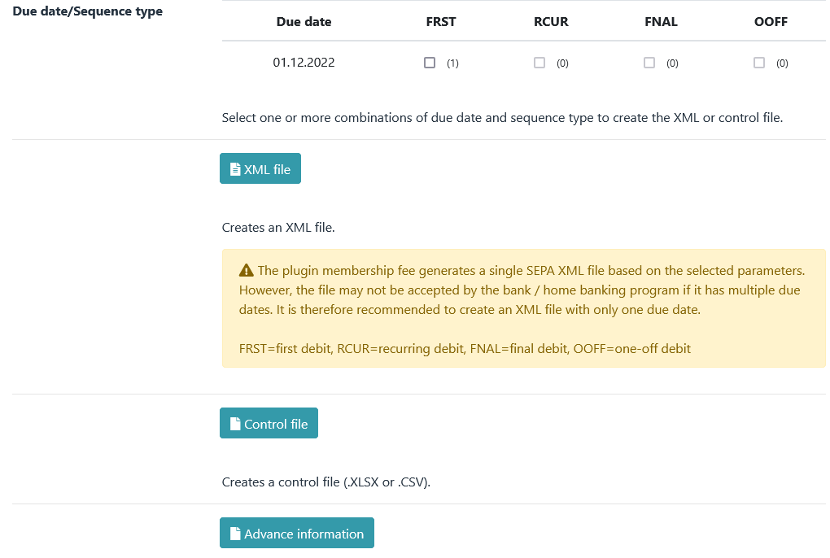

We click on FRST and first select XML file and then control file. We have now created our first export files. The control file contains the same data as the XML file, only edited to be more readable.

This would test the most important views once.

Contribution calculation

First, all data that was entered for a member in the previous section (contribution, mandate reference, mandate date, due date, etc.) will be deleted again.

To test the contribution calculation, we first create a role and enter 99 for contribution and Annually for contribution period.

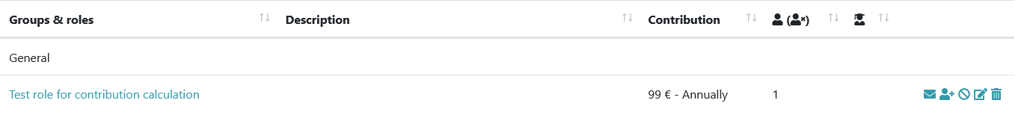

We then add a member to this role and carry out a contribution calculation (→ Fees - Recalculation - Recalculation).

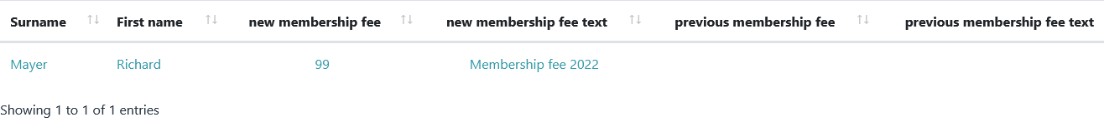

If the contribution now calculated is displayed correctly in the Contribution Payments module (→ Fees – Contribution Payments – Edit Contribution payments), all the basic functions have been successfully tested and are working.

The created test roll can now be deleted again. The calculated contribution is removed again via → Fees - Delete – Delete – Delete all.

Update

In the case of an update, all files from membership fee must always be replaced.

If the file manager offers the possibility to upload and unpack ZIP files, then the following procedure should be followed:

- Delete the entire membership fee installation directory (including all files and folders).
- Use the file manager to upload and unzip the file "mitgliedsbeitrag_x.y.z.zip". (The subfolder "MembershipFee" will be created automatically).

If the file manager does not offer the option of unpacking, then proceed as follows:

- First delete all files and folders in the plugin directory from membership fee.
- Then copy all files and folders of "MembershipFee" from the unzipped zip file into the plugin directory.

Notice

From plugin version 6.0.0 onwards, the plugin folder must be named "MembershipFee", or it may need to be renamed.

The menu structure

All functions of the plugin are accessible via a menu.

The current status of the premium calculation is shown above the menu.

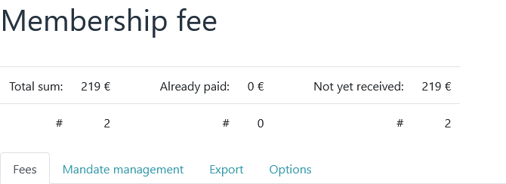

Fees menu
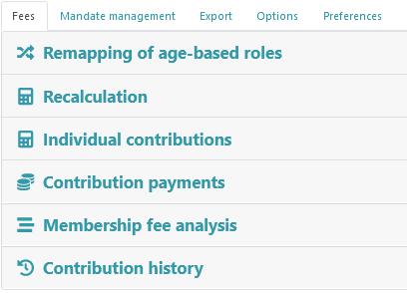
The main functions of the plugin, such as remapping, recalculation and payment of contributions, can be accessed via the menu items of the Fees tab.

Mandate management menu
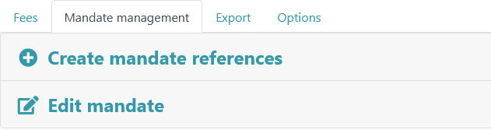
Mandates can be edited and mandate references generated via the mandate management.

Export menu
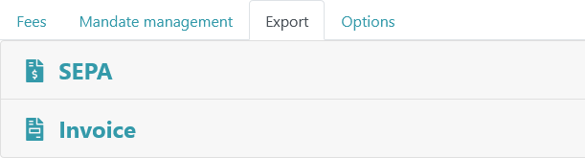
All export functions are accessible via Export.

Options menu
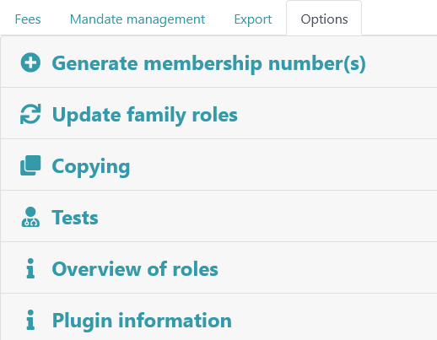
Options offers the possibility of generating membership numbers, copying profile data, displaying a role overview or various checks.

Preferences menu
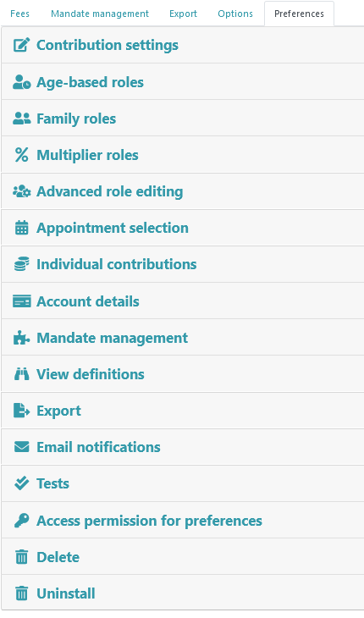

All basic settings can be accessed via the Settings tab..

Notice

By default, this menu is only visible to administrators.

Age-based roles

Basics
A corresponding role must be created for each age range for an age-based determination of contributions. The entire age range must be covered without gaps.

The role name is crucial as it indicates the age range. The relevant age information must be surrounded by separators (→ Preferences - Age-based roles - Separator).

Possible separators would be eg * or # or + or - or _ or ! or %.

Syntax:
any text<separator><age from><separator>any text<separator><age to><separator>any text

Examples of role names with different separators:
- Members between *0* and *14* years
- Members from *15* to *17* years
- any text *18* any text *99*
- -0- to -18-
- Members -19- to -80- years

Example of a grading with the separator *:
- Members between *0* and *14* years
- Members between *15* and *17* years
- Members between *18* and *59* years
- Members between *60* and *110* years

A new member will be placed in one or more of these age-based roles (which does not matter) upon initial admission. Via → Fees - Remapping of age-based roles, a routine is triggered that reassigns all members of age-based roles to the age-based roles based on their age. The reference time is always December 31st. of the past year (→ Preferences - Age-based roles - Monthly offset).

Notice

Members who were born after the reference time are not allowed in an age-based role because they do not yet exist for the program (relative to the reference time). Therefore, place these members either in a family or in a separate fixed contribution role.

Usage
In the first step, one or more separators are defined via → Preferences - Age-based roles - Separator.
The roles are then created for the defined separators and the members are added (Because these are contribution roles, contribution and contribution period must be specified).

Example of role names for a scale with the separator *:
- Members between *0* and *14* years
- Members between *15* and *17* years
- Members between *18* and *59* years
- Members between *60* and *100* years

Notice

In the above example, if a member of → Fees - Remapping of age-based roles is older than 100 years, an error message is displayed.

After all roles have been created, you should check via → Options - Overview of roles whether all age-based roles are correctly recognized by the plugin.

After that, the members can be reassigned to the age-based roles via the remapping.

Remapping of age-based roles

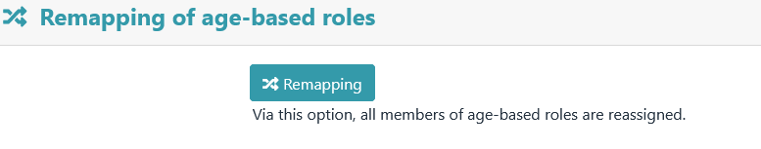

All members of age-based roles are reassigned via this menu item.

After clicking the "Remapping" button, a preview appears first.

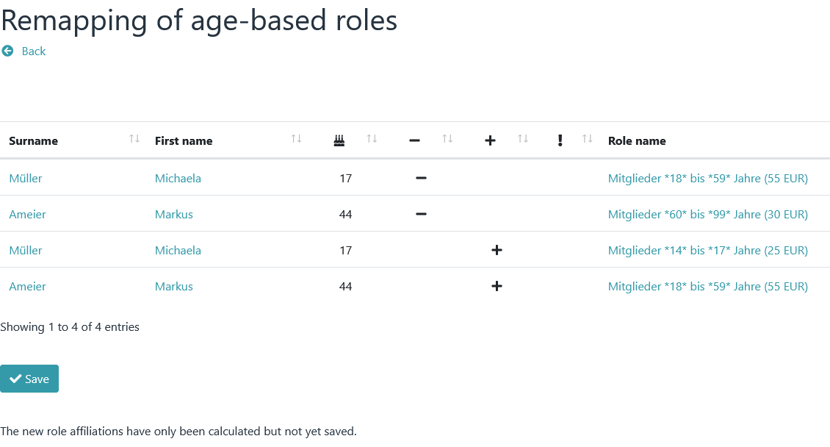
The new assignments are only saved after you click on "Save".

Reference time/month offset

The reference time is always December 31st. (24 hours) of the past year.
Example of the division into an age-based role:
A role with the following age restrictions should be given: Members %1% to %2% years
In this case, it is checked whether the member on 31.12. (midnight) of the past year still fit into the age structure of 1 to 2 years (minimum was 1 year old and maximum was 2 years and 365 days old). If not, it will be moved to another role.
With a monthly offset, this reference time can be set full months in the future or in the past.

Family roles

Basics

Contributions defined for a family role apply to the entire family or group, not to each individual member. All members of a family role pay a joint contribution.

In order for the plugin to be able to distinguish family roles from other contribution roles, all family roles must begin with a clearly defined prefix, e.g. "Fam" or "Family" (→ Preferences – Family Roles - Prefix).

Any number of family roles can be defined (e.g. Fam100 with a contribution of EUR 100 or Fam200 with a contribution of EUR 200). However, it should be noted that all prefixes are different from one another. "Fam" cannot be used at the same time as "Family".

Important NOTE

Even if family roles are not used, at least one family must be defined with a family role prefix, otherwise the plugin will classify all contribution roles as family roles and the contributions will be calculated incorrectly.

Examples of role names:
- with the family role prefix "Family"
* Family Meier Hubert
* Family Huber
- with the family role prefix "Fam100"
* Fam100 Roller
* Fam100 Mueller Felix

Usage

First, one or more family roles (with prefix, contribution and contribution period) are defined via → Preferences – Family roles.
Then the family roles are created and members are assigned to these roles.

Example:
role with the following data was defined via → Preferences – Family roles:
- Prefix: Fam100
- Contribution: 100
- Contribution Period: Monthly

The following roles could then be defined via “Groups & roles”:
- "Fam100 Meier Hubert" (with the members Meier Hubert, Meier Hildegard)
- "Fam100 Wildstetter" (with the members Wildstetter Anton, Wildstetter Hilde)

After all roles have been defined via "Groups & Roles", they must be updated. To do this, run → Options - Update family roles. This will sync and update the Contribution, Contribution Period, and Description entries of family roles with the information in the settings.

Finally you could run → Options - Tests and correct any displayed errors.

Payer

In the case of family roles, the plugin marks the first member who has account data as the party liable to pay. The calculated contributions are assigned to this payer.

If no account details are stored for any family member, the first member found in the database is designated as the payer. This could possibly also be a small child.

To prevent this special case, a leader can be appointed for a family. In this case, the leader is the person liable to pay for the program, regardless of whether account details are stored with him or not.

Important NOTE

A leader of a family cannot be the leader of another family at the same time.

Multiplier roles

A special form of family roles are multiplier roles (→ Preferences - Multiplier roles). In these types of roles, the contribution value of a role is not added, but serves as a multiplier.

Normally, a family role proceeds as follows:

All members of the family are traversed and checked to see if she is a member of another contributing role. If so, that role's contribution is added to the payer of the family role. Finally, the contribution of the family role is added to the payer's account.
If a family role is declared as a multiplier role, then the point "Finally, the contribution of the family role is added to the payer's account" has a different function. The contribution entered in the family role is now a percentage (70 means 70% of the contribution).
Example:
There should be a family role with a contribution of 60 €. This role has 4 members. Each member is in another contribution role with a contribution of €50 each.

Normally, the payer of this family role would be charged €260 (50+50+50+50+60) .

However, if this family role is declared as a multiplier role, the following calculation applies (50+50+50+50) * 60% equals 120 €.

Fixed Contribution Roles

Basics

All other roles where a contribution and a contribution period are defined are declared as fixed contribution roles. The names of these roles and the categories they are in are not important . As soon as a member belongs to one or more of these roles, the contribution of the role is included in the contribution calculation.

About fixed contribution roles can

- any number of divisional contributions
- contributions for young people
- contributions for students
- contributions for honorary members (fee 0 EUR)
- contribution reductions (negative contribution; minimum requirements: plugin version 4.3.2, Admidio version 3.3.8)
- contributions for seniors

be calculated.

Usage

Create one or more roles via "Groups & roles" and define a contribution and a contribution period for each role. Then add any number of members to these roles.

After creating the roles, you should use → Options – Overview of roles to check whether all roles are recognized.

Individual contributions

Basics

In addition to the contribution roles already presented, there are individual contributions that can be used to calculate individual contributions such as electricity or water consumption.

Individual contributions are divided into two categories:
- basic amount
  - A basic amount is calculated if the member is a member of a specific role.
- consumption amount
  - A consumption amount is calculated if the member is a member of a specific role
  - and a consumption value is specified in a profile field.

Notice

No contribution roles (with contribution and contribution period) are required for the calculation of individual contributions . Only role affiliations are evaluated. All settings (amount, consumption, etc.) are defined via → Preferences – Individual contributions.

Usage

An individual water consumption with basic and consumption amount is to be calculated.

Basic amount
In the first step, a new configuration for a basic amount is created under → Preferences - Individual contributions ( Description eg "Water charges basic amount").
- A role is selected under Role for which this basic amount is to be calculated
- and enter an amount under Basic or consumption amount.
When calculating the individual contributions, it is checked whether a member is a member of this selected role. If so, the value of the base or consumption amount is added to an existing membership fee as a "base amount".

Example:
If 30 is specified as the Basic or consumption amount, the value 30 (as the basic amount) is added to an existing membership fee

Consumption amount
A further configuration is then created under → Preferences – Individual contributions. This time for the consumption amount (Description eg "Water charges consumption amount").
- Under Role, another role is selected for which this consumption amount is to be calculated
- Under Basic or consumption amount, an amount is to be specified,
- and under Profile field, select a profile field that contains a corresponding consumption value .

Example:
If 0.70 is entered as the Basic or consumption amount and the selected profile field contains 428 as the consumption information, this results in a consumption of 0.70×428 = 299.60. Thus the value 299.6 (as consumption) is added to an existing membership fee.

Notice
If a consumption amount is to be defined, an associated profile field must also be selected. Mathematically, the value of "Basic or consumption amount" is multiplied by the value of the selected profile field. If no profile field is specified (for a basic amount), it is multiplied by 1.

Contribution calculation

Contribution and contribution period

By default, a contribution and a contribution period can be assigned to a role in Admidio. The plugin evaluates these entries.

Only roles for which a contribution and a contribution period are defined are relevant for a contribution calculation (a contribution of 0 € is also possible, eg for honorary members).

A member can belong to one or more roles. The contributions entered for these roles are added up. In which Admidio category these roles are located is not important.

The plugin always considers the contribution defined in a role (regardless of the "Contribution period" setting) as an annual contribution. The specification of a role's contribution period is used for the "Prorated contribution calculation" function.

Prorated contribution calculation

If a member terminates their membership in a role during the year or joins a new role during the year, a prorated contribution calculation will be carried out.

The end of a role membership is used for the pro rata calculation when membership ends.
Depending on the configuration (→ Preferences - Contribution settings – Calculation of proportional membership fee), either the joining date or the start of a role membership is used for the pro rata calculation at the beginning of a membership.

Contribution period Monthly : Every month that has started is calculated

Example:
Joining in April -> April to December are calculated = 9 months = 9/12 of the annual fee
Leaving in June -> January to June are calculated = 6 months = 6/12 of the annual fee

Contribution period Quarterly : In the joining/leaving year, each started quarter is calculated

Example:
Joining in the second quarter (Apr, May, Jun) -> 9 months are calculated = 9/12 of the annual fee
Joining in the fourth quarter (Oct, Nov, Dec) -> 3 months are calculated = 3/12 of the annual fee

Contribution period Half-yearly : In the joining/leaving year, each started half-year is calculated

Example:
Joining in the first half of the year -> 12 months are calculated = 12/12 of the annual fee
Joining in the second half of the year -> 6 months are calculated = 6/12 of the annual fee
Leaving in the first half of the year -> 6 months are calculated = 6/12 of the annual fee
Leaving in the second half of the year -> 12 months are calculated = 12/12 of the annual fee

Contribution Period Annual and One time : The full contribution of a role accrues in the entry/exit year.

Notice

A contribution calculation (also a pro rata) is only carried out for active members. That is, a member must be an active member of the role on the day the calculation is performed. Future and former role memberships are not taken into account.

Prorated contribution calculation of family roles

The prorated contribution calculation of family roles works according to a similar principle.

Since it is not technically possible to assign an end date to a family role (in order to carry out calculations from - to), the data of the payer of the respective family role is used for the pro rata contribution calculation of family roles.

The end of a role membership is used for the pro rata calculation when membership ends.

Depending on the configuration, either the join date or the start of a role membership is used for the pro rata calculation at the start of a membership.

Recalculation

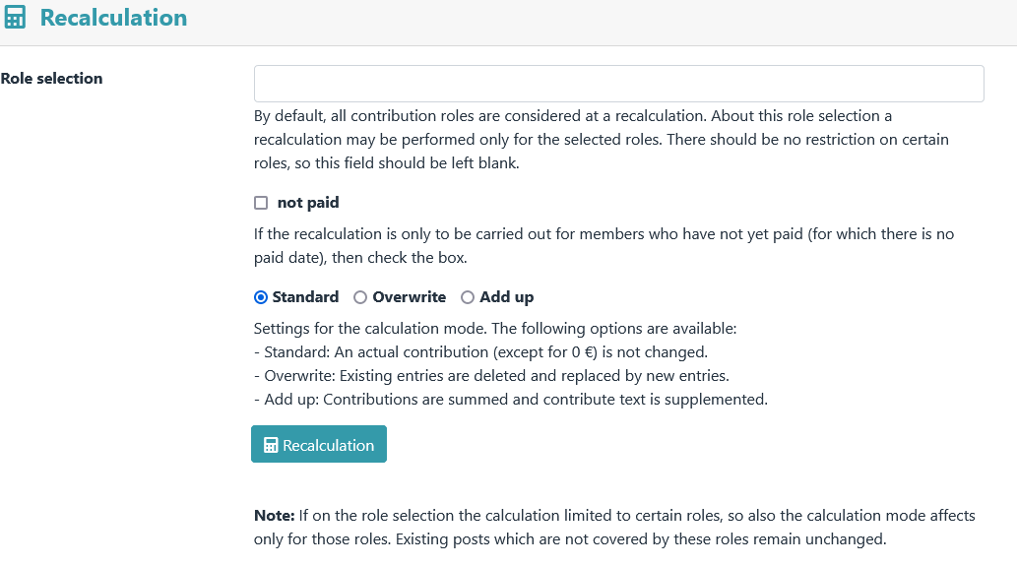

Membership fees are recalculated via Recalculation.

After clicking the "Recalculation" button, a preview appears first.

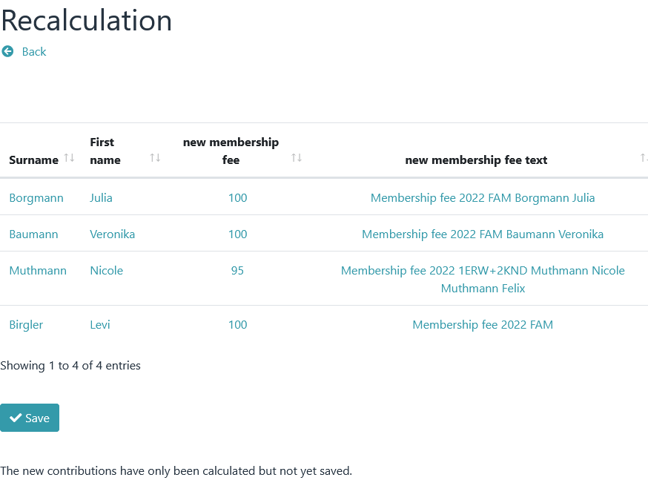
The new amounts are only saved after you click on "Save".

Individual contributions

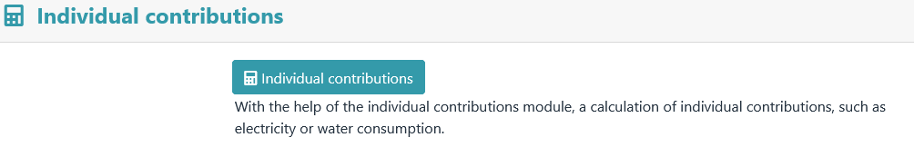

Individual contributions can be used to calculate individual contributions. This menu item is only available after activation ( → Preferences - Individual contributions )

After clicking on the “Individual Contributions” button, a preview appears first.

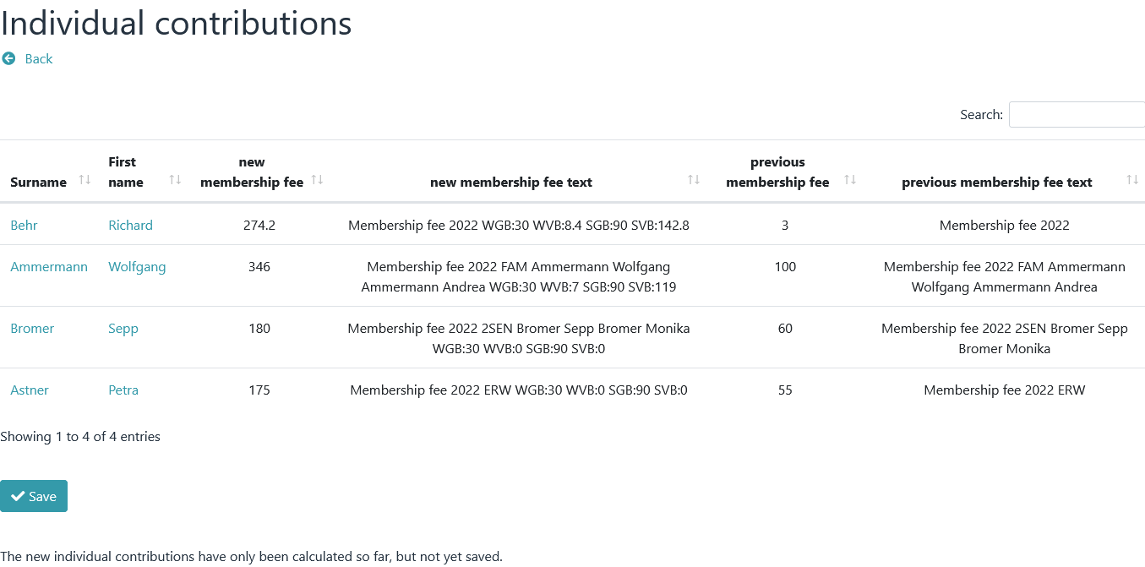
The new amounts are only saved after you click on "Save".

Notice

A calculation of individual contributions should always be carried out only after the contribution has been calculated, since a contribution text generated by the Individual contributions module is always appended to an existing text.

Individual contributions are configured in → Preferences – Individual contributions.

Contribution payments
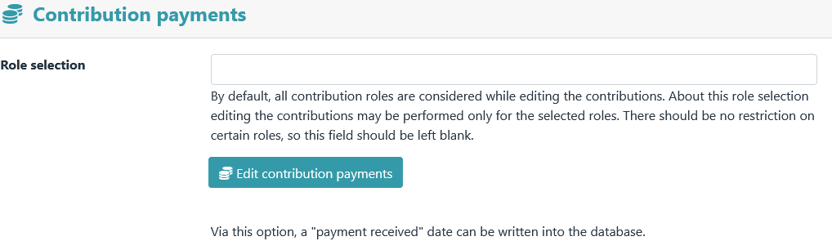

If the membership fee has been paid, this can be noted in the database. To do this, the date of the payday (paid date) is written to the database.

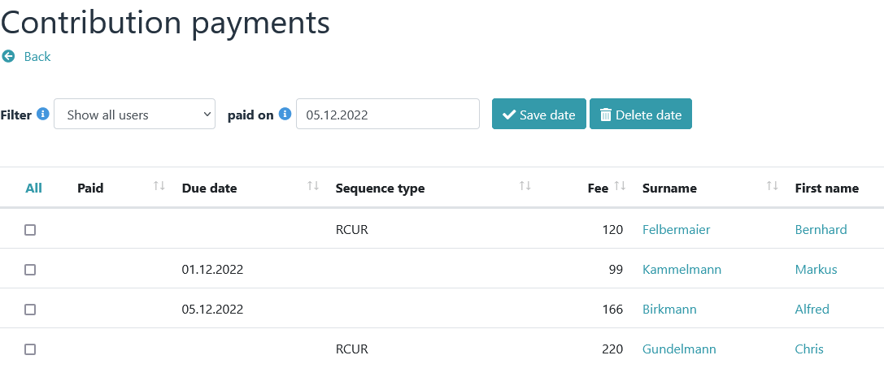

In the first step, the date is set (via "paid on") and those are marked for which a date should be entered.

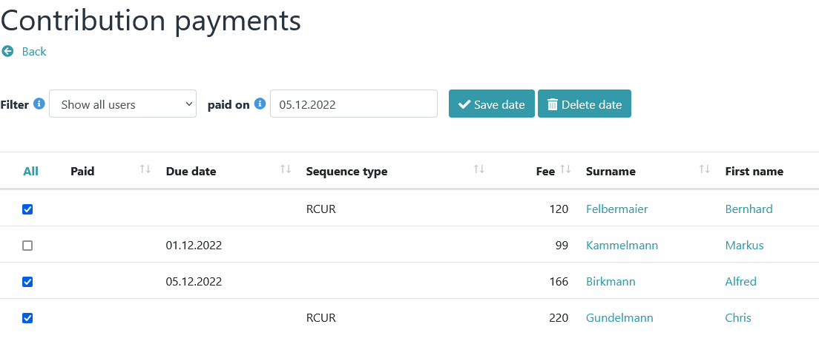

The new paid date is then set using the "Save date" button.

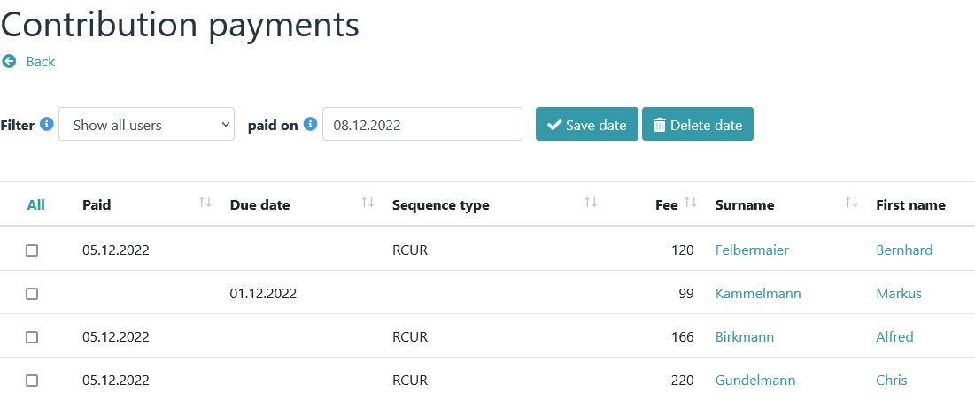

Important NOTE

Setting a paid date also causes:
- the deletion of any existing due date
- the change of the SEPA sequence type FRST to RCUR

Notice

A global reset (deletion) of the paid date is possible via → Fees - Delete.

Payment reminder
If a payment has not been made, an e-mail with a predefined text can be sent as a reminder (→ Preferences – Email notifications – Contribution payments e-mail message).

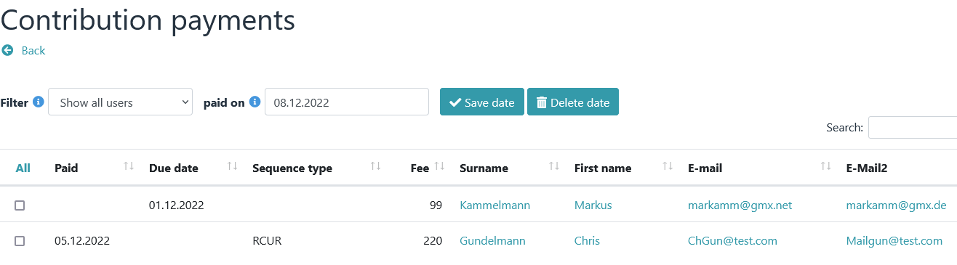
To do this, a profile field of the E-Mail type must be displayed in at least one column in the Contribution payments module. When clicking on an e-mail address, the message module appears with the predefined text.

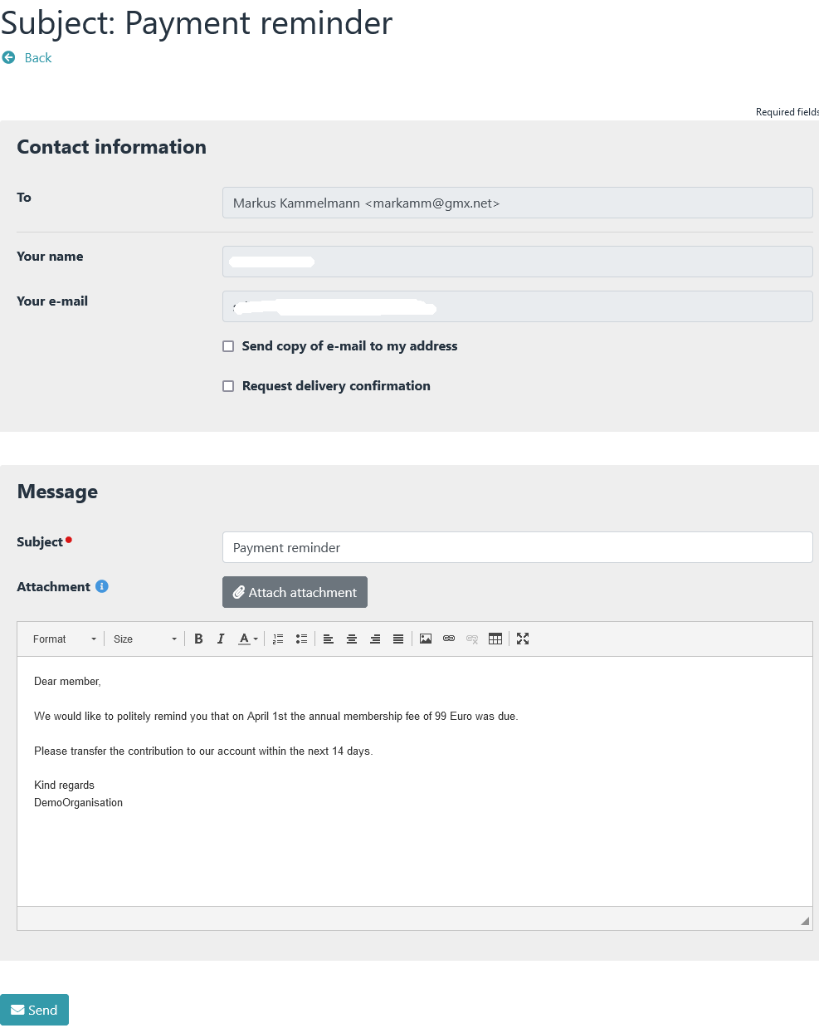

Membership fee analysis
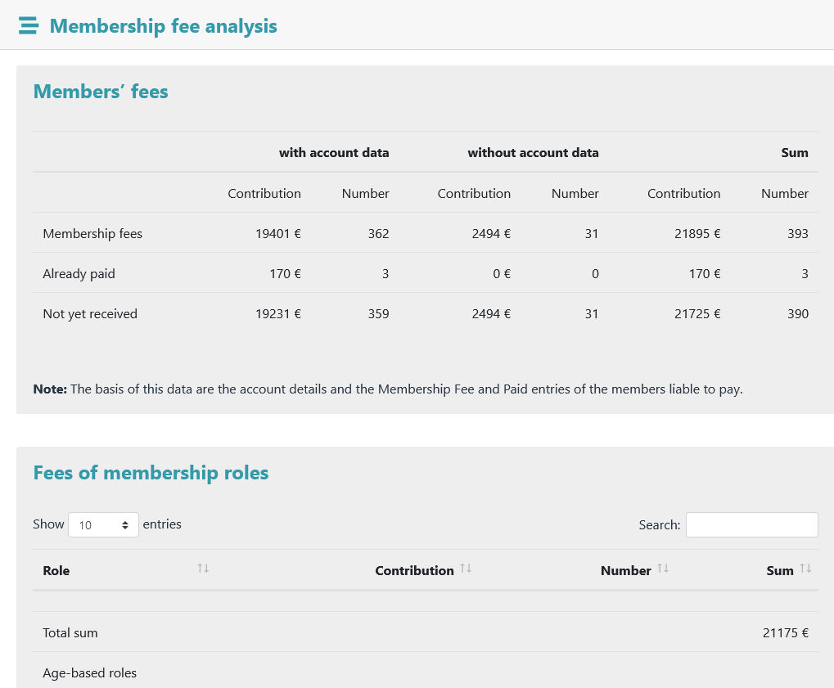

The membership fee analysis serves as a quick overview of the expected membership contributions.

Contribution history
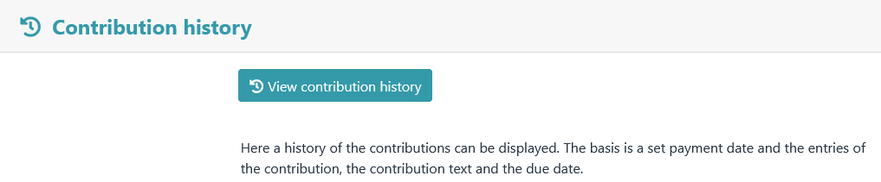

A history of contribution payments can be viewed here.

Export

SEPA

All SEPA-specific export functions are summarized under the SEPA menu item. However, downloading a file or sending preliminary information is only possible if at least one due date has been set.

Important NOTE

All SEPA functions require a previously performed and completed contribution calculation.

All data generated via the SEPA functions such as mandate reference, mandate date, sequence type, etc. can be subsequently changed by editing a member's profile data. A manual change here should be carefully considered. Each SEPA function builds on another and requires the existence of certain data.

Example:

A due date can only be set via the "Due date" module if a mandate reference and a mandate date are available. However, if a due date is entered via a member's profile without the mandate reference and mandate date being available, malfunctions can occur as the program continues to run.

The membership fee plugin can process the following mandate terms:

FRST first direct debit sequence
RCUR recurrent direct debit sequence
FNAL final direct debit sequence
OOFF one-off direct debit sequence

When setting a paid date for the first time, the direct debit type "FRST" is permanently changed to "RCUR".

The direct debit type "RCUR" can only be changed
- about a mandate change
- via the menu item → Export – SEPA - Due date
- or by editing a member's profile

Due date
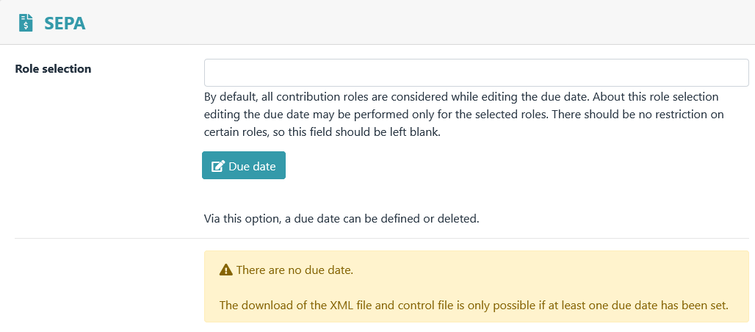

“Due date” view is accessed via the menu item Due date .

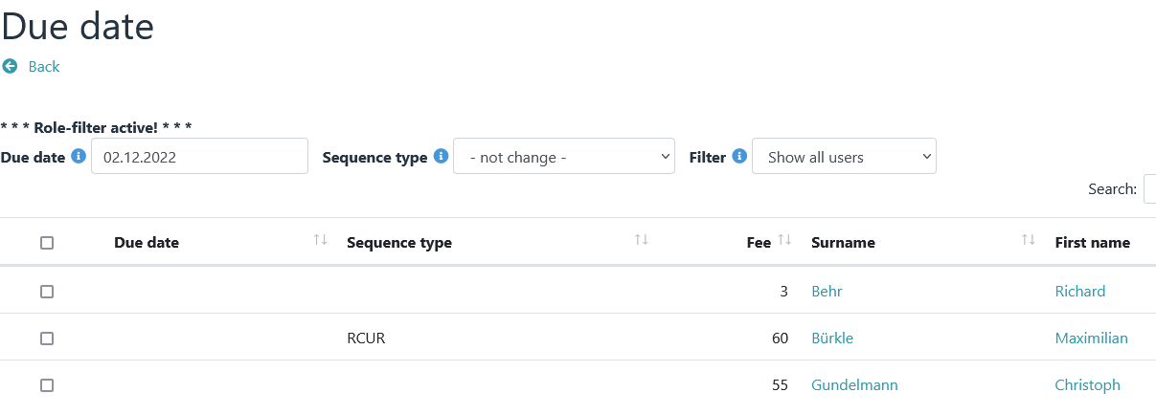

A due date can be set via this view.

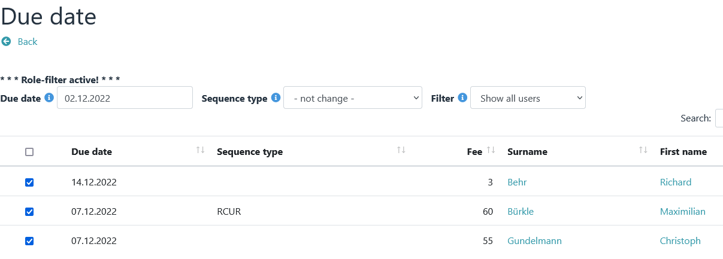

Notice

A global reset (deletion) of the due date is possible via → Fees - Delete.

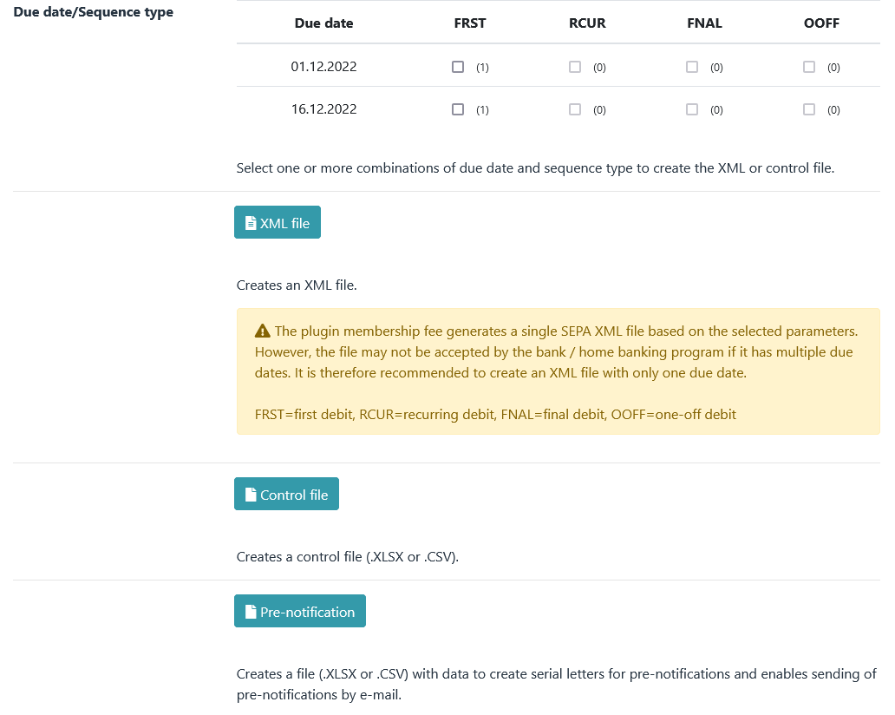

It is only possible to export data if at least one due date exist.

XML file

Notice

In the past, some savings banks and Jameica/Hibiscus could not read the XML files created by the plugin according to specification 3.1 of the DFU agreement. Problems were caused by the position and multiple presence of the PmtTpInf block in the XML file. With version 4.3.2 of the plugin, the program code has therefore been revised and adapted accordingly.

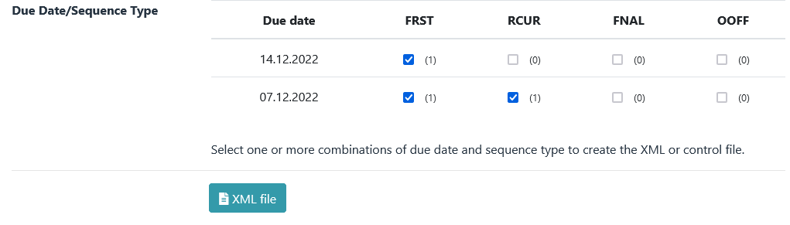

If you select several combinations of due date and sequence type under → Export - SEPA , an XML file with several PmtTpInf blocks is generated. With the settings in the example above, a file with the following file name is created: sepa_2022-12-14-FRST_2022-12-07-FRST_2022-12-07-RCUR.xml.

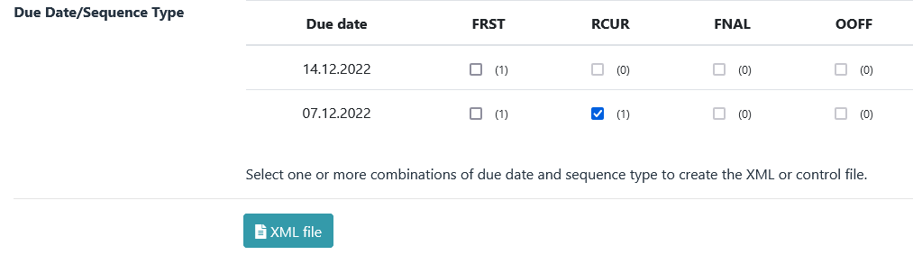

If only one combination of due date and sequence type is selected under → Export - SEPA (only one box is checked), an XML file with exactly one PmtTpInf block is generated. This file should be able to be read by all savings banks, home banking programs, etc. With the settings in the example above, a file with the following file name is created: sepa_2022-12-07-RCUR.xml.

Control file
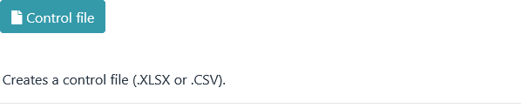

A control file contains the same data as an XML file. For better readability, they are just displayed differently.

The structure is fixed and cannot be changed.

Pre-notification

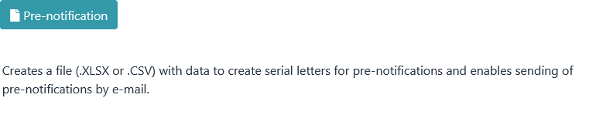
After clicking the "Pre-notification" button, the module view appears.

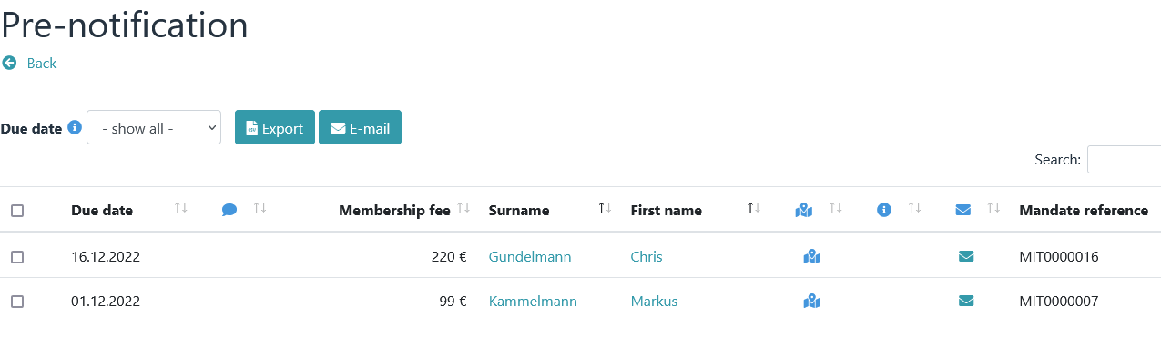

Notice

Prior to a direct debit, the payee must inform the payer of the planned collection in writing by means of a pre-notification, at least 14 days before the debit . This can also be done by means of a contract or an invoice, which can also contain several due dates and the corresponding collection amounts.

A pre-notification must be created again if the amount of a recurrent direct debit sequence changes.

Pre-notifications must always be sent to the account holder. In exceptional cases (address of the account holder is not known), the member is to be informed as an alternative, with the request that this information be forwarded to the account holder. A message text with placeholders can be defined under → Preferences – Email notifications .

Example:

Email to a tagged member
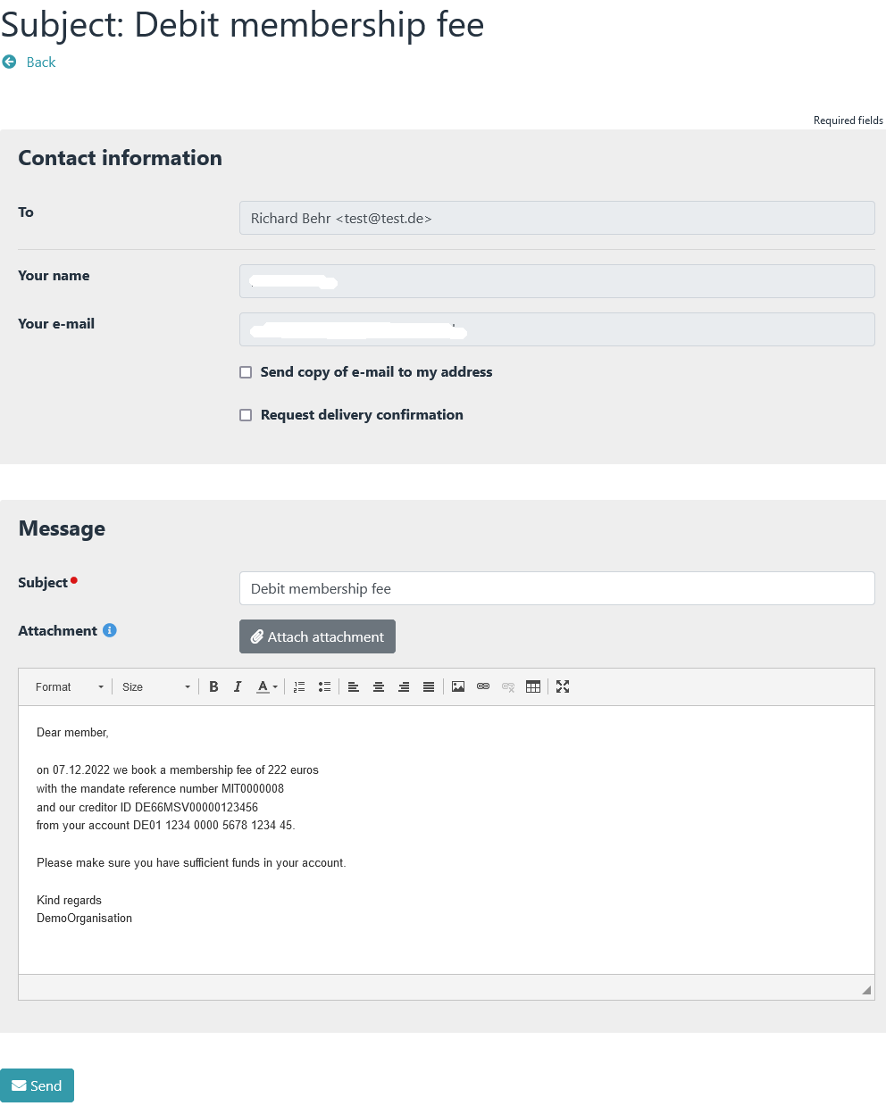
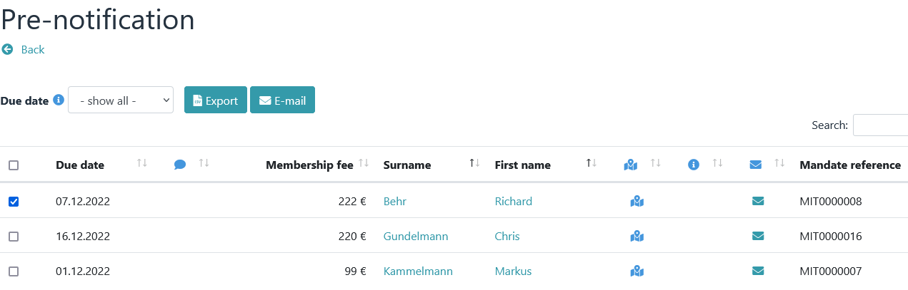

The body of the message contains unique information because the message is sent to only one person.

Example:

Email to multiple tagged members

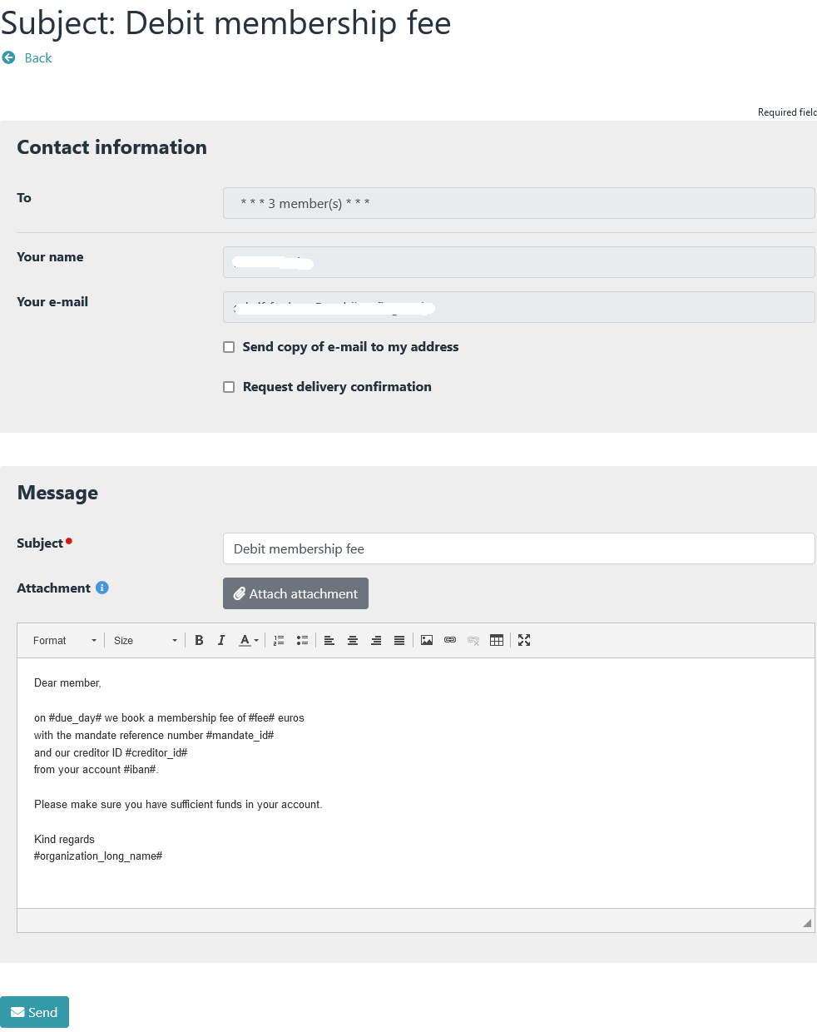
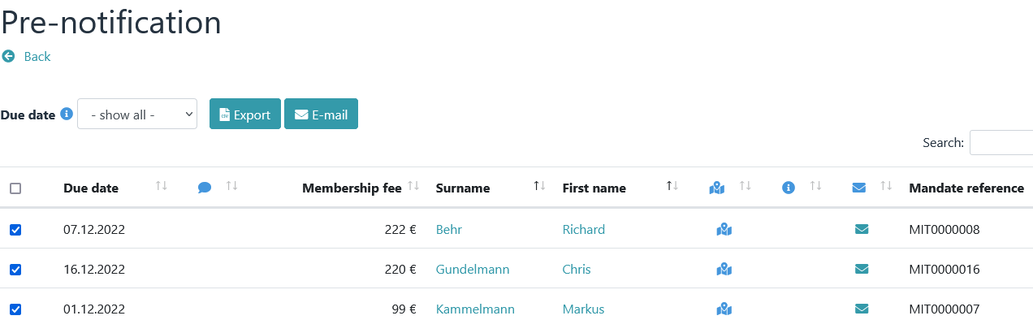

The message text contains placeholders. These will only be replaced after the "Send" button has been clicked.

Invoice

Invoices can be created via the Invoice menu item . This menu item also offers the option of sending transfer requests by email.

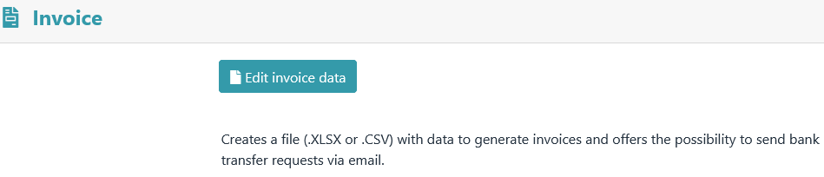

After clicking on the "Edit invoice data" button, the module view appears.

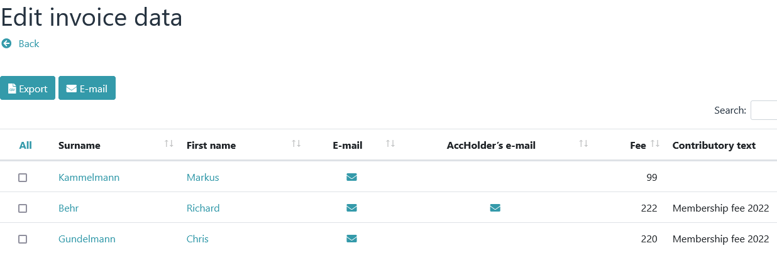

The displayed columns (profile fields) can be defined under → Preferences – View definitions.

Notice

This module only shows members who do NOT have an IBAN.

The Export button

The Export button creates a file with data for serial letters based on the selected members.

The structure of the file is hard-coded.

The E-mail button

Notice

Any number of email profile fields can be created in Admidio. If an e-mail is sent in this module via checkboxes and the e-mail button, the first step is to check whether an account holder e-mail address is available. If so, it will be sent to them. If this is empty, it is checked whether a standard e-mail address is available. If so, it will be sent to them.

Other e-mail addresses are not requested.

However, additional e-mail addresses can be displayed via → Settings – View definitions – Invoice. Sending is then possible via the "letter symbol".

Example:

Email to a tagged member
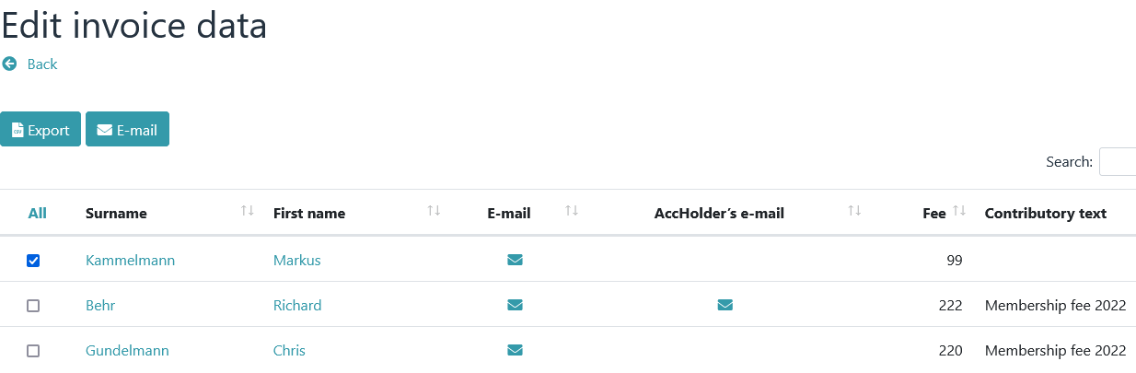
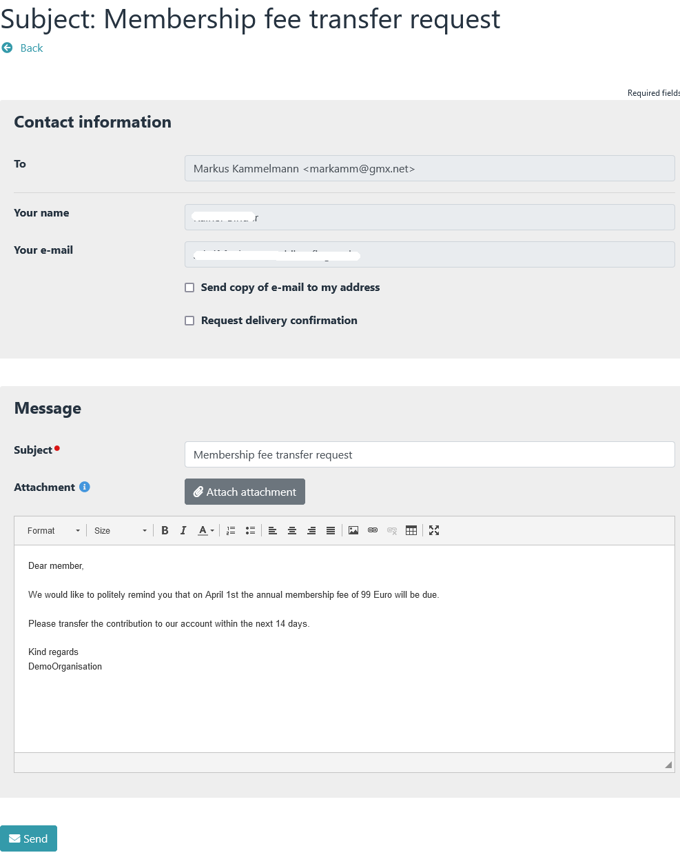

The body of the message contains unique information because the message is sent to only one person.

Example:

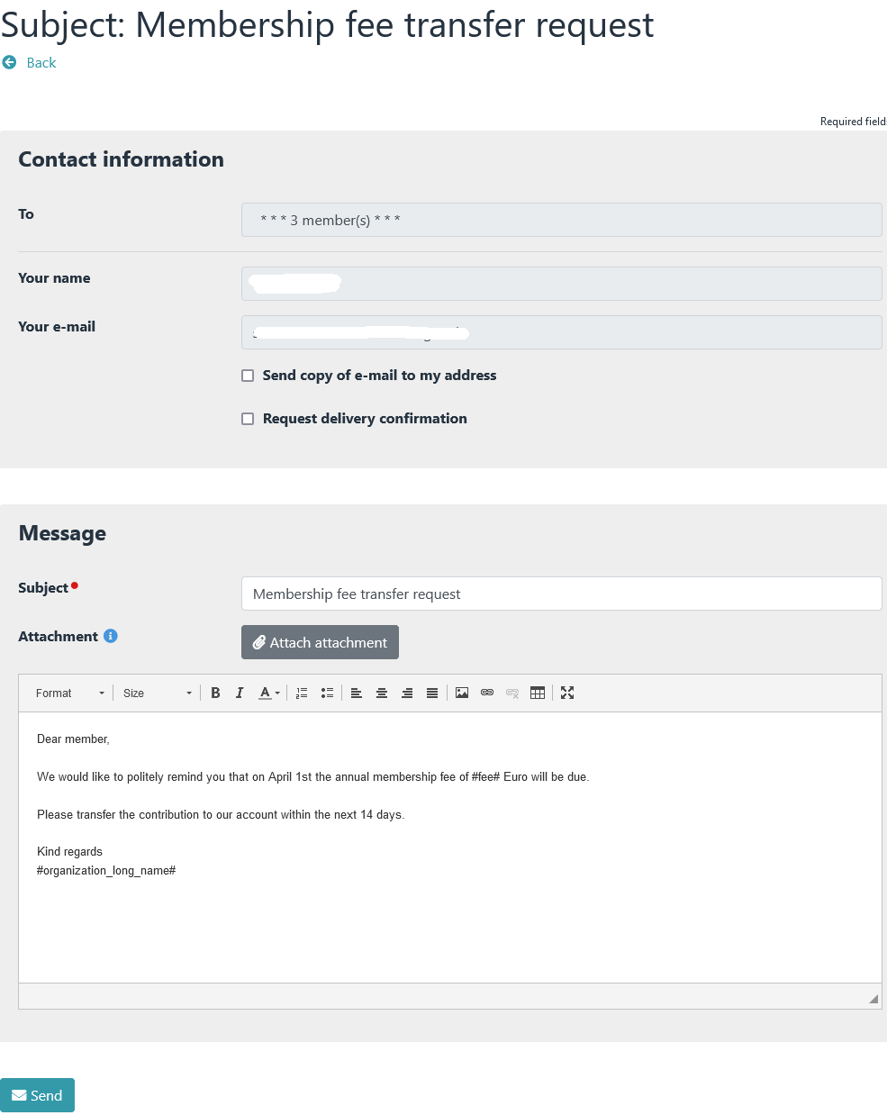
Email to multiple tagged members

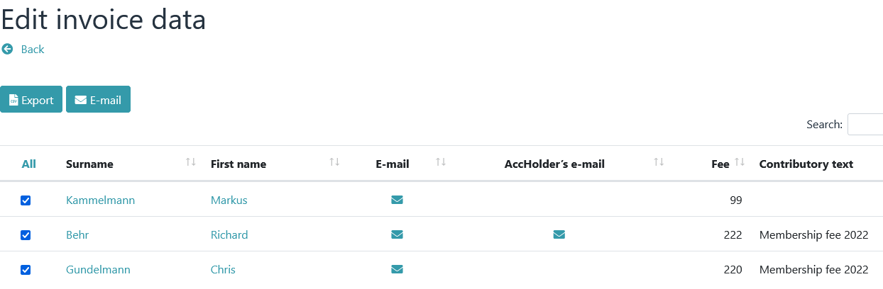

The message text contains placeholders. These will only be replaced after the "Send" button has been clicked.

Mandate management

Create mandate references
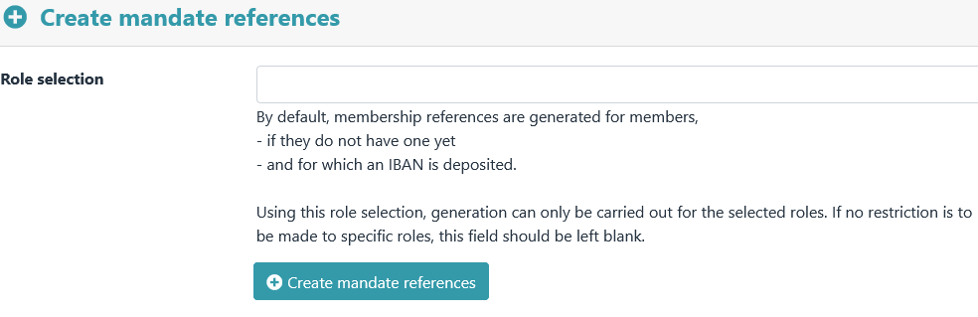

This allows mandate references to be generated depending on the specifications in → Preferences - Mandate Management

After clicking the button "Create mandate references" a preview appears first.

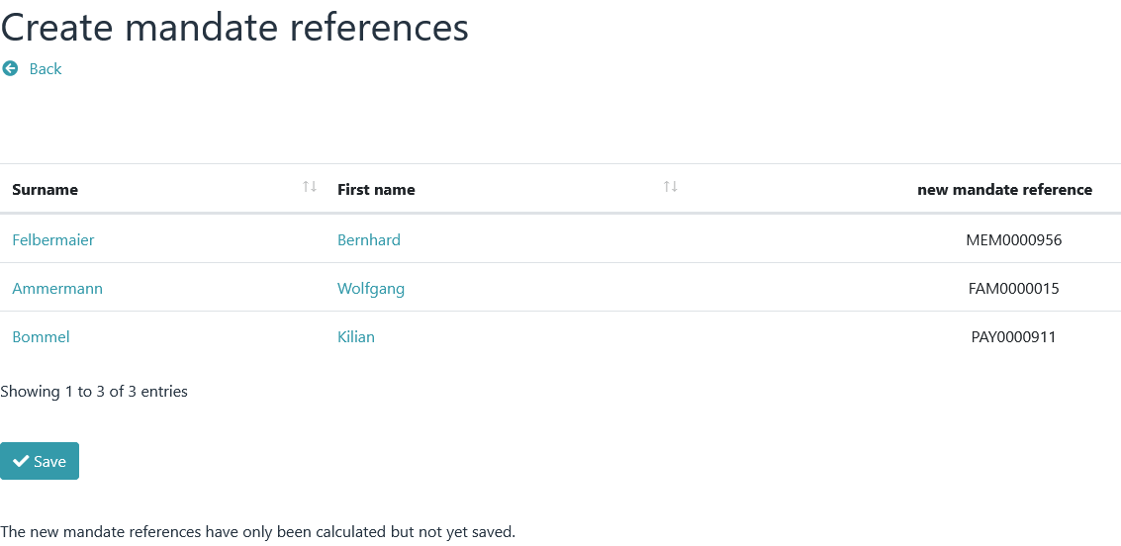

The new mandate references are only saved after you click on "Save".

Edit mandate

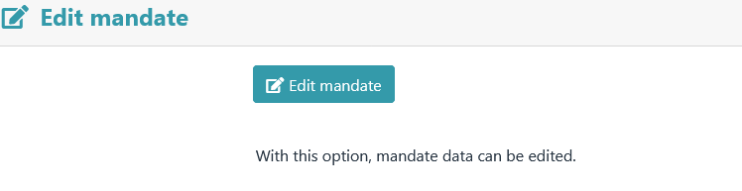
This menu item can be used to set a mandate date or change the mandate.

The Mandates view.
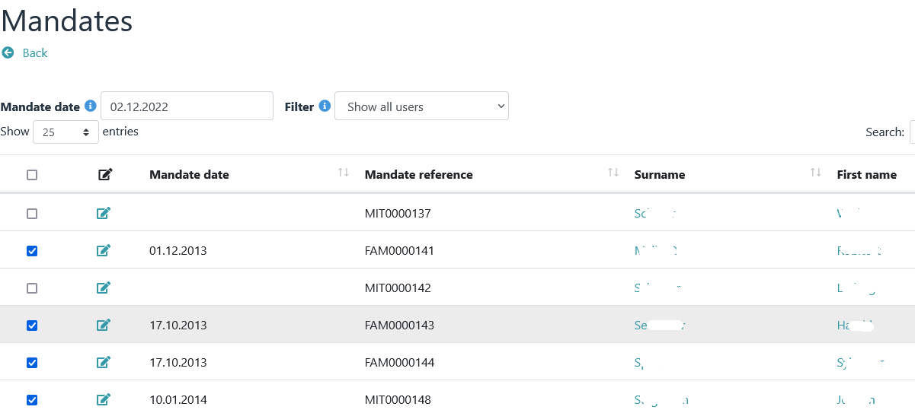

The change of mandate view is called up via the "Change of mandate" button.

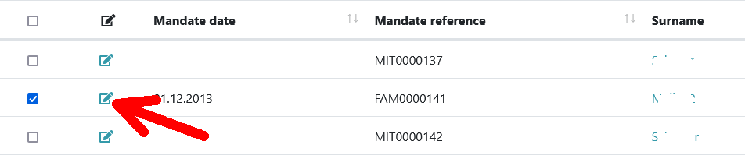

a notice

Mandate changes are required if mandate data have changed since the last collection.
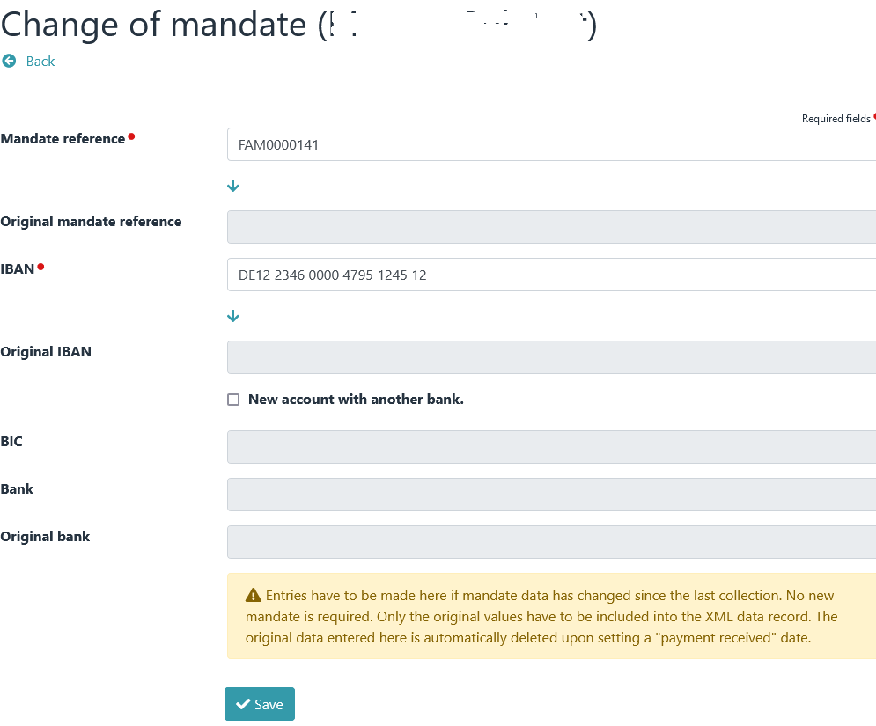

The mandate change for debtors.

Options

Generate membership number(s).
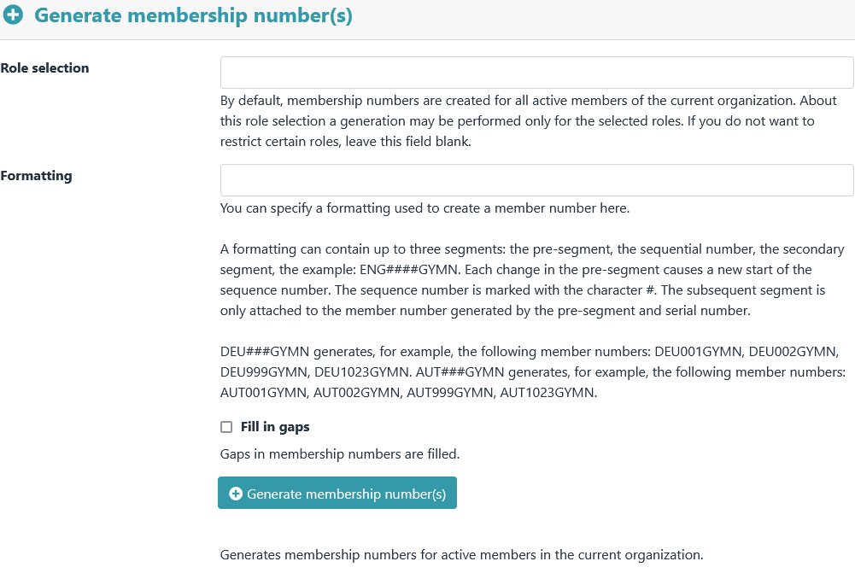

Member numbers for active members of the current organization can be created via this menu item.

After clicking the button "Generate membership number(s)" a preview appears first.
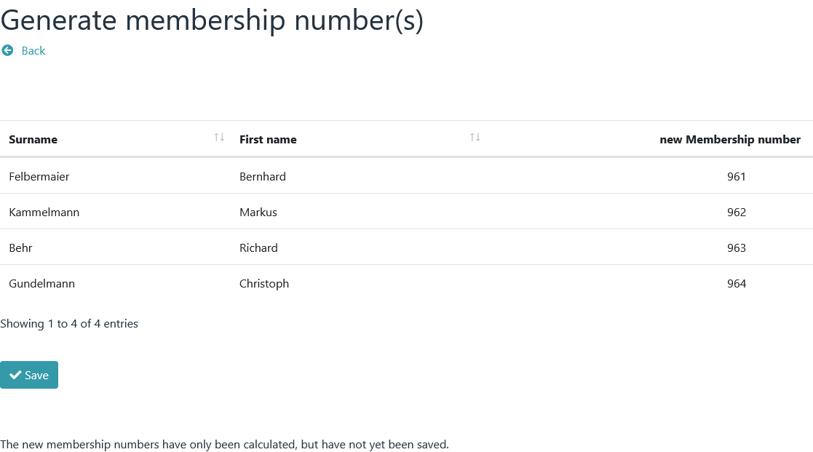
The new membership numbers are only saved after you click on "Save".

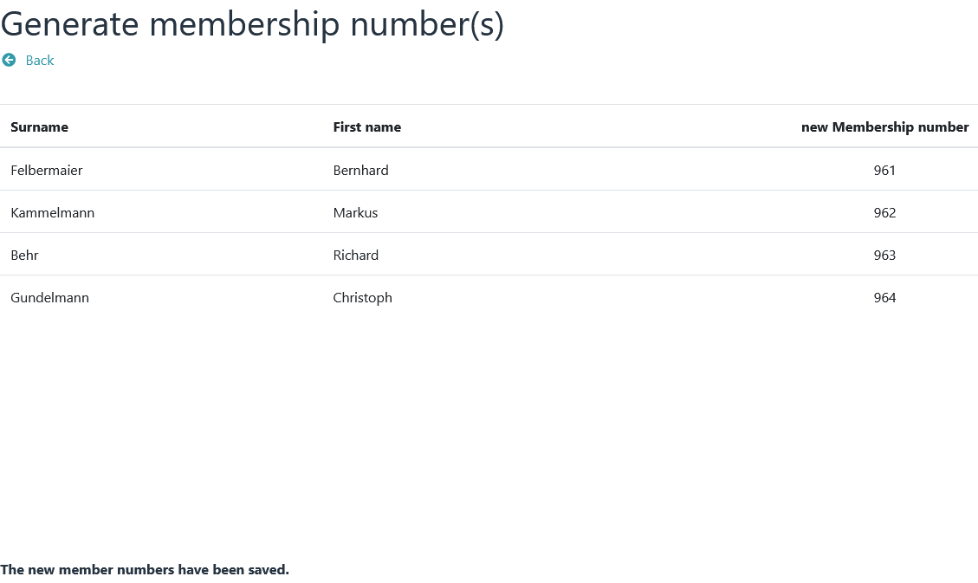

Update family roles
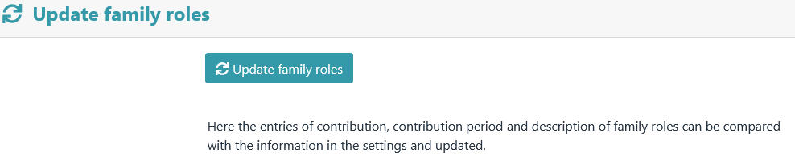

Here, the entries for contribution, contribution period and description of family roles can be compared with the information in the settings and updated.

After clicking the "Update family roles" button, a preview appears first. Differences in entries are highlighted in bold.

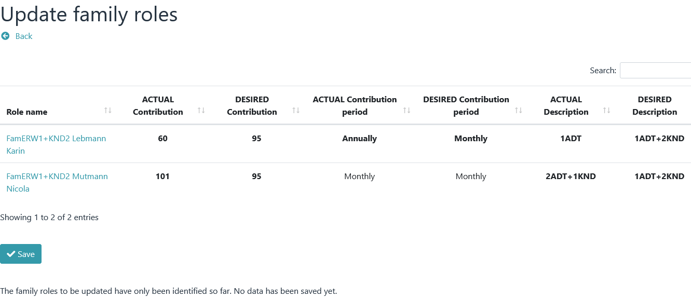

The new data will not be saved until you click on "Save".

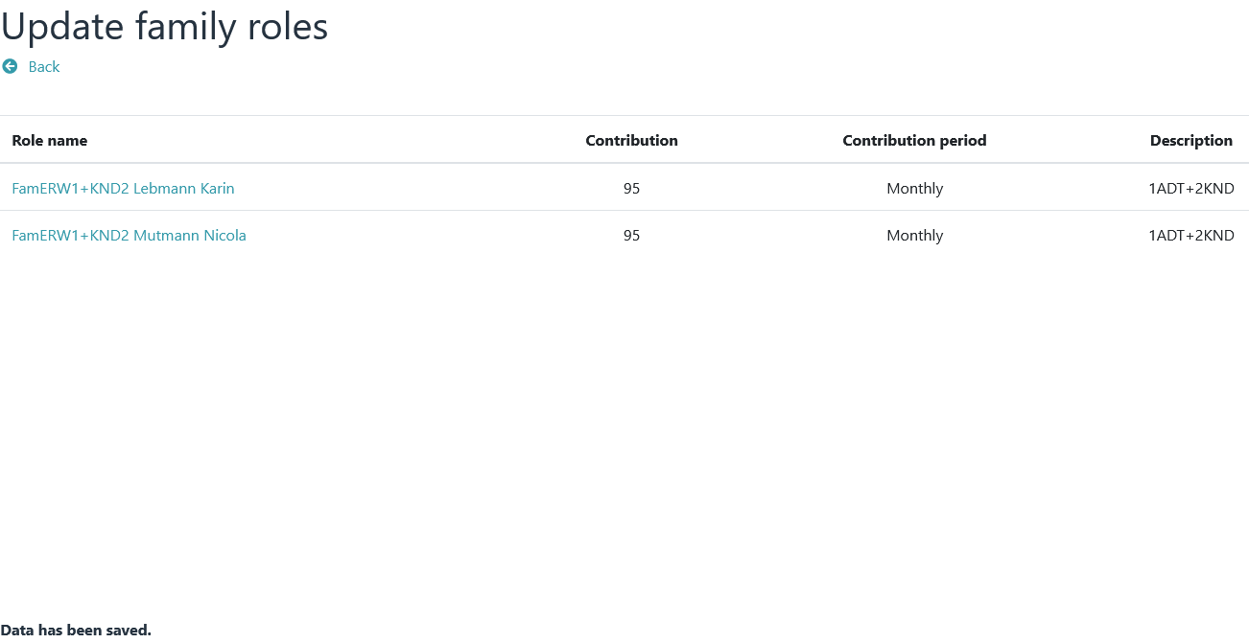

Copy


Using "Copy" the contents of profile fields can be copied from one member to another member.

The view of the "Copy" option.

First select source and target of the copy process.

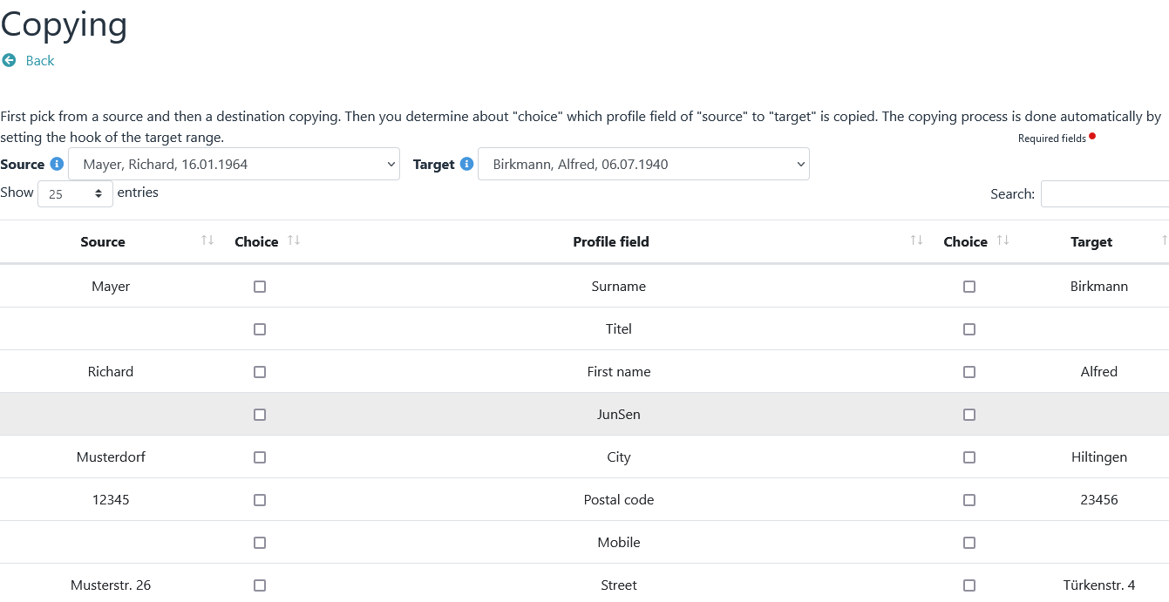

Then select the profile field that is to serve as the source and then the profile field that is to serve as the target.

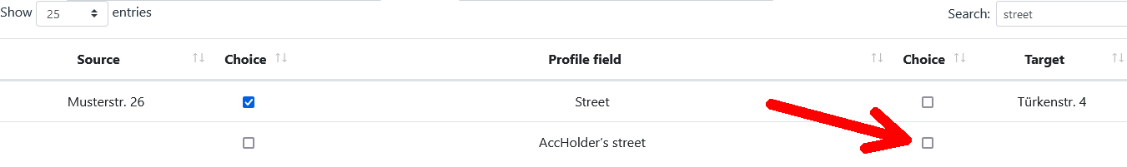

The finished result of a copy operation.
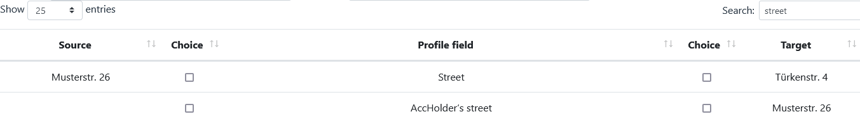

Tests

Tests have no influence on the calculation of contributions. As the name suggests, they only serve to check certain data. Each check can be activated or deactivated via → Preferences – Tests .

Age-bases roles
Checks whether there are gaps or overlaps in the age-based roles, based on the age information.

Role membership (age-based roles)
Checks whether a member is in several age-based roles (e.g. in grading % and in grading & at the same time)

Role membership (mandatory)
Checks if a member is in at least one mandatory role membership.

Role membership (exclusion)
Checks if a member is in mutually exclusive roles.

Family roles
Checks whether there are members in family roles who should not be in this family role due to their age.

Account details
Checks whether the account holder field is filled in the account data. If so, address data must also be filled out.

Notice

If the member is also the account holder, the account holder field must contain **NO** content , it must be empty. In this case, only the IBAN field needs to be filled out
(BIC and bank can, but do not have to be filled out)

If the account holder/payer and member are not identical,
this data must also be given :
* First and last name of the account holder
* Street and house number
* Postal code
* Location

Mandate management
Checks whether mandate ID and mandate date are available (requirement: IBAN and membership fee must be filled out)

IBAN test
Check for correct IBAN

BIC test
1. Check: Checks for the presence of a BIC. Payments outside the EU / EEA continue to require a BIC (Currently the following countries: Switzerland, Monaco, San Marino, Jersey, Guernsey, Isle of Man, St. Pierre and Miquelon).

2. Check: Check the formatting of the BIC. A BIC consists of a 4-digit bank code, a 2-digit country code, a 2-digit city code, and an optional 3-digit branch code.

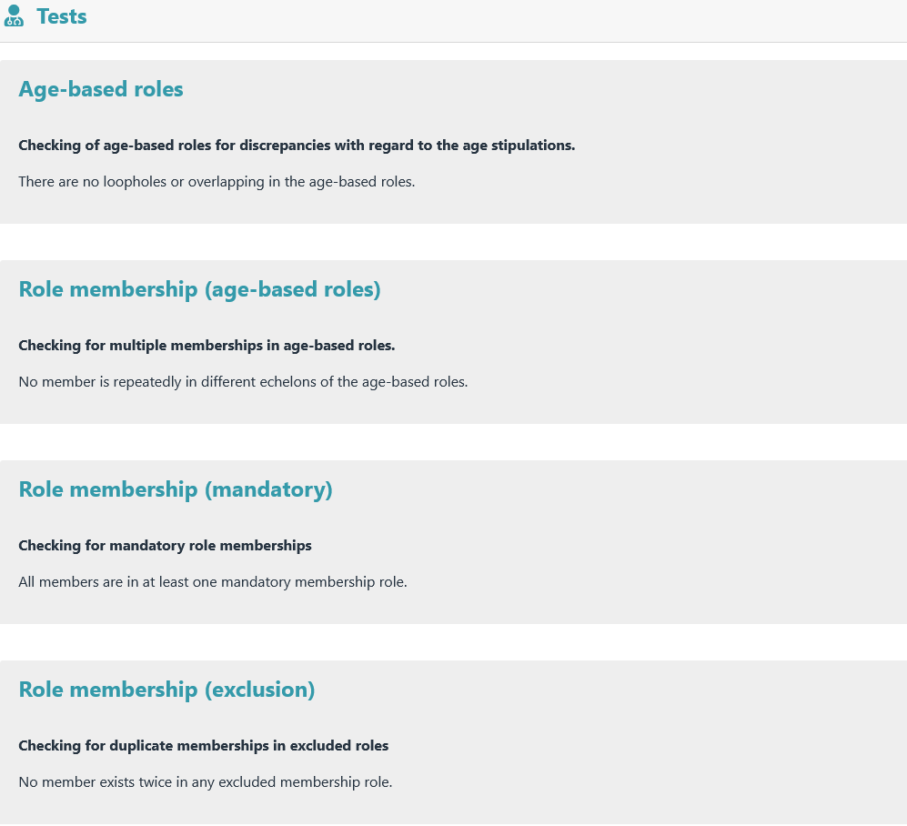
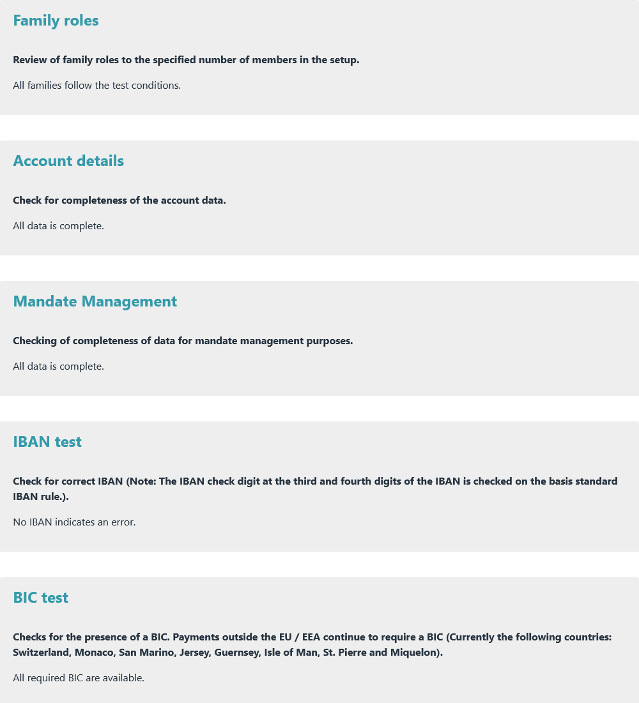
Display when all test conditions are met.

Examples of unfulfilled test conditions.

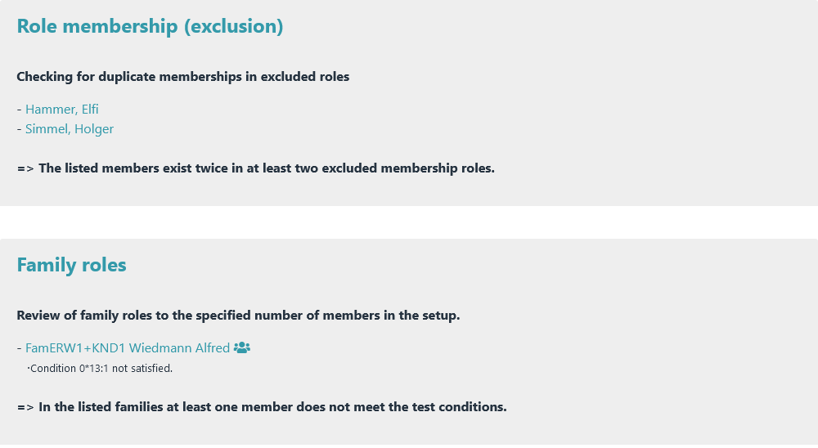

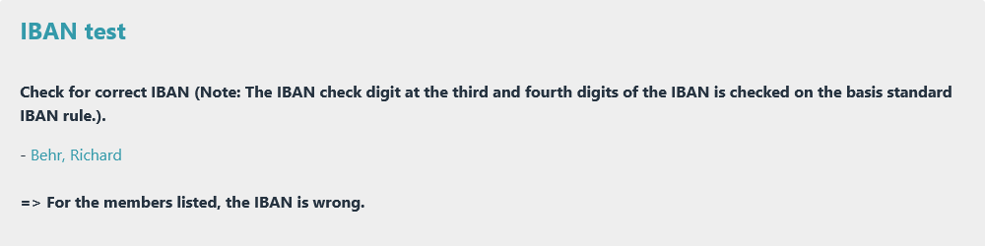

Overview of roles
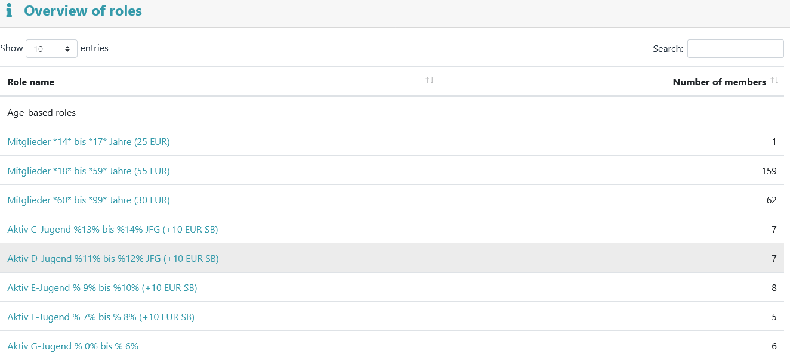

The role overview provides an overview of all contribution roles and their number of members.

Plugin information

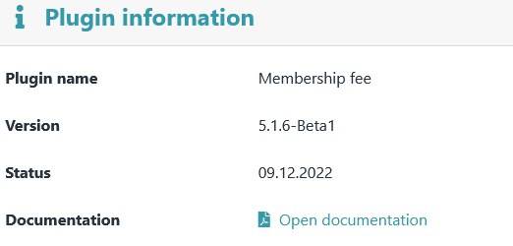
Information about the version and status of the plugin is displayed here.

Preferences

Contribution settings
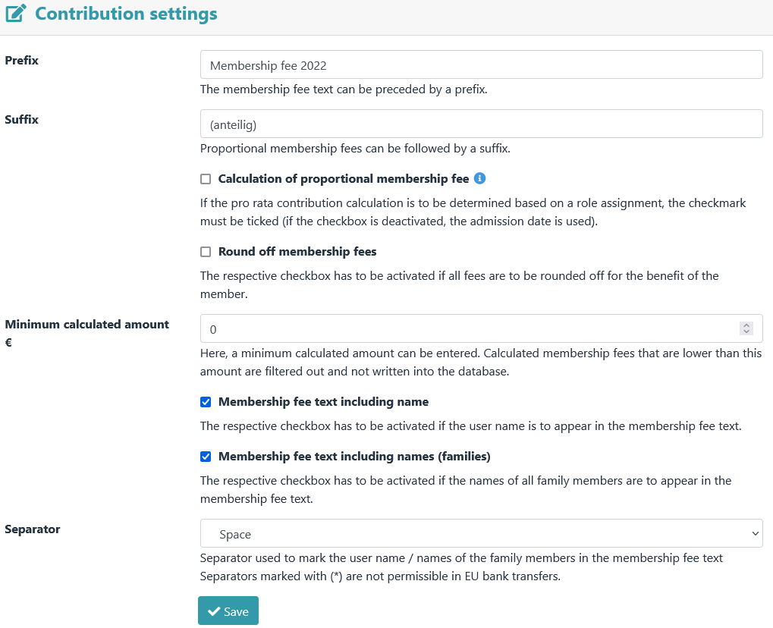

General contribution settings.

Age-based roles

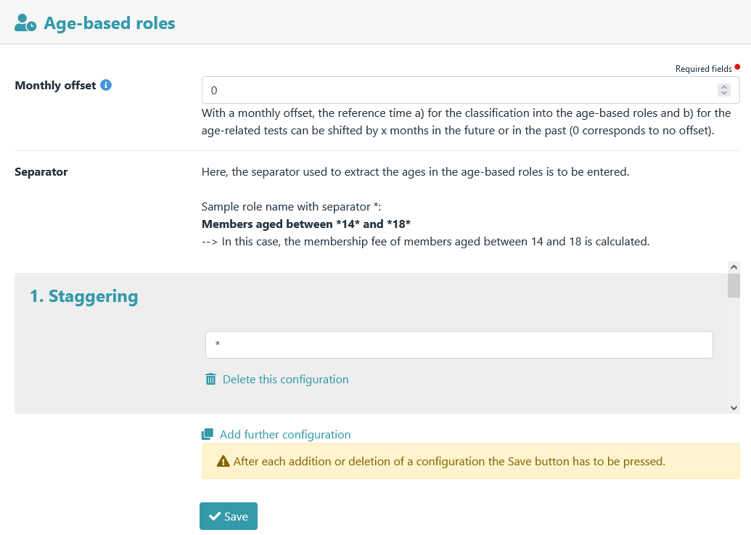

Settings for the age-based roles.

Family roles
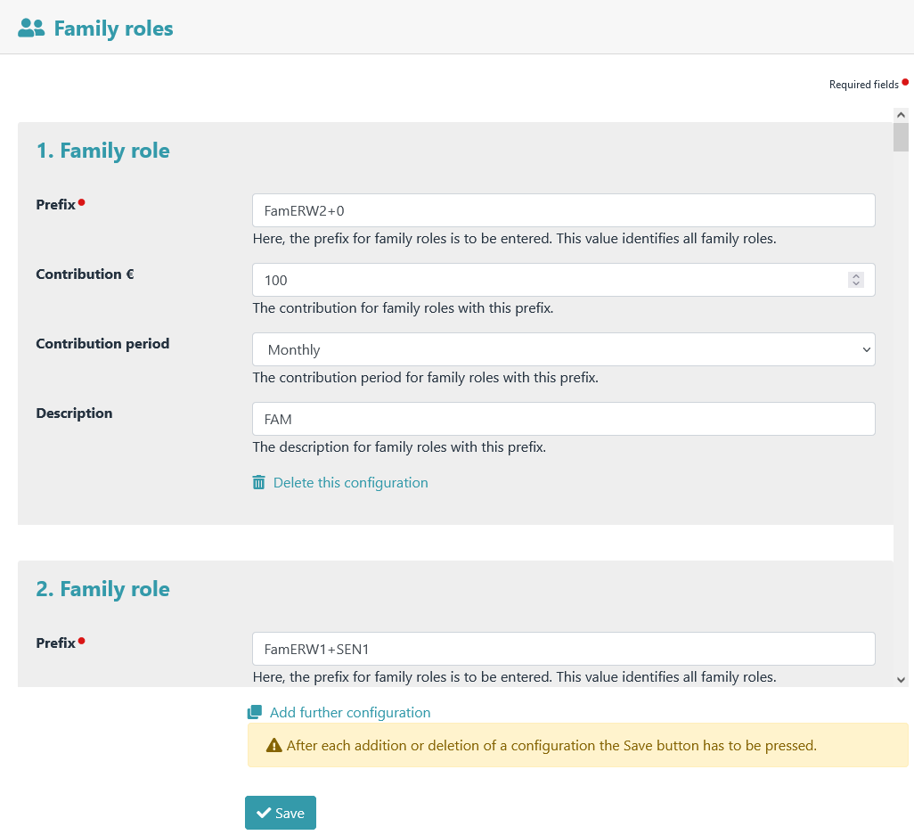
Family role settings.

Multiplier roles

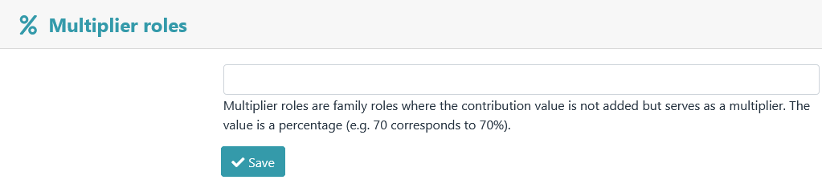
Here one or more contribution roles can be defined as multiplier roles.

Advanced role editing

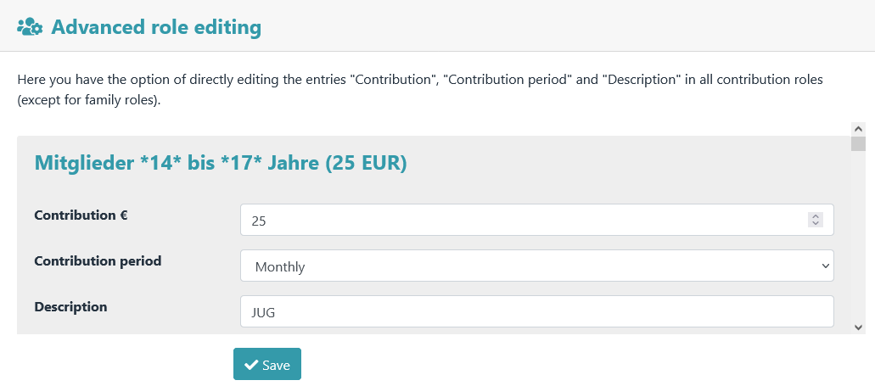
Values of contribution, contribution period and description of contribution roles (except family roles) can be edited via the Advanced role editing. Only via this menu item is it possible to enter a decimal value or a negative contribution for a role (this is no longer possible via → Admidio – Groups & Roles – Edit Role ) .

Apointment selection
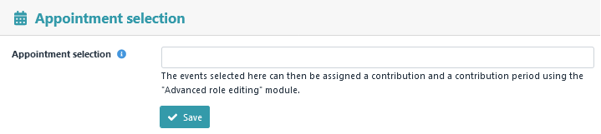
Events can be created using the Admidio "Events" module. If the option "Enable registration for this event" is activated for an event, a role (role type: "Confirmation of attendance") with the same name as the event is generated. All participants in this event become members of this role. However, since this is a special role type, Admidio does not allow a fee or a fee period to be assigned to this role by default.
The "Apointment selection" feature assigns a contribution of 0 and a contribution period of "One time" to the selected events/dates. This allows the plugin to recognize them as contribution roles, enabling further editing via the "Advanced role editing" module.

Individual contributions
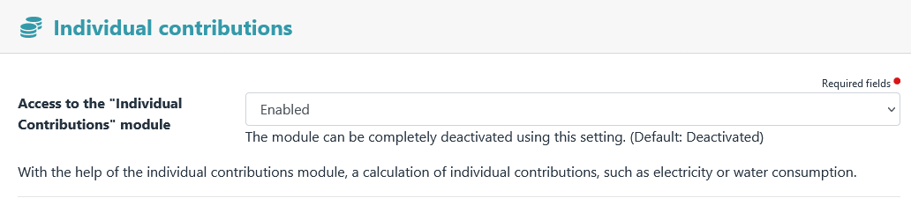
individual contributions module can be activated or deactivated here.
Examples of configurations of basic and consumption amount of water and electricity.
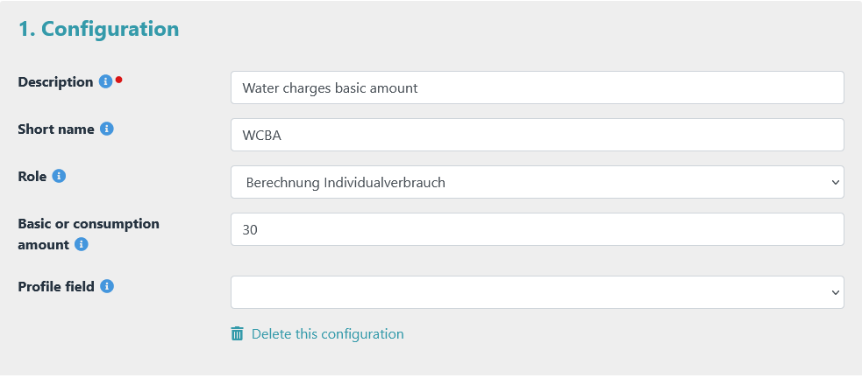
Example basic amount of water charges

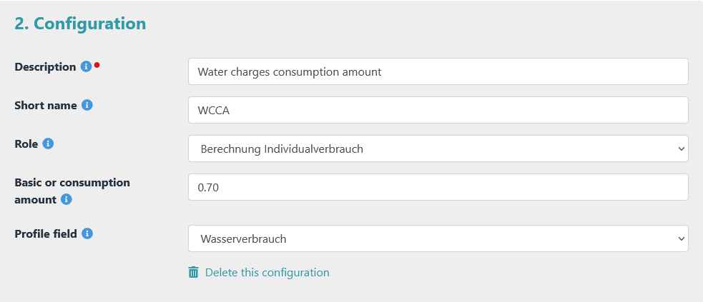
Example consumption amount water charges

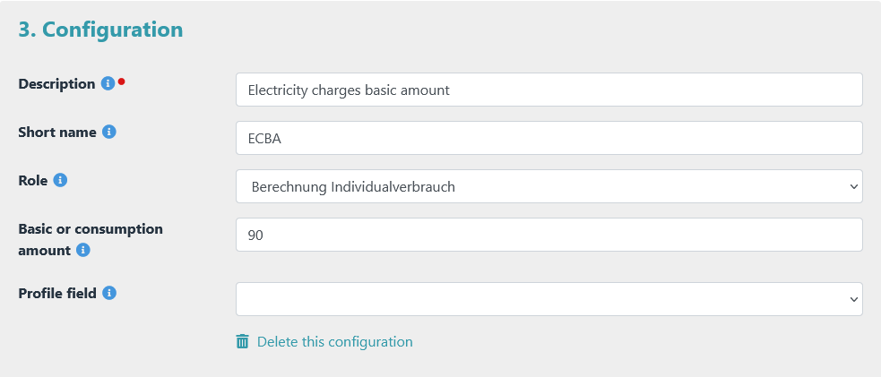
Example basic amount of electricity charges

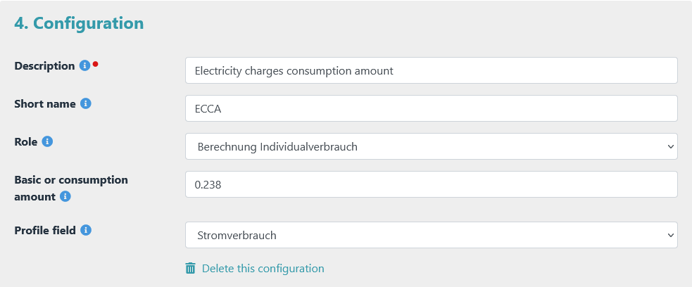
Example consumption amount electricity charges

Account details
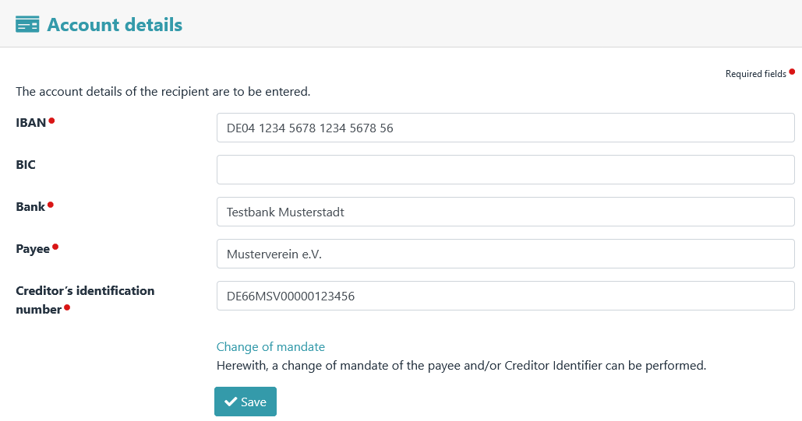

The payee's account details.

The Change of Mandate view is accessed via the "Change of Mandate" link.

Notice

Mandate changes are required if mandate data have changed since the last collection.

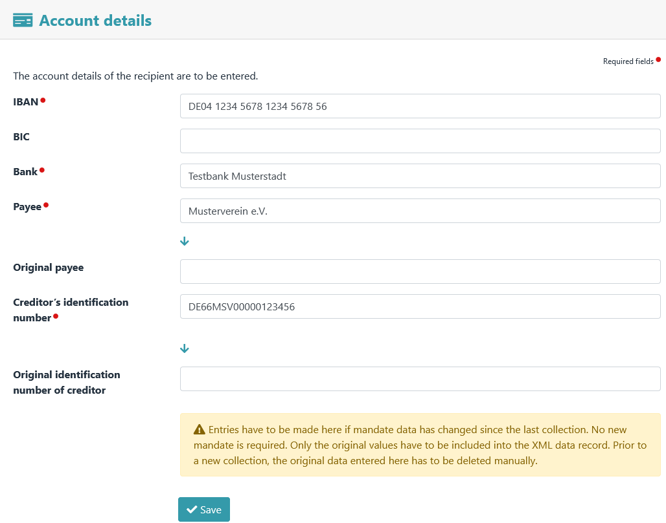

The change of mandate of the payee.

Mandate management
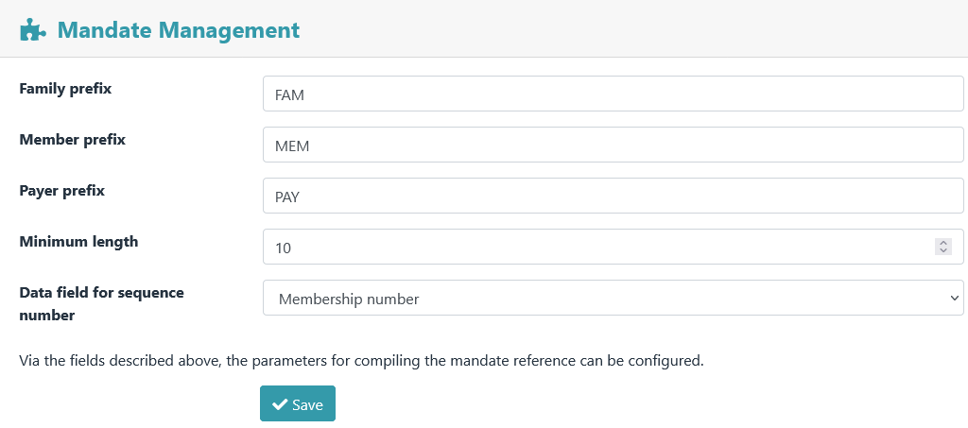
The parameters for the composition of the mandate reference are set here.

Notice

Once a mandate reference has been created, it should not be changed. If it is changed, a change of mandate must be carried out.

A mandate reference is divided into 3 sections. The number of characters (=minimum length) is specified in the menu.

Section 1 | Section 2 | Section 3
Digits 1 to x | Digits x+1 to y | Digits y+1 to z
prefix | zeros | sequential number

The prefix

The prefix in section 1 can be assigned individually. A distinction is made between:
- Families (e.g. FAM or FAMILY)
- Members who act as self-payers (e.g. SLF)
- Members who have a payer (e.g. PAY)

Notice

A prefix can, but does not have to be entered. There is also no need to define different prefixes.

The zeros

Section 2 is filled with zeros (0) if the set minimum length has not yet been reached.

The sequential number

Section 3 is a sequential number. To do this, a database field with clear content ( e.g. member number or user_id) is selected. The value from this database field is used as a sequential number.

Example 1: | Example 2:
- Specified minimum length: 10 | - Specified minimum length: 5
- Prefix: FAM | - Prefix: MEMBER
- Sequential number: 566 | - Sequential number: 723
- => results in the following mandate reference: FAM0000566 | - => results in the following mandate reference: MEMBER723

View definitions

This menu item can be used to define the columns (profile fields) to be displayed for the views
- Contribution payments,
- Mandate management,
- Due date and
- Invoice

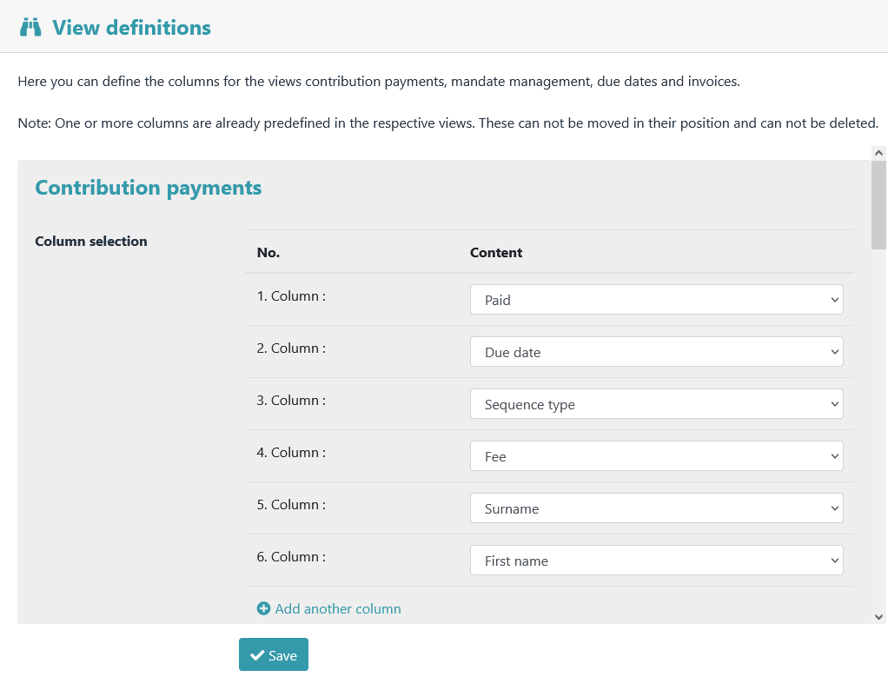

Export
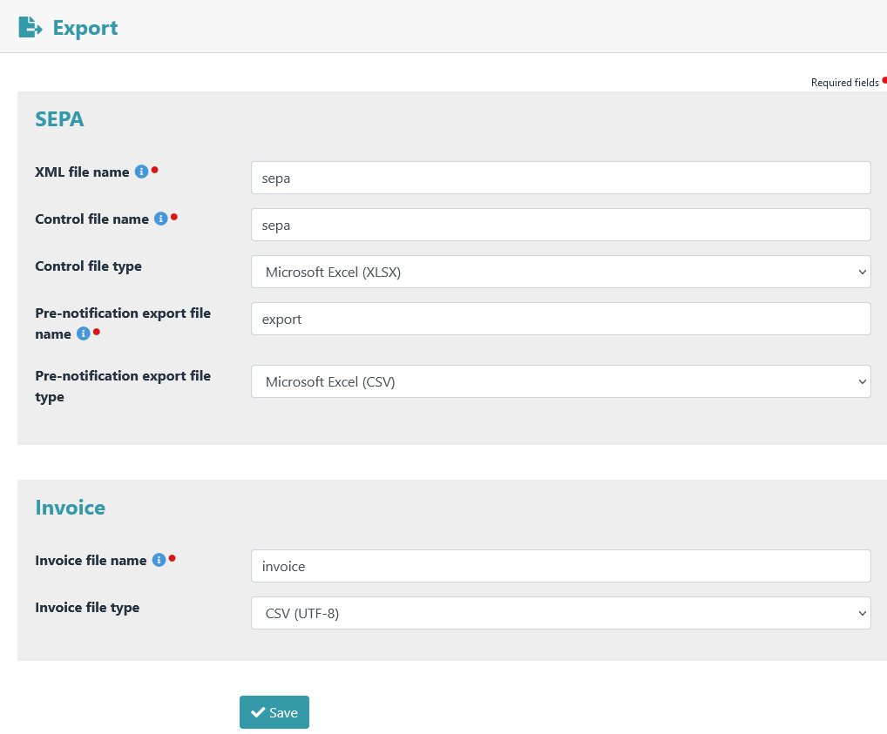

Settings for data export.

Email notifications

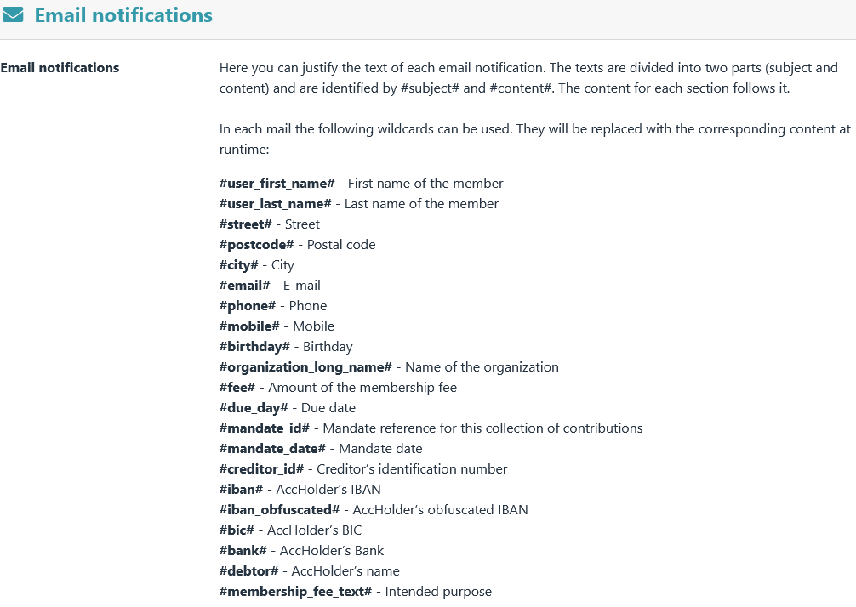

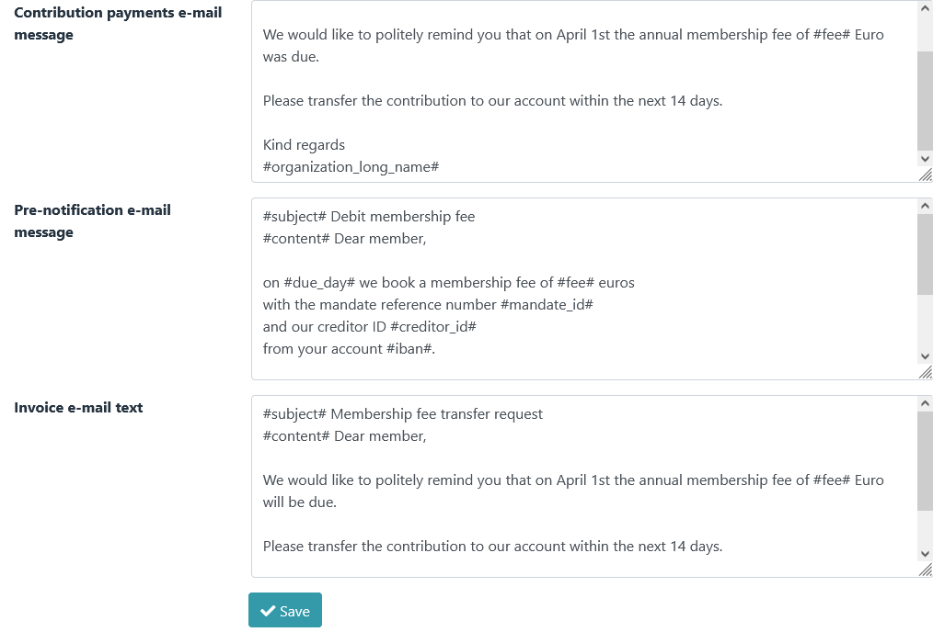

Tests

Settings for the role checks
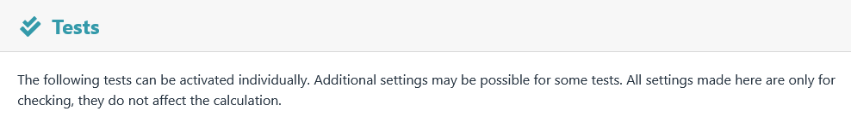

Enable tests

All tests can be activated separately.
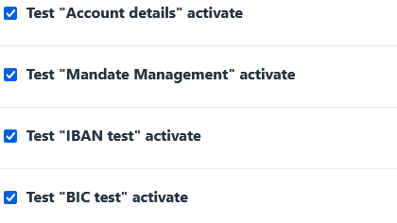

Role membership (age-based roles)

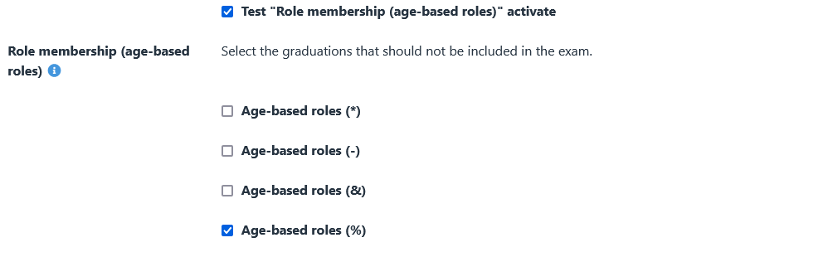
Here you can select which scales should not be included in the "Role membership (age-based roles)" test.

Role membership (mandatory) and Role membership (exclusion)

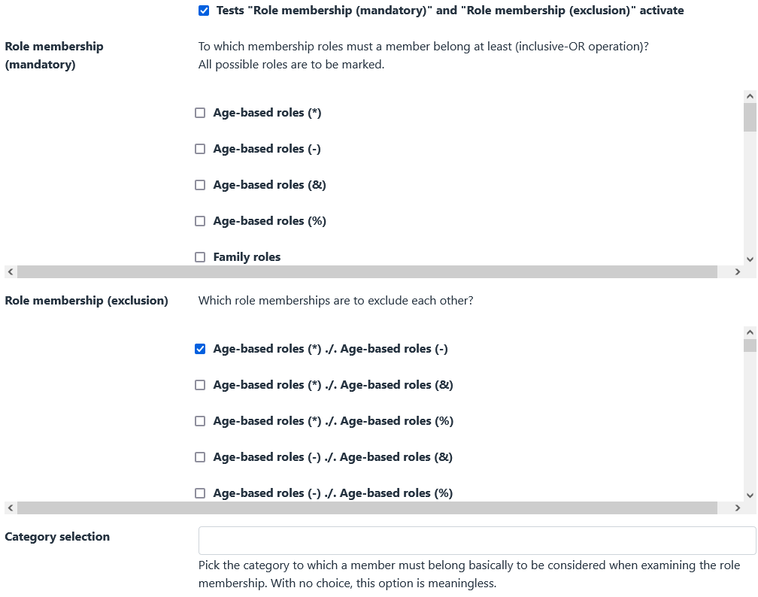
Role membership (mandatory)

All contribution roles to which a member should at least belong must be selected here. All possible roles are to be marked.

For example, a member should either be in
- an age-based role
- OR in a family role
- OR in an honorary members role

-> in this case tick the boxes: "Age-based roles", "Family roles" and "Honorary members"

Role membership (exclusion)

Here you have to select which contribution roles should be mutually exclusive.

For example, if a member is not allowed to be in an age-based role and a family role at the same time
(-> double contribution calculation), then "Age-based roles ./. Family roles" is to be marked.

Family roles
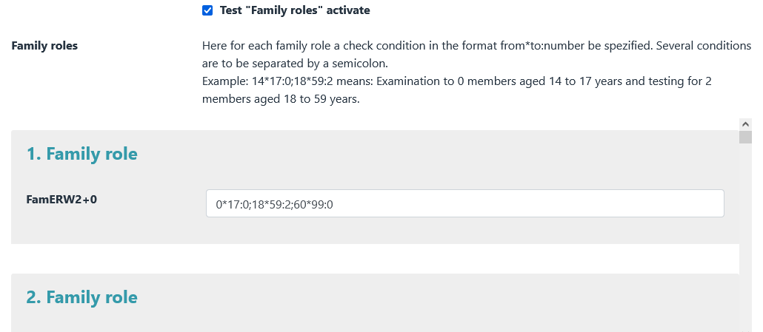
The test conditions for family roles are defined here. A separate test condition in the format "from*to:number" can be specified for each prefix of a family role. Multiple conditions must be separated by semicolons.

It is checked whether a member of a family role should not be in a family role with this prefix due to his age.

All checks of family roles refer to the reference time that was defined for the age-based roles.

Examples of test conditions for family roles:

exam on | test condition
-0 people from 0 to 17  -2 people from 18 to 59  -0 people from 60 to 99 | 0*17:0;18*59:2;60*99:0
-0 people from 0 to 13  -1 person from 14 to 17  -2 people from 18 to 59  -0 people from 60 to 99 | 0*13:0;14*17:1;18*59:2;60*99:0
-0 people from 0 to 17  -1 person from 18 to 59  -1 people from 60 to 99 | 0*17:0;18*59:1;60*99:1
-0 people from 0 to 17  -0 people from 18 to 59  -2 people from 60 to 99 | 0*17:0;*18:59::0*;60*99:2

The use of complex family role prefixes is also possible.

The author of the plugin currently uses the following family role prefixes:

With the following specifications:
- Child: 0 to 13 years
- Youth: 14 to 17 years
- Adult: 18 to 59 years old
- Senior: 60 to 99 years

family role prefix | description | test condition
FamERW1+JUG1+0 | 1 adult + 1 youth | 0*13:0;14*17:1;18*59:1;60*99:0
FamERW1+JUG1+KND1 | 1 adult + 1 youth + 1 child | 0*13:1;14*17:1;18*59:1;60*99:0
FamERW1+JUG1+KND2 | 1 adult + 1 teenager + 2 children | 0*13:2;14*17:1;18*59:1;60*99:0
FamERW1+JUG1+SEN1 | 1 adult + 1 youth + 1 senior | 0*13:0;14*17:1;18*59:1;60*99:1
FamERW1+KND1 | 1 adult + 1 child | 0*13:1;14*17:0;18*59:1;60*99:0
FamERW1+KND2 | 1 adult + 2 children | 0*13:2;14*17:0;18*59:1;60*99:0
FamERW1+KNDx | 1 adult + many children | 14*17:0;18*59:1;60*99:0
FamERW1+SEN1 | 1 adult + 1 senior | 0*17:0;18*59:1;60*99:1
FamERW1+STD1+SEN1 | 1 adult + 1 student + 1 senior | 0*13:0;14*24:1;25*59:1;60*99:1
FamERW2+0 | 2 adults | 0*17:0;18*59:2;60*99:0
FamERW2+ERW1+0 | 3 adults | 0*17:0;18*59:3;60*99:0
FamERW2+ERW1+JUG1+0 | 3 adults + 1 teenager | 0*13:0;14*17:1;18*59:3;60*99:0
FamERW2+ERW1+JUG1+KNDx | 3 adults + 1 teenager + many children | 14*17:1;18*59:3;60*99:0
FamERW2+ERW1+JUG2 | 3 adults + 2 teenagers | 0*13:0;14*17:2;18*59:3;60*99:0
FamERW2+ERW1+KNDx | 3 adults + many children | 14*17:0;18*59:3;60*99:0
FamERW2+ERW2 | 4 adults | 0*17:0;18*59:4;60*99:0
FamERW2+JUG1+0 | 2 adults + 1 teenager | 0*13:0;14*17:1;18*59:2;60*99:0
FamERW2+JUG1+KNDx | 2 adults + 1 teenager + many children | 14*17:1;18*59:2;60*99:0
FamERW2+JUG2+0 | 2 adults + 2 teenagers | 0*13:0;14*17:2;18*59:2;60*99:0
FamERW2+JUG2+KNDx | 2 adults + 2 teenagers + many children | 14*17:2;18*59:2;60*99:0
FamERW2+KNDx | 2 adults + many children | 14*17:0;18*59:2;60*99:0
FamERW2+SEN1 | 2 adults + 1 senior | 0*17:0;18*59:2;60*99:1
FamERW2+STD1 | 2 adults + 1 student | 0*13:0;14*24:1;25*59:2;60*99:0
FamSEN2 | 2 seniors | 0*59:0;60*99:2

The initial configuration is certainly very time-consuming and requires extensive planning.

Example:
Max Mustermann joins the association with his wife and many children. A role with the name FamERW2+KNDx Mustermann Max is created for this purpose.

After a few years, one of the children becomes a teenager.
→ The name of the role is renamed to FamERW2+JUG1+KNDx Mustermann Max.

Again after a few years, a second child becomes a teenager.
→ The name of the role is renamed to FamERW2+JUG2+KNDx Mustermann Max.

Then one of the teenagers becomes an adult.
→ The name of the role is renamed to: FamERW2+ERW1+JUG1+KNDx Mustermann Max .

etc. etc.

Conclusion: A lot of work in the definition, but after that it's pretty much a sure-fire success.

Extended test conditions
From membership fee v5.3.0 onwards, extended test conditions can be used. The syntax for this is: <from>*<to>:<number_1>:<number_2>....:<number_n>. Example: 0*14:0:2:4 --> Checks whether there are 0, 2 or 4 members between the ages of 0 and 14 in this role.

Access permission for preferences

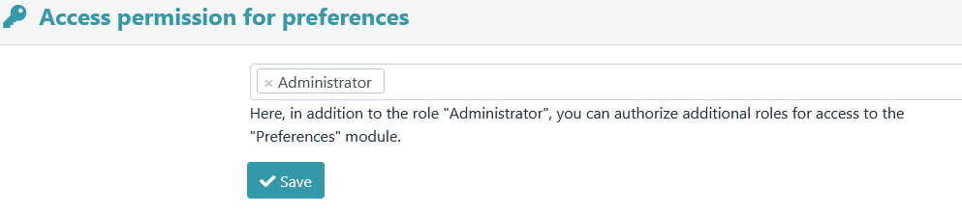
Here you can authorize other roles, in addition to the “Administrator” role, to access the Preferences module.

Delete Amounts



Entries such as contribution, contribution text, paid date or due date can be deleted from the database via Delete.

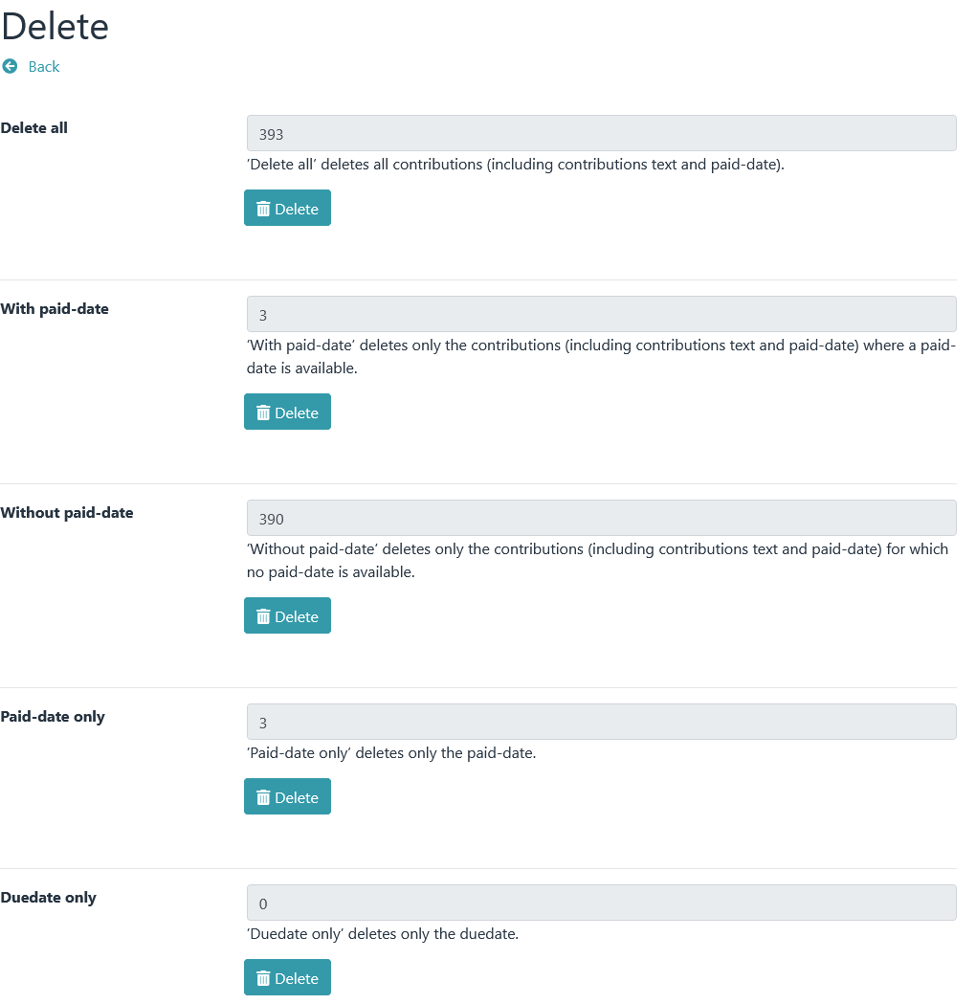

Uninstall

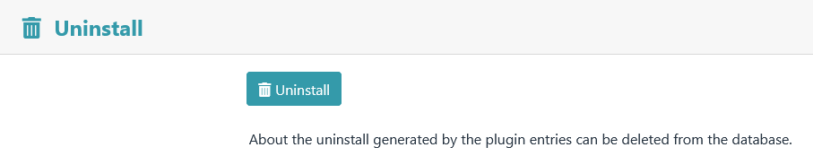

All data created by the plugin can be deleted again by uninstalling it.

Uninstallation removes:
- the menu item created during installation
- the access role created during installation
- all profile fields created by the plugin and the data stored within them
- all configuration data

DANGER

Deleted user data (e.g. IBAN or membership number) cannot be restored!

Message after completed uninstallation.
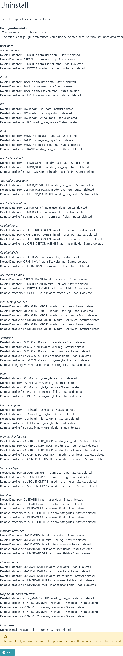

Saving the configuration

All configuration data is stored in a table named adm_plugin_preferences in the Admidio database. If this table does not exist, it will be created.

The configurations of the following plugins are currently stored in this table:
- Mitgliedsbeitrag (membership fee)
- Geburtstagsliste
- FormFiller
- KeyManager
- Documents
- DeclarationOfMembership

The table entries of the membership fee plugin all begin with the letters "PMB".

Information on contribution calculation on the overview page

As information for the member, the current status of the contribution collection can be displayed on the Admidio overview page.

To do this, the following lines must be inserted into the file “adm_themes/simple/templates/overview.tpl”:

<div class="admidio-overview-plugin col-sm-6 col-lg-4 col-xl-3" id="admidio-plugin-membership_fee">
<div class="card admidio-card">
<div class="card-body">
{load_admidio_plugin plugin="membership_fee" file="membership_fee_overview.php"}
</div>
</div>
</div>

Display without login:

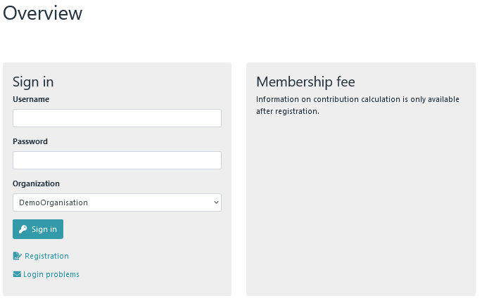

Display after login:

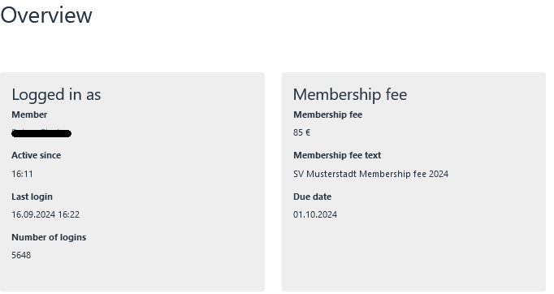

Procedure for a contribution calculation

The following conditions must be met
- Basic settings are entered
- Basic functions have been tested
- Contribution roles are defined (and are also recognized by the plugin → Options – Overview of roles )
- All test conditions should already be defined under → Preferences – Tests

Rough process

- First, a contribution calculation is carried out. Then the due date is set, the XML file is generated and the contributions are collected.

- When all contributions have been collected, the paid date is set. Setting this date is important as it triggers several follow-up actions (e.g. FRST becomes RCUR, mandate changes are rolled back, etc.). It is not important when this date is set. It only matters that it is set.
- If more members join the association in the course of a year, the same procedure is repeated. So carry out the contribution calculation, set the due date, collect contributions, set the paid date.

- At the end of a year (when all contributions have been collected) a "Delete" is performed. This will delete all contributions, contribution texts or due dates. Now you can start again in the new year with the first collection of contributions of the year, the total collection.

Schedule
(a new member is added)

Admission of the new member
The new member is added to Admidio. As part of the admission, it is already included in the various contribution roles (e.g. in an age-based role or in a family role).

Notice

The mandate date can also be included as part of the new inclusion.

Generate membership number
If you are working with membership numbers, create a membership number via → Options – Generate Membership number(s).

Create mandate reference
Via the menu item → Mandate management - Create mandate references.

Enter mandate date
If you have not already done so, enter a mandate date via → Mandate management - Edit mandate (or by editing the member's profile).

Perform remapping
If working with age-based roles, carry out a remapping now

Contribution calculation
Via → Fees - Recalculation .

Due Date
Call up the Due date module via → Export – SEPA - Due date and assign a due date .

XML file
After a due date has been set, an XML file can also be generated via → Export – SEPA - XML file .

Pre-notification
A pre-notification can also only be created via → Export – SEPA - pre-notification if a due date has been assigned.

Distribution of the XML file
After the XML file has been created, it can be sent to a bank via a home banking program (e.g. StarMoney or Jameica/Hibiscus).

Completion of a contribution calculation
In order to complete the entire process, it is important that a paid date is set. Setting this date changes a sequence type FRST to sequence type RCUR.

