SudokuHelper

Description

This small plugin helps with solving Sudoku puzzles.

However, as the name suggests, it is only a "helper", a utility program; it does not solve a Sudoku automatically.

Information

Author: rmb
Plugin version: 3.2
Required Admidio version 5.0
Supported databases: MySQL
Supported languages: German (informal), German (formal), English
License: GPL 2
Source code: GitHub

Screenshots

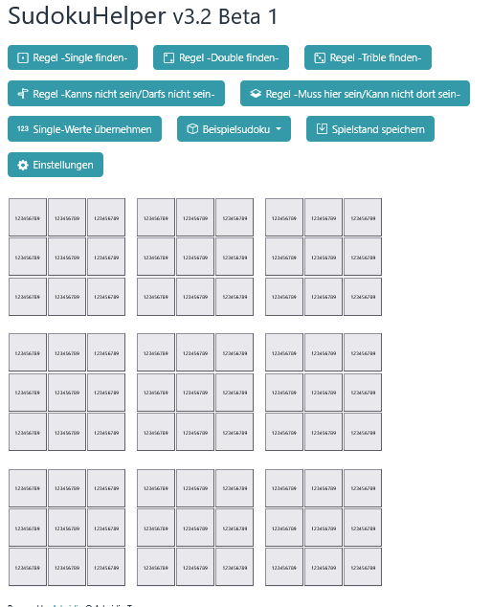
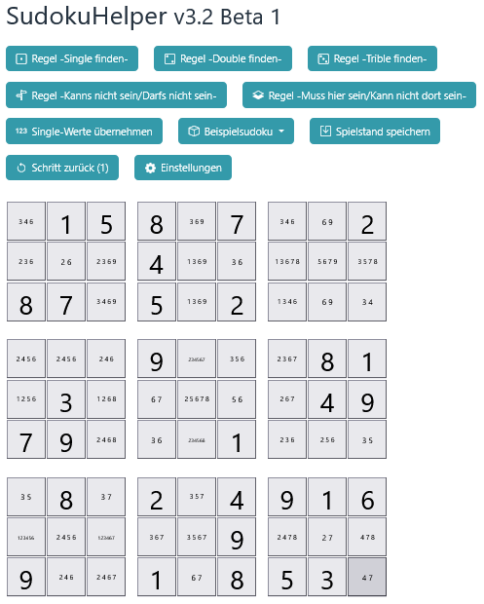

How it works

An empty Sudoku puzzle is structured as follows: It is a square consisting of 9 rows and 9 columns, for a total of 81 boxes. This square is further subdivided into sub-squares, each containing 9 boxes.

Each box can contain a number between 1 and 9. This is displayed as follows when SudokuHelper starts:



Each box is designed as a "button" and can be clicked.

For example, if you want to set a box to a specific value, you click on the box.

The following window will open:

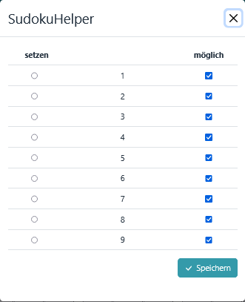

The column “possible” (“möglich”) indicates that all numbers from 1 to 9 would still be possible for this box.

The "set" (“setzen”) column allows you to set a box to a specific number.

In the following example, row 5, column 6 was set to "3":

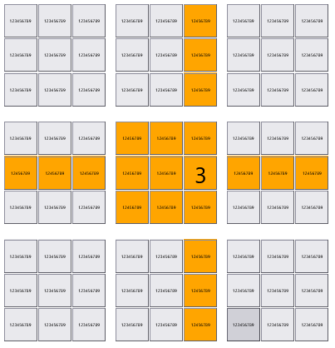

As a result, the “3” cannot be placed in any other box of row 5, column 6 and the sub-square in which the “3” is located.

All boxes that were changed in this step are highlighted in color for better visibility.

Another example:

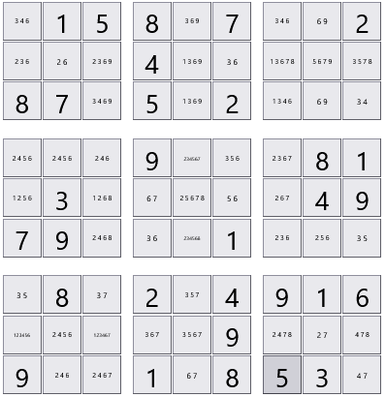

In row 6, the combination 4 & 8 is only present in column 3 and column 5.

To indicate this, remove all impossible numbers from these two boxes. To do this, click on the box in row 6, column 3 and remove the impossible numbers 2 and 6.

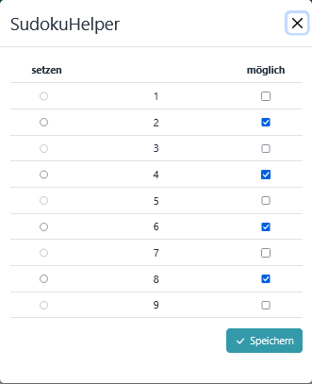
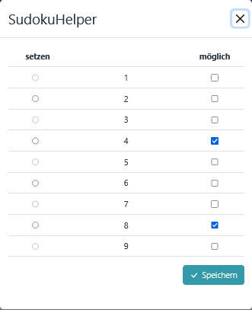

Result:
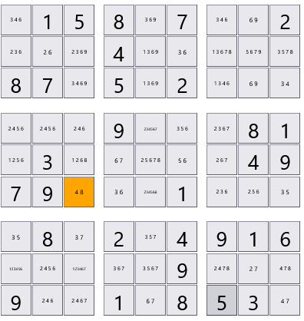

Proceed in the same way with the box in row 6, column 5.

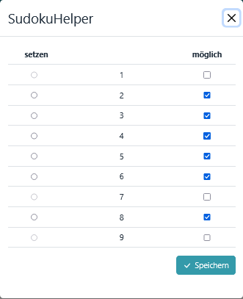
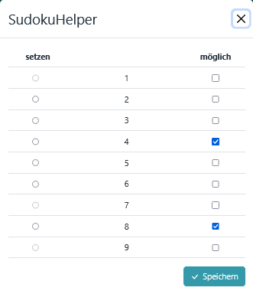

Result:

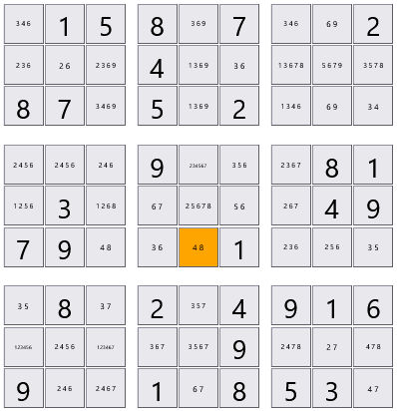

Sudoku can be solved step by step by placing a box on a number and removing impossible numbers.

To assist with solving puzzles, SudokuHelper includes several predefined rules (or strategies). These are described in the section "The Menu Bar".

The installation

The following steps must be performed for installation:

- Place all plugin files in the folder
<your Admidio installation>/adm_plugins/ SudokuHelper . (If the folder does not yet exist, it must be created).

- Have an administrator start the installation script.
To do this, open the following file:
<your Admidio installation> /adm_plugins/SudokuHelper/system/install.php

The installation routine creates a menu item with access rights.

The menu bar

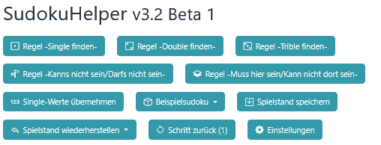

The button “Rule: -Find single numbers-”

This rule finds numbers that occur only once.
- in one line
- in a column
- or in a sub-square

Example:
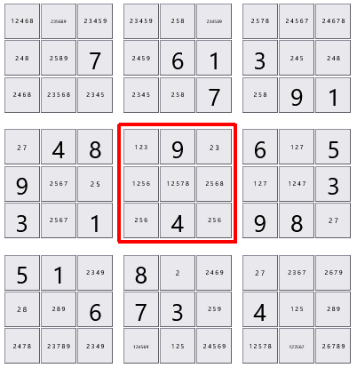

In the marked sub-square, the numbers 7 and 8 each appear only once.
The rule "Find single numbers " identifies these "singles" and removes all other possible numbers.
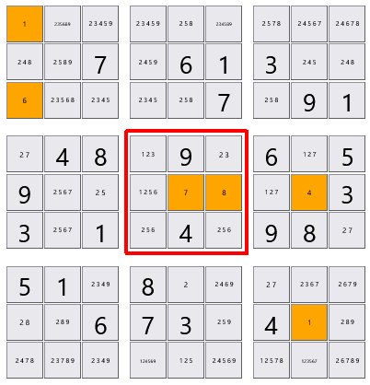

These "single values" can be directly copied and saved using the "Accept single values" button.
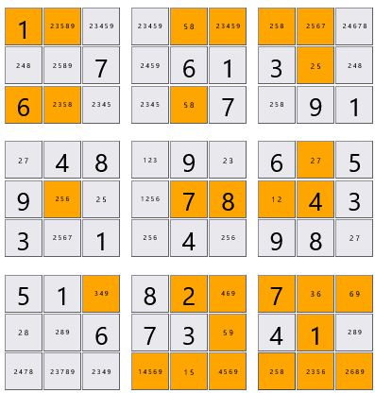

The button “Rule: -Find double numbers-”

This rule applies to pairs of two,
- in one line
- in a column
- or in a sub-square
and removes all other possible numbers.

Example:
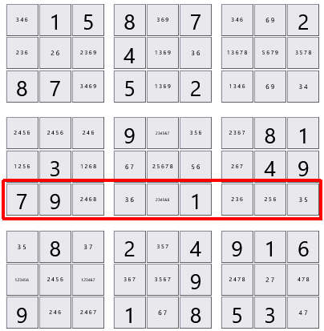

In the row marked in red, the combination 4,8 appears exactly twice.

The "Find Double" rule recognizes this combination and removes all other possible numbers.
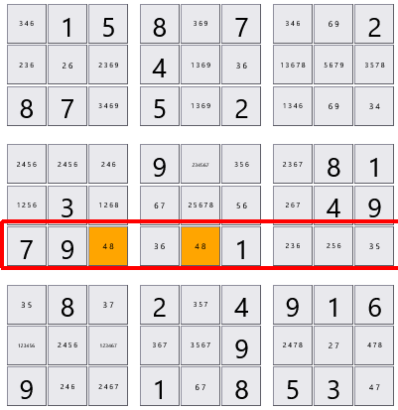

The button “Rule: -Find trible numbers-”

This rule applies to pairs of three,
- in one line
- in a column
- or in a sub-square
and removes all other possible numbers.

The button “Rule: -Cannot be/Must not be-”

Rule: If a number cannot be in one area, it cannot be in another either.

Example:
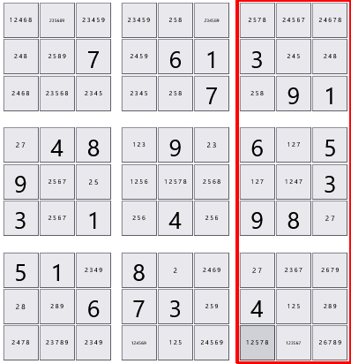

The number 4 cannot be in the blue zone and therefore must not be in the green zone either.
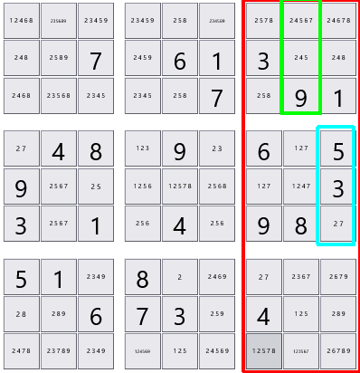

Result:
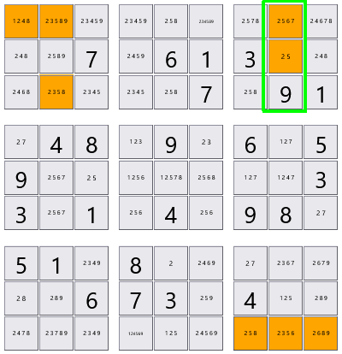

The button “Rule -Must be here/Cannot be there-”

Rule: Certain numbers must be here and therefore cannot be there.

Example:

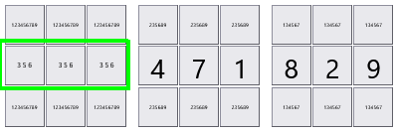

In this line, in the green area, the numbers 3, 5 and 6 still need to be inserted.

Therefore, they cannot occur in the areas marked in red.
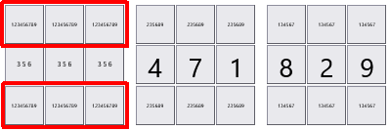

Result after applying the rule:

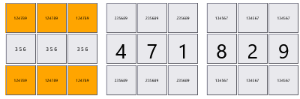

The button "Save single values"
The "Accept single values" button allows you to accept and save individual numbers.

The button "Sample Sudoku"
Two example Sudoku puzzles can be displayed here for testing.

The button "Save the game"
Saves the current game progress with date and time.

The button "Restore the game"
Restoring a saved state

The button "Step back"
Every change in the Sudoku puzzle is saved in a history. You can go back one step in the history at a time.

The button “Preferences”

The "Preferences" menu

The "Preferences" menu is divided into two menu items:

- Information
- Uninstallation

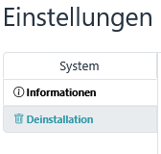

Menu item “Information”

General information about the plugin, such as version and status.

The documentation can also be accessed here.

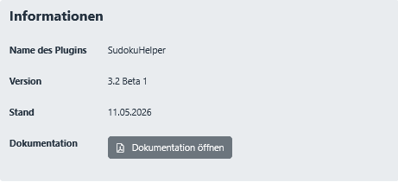

Menu item “Uninstallation”

The plugin can be removed via the "Uninstallation" option.

