Starting Visual C++ from the Start button

The main purpose of this section is to show you how to open and Microsoft Visual C++ to you. This section will also attempt to explain you how to start a simple project, which consists of header, source and resource files.

For your part, you must self study the steps on how to open up Visual C++ from your Start button. You must understand that not all computers have the same set-ups, so you must improvise on this section.

These are the steps in opening up Visual C++ from the start button.

- Click on button.
- You should be able to see this 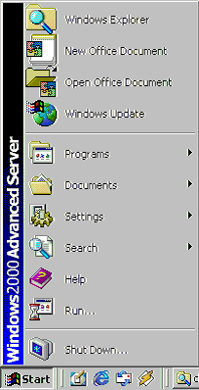
- Now click on Programs 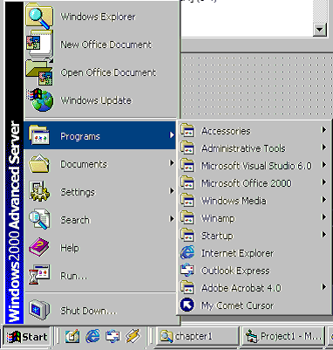
- Now click on Microsoft Visual Studio 6.0 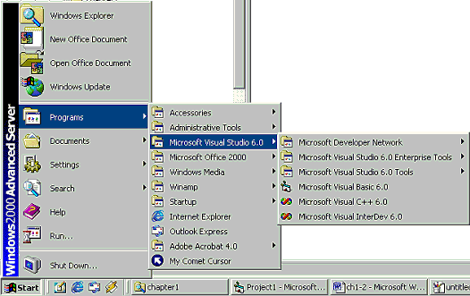
- Then click on Microsoft Visual C++ 6.0 Icon. 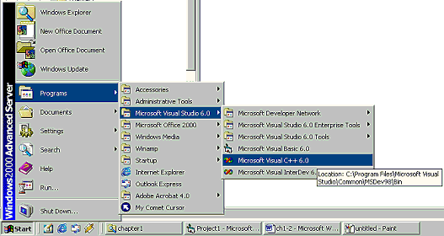
- Now you should be inside the Visual C++ environment. 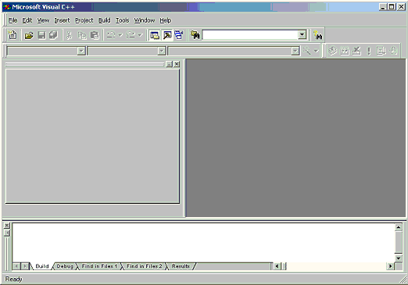

Lastly, to start a sample project, you must click on File menu and then click on New.

