To be emailed to mri.admin@mrc-cbu.cam.ac.uk, and signed version given to:
Neuroimaging Facilities Manager, MRC CBSU, 15 Chaucer Road, Cambridge, CB2 7EF
SLOTS WILL NOT BE ALLOCATED UNTIL SIGNED DOCUMENTS ARE RECEIVED

Part A: Details

1. | Project and PI details:
1.1 | Name of Project: | Fast periodic visual stimulation as a fast localiser for word and object categories in EEG/MEG
1.2 | Researchers involved: | Olaf Hauk & Matt Lambon Ralph (MRC CBU)  Bruno Rossion & Marion Marchive (University of Lorraine)  Aliette Lochy & Christine Schiltz (University of Luxembourg)  Angélique Volfart (Queensland University of Technology)
1.3 | Primary contact address, telephone number and email: | Olaf Hauk  MRC CBU, University of Cambridge  15 Chaucer Road, Cambridge CB2 7EF  +44(0)1223 7 69490  olaf.hauk@mrc-cbu.cam.ac.uk
1.4 | If any of the researchers involved are not CBSU staff, please give their visitor status: | Marion Marchive will be a visiting student (approval ref: RC22/138)
1.5 | List all researchers involved in running the scans: | Marion Marchive, Olaf Hauk
2. | If an internal (CBSU MEG) project:
2.1 | At what stage are previous projects led by the PI of this project (if none, write “N/A”)? | Published as papers, pre-print or theses  Most relevant to this project: https://pubmed.ncbi.nlm.nih.gov/34363957/
2.2 | When was the project presented at a CBSU Research Group Meeting (if not, why not)? | 19.9.2019 (follow-up of a previous FPVS study)
2.3 | When was the project presented at the Project Presentation meeting (PPM) (if not, why not)? | 30.1.2023
2.4 | If all or partially QQ-funded, give QQ code and % of funding to come from QQ (e.g. 100%) | Project code: SUAG/087 (MLR)
2.5 | If all or partially grant-funded via CBSU, give CBSU grant code and % of funding to come from grant (e.g. 100%) | -
2.6 | If all or partially funded by external collaborators, give % of funding to come from external collaborators (and complete Section 3) | -
2.7 | If with external collaborators, has a collaboration agreement been signed (if not, why not)? | -
3. | If an external project:
3.1 | Who is the Sponsor of the study (all studies must have a sponsor, as defined by the NHS Research Governance Framework)? | -
3.2 | Do you wish to run data analyses on CBSU computers (in which case, you will be invoiced an additional amount), or do you only want access to the raw (DICOM) data? | -
3.3 | What is the MRC CBSU purchase order code for paying for scans? (usually generated by your finance dept) | -
3.4 | If also partially funded by MRC CBSU, please give % of external funding and state where the remaining CBSU component is being paid from | -
4. | Ethics/Insurance (both internal and external):
4.1 | Ethics approval received from:  (note: if NHS patients* involved, must be NRES) | CPREC
4.2 | What is the ethics reference number? | PRE.2019.094 (MLR)
4.3 | What is the insurance code for any non-MRC staff involved in scanning | TBD
4.4 | If this is a clinical trial, give Authorisation Number (CTA) (and any ISRCTN or EudraCT number) | -
5 | Request Details:
5.1 | How many slots are you requesting? | 25 (1 2h slot per participant)
5.2 | How many volunteers are you testing? Please give justification for number (e.g., power). | 27 participants. Power analysis based on Lochy et al (2015). Cohen’s d from Lochy et al (2015) for word/pseudoword contrast = 0.89. Using pwr.t.test in R for power of 80% this gave n = 12. Two previous studies used n=10 (Lochy et al. 2015, Barnes et al. 2021), and our own previous study had n=16. We want n=25 to allow for drop-outs, to estimate the fraction of individual participants with significant FPVS responses, to and perform correlations with reading proficiency measures.
5.3 | How many pilot slots (additional to above) do you want to run (>1 week beforehand)? | 2
5.4 | Are the volunteers patients* or from a special population that inhibits the use of backup volunteers? If so, please detail | -
5.5 | What is the total time required in the MEG scanner per slot? (in minutes) | 60 minutes
5.6 | How much additional preparation time will there be? | 45 minutes to prepare the EEG cap and digitisation
5.7 | Is this project standard or high priority?  If high please give your reasons | High priority (MM only available for 4 months)
5.8 | When will you be ready to start? | March 2023
5.9 | Will you be able to take slots available from last minute cancellations by others? | Yes (depending on volunteer availability)
5.10 | By when do you want to finish the scanning? | Late June 2023
5.11 | What dates are you unavailable (eg away)? | -
5.12 | Are consecutive slots a problem? | No
5.13 | Any non-standard setup / equipment / procedures (including EEG, or supine rather than seated position)? | EEG; 20 mins behavioural tests.
5.14 | Are the testing researchers “MEG Qualified Researchers” (see MEG SOPs)? | OH yes, MM needs to be trained as researcher
5.15 | Are the testing researchers “MEG Qualified Operators” ? If Yes, do you require a second operator present? | OH can operate some slots, but core-operated slots will be required
5.16 | Will you need MRI structurals? If so, will you acquire new ones, or seek permission from volunteers to use ones acquired by other projects via a Scan Release Form? | Where possible existing ones, but some additional scans may be required.
5.17 | Have you submitted a pre-registration report, eg on OSF website or to a journal? If not, why not? | Not yet – we are discussing in our group.

*The term patient means 'stable' patients; that is, participants who have a neurological history, but who do not require ongoing medical attention and for whom MRI poses no significant risks over and above those that apply to a normal healthy participant.

Part B: Procedures, protocols and predictions

Proposal background and basic procedure:
Background:
Fast periodic visual stimulation (FPVS), also known as frequency tagging, is an emerging technique in the visual perception literature (Rossion et al, 2014; Rossion et al, 2015). FPVS is a variant of the steady state visual evoked potential (SSVEP) paradigm, whereby a sequence of visual stimuli are presented at a fixed periodic rate, this periodic repetition of a stimulus, or a property of a stimulus, elucidates periodic changes in neural populations sensitive to the stimulus which can be measured with EEG/MEG (Rossion et al, 2014). FPVS differs from the SSVEP paradigm via the introduction of an “oddball” stimulus, a condition of interest that is repeated periodically at a slower frequency throughout the base sequence. For example, in a sequence of object stimuli, a face is repeated every 5th stimulus (OOOOFOOOOF). FPVS measures the response to both the periodic base frequency and the oddball (condition of interest). With faces, this paradigm produces highly reliable stimulus-discrimination response with only a few minutes of recording and without requiring a demanding task. Thus, it promises to be an efficient tool to probe perceptual and cognitive functions in patient populations (e.g. lexical and semantic retrieval in semantic dementia patients).

Thus far, the majority of the research using FPVS has been conducted in the context of face processing using EEG (Rossion et al, 2015; Jonas et al, 2016; Collins et al, 2018). One study has extended FPVS to measure lexical processing using EEG (Lochy et al, 2015). A sample of 10 participants saw FPVS sequences from three conditions: words/pseudofonts, words/nonwords, words/pseudowords. Responses to the base frequency (10Hz) was seen in all 10 participants in Oz electrodes, and responses to the oddball frequency (2Hz) in response to words were seen in left lateralised occipito-temporal electrodes in all three conditions. The conclusion from this study was that FPVS provides a sensitive measure to capture automatic lexical access.

However, this was not confirmed in an EEG study by Barnes et al. (2021), who found reliable FPVS responses in only 10% of datasets (across 10 participants). Also, our previous FPVS study using combined EEG+MEG at the CBU included a word-vs-pseudoword condition but did not produce significant FPVS responses (we only published the face results, Hauk et al., Neuroimage 2021, https://pubmed.ncbi.nlm.nih.gov/34363957/). We have identified several parameters with respect to stimulus characteristics (e.g. variability in word length, nature of pseudowords) and task (e.g. focussed vs deployed attention). An EEG study investigating and optimising these parameters is close to submission (Lochy et al., in prep). Furthermore, we will also include a non-word condition in our study, and explore the effect of varying the base frequency and its relationship to individual reading proficiency. There are currently no FPVS studies using combined EEG+MEG except our own previous one (Hauk et al., 2021). We will use the optimised spatial resolution of these measurements to test whether word-related FPVS responses are an indicator of different (anterior) temporal lobe functions.

Procedure:
We will test 25 healthy adult participants using EEG/MEG. This sample size was derived from a power analysis using values obtained from Lochy et al (2015). We converted t-scores from the word/pseudoword contrast (this was the closest contrast to what we will be testing) into an effect size (Cohens d’ = 0.89), and used R (pwr.t.test) to estimate that for power of 80% we would need a sample size of 12. Two previous published studies (Lochy et al. 2015; Barnes et al. 2021) employed only 10 participants. Our own previous EEG+MEG studies contained data from 16 participants. We reason that we will need a larger sample than this because we aim to measure a more sensitive comparison (real words embedded in real words compared to real words in pseudowords as in Lochy et al (2015)). Please note that our main aim is to detect FPVS responses in the majority of individual datasets, not just at a group level, in order to explore its useful to monitor patient populations.

Our main aim will be to replicate and extend FPVS results for lexical processing in English. Our paradigm will focus on the following experimental manipulations:
  - Three word conditions:
    - Words vs Consonant Strings
    - Words vs Non-Words
    - Words vs Pseudowords
  - 30 stimuli per condition
  - Task: colour change detection of vertical bars flanking the words
  - 10/8/6 Hz base frequency, 2 Hz deviant frequency
  - Behavioural test for reading proficiency

Our main inclusion criteria for participants are:

- Neurologically and mentally healthy
- Native monolingual English speakers
- right handed
- 18-40 years old
- Normal or corrected-to-normal vision
- No history of neurological conditions
- No history of dyslexia
- Able to have an MRI (if not already available)

The MEG experiment will require about 47 minutes of recording time, plus minutes for behavioural testing outside the scanner.

For data analysis, we will follow the same steps as in Hauk et al. (2021)
(with faces, following Rossion et al (2015), Lochy et al (2015), Rossion et al. (2020)):
- Preprocessing:
  - Maxfilter (MEG)
  - (Possibly) ICA to remove heart/eye artefacts
  - Bandpass filter between 0.1 – 100Hz
  - Downsample to 250Hz to reduce file size/processing time
- Frequency domain analysis:
  - Repetitions within each condition are averaged in the time domain in each individual
  - Fast Fourier Transform (FFT) applied to averaged segments and amplitude spectra extracted for all channels
  - Calculate z scores for frequencies of interest vs. noise (z scores larger than 1.96 are considered significant at p<0.05, two tailed)
- Source estimation (not previously attempted with Words-FPVS):
  - Minimum norm in MNE-Python, individual MRIs for head modelling
  - Include “resting state” at beginning and end of sessions for noise covariance estimation

We do not see any major outstanding issues that need to be addressed:

- We have all the necessary expertise
(we ran FPVS before and collaborate with the Rossion group).
- PhD student from Rossion lab with be here to set-up and pilot the experiment.
- We have all the necessary methods (we ran and published FPVS with EEG+MEG before).

We hope to achieve our objectives within this time frame:
- Marion Marchive visits from March to June 2023 (data acquisition and pre-processing).
- Main analysis, discussion and writing up till the end of 2023.

Possible Publication:
- Lochy et al., PNAS 2018 (words, with intracerebral recordings)
- Hauk et al., Neuroimage 2021 (faces, EEG+MEG)
=> Somewhere between Neuroimaging and PNAS.

References:

Barnes, L., Petit, S., Badcock, N. A., Whyte, C. J., & Woolgar, A. (2021). Word Detection in Individual Subjects Is Difficult to Probe With Fast Periodic Visual Stimulation. Frontiers in Neuroscience, 15(March). https://doi.org/10.3389/fnins.2021.602798.

Collins, E., Robinson, A. K., & Behrmann, M. (2018). Distinct neural processes for the perception of familiar versus unfamiliar faces along the visual hierarchy revealed by EEG. NeuroImage, 181, 120–131.

Hauk O, Rice GE, Volfart A, Magnabosco F, Ralph MAL, Rossion B. Face-selective responses in combined EEG/MEG recordings with fast periodic visual stimulation (FPVS). Neuroimage. 2021 Nov 15;242:118460. doi: 10.1016/j.neuroimage.2021.118460. Epub 2021 Aug 5. PMID: 34363957; PMCID: PMC8463833.

Hauk O, Rice GE, Volfart A, Magnabosco F, Ralph MAL, Rossion B. Face-selective responses in combined EEG/MEG recordings with fast periodic visual stimulation (FPVS). Neuroimage. 2021 Nov 15;242:118460. doi: 10.1016/j.neuroimage.2021.118460. Epub 2021 Aug 5. PMID: 34363957; PMCID: PMC8463833.

Jonas J, Jacques C, Liu-Shuang J, Brissart H, Colnat-Coulbois S, Maillard L, & Rossion B. (2016). A face-selective ventral occipito-temporal map of the human brain with intracerebral potentials. PNAS, 1-10.

Lochy A, Van Belle G, & Rossion B. (2015). A robust index of lexical representation in the left occipito-temporal cortex as evidenced by EEG responses to fast periodic visual stimulation. Neuropsychologia, 66, 18-31.

Rossion B. (2014). Understanding individual face discrimination by means of fast periodic visual stimulation. Experimental Brain Research, 232, 1599-1621.

Rossion B, Torfs K, Jacques C, & Liu-Shuang J. (2015). Fast periodic presentation of natural images reveals a robust face-selective electrophysiological response in the human brain. Journal of Vision, 15:1, 1-18.

Rossion, B, Retter, TL, Liu-Shuang, J. Understanding human individuation of unfamiliar faces with oddball fast periodic visual stimulation and electroencephalography. Eur J Neurosci. 2020; 52: 4283– 4344.

Volfart A, Rice GE, Lambon Ralph MA, Rossion B. Implicit, automatic semantic word categorisation in the left occipito-temporal cortex as revealed by fast periodic visual stimulation. Neuroimage. 2021 Sep;238:118228. doi: 10.1016/j.neuroimage.2021.118228. Epub 2021 May 31. PMID: 34082118; PMCID: PMC7613186.

Hypotheses and Predictions:

We included a face condition as a sanity check of our procedure, and we expect to replicate the well-established findings by Rossion et al. 2014, as well as our own previous results:
- Base response at 6Hz, bilaterally in Oz electrodes.
- Oddball response at 1.25Hz in right lateralised occipito-temporal electrodes.
- Sources in visuo-temporal cortex.

The main interest of our study are the word conditions, for which we will test the following main predictions:

- Faces vs Objects: base response at 6Hz in Oz electrodes, oddball response at 2Hz right-lateralised (Rossion et al, 2015).
- Word conditions: Oddball response at 2Hz for words vs (consonants, non-word, pseudoword) stimuli, left-lateralised.
- Effect sizes: (words vs consonant strings) > (words vs non-words) > (words vs pseudowords) (> 0?).
- Localisation: More anterior for more lexical contrasts (W vs PW > W vs NW > W vs CS).
- Effect size correlates positively with reading proficiency across participants.
- Optimal base frequency depends on reading proficiency.

Feedback from PPM:

Matt Davis:
Why will you consider base frequencies 6-810Hz but not lower? 6Hz may still be too high for some readers.
Response: We want to keep the oddball frequency of 2Hz employed by Lochy et al. (2015), and 4Hz would be its second harmonic. Thus, we can only start with 6Hz. In our view this is a realistic presentation rate for relatively skilled readers, e.g. it corresponds to a reading rate of an easy text.

What is your justification for the behavioural reading tests, e.g. why did you include the Boston Naming Task but not Mill Hill reading test?
We are currently looking into different options with our collaborators and have already considered the Mill Hill test. We already emailed Lucy MacGregar (as suggested by MD) and will make a final choice of reading tests in due course.

Rik Henson:
If the main aim of this study is replication, then why is this not a pre-registered report?
Response: I agree pre-registration would strengthen our project and we are discussing the options with our collaborators. There is no time for a proper pre-registered report (involving peer-review), but posting a pre-registration report on OSF would be possible.

Instead of a statistical power analysis across participants, wouldn’t it be better to run a power analysis per participant (i.e. number of trials)?
Response: We will run three repetitions per conditions and we will check how effect size improves from one to three sessions. We agree there are a more design parameters to explore but our experiment will already take more than one hour and include additional behavioural tests.

With respect to the number of participants, make sure it allows for full counter-balancing.
Response: We will take this into account. There may be reasons why conditions should be presented in a certain sequence (e.g. from “most lexical” to “least lexical”), which we will discuss within our team.

Wouldn’t it be more important to vary oddball frequency rather than base frequency?
Response: This is not clear. We would like to keep the 2Hz oddball frequency from Lochy et al. (2015). Without base stimuli, 2Hz certainly allows full word recognition. A high base frequency may result in a masking process of the orthographic stimuli, thus preventing or reducing lexical processing of the word stimuli. If we had more time available we would certainly like to explore more parameters, but within the objectives of the current study we think that testing multiple base frequencies is more relevant.

_____________________________________________________________________________________________PART C: Checklist and Disclaimer

Tick
1. I confirm that the ethics and other appropriate regulatory approvals, insurance and funding detailed above are all valid, and evidence of this has been provided to the CBSU Neuroimaging Facilities Manager: including hard-copies of the ethics approval letter, the certificate of insurance and confirmation of funding (if not CBSU-managed). An electronic version of the full ethics application must be provided promptly if requested. | x
2. I confirm that all researchers involved in scanning are named on the ethics, have read and understood the ethics, and have appropriate CRB clearance and Occupational Health clearance (as part of their CBSU staff or visitor status). | x
3. I confirm that all researchers involved in scanning have the appropriate training and expertise, including attending the MEG researcher training and signing and returning the form at the end of the SOPs to say they have read the SOPs, and will abide by local rules and safety procedures detailed in those SOPs. | x
4. I confirm that personal information about participants will be protected and will not shared with people either directly or indirectly other than as expected from consent given by participants and by the ethics approval. Anonymised data will also be handled in line with consent obtained and ethics approval. | x
5. I acknowledge that ensuring the project is conducted in accordance with the regulatory approvals given is my responsibility. | x
6. I agree to inform the MEG facilities manager of any safety incident or event that occurs that would affect persons or use of the MRI facilities. | x
7. I agree to acknowledge the MRC CBSU in any publication arising from this research. | x
8. I understand that slots cancelled with less than 10 days notice may incur charges (and therefore it is advised that you cost for potential cancellations within your budget) | x
9. If an internal (CBSU-administered) project:  I understand that all recorded data are MRC/UCAM property; any data leading to publication will be stored at the CBSU Repository and anonymised data may be shared with others, subject to the ethical approval. | x

By signing below, you warrant that all information contained in this application is correct and that you will inform mri.admin@mrc-cbu.cam.ac.uk of any changes which may affect any access granted. To the extent permitted by law, MRC disclaims any liability associated with the hosting and conduct of the study.

Signed by Principal Investigator (PI): 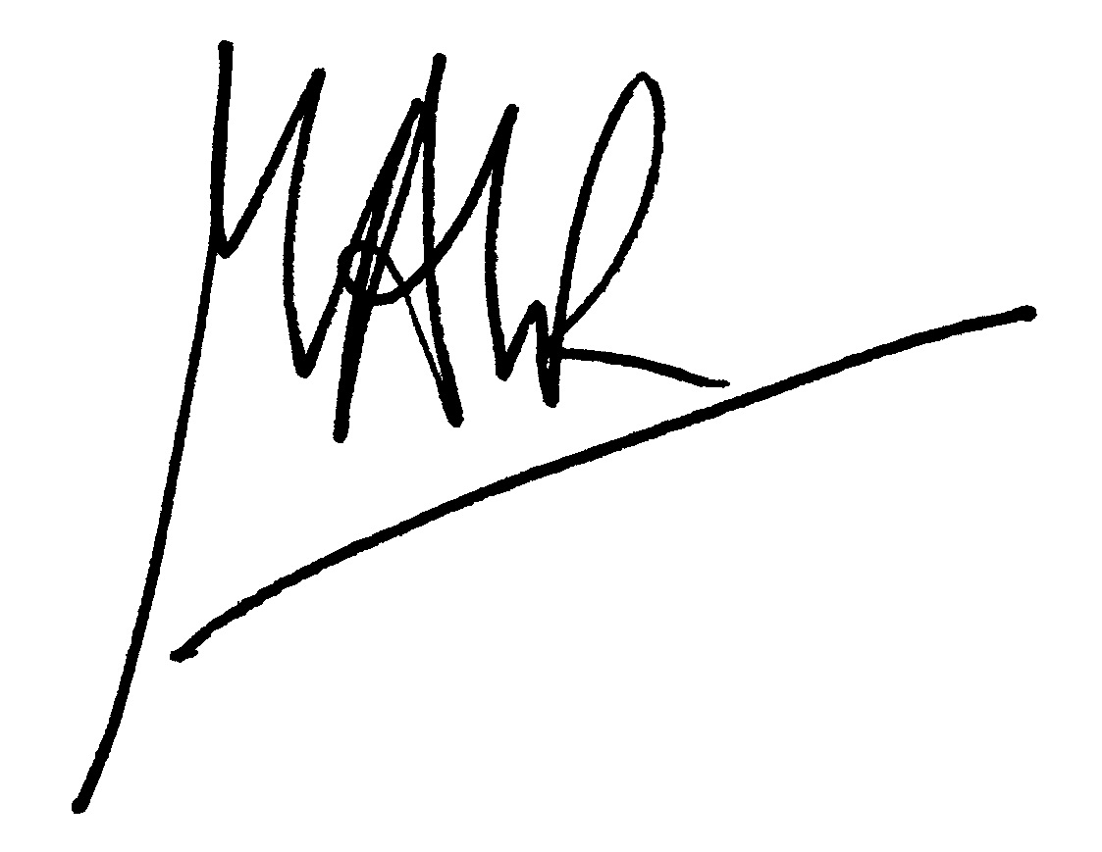

This study has been peer-reviewed, signed by

(For internal studies, signatory must be CBU PL/PLT confirming that study was stated in QQR programme, or if not, signatory must be an independent CBU PL/PLT; for external studies, signatory is confirming some form of independent peer-review)

(If external) Signed by PI’s Head of Department (pp. Signature NOT acceptable)

Print name (PI): Print name (HoD):

Date: 30/01/23 Date:

Checked and Signed by Neuroimaging Facilities Manager: Date:

