So you want to do an (MRI) Imaging project at the CBSU?
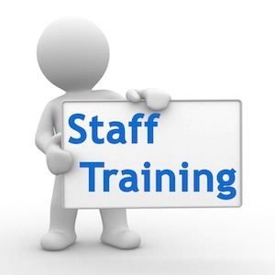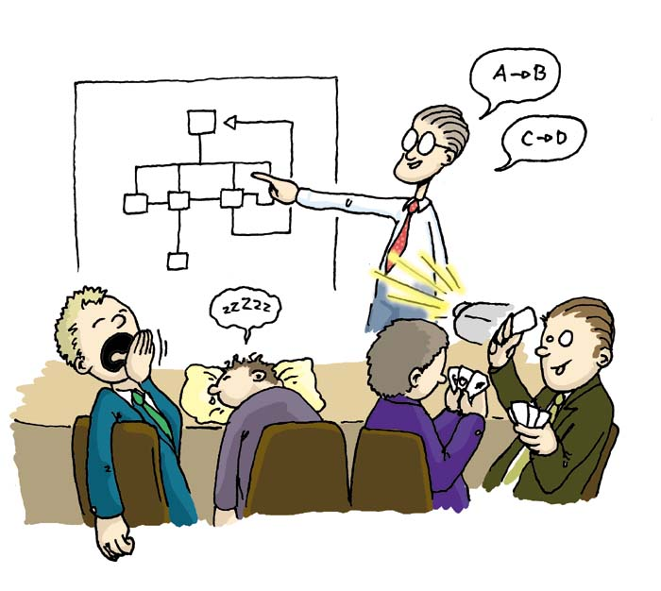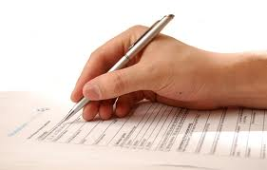
- Sign up for:  - panel induction  - MRI safety training.  Read thE SOPS in advance of the training: here  - Make sure you have imaging rights (see IT)  at this point It is Highly advisable to approach the neuroimaging facilities manager (NFM) about your expectations etc... | - discuss your proposed project at your scientific group meeting and with your supervisor.  Make sure there is an ethics approval in place for your study!  ethics applications can take up to 2 months to process | - Present your project at an IIG  (Mondays 12:30 in the lecture room)  IIG info here  Presentation templates here | - Fill out an imaging request form and return to NFM  2 days before the IMC (imaging management committee) are scheduled to meet  ALL Forms found on the intranet here:

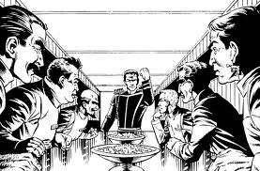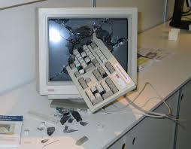
- Your project will be discussed at the IMC and will hopefully be approved and given high or standard priority.  (IMC info here) | - Discuss requirements / complications / variables with NFM. Your project will then be allocated time on the schedule the average backlog / waiting time is about 2 months | - Prepare your stimuli  if you have unusual technical demands Seek extra informal time in the scanner room (e.g. eye tracker / EEG etc..) You may need to approach the technical department | - Book subjects using your RAS Researcher Interface and SONA  Give 2 weeks notice of any cancellations and 3 weeks for whole project deferrals / Cancellations.

