Term Project

**Advanced Database Concepts – COMP 214 SECTION 003**

Project Case:

**Bank Database / User Accounts**

Presented by:

**Thalyta Hulsen Lemos - 300861728**

**Eduardo Sanchez - 300987998**

**Andre Ribeiro - 301022010**

**Paulo Chain - 300998034**

Date:

**August 9, 2019**

Instructor:

**Zoran Sarajlic**

Centennial College – Progress Campus

Software Engineering Technician

Table of Contents

Problem Domain Description 3

ERD 3

Scripts (Screenshots) 4

Creating Tables 4

Sequence and Indexes 5

Populating Tables 6

Store Functions 7

Store Procedures 7

Triggers 10

Front End Screenshots 11

Index 11

All Customers 11

Find customer by ID 12

Login 13

Accounts 13

Transactions 14

Database in Visual Studio 15

Procedure in Visual Studio 16

Method that calls a procedure 16

DbSet from Visual Studio 17

Testing 19

Stored Functions 19

Stored Procedures 20

Trigger 24

# Problem Domain Description

The bank requires a software to deposit certain amount of money into the account of its customers. To do the operation, the user needs to access into the platform and find the customer by his/her ID. The user selects the account in the new screen, type the amount to deposit in the blank field and clicks the button enter. Once submitted, the procedures add a new record to the banktransaction table and the trigger updates the amount to the current balance in the bankaccount table, where the user accounts are listed as well and then the website will show a message displaying the a message to inform the if the transaction was successful.

# ERD

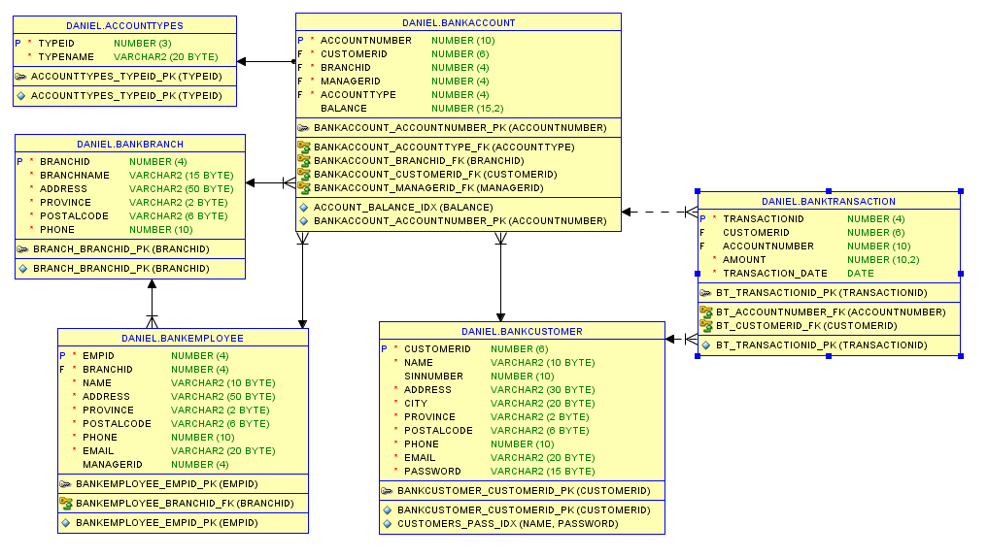

# Scripts (Screenshots)

## Creating Tables

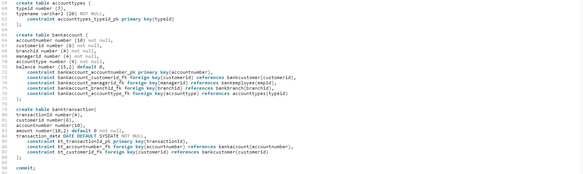

## Sequence and Indexes

## Populating Tables

## Store Functions

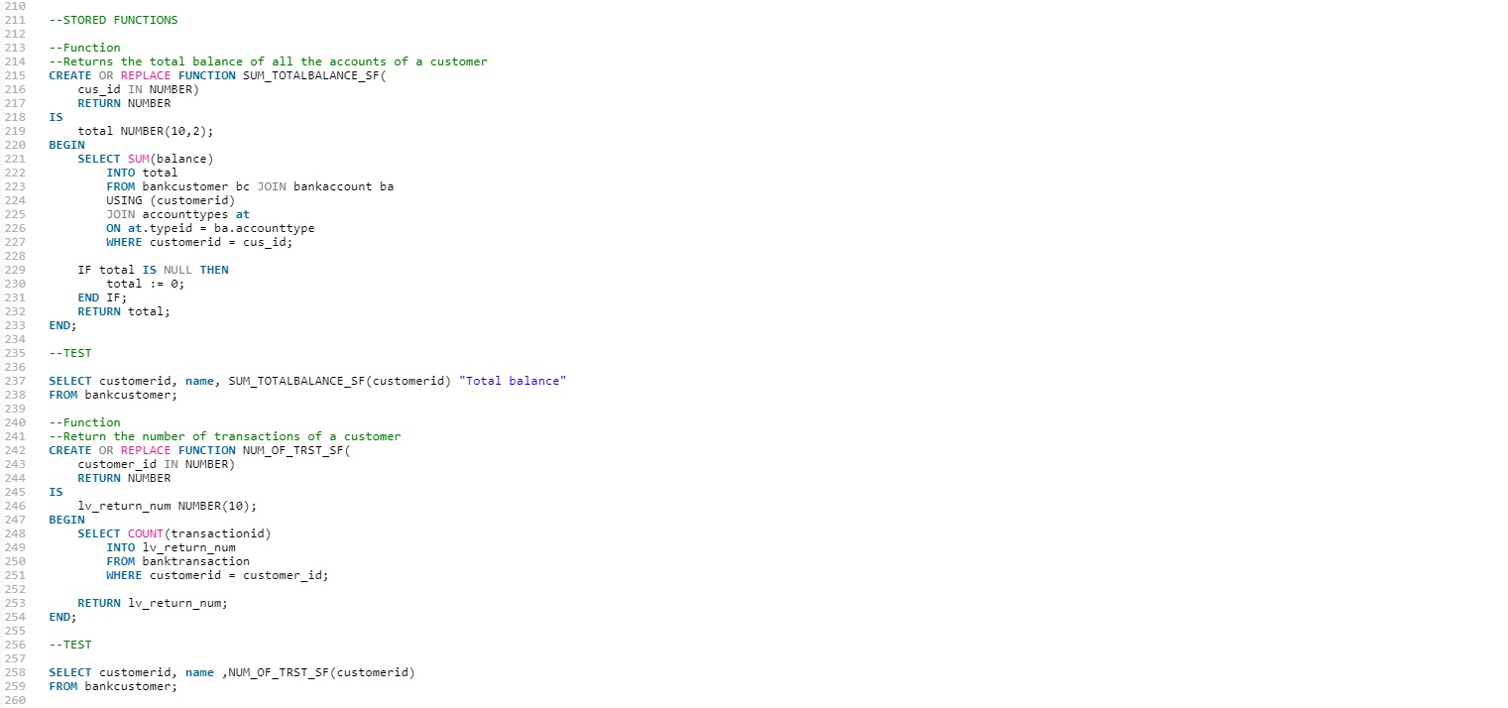

## Store Procedures

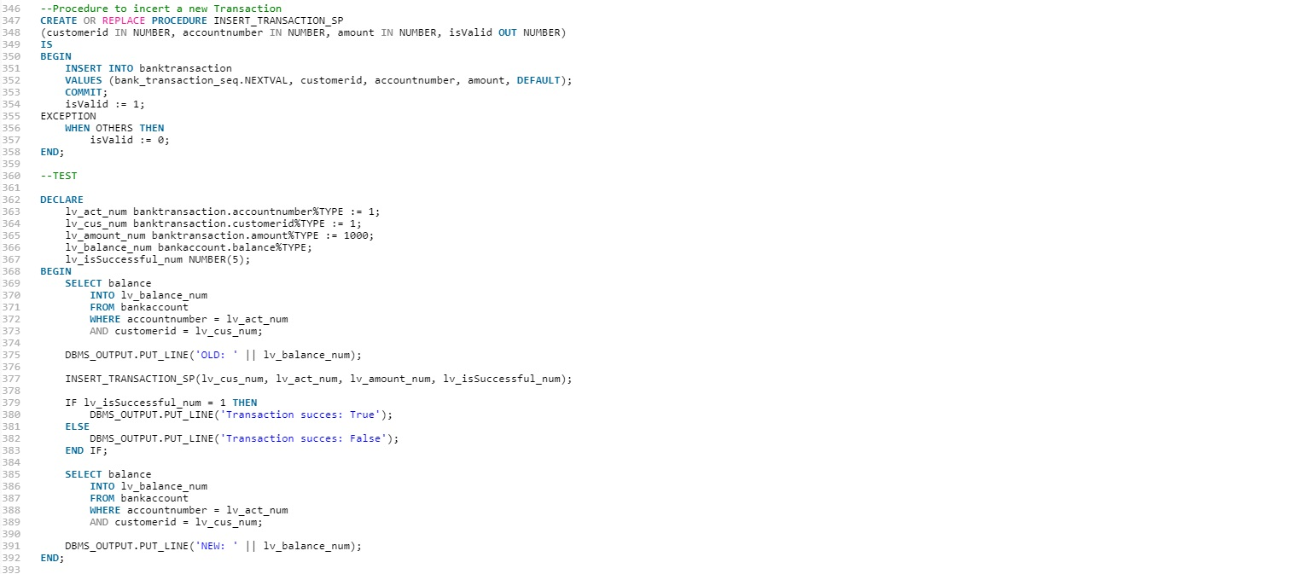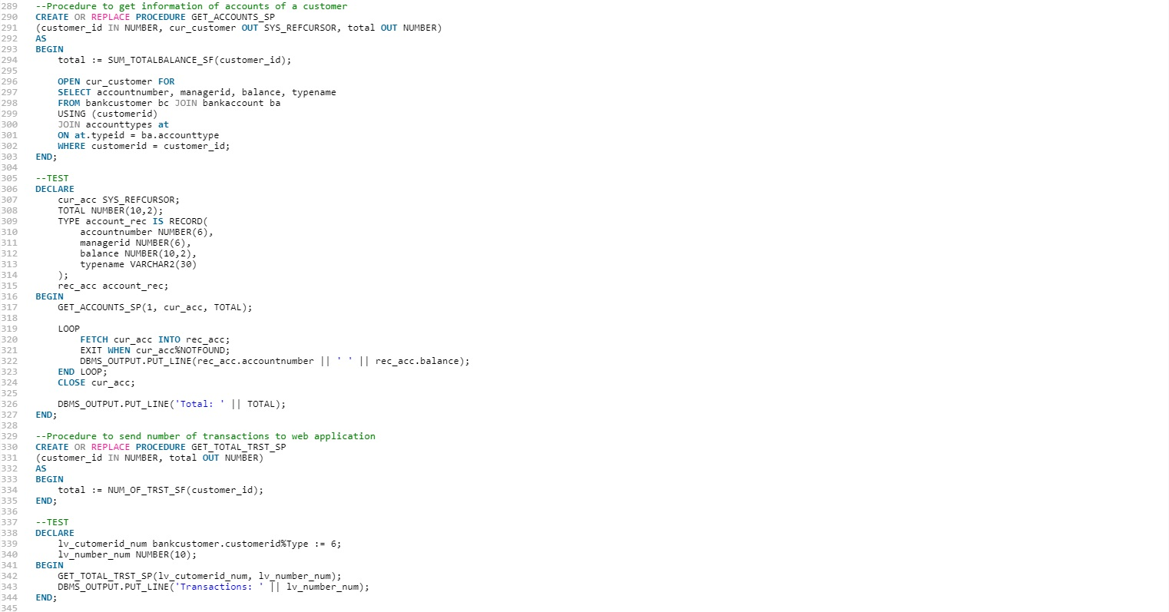

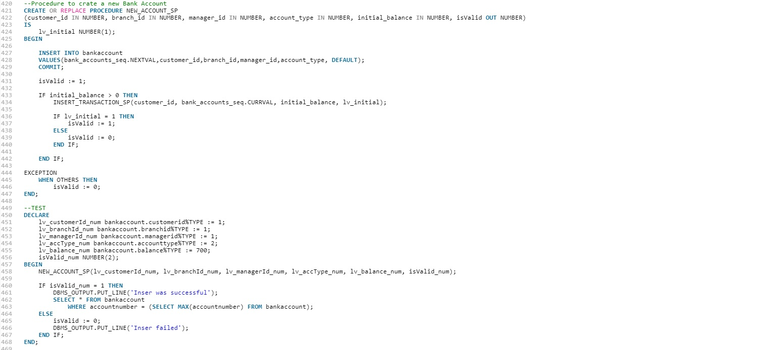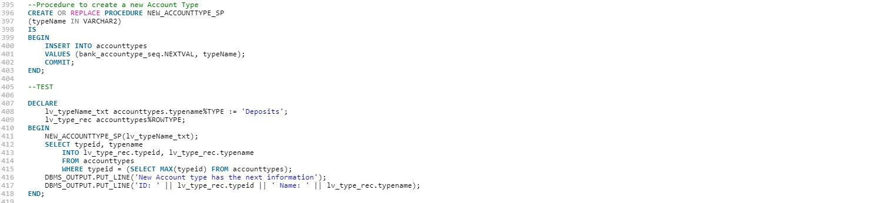

## Triggers

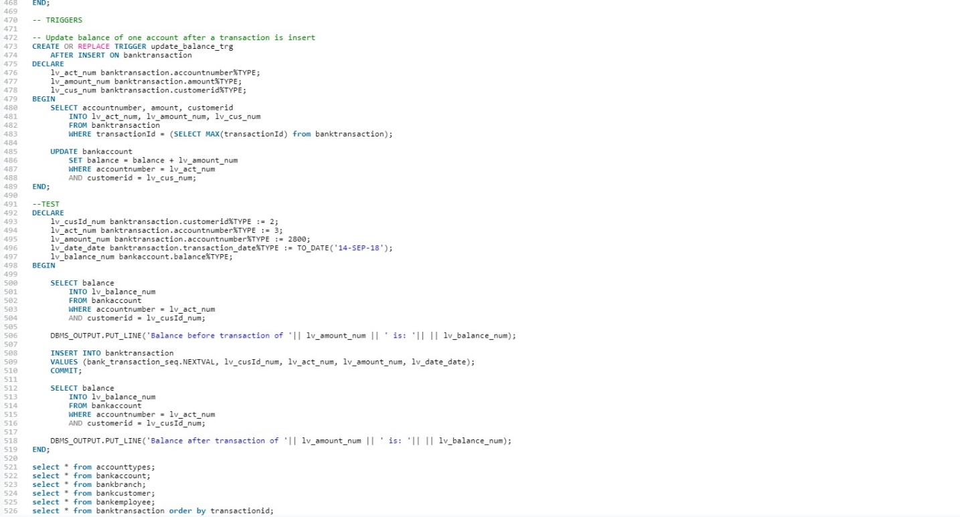

Trigger update_balance_trg update the balance of the account after a new transaction is added.

# Front End Screenshots

## Index

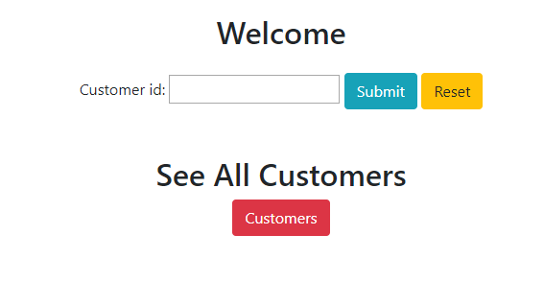

## All Customers

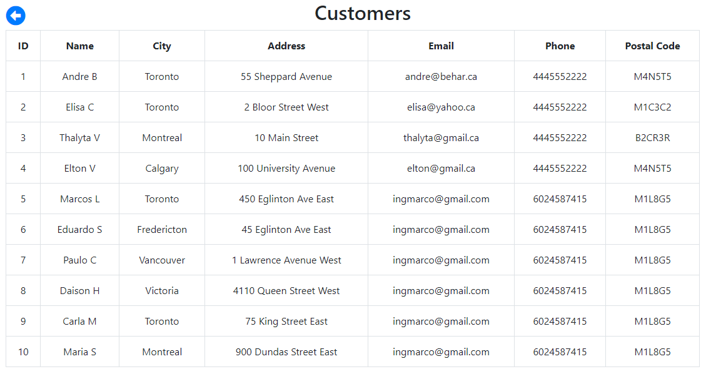

## Find customer by ID

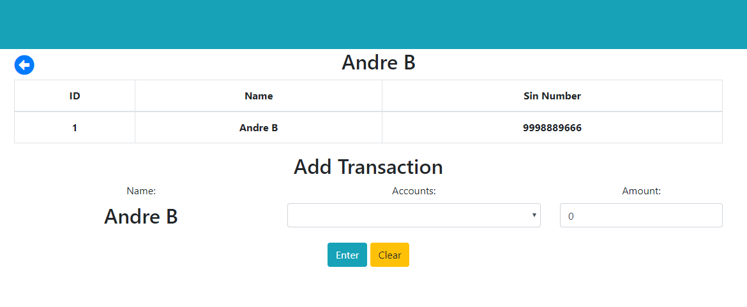

Adding a transaction to checking account

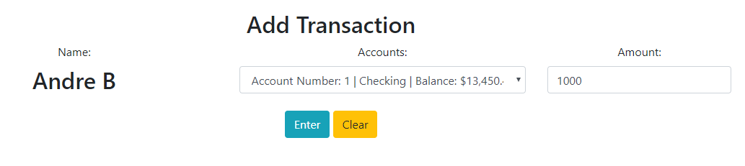

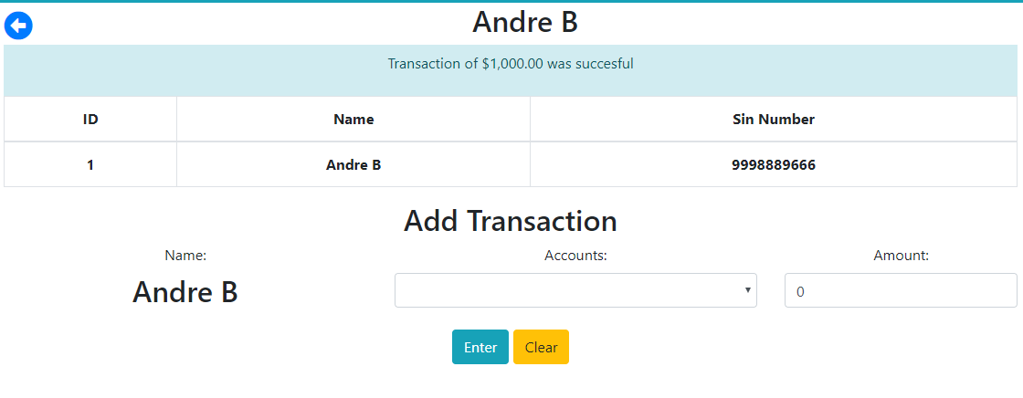

Updated balance is displayed

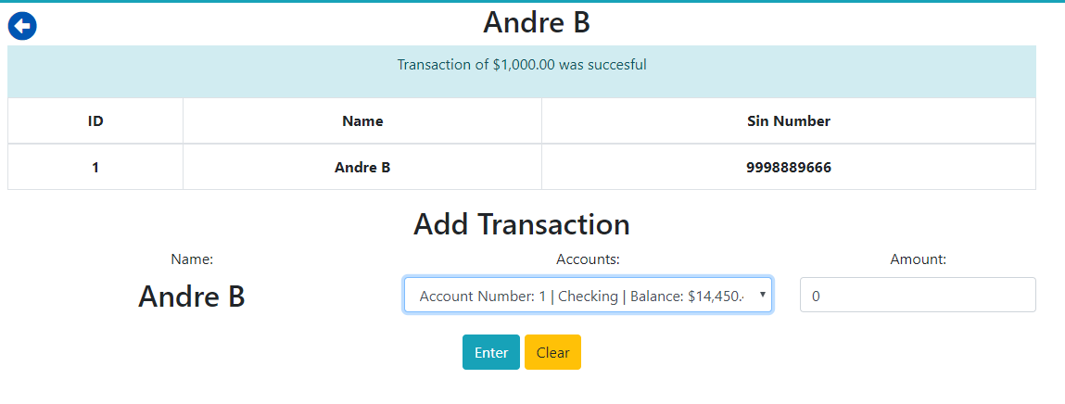

## Login

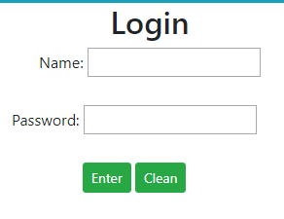

## Accounts

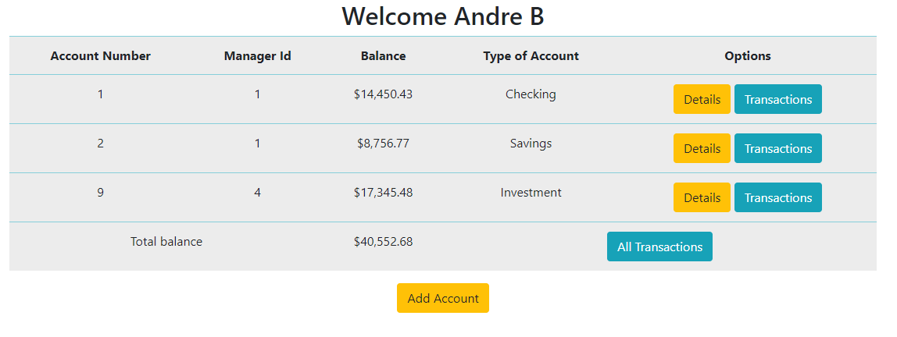

## Transactions

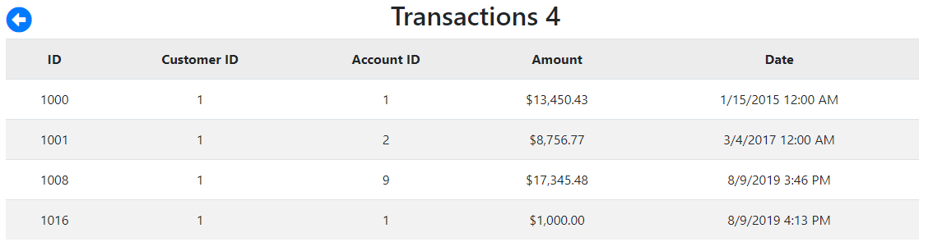

Last transaction of $1000.00 is shown.

# Database in Visual Studio

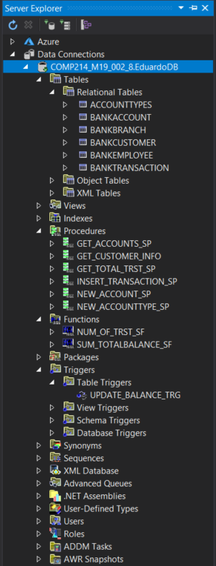

# Procedure in Visual Studio

## Method that calls a procedure

Method AddTransaction() creates the parameters and send them to the stored procedure in the database.

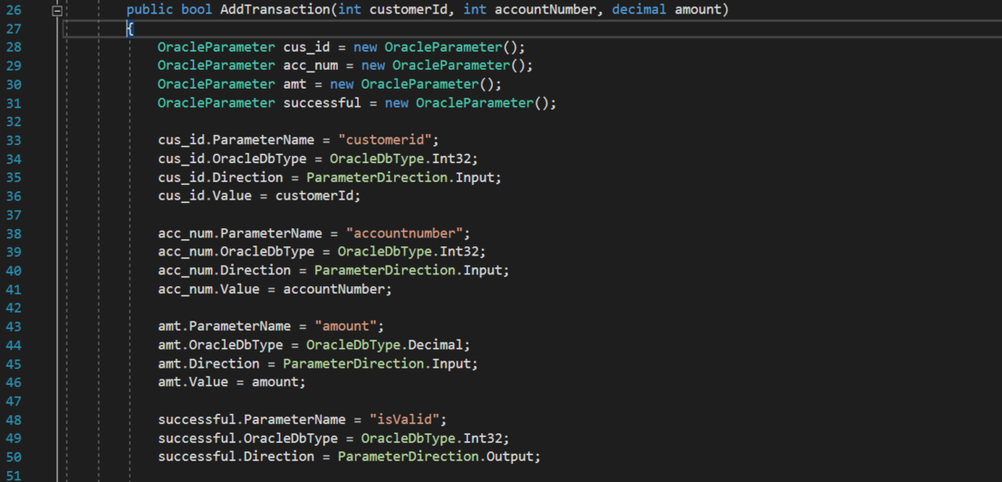

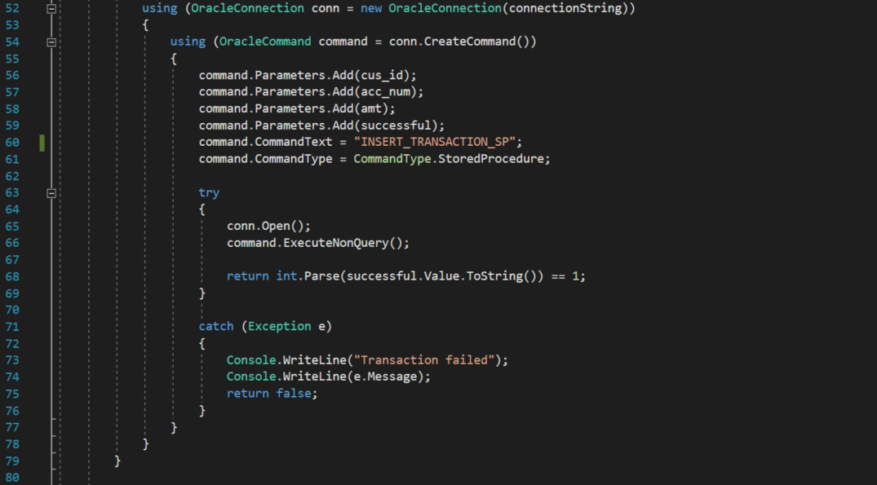

## DbSet from Visual Studio

Creation of class that inherits DbContext class from library Oracle.EntityFramework.

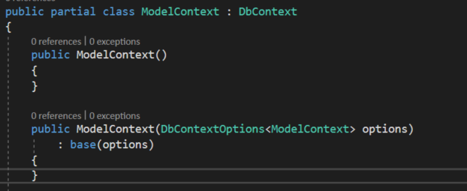

Creation of DbSet that uses the model Bancustomer.



Model class that supports the records

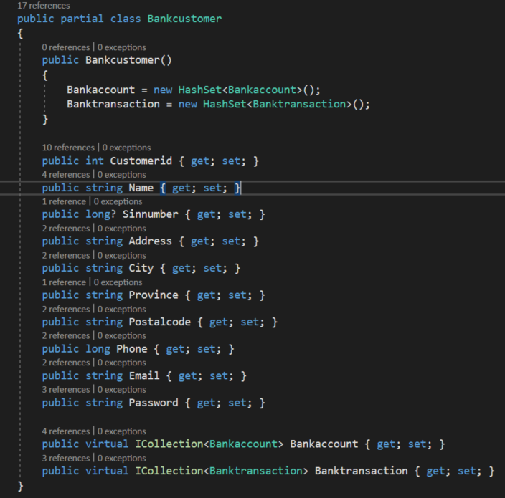

Connection String



# Testing

## Stored Functions

Test of function SUM_TOTALBALANCE_SF

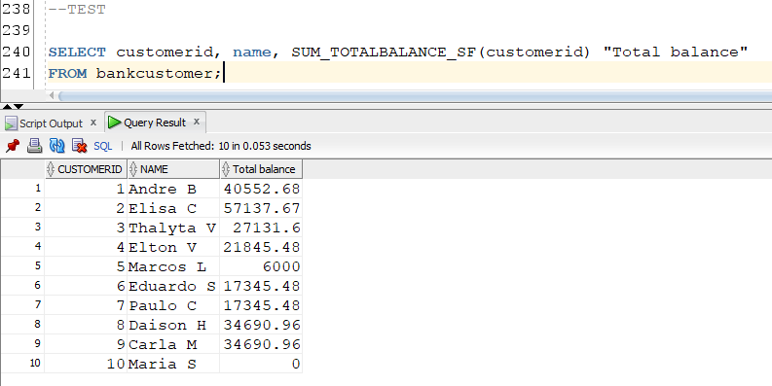

Test of function NUM_OF_TRST_SF

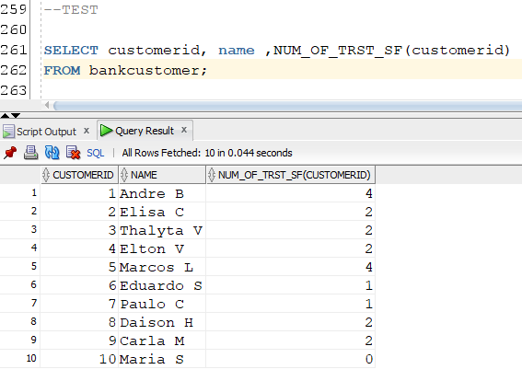

## Stored Procedures

Test for GET_ACCOUNTS_SP

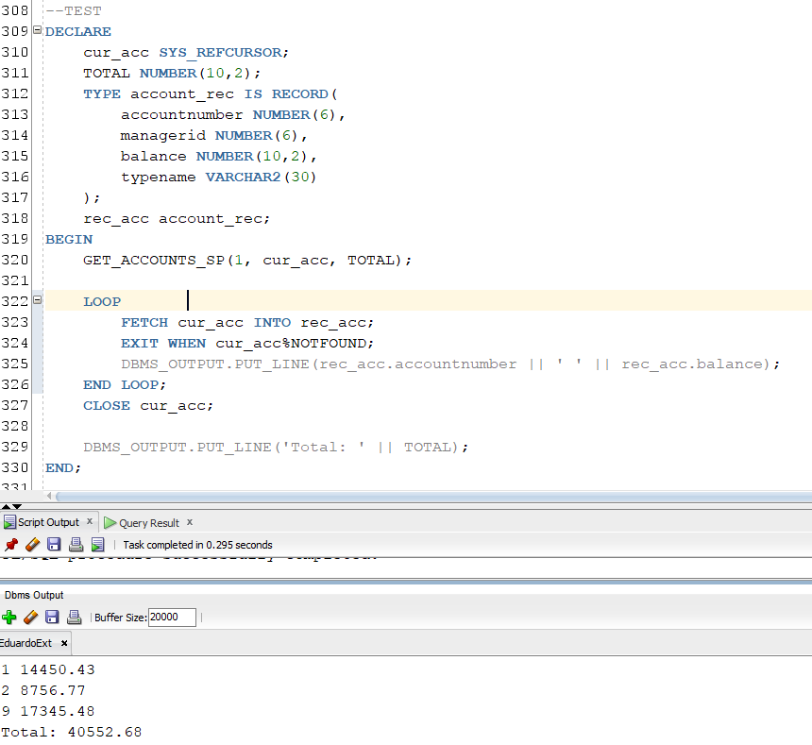

Test for GET_TOTAL_TRST_SP

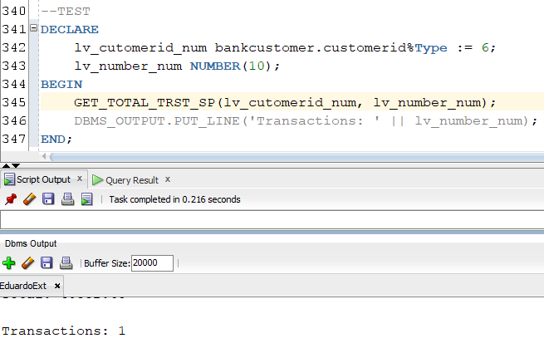

Test for INSERT_TRANSACTION_SP

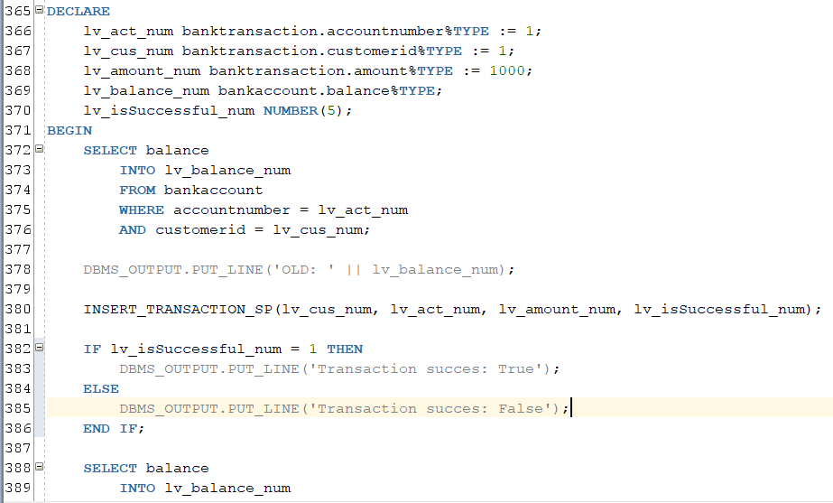

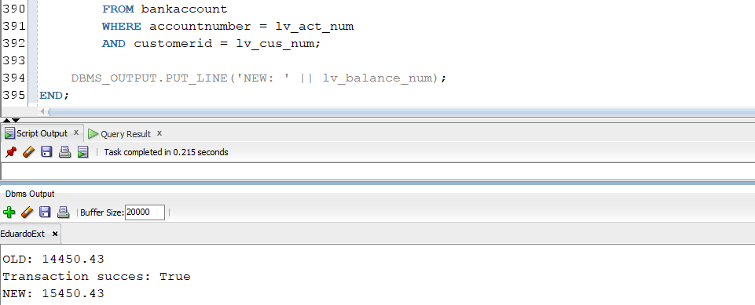

Test for NEW_ACCOUNTTYPE_SP

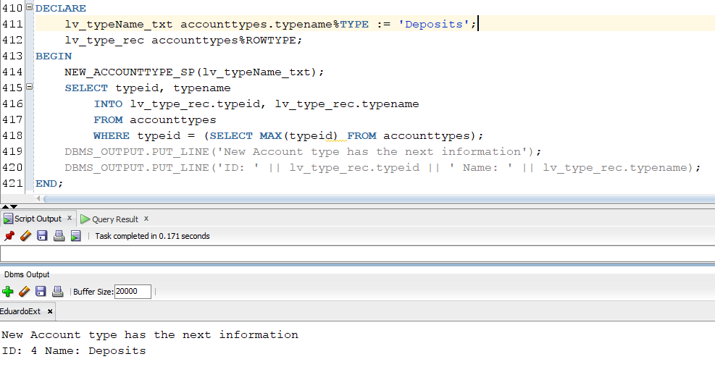

Test for NEW_ACCOUNT_SP

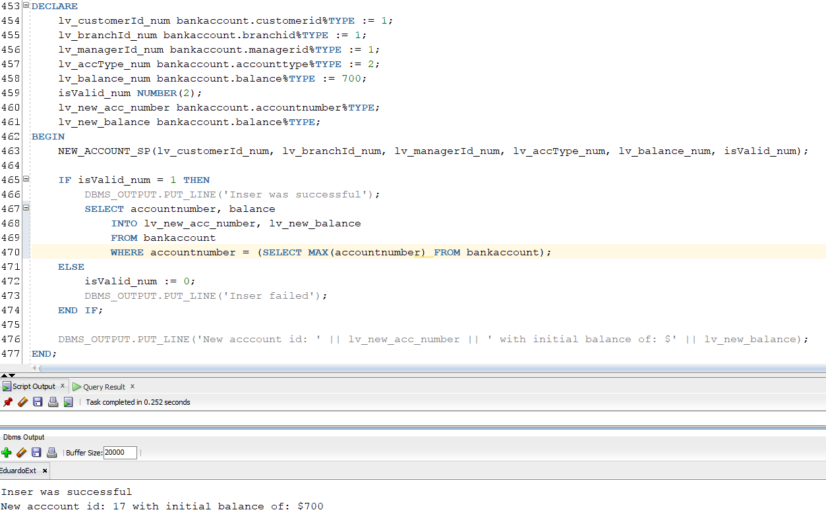

## Trigger

Test for trigger UPDATE_BALANCE_TRG

