**Farmers Market Stock Database**

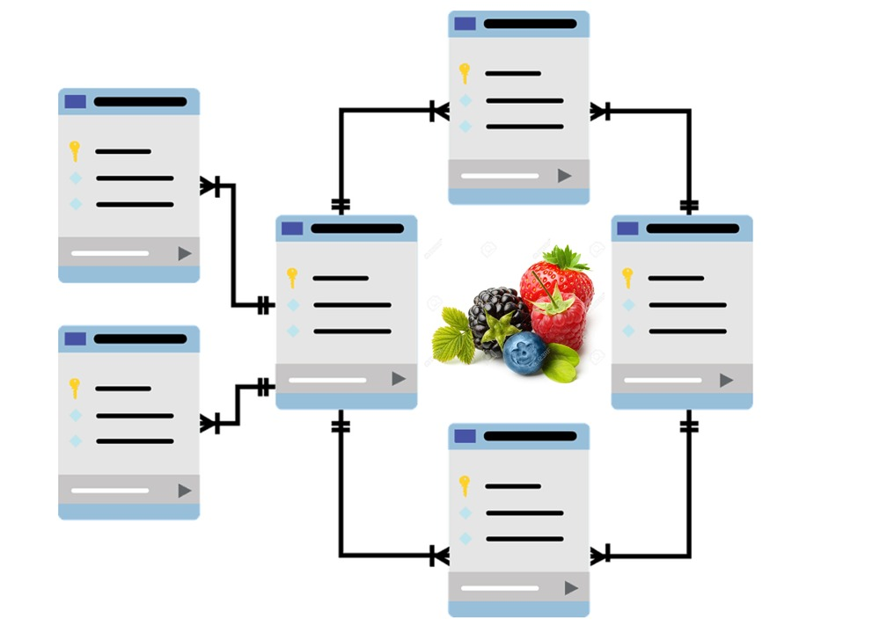

Group members:

Leader: Luana Cesar 301014021

Andrea Pineda 301075816

Raphael Molinaro 301098080

# Farmer Market Stock

## Problem Description

Farmers Market Stock is a database for berry fruits corporation farmers who have poor inventory management that result in out-of-stock, low production efficiency and data redundancy of their stock items. The implementation of this database should maximize efficiency and profitability through following up all inventory steps of received, stocked and sold items.

The stakeholders are farmers, management team (inventory manager, accountant), and consumers.

### Farmers

* Lack data integrity.
* Delivery Time. The time that is required for delivering the products is too short.
* Financial Details. The payments are not received on time.
* Lack of product description. The management team of the company is not providing enough information about the product required such as its specific type.

### Management Team

* There is not an updated record of the farmers personal information.
* Out of Stock. Sometimes, the company is not able to replenish its product on its shelf.
* Lack of inventory forecast. There are lots expired products because there is not a market demand analysis.
* Lack of tracking of shipping products. Sometimes, the company needs to send the products many times because the product is not received or lost by the grocery stores.

### Consumers (Grocery Stores)

* Delay in receiving the product. The product is received after the estimated date.
* Lack of items. The products that are requested are not available to fast shipping due to being out of stock.
* Late Order Process. The processing time between the order check out and the payment due date is too long.
* Payment Due date. They do not have the option to choose payment methods.
* Payment Transparency. Grocery stores are not receiving the order receipts in order to have a record of them.

In conclusion, it is extremely necessary to have a database that provides efficient management of the inventory and demand forecast in order to avoid running out of stock or overstock.

The creation of a database will provide a useful tool to facilitate the trade between stakeholders and the company.

## Fact Finding

### Secure Digital Records

The absence of a digital database on Farmer Stock Records brings a massive waste of time and resources during the distribution process. The insufficient personal contact information impairs the accounting team ability to find or follow up on orders or place an invoice order on time-manners. Creating and updating a digital database will prevent new redundancy or missing records. The financial operating team will reduce costs, boost orders and payments and speed up deliveries.

### Demand Planning Forecast

The absence of all transaction historical data from suppliers and consumers drives several disadvantages to supply chain management. The integral order analysis from suppliers to consumers leads to lost clients and low profit sales. A high-quality data analysis in this database will ends the miscommunication between suppliers or consumers. Also, it will smooth all collaboration with suppliers, and consequently, gather a reliable forecast to fewer stock shortages.

## Business Rules and Understanding

### Registration

Participating Farmers and their stock are registered in the corporation’s database. They are registered to supply their products which will be sent to grocery store through the corporation. Customers are small and large groceries stores. Farmers can register to provide their products to the corporation. The corporation collects the farmers information and the amount and type of inventory they have.

### General use and access to information

Farmers will not have access to the database because the corporation itself will be in charge of updating the product information and delivery estimates in the database. The management team will have full access to the database. They will track inventory that will update the database with information about the product, the customer, stock and order status. Customers will have access to information about the product, order status and the estimated delivery date.

### Stock update

The management team will be responsible for checking the stock status and will place the orders for the farmers, for delivery. If the stock is full they can have more control over orders and schedule their delivery.

### Product tracking

The management team will be able to update the status order according to the product tracking. Once the product has been delivered, the grocery store will be able to track when the product will arrive.

### Contact with farmers

The management team will contact the farmers based on the status of their stock and the client orders.

### Accounting Information Collection

Accountant can use this system to gather and organize all client payment information and confirm payment to the customers.

## Database Users

### Farmers (Suppliers)

### Grocery store Clients (Customers)

* Management Team & Accountant (Managers)

## User’s Data Requirements

|  |  |  |
| --- | --- | --- |
| **Users** | **Table** | **Fields** |
| Farmers, Manager | SUPPLIER | SupplierID |
| SupplierFirstName |
| SupplierLastName |
| Address |
| State |
| PostalCode |
| Email |
| Phone |
| DeliveryOrder |
| Grocery Store Clients, Manager | CUSTOMER | BranchOrderID |
| FirstName |
| LastName |
| Address |
| State |
| PostalCode |
| Email |
| Phone |
| Grocery Store Clients, Manager | ORDERS | OrderID |
| BranchOrderID |
| OrderStatus |
| OrderDate |
| ShipmentID |
| Grocery Store Clients,  Accountant | PAYMENTORDER | PaymentID |
| OrderID |
| PaymentDueDate |
| PaymentStatus |
| Accountant, Grocery Store Clients. | SHIPMENT | ShipmentID |
| ShipAddress |
| ShipPostalCode |
| ShipState |
| ShipCity |
| ShipCost |
| Grocery Store Clients,  Farmers | PRODUCT | ProductID |
| OrderID |
| FruitCode |
| Unit |
| PayedPrice |
| Grocery Store Clients,  Farmers | BERRY FRUIT | FruitCode |
| Category |
| StockQuantity |
| RetailPrice |
| ManagerID |
| Manager, Grocery Store Clients, | INVENTORYCUSTOMER | BranchOrderID |
| ManagerID |
| Manager, Farmers | INVENTORYSUPPLIER | SupplierID |
| ManagerID |
| Manager | MANAGER | ManagerID |
| FirstName |
| LastName |
| Password |

**ER Diagram**

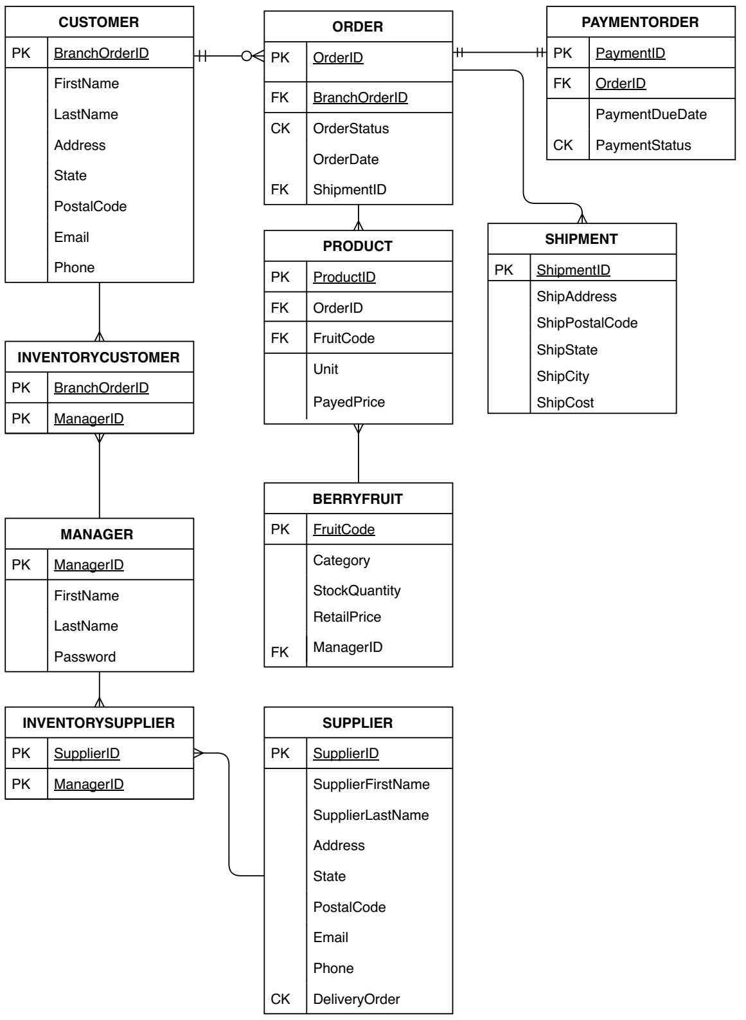

LINK to access ER diagram = <ER.pdf>

LINK to access ER diagram = <ER_draw.drawio>

**Table Relationships**

|  |  |  |
| --- | --- | --- |
| **Table Name** | **Relationship** | **Table Name** |
| Customer | 1:M | Order |
| 1:M | InventoryCustomer |
| Orders | 1:1 | PaymentOrder |
| 1:M | Shipment |
| 1:M | Product |
| Product | M:1 | BerryFruit |
| InventoryCustomer | M:1 | Manager |
| Manager | 1:M | InventorySupplier |
| InventorySupplier | M:1 | Supplier |

**Metadata**

|  |  |  |  |  |
| --- | --- | --- | --- | --- |
| **Table** | **Attributes (Columns)** | **Data Type** | **Constraint Type** | **Required** |
| SUPPLIER | SupplierID | NUMBER(4, 0) | Primary Key | YES |
| SupplierFirstName | VARCHAR2(30) |  | YES |
| SupplierLastName | VARCHAR2(30) |  | YES |
| Address | VARCHAR2(100) |  | NO |
| State | CHAR (2) |  | NO |
| PostalCode | VARCHAR2(6) |  | YES |
| Email | VARCHAR2(30) |  | YES |
| Phone | NUMBER(10, 0) |  | NO |
| DeliveryOrder | CHAR(1) | CHECK (‘y’||’n’) | YES |
| CUSTOMER | BranchOrderID | NUMBER(4) | PRIMARY KEY | YECRS |
| FirstName | VARCHAR2(30) |  | YES |
| LastName | VARCHAR2(30) |  | YES |
| Address | VARCHAR2(100) |  | YES |
| State | CHAR (2) |  | YES |
| PostalCode | VARCHAR2(6) |  | YES |
| Email | VARCHAR2(30) |  | YES |
| Phone | NUMBER(10, 0) |  | NO |
| ORDERS | OrderID | NUMBER(4,0) | PRIMARY KEY | YES |
| BranchOrderID | NUMBER(4,0) | Foreign Key | YES |
| OrderStatus | CHAR(1) | CHECK (‘y’||’n’) | YES |
| OrderDate | DATE |  | YES |
| ShipmentID | NUMBER(4,0) |  | YES |
| PAYMENTORDER | PaymentID | NUMBER(4,0) | PRIMARY KEY | YES |
| OrderID | NUMBER(4,0) | FOREIGN KEY | YES |
| PaymentDueDate | DATE |  | YES |
| PaymentStatus | CHAR(1) | CHECK (‘Y’||’N’) | YES |
| SHIPMENT | ShipmentID | NUMBER(4, 0) | PRIMARY KEY | YES |
| ShipAddress | VARCHAR2(100) |  | YES |
| ShipPostalCode | VARCHAR2(6) |  | YES |
| ShipState | CHAR(2) |  | NO |
| ShipCity | VARCHAR2(15) |  | NO |
| ShipCost | NUMBER(6,2) |  | YES |
| PRODUCT | ProductID | NUMBER(4, 0) | PRIMARY KEY | YES |
| OrderID | NUMBER(4, 0) | FOREIGN KEY | YES |
| FruitCode | NUMBER(4, 0) | FOREIGN KEY | YES |
| Unit | NUMBER(6, 2) |  | YES |
| PayedPrice | NUMBER(8, 2) |  | YES |
| BERRY FRUIT | FruitCode | NUMBER(4, 0) | PRIMARY KEY | YES |
| Category | VARCHAR2(20) |  | YES |
| StockQuantity | NUMBER(6, 2) |  | YES |
| RetailPrice | NUMBER(8, 2) |  | YES |
| ManagerID | NUMBER(4, 0) | FOREIGN KEY | YES |
| INVENTORYCUSTOMER | BranchOrderID | NUMBER(4, 0) | PRIMARY KEY | YES |
| ManagerID | NUMBER(4, 0) | PRIMARY KEY | YES |
| INVENTORYSUPPLIER | SupplierID | NUMBER(4, 0) | PRIMARY KEY | YES |
| ManagerID | NUMBER(4, 0) | PRIMARY KEY | YES |
| MANAGER | ManagerID | NUMBER(4, 0) | PRIMARY KEY | YES |
| FirstName | VARCHAR2(30) |  | YES |
| LastName | VARCHAR2(30) |  | YES |
| Password | CHAR(8) |  | NO |