# MongoDB

1. Download and install MongoDB at <http://www.mongodb.org/downloads>. Select the ‘Complete’ installation, NOT ‘Custom’

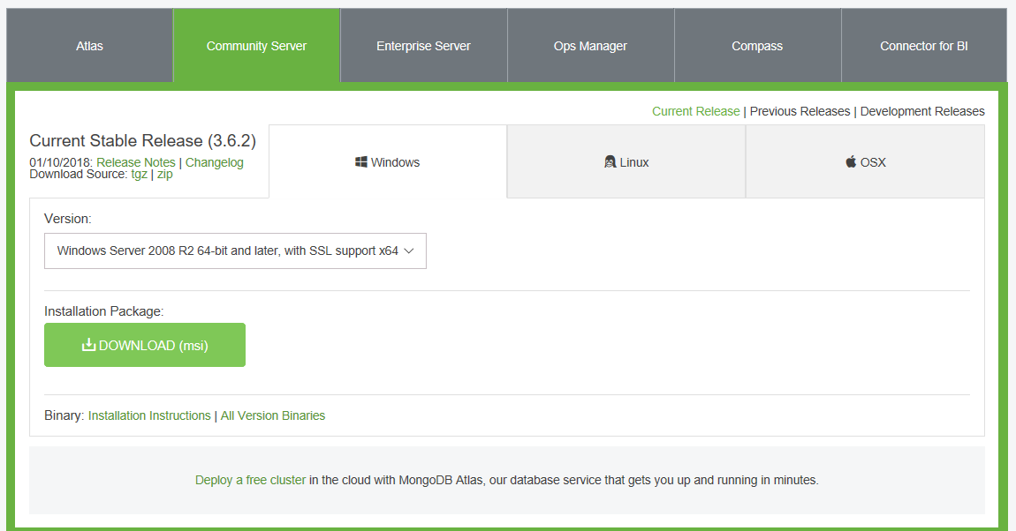

2. Create a database folder in C:\ named ‘data’

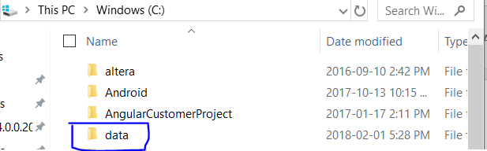

3. Create another folder within data named ‘db’

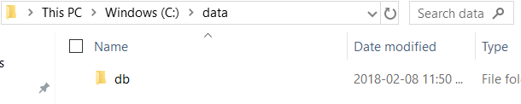

4. Locate the directory ‘bin’ within where MongoDB was installed (C:\Program Files\MongoDB\Server\3.6\bin for me), and open two terminals in the ‘bin’ folder. Execute ‘mongod’ in the first terminal, then ‘mongo’ in the second. You should never need to interact with these terminals again, simply keep them minimized on your computer UNTIL THE END OF TIME

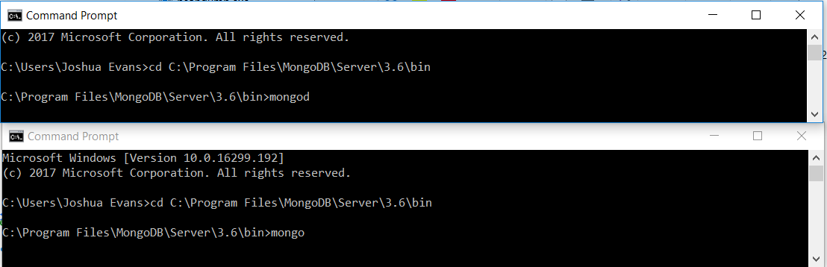

# NodeJS

1. Download and install NodeJS at <https://nodejs.org/en/download/>. Simply click through, accepting all default choices.

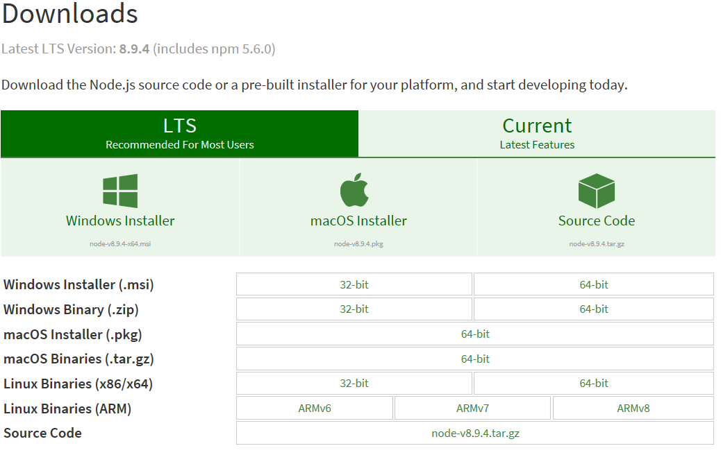

# GitHub

1. Whatever work you have within your SOLVERE folder right now, save it somewhere else on your computer. Then, delete the SOLVERE folder.

2. Navigate to where you’d like on your computer (I chose C:\Users\Joshua Evans), and GitBash there. Then, execute ‘git clone [git@github.com:UWO-ECE-Software-Engineering/SOLVERE.git](mailto:git@github.com:UWO-ECE-Software-Engineering/SOLVERE.git)’

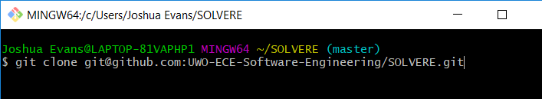

3. Go into the new folder ‘SOLVERE’, and delete the folder ‘front-end’

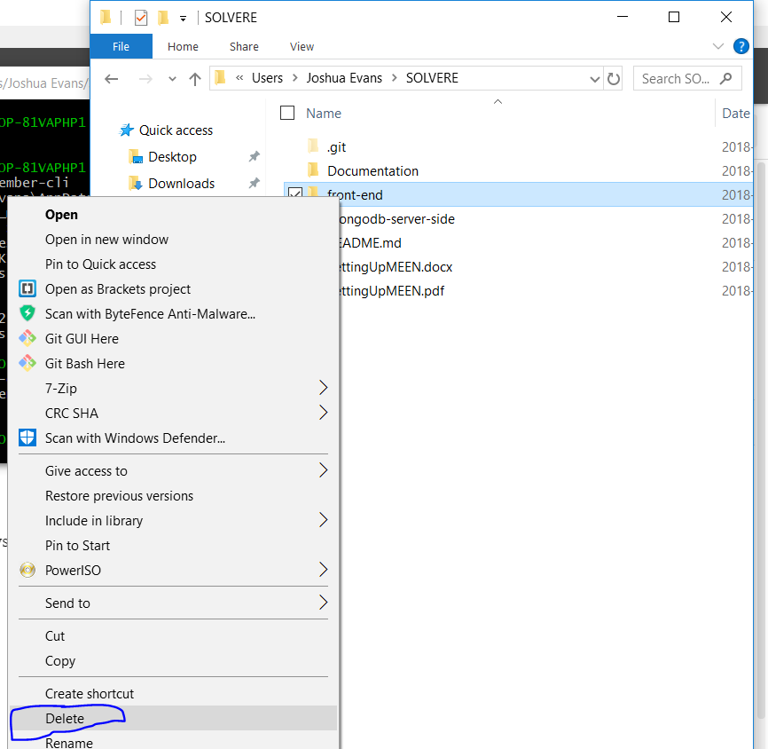

# Ember

1. Navigate inside the SOLVERE directory using GitBash, and execute ‘npm install -g ember-cli’

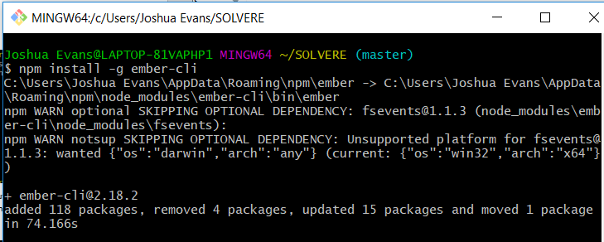

2. Within SOLVERE, execute ‘ember new front-end’. Note: This may take \**insert large number\** minutes

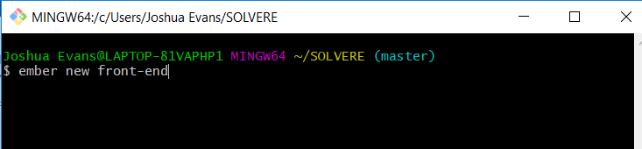

3. Within SOLVERE, execute ‘git checkout front-end’



4. Within front-end, execute ‘npm install’, then ‘bower install’

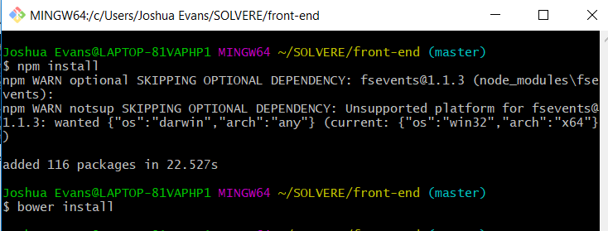

# Starting the System

1. You should always have MongoDB running on your computer (see top of document for reference)

2. To start the backend, navigate to SOLVERE/mongodb-server-side in some command-line-interface, and execute ‘nodemon’

3. To start the frontend, navigate to SOLVERE/front-end in some command-line-interface, and execute ‘ember s’