***Mirrored* README**

**Project by: Mdk6jd, Lmh2sb, Rnm6u**

Our main goal for our prototype of *Mirrored* was to perfect the mirrored movement mechanic for both synchronized and desynchronized movement.

The arrow keys are used for movement. Up/Down will move both characters Up and Down. Left/Right will move the character on the left Left and Right——the character on the right will have Mirrored movements to the one on the left. Space bar is used to switch between synchronized and desynchronized movement. When you start the game, the default setting will be synchronized movement.

We define synchronized movement as movement where collisions on one of the player’s characters also affects the movement of the player’s other character. We define desynchronized movement to be movement where collisions on one of the player’s characters affects the same character’s movement but the other character is free to move as long as there are no obstacles in the way.

For example, let us assume that both characters are moving horizontally and the one on the left hits a wall while the one on the right has no obstacles in front of him. If the two characters were moving under synchronized movement, the left player would obviously stop moving in that direction because he hit a wall, but with synchronized movement, the other character would stop as well. In this case, their movement is tightly coupled.

Let us assume the same scenario except this time, the characters are moving under desynchronized movement. In this case, the player on the left would again, stop moving in that direction because he hit a wall. The player on the right would keep moving in the same direction he was moving as long as no obstacles are in his way. The two character’s movement is loosely coupled.

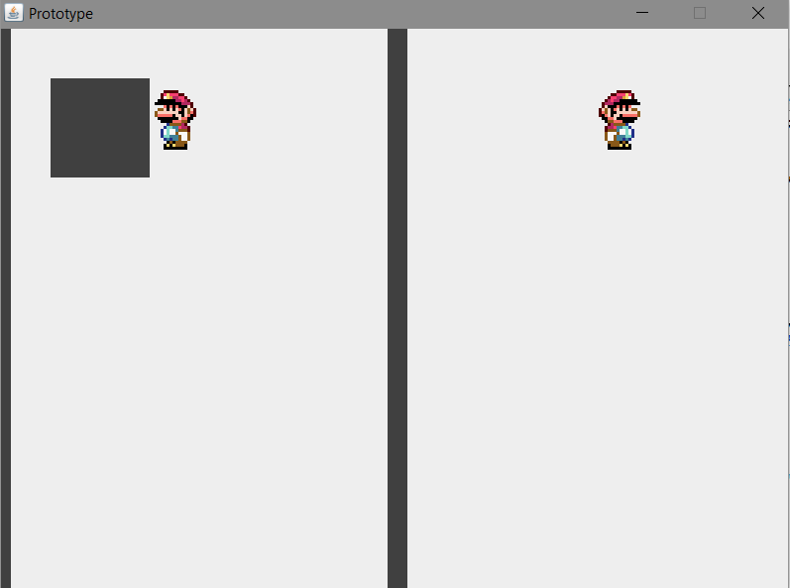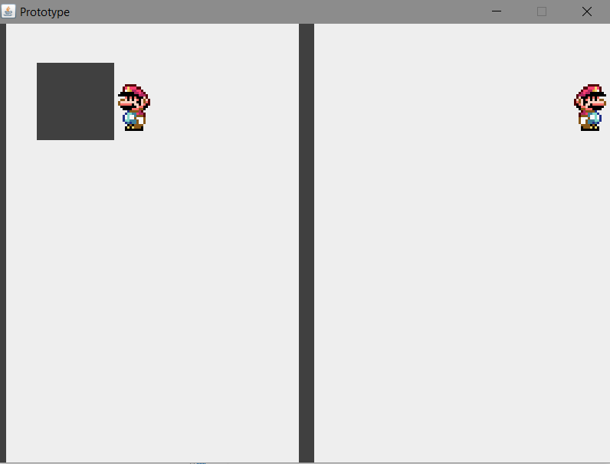

Desynchronized Movement

Synchronized Movement