# Riley’s 2D Height Map Generator

Experiment for playing with procedurally generated 2d height maps. I downloaded a free tileset from deviantart and edited them a little bit with Gimp to get the right look and feel. There are 6 different tiles - deep water, shallow water, beach, forest, hills, and mountains.

The current version was set up to make sure the graphic display is working right. I need to make the tiles smaller - right now they are 60X60 pixels which makes for a map with a small number of tiles. The actual map is generated with a simple random number generator, so it's not an actual "map," but really a random collection of those 6 tiles.

I have the display working, with pseudo-random tile placement. The 6 tiles range in height from 0 to 5, where deep water is a 0 and mountains are 5. The tiles are currently placed pseudo-randomly, and the result is not a real "map," but it does have the framework I need to implement a noise function to generate a real 2D height map. I'm starting by researching the Simplex noise function for height map generation.

UPDATE 4/20/16:

I fixed the size of the tiles, and now have my base "random" map, which is essentially just randomly-placed tiles. It's not totally random, as I implemented a simple pseudo-random algorithm I came up with. You will notice the result is that tiles are often "repeated", with the same tile often appearing multiple times in a horizontal string. The result still is a long ways from being a real "map", though:

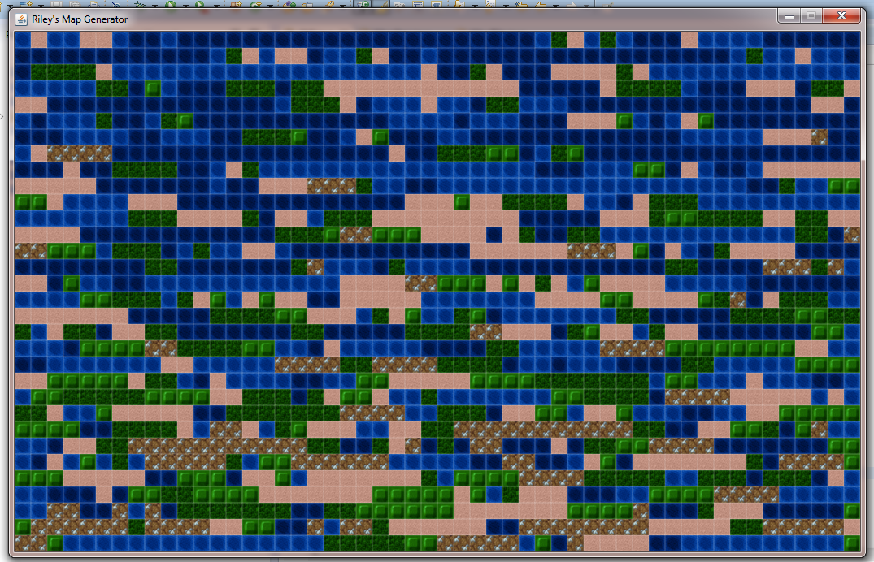

UPDATE 5/12/16: First attempt at implementing a Perlin noise algorithm. I still want to mess around with the persistence, as well as the correct height values for each tile, but this is a good start:

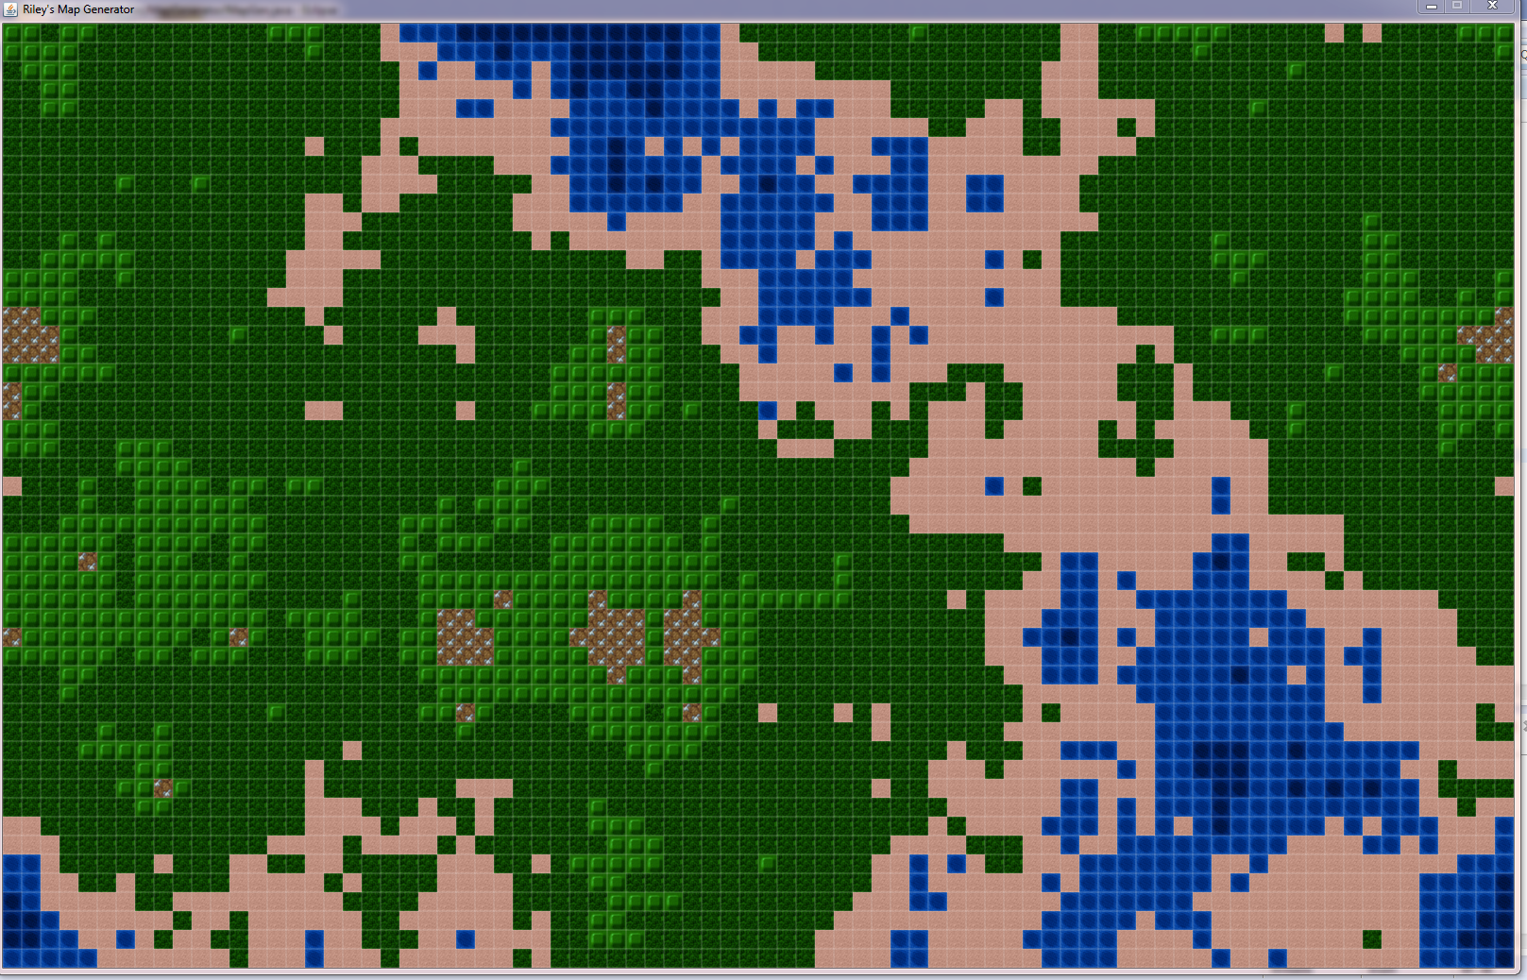

After tweaking the algorithm a little (playing around with different persistence and octave values), as well as adjusting the height values corresponding to each tile, I now have this:

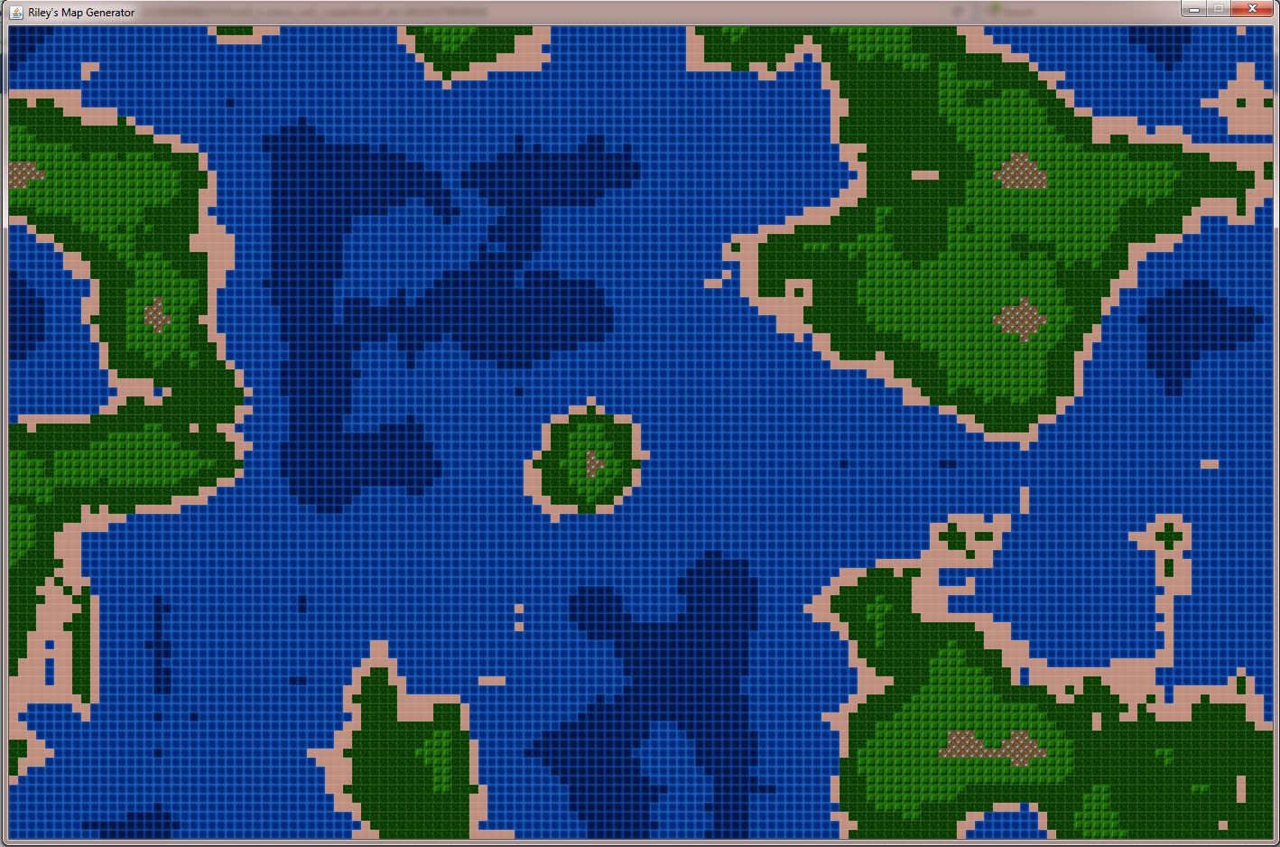

I reduced the size of each tile by a lot, so now they are only 10X10 pixels, which allows for creation of larger maps. I also found a pretty good “height” to tile image correspondence, which generates realistic island maps: the maps are roughly 50% water, with the forest and hill tiles appearing much more abundantly than the beach or mountain tiles.

# Future Work:

The algorithm takes about 10 seconds to produce a new map, which can definitely be optimized. I also have a lot of things I want to add here… I’m going to look at implementing a pathfinding algorithm, as well as a function to let users “navigate” around a larger map by moving the viewport. I would also like to add another layer which would allow a tile to be highlighted or “active,” and I could add a loading/start menu as well as options to change the attributes of the random map to be generated (more or less smooth, more or less water, etc.)