**Image Registration**

* **Packages Required:**

1. PyQt5
2. Pillow or PIL
3. opencv-python
4. opencv-contrib-python os
5. matplotlib

* **Command Line Help:**

Run the below command to view the help/usage message displayed by the solution:

python ImageRegistration.py -h

or

python ImageRegistration.py --help

**Help Message:**

Below Help message should be displayed in the console:

**Please read the user instructions document "ReadMe.pdf" for more details**

* **Startup and HomePage:**

Run the below command to view the homepage of the application as shown in the below screenshot:

**Command:**

python ImageRegistration.py

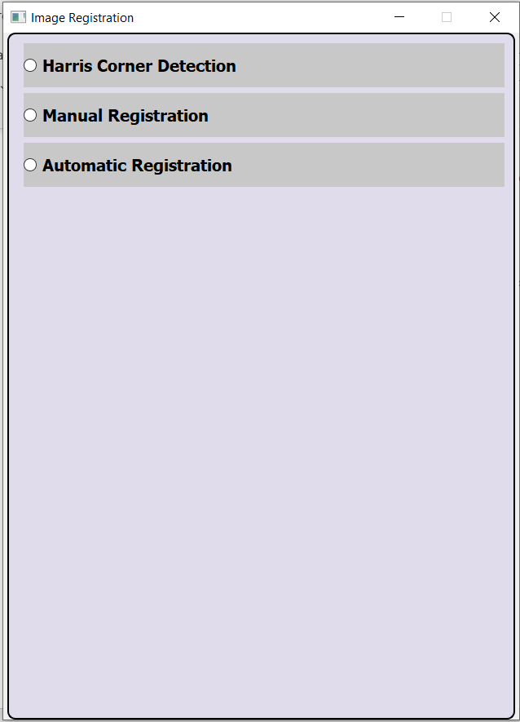

* **Harris Corner Detection:**

1. Click on "**Harris Corner Detection**" radio button in the homepage. **"Harris Corner Detection**” Page should be displayed as shown in the below screenshot.

2. Using the browse buttons, choose the Image file on which Harris corner detection needs to be performed. Specify the value for Harris Param (default is 0.1). Click on "Run Harris Corner Detection" button.

3. The image should be displayed properly with points identified using Harris corner highlighted in Red color.

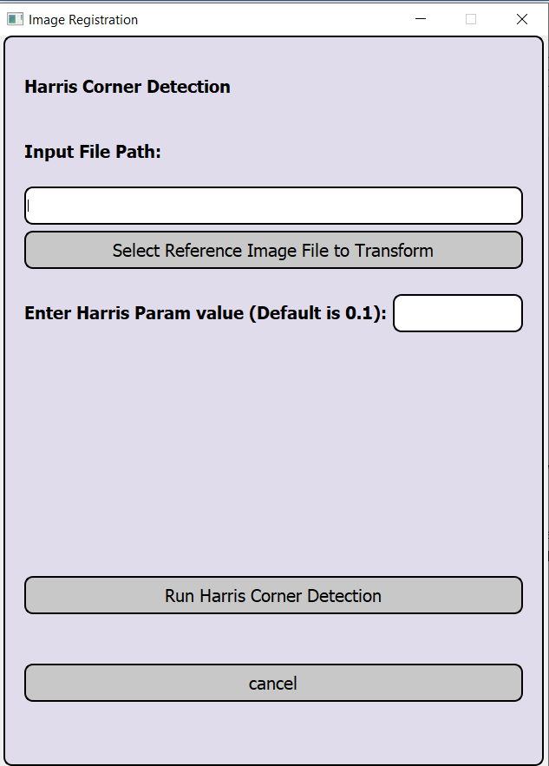

* **Manual Registration:**

1. Select manual registration from the HomePage

2. Using the two browse buttons, select the Reference Image file and Target Image file.

3. Click on Perform Manual Registration button.

4. The Reference Image should be displayed for choosing the required points for matching. Now Select atleast 4 points in the reference image, press any key from keyboard after choosing the points.

6. The Target Image should be displayed for choosing the required points for matching. Now Select atleast 4 points in the target image, press any key from keyboard after choosing the points.

7. The Reference Image, Target Image and Final Transformed Image based on chosen points should be displayed in 3 separate windows.

8. Close the displayed Images. Press cancel button on the UI Page. The user should navigate back to the homepage.

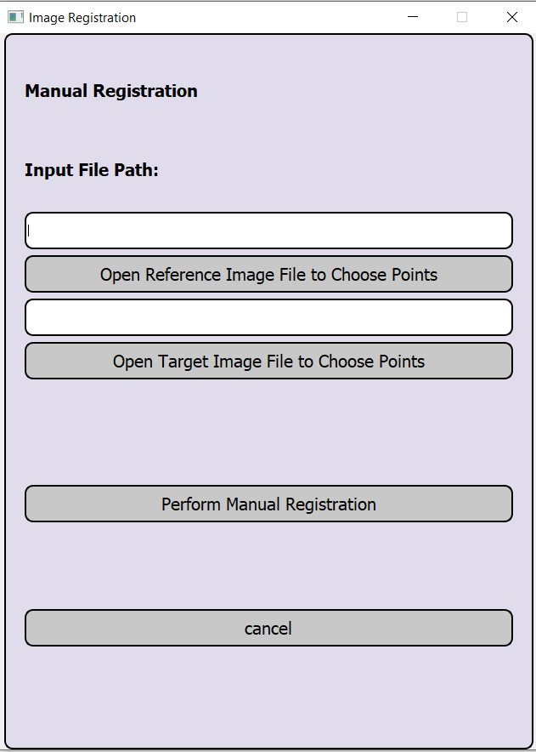

* **Automatic Registration:**

1. Select Automatic registration from the HomePage

2. Using the two browse buttons, select the Reference Image file and Target Image file.

3. Click on Perform Automatic Registration button.

4. The Reference Image, Target Image and Final Transformed Image based on auomatic registration should be displayed in 3 separate windows..

5. Close the displayed Images. Press cancel button on the UI PageThe user should navigate back to the homepage.

