**Please read the document "MeritsAndLimitations.pdf" for details on Merits and Limitations of Histogram Equalization and Matching**

* **Packages Required:**

1. PyQt5
2. Pillow or PIL
3. opencv-python
4. opencv-contrib-python os

* **Command Line Help:**

Run the below command to view the help/usage message displayed by the solution:

python HistogramEqualizationAndMatching.py -h

or

python HistogramEqualizationAndMatching.py --help

**Help Message:**

Below Help message should be displayed in the console:

**Please read the user instructions document "ReadMe.pdf" for more details**

* **Startup and HomePage:**

Run the below command to view the homepage of the application as shown in the below screenshot:

**Command:**

python HistogramEqualizationAndMatching.py

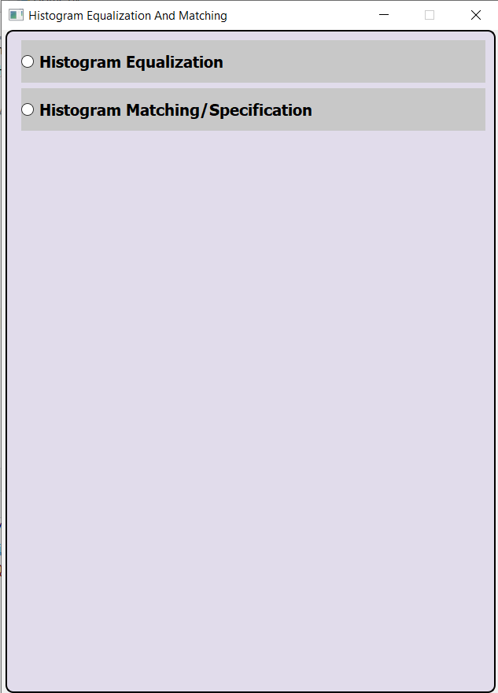

* **Histogram Equalization:**

1. Click on "Histogram Equalization" radio button in the homepage. "Histogram Equalization" Page should be displayed as shown in the below screenshot.

2. Click on Browse file button in the "Histogram Equalization" Page.

3. Using the dialog box, Browse to an Image file.

4. Click on Apply button.

5. The Original Image and the Equalized Image should be displayed. The Original Image Histogram Plot and the Equalized Image Histogram Plot should be displayed properly.

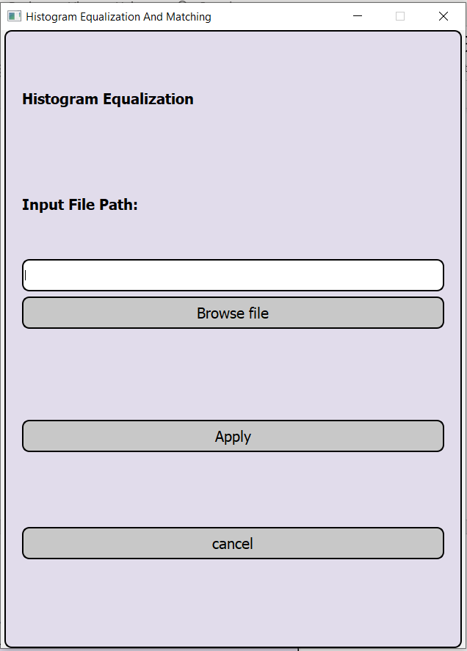

* **Histogram Matching/Specification:**

1. Click on "Histogram Matching/Specification" radio button in the homepage. "Histogram Matching/Specification" Page should be displayed as shown in the below screenshot.

2. Click on “Select Original Image File to Transform” and “Select Specified Image File” button in the "Histogram Matching/Specification " Page(Images chosen should be of the same size).

3. Using the dialog box, Browse file 1 and file 2 to an Image file.

4. Click on Apply button.

5. The Original Image, the Specified Image and the Result Images should be displayed properly.

6. The Original Image Histogram Plot, Specified Image histogram Plot and the result Image Histogram Plot should be displayed.

