* **Command Line Help:**

Run the below command to view the help/usage message displayed by the solution:

python pixel_ops.py -h

or

python pixel_ops.py --help

**Help Message:**

Below Help message should be displayed in the console:

**Please read the user instructions document "ReadMe.pdf" for more details**

* **Startup and HomePage:**

Run the below command to view the homepage of the application as shown in the below screenshot:

**Command:**

python pixel_ops.py

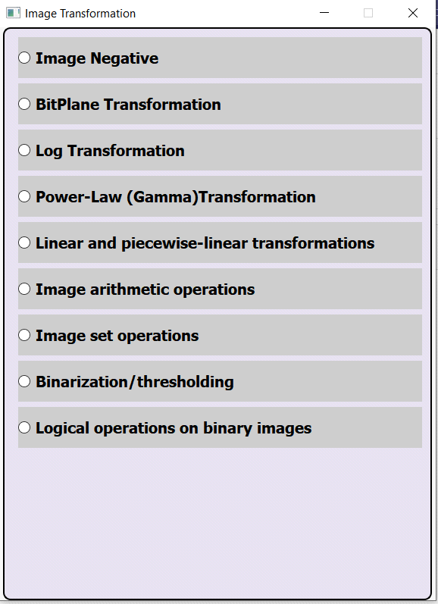

* **Image Negative Transformation:**

1. Click on "Image Negative" radio button in the homepage. "Image Negative Transformation" Page should be displayed as shown in the below screenshot.

2. Click on Browse file button in the "Image Negative Transformation" Page.

3. Using the dialog box, Browse to an Image file and click Open button

4. Click on Apply button.

5. The Original Image and the Transformed Image using Image Negative transformation should be displayed properly.

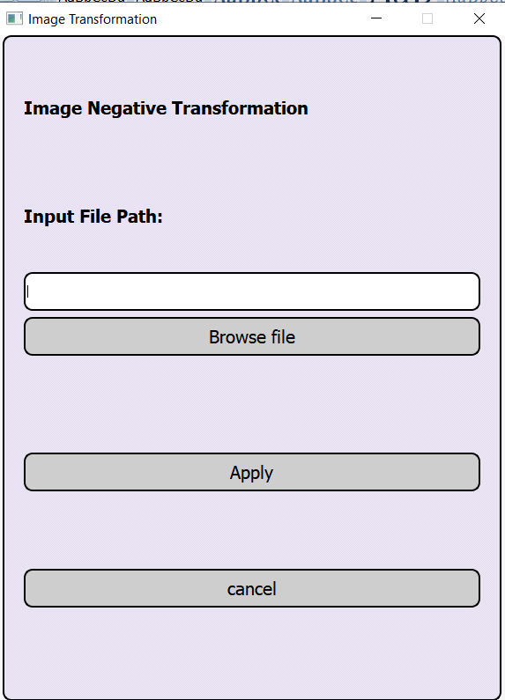

* **Logarithmic Transformation:**

1. Click on "Log Transformation " radio button in the homepage. " Logarithmic Transformation" Page should be displayed as shown in the below screenshot.

2. Click on Browse file button in the " Logarithmic Transformation" Page.

3. Using the dialog box, Browse to an Image file and click Open button

4. Click on Apply button.

5. The Original Image and the Transformed Image using Logarithmic Transformation transformation should be displayed properly.

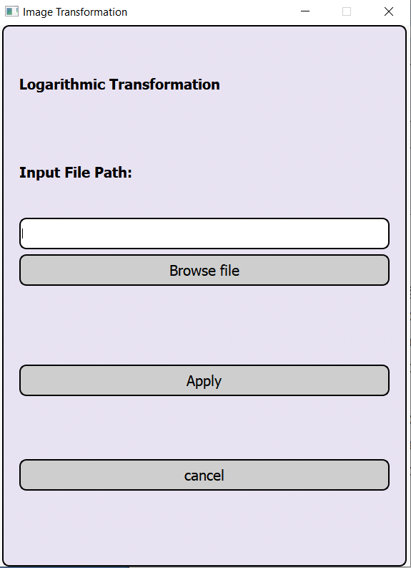

* **Power-Law (Gamma) Transformation:**
* Click on " Power-Law (Gamma) Transformation " radio button in the homepage.

“Power-Law (Gamma) Transformation" Page should be displayed as shown in the below screenshot.

2. Click on Browse file button in the " Power-Law (Gamma) Transformation" Page.

3. Using the dialog box, Browse to an Image file and click Open button

4. Enter the required gamma value (float/decimal value). Click on Apply button.

5. The Original Image and the Transformed Image using Power-Law (Gamma) Transformation transformation should be displayed properly.

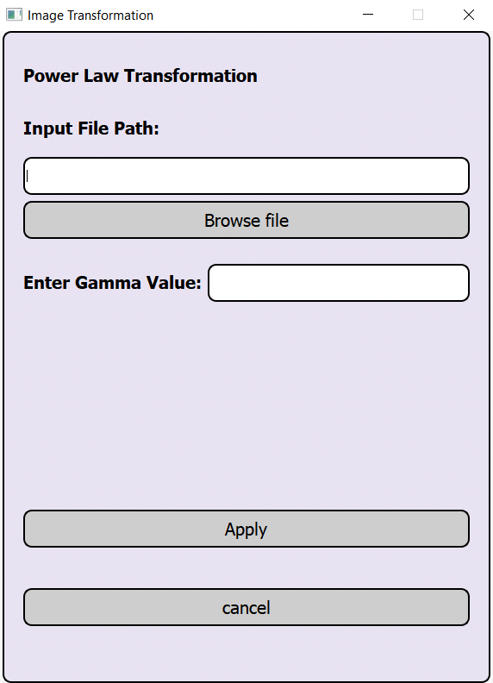

* **Image Set Transformation:**

1. Click on "Image Set operations" radio button in the homepage. "Set Transformation" Page should be displayed as shown in the below screenshot.

2. Click on Browse file 1 and Browse file 2 button in the "Set Transformation" Page(Images

chosen should be of the same size).

3. Using the dialog box, Browse file 1 and file 2 to an Image file and click Open button

4. Click on Apply button.

5. The Original Image and the Transformed Image using different set operations(Union, Intersection, Difference, Complement) transformation should be displayed properly.

6. Using Switch Images Path check box, input path images should be switched.

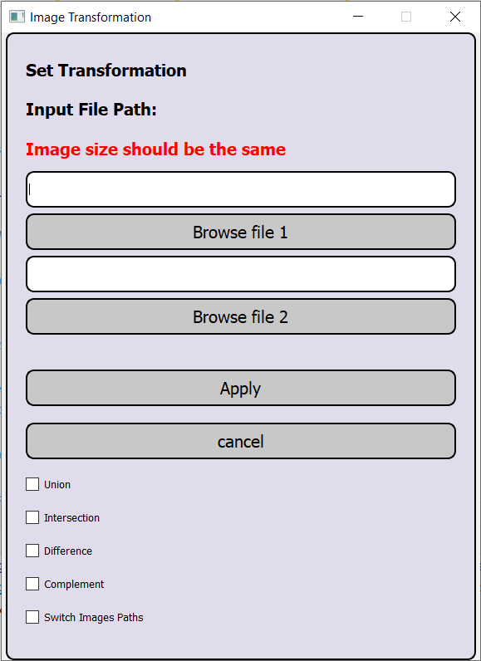

* **Binarization/thresholding Transformation:**

1. Click on "Binarization/Thresholding Transformation " radio button in the homepage. " Binarization/Thresholding Transformation" Page should be displayed as shown in the below screenshot.

2. Click on Browse file button in the " Binarization/Thresholding Transformation" Page.

3. Using the dialog box, Browse to an Image file and click Open button

4. Click on Apply button.

5. Selecting the check box for different thresholds, the Transformed Image for the selected thresholds should be displayed properly.

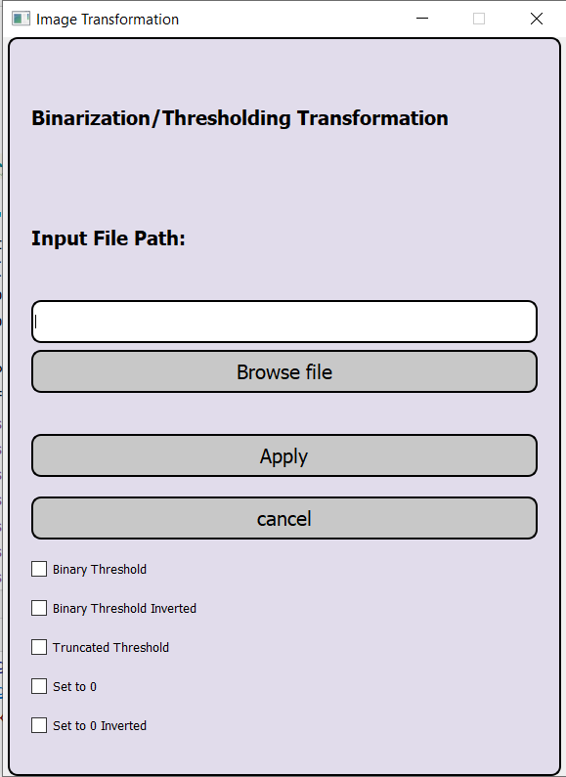

* **Logical Transformation:**

1. Click on "Logical operations" radio button in the homepage. "Logical Transformation" Page should be displayed as shown in the below screenshot.

2. Click on Browse file 1 and Browse file 2 button in the "Logical Transformation" Page(Images chosen should be of the same size).

3. Using the dialog box, Browse file 1 and file 2 to an Image file and click Open button

4. Click on Apply button.

5. The Original Image and the Transformed Image using different logical operations(And, Or, Xor, Not) transformation should be displayed properly.

6. Using Switch Images Path check box, input file path images should be switched.

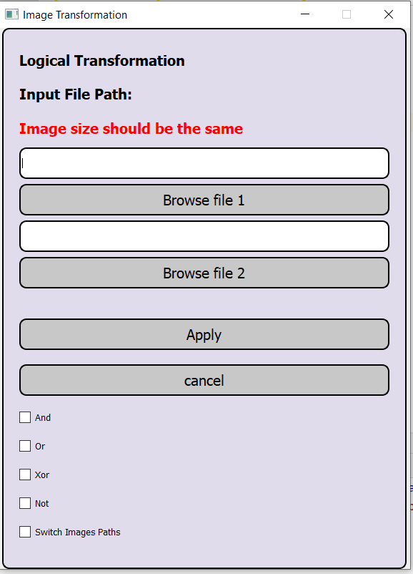

* **Bit-Plane Transformation:**

1. Click on “Bit-Plane Transformation” radio button in the homepage. “Bit-Plane Transformation” Page should be displayed as shown in the below screenshot.
2. Click on Browse file button in the “Bit-Plane Transformation” page.
3. Using the dialog box, Browse to an Image file and click Open button, Then click the Apply button.
4. The Original Image and the Transformed image using Bit-Plane Transformation will be displayed with each bit labeled.

* **Linear and piecewise-linear transformation:**

1. Click on “Linear and piecewise-linear transformation” radio button in the homepage. “Linear and piecewise-linear transformation” Page should be displayed as shown in the below screenshot.
2. Click on Browse file button in the “Linear and piecewise-linear transformation” page.
3. Using the dialog box, Browse to an Image file and click Open button.
4. Then select the Values you want for Input intensity 1, output intensity 1, Input intensity 2, output intensity 2, then click apply. ( if you want to change the values again on the same image you need to click apply after changing the input values).
5. The Original Image and the Transformed image using Linear and piecewise-linear transformationwill be displayed in grayscale.

* **Image arithmetic operation:**

1. Click on “Image arithmetic operation” radio button in the homepage. “Image arithmetic operation” Page should be displayed as shown in the below screenshot.
2. Click on Browse file 1 button in the “Image arithmetic operation” page for the path to the first image.
3. Using the dialog box, Browse to an Image file and click Open button.
4. Click on Browse file 2 button in the “Image arithmetic operation” page for the path to the second image.
5. Using the dialog box, Browse to an Image file and click Open button.
6. Then select the operation you want to perform on the pictures which are Addition, Subtraction, Multiply, Division, and to switch the paths of the input files.
7. You can select multiple operation you want to preform and a window will open for each operation and Click Apply to run the operation.
8. The Original Image and each operation will display in its own window.

