**DOCUMENT TRACKING SYSTEM**

PMISD-MIS

Issued: July 2021

**Step**

**1**

**LOGIN IN THE DOCUMENT TRACKING SYSTEM**

**Step**

**2**

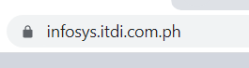

Input the URL in any browsers address bar (e.g. Mozilla, Google Chrome)

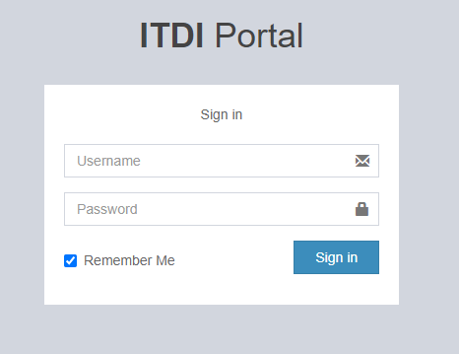

Input Username and Password then click Login

Click Sign in to continue logging in

**3**

**Step**

**LANDING PAGE OF ITDI APPLICATIONS**

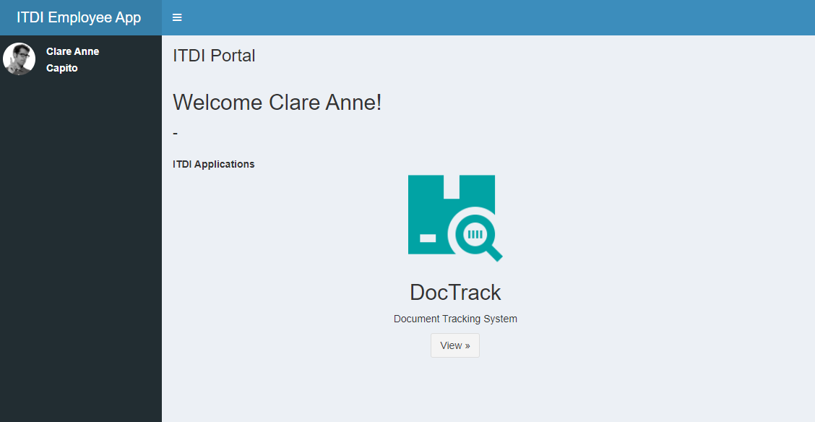

Click **View to go to Document Tracking System**

**1**

**Step**

**CREATING DOCUMENT (INTERNAL COMMUNICATION)**

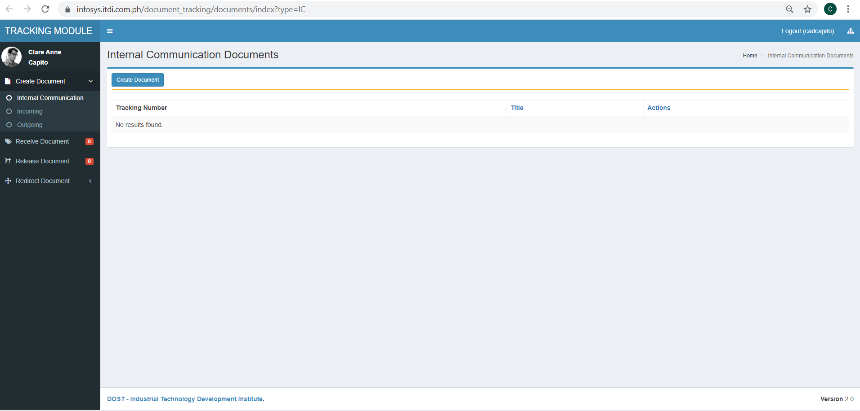

Click **Create Document** button

Click any of the three document type to view all documents created and received of respective type

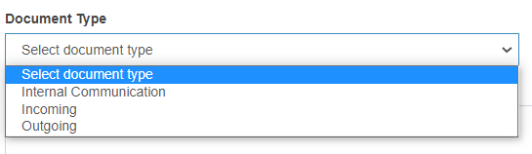

**Select Document Type**

**2**

**Step**

**INPUT DOCUMENT DETAILS**

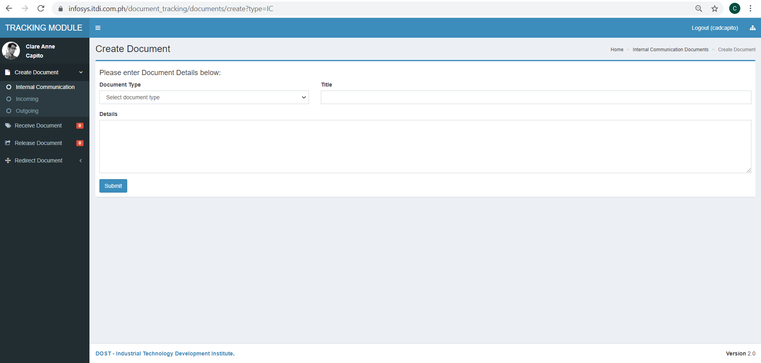

Input **Title** of the document to be created

Input short detail about the document

Click **Submit** to create document

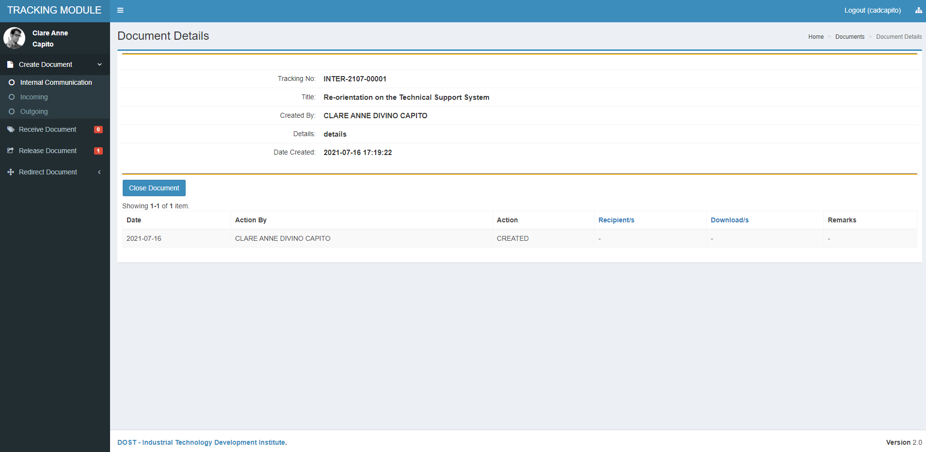

**3**

**Step**

**INITIAL REVIEW PAGE OF DOCUMENTED CREATED**

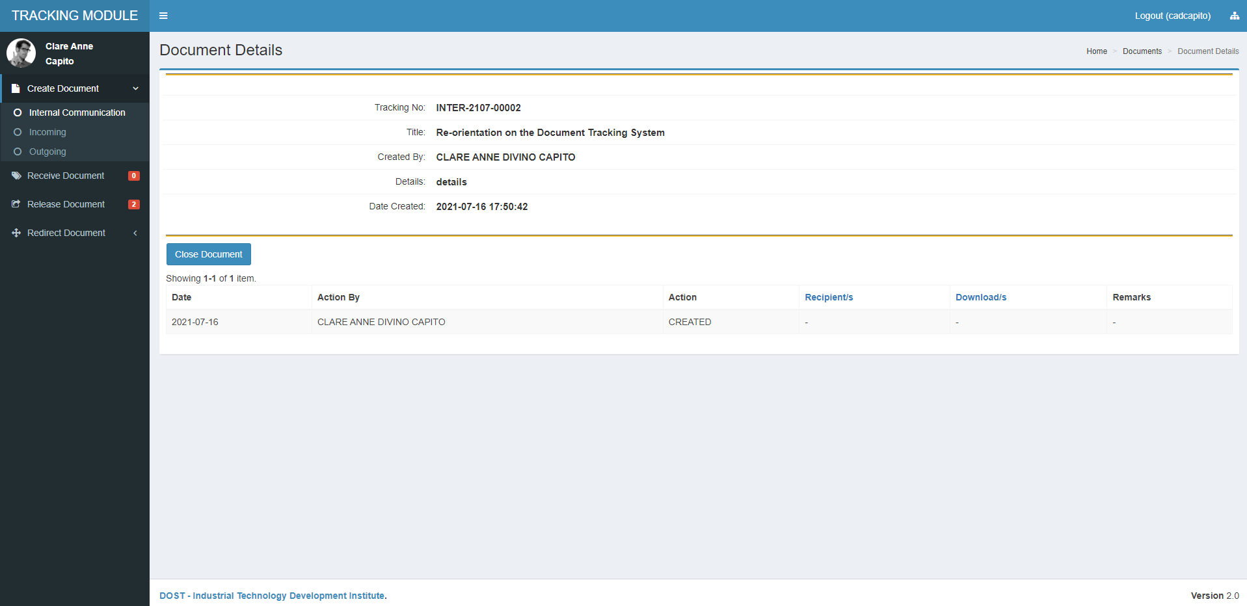

Document Details

The document will no longer be available for releasing/receive

Table display for document history

**4**

**Step**

**RELEASING DOCUMENT**

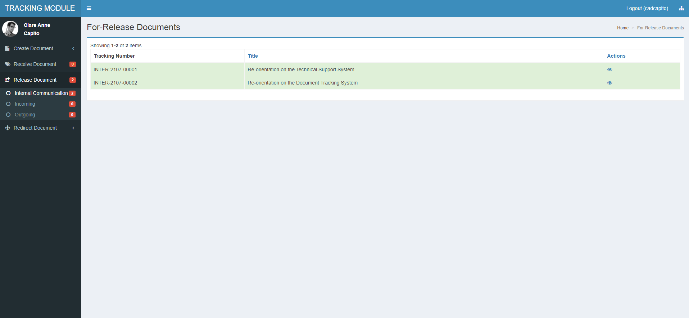

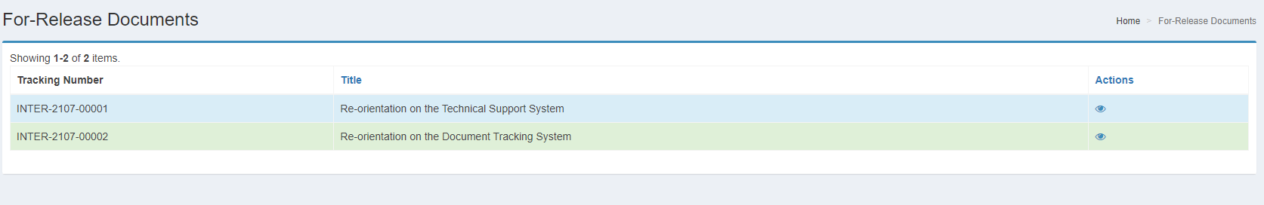

Click **Eye Icon** to view and release document

Table list of all for release document

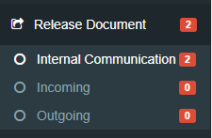

Click any of the three document type to view all for release document of respective type

The number indicates how many files are still new/unviewed



Viewed Document  
Newly Created/Received Document (Unviewed)

**Legend:**

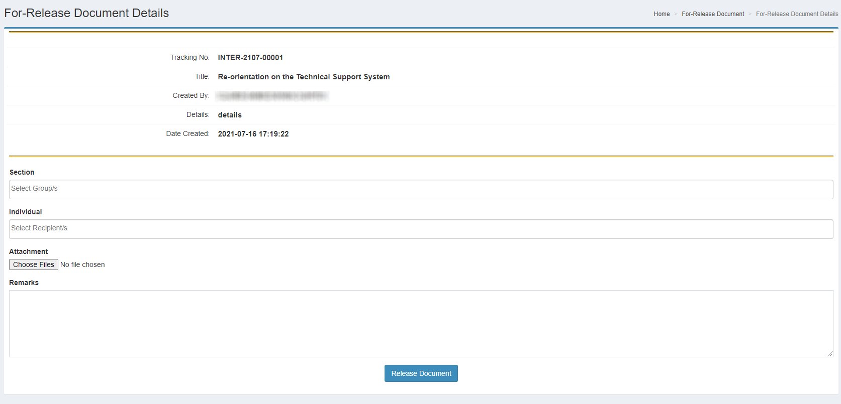

**5**

**Step**

**ASSIGN SECTION OR INDIVIDUAL TO SEND COPY OF THE DOCUMENT**

Select **Section/s** in the dropdown list where the document will be sent

Select **Individual/s** in the dropdown list where the document will be sent

Attach the document to be sent

Click **Release Document** to send the document to the chosen section/s or individual/s

Write any instructions or notes pertaining to the document

**Tracking No. Legend:**

Sample: INTER-2107-00001

WWW-YYMM-ZZZZ

**YY**

**WWW**

Type of document to be released”

INTER – Internal Document

INC – Incoming Document

OUT – Outgoing Document

Service complete

**Note:** You can select as many Sections and/or Individual as needed.

Maximum file attachment is 10, maximum size is 32MB

Running Number

**ZZZZ**

Month

**MM**

Year

**1**

**Step**

**CHECKING HISTORY OF DOCUMENT**

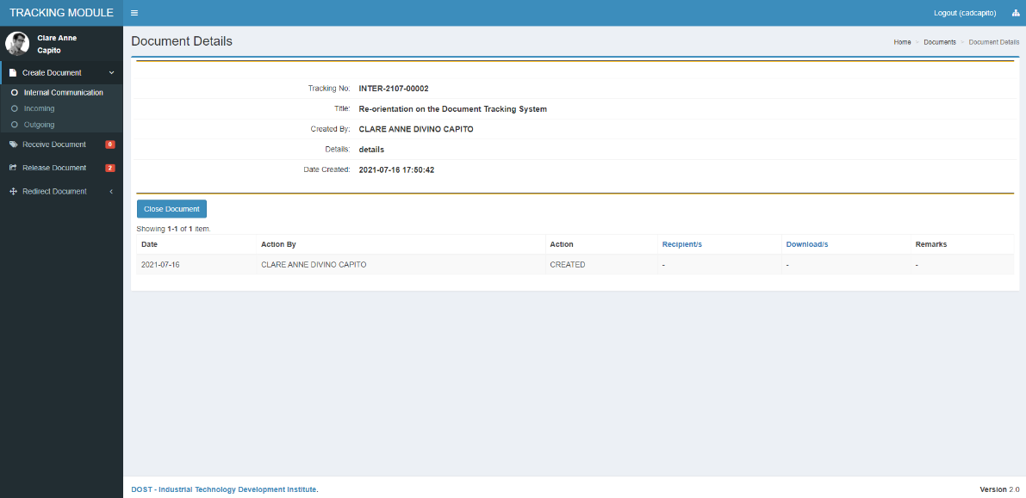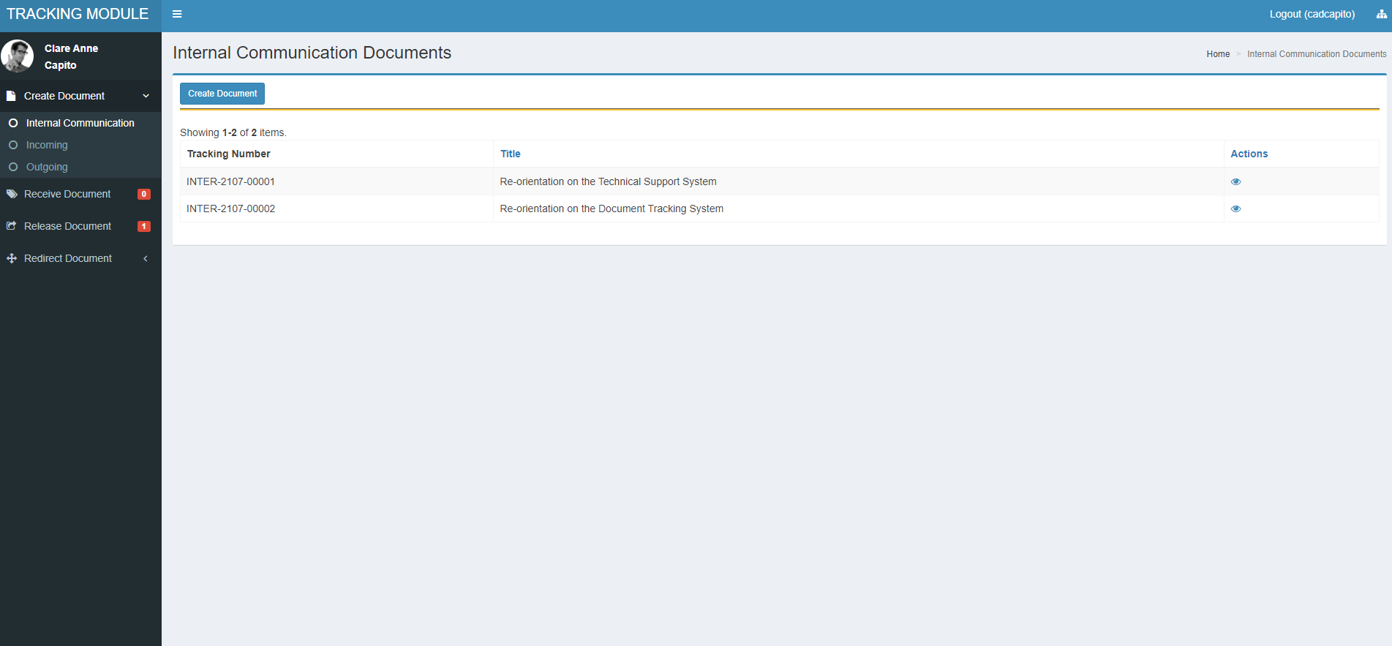

*Refer to Create Document Step3 for more detailed representation*

Click **Eye Icon** to **view details**

Table list of all created/received documents

Click any of the three document type to view all documents created and received of respective type

**2**

**Step**

**CHECK STATUS OF THE DOCUMENT IF ALREADY RECEIVED**

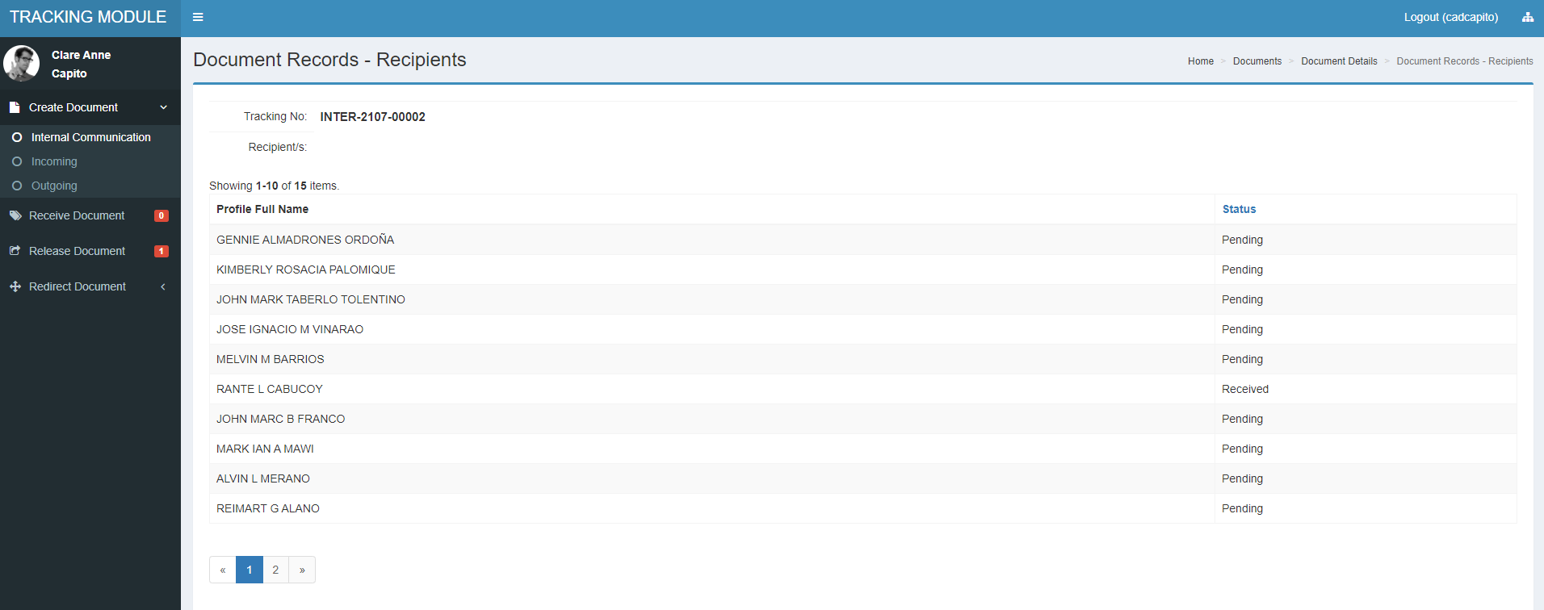

Status if not yet received

Status of document if already received

**1**

**Step**

**RECEIVING DOCUMENT**

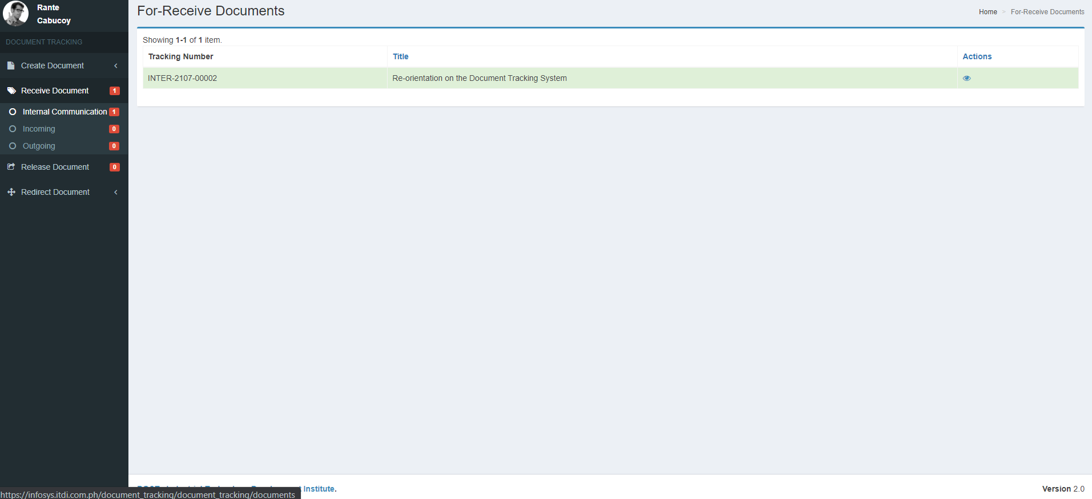

**View document for-receive**

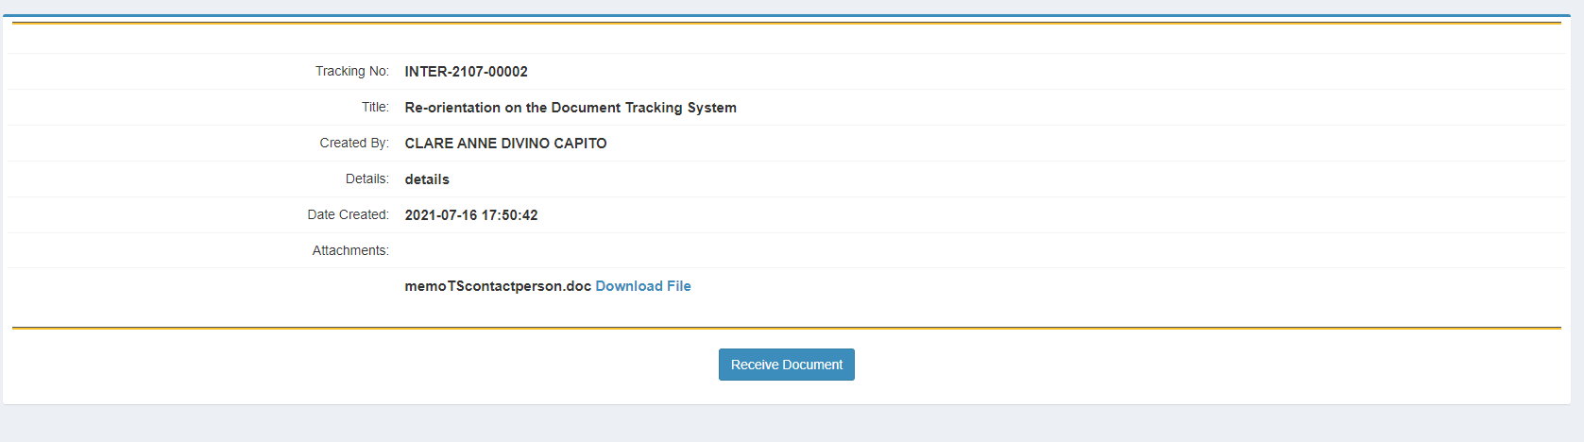

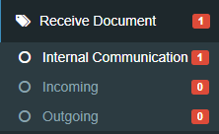

Click **Button** to receive document

Click any of the three document type to view all for receive document of respective type

The number indicates how many files are still new/unviewed