Lecture 6: R functions

Rachael McVicar

1/24/2020

## Section 1: Improving analysis code by writing functions

let’s insert a code chunk with the shortcut Option-CMD-i

plot(1:5, col="blue", type="o")

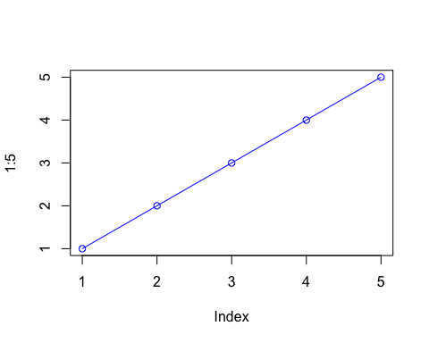

x<- (1:10)  
x

## [1] 1 2 3 4 5 6 7 8 9 10

## More on reading input files

We will use the read.table() function again

read.table("test1.txt", header=TRUE, sep= ",")

## Col1 Col2 Col3  
## 1 1 2 3  
## 2 4 5 6  
## 3 7 8 9  
## 4 a b c

read.table("test2.txt", header=TRUE, sep="$")

## Col1 Col2 Col3  
## 1 1 2 3  
## 2 4 5 6  
## 3 7 8 9  
## 4 a b c

read.table("test3.txt")

## V1 V2 V3  
## 1 1 6 a  
## 2 2 7 b  
## 3 3 8 c  
## 4 4 9 d  
## 5 5 10 e

### back after break

### ‘R’ first function (coding puns woooooo)

This is an example function named add with input x and y

add <- function(x, y=1) {  
 # Sum the input x and y  
 x + y  
}

let’s try using it

add(x=c(1,6,2), 4)

## [1] 5 10 6

#2nd function wooo A 2nd function to re-scale data to lie between 0 and 1

rescale <- function(x) {  
 rng <-range(x)  
 (x - rng[1]) / (rng[2] - rng[1])  
}

Lets test this function

rescale(c(1:10,30,100))

## [1] 0.00000000 0.01010101 0.02020202 0.03030303 0.04040404 0.05050505  
## [7] 0.06060606 0.07070707 0.08080808 0.09090909 0.29292929 1.00000000

rescale(c(1:10, NA))

## [1] NA NA NA NA NA NA NA NA NA NA NA

x<- c(1:10, NA)  
rescale(c(1:10, NA))

## [1] NA NA NA NA NA NA NA NA NA NA NA

rng <- (range(x, na.rm=TRUE))

Fix for missing values NAs

rescale2<- function(x) {  
rng <- (range(x, na.rm=TRUE))  
 (x - rng[1]) / (rng[2] - rng[1])  
}

rescale2(c(1:10, NA))

## [1] 0.0000000 0.1111111 0.2222222 0.3333333 0.4444444 0.5555556 0.6666667  
## [8] 0.7777778 0.8888889 1.0000000 NA

Taking things a bit too far…. :b

rescale3 <- function(x, na.rm=TRUE, plot=FALSE) {  
 if(na.rm) {  
 rng <-range(x, na.rm=na.rm)  
 } else {  
 rng <-range(x)  
 }  
 print("Hello")  
 answer <- (x - rng[1]) / (rng[2] - rng[1])  
 print("is it me you are looking for?")  
 if(plot) {  
 plot(answer, typ="b", lwd=4)  
 }  
 print("I can see it in ...")  
}

rescale3(x, plot=TRUE)

## [1] "Hello"  
## [1] "is it me you are looking for?"

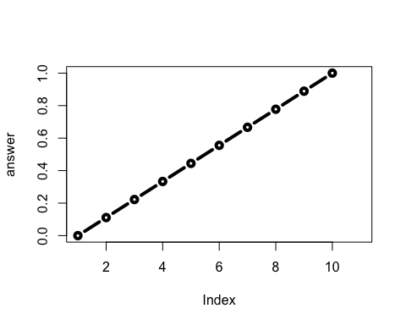

## [1] "I can see it in ..."

## Section 2: Writing and calling a function