The IAE Foundational Paper: A Framework for Modular and Scalable AI Agents
Authors: [Your Name/Team] Version: 1.0 Date: [Date]

Abstract
The rapid evolution of AI, particularly Large Language Models (LLMs), has created a demand for robust architectural patterns for building sophisticated AI agents. This paper introduces the Intelligent Agent Ecosystem (IAE) framework, a comprehensive approach for designing, building, and managing complex AI agents. IAE is founded on the “MAD” (Model-Action-Decision) architecture, which separates cognitive processes from execution. We define four core disciplines—Intelligent Context Curation & Management (ICCM), Intelligent Decision Engineering (IDE), Intelligent Execution & Evaluation (IEE), and Intelligent Agent Engineering (IAE)—that form a quaternary structure for agent development. The framework is unified by five canonical data contracts, ensuring interoperability and modularity. Finally, we introduce the concept of “Half-MADs,” reusable, specialized capabilities that can be composed into full agents, fostering a scalable and collaborative ecosystem. This paper provides the foundational principles and specifications for the IAE framework, aiming to standardize and accelerate the development of next-generation AI agents.

1. Introduction

1.1. Motivation
The proliferation of powerful LLMs has unlocked unprecedented potential for autonomous and semi-autonomous AI agents. However, building these agents often involves monolithic, tightly-coupled codebases that are difficult to maintain, scale, and debug. As agent capabilities grow, so does their complexity. There is a pressing need for a structured, disciplined architectural framework that promotes modularity, reusability, and clear separation of concerns. The IAE framework is our proposed solution to this challenge.

1.2. Core Insight: Separation of Cognition from Action
The cornerstone of the IAE framework is the MAD (Model-Action-Decision) architecture, which mandates a strict separation between the “Thinking Engine” and the “Doing Engine.”
- The Thinking Engine is responsible for all cognitive tasks: understanding context, reasoning, evaluating options, and making decisions.
- The Doing Engine is responsible for executing the decisions made by the Thinking Engine. It interacts with external tools, APIs, and environments, and reports the outcomes.
This separation allows for independent development, testing, and optimization of cognitive and execution components. A central State Manager maintains the agent’s memory and history, providing a shared source of truth for all components.
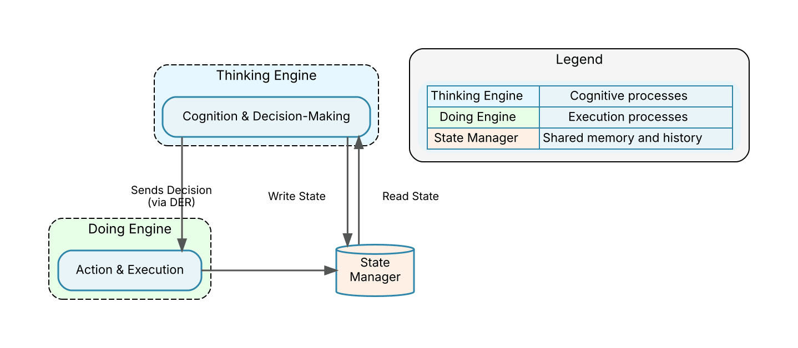
Figure 1: The MAD Architecture. The Thinking Engine and Doing Engine operate independently, coordinated through the State Manager.

2. The Four Disciplines of IAE
To operationalize the MAD architecture, we define four distinct but interrelated engineering disciplines. These disciplines provide a structured approach to building and managing the components of a full agent.

2.1. The Quaternary Structure
The four disciplines—ICCM, IDE, IEE, and IAE—collectively form the quaternary structure of a “Full MAD” agent. Each discipline contributes a critical piece of the agent’s overall functionality, with IAE serving as the integration layer.
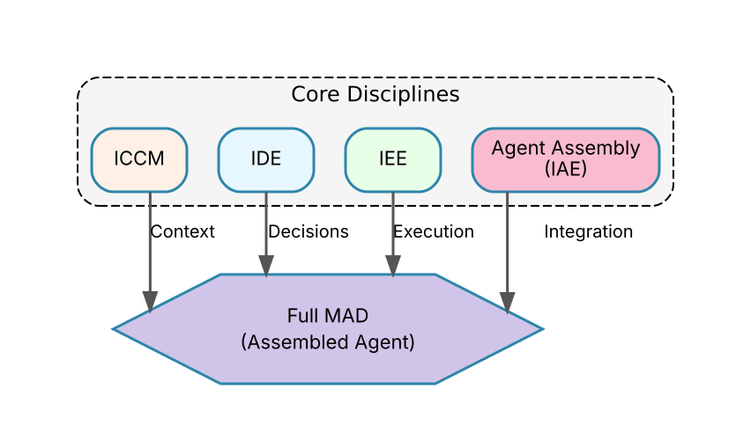
Figure 2: The Quaternary Structure. The four core disciplines contribute specialized capabilities to assemble a Full MAD agent.

2.2. The Disciplines
- Intelligent Context Curation & Management (ICCM): This discipline focuses on building the “awareness” of the agent. It involves gathering, processing, and structuring information from various sources (user input, documents, system state) into a coherent context that the Thinking Engine can understand.
- Intelligent Decision Engineering (IDE): IDE is the core of the Thinking Engine. This discipline involves designing the agent’s reasoning processes. This includes prompt engineering, rule-based systems, fine-tuning models, and chaining cognitive steps to arrive at a well-formed decision.
- Intelligent Execution & Evaluation (IEE): IEE governs the Doing Engine. It focuses on reliably executing the agent’s decisions by interacting with tools, APIs, and other systems. A key part of IEE is evaluating the outcome of actions and translating them into structured feedback for the State Manager.
- Intelligent Agent Engineering (IAE): IAE is the discipline of assembly and orchestration. It involves integrating the components from the other three disciplines, managing the agent’s state, and defining the overall operational feedback loop that allows the agent to learn and improve over time.

2.3. The State Manager
The State Manager is the persistent memory and central nervous system of the agent. It is not just a database; it is an active component that tracks conversation history, tool outputs, user feedback, and internal reasoning traces. All disciplines interact with the State Manager to read the current state and write updates, ensuring a consistent and shared understanding of the agent’s world.

2.4. Operational Feedback Loop
The IAE framework is designed for continuous improvement. The operational feedback loop is a six-stage process that enables an agent to learn from its actions and refine its future decisions. The stages are: 1) Decision, 2) Action, 3) Observation, 4) State Update, 5) Context Refresh, and 6) Better Decision. This cycle ensures that every action provides feedback that can be incorporated into the agent’s context, leading to more informed and effective decisions over time.
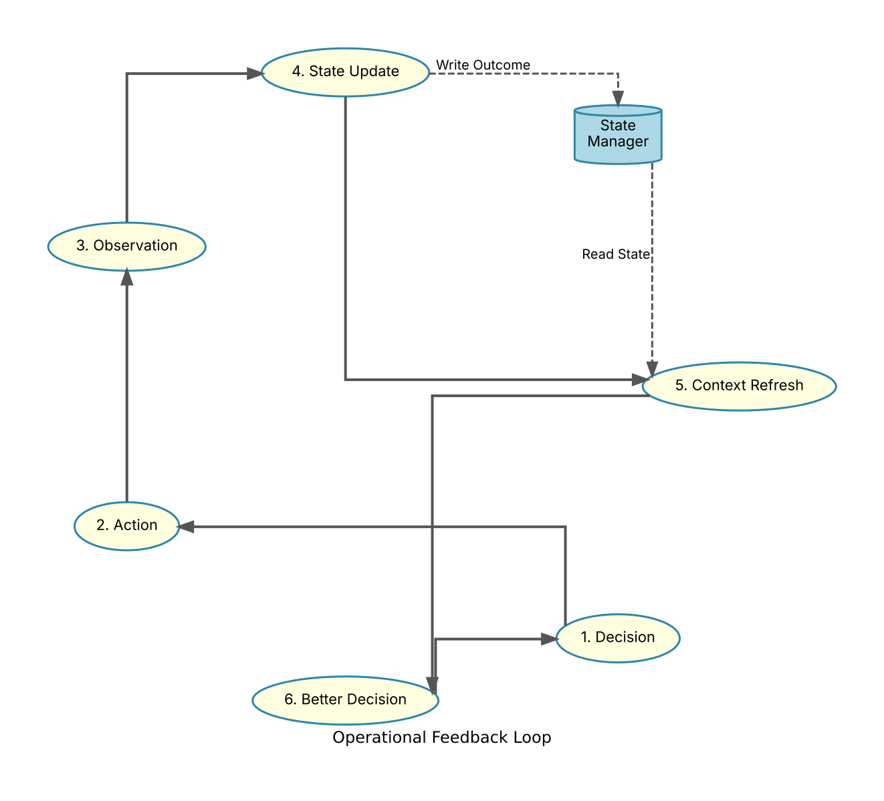
Figure 3: The Operational Feedback Loop. The agent continuously improves by cycling through decision, action, observation, and context refinement, with the State Manager mediating state.

3. Canonical Contracts
To ensure modularity and interoperability, the IAE framework defines five canonical data contracts. These are standardized data structures that govern the flow of information between the different components and disciplines of an agent.

3.1. The Five Contracts
- Structured Context (SC): The output of ICCM. A well-defined data structure (e.g., a JSON object) that represents all the information the agent needs to make a decision.
- Rule Engine Output (REO): The internal output of the IDE’s rule engine, which informs the final decision-making process.
- Decision & Execution Request (DER): The output of IDE. It contains the final decision and a clear, machine-readable request for the Doing Engine to execute an action.
- Execution Outcome (EO): The output of IEE. It provides a structured report on the result of an action, including success/failure status, outputs, and any errors.
- Reasoning Trace (RT): An audit trail produced by both IDE and IEE. It logs the intermediate steps, thoughts, and tool calls, providing transparency and enabling debugging.

3.2. Data Flow
These contracts create a predictable data pipeline, flowing from context curation to decision-making to execution, with the reasoning trace providing an observational layer throughout.
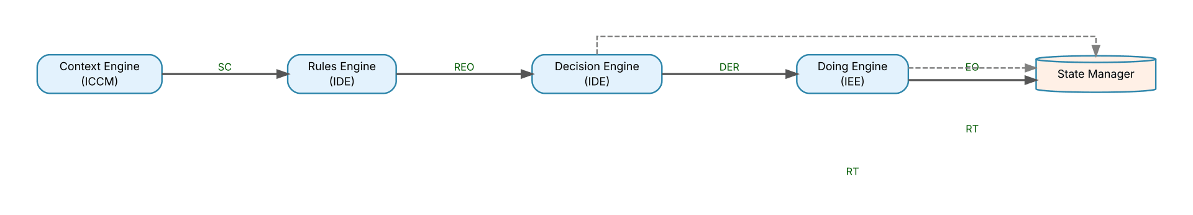
Figure 4: Canonical Contracts Data Flow. Standardized contracts ensure a clean and predictable flow of information between agent components.

4. Half-MADs: Reusable Capabilities
While a “Full MAD” represents a complete, autonomous agent, not all capabilities need to be implemented as such. We introduce the concept of “Half-MADs”: specialized, reusable services that perform a specific function within the Thinking or Doing domain.
A Half-MAD is an agent-like service that exposes its capabilities through a standardized communication interface (e.g., an API conforming to a “Conversation Protocol”). They are “half” because they typically focus on either a cognitive task (like summarizing a document) or an execution task (like managing a calendar) but do not constitute a complete, self-contained agent.
Full MADs can delegate tasks to Half-MADs, allowing for the creation of a rich ecosystem of interoperable capabilities. This promotes reuse, reduces development time, and allows teams to build and share specialized components. We have identified seven foundational Half-MADs:
- Conversation Services: Dewey (documentation), Godot (waiting for external events), Marco (search), LLM Conductor.
- Artifact Services: Horace (long-running tasks), Gates (access control), Playfair (diagramming).
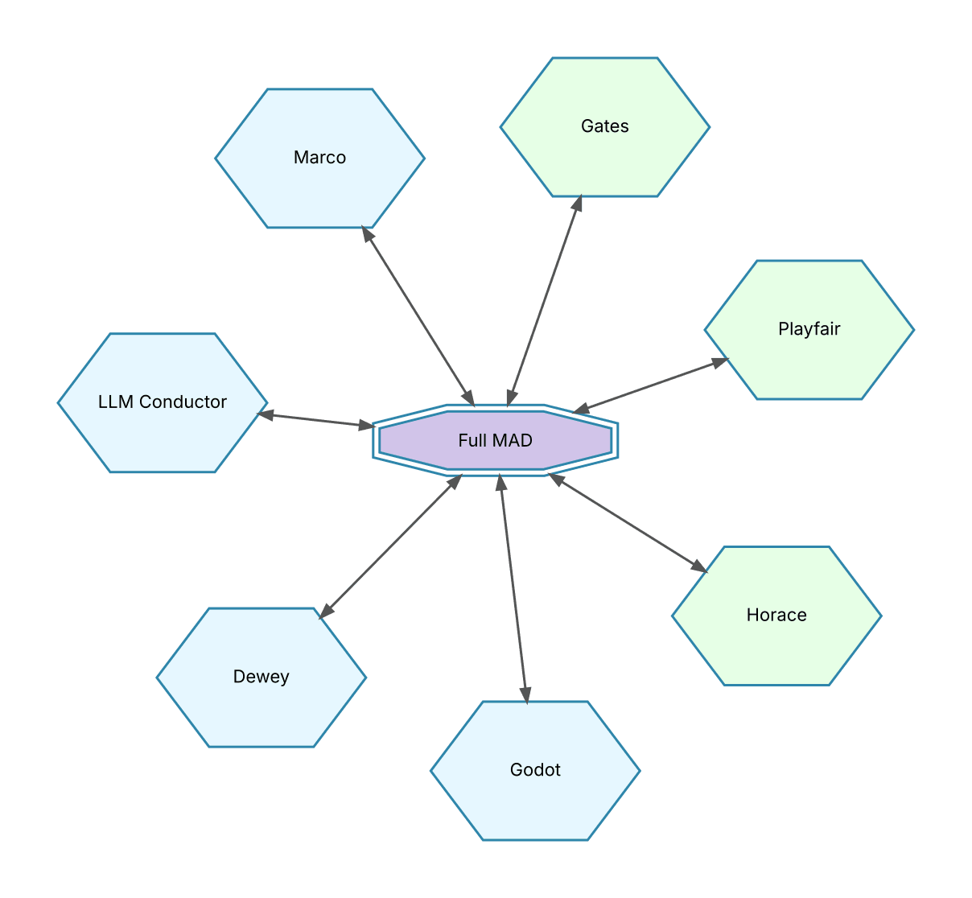
Figure 5: Half-MADs Ecosystem. A Full MAD agent can leverage a suite of specialized Half-MADs for various cognitive and execution tasks.

5. Conclusion
The Intelligent Agent Ecosystem (IAE) framework provides a disciplined, modular, and scalable approach to designing and building complex AI agents. By enforcing the separation of cognition and action through the MAD architecture, defining clear engineering disciplines, standardizing data flow with canonical contracts, and fostering reusability with Half-MADs, IAE aims to bring structure and robustness to the rapidly evolving field of AI agent development. This foundational paper serves as the starting point for a comprehensive set of standards and best practices that we believe will empower developers to build the next generation of intelligent systems.

