MACHINE LEARNING

***PROJECT REPORT***

Student’s Name – Megha R

PGP-DSBA

|  |  |  |
| --- | --- | --- |
| **1** | **Problem 1:** | **3** |
| 1.1 | Read the dataset. Do the descriptive statistics anddo the null value condition check. Write an  inference on it. | 3 |
| 1.2 | Perform Univariate and Bivariate Analysis. Do exploratory data analysis. Check for Outliers. | 5 |
| 1.3 | Encode the data (having string values) for  Modelling. Is Scaling necessary here or not? DataSplit: Split the data into train and test (70:30). | 29 |
| 1.4 | Apply Logistic Regression and LDA (linear discriminant analysis). | 31 |
| 1.5 | Apply KNN Model and Naïve Bayes Model. Interpret the results. | 34 |
| 1.6 | Model Tuning, Bagging (Random Forest should be applied for Bagging), and Boosting. | 37 |
| 1.7 | Performance Metrics: Check the performance of Predictions on Train and Test sets using Accuracy, Confusion Matrix, Plot ROC curve and get ROC_AUC score for each model. Final Model: Compare the models and write inference which  model is best/optimized. | 50 |
| 1.8 | Based on these predictions, what are the insights? | 98 |
| **2** | **Problem 2:** | **100** |
| 2.1 | Find the number of characters, words, and sentences for the mentioned documents. | 100 |
| 2.2 | Remove all the stopwords from all three speeches. | 101 |
| 2.3 | Which word occurs the most number of times in his  inaugural address for each president? Mention thetop three words. (after removing the stopwords) | 102 |
| 2.4 | Plot the word cloud of each of the speeches of the variable. (after removing the stopwords) | 103 |

# Problem 1:

You are hired by one of the leading news channels CNBE who wants to analyze recent elections. This survey was conducted on 1525 voters with 9 variables. You have to build a model, to predict which party a voter will vote for on the basis of the given information, to create an exit poll that will help in predicting overall win and seats covered by a particular party.

* 1. **Read the dataset. Do the descriptive statisticsand do the null value condition check. Write an inference on it.**

**Data Information:**

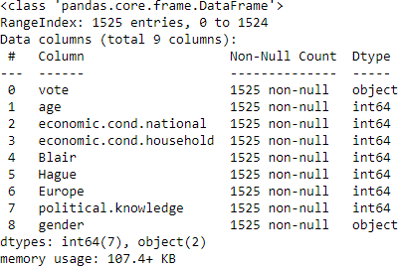

# Observation:

* + - We have dropped the 'unnamed' column from the datasetas it is not useful for our study.
    - The dataset had 8 duplicated values. So, we are droppedthem.
    - The data set had 1525 rows and 9 columns. After dropping the duplicate values, there are 1517 rows and 9columns.
    - It has 7 numerical data types and 2 categorical data types.
    - There is no null value in any column.

# Checking for missing values:

There are no missing values.

# Checking for duplicated values:

There are 8 duplicated values. So, we are dropping them.

# Data description:

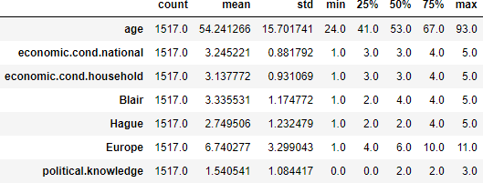

**Checking the skewness of the data:**

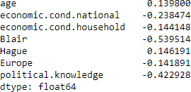

# The rule of thumb of skewness seems to be:

* + - If the skewness is between -0.5 and 0.5, the data arefairly symmetrical.
    - If the skewness is between -1 and – 0.5 or between 0.5and 1, the data are moderately skewed.
    - If the skewness is less than -1 or greater than 1, the dataare highly skewed.

# Insights:

* + - Here, we can see that there isn't much skewness in thedata. All the values seems to be between -0.5 and 0.5.
    - The value of 'Blair' is a little bit higher than -0.5.
    - The data overall, is fairly symmetrical.

# 1.2) Perform Univariate and Bivariate Analysis. Do exploratory data analysis. Check for Outliers.

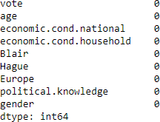**Exploratory Data Analysis: Null value check:**

There are no null values present in the data.

# Data types:

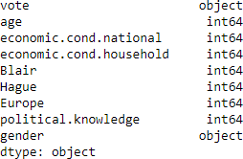

There are 7 numerical and 2 categorical data types in the data.

# Shape of the data:

There are 1517 rows and 9 columns in the data.

# Univariate Analysis: Description of 'age':

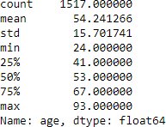

**Histogram and box plot of 'age':**

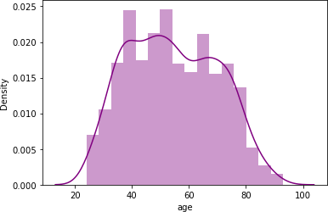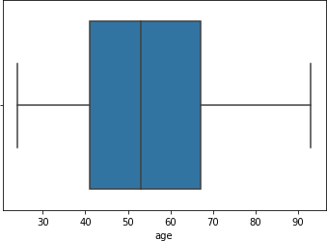

# Observation:

* The data is normally distributed.
* Maximum number of people are aged between 40 and 70.
* Outliers are not present.
* The minimum value is 24 and the maximum value is 93.
* The mean value is 54.241266

# Count plot of 'vote':

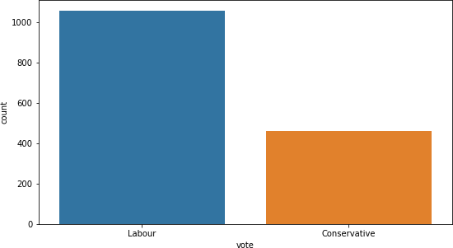

**Viewing the exact values of the variables of 'vote':**

# Observation:

* Labour party has higher number of votes. It has morethan double the votes of conservative party.
* Labour party has 1057 votes.
* Conservative party has 460 votes.

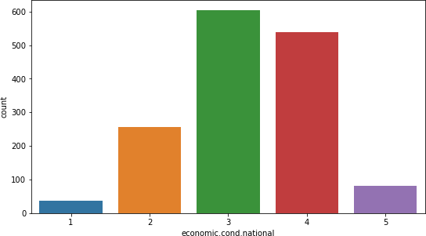

# Count plot of 'economic.cond.national':

**Viewing the exact values of the variables of 'economic.cond.national':**

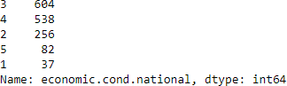

# Mean of 'economic.cond.national':



**Observation:**

* The top 2 variables are 3 and 4.
* 1 has the least value which is 37.
* 3 has the highest value which is 604.
* 3 is slightly higher than the 2nd highest variable 4 whosevalue is 538.
* The average score of 'economic.cond.national' is 3.245221

# Count plot of 'economic.cond.household':

**Viewing the exact values of the variables of 'economic.cond.household':**

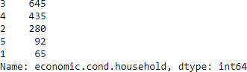

# Mean of 'economic.cond.household':



**Observation:**

* The top 2 variables are 3 and 4.
* 1 has the least value which is 65.
* 3 has the highest value which is 645.
* 3 is moderately higher than the 2nd highest variable 4whose value is 435.
* The average score of 'economic.cond.household' is 3.137772

# Count plot of 'Blair':

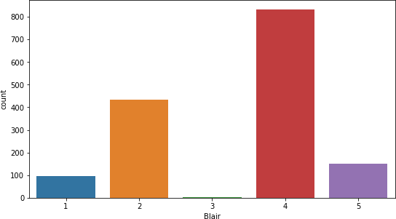**Viewing the exact values of the variables of 'Blair':**

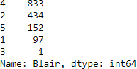

# Mean of 'Blair':



**Observation:**

* The top 2 variables are 2 and 4.
* 3 has the least value which is 1.
* 4 has the highest value which is 833.
* 4 is much higher than the 2nd highest variable 2 whosevalue is 434.
* The average score of 'Blair' is 3.335531

# Count plot of 'Hague':

**Viewing the exact values of the variables of 'Hague':**

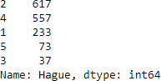

# Mean of 'Hague':



**Observation:**

* The top 2 variables are 2 and 4.
* 3 has the least value which is 37.
* 2 has the highest value which is 617.
* 2 is slightly higher than the 2nd highest variable 4 whosevalue is 557.
* The average score of 'Blair' is 2.749506

# Count plot of 'Europe':

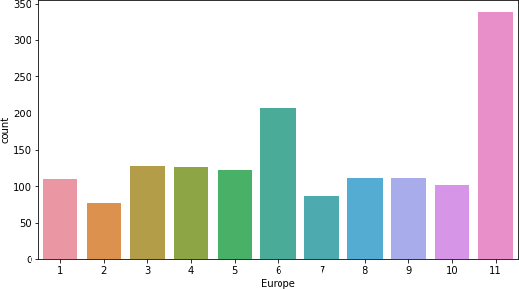

**Viewing the exact values of the variables of 'Europe':**

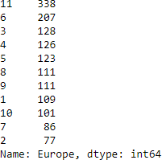

# Mean of 'Europe':



**Observation:**

* The top 2 variables are 11 and 6.
* 2 has the least value which is 77.
* 11 has the highest value which is 338.
* 11 is moderately higher than the 2nd highest variable 6whose value is 207.
* The average score of 'Europe' is 6.740277

# Count plot of 'political.knowledge':

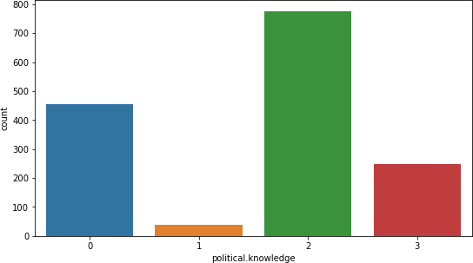

**Viewing the exact values of the variables of 'political.knowledge':**

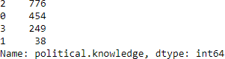

# Mean of 'Europe':



**Observation:**

* The top 2 variables are 2 and 0.
* 1 has the least value which is 38.
* 2 has the highest value which is 776.
* 2 is much higher than the 2nd highest variable 0 whose value is 454.
* We can see that, 454 out of 1517 people do not have any knowledge of parties' positions on European integration which is 29.93% of the total population.
* The average score of 'Europe' is 6.740277

# Bivariate Analysis:

**Strip plot of 'vote' and 'age':**

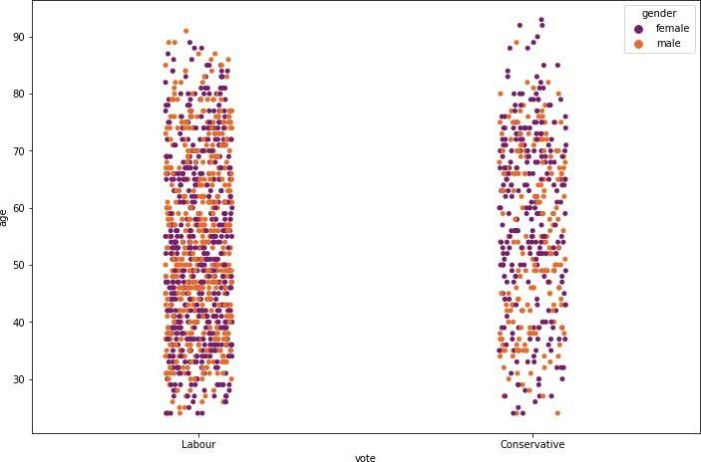

# Viewing the exact values of the variables of 'vote'with respect to 'gender':

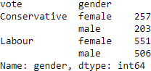

**Observation:**

* We can clearly see that, the labour party has got morevotes than the conservative party.
* In every age group, the labour party has got more votesthan the conservative party.
* Female votes are considerably higher than the male votesin both parties.
* In both genders, the labour party has got more votes thanthe conservative party.

# Strip plot of 'vote' and 'economic.cond.national':

**Viewing the exact values of the variables of 'vote'with respect to 'economic.cond.national':**

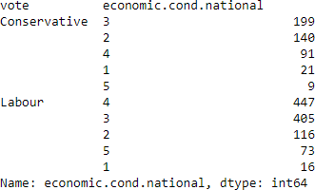

# Observation:

* Labour party has higher votes overall.
* Out of 82 people who gave a score of 5, 73 people have voted for the labour party.
* Out of 538 people who gave a score of 4, 447 people have voted for the labour party. This is the highest set of people in the labour party.
* Out of 604 people who gave a score of 3, 405 people have voted for the labour party. This is the 2nd highest set of people in the labour party. The remaining 199 people who have voted for the

conservative party is the highest set of people in that party.

* Out of 256 people who gave a score of 2, 116 people have voted for the labour party. 140 people have voted for the conservative

party. This is the instance where the conservative party has got more votes than the labourparty.

* Out of 37 people who gave a score of 1, 16 people have voted for the labour party. 21 people have voted for the conservative party.
* The score of 3, 4 and 5 have more votes in the labour party.
* The score of 1 and 2 have more votes in the conservativeparty.

# Strip plot of 'vote' and 'economic.cond.household':

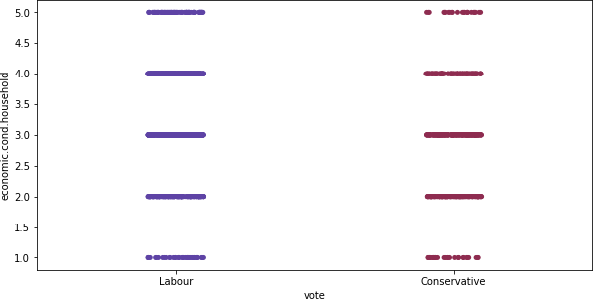

**Viewing the exact values of the variables of 'vote'with respect to 'economic.cond.household':**

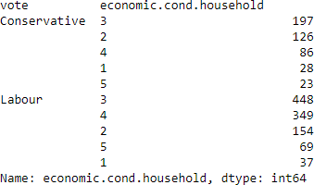

# Observation:

* Labour party has higher votes overall.
* Out of 92 people who gave a score of 5, 69 people have voted for the labour party.
* Out of 435 people who gave a score of 4, 349 people have voted for the labour party. This is the 2nd highest set of people in the labour party.
* Out of 645 people who gave a score of 3, 448 people have voted for the labour party. This is the highest set of people in the labour party. The remaining 197 people who have voted for the

conservative party is the highest set of people in that party.

* Out of 280 people who gave a score of 2, 154 people have voted for the labour party. 126 people have voted for the conservative party.
* Out of 65 people who gave a score of 1, 37 people have voted for the labour party. 28 people have voted for the conservative party.
* In all the instances, the labour party have more votes than the conservative party.

# Strip plot of 'vote' and 'Blair':

**Viewing the exact values of the variables of 'vote'with respect to 'Blair':**

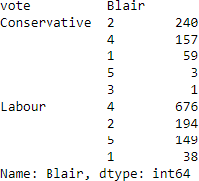

# Observation:

* Labour party has higher votes overall.
* Out of 152 people who gave a score of 5, 149 people have voted for the labour party. The remaining 3 people, despite giving a score of 5 to the labour leader, have chosen to vote for the

conservative party.

* Out of 833 people who gave a score of 4, 676 people have voted for the labour party. The remaining 157 people, despite giving a

score of 4 to the labour leader, have chosen to vote for the conservative party.

* Only 1 person has given a score of 3 and that person hasvoted for the conservative party.
* Out of 434 people who gave a score of 2, 240 people have voted for the conservative party. The remaining 194 people, despite

giving an unsatisfactory score of 2 to the labour leader, have chosen to vote for the labour party.

* Out of 97 people who gave a score of 1, 59 people have voted for the conservative party. The remaining 38 people, despite

giving the lowest score of 1 to the labourleader, have chosen to vote for the labour party.

* The score of 4 and 5 have more votes in the labour party.
* The score of 1, 2 and 3 have more votes in the conservative party.

# Strip plot of 'vote' and 'Hague':

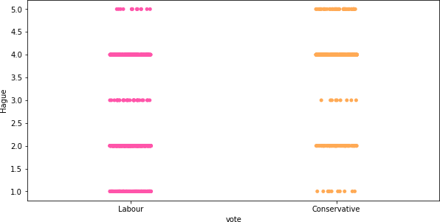

**Viewing the exact values of the variables of 'vote'with respect to 'Hague':**

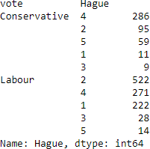

# Observation:

* Labour party has higher votes overall.
* Out of 73 people who gave a score of 5, 59 people have voted for the conservative party. The remaining 14people, despite giving

a score of 5 to the conservative leader, have chosen to vote for the labour party.

* Out of 557 people who gave a score of 4, 286 people have voted for the conservative party. The remaining 271

people, despite giving a score of 4 to the conservative leader, have chosen to vote for the labour party.

* Out of 37 people who gave a score of 3, 28 have voted for the labour party. The remaining 9, despite giving an average score

of 3 to the conservative party, have chosento vote for the conservative party.

* Out of 617 people who gave a score of 2, 522 people have voted for the labour party. The remaining 95 people, despite giving an unsatisfactory score of 2 to the conservative leader, have chosen to vote for the conservative party.
* Out of 233 people who gave a score of 1, 222 people havevoted for the labour party. The remaining 11 people,despite

giving the lowest score of 1 to the conservative leader, have chosen to vote for the conservative party.

* The score of 4 and 5 have more votes in the conservative party, although in 4, the votes are almost equal in boththe parties. Conservative party gets slightly higher.
* The score of 1, 2 and 3 have more votes in the labourparty. Still, a significant percentage of people who gave a bad score to the conservative leader still chose to vote for 'Hague'.

# Strip plot of 'vote' and 'Europe':

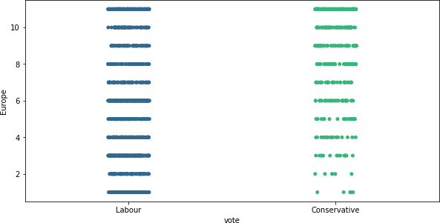

**Viewing the exact values of the variables of 'vote'with respect to 'Europe':**

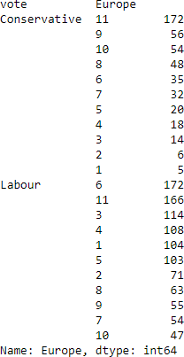

# Observation:

* Out of 338 people who gave a score of 11, 166 peoplehave voted for the labour party and 172 people have voted for the conservative party.
* People who gave score of 7 to 10 have voted for labourand conservative almost equally. Conservative party seem to be slightly higher in these instances.
* Out of 207 people who gave a score of 6, 172 people have voted for the labour party and 35 people have voted for the conservative party.
* People who gave a score of 1 to 6 have predominantly voted for the labour party. As we can see, there are a totalof 770 people who have given scores from 1 to 6. Out of 770 people,

672 people have voted for the labour party. So, 87.28% of the people have chosen labour party.

* So, we can infer that lower the 'Eurosceptic' sentiment, higher the votes for labour party.

# Strip plot of 'vote' and 'political.knowledge':

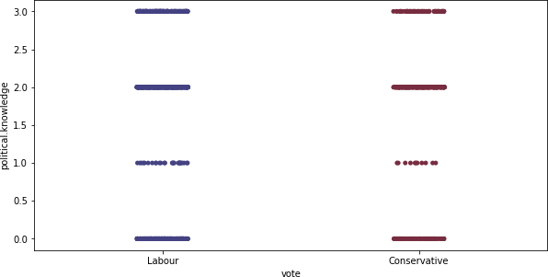

**Viewing the exact values of the variables of 'vote'with respect to 'political.knowledge':**

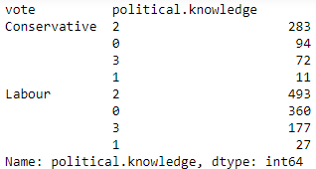

# Observation:

* Out of 249 people who gave a score of 3, 177 people have voted for the labour party and 72 people have voted for the conservative party.
* Out of 776 people who gave a score of 2, 493 people have voted for the labour party and 283 people have voted for the conservative party.
* Out of 38 people who gave a score of 1, 27 people have voted for the labour party and 11 people have voted for the conservative party.
* Out of 454 people who gave a score of 0, 360 people have voted for the labour party and 94 people have voted for the conservative party.
* We can see that, in all instances, labour party gets the higher number of votes.
* Out of 1517 people, 454 people gave a score of 0. So, this means that, 29.93% of the people are casting their votes without any political knowledge.

# Checking pair-wise distribution of the continuous variables:

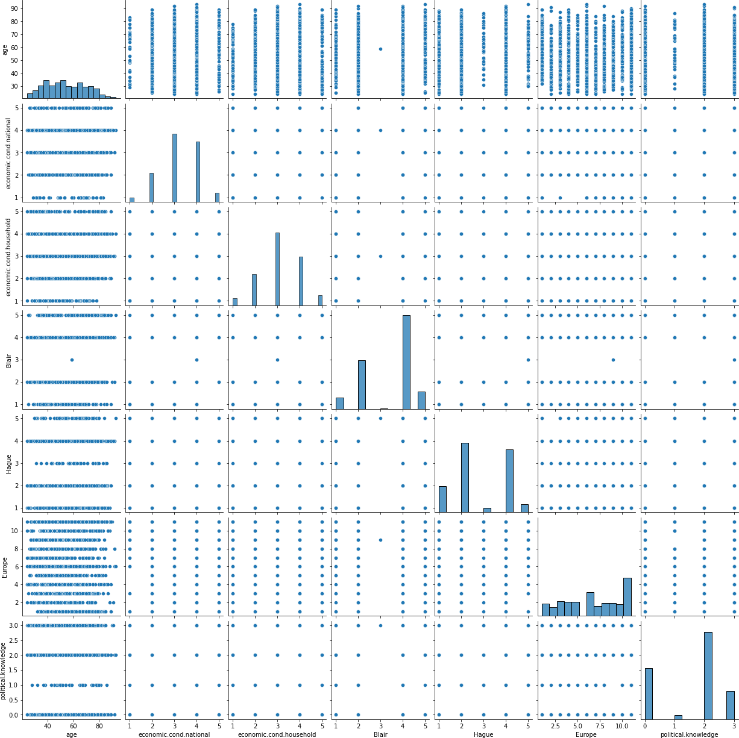

**Observation:**

* Pair plot is a combination of histograms and scatter plots.
* From the histogram, we can see that, the 'Blair','Europe'

and 'political.knowledge' variables are slightly left

skewed.

* All other variables seem to be normally distributed.
* From the scatter plots, we can see that, there is mostly no correlation between the variables.
* We can use the correlation matrix to view them moreclearly.

Correlation matrix is a table which shows the correlation coefficient between variables. Correlation values range from -1 to +1. For values closer to zero, it means that, there is no linear trend between two variables. Values close to 1 means that the correlation is positive.

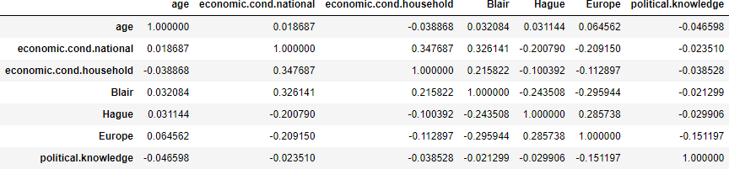

The correlation heat map helps us to visualize the correlation between two variables.

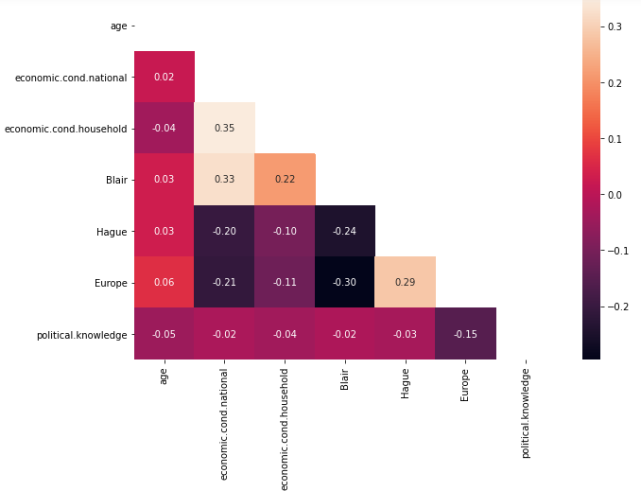

# Observation:

* We can see that, mostly there is no correlation in thedataset through this matrix. There are some variables that are moderately positively correlated and some thatare slightly negatively correlated.
* ‘economic.cond.national’ with ‘economic.cond.household’ have moderate positive correlation.
* ‘Blair' with 'economic.cond.national' and ‘economic.cond.household’ have moderate positive correlation.
* ‘Europe’ with ‘Hague’ have moderate positive correlation.
* 'Hague' with 'economic.cond.national' and 'Blair' have moderate negative correlation.
* 'Europe' with 'economic.cond.national' and 'Blair' have moderate negative correlation.
  1. **Encode the data (having string values) for Modelling. Is Scaling necessary here or not? Data Split: Split the data into train and test (70:30).**

**Viewing the data after encoding:**

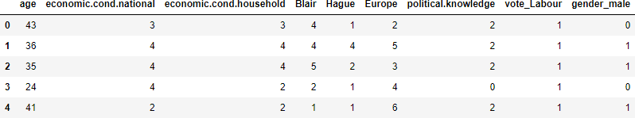

# Encoded data info:

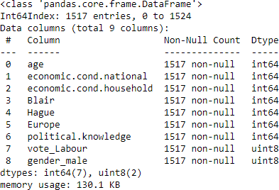

**Train-test-split:**

Our model will use all the variables and 'vote_Labour' is the target variable. The train-test split is a technique for evaluating the performance of a machine learning algorithm.The procedure involves taking a dataset and dividing it into two subsets.

* **Train Dataset:** Used to fit the machine learning model.
* **Test Dataset:** Used to evaluate the fit machine learning model.

The data is divided into 2 subsets, training and testing set. Earlier, we have extracted the target variable ‘vote_Labour’ ina separate vector for subsets. Random state chosen as 1.

* **Training Set:** 70percent of data.
* **Testing Set:** 30 percent of the data.

# Train-Test-Split Shape:

**Why scaling?:**

* The dataset contains features highly varying in magnitudes, units and range between the 'age' columnand other columns.
* But since, most of the machine learning algorithms use Eucledian distance between two data points in their computations, this is a problem.
* If left alone, these algorithms only take in the magnitude of features neglecting the units.
* The results would vary greatly between different units, 1km and 1000 metres.
* The features with high magnitudes will weigh in a lot more in the distance calculations than features with low magnitudes.
* To supress this effect, we need to bring all features to the same level of magnitudes. This can be acheived by scaling.
* in this case, we have a lot of encoded, ordinal, categorical and continuous variables. So, we use the minmaxscaler technique to scale the data.

# Viewing the data after scaling:

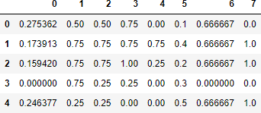

* 1. **Apply Logistic Regression and LDA (linear discriminant analysis).**

# Logistic Regression Model:

There are no outliers present in the continuous variable 'age'.The remaining variables are categorical in nature. Our modelwill use all the variables and 'vote_Labour' is the target variable.

# Accuracy - Train data:

**Accuracy - Test data:**



# Classification report - Train data:

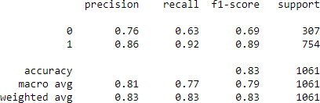

**Classification report - Test data:**

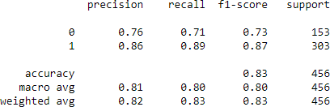

# Logistic Regression Model - ObservationTrain data:

* Accuracy: 83.41%
* Precision: 86%
* Recall: 92%
* F1-Score: 89%

# Test data:

* Accuracy: 82.68%
* Precision: 86%
* Recall: 89%
* F1-Score: 87%

# Validness of the model:

* The model is not over-fitted or under-fitted.
* The error in the test data is slightly higher than the train data, which is absolutely fine because the error margin is low and the error in both train and test data is not too high. Thus, the model is not over-fitted or under-fitted.

# Linear Discriminant Analysis Model:

There are no outliers present in the continuous variable 'age'.The remaining variables are categorical in nature. Our modelwill use all the variables and 'vote_Labour' is the target variable.

# Accuracy - Train data:

**Accuracy - Test data:**



# Classification report - Train data:

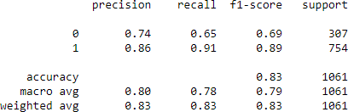

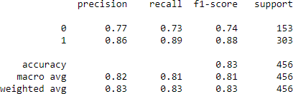**Classification report - Test data:**

# Linear Discriminant Analysis Model - Observation Train data:

* Accuracy: 83.41%
* Precision: 86%
* Recall: 91%
* F1-Score: 89%

# Test data:

* Accuracy: 83.33%
* Precision: 86%
* Recall: 89%
* F1-Score: 88%

# Validness of the model:

* The model is not over-fitted or under-fitted.
* The error in the test data is slightly higher than the train data, which is absolutely fine because the error margin is low and the

error in both train and test data is not too high. Thus, the model is not over-fitted or under-fitted.

# Apply KNN Model and Naïve Bayes Model. Interpret the results.

**K-Nearest Neighbor Model:**

There are no outliers present in the continuous variable 'age'.The remaining variables are categorical in nature. Our modelwill use all the variables and 'vote_Labour' is the target variable. We take K value as 7.

# Accuracy - Train data:

**Accuracy - Test data:**



# Classification report - Train data:

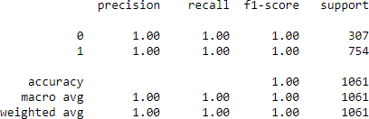

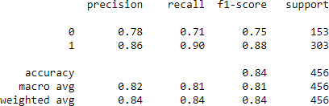**Classification report - Test data:**

# K-Nearest Neighbor Model - ObservationTrain data:

* Accuracy: 100%
* Precision: 100%
* Recall: 100%
* F1-Score: 100%

# Test data:

* Accuracy: 83.77%
* Precision: 86%
* Recall: 90%
* F1-Score: 88%

# Validness of the model:

* The model is over-fitted.
* As we can see, the train data has a 100% accuracy andtest data has 84% accuracy. The difference is more than 10%. So, we can infer that the KNN model is over-fitted.

# Naïve Bayes Model:

There are no outliers present in the continuous variable 'age'. The remaining variables are categorical in nature. Our model will use all the variables and 'vote_Labour' is the target variable.

# Accuracy - Train data:



**Accuracy - Test data:**



# Classification report - Train data:

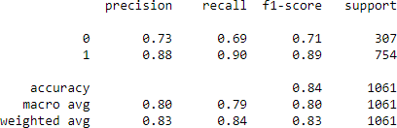

**Classification report - Test data:**

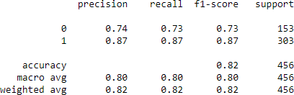

# Naïve Bayes Model - Observation Train data:

* Accuracy: 83.51%
* Precision: 88%
* Recall: 90%
* F1-Score: 89%

# Test data:

* Accuracy: 82.24%
* Precision: 87%
* Recall: 87%
* F1-Score: 87%

# Validness of the model:

* The model is not over-fitted or under-fitted.
* The error in the test data is slightly higher than the train data, which is absolutely fine because the error margin is low and the error in both train and test data is not too high. Thus, the model

is not over-fitted or under-fitted.

* 1. **Model Tuning, Bagging (Random Forest**

**should be applied for Bagging), and Boosting. Logistic Regression Model Tuning:**

# Best parameters:

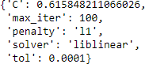

**Accuracy - Train data:**

# Accuracy - Test data:



**Classification report - Train data:**

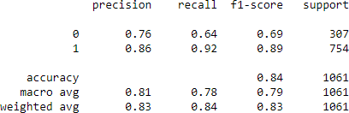

**Classification report - Test data.**

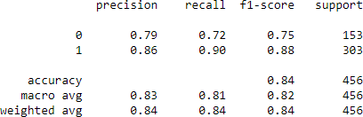

**Logistic Regression Model Tuned - Observation**

# Train data:

* Accuracy: 83.6%
* Precision: 86%
* Recall: 92%
* F1-Score: 89%

# Test data:

* Accuracy: 84.21%
* Precision: 86%
* Recall: 90%
* F1-Score: 88%

# Comparison on performance of both regular andtuned logistic regression models:

|  |  |  |
| --- | --- | --- |
|  | **Regular Model**  **(%)** | **Tuned Model (%)** |
| **Train:** |  |  |
| **Accuracy** | 83.41 | 83.6 |
| **Precision** | 86 | 86 |
| **Recall** | 92 | 92 |
| **F1-score** | 89 | 89 |
| **Test:** |  |  |
| **Accuracy** | 82.68 | 84.21 |
| **Precision** | 86 | 86 |
| **Recall** | 89 | 90 |
| **F1-score** | 87 | 88 |

* As we can see from the above tabular comparison, there is not much difference between the performance regular LR model and tuned LR model.
* The values are high overall and there is no over-fitting or under-fitting. Therefore both models are equally good

models.

# Linear Discriminant Analysis Model Tuning: Best parameters:

**Accuracy - Train data:**

# Accuracy - Test data:



**Classification report - Train data:**

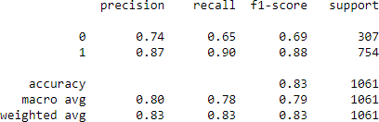

# Classification report - Test data:

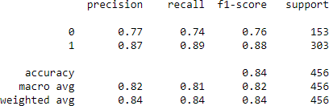

**LDA Model Tuned - Observation Train data:**

* Accuracy: 83.22%
* Precision: 87%
* Recall: 90%
* F1-Score: 88%

# Test data:

* Accuracy: 83.99%
* Precision: 87%
* Recall: 89%
* F1-Score: 88%

# Comparison on performance of both regular andtuned LDA models:

|  |  |  |
| --- | --- | --- |
|  | **Regular Model (%)** | **Tuned Model (%)** |
| **Train:** |  |  |
| **Accuracy** | 83.41 | 83.22 |
| **Precision** | 86 | 87 |
| **Recall** | 91 | 90 |
| **F1-score** | 89 | 88 |
| **Test:** |  |  |
| **Accuracy** | 83.33 | 83.99 |
| **Precision** | 86 | 87 |
| **Recall** | 89 | 89 |
| **F1-score** | 88 | 88 |

* As we can see from the above tabular comparison, thereis not much difference between the performance of regular LDA model and tuned LDA model.
* The values are high overall and there is no over-fitting or under-fitting. Therefore both models are equally good

models.

# K-Nearest Neighbour Model Tuning: Best parameters:



**Accuracy - Train data:**

# Accuracy - Test data:

**Classification report - Train data:**

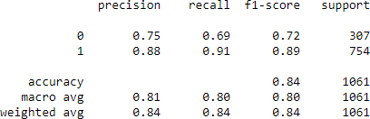

# Classification report - Test data:

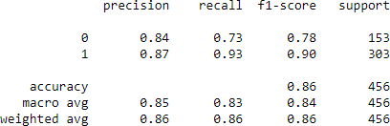**KNN Model Tuned - Observation Train data:**

* Accuracy: 84.35%
* Precision: 88%
* Recall: 91%
* F1-Score: 89%

# Test data:

* Accuracy: 86.18%
* Precision: 87%
* Recall: 93%
* F1-Score: 90%

# Comparison on performance of both regular andtuned KNN models:

|  |  |  |
| --- | --- | --- |
|  | **Regular Model (%)** | **Tuned Model (%)** |
| **Train:** |  |  |
| **Accuracy** | 100 | 84.35 |
| **Precision** | 100 | 88 |
| **Recall** | 100 | 91 |
| **F1-score** | 100 | 89 |
| **Test:** |  |  |
| **Accuracy** | 83.77 | 86.18 |
| **Precision** | 86 | 87 |
| **Recall** | 90 | 93 |
| **F1-score** | 88 | 90 |

* There is no over-fitting or under-fitting in the tuned KNNmodel. Overall, it is a good model.
* As we can see, the regular KNN model was over-fitted. But model tuning has helped the model to recover fromover- fitting.
* The values are better in the tuned KNN model.
* Therefore, the tuned KNN model is a better model.

# Ensemble Random Forest Classifier Feature importances:

* Here,
* 0 = age
* 1 = economic.cond.national
* 2 = economic.cond.household
* 3 = Blair
* 4 = Hague
* 5 = Europe
* 6 = political.knowledge
* 7 = gender_male

# Accuracy - Train data:



**Accuracy - Test data:**

# Classification report - Train data:



**Classification report - Test data:**

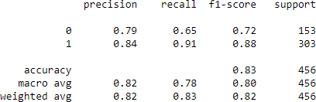

# Random Forest Classifier - Observation Train data:

* Accuracy: 100%
* Precision: 100%
* Recall: 100%
* F1-Score: 100%

# Test data:

* Accuracy: 82.68%
* Precision: 84%
* Recall: 91%
* F1-Score: 88%

The model is over-fitted. We will use bagging to improve the performance of the model.

# Ensemble technique - Bagging Accuracy - Train data:



**Accuracy - Test data:**



The RF model even after using bagging technique, is still over-fitted.

# Ensemble technique - AdaBoosting Accuracy - Train data:

**Accuracy - Test data:**



The model is not over-fitted. The values are good. Therefore,the model is a good model.

# Ensemble technique - Gradient Boosting Accuracy - Train data:



**Accuracy - Test data:**



The model is not over-fitted. The values are better than AdaBoosting model. The model is a good model.

# Random Forest model Tuning Best parameters:

**Bagging tuned: Accuracy - Train data:**



# Accuracy - Test data:

**Classification report - Train data:**

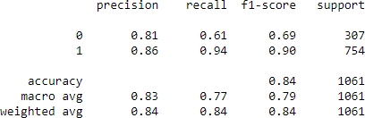

# Classification report - Test data:

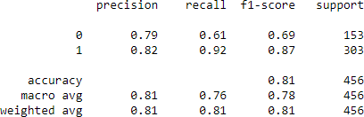

The tuning of the model has help the model recover from over-fitting. Now the model is a good model.

# Random Forest tuned - AdaBoosting Accuracy - Train data:

**Accuracy - Test data:**



# Classification Report - Train data:

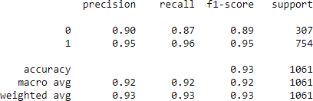**Classification Report - Test data:**

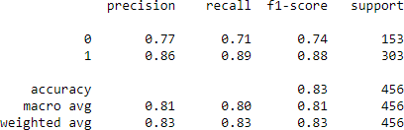

There is no over-fitting. There is improvement from the regularmodel. The model is a good model.

# Gradient Boosting Classifier Tuned Best parameters:

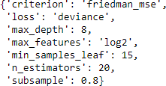

**Accuracy - Train data:**



# Accuracy - Test data:



**Classification Report - Train data:**

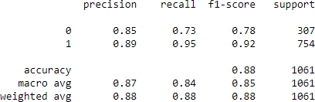

# Classification Report - Test data:

* The gradient boost classifier after tuning, has improvedthe model significantly.
* The difference between the train and test accuracies hasalso been reduced.
* Overall, the tuned Gradient Boost classifier is a better model.
  1. 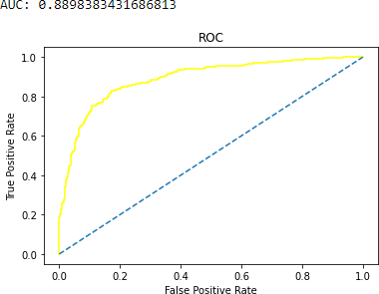**Performance Metrics: Check the performance of Predictions on Train and Test sets using Accuracy, Confusion Matrix, Plot ROC curve and get ROC_AUC score for each model. Final Model: Compare the models and write inference which model is best/optimized.**

**Logistic Regression Model - Regular: Predicted Class and probs:**

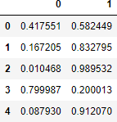

# Accuracy - Train:

**ROC and AUC - Train:**

# Accuracy - Test:

**ROC and AUC - Test:**

# Confusion matrix - Train:

**Classification report - Train:**



# Confusion matrix - Test:

**Classification report - Test:**



# Observation: Train data:

* Accuracy: 83.41%
* Precision: 86%
* Recall: 92%
* F1-Score: 89%
* AUC: 88.98%

# Test data:

* Accuracy: 82.68%
* Precision: 86%
* Recall: 89%
* F1-Score: 87%
* AUC: 88.4%

The model is not over-fitted or under-fitted. It is a good model. **Logistic Regression Model - Tuned:Predicted Class and probs:**

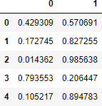

# Accuracy - Train:



**ROC and AUC - Train:**

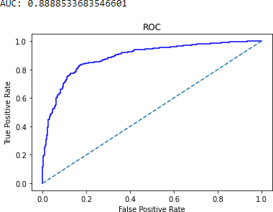

# Accuracy - Test:

**ROC and AUC - Test:**

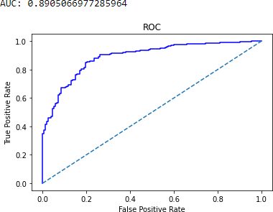

# Confusion matrix - Train:

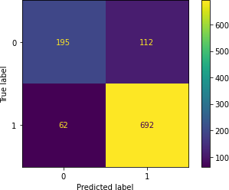

**Classification report - Train:**



# Confusion matrix - Test:

**Classification report - Test:**



# Observation: Train data:

* Accuracy: 83.6%
* Precision: 86%
* Recall: 92%
* F1-Score: 89%
* AUC: 88.89%

# Test data:

* Accuracy: 84.21%
* Precision: 86%
* Recall: 90%
* F1-Score: 88%
* AUC: 89.05%

# Comparison between the regular LR model and tuned LR model:

* As we can see, there is not much difference between the performance of regular LR model and tuned LR model.
* The values are high overall and there is no over-fitting orunder- fitting. Therefore both models are equally good models.

# LDA Model - Regular: Predicted Class and probs:

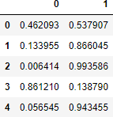

**Accuracy - Train:**



# Accuracy - Test:



**ROC and AUC - Train:**

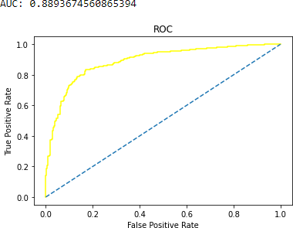

# ROC and AUC - Test:

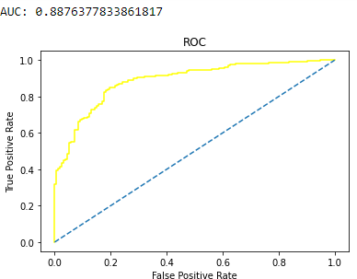

**Confusion matrix - Train:**

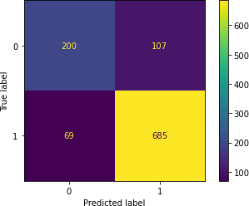

# Classification report - Train:

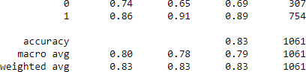

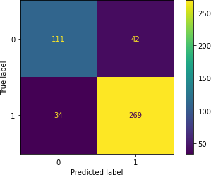**Confusion matrix - Test:**

# Classification report - Test:



**Observation:**

# Train data:

* Accuracy: 83.41%
* Precision: 86%
* Recall: 91%
* F1-Score: 89%
* AUC: 88.94%

# Test data:

* Accuracy: 83.33%
* Precision: 86%
* Recall: 89%
* F1-Score: 88%
* AUC: 88.76%

# Validness of the model:

* The model is not over-fitted or under-fitted.
* The error in the test data is slightly higher than the train data, which is absolutely fine because the error margin is low and the

error in both train and test data is not too high. Thus, the model is not over-fitted or under-fitted

# LDA Model - Tuned: Predicted Class and probs:

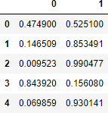

**Accuracy - Train:**



# ROC and AUC - Train:

**Accuracy - Test:**



# ROC and AUC - Test:

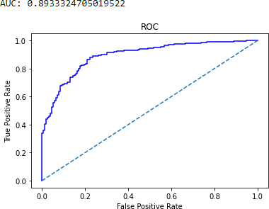

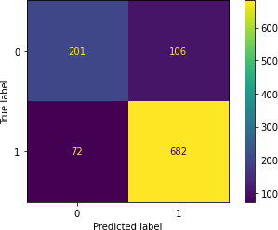**Confusion matrix - Train:**

# Classification report - Train:



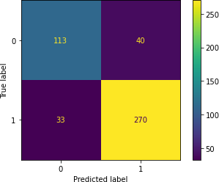**Confusion matrix - Test:**

# Classification report - Test:



**Observation:**

# Train data:

* Accuracy: 83.22%
* Precision: 87%
* Recall: 90%
* F1-Score: 88%
* AUC: 88.68%

# Test data:

* Accuracy: 83.99%
* Precision: 87%
* Recall: 89%
* F1-Score: 88%
* AUC: 89.33%

There is no over-fitting or under-fitting in the tuned LDAmodel. Overall, it is a good model.

# Comparison between the regular LDA model and tuned LDA model

* As we can see, there is not much difference between the performance of regular LDA model and tuned LDA model.
* The values are high overall and there is no over-fitting orunder- fitting.
* Therefore both models are equally good models.

# KNN Model - Regular: Predicted Class and probs:

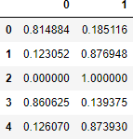

**Accuracy - Train:**

ROC and AUC - Train:

# Accuracy - Test:



**ROC and AUC - Test:**

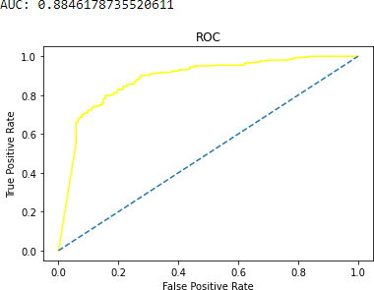

# Confusion matrix - Train:

**Classification report - Train:**



# Confusion matrix - Test:

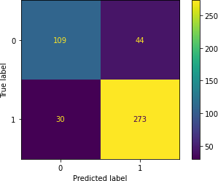**Classification report - Test:**



# Observation: Train data:

* Accuracy: 100%
* Precision: 100%
* Recall: 100%
* F1-Score: 100%
* AUC: 100%

# Test data:

* Accuracy: 83.77%
* Precision: 86%
* Recall: 90%
* F1-Score: 88%
* AUC: 88.46%

# Validness of the model

* The model is over-fitted.
* As we can see, the train data has a 100% accuracy andtest data has 84% accuracy. The difference is more than 10%. So, we can infer that the KNN model is over-fitted.

# KNN Model - Tuned: Predicted Class and probs:

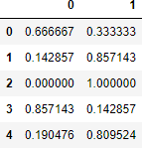

**Accuracy - Train:**



# Accuracy - Test:



**ROC and AUC - Train:**

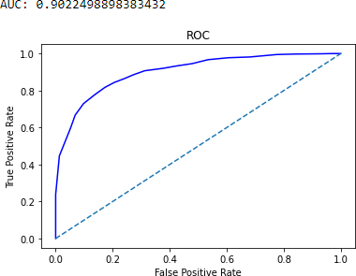

# ROC and AUC - Test:

**Confusion matrix - Train:**

# Classification report - Train:



**Confusion matrix - Test:**

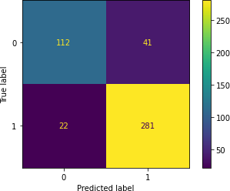

# Classification report - Test:



**Observation:**

# Train data:

* Accuracy: 84.35%
* Precision: 88%
* Recall: 91%
* F1-Score: 89%
* AUC: 90.23%

# Test data:

* Accuracy: 86.18%
* Precision: 87%
* Recall: 93%
* F1-Score: 90%
* AUC: 92.27%

There is no over-fitting or under-fitting in the tuned KNNmodel.

Overall, it is a good model.

* Comparison between the regular KNN model and tunedKNN model:
* As we can see, the regular KNN model was over-fitted.But model tuning has helped the model to recover from over-fitting.
* The values are better in the tuned KNN model.
* Therefore, the tuned KNN model is a better model.

# Naïve Bayes Model - Regular: Predicted Class and probs:

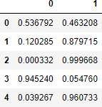

**Accuracy - Train:**

# ROC and AUC - Train:

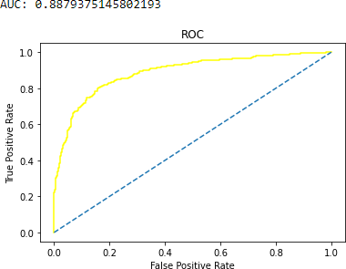

**Accuracy - Test:**

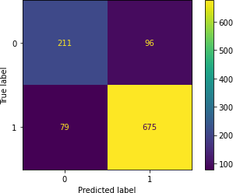

# ROC and AUC - Test:

**Confusion matrix - Train:**

# Classification report - Train:



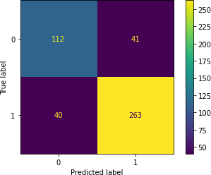**Confusion matrix - Test:**

# Classification report - Test:



**Observation:**

# Train data:

* Accuracy: 83.51%
* Precision: 88%
* Recall: 90%
* F1-Score: 89%AUC: 88.79%

# Test data:

* Accuracy: 82.24%
* Precision: 87%
* Recall: 87%
* F1-Score: 87%
* AUC: 87.64%

# Validness of the model

* The model is not over-fitted or under-fitted.
* The error in the test data is slightly higher than the train data, which is absolutely fine because the error margin is low and the

error in both train and test data is not too high. Thus, the model is not over-fitted or under-fitted.

* There is no hyper-parameters to tune in Naive Bayes model. So, we cannot tune this model.

# Ensemble Random Forest Classifier - Regular: Predicted Class and probs:

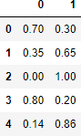

**Accuracy - Train:**



# ROC and AUC - Train:

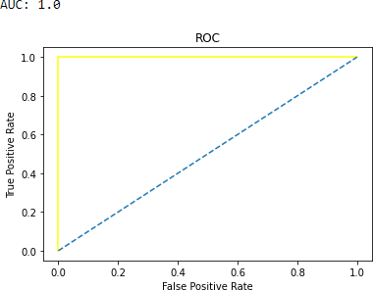

**Accuracy - Test:**



# ROC and AUC - Test:

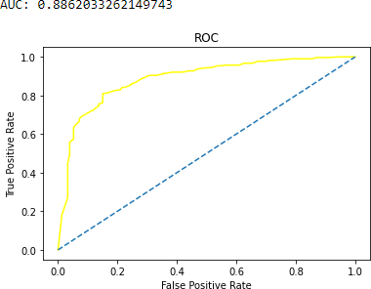

**Confusion matrix - Train:**

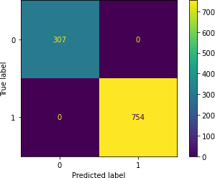

**Classification report - Train:**



# Confusion matrix - Test:

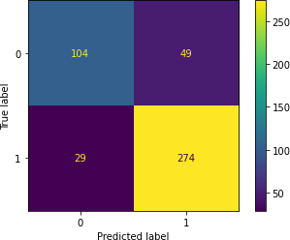

**Classification report - Test:**

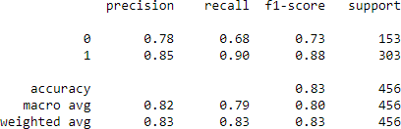

# Observation:

**Train data:**

* Accuracy: 100%
* Precision: 100%
* Recall: 100%
* F1-Score: 100%
* AUC: 100%

# Test data:

* Accuracy: 82.68%
* Precision: 84%
* Recall: 91%
* F1-Score: 88%
* AUC: 88.62%

The model is over-fitted. So we will use bagging to improve the performance of the model.

# Bagging - Regular: Predicted Class and probs:

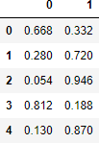

**Accuracy - Train:**



# ROC and AUC - Train:

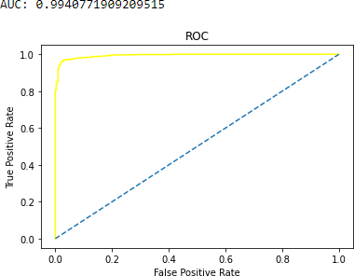

**Accuracy - Test:**

# ROC and AUC –

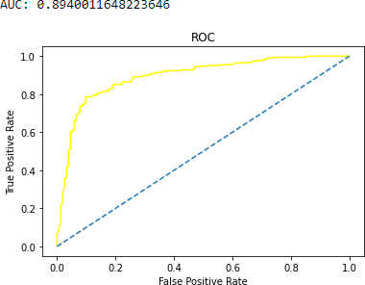

**Test:**

# Confusion matrix - Train:

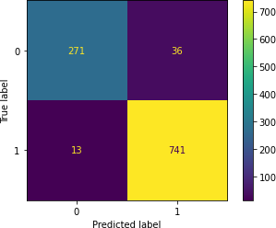

**Classification report - Train:**

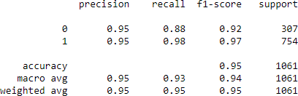

# Confusion matrix - Test:

**Classification report - Test:**

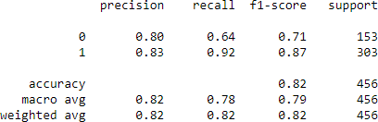

# Observation:

**Train data:**

* Accuracy: 95.38%
* Precision: 95%
* Recall: 98%
* F1-Score: 97%
* AUC: 99.4%

# Test data:

* Accuracy: 82.46%
* Precision: 83%
* Recall: 92%
* F1-Score: 87%
* AUC: 89.4%

After using bagging, the model is still over-fitted. The values are high. But the difference between the train and test accuracy is high.

# Bagging - Tuned: Predicted Class and probs:

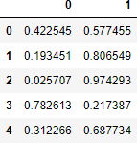

**Accuracy - Train:**

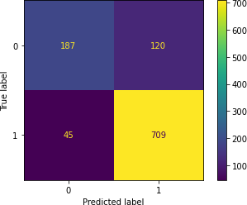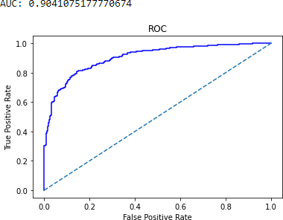

**ROC and AUC - Train:**

# Accuracy - Test:



**ROC and AUC - Test:**

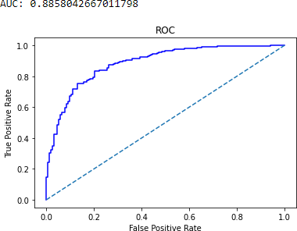

**Classification report - Train:**



# Confusion matrix - Test:

**Classification report - Test:**



# Observation:

**Train data:**

* Accuracy: 84.45%
* Precision: 86%
* Recall: 94%
* F1-Score: 90%
* AUC: 90.41%

# Test data:

* Accuracy: 81.36%
* Precision: 82%
* Recall: 92%
* F1-Score: 87%
* AUC: 88.58%

The tuning of the model has help the model recover from over-fitting. Now the model is a good model.

# AdaBoosting - Regular: Predicted Class and probs:

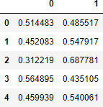

**Accuracy - Train:**



# ROC and AUC - Train:

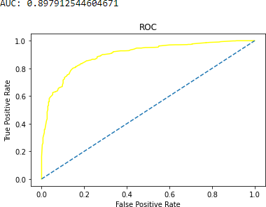

**Accuracy - Test:**



# ROC and AUC – Test

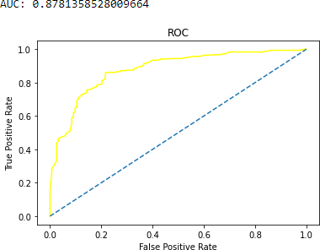

**:**

**Confusion matrix - Train:**

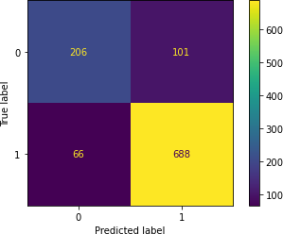

# Classification report - Train:

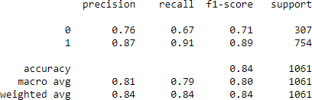

**Confusion matrix - Test:**

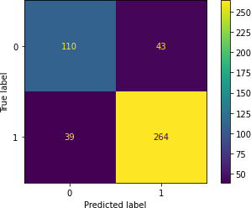

# Classification report - Test:

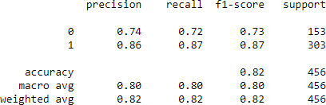

**Observation:**

# Train data:

* Accuracy: 84.26%
* Precision: 87%
* Recall: 91%
* F1-Score: 89%
* AUC: 89.79%

# Test data:

* Accuracy: 82.02%
* Precision: 86%
* Recall: 87%
* F1-Score: 87%
* AUC: 87.81%

The tuning of the model has help the model recover from over-fitting. Now the model is a good model.

# AdaBoosting - Tuned: Predicted Class and probs:

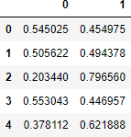

**Accuracy - Train:**



# ROC and AUC - Train:

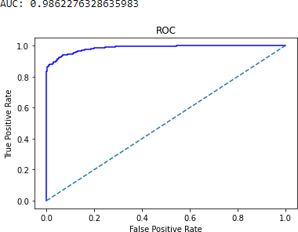

**Accuracy - Test:**



# ROC and AUC - Test:

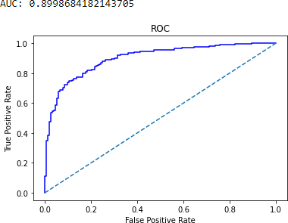

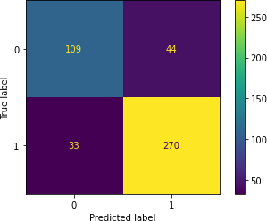**Confusion matrix - Train:**

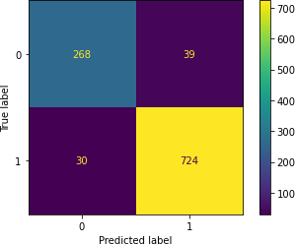

# Classification report - Train:



**Confusion matrix - Test:**

# Classification report - Test:



**Observation:**

# Train data:

* Accuracy: 93.5%
* Precision: 95%
* Recall: 96%
* F1-Score: 95%
* AUC: 98.62%

# Test data:

* Accuracy: 83.11%
* Precision: 86%
* Recall: 89%
* F1-Score: 88%
* AUC: 89.99%

The model is a good model. There is no over-fitting. There is improvement from the reguar model.

# Gradient Boosting - Regular: Predicted Class and probs:

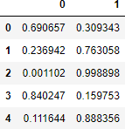

**Accuracy - Train:**



# ROC and AUC - Train:

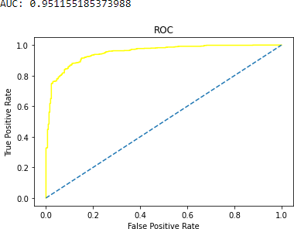

**Accuracy - Test:**

# ROC and AUC - Test:

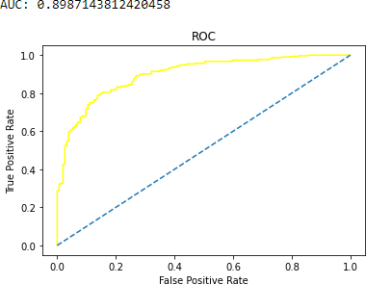

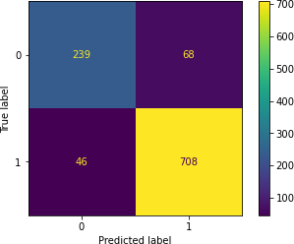**Confusion matrix - Train:**

# Classification report - Train:

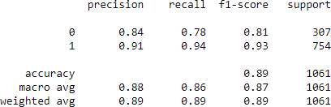

**Confusion matrix - Test:**

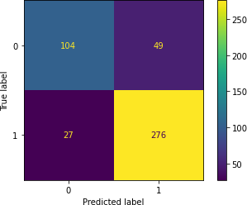

# Classification report - Test:

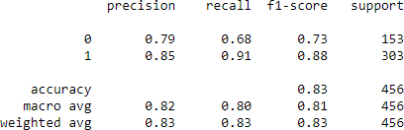

**Observation:**

# Train data:

* Accuracy: 89.26%
* Precision: 91%
* Recall: 94%
* F1-Score: 93%
* AUC: 95.11%

# Test data:

* Accuracy: 83.33%
* Precision: 85%
* Recall: 91%
* F1-Score: 88%
* AUC: 89.87%

The values are high. There is no over-fitting of any sorts. Themodel is a good model.

# Gradient Boosting - Tuned: Predicted Class and probs:

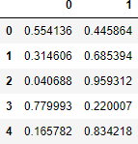

**Accuracy - Train:**

# ROC and AUC - Train:

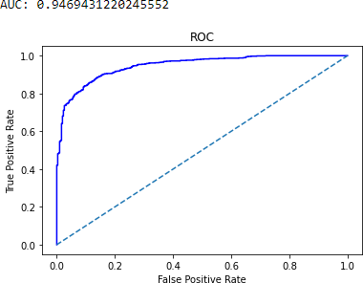

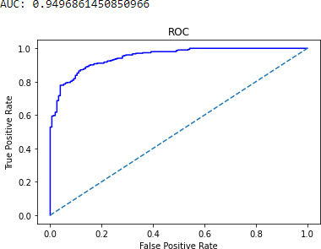**Accuracy - Test:**

# ROC and AUC - Test:

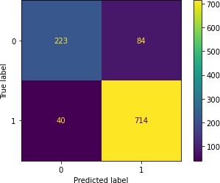**Confusion matrix - Train:**

# Classification report - Train:

**Confusion matrix - Test:**

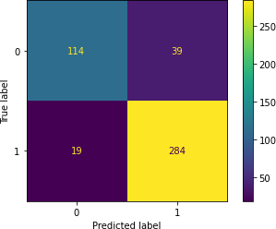

# Classification report - Test:

**Observation:**

# Train data:

* Accuracy: 88.31%
* Precision: 89%
* Recall: 95%
* F1-Score: 92%
* AUC: 94.69%

# Test data:

* Accuracy: 87.28%
* Precision: 88%
* Recall: 94%
* F1-Score: 91%
* AUC: 94.97%

The tuning of the Gradient Boost model has improved the model further. The values are high. The better is better than the regular model.

# Comparison of train data of all models in a structured tabular manner:

|  |  |  |  |  |  |
| --- | --- | --- | --- | --- | --- |
|  | Accurac y | Precisio n | Recall | F1-  Score | AUC |
| LR - Regular | 83.41% | 86% | 92% | 89% | 88.98  % |
| LR - Tuned | 83.6% | 86% | 92% | 89% | 88.89  % |

|  |  |  |  |  |  |
| --- | --- | --- | --- | --- | --- |
| LDA - Regular | 83.41% | 86% | 91% | 89% | 88.94  % |
| LDA - Tuned | 83.22% | 87% | 90% | 88% | 88.68  % |
| KNN - Regular | 100% | 100% | 100% | 100% | 100% |
| KNN - Tuned | 84.35% | 88% | 91% | 89% | 90.23  % |
| Naïve Bayes - Regular | 83.51% | 88% | 90% | 89% | 88.79  % |
| Random Forest -  Regular | 100% | 100% | 100% | 100% | 100% |
| Bagging - Regular | 95.38% | 95% | 98% | 97% | 99.4% |
| Bagging - Tuned | 84.45% | 86% | 94% | 90% | 90.41  % |
| AdaBoosting - Regular | 84.26% | 87% | 91% | 89% | 89.79  % |
| AdaBoosting - Tuned | 93.5% | 95% | 96% | 95% | 98.62  % |
| Gradient Boosting -  Regular | 89.26% | 91% | 94% | 93% | 95.11  % |
| Gradient Boosting -  Tuned | 88.31% | 89% | 95% | 92% | 94.69  % |

**Comparison of test data of all models in a structured tabular manner:**

|  |  |  |  |  |  |
| --- | --- | --- | --- | --- | --- |
|  | Accurac y | Precisio n | Recall | F1-  Score | AUC |
| LR - Regular | 82.68% | 86% | 89% | 87% | 88.4% |
| LR - Tuned | 84.21% | 86% | 90% | 88% | 89.05  % |
| LDA - Regular | 83.33% | 86% | 89% | 88% | 88.76  % |
| LDA - Tuned | 83.99% | 87% | 89% | 88% | 89.33  % |
| KNN - Regular | 83.77% | 86% | 90% | 88% | 88.46  % |
| KNN - Tuned | 86.18% | 87% | 93% | 90% | 92.27  % |
| Naïve Bayes - Regular | 82.24% | 87% | 87% | 87% | 87.64 |

|  |  |  |  |  |  |
| --- | --- | --- | --- | --- | --- |
|  |  |  |  |  | % |
| Random Forest -  Regular | 82.68% | 84% | 91% | 88% | 88.62  % |
| Bagging - Regular | 82.46% | 83% | 92% | 87% | 89.4% |
| Bagging - Tuned | 81.36% | 82% | 92% | 87% | 88.58  % |
| AdaBoosting - Regular | 82.02% | 86% | 87% | 87% | 87.81  % |
| AdaBoosting - Tuned | 83.11% | 86% | 89% | 88% | 89.99  % |
| Gradient Boosting -  Regular | 83.33% | 85% | 91% | 88% | 89.87  % |
| Gradient Boosting -  Tuned | 87.28% | 88% | 94% | 91% | 94.97  % |

# Comparing the AUC, ROC curve on the train data of all the tuned models:

In all the models, tuned ones are better than the regular models. So, we compare only the tuned models and describe which model is the best/optimized.

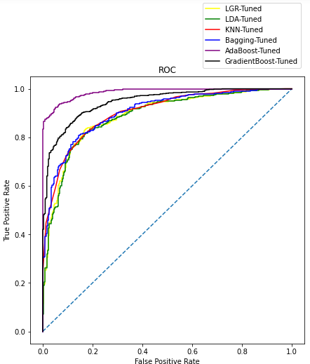

# Comparing the AUC, ROC curve on the test data of all the tuned models:

In all the models, tuned ones are better than the regular models. So, we compare only the tuned models and describe which model is the best/optimized.

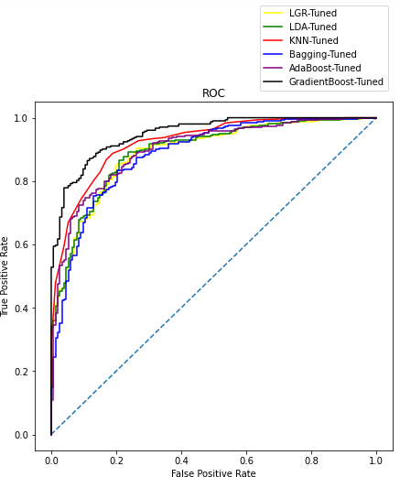

# Conclusion:

* There is no under-fitting or over-fitting in any of thetuned models.
* All the tuned models have high values and every model is good. But as we can see, the most consistent tuned model in both train and test data is the Gradient Boost model.
* The tuned gradient boost model performs the best with 88.31% accuracy score in train and 87.28% accuracy score in test. Also it has the best AUC score of 94% inboth train and test data which

is the highest of all the models.

* It also has a precision score of 88% and recall of 94% which is also the highest of all the models. So, we conclude that Gradient Boost Tuned model is the best/optimized model.

# Based on these predictions, what are the insights?

**Insights:**

* + 1. Labour party has more than double the votes of conservative party.
    2. Most number of people have given a score of 3 and 4 for the national economic condition and the average score is 3.245221
    3. Most number of people have given a score of 3 and 4 for the household economic condition and the average score is 3.137772
    4. Blair has higher number of votes than Hague and the scores are much better for Blair than for Hague.
    5. The average score of Blair is 3.335531 and the average score of Hague is 2.749506. So, here we can see that,Blair has a better score.
    6. On a scale of 0 to 3, about 30% of the total population has zero knowledge about politics/parties.
    7. People who gave a low score of 1 to a certain party, still decided to vote for the same party instead of voting for the other party. This can be because of lack of political knowledge among the people.
    8. People who have higher Eurosceptic sentiment, has voted for the conservative party and lower the Eurosceptic sentiment, higher the votes for Labour party.
    9. Out of 454 people who gave a score of 0 for political knowledge, 360 people have voted for the labour partyand 94 people have voted for the conservative party.
    10. All models performed well on training data set as well as test dat set. The tuned models have performed better than the regular models.
    11. There is no over-fitting in any model except Random Forest and Bagging regular models.
    12. Gradient Boosting model tuned is the best/optimized model.

# Business recommendations:

* + 1. Hyper-parameters tuning is an import aspect of modelbuilding. There are limitations to this as to process these combinations, huge amount of processing power is required. But if tuning can be done with many sets ofparameters, we might get even better results.
    2. Gathering more data will also help in training the models and thus improving the predictive powers.
    3. We can also create a function in which all the modelspredict the outcome in sequence. This will helps in better understanding and the probability of what the outcome will be.
    4. Using Gradient Boosting model without scaling for predicting the outcome as it has the best optimized performance.

# Problem 2:

In this particular project, we are going to work on the inaugural corpora from the nltk in Python. We will be lookingat the following speeches of the Presidents of the United States of America:

President Franklin D. Roosevelt in 1941 President John F. Kennedy in 1961 President Richard Nixon in 1973

# 2.1) Find the number of characters, words, and sentences for the mentioned documents.

**Number of characters:**

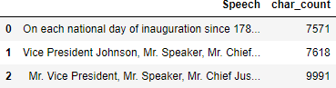

* + - President Franklin D. Roosevelt's speech have 7571 characters (including spaces).
    - President John F. Kennedy's speech have 7618 characters (including spaces).
    - President Richard Nixon's speech have 9991 characters (including spaces).

# Number of words:



* + - There are 1526 words in President Franklin D. Roosevelt's speech.
    - There are 1543 words in President John F. Kennedy'sspeech.
    - There are 2006 words in President Richard Nixon's speech.

# Number of sentences:



* + - There are 68 sentences in President Franklin D. Roosevelt's speech.
    - There are 52 sentences in President John F. Kennedy'sspeech.
    - There are 68 sentences in President Richard Nixon's speech.
  1. **Remove all the stop-words from all three speeches.**

Before, removing the stop-words, we have changed all theletters to lowercase and we have removed special characters.

# Word count before the removal of stop-words:

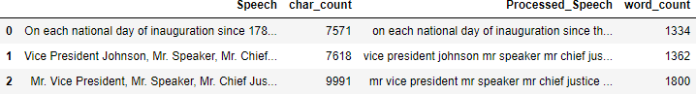

Before the removal of stop-words,

* + - President Franklin D. Roosevelt's speech have 1334 words.
    - President John F. Kennedy's speech have 1362 words.
    - President Richard Nixon's speech have 1800 words.

# Word count after the removal of stop-words:

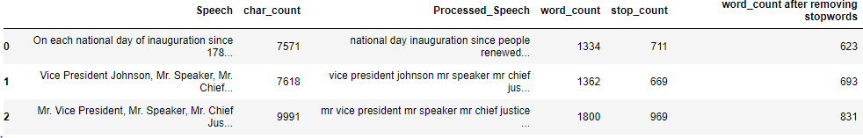

After the removal of stop-words,

* + - President Franklin D. Roosevelt's speech have 623 words.
    - President John F. Kennedy's speech have 693 words.
    - President Richard Nixon's speech have 831 words.

**2.3) Which word occurs the most number of times in his inaugural address for each president? Mention the top three words. (after removing the stop-words)**

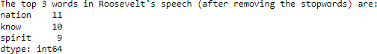**Top 3 words in Roosevelt's speech:**

The top 3 words are,

* + - nation - 11
    - know - 10
    - spirit - 9

# Top 3 words in Roosevelt's speech:

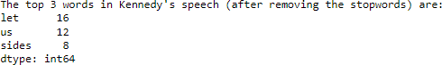

The top 3 words are,

* + - let - 11
    - us - 10
    - sides - 9

# Top 3 words in Roosevelt's speech:

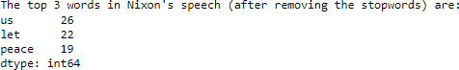

The top 3 words are,

* + - us - 26
    - let - 22
    - peace – 19
  1. **Plot the word cloud of each of the three speeches. (after removing the stop-words)**

**Word cloud of Roosevelt's speech:**



# Word cloud of Kennedy's speech:



**Word cloud of Nixon's speech:**

